
Shri. Vile Parle Kelavani Mandal's
Institute of Technology, Dhule
Survey No. 499, Plot No.2, Behind Gurudwara, Mumbai Agra Highway, Dhule (MS)
Name:- Anushka Paras Jain  Roll no:- 01 Date :- / /2022  Branch :-Final Year B.Tech (Computer Department)  Exp. No:-6  Subject:- Cloud Computing Lab | Sign :-
 | Remark :-
Aim: Installation and configuration of virtual machine using Virtual Box and perform python programming

What will you learn by performing this experiment?
After Performing this experiment will come to know how to create virtualization environment using Oracle’s Virtual box.

Hardware/Software Required: 2GB RAM,320 GB hard, dual core processor Virtual Box, Windows8 OS.

Theory:
Virtualization is the creation of a virtual version of something, such as an operating system, a server, a storage device or network resources.
Advantages of virtual installation:
The size of the installation doesn't have to be predetermined. It can be a dynamically resized virtual hard drive.We do not need to reboot in order to switch between different OS.The virtual machine will use our main OS internet connection.The virtual machine will set up its own video configuration, so we don't have to worry about installing proprietary graphics drivers to get a reasonable screen resolution.It's low commitment. If we later decide you don't like Ubuntu, all we have to do is Delete the virtual hard drive and uninstall VirtualBox.

Procedure/ Program:

The Installation process of Virtualbox

Install the VirtualBox program. If we are using Windows, double-click the setup file and follow the prompts to install.
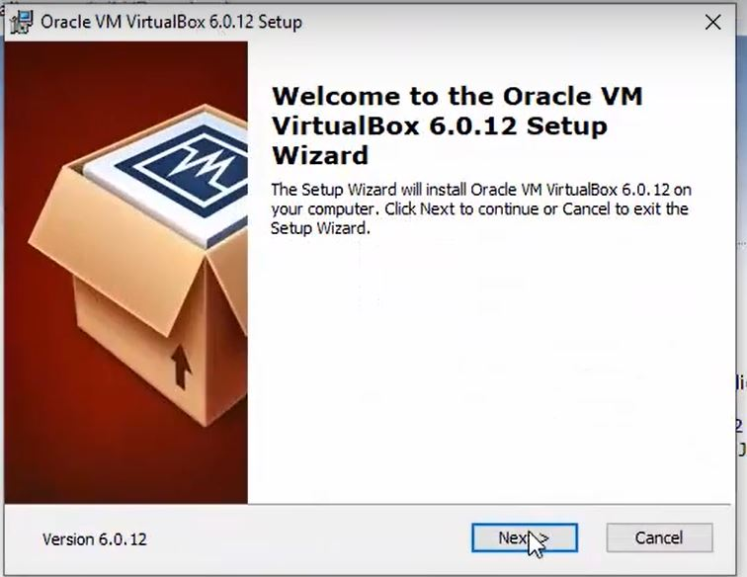

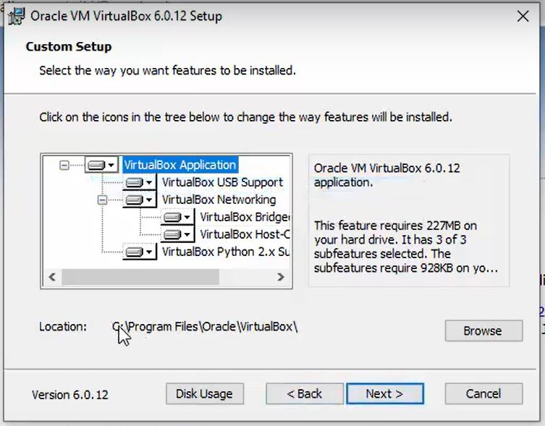
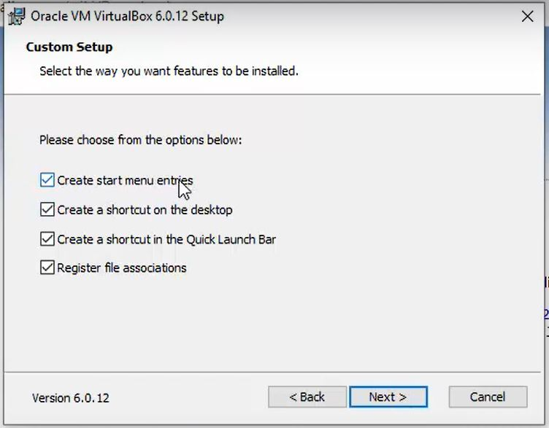

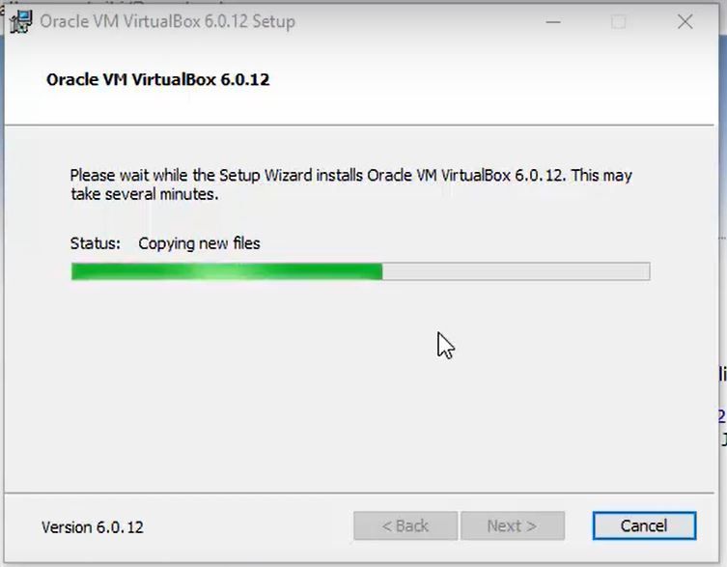

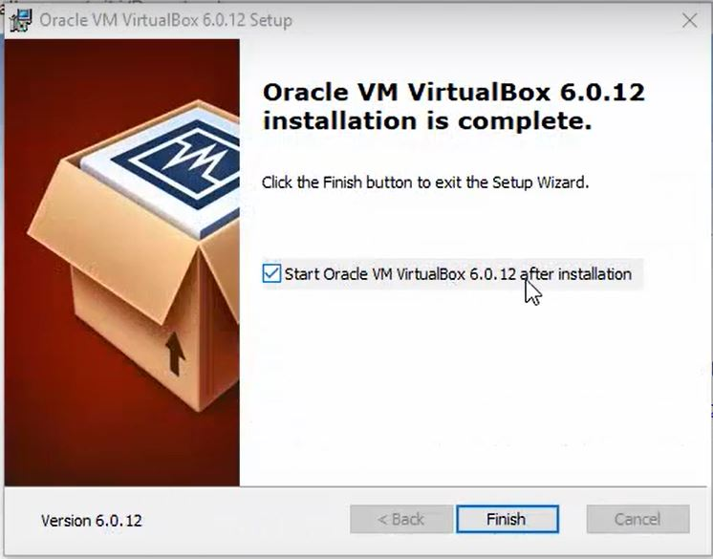

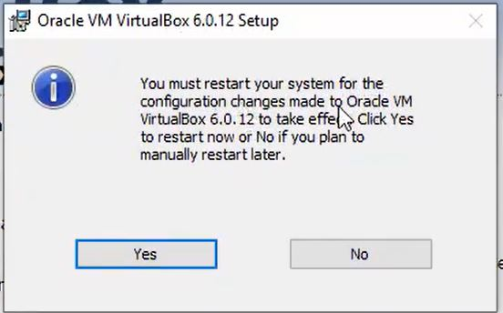

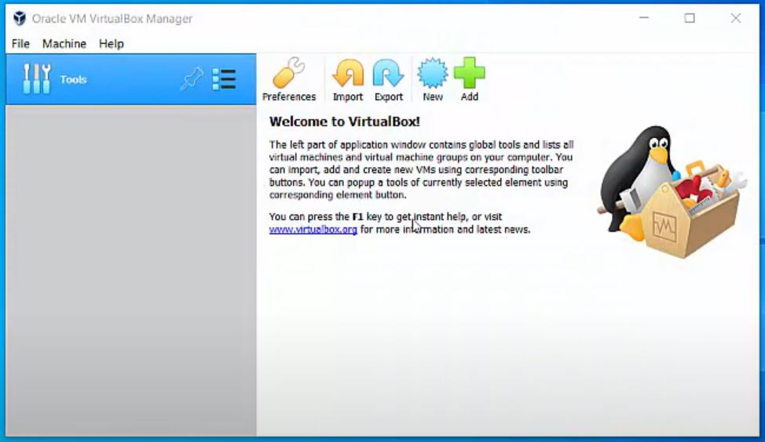

Installation of virtual OS in virtual box:

Step 1: Click New button to create virtual machine and choose the operating system and it’s path.

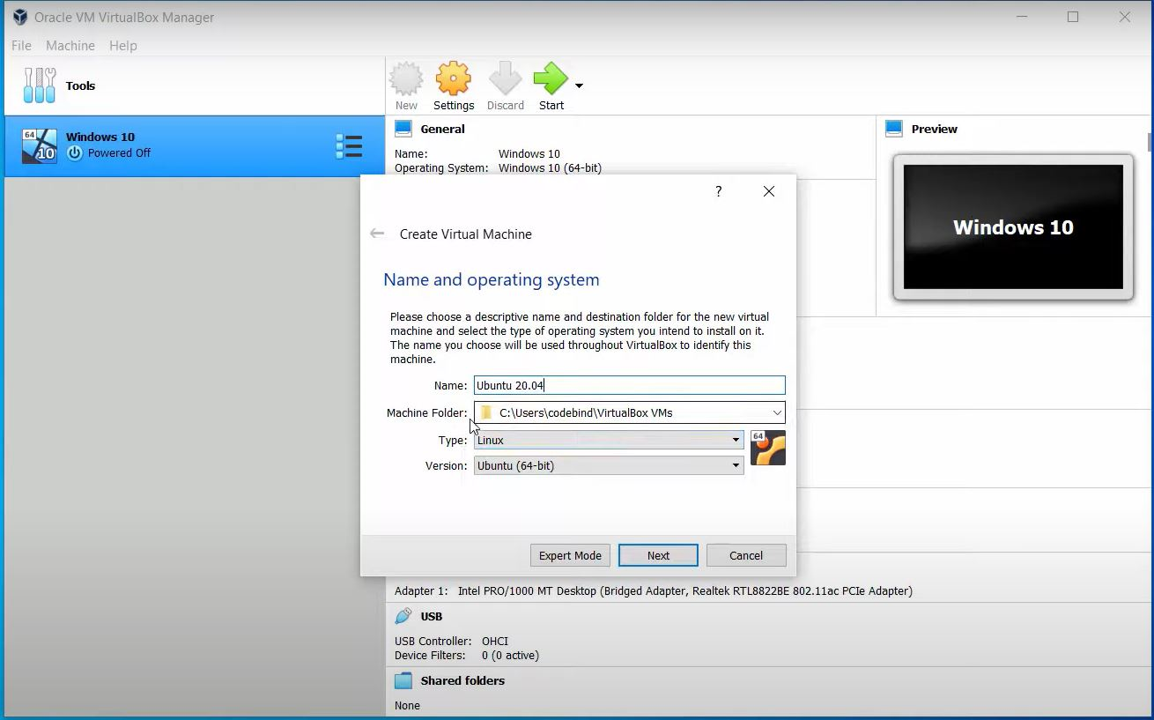

Step 2: select type of hard disk
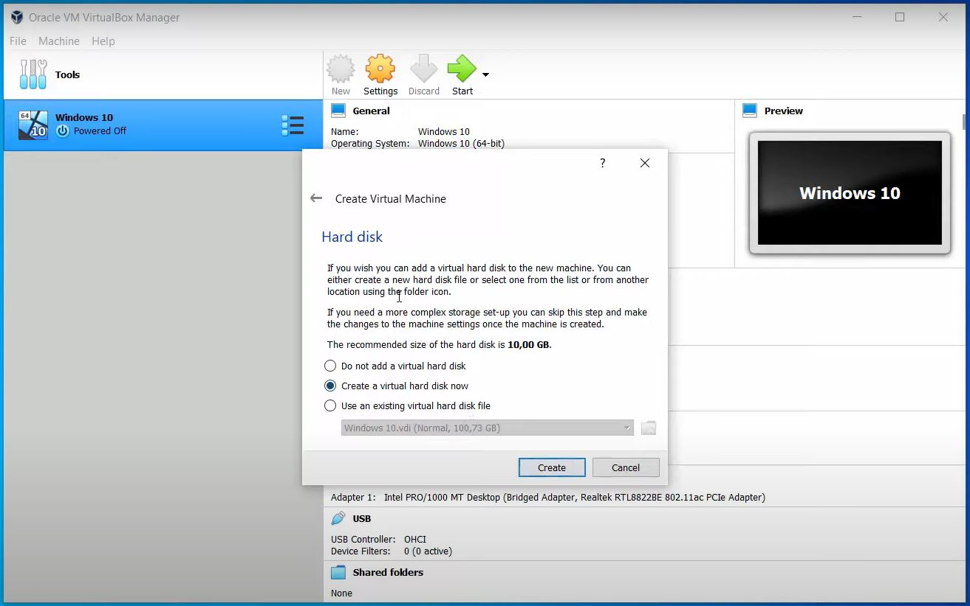

Step 3: select memory size of the RAM.

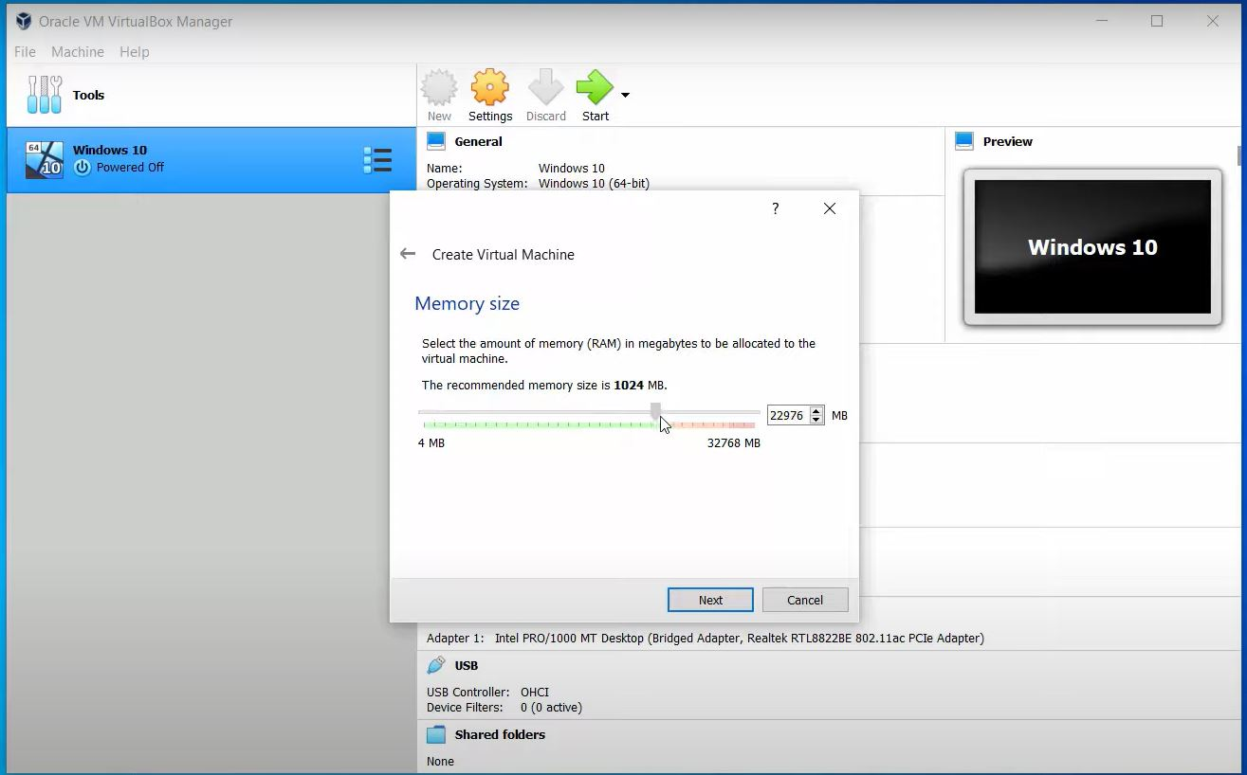

Step 4: choose hard disk file type

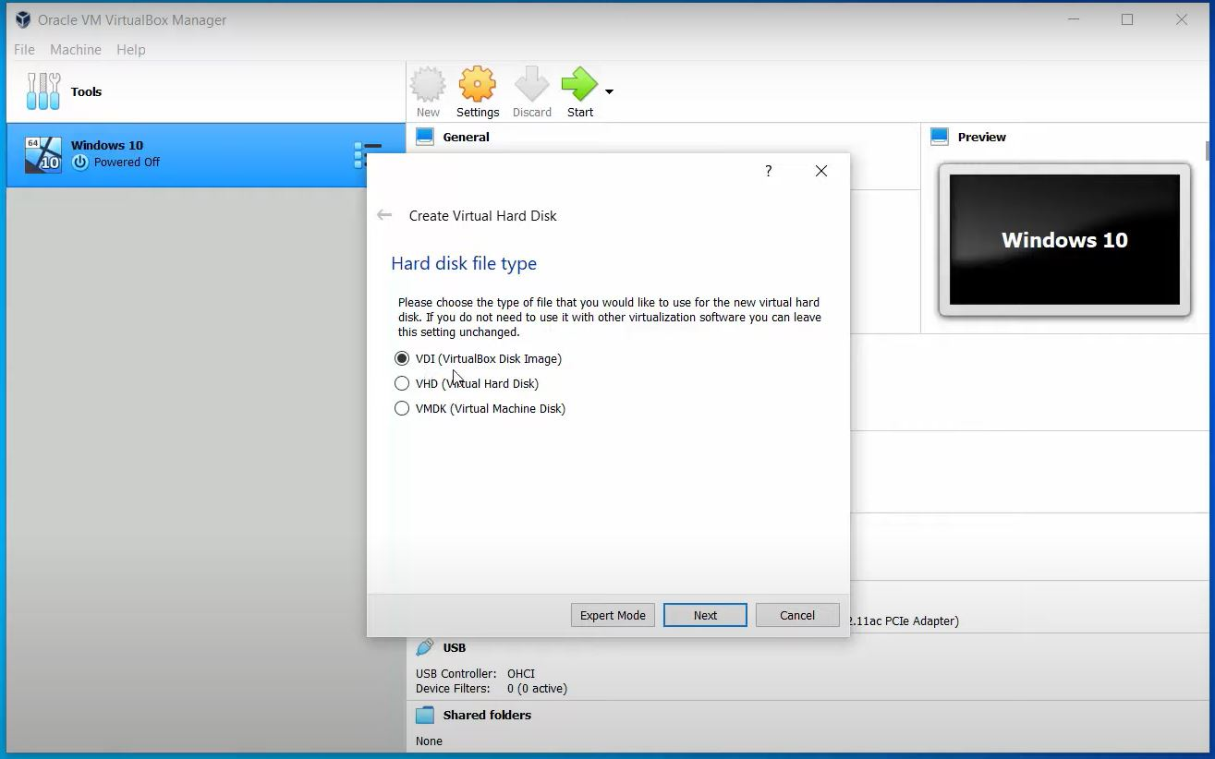

Step 5: select storage allocation type.

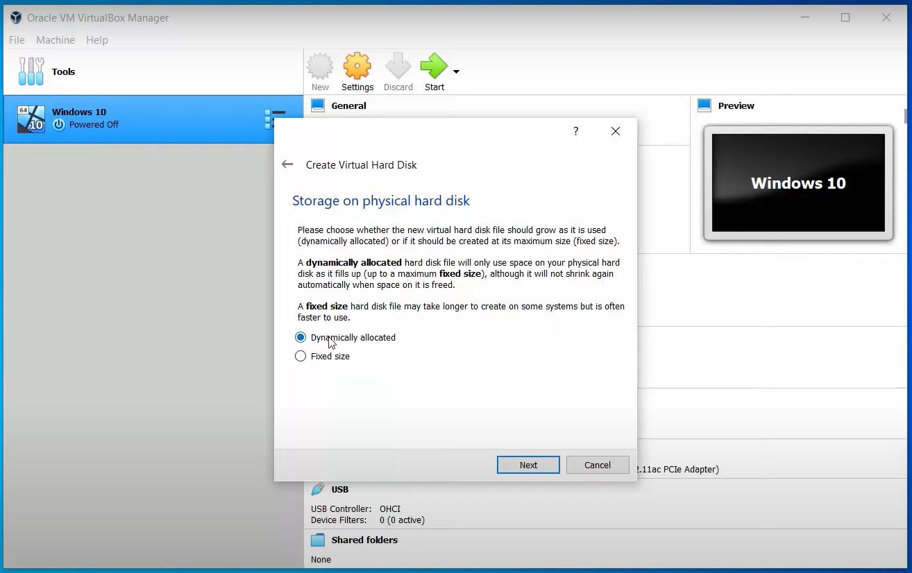

Step 6: select the setup file of the operating system and the size of the hard disk.

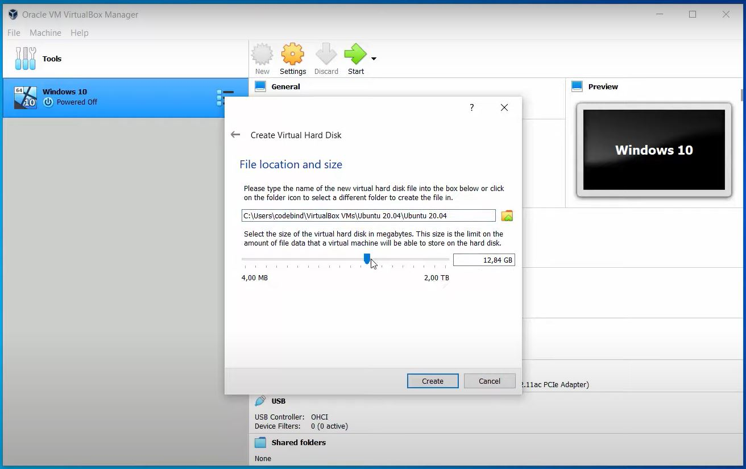

Step 7: virtual machine created.

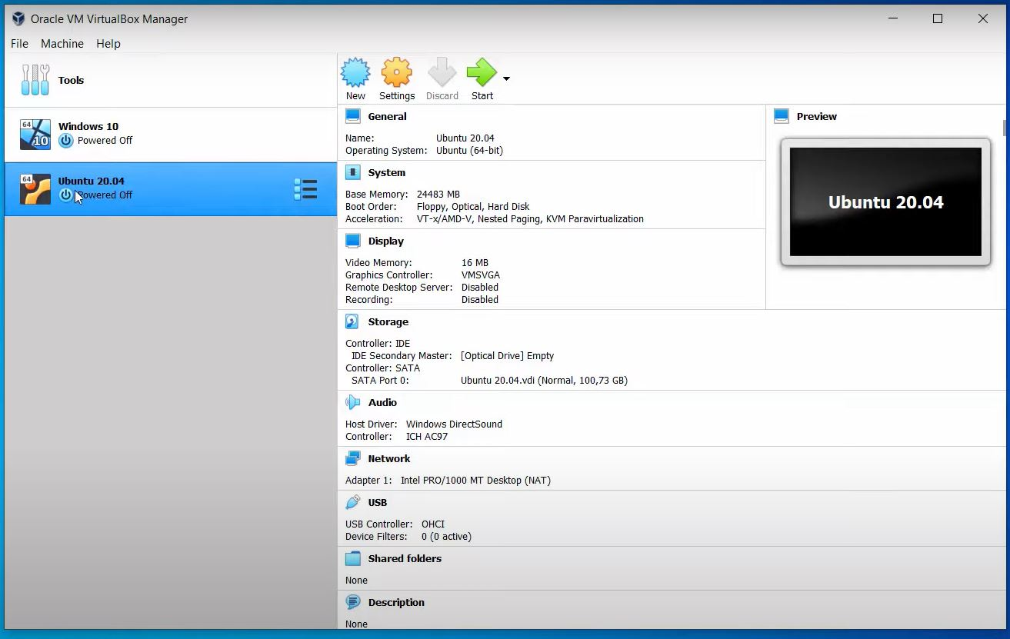

Step 8: installation of the operating system.

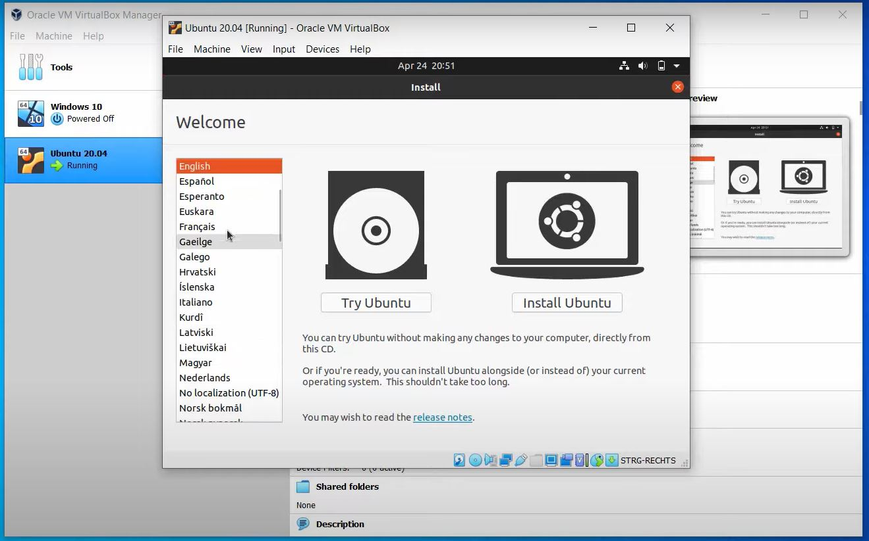

Result:

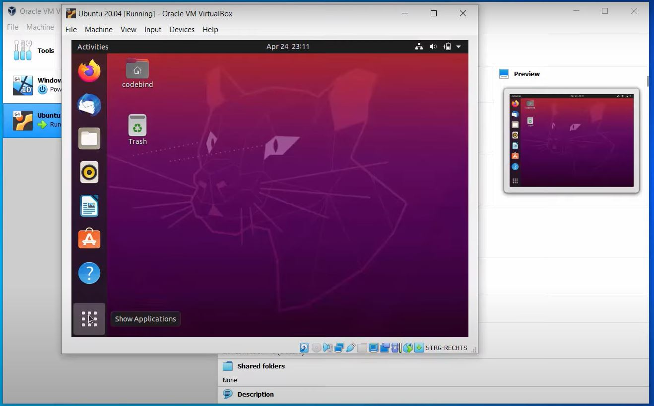

Conclusion and Discussion:

After installing virtualization layer on the host operating system using virtual box software the students are able to experience the benefits of virtualization and how they can work on more than one operating system at a time.

