
Shri. Vile Parle Kelavani Mandal's
Institute of Technology, Dhule
Name:-Anushka Paras Jain  Roll no:- 01 Date :- / /2023  Branch :-Final Year B.Tech (Computer Department)  Exp. No:-8  Subject:- Cloud Computing Lab | Sign :-
 | Remark :-
Survey No. 499, Plot No.2, Behind Gurudwara, Mumbai Agra Highway, Dhule (MS)

Aim: Create an application (Ex: Word Count) using Hadoop Map/Reduce.

Theory:

THE MAPREDUCE MODEL

Traditional parallel computing algorithms were developed for systems with a small number of processors, dozens rather than thousands. So it was safe to assume that processors would not fail during a computation. At significantly larger scales this assumption breaks down, as was experienced at Google in the course of having to carry out many large-scale computations similar to the one in our word counting example. The MapReduce parallel programming abstraction was developed in response to these needs, so that it could be used by many different parallel applications while leveraging a common underlying fault-tolerant implementation that was transparent to application developers. Figure 11.1 illustrates MapReduce using the word counting example where we needed to count the occurrences of each word in a collection of documents.

MapReduce proceeds in two phases, a distributed ‗map‘ operation followed by a distributed ‗reduce‘ operation; at each phase a configurable number of M ‗mapper‘ processors and R ‗reducer‘ processors are assigned to work on the problem (we have usedM = 3 and R = 2 in the illustration). The computation is coordinated by a single master process (not shown in the figure).

A MapReduce implementation of the word counting task proceeds as follows: In the map phase each mapper reads approximately 1/M th of the input (in this case documents), from the global file system, using locations given to it by the master. Each mapped then performs a
‗map‘ operation to compute word frequencies for its subset of documents. These frequencies are sorted by the words they represent and written to the local file system of the mapper. At the next phase reducers are each assigned a subset of words; in our illustration
the first reducer is assigned w1 and w2 while the second one handles w3 and w4. In fact during the map
phase itself each mapper writes one file per reducer, based on the words assigned to each reducer, and keeps the master informed of these file locations. The master in turn informs the reducers where the partial counts for their words have been stored on the local files of respective mappers; the reducers then make remote procedure call requests to the mappers to fetch these.
Each reducer performs a reduce‘ operation that sums up the frequencies for each word, which are finally written back to the GFS file system

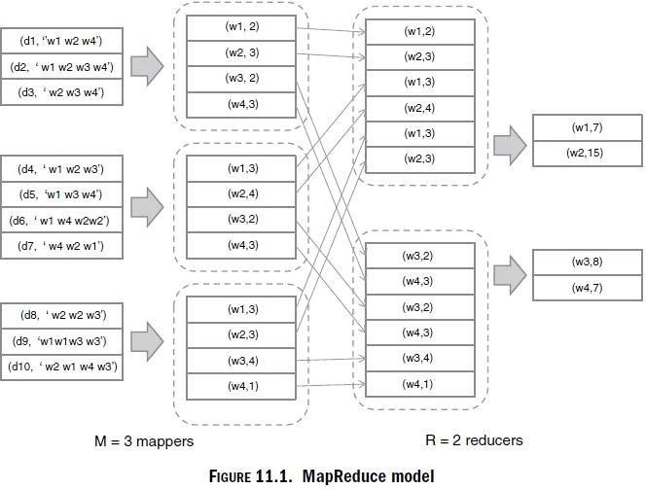

The MapReduce programming model generalizes the computational structure of the above example. Each map operation consists of transforming one set of key-value pairs to another:

Map: (k1, v1) → [(k2, v2)]………………………………
(11.4)

In our example each map operation takes a document indexed by its id and emits a list if word- count pairs indexed by word-id: (dk, [w1 ...... wn]) → [(wi, ci)]. The reduce operation groups the results of the map step using the same key k2 and performs a function f on the list of values that correspond to each
Reduce: (k2, [v2]) → (k2, f ([v2]))……………………….
(11.5)

In our example each reduce operation sums the frequency counts for each word:



The implementation also generalizes. Each mapper is assigned an input-key range (set of values for k1) on which map operations need to be performed. The mapper writes results of its map operations to its local disk in R partitions, each corresponding to the output-key range (values of k2) assigned to a particular reducer, and informs the master of these locations. Next each reducer fetches these pairs from the respective mappers and performs reduce operations for each key k2 assigned to it. If a processor fails during the execution, the master detects this through regular heartbeat communications it maintains with each worker, wherein updates are also exchanged regarding the status of tasks assigned to workers.

If a mapper fails, then the master reassigns the key-range designated to it to another working node for re-execution. Note that re-execution is required even if the mapper had completed some of its map operations, because the results were written to local disk rather than the GFS. On the other hand if a reducer fails only its remaining tasks (values k2) are reassigned to another node, since the completed tasks would already have been written to the GFS.

Finally, heartbeat failure detection can be fooled by a wounded task that has a heartbeat but is making no progress: Therefore, the master also tracks the overall progress of the computation and if results from the last few processors in either phase are excessively delayed, these tasks are duplicated and assigned to processors who have already completed their work. The master declares the task completed when any one of the duplicate workers complete.

Such a fault-tolerant implementation of the MapReduce model has been implemented and is widely used within Google; more importantly from an enterprise perspective, it is also available as an open source implementation through the Hadoop project along with the HDFS distributed file system.

The MapReduce model is widely applicable to a number of parallel computations, including database-oriented tasks which we cover later. Finally we describe one more example, that of indexing a large collection of documents, or, for that matter any data including database records: The map task consists of emitting a word-document/record id pair for each word: (dk, [w1 . . .wn]) → [(wi, dk)]. The reduce step groups the pairs by word and creates an index entry for each word: [(wi, dk)] → (wi, [di1 . . .
dim]).

Indexing large collections is not only important in web search, but also a critical aspect of handling structured data; so it is important to know that it can be executed efficiently in parallel using
MapReduce. Traditional parallel databases focus on rapid query execution against data warehouses that are updated infrequently; as a result these systems often do not parallelize index creation sufficiently well.

Open in any Browser

- Open in any Browser NameNode - http://localhost:50070/ 

- Open in any Browser JobTracker - http://localhost:50030/ 

- open hadoop/hadoop-1.2.1 create a document type something in that document and save it as test.txt 

- bin/hadoop fs -ls / 

Found 1 items

drwxr-xr-x - vishal supergroup 0 2014-04-15 01:13 /tmp

- bin/hadoop fs -mkdir example 

- bin/hadoop fs -ls /user/vishal/ 

Found 1 items

drwxr-xr-x - vishal supergroup /user/vishal/example

- bin/hadoop fs -copyFromLocal test.txt /user/vishal/example 

- bin/hadoop jar hadoop-examples-1.2.1.jar wordcount /user/vishal/example/test.txt /hello 

(OR)

- In Eclipse New → Java Project → Provide Project Name → Next →Select Libraries →Add

→ → → → 
Externals JARs Go to Hadoop hadoop-1.2.1 select all jar files again click on Add

External JARs → go to hadoop → hadoop-1.2.1 → lib → select all JAR files → click on Finish.

• Right Click on Src Folder → Select Class → Provide a Class name: WCE → Package name:

com.WordCount.Example → Click on Finish.

package com.WordCount.Example;

import
java.io.IOException; import java.util.*;

import org.apache.hadoop.fs.Path; import org.apache.hadoop.conf.*; import org.apache.hadoop.io.*; import
org.apache.hadoop.mapred.*;
import org.apache.hadoop.util.*;

public class WCE

{

public static class Map extends MapReduceBase implements Mapper<LongWritable, Text, Text, IntWritable>

{

private final static IntWritable one = new IntWritable(1); private Text word = new Text();

public void map(LongWritable key, Text value, OutputCollector<Text, IntWritable> output, Reporter reporter) throws IOException

{
String line = value.toString();

StringTokenizer tokenizer = new
StringTokenizer(line); While
(tokenizer.hasMoreTokens())

{

word.set(tokenizer.nextToken());
output.collect(word, one);

}

}

}

public static class Reduce extends MapReduceBase implements Reducer<Text, IntWritable, Text, IntWritable> {

public void reduce(Text key, Iterator<IntWritable> values, OutputCollector<Text, IntWritable> output, Reporter reporter) throws IOException {

int sum = 0;

while (values.hasNext())

{

sum += values.next().get();

}

output.collect(key, new IntWritable(sum));

}}

public static void main(String[] args) throws Exception
{ JobConf conf = new JobConf(WCE.class); conf.setJobName("wordcount"); conf.setOutputKeyClass(Text.class); conf.setOutputValueClass(IntWritable.class); conf.setMapperClass(Map.class); conf.setCombinerClass(Reduce.class);
conf.setReducerClass(Reduce.class);
FileInputFormat.addInputPath(conf, new Path(args[0]));
FileOutputFormat.setOutputPath(conf, new
Path(args[1])); JobClient.runJob(conf);

}}

→ → → → 
• Right Click on Project Name New File sample type something in the sample file.

→ → → → 
- Right Click on Project Name Export Click on Java JAR File Provide a JAR File

Name → Select The Location where to save the JAR file.

→ → → → → 
- Right Click on Project Name Run as Run Configuration Java Application new

→ → 
In Main WordCount Click on Search and click on the JAR File which you have
→ → → → 
created Click on Arguments Provide under Program arguments sample output Click on Run.

→ →
• Right Click on Project Name Refresh An output file is created in your project. 

Conclusion: Hence we have implemented Map Reduce example such as Word Count program on an file which will count the no.of times a word repeats in the given file.

