
Shri. Vile Parle Kelavani Mandal's
Institute of Technology, Dhule
Survey No. 499, Plot No.2, Behind Gurudwara, Mumbai Agra Highway, Dhule (MS)
Name:- Anushka Paras Jain  Roll no:- 01 Date :- / /2023  Branch :-Final Year B.Tech (Computer Department)  Exp. No:-8  Subject:- Cloud Computing Lab | Sign :-
 | Remark :-
Aim: Implementation of SOAP Web services in C#/JAVA Applications.
Steps:

1. Overview
In this article, we will take a look at the SOAP Web Service examples.

2. SOAP Web Service Example
Using Apache Axis, SOAP web services are built. SOAP is an acronym for Simple Object Access Protocol. SOAP is used for developing web services that are based on XML based industry-standard protocol. SOAP security is based on WS Security. SOAP web services are platform and language independent.

2.1 Prerequisites
Java 8 is required on the Linux, windows or mac operating system. Eclipse Oxygen can be used for this example. Apache Tomcat 9.0 is used as a servlet container to deploy the examples.

2.2 Download
You can download Java 8 from the Oracle web site . Eclipse Oxygen can be downloaded from the eclipse web site. Apache Tomcat 9.0 can be downloaded from the apache website.

2.3 Setup
Below are the setup commands required for the Java Environment.
Setup
1  2  3  4 | JAVA_HOME="/desktop/jdk1.8.0_73"  export JAVA_HOME  PATH=$JAVA_HOME/bin:$PATH  export PATH

2.4 IDE

2.4.1 Eclipse Oxygen Setup
The ‘eclipse-java-oxygen-2-macosx-cocoa-x86_64.tar’ can be downloaded from the eclipse website. The tar file is opened by double click. The tar file is unzipped by using the archive utility. After unzipping, you will find the eclipse icon in the folder. You can move the eclipse icon from the folder to applications by dragging the icon.

2.5 Launching IDE

2.5.1 Eclipse Java
Eclipse has features related to language support, customization, and extension. You can click on the eclipse icon to launch eclipse. The eclipse screen pops up as shown in the screenshot below:
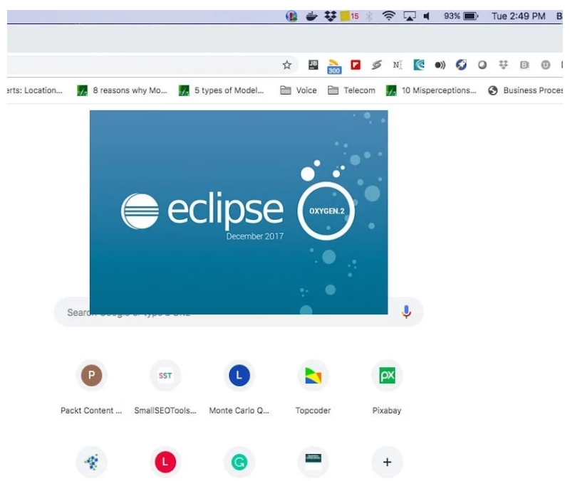
You can select the workspace from the screen which pops up. The attached image shows how it can be selected.
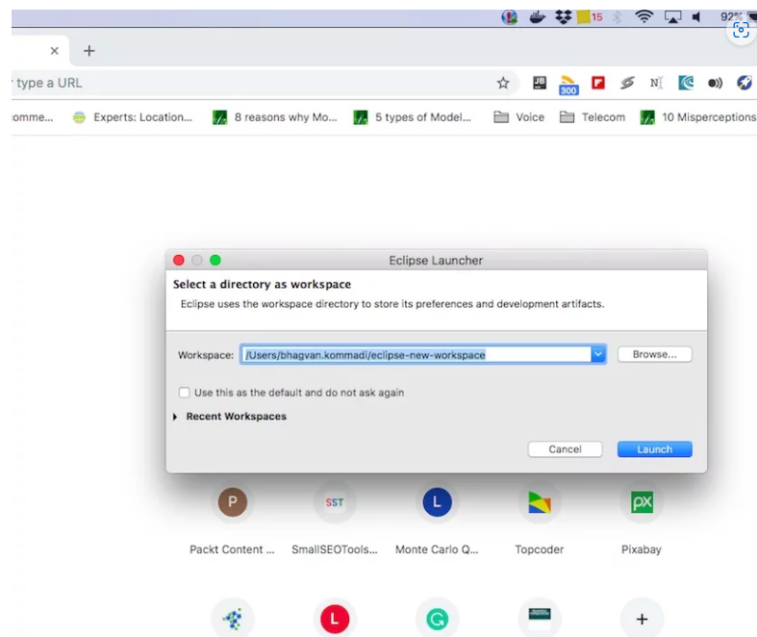
You can see the eclipse workbench on the screen. The attached screenshot shows the Eclipse project screen.
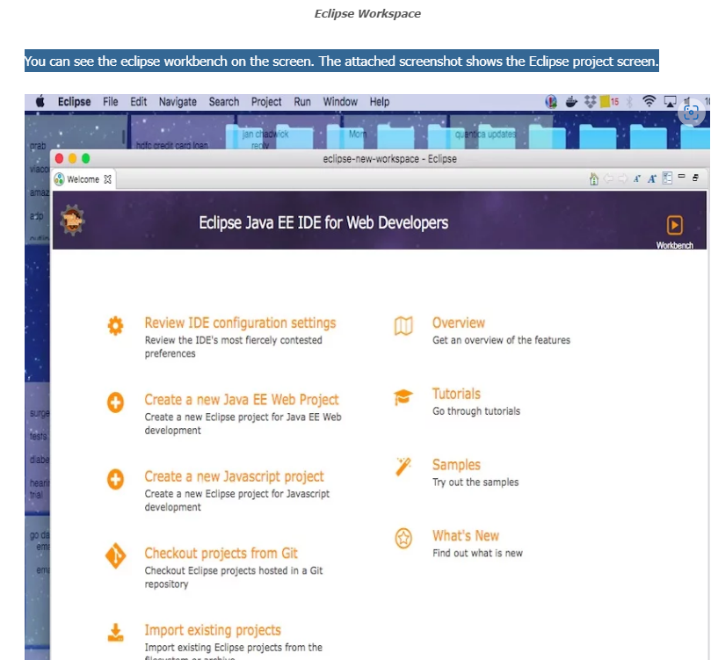
Java Hello World class prints the greetings. The screenshot below is added to show the class and execution on eclipse.
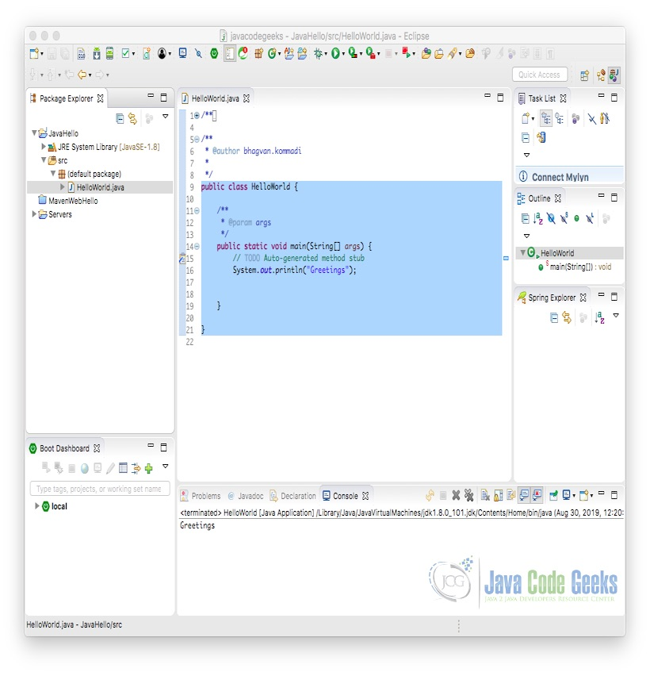

2.6 SOAP Web Service in Java
SOAP is based on Web Services Description Language (WSDL). First, we create the service. The code below shows the service Greetings implementation.Greetings Service
1  2  3  4  5  6  7 | public class Greetings {  public String getMessage(String message)  {  return "received message "+ message;  }  }
WSDL is created by using the eclipse menu. The screenshot below shows the menu navigation.
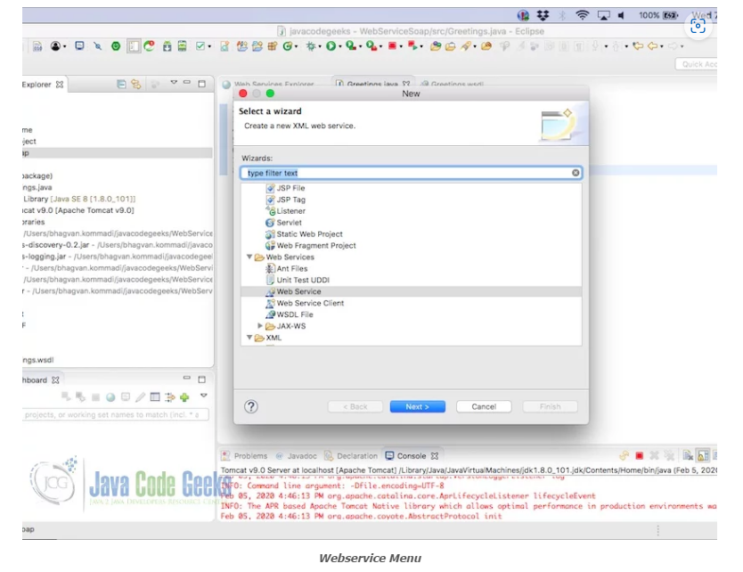
In the screen, after selecting Next you will be navigated to the selection of the Service implementation. The screenshot below shows the service implementation selection of the Greetings Service.
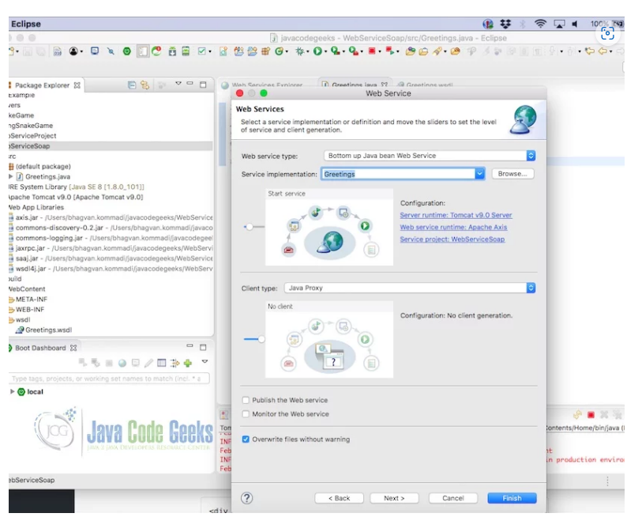
WSDL is created for the Greetings Service.
The Greetings web service is tested using the eclipse web service explorer. The test is successful as shown in the screenshot below.
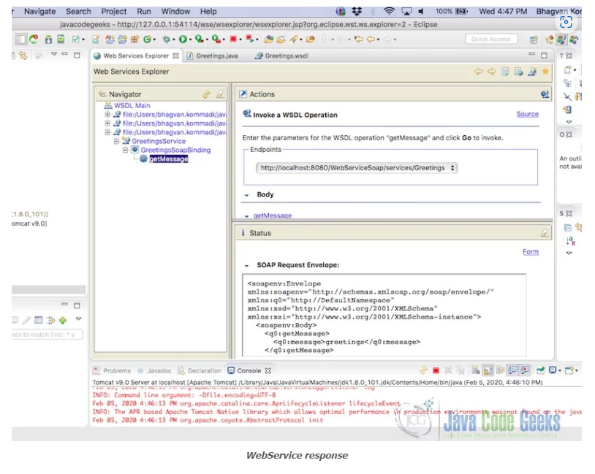
The input for the test is set as greetings. The output is shown from the screenshot below:

