Game Design Document

Fill up the following document

1. Write the title of your project.

The Frogger Game

1. What is the goal of the game?

To make the frogs reach safely to their homes.

1. Write a brief story of your game.

The game is a about a frog and his family. They are trying to cross a road and go to their homes. But they are stuck as they don’t know know how to cross the road. You need to help them reach the river safely.

1. Which are the playing characters of this game?

* Playing characters are the ones who respond to the user based on the input from the user.
* Cars, monkeys, dinos, wizards, etc., are the playing characters in the game.

|  |  |  |
| --- | --- | --- |
| Number | Character Name | What can this character do? |
| 1 | Young Frog | Can move forward and backward |
| 2 | Frog’s Dad | Can move forward and backward |
| 3 | Frog’s Mom | Can move forward and backward |
| 4 | Frog’s Sister | Can move forward and backward |
| 5 | Frog’s Brother | Can move forward and backward |
| 6 | Frog’s Grandmother | Can move forward and backward |
| 7 |  |  |
| 8 |  |  |

1. Which are the Non-Playing Characters of this game?

* Non-Playing characters are the ones that don't have an action or behavior when the user interacts with the game.
* Hurdles, stones, bananas, coins, etc., are non-playing characters in the game.

|  |  |  |
| --- | --- | --- |
| Number | Character Name | What can this character do? |
| 1 | Cars | Randomly move across the road |
| 2 | Trucks | Randomly move across the road |
| 3 | Frog’s Food | Will give energy to Frogs |
| 4 | Logs | Randomly move across the river |
| 5 | Bicyles | Randomly move across the road |
| 6 | Crab | Randomly moving across the river |
| 7 |  |  |
| 8 |  |  |

Draw your imagination of this game. What does this game look like?

* Draw the game either on your computer or on paper.
* Add images of the game scenes to show each of the playing and non-playing characters at least once.

This game looks like a scenery of frog waiting at the end of road longing to cross it and going

into the river.

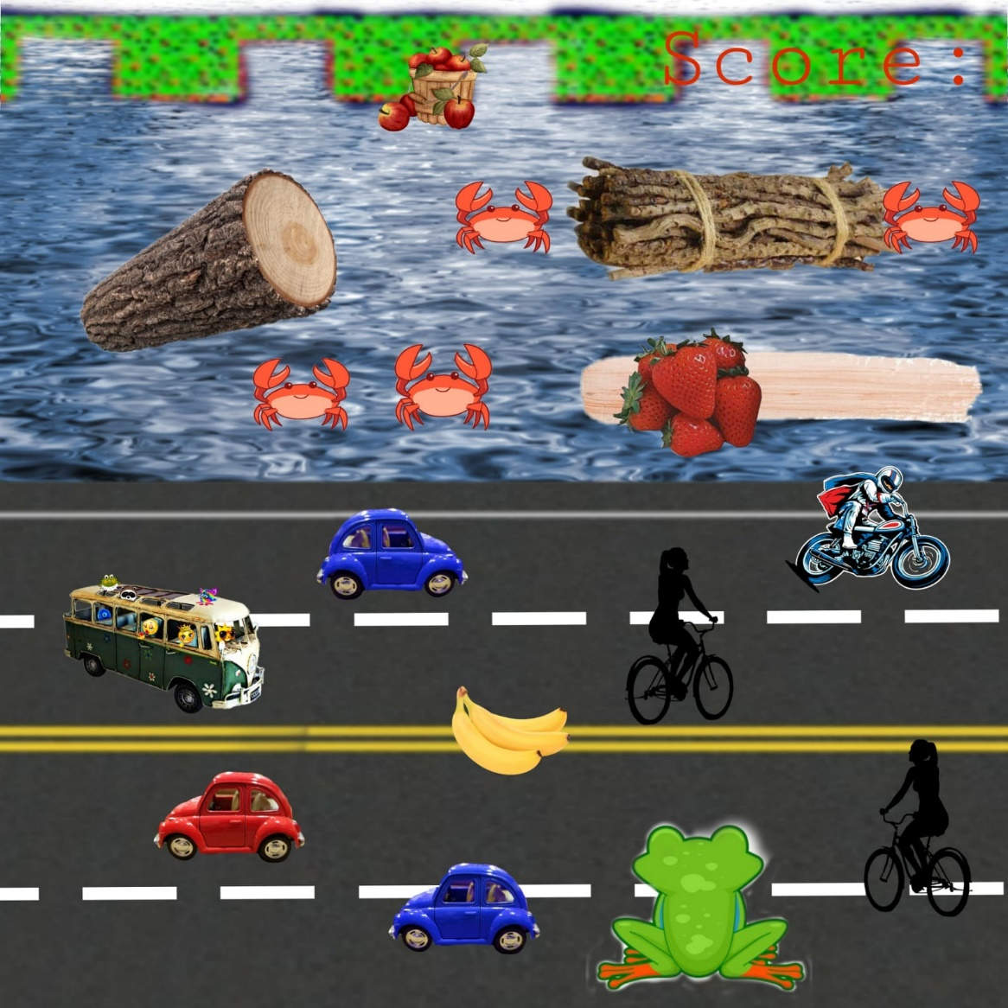

How do you plan to make your game engaging?

With the feedback which is by adding sounds on achievements and for giving warnings will make the game more interesting. The increasing score and compliments in between the game will motivate the players to continue the game.