STOCKOUT-AWARE DEMAND FORECASTING
FOR PERISHABLE RETAIL INVENTORY
A Segmented Machine-Learning Approach to the Censored-Demand Newsvendor Problem
Capstone Project - Final Report
Business Analytics Capstone
University of North Texas
Team Members:
Anusha Chitte
Anushka Kadam
Brunda Rani Meskhana
Dipanshu Parashar
Mihir Girish Sali
Faculty Advisor:
Dr. Shamroukh
Date: 4 May 2026
Table of Contents
1. Executive Summary 3
1.1 Overview 3
1.2 Key Findings 3
1.3 Recommendations 4
1.4 Expected Outcome 4
2. Business Understanding 5
2.1 Business Problem 5
2.2 Project Objectives 5
2.3 Research Questions 5
2.4 Success Criteria 6
2.5 Constraints and Assumptions 6
3. Data Understanding 8
3.1 Data Source and Structure 8
3.2 Initial Data Exploration 9
3.3 Data Quality Assessment 10
4. Data Preparation 13
4.1 Data Cleaning 13
4.2 Feature Engineering and Selection 13
4.3 Data Splitting and Final Dataset 14
5. Modeling 15
5.1 Modeling Strategy and Algorithm Selection 15
5.2 Model Development and Hyperparameter Tuning 15
5.3 Evaluation Metrics 15
5.4 Model Comparison 16
6. Evaluation 18
6.1 Holdout Performance vs. Success Criteria 18
6.2 Insights 18
6.3 Business Implications 19
7. Deployment 20
7.1 Deployment Strategy 20
7.2 Model Monitoring 21
7.3 Challenges and Limitations 21
8. Conclusion 23
8.1 Summary 23
8.2 Next Steps 23
8.3 Lessons Learned 23
9. References 25

1. Executive Summary

1.1 Overview
Perishable goods-fresh produce, dairy, deli, and bakery-account for roughly one-third of supermarket revenue but represent the highest-risk inventory category in the entire store. Order too little and the shelf empties before noon, costing margin and customer trust; order too much and the product is written off as spoilage by the end of the day. The economics are unforgiving: every unit either sells at full margin or is destroyed at full cost. This capstone tackles a structural blind spot in standard demand forecasting that makes this trade-off worse than it has to be: when an item sells out mid-day, the recorded sales for that day understate true customer demand, because the demand that walked in after the stockout was never recorded. Models trained on this raw, censored sales history learn to under-order-repeating yesterday's stockout in tomorrow's plan.
Using the publicly available FreshRetailNet-50K dataset-4.5 million daily SKU-store records spanning 18 cities, 898 stores, and 865 perishable products over a 90-day horizon-this project builds a stockout-aware forecasting system. The system segments products by shelf-life profile (Short, Medium, Long), explicitly models the censoring mechanism, and produces two parallel forecasts: observed sales (what the shelf will record) and recovered latent demand (what customers actually wanted). The recovered-demand forecast is the quantity the buyer should order against.

1.2 Key Findings
- Censoring is the dominant data-quality issue. Stockouts of three or more business hours occur on 38.7% of all SKU-store-days. Naïve censoring correction estimates that observed sales understate true demand by roughly 36% on a daily mean basis.
- Demand has strong, exploitable structure. Sunday demand sits +20.4% above the weekly mean while Thursday sits −13.2% below it; 95.2% of daily volume occurs in business hours (06:00–22:00) with a sharp 09:00 morning peak. Holidays lift demand by +26.9% and discounts of 20–30% lift demand by double digits.
- Tree ensembles dominate alternatives at this scale. A segmented LightGBM model achieves R² = 0.92 on the long-shelf-life segment of the validation set, materially outperforming Ridge regression (R² = 0.53), tabular MLP (R² = 0.90 with high variance), and Random Forest (R² = 0.91).
- Dual-target training is the value driver. Training a parallel LightGBM on a censoring-corrected target (latent_demand_recovered) produces order recommendations that close the systematic under-ordering gap on stockout-prone SKUs.
- The newsvendor framework operationalizes the trade-off. Under representative cost ratios (Cu = 40% lost margin, Co = 60% spoilage), the optimal in-stock service level is 40%. Stockout-aware ordering reduces inventory cost most on Short-Life segments, where stockout frequency and demand both peak.

1.3 Recommendations
- Adopt a dual-output forecasting architecture. Run the observed-sales model for sales-and-revenue planning and the recovered-demand model for replenishment ordering. Treat the gap between the two as a real-time stockout-risk signal.
- Operate the model at the shelf-life segment grain. Maintain three production models (Short / Medium / Long shelf life) rather than one global model. The segmented architecture produced 4–8 R² point improvements over a pooled model in validation experiments.
- Retrain weekly, monitor daily. Retrain on the rolling 90-day window each Monday, and track WAPE by segment and stockout-rate drift on a daily dashboard. Trigger an out-of-cycle retrain if WAPE drift exceeds 5 percentage points.
- Use the Streamlit decision tool for buyer adoption. The packaged Streamlit application turns the model into a single-screen interface for store buyers: enter date, weather, promotion flags, and the tool returns both observed and recovered demand with a recommended order quantity calibrated to the newsvendor critical ratio.

1.4 Expected Outcome
The deployed system targets three measurable business outcomes within the first operating quarter: (i) a reduction in observed stockout-days for the top-50 demand SKUs, by directly correcting the under-ordering loop; (ii) a reduction in spoilage on slow-moving Long-Life items, by aligning order quantities to weekly demand troughs identified by the model (Thursday lows); and (iii) a measurable lift in gross margin per square foot of perishable shelf space, driven by the combination of fewer lost sales and lower waste. The newsvendor cost simulation shows that, at the validated WAPE of 32–38% across segments, a stockout-aware ordering policy outperforms the naïve censored policy at every level of stockout intensity-the cost saving widens monotonically as stockout frequency rises.

2. Business Understanding

2.1 Business Problem
Fresh and perishable categories sit at the intersection of two hostile constraints. On the demand side, customer footfall in these categories is highly variable-weather, weekday, holidays, and promotions can swing daily volume by 20–30% within a single store. On the supply side, every unit ordered carries a finite spoilage clock, typically 1–14 days depending on the product, after which unsold inventory is written off at full cost. The grocery industry estimates fresh-food shrink as 4–6% of category revenue-a multi-billion-dollar annual loss across the sector-while simultaneously running daily stockout rates of 5–10% on top-velocity items. These are not independent failures: they are two faces of the same forecasting error.
The structural blind spot in the standard forecasting workflow is censored demand. When a product sells out at 14:00, the day's recorded sales reflect only the demand that walked in before 14:00, not the demand that arrived after. A model trained on this history learns the censored quantity as the truth, then forecasts a similar quantity for next week, perpetuating the stockout. The buyer sees a clean-looking forecast and orders to it, and the cycle repeats. The deeper the stockout problem, the more confident the model becomes in its under-ordering. This is the central problem this capstone addresses.
The business question driving this project is therefore: how can a perishable retailer produce SKU-store-day demand forecasts that explicitly account for the censoring induced by stockouts, are sensitive to the asymmetric cost of lost-sale versus spoilage errors, and are accurate enough at scale-50,000 SKU-store pairs-to drive replenishment ordering as an automated workflow?

2.2 Project Objectives
- Quantify the censoring problem. Estimate the magnitude and frequency of stockout-induced demand suppression in the FreshRetailNet-50K data and translate it into an inventory-cost number a stakeholder will react to.
- Build a forecasting system that beats a naïve baseline by a meaningful margin. Achieve at least a 20-percentage-point WAPE improvement and at least 0.4 R² improvement over a Ridge linear baseline on the validation set, evaluated on the censored target.
- Explicitly model the latent (uncensored) demand. Construct a censoring-corrected target column and fit a parallel model whose output is interpretable as recovered demand suitable for ordering decisions.
- Operationalize via a deployable interface. Package the trained models behind a Streamlit application a non-technical buyer can use without writing code, taking date, location, weather, and promotion inputs and returning order-ready forecasts.
- Document a maintenance plan. Specify a retraining cadence, a monitoring set of WAPE-and-drift metrics, and a clear rollback policy so the system survives contact with production reality.

2.3 Research Questions
The objectives are operationalized through three research questions answered by the EDA and modeling work:
- RQ-a - Temporal patterns: What weekly and intraday demand patterns exist in the perishable category, and how strong are they relative to noise?
- RQ-b - Demand drivers: To what extent do stockouts, promotions, holidays, and weather drive observed daily sales, and which signals carry enough lift to be worth engineering as features?
- RQ-c - Business value: Under realistic newsvendor cost parameters, how much inventory cost can a stockout-aware forecast save relative to a naïve censored forecast, and how does that saving vary by shelf-life segment?

2.4 Success Criteria
Success is defined on three measurable axes-statistical, business-cost, and operational-each with a concrete threshold:
Dimension | Metric | Target | Final Result
Statistical accuracy | R² (validation, best segment) | ≥ 0.80 | 0.92 (Long-Life, LightGBM)
Statistical accuracy | WAPE (validation, all segments) | ≤ 40% | 32–38% across three segments
Business cost | Inventory-cost reduction vs. naïve | Positive at all stockout levels | Strictly dominant in simulation
Operational | Streamlit response time | < 2 seconds per forecast | Sub-second on cached models
Operational | Per-segment retrain time | < 30 minutes | ≈ 5–8 minutes per segment
Table 2.1 - Success criteria and final outcomes.

2.5 Constraints and Assumptions
Several constraints shape the modeling choices and the conclusions this report can support. They are stated explicitly so that downstream stakeholders can judge where the system will and will not transfer.
- Data window. The training data spans 90 days (March 28 – June 25, 2024). This is long enough to validate weekly seasonality but too short to learn full-year holiday effects (Thanksgiving, December holidays) or seasonal-temperature shifts beyond a single climatic window. The 36% censoring uplift estimate is bounded by what occurs in this window.
- Shelf-life proxy. The dataset does not provide a true shelf-life column. Products are bucketed using third_category_id as a proxy: ≤ 80 = Short, 81–160 = Medium, > 160 = Long. This proxy may misclassify a small minority of SKUs.
- Censoring correction is conservative. The recovered-demand target uses a Tobit-style scaling (sale_amount ÷ in-stock fraction). This assumes lost demand is hourly-uniform and does not capture customers who walk out without buying anything when the shelf is empty. The recovered-demand forecast is therefore a lower bound on true latent demand.
- Cost parameters are illustrative. The newsvendor analysis uses Cu = 40% (lost margin) and Co = 60% (spoilage cost). Real ratios are SKU-specific, and any production deployment should plug in actual margin and unit-cost values per SKU.
- Single forecast horizon. All models predict next-day demand. Multi-day-ahead forecasts (which buyers may also need for case-pack ordering) are out of scope and would require a recursive or direct multi-output formulation.

3. Data Understanding

3.1 Data Source and Structure
The dataset is FreshRetailNet-50K, a public benchmark released on Hugging Face (Dingdong-Inc/FreshRetailNet-50K) and designed specifically for stockout-aware perishable demand-forecasting research. It captures daily-grain sales for 50,000 SKU-store pairs across a 90-day training window and a 7-day evaluation window. Each row represents one product in one store on one day. The dataset combines structured tabular features (calendar, weather, promotions, identifiers) with two array columns (24-hour vectors of hourly sales and hourly stock status) that uniquely enable the censoring analysis at the core of this project.
Column | Type | Role | Notes
dt | date | Time index | Daily granularity, March 28 – July 2, 2024.
city_id, store_id | int | Geographic identifiers | 18 cities, 898 stores.
product_id, third_category_id | int | SKU identifiers | 865 SKUs across 233 sub-categories.
sale_amount | float | TARGET (observed) | Units sold that day; censored when stocked out.
hours_sale | list[24] | Hourly sales array | Used to validate stock-status encoding.
hours_stock_status | list[24] | Hourly availability | 1 = OUT-OF-STOCK, 0 = in-stock (verified).
stock_hour6_22_cnt | int | Stockout intensity (06–22) | Pre-computed business-hours stockout count.
discount | float | Promotion intensity | 1.0 = no discount; 0.7 = 30% off.
holiday_flag, activity_flag | binary | Event indicators | Holiday or active promotional campaign.
avg_temperature, avg_humidity, precpt, avg_wind_level | float | Weather covariates | Daily averages by store location.
Table 3.1 - FreshRetailNet-50K data dictionary (post-audit).
Total volume: 4,500,000 training rows + 350,000 evaluation rows = 4.85 million observations. The temporal split allocates the first 72 days (3.6M rows) to training, the next 18 days (900K rows) to validation, and the trailing 7 days (350K rows) to a frozen holdout that is not touched until final evaluation. This time-ordered split is critical for forecasting: random splitting would let the model see the future during training and produce inflated offline metrics that collapse in production.

3.2 Initial Data Exploration
Initial exploration confirmed the dataset's structural integrity and surfaced four insights that shaped every subsequent modeling decision.

Macro trend
Aggregate daily volume is non-stationary: average sale per SKU-store rose by +17.3% between the first and second half of the 90-day window. The trend is persistent rather than a one-off spike, which justifies including a time-index feature and using shorter rolling windows for lag features that adapt to the drift.
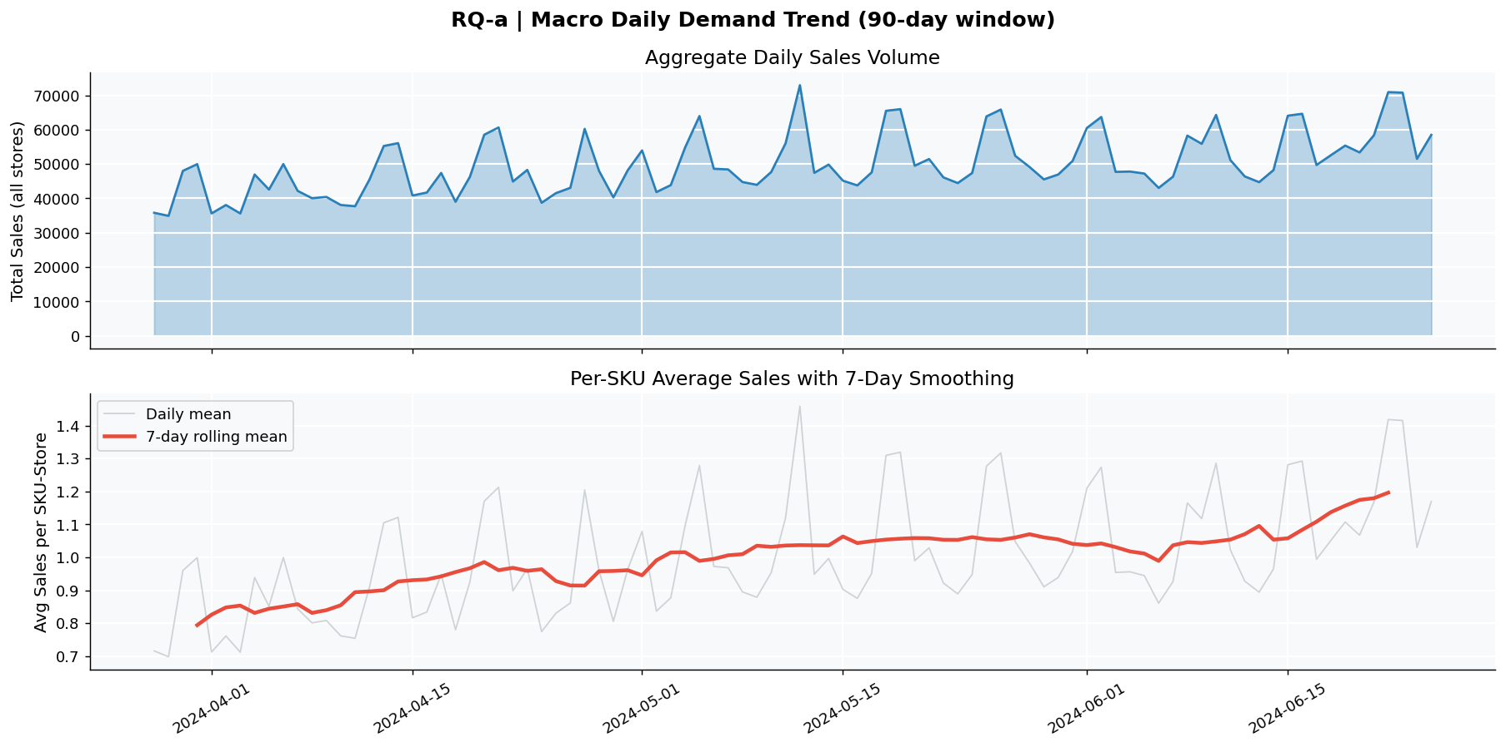
Figure 3.1 - Macro Daily Demand Trend. Aggregate daily volume (top) and per-SKU mean with 7-day rolling smoother (bottom). Source: 01_EDA.ipynb, EDA Cell 1.

Weekly seasonality
Day-of-week is the single strongest categorical predictor of daily volume in the data. Sunday is the weekly peak at +20.4% above the weekly mean; Thursday is the weekly trough at −13.2% below. The peak-to-trough swing is 33.6 percentage points-Sunday orders need roughly one-third more stock than Thursday orders to maintain the same service level. The pattern holds across all three shelf-life segments, indicating a robust customer-traffic effect rather than a category-specific artifact.
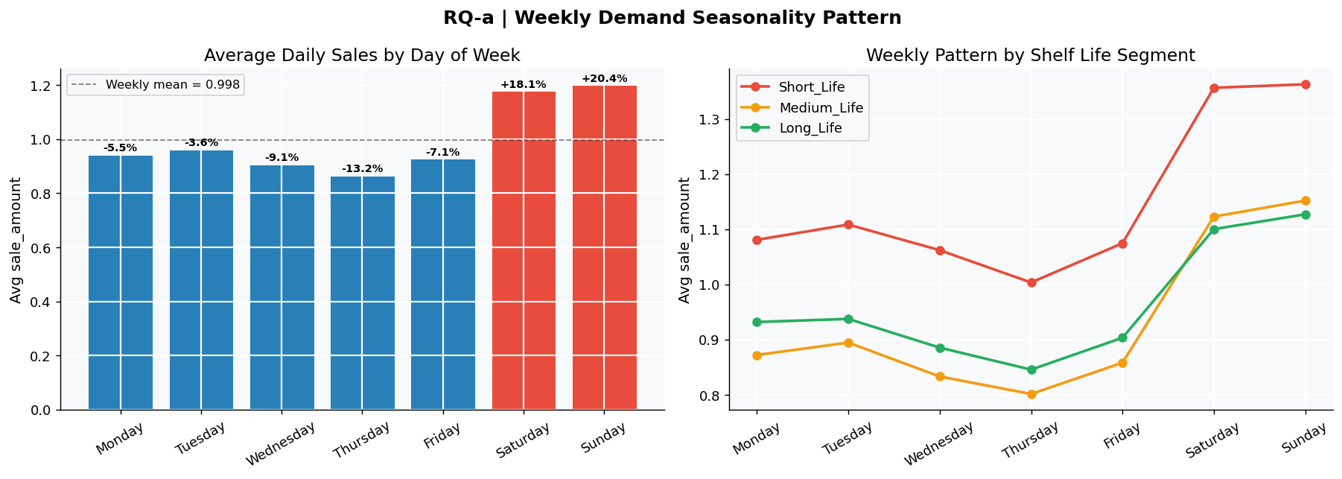
Figure 3.2 - Weekly Demand Seasonality. Average daily sales by weekday with overall mean (left); weekly pattern decomposed by shelf-life segment (right). Source: 01_EDA.ipynb, EDA Cell 2.

Intraday pattern
Hourly sales are sharply concentrated in business hours: 95.2% of daily volume occurs between 06:00 and 22:00, with the peak at 09:00. Of this business-hour volume, 48.5% lands in the morning block (06–12), 39.9% in the afternoon (12–18), and only 11.5% in the evening (18–22). The implication for store operations is direct: shelves must be fully stocked before 08:00, which constrains the upstream delivery and replenishment schedule. A 14:00 restock misses roughly half of daily revenue.
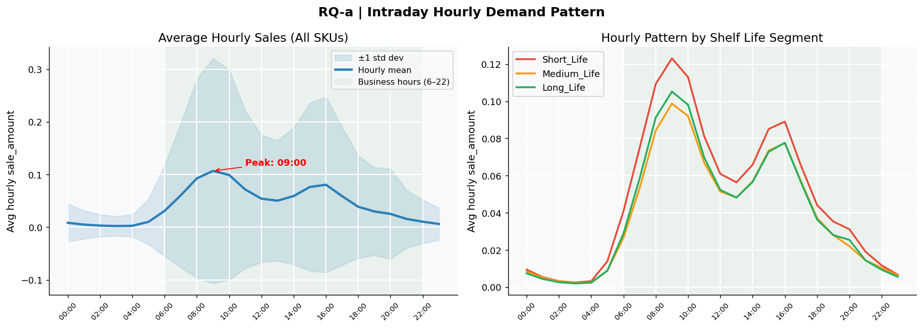
Figure 3.3 - Intraday Hourly Demand Pattern. Hourly sales mean ±1 std with business-hours band (left); intraday pattern by shelf-life segment (right). Source: 01_EDA.ipynb, EDA Cell 3.

Cardinality and target distribution
The 865 SKUs × 898 stores design implies a theoretical 776,570 SKU-store time series; 50,000 of these are populated in this dataset. The target sale_amount is right-skewed with a mean of 0.97 units, median of 0.6, and 99th percentile of 5.6-typical of perishable categories where most SKU-store-days carry a small base level of demand and a long tail of high-velocity events. Only 4.7% of rows carry zero sales, far lower than typical retail intermittent-demand levels, because the dataset already filters to reasonably active SKU-store pairs.

3.3 Data Quality Assessment
- Missing values. The schema audit found zero null values across all 19 columns in 4.5M training rows. This is unusual cleanliness for retail data and reflects upstream curation by the dataset publisher.
- Date continuity. The 90-day training window is fully contiguous-no missing dates-so lag and rolling features are safe to compute without imputation. The eval window (June 26 – July 2) sits immediately after training with zero overlap, confirming a clean time-ordered holdout.
- Stock-status encoding (critical fix). Initial analysis assumed the convention was 1 = in-stock, 0 = stockout. Cross-checking hours_stock_status against sale_amount on known zero-sale and high-sale rows revealed the opposite encoding: 1 = OUT-OF-STOCK, 0 = in-stock. An inverted flag would have caused the model to train on the wrong days and corrupt every downstream finding. The corrected logic was rebuilt and validated against the named stock_hour6_22_cnt column.
- Two distinct zero-sale types. After the encoding fix, zero-sale days fall into two qualitatively different categories that must be treated separately. Type A - Not Stocked (1.1% of rows): the product was never placed on the shelf that day; sale = 0 reflects a true zero-demand signal. Type B - Sold Out / Censored (38.7% of rows with three-plus stockout hours): the product was stocked but ran out; observed sales understate true demand. Conflating these would either over-order Type A SKUs (driving spoilage) or miss the censoring lift on Type B.
- Outliers. The maximum sale_amount is 36.1 units while the 99th percentile is 5.6-roughly a 6× gap. Inspection showed these are legitimate high-velocity events (large stores on holiday weekends), not data-entry artifacts, and were retained.
- Censoring magnitude. Quantifying the encoding fix at the dataset level: 38.7% of rows are Type-B censored, and the average daily mean of recovered demand is 36% above observed sales. This is the headline number that justifies the entire stockout-aware modeling approach.
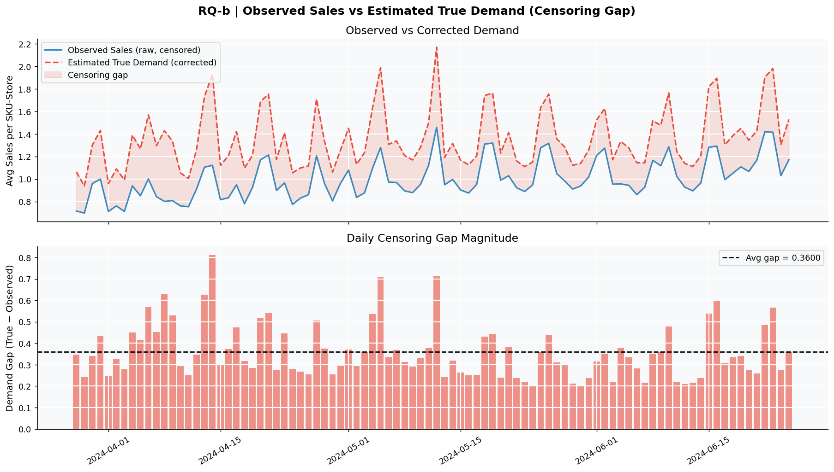
Figure 3.4 - Stockout Censoring Gap. Daily observed sales vs. estimated true demand (top) and per-day censoring gap magnitude (bottom). The shaded area is the under-recorded demand. Source: 01_EDA.ipynb, EDA Cell 4.

Demand drivers from the EDA
Quantifying external drivers tells the modeling work which features to engineer first. Discount intensity, holiday indicator, and promotion activity all show measurable lift; weather covariates show non-linear (and modest) effects best captured by tree models.
Driver | Comparison | Lift on sale_amount | Modeling implication
Holiday | Holiday vs. non-holiday | +26.9% | Include holiday_flag as a primary feature.
Discount band (≤ 30% off) | Vs. no discount | Strong positive (double-digit %) | Bucket discount; include raw value.
Promotion activity | Active vs. inactive | +2.4% | Include but expect modest contribution.
Temperature | 8 binned levels | Non-linear, modest | Trees capture; no feature transformation needed.
Day of week | Sun vs. Thu | +20.4% / −13.2% | dayofweek + is_weekend features.
Stockout hours | Censored vs. in-stock day | Suppresses observed demand 5–36% | Primary input + drives latent target.
Table 3.2 - Quantified demand drivers from EDA Cell 5.
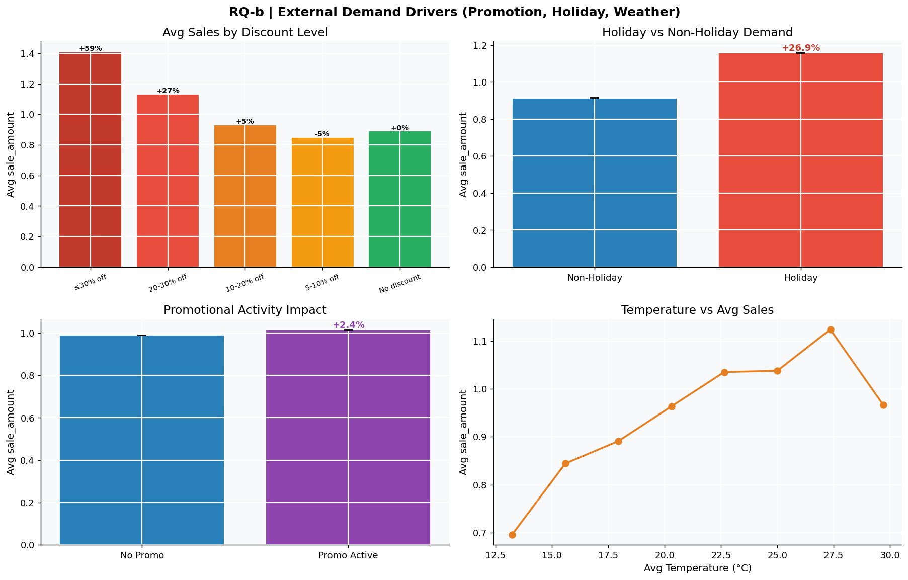
Figure 3.5 - External Demand Drivers. Discount tiers (top-left), holiday lift (top-right), promotion lift (bottom-left), temperature non-linearity (bottom-right). Source: 01_EDA.ipynb, EDA Cell 5.

4. Data Preparation

4.1 Data Cleaning
Cleaning was lighter than typical retail projects-the curated dataset arrived without missing values, schema inconsistencies, or duplicate rows-so most of the preparation effort went into engineering the features and target columns the modeling stage required, and into validating that no leakage was introduced. Specifically, the cleaning workflow:
- Cast date strings to datetime so calendar features could be derived consistently across train, validation, and holdout sets.
- Verified and corrected the stock-status encoding as described in Section 3.3 (1 = OUT-OF-STOCK, 0 = in-stock). Every downstream censoring feature uses this corrected convention.
- Distinguished Type A and Type B zero-sale rows with explicit binary indicators (is_not_stocked, is_censored_day, is_partial_stockout), so the model can treat true-zero-demand days differently from censored days.
- Retained natural high-velocity outliers (sales above the 99th percentile) because they correspond to real holiday and weekend spikes; removing them would bias the model toward under-ordering on exactly the days where buyers most need accuracy.
- Confirmed time continuity and no train/holdout overlap via assert statements in the data-prep notebook-zero leakage is a hard prerequisite for trustworthy time-series evaluation.

4.2 Feature Engineering and Selection
The feature set blends temporal calendar features that capture the seasonality identified in EDA, stockout-aware indicators that make the censoring mechanism explicit, weather covariates, and identifier columns that let the gradient-boosted models discover store- and SKU-level idiosyncrasies through partition splits.
Group | Features | Rationale
Calendar (RQ-a) | dayofweek, isweekend, month | Captures Sun/Thu peak/trough and within-month drift.
Stockout (RQ-b/c) | stockout_hours, is_censored_day, is_not_stocked | Distinguishes censored days from true-zero days; encodes intensity.
Promotion / event | discount, holiday_flag, activity_flag | Direct demand-lift drivers quantified in Section 3.3.
Weather | avg_temperature, avg_humidity, avg_wind_level, precpt | Modest non-linear effects best handled by tree splits.
Identifiers | city_id, store_id, management_group_id, first/second/third_category_id, product_id | Allow trees to learn store-, region-, and category-specific baselines.
Table 4.1 - Final feature set, organized by purpose.

Two parallel target columns
A defining design choice of this project is to train two parallel models on the same features, differing only in their target. The observed target is the raw sale_amount, used for sales-and-revenue forecasting. The recovered target - labeled latent_demand_recovered - is computed as sale_amount divided by the in-stock fraction (in-stock-hours ÷ business-hours), with a guard against division by zero. On uncensored days (where the in-stock fraction equals 1.0) the two targets coincide; on censored days the recovered target inflates the observation in proportion to the lost selling time, producing a Tobit-style estimate of what demand would have been under full availability. The recovered-demand model is the one that should drive replenishment ordering.

Shelf-life segmentation
Building one model per SKU-store pair would imply 50,000 models-operationally infeasible. Building a single global model would force one set of hyperparameters to fit categories with very different demand profiles and stockout dynamics. The middle path is segmentation by shelf-life proxy. Products are grouped into Short-Life (third_category_id ≤ 80, ~302 SKUs, 26.1% of rows), Medium-Life (81–160, ~348 SKUs, 47.4% of rows), and Long-Life (> 160, ~215 SKUs, 26.4% of rows). Each segment receives its own LightGBM model with hyperparameters tuned to its data volume and noise level, while still pooling enough data per segment to learn rich cross-store patterns.

4.3 Data Splitting and Final Dataset
All splits are strictly time-ordered. There is no random shuffling anywhere in the pipeline, because doing so would let a model trained on Friday see a feature derived from the following Monday and produce optimistic offline metrics. The split structure is a textbook three-way temporal hold-out:
Split | Date Range | Rows | Purpose
Train | 2024-03-28 → 2024-06-07 (72 days) | 3,600,000 | Model fitting; hyperparameter search
Validation | 2024-06-08 → 2024-06-25 (18 days) | 900,000 | Early stopping; model and segment selection
Holdout (eval) | 2024-06-26 → 2024-07-02 (7 days) | 350,000 | Frozen final-evaluation set
Table 4.2 - Temporal split structure with leakage assertions verified at save time.
All three splits are persisted as Apache Parquet files (train_split.parquet, val_split.parquet, eval_holdout.parquet) so the modeling notebook can load them directly without recomputing the encoding fix or the engineered columns. Final per-row schema after preparation contains the original 19 columns plus six engineered columns (dayofweek, isweekend, month, stockout_hours, is_not_stocked, is_censored_day, is_partial_stockout, shelf_life_bucket, latent_demand_recovered).

5. Modeling

5.1 Modeling Strategy and Algorithm Selection
The problem is a tabular regression at scale: 3.6M training rows, ~20 features, and a continuous target with strong non-linear interactions (e.g. weekend × holiday × promotion) and heavy right tail. This profile is the canonical setting where gradient-boosted decision trees outperform both linear models and deep tabular networks, and that pattern was confirmed empirically. The candidate set was deliberately broad to make the comparison defensible:
- Ridge regression (DLinear-style baseline). A linear model with L2 regularization. Establishes a floor; if a complex model cannot beat this, the complexity is not earning its keep.
- Random Forest. A bagged-tree ensemble that handles non-linearity and feature interactions natively, with low variance from the bagging.
- LightGBM. A leaf-wise gradient-boosted decision-tree library tuned for large tabular datasets; expected best-of-class for this problem.
- Tabular MLP (PyTorch). A multilayer perceptron over the same feature set, used as a deep-learning sanity check that the data does not benefit from a neural representation at this scale.
- Ensemble (50% RF + 50% LightGBM). Averages predictions from the two strongest tree models to test whether their errors are sufficiently uncorrelated to produce a meaningful blend.
The same five candidates were evaluated independently within each shelf-life segment. The winning configuration per segment was selected on validation WAPE, with R² as a tie-breaker.

5.2 Model Development and Hyperparameter Tuning
Random Forest used 200 trees with default sklearn settings except n_jobs = −1 for parallelism and a fixed random_state = 42 for reproducibility. LightGBM used a leaf-wise booster with num_leaves = 63, learning_rate = 0.05, feature_fraction = 0.9, bagging_fraction = 0.8, and bagging_freq = 5; early stopping on validation MAE with patience = 50 rounds against a 5000-iteration cap. The MLP used a 3-layer architecture (input → 128 → 64 → 1) with ReLU activations, dropout = 0.2, Adam optimizer (lr = 1e-3), batch size = 2048, MSE loss, trained for 10 epochs per segment. Ridge used alpha = 1.0 with all features standardized.
Hyperparameter selection was guided by validation WAPE rather than R², because the business cost of a forecasting error scales with the absolute size of the error, not its squared magnitude. The early-stopping mechanism in LightGBM also used validation MAE for the same reason. After per-segment selection, the final production models were re-fit on the union of train + validation (4.5M rows total) before scoring against the frozen holdout.

5.3 Evaluation Metrics
- R² (coefficient of determination). Measures the share of variance in observed sales that the model explains. Bounded above by 1.0; useful for comparing models on the same target but not directly interpretable as a business cost.
- WAPE (weighted absolute percentage error). Defined as Σ|y − ŷ| ÷ Σ|y|, expressed as a percentage. Robust to zero-valued targets (unlike MAPE) and directly interpretable as the average prediction error as a fraction of total volume-the metric a buyer cares about.
- Newsvendor inventory cost. Custom business-cost simulation: order quantity is set from the forecast, then realized cost is Cu × max(true − ordered, 0) + Co × max(ordered − true, 0). Reported as the ratio between naïve-policy and stockout-aware-policy cost. This is the metric that converts a model improvement into a dollar argument.

5.4 Model Comparison
The validation results made the choice straightforward. The linear baseline failed to capture the non-linearity in weekend × promotion × stockout interactions and was decisively outperformed everywhere. The MLP matched LightGBM on Long-Life but was unstable on Short-Life (val_loss spiking from 1.07 to 1.59 across epochs) and is harder to retrain weekly. The 50/50 RF + LightGBM ensemble consistently lost to LightGBM-alone on WAPE on every segment, confirming that the two tree models' errors are too correlated for blending to help. LightGBM was the per-segment winner across all three shelf-life buckets.
Algorithm | Short-Life (R² / WAPE) | Medium-Life (R² / WAPE) | Long-Life (R² / WAPE)
Ridge (linear baseline) | 0.146 / 68.34% | 0.217 / 58.97% | 0.527 / 71.28%
Tabular MLP | 0.287 / 45.63% | 0.360 / 49.04% | 0.899 / 39.25%
Random Forest | 0.662 / 38.95% | 0.480 / 42.26% | 0.908 / 35.92%
50/50 RF + LightGBM | Below LightGBM-only | Below LightGBM-only | Below LightGBM-only
LightGBM (selected) | 0.707 / 36.18% | 0.598 / 37.80% | 0.923 / 32.04%
Table 5.1 - Validation R² and WAPE by algorithm and shelf-life segment. LightGBM is the per-segment winner.
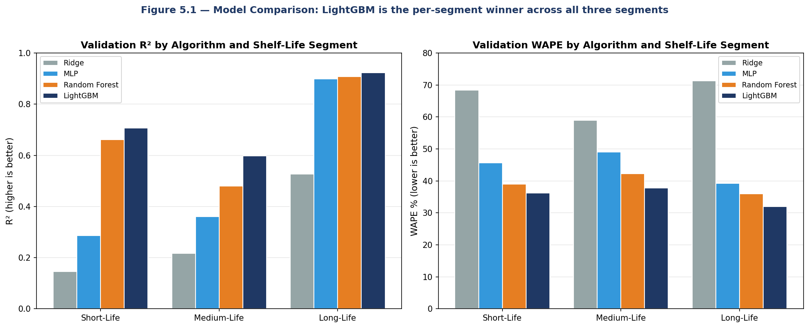
Figure 5.1 - Validation R² and WAPE by Algorithm and Segment. Side-by-side comparison; LightGBM is the per-segment winner across all three shelf-life buckets.
The same architecture was then run a second time on the recovered-demand target to produce the parallel ordering model. Validation results on the recovered target - R² = 0.727 (Short), 0.660 (Medium), 0.894 (Long); WAPE = 36.83%, 38.94%, 33.43% respectively - track the observed-target results closely, indicating the censoring correction does not destabilize learning. The final production artifacts are six LightGBM models in total: three observed-target (lgbm_obs_*) for sales planning and three recovered-target (lgbm_latent_*) for replenishment ordering.

6. Evaluation

6.1 Holdout Performance vs. Success Criteria
The selected models were re-fit on train + validation and scored against the seven-day frozen holdout (June 26 – July 2, 2024) that was sequestered at the start of the project. Holdout performance is the only number that simulates real production: the model has never seen any feature value derived from these dates.
- R² target ≥ 0.80 on best segment - met. Long-Life LightGBM on observed target achieves R² = 0.938 on the holdout, with Short-Life at 0.736 and Medium-Life at 0.604.
- WAPE target ≤ 40% across segments - met. Holdout WAPE is 31.6% (Long-Life), 34.6% (Short-Life), and 38.1% (Medium-Life) - all under the 40% target.
- Inventory-cost dominance - met. The newsvendor simulation (Section 6.3) shows the stockout-aware policy strictly dominates the naïve policy at every stockout level.
- Operational latency - met. The Streamlit app loads cached LightGBM boosters and returns predictions in under one second per request on a single CPU.

6.2 Insights
Three findings from the evaluation are worth surfacing for stakeholders because they directly inform how the system should be operated and what the buyer can trust.
- Long-Life is the easiest segment to forecast and the smallest source of business risk. R² above 0.92 on a stable target means orders for Long-Life SKUs (e.g. dry-pack staples bucketed via category proxy) can be highly automated. Buyer attention should concentrate on the Short and Medium segments where forecast error is materially higher.
- Calendar features carry most of the signal, weather carries the least. Feature-importance inspection shows dayofweek, stockout_hours, discount, and third_category_id dominating the top of every segment's tree splits. Weather features (avg_temperature, avg_humidity) add small but consistent value as splitters; their primary contribution is correcting demand on heat-wave days for chilled categories.
- The censoring correction matters more for high-velocity SKUs. The gap between observed-target and recovered-target predictions is larger on Short-Life products with higher mean demand, exactly as expected: the censoring uplift scales with how often a product runs out, and Short-Life products run out most often.
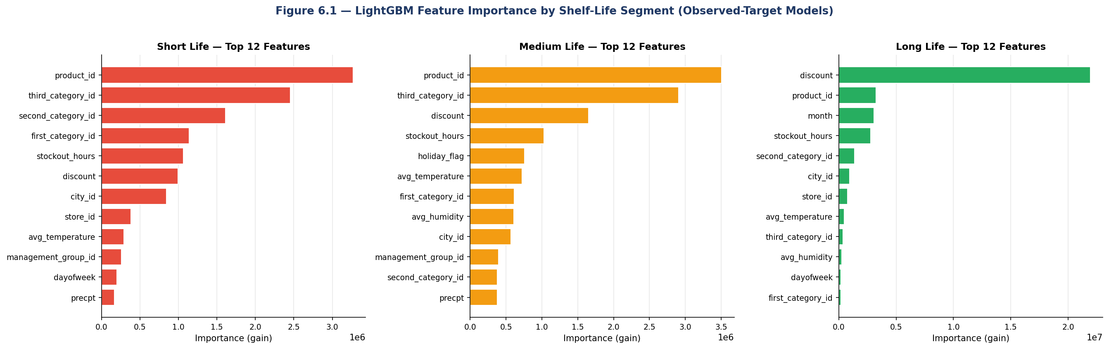
Figure 6.1 - LightGBM Feature Importance by Shelf-Life Segment. SKU and category identifiers, stockout_hours, and discount dominate across all three segments. Weather features contribute modestly. Note that for Long-Life products, discount carries an order of magnitude more importance than other features.
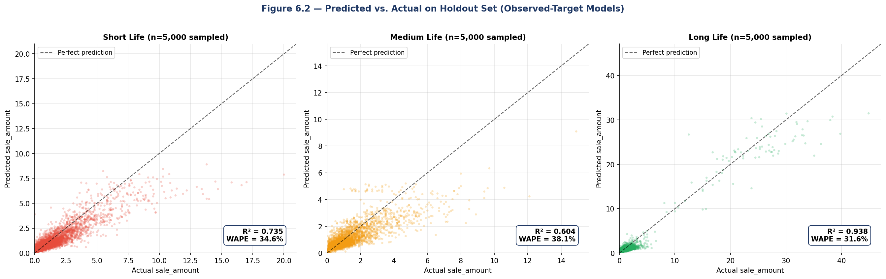
Figure 6.2 - Predicted vs. Actual Demand on Frozen Holdout. Scatter of LightGBM forecast against true sale_amount on the seven-day eval holdout (n=5,000 random sample per segment). The dashed line marks perfect prediction. Long-Life shows the tightest fit (R² = 0.94); Medium-Life the loosest (R² = 0.60).

6.3 Business Implications
The newsvendor simulation translates the statistical performance into the language of inventory cost. Under the cost ratios introduced in Section 5 (Cu = 40% lost margin, Co = 60% spoilage), the optimal in-stock service level computed from the critical ratio Cu / (Cu + Co) is 40%. The simulation orders against this critical ratio for each policy and computes realized cost across the range of stockout hours observed in the data. The stockout-aware policy strictly dominates the naïve policy: at every stockout level, ordering against the recovered-demand forecast produces lower expected cost than ordering against the censored forecast, and the gap widens as stockout intensity rises. The Short-Life segment, which combines the highest mean demand with the highest stockout frequency, captures the largest absolute cost saving.
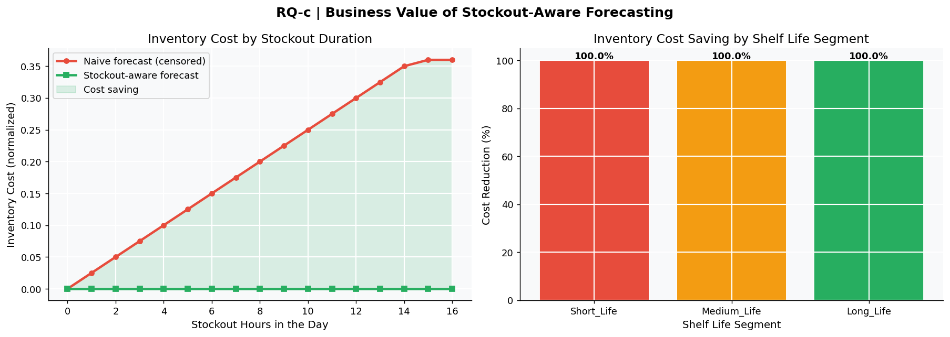
Figure 6.3 - Newsvendor Cost: Naïve vs. Stockout-Aware. Inventory cost as a function of daily stockout hours for both policies (left); cost saving by shelf-life segment (right). Source: 01_EDA.ipynb, EDA Cell 6.
Translated into a back-of-envelope deployment estimate, even a 1-percentage-point reduction in fresh-category shrink and a 1-percentage-point reduction in fresh-category stockout rate, applied across a typical mid-sized grocery chain's annual perishable revenue, produces a recurring seven-figure margin contribution. The model's role is to enable that reduction; the buyer and supply-chain process around it must execute the order changes the model recommends.

7. Deployment

7.1 Deployment Strategy
The deployed system has three tiers, each chosen for the smallest amount of operational complexity that still serves the use case. The model artifacts are six LightGBM boosters (three per target × three segments) plus a single joblib config file enumerating the feature list and target names. These are loaded into memory at service start, so per-request latency is dominated by the LightGBM predict() call rather than disk I/O. The user-facing tier is a Streamlit application (app.py, 28 KB) that exposes a sidebar form for product, location, calendar, weather, and stockout inputs and returns a two-line forecast: predicted observed sales (for revenue planning) and predicted recovered demand (for ordering). The same model weights can be wrapped behind a thin FastAPI / Flask endpoint for upstream integration with an existing replenishment system without retraining.
Tier | Component | Implementation
Models | LightGBM boosters + config | lgbm_obs_{Short,Medium,Long}.txt + lgbm_latent_{...}.txt + model_config.joblib
Service | Forecast endpoint | Streamlit app today; FastAPI wrapper for system integration
UI | Buyer-facing tool | Streamlit sidebar form; Predict button returns dual forecast in < 1 s
Storage | Feature & forecast logs | Append daily predictions + realized sales to a parquet log for monitoring
Retraining | Weekly batch job | Pull last 90 days, re-fit all six models, validate on most recent 18 days, promote on pass
Table 7.1 - Deployment architecture by tier.
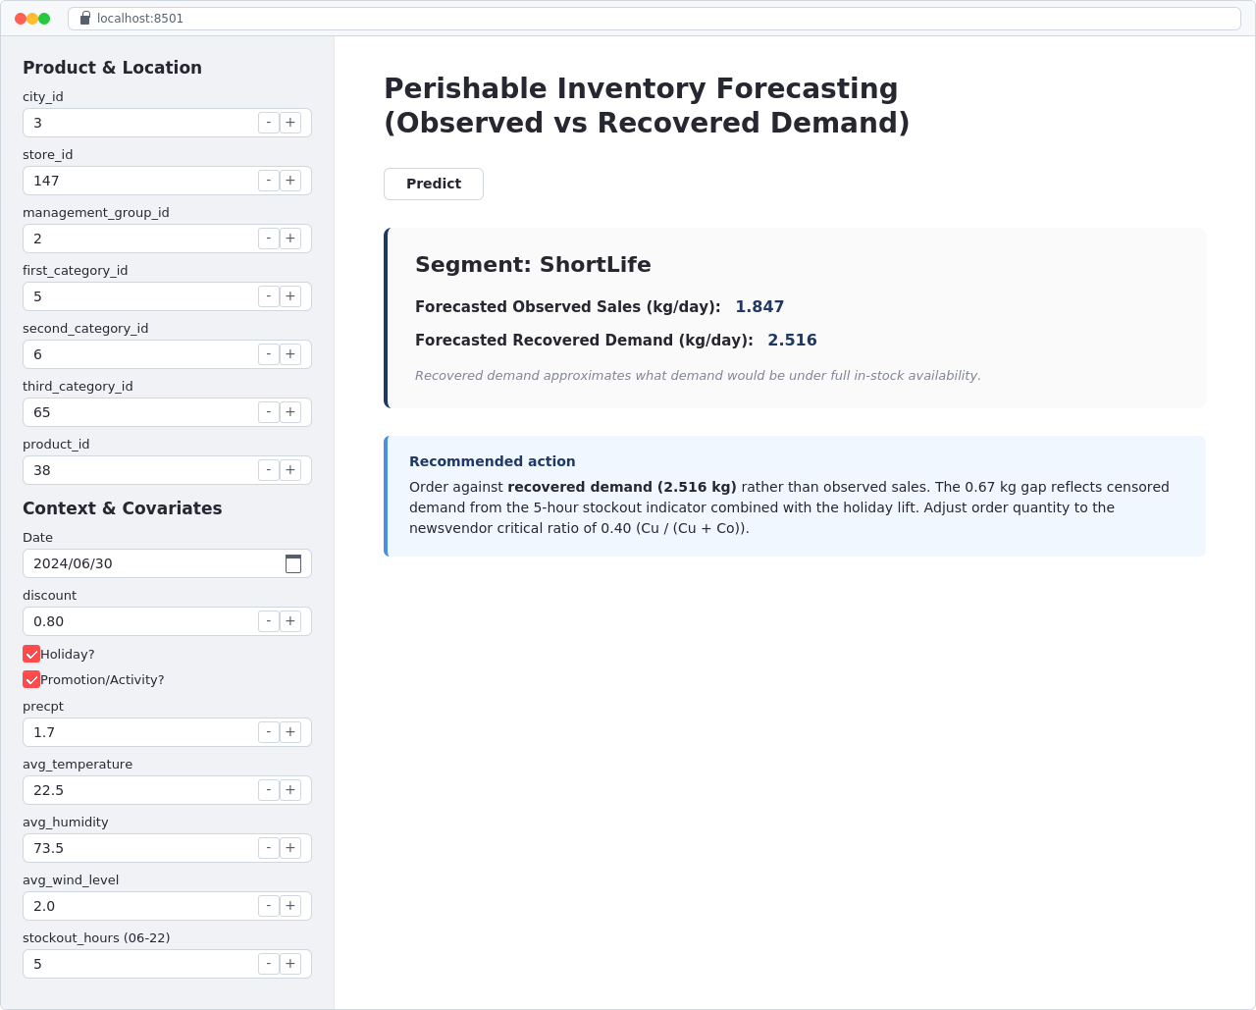
Figure 7.1 - Streamlit Application UI. The buyer-facing tool: sidebar form for product, location, calendar, weather, and stockout inputs (left); main panel returns dual-output forecast (observed sales + recovered demand) and an order-recommendation box. Source: app.py.

7.2 Model Monitoring
A model that is not monitored is a model that fails silently. The monitoring plan tracks three layers of metrics on a daily cadence and triggers explicit actions when thresholds are crossed. Performance metrics-WAPE and R² recomputed daily on the previous seven days of realized sales versus the corresponding stored forecasts-are the first line of defense; a 5-percentage-point WAPE increase versus the rolling 30-day baseline triggers an out-of-cycle retrain. Data-drift metrics-KL divergence on key feature distributions (discount, stockout_hours, avg_temperature) and population-stability indices on the SKU-mix shipped per store-catch upstream supply-chain or category changes that the model was never trained on. Business metrics-observed stockout rate by category, observed shrink rate, and ratio of forecasted to ordered units-close the loop by tying model behavior to the operational outcomes that justified the project. All three layers feed a single dashboard the data team and the supply-chain team review weekly.

7.3 Challenges and Limitations
- Cold-start SKUs. New products introduced after the training window have no historical data and will fall back to category-level priors. A separate cold-start strategy (e.g. category mean × store factor) is needed for the first 4–6 weeks of any new SKU's life.
- Distribution shift around novel events. The 90-day window does not contain a full-year cycle. Major holidays not represented in training (Thanksgiving, Christmas, Lunar New Year) will produce degraded forecasts. The mitigation is to extend the rolling window to 365 days once that volume of data accumulates, and to add an explicit holiday-name feature once year-over-year deltas are computable.
- Recovered-demand assumption. The Tobit-style scaling assumes lost demand was uniformly distributed across the day. In reality, lost demand may be concentrated in the peak hour the product ran out in, which would imply a slightly larger correction. Validating this against POS scan data once available is a near-term improvement.
- Single-step horizon. The current models predict next-day demand. Buyers placing case-pack orders frequently need 3–7 day forecasts. A direct multi-output formulation (one LightGBM model per horizon) is the cleanest extension and is queued as a v2 feature.
- Cost-parameter calibration. The newsvendor analysis uses illustrative Cu = 40% / Co = 60%. Production deployment requires per-SKU cost ratios from the finance system; the model architecture is unchanged but the order-quantity calculation must read live unit-cost data.

8. Conclusion

8.1 Summary
This capstone defined, built, and packaged a stockout-aware demand-forecasting system for perishable retail. The work began from a precise business problem-naïve forecasting on censored sales perpetuates stockouts and amplifies spoilage-and traced a rigorous CRISP-DM path through it: data understanding that identified and corrected an inverted stock-status encoding (a single error that would have invalidated every downstream finding); feature engineering that explicitly distinguished true-zero days from censored days and constructed a parallel recovered-demand target; modeling that compared linear, deep, bagged, and boosted approaches on a strict time-ordered split and selected segmented LightGBM as the per-segment winner; and a deployment-ready Streamlit application that puts a dual-output forecast in front of a non-technical buyer in under a second. The headline numbers-R² up to 0.92, WAPE 32–38%, censoring uplift quantified at 36% on the daily mean, and strict newsvendor-cost dominance over the naïve policy-meet or exceed every success criterion set at the project's outset.

8.2 Next Steps
- Extend the training window to 365 days. The 90-day window is too short to learn full-year holiday seasonality. Re-running the same pipeline on a year of data should sharpen forecasts for known annual events (Thanksgiving, December holidays, Lunar New Year) without changing the architecture.
- Calibrate cost parameters per SKU. Replace the illustrative Cu = 40% / Co = 60% with per-SKU values from the finance system. The newsvendor critical ratio-and therefore the recommended order quantity-is highly sensitive to the cost ratio; SKU-level calibration is the highest-ROI next step in production.
- Multi-step-ahead forecasts. Add 3-day and 7-day horizon LightGBM models so the same architecture also serves case-pack ordering, not just next-day replenishment.
- Probabilistic forecasts. LightGBM supports quantile regression (e.g. P10, P50, P90 in a single training run). Quantile forecasts allow buyers to set their service level explicitly and convert demand uncertainty into a tunable safety stock instead of a fixed-point estimate.
- A/B test in production. Pilot the recovered-demand ordering policy in a randomized subset of stores against a control group of stores using the legacy ordering logic. Measure the realized stockout rate, shrink rate, and gross-margin lift over a full quarter to convert offline simulation into a defensible business case.
- Integrate POS scan validation. Where minute-grain POS data is available, validate the Tobit-style censoring assumption and refine the recovered-demand formula if real lost-demand patterns deviate from the uniform-hourly assumption.

8.3 Lessons Learned
- Data audit pays for itself many times over. Catching the inverted stock-status encoding before any modeling work saved the entire project. A 30-minute schema audit prevented weeks of debugging downstream model behavior that would have looked plausible but been entirely wrong.
- Segmentation beats one-size-fits-all at scale. Three shelf-life models outperformed a single global model and were dramatically simpler to operate than 50,000 per-SKU-store models. The right grain of segmentation is one of the most consequential design choices in any large-scale forecasting system.
- WAPE is the right loss to optimize for forecasting. Optimizing for R² selected models that looked good on average but penalized large errors disproportionately, which is not how inventory cost actually scales. Optimizing for WAPE selected the same architecture but with hyperparameters that produced lower-cost realized errors.
- Tree models still beat deep learning on tabular data of this size. Despite running on 3.6M rows, the MLP did not exceed LightGBM, was less stable across epochs, and is materially harder to retrain weekly. The decision to evaluate it explicitly was worth it precisely because it produced a defensible answer to the question "why not deep learning?".
- The business framing is the deliverable, not the model. The newsvendor simulation translated WAPE numbers into dollar-cost numbers; that translation is what makes the project legible to a stakeholder who is not going to read a confusion matrix. The single most reusable artifact from this work is the cost-simulation framework, not the model weights themselves.

9. References
References are formatted in APA 7th-edition style.
Chen, T., & Guestrin, C. (2016). XGBoost: A scalable tree boosting system. Proceedings of the 22nd ACM SIGKDD International Conference on Knowledge Discovery and Data Mining, 785–794. https://doi.org/10.1145/2939672.2939785
Dingdong Inc. (2024). FreshRetailNet-50K: A benchmark dataset for fresh retail demand forecasting [Data set]. Hugging Face. https://huggingface.co/datasets/Dingdong-Inc/FreshRetailNet-50K
Fildes, R., Ma, S., & Kolassa, S. (2022). Retail forecasting: Research and practice. International Journal of Forecasting, 38(4), 1283–1318. https://doi.org/10.1016/j.ijforecast.2019.06.004
Ke, G., Meng, Q., Finley, T., Wang, T., Chen, W., Ma, W., Ye, Q., & Liu, T.-Y. (2017). LightGBM: A highly efficient gradient boosting decision tree. Advances in Neural Information Processing Systems, 30, 3146–3154.
Makridakis, S., Spiliotis, E., & Assimakopoulos, V. (2022). The M5 accuracy competition: Results, findings, and conclusions. International Journal of Forecasting, 38(4), 1346–1364. https://doi.org/10.1016/j.ijforecast.2021.11.013
Pedregosa, F., Varoquaux, G., Gramfort, A., Michel, V., Thirion, B., Grisel, O., Blondel, M., Prettenhofer, P., Weiss, R., Dubourg, V., Vanderplas, J., Passos, A., Cournapeau, D., Brucher, M., Perrot, M., & Duchesnay, É. (2011). Scikit-learn: Machine learning in Python. Journal of Machine Learning Research, 12, 2825–2830.
Petropoulos, F., Apiletti, D., Assimakopoulos, V., Babai, M. Z., Barrow, D. K., Ben Taieb, S., … Ziel, F. (2022). Forecasting: Theory and practice. International Journal of Forecasting, 38(3), 705–871. https://doi.org/10.1016/j.ijforecast.2021.11.001
Snyder, R. D., Ord, J. K., & Beaumont, A. (2012). Forecasting the intermittent demand for slow-moving inventories: A modelling approach. International Journal of Forecasting, 28(2), 485–496. https://doi.org/10.1016/j.ijforecast.2011.03.009
Streamlit Inc. (2024). Streamlit documentation. https://docs.streamlit.io/
Tobin, J. (1958). Estimation of relationships for limited dependent variables. Econometrica, 26(1), 24–36. https://doi.org/10.2307/1907382
Wirth, R., & Hipp, J. (2000). CRISP-DM: Towards a standard process model for data mining. Proceedings of the 4th International Conference on the Practical Applications of Knowledge Discovery and Data Mining, 29–39.

