Static Routing Lab Exercise
In this lab, it demonstrates how to set static routes between devices with transit route between MLS and also with VLAN segmentation.

Overview
This repository contains a Cisco Packet Tracer lab demonstrating how to build a small enterprise network using:
- Layer-3 Switching
- SVI-based Inter-VLAN Routing
- Static Routing
- Trunking & VLAN segmentation
- Transit VLAN between multilayer switches

Network Topology

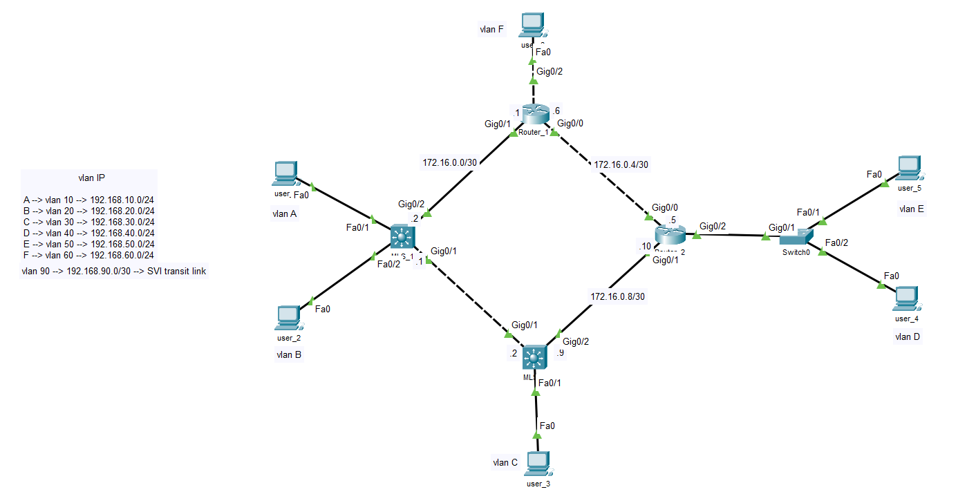

VLAN and IP Addressing
VLAN | Subnet
10 | 192.168.10.0/24
20 | 192.168.20.0/24
30 | 192.168.30.0/24
40 | 192.168.40.0/24
50 | 192.168.50.0/24
60 | 192.168.60.0/24
90 | 192.168.90.0/24

Key Configurations
- Create SVI for vlans which are connected on MLS.
- Create common vlan 90 to setup transit routes.
- Config trunk link for carry vlan 90 traffic between MLS
- Create sub-interface on router for connected vlans.
- Set static routing on reach MLS and Routers.

Note: Make sure give ip routing command in MLSes for enable inter vlan routing.

Note on Basic Security Configurations
This lab intentionally does not include the following initial security configurations:
- console / VTY passwords
- MOTD banners
- SSH setup
- privilege mode protection
- password encryptions
These were omitted because the objective of this lab is strictly:
- VLAN creation
- SVI routing
- Static routing
- Trunk configuration

What This Lab Demonstrates
- Difference between SVI routing and router-on-a-stick
- How multilayer switches route between VLANs
- How transit VLAN use to set routes between MLS devices
- How to configure static routes on L3 switches and routers

How to Use This Repository

- Clone the repo
- Open the .pkt file in Cisco Packet Tracer
- Review configurations or load the exported configs
- Test connectivity between all VLANs
- Modify, break, and rebuild the design to reinforce learning

