**Social Media and Text Analytics**

**Topic Modeling**

**Problem Statement:** Researchers have access to large online archives of scientific articles. As a consequence, finding relevant articles has become more difficult. Tagging or topic modelling provides a way to give token of identification to research articles which facilitates recommendation and search process.

Given the abstract and title for a set of research articles, predict the topics for each article included in the test set.

**Solution:**

1. Install necessary libraries then load dataset

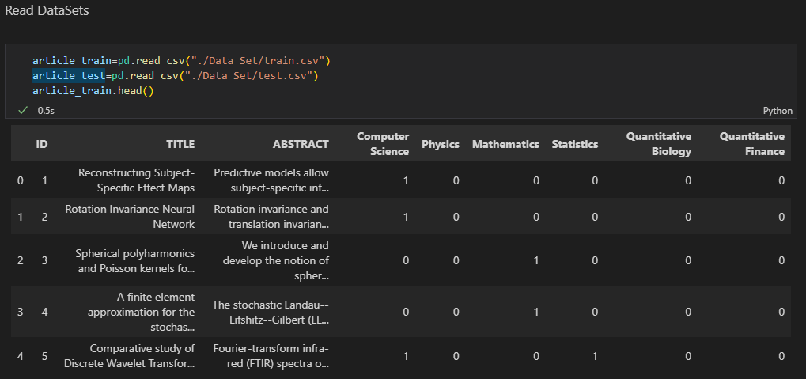

2)Visualize topic distribution in train dataset

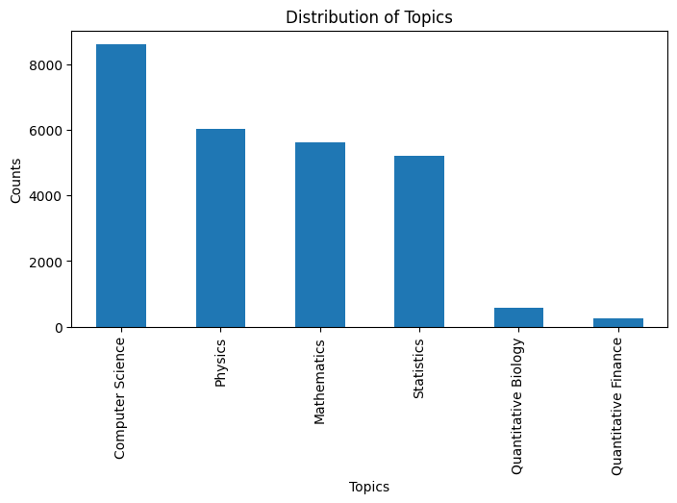

3)Merge Title and abstract

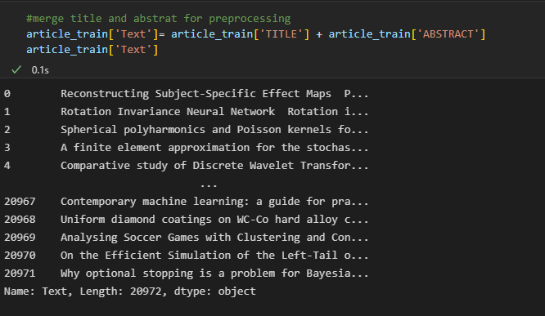

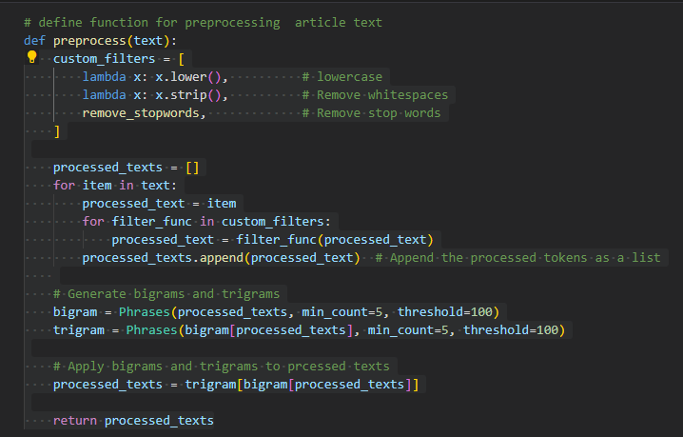 4)Pre-processing

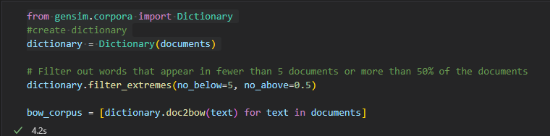 5) Create Dictionary

6) LDA modeling

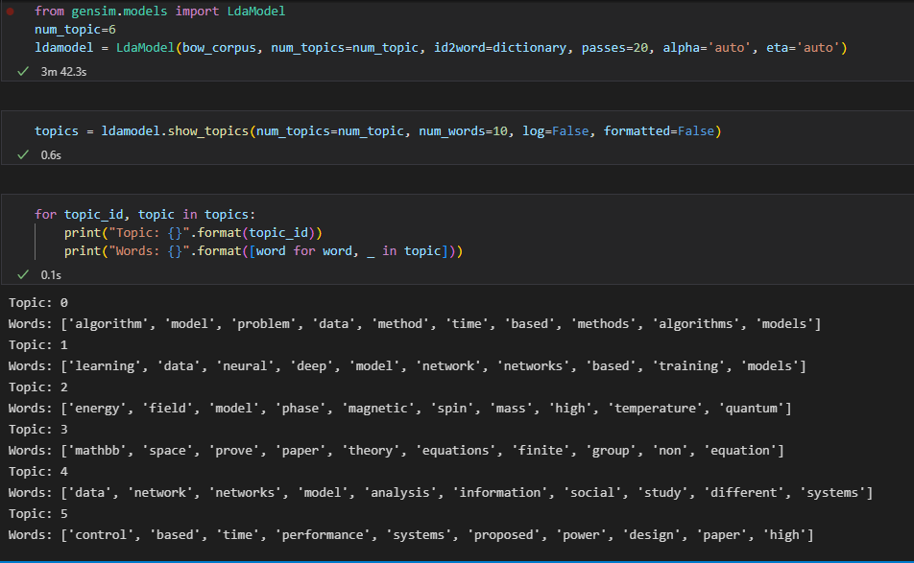

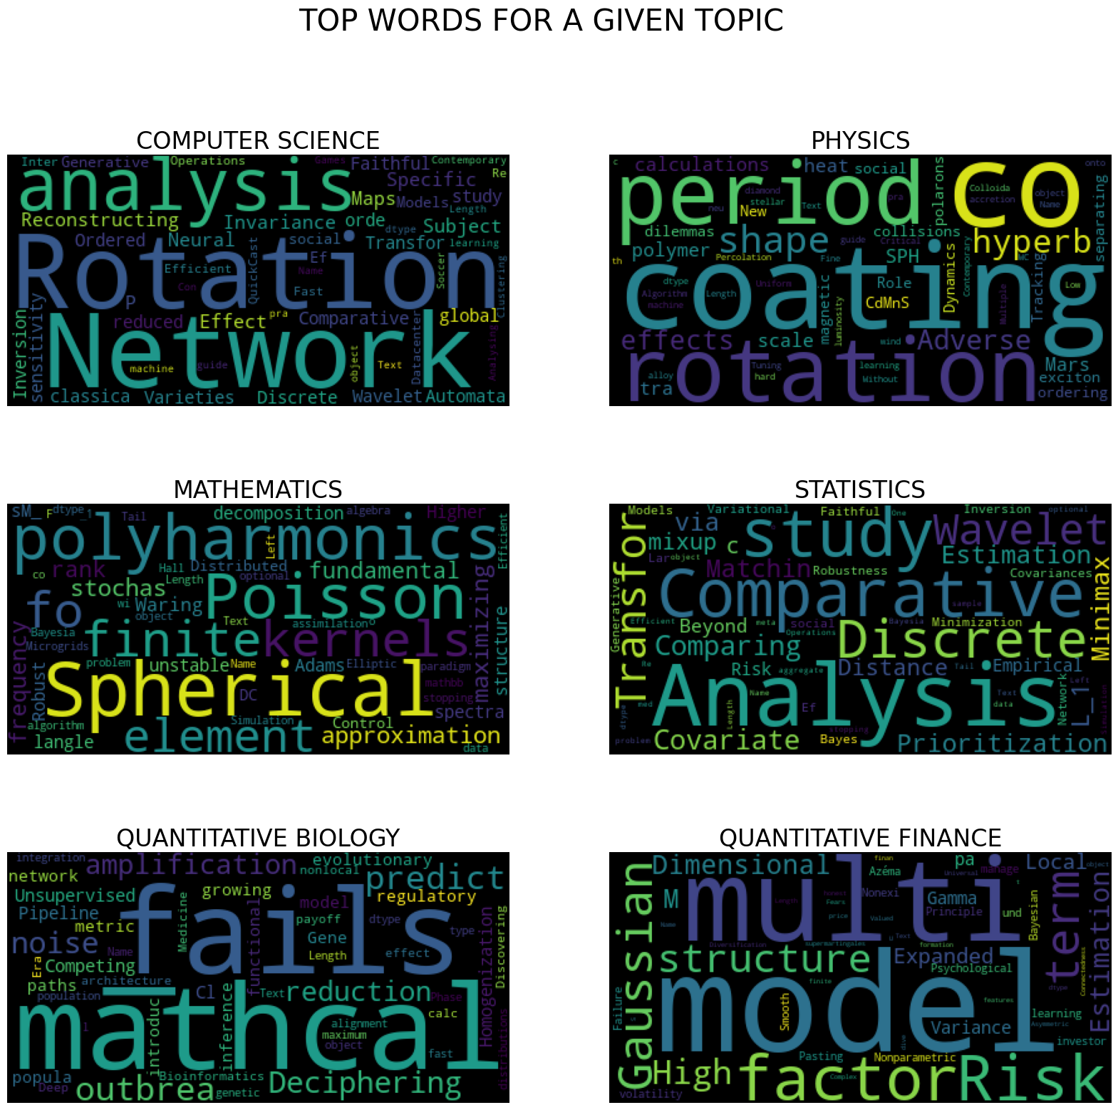 7)Word Cloud for each topic

8)Manual Prediction

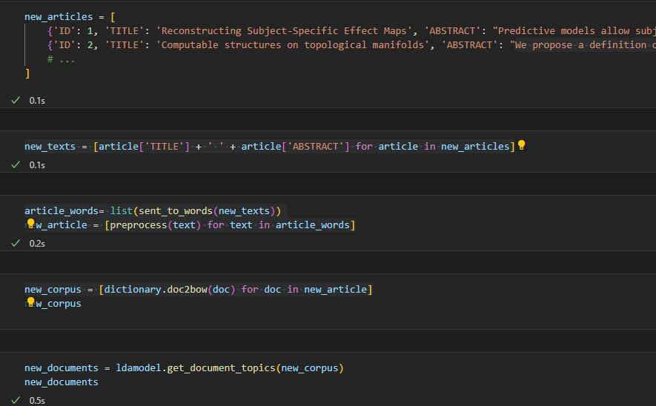

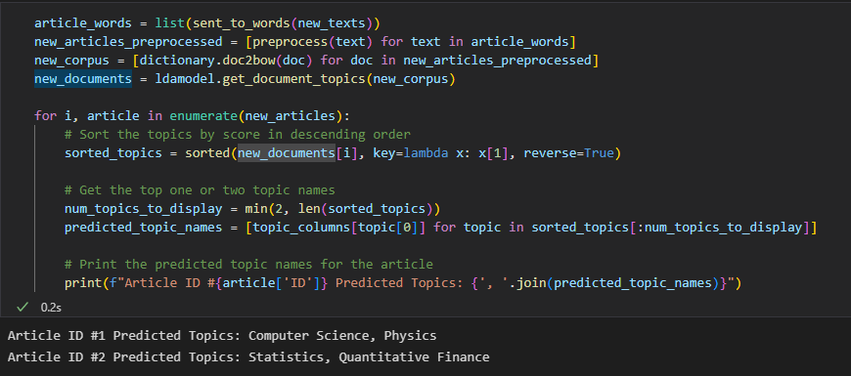

9) Test.csv file prediction

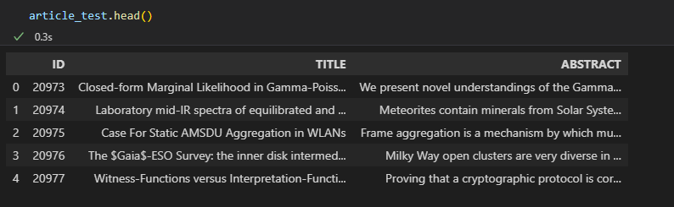

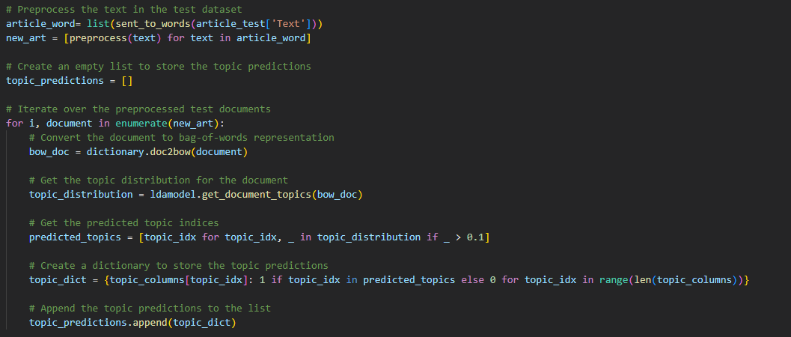

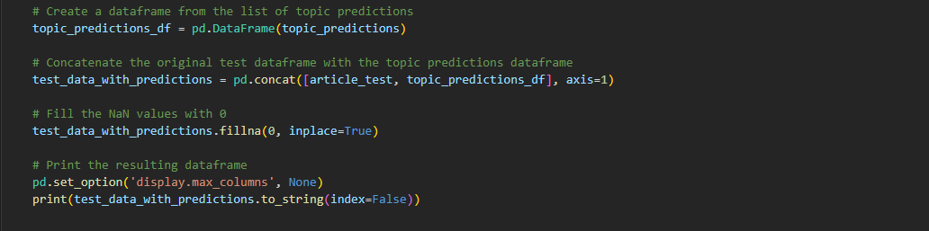

10)Text Prediction file downloaded & dump model

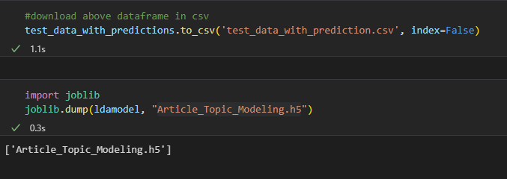

11) Create Flask UI for above model

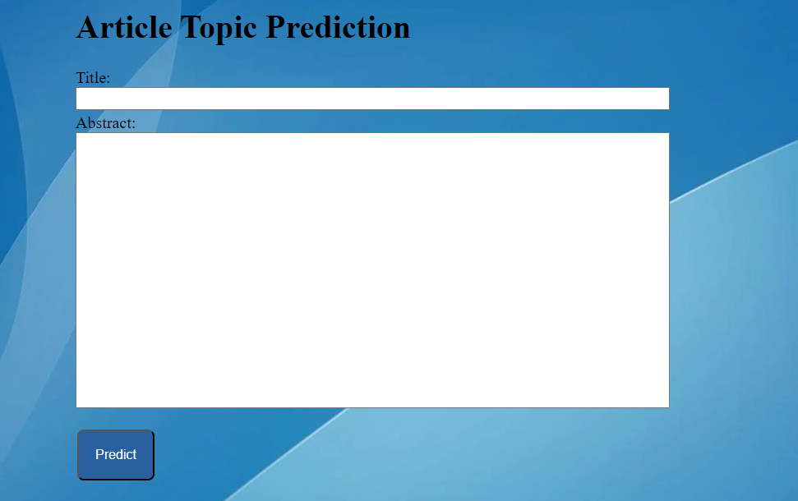

12) Deploy above project on Heroku.