AI Workflow Audit — FL-01

Part 1: Task Classification
 | Task | Classification | Rationale
1 | Daily journaling | Just Me | Personal reflection is meant to be raw and honest — running it through AI would filter my own unfiltered thinking.
2 | Eating meals | Just Me | Physical, personal daily activity — AI has no role here at all.
3 | Gym / workout session | Just Me | Physical activity that only I can do; the value is in doing it, not planning it.
4 | Watching movies for fun | Just Me | Pure leisure — the point is to disconnect and enjoy, not optimize.
5 | Playing mobile games | Just Me | Leisure and skill-building through play itself — AI can't play for me.
6 | Attending college classes | Just Me | Requires physical presence and live attention; nothing to delegate.
7 | Studying coding concepts | Collaborate | Learn through follow-up questions and discussion.
8 | Debugging errors | Collaborate | Iterative troubleshooting and verification.
9 | Git/GitHub workflow | Collaborate | Guidance with commands while executing yourself.
10 | Making reels | Collaborate | AI brainstorms; final creativity is yours.
11 | DSA practice | Delegate to AI with review | Attempt first, AI reviews.
12 | Resume / LinkedIn | Delegate to AI with review | AI drafts, you edit.
13 | README / Documentation | Delegate to AI with review | AI drafts, you verify.
14 | Research new library/tool | Delegate to AI with review | AI summarizes, verify with docs.
15 | Mock interview | Collaborate | Interactive role-play.

Part 2: Toolkit Setup
- Claude account created
- ChatGPT account created
- Anthropic Academy account created
- Enrolled in AI Fluency: Framework & Foundations
- Completed Module 1

Part 3: Claude Project Configuration
Project name: Backend Engineering Track
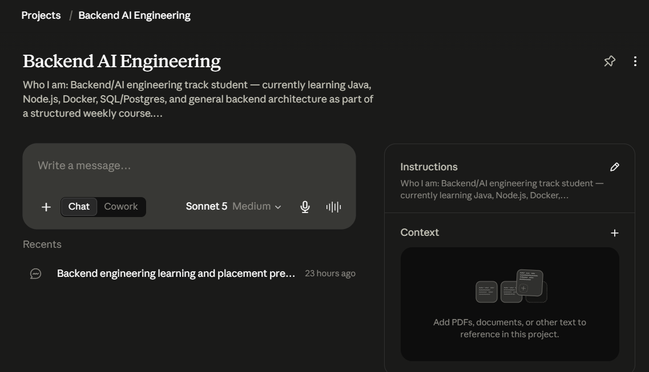

Custom Instructions
Who I am: Anushka, backend/AI engineering track student.
Tone preferences: Direct, step-by-step, explain the why not just the how.
Current goals: Finish backend assignments, prepare for placements, and build backend projects on GitHub.

Part 4: Three Target Tasks for FL-02 → FL-04
Task | Classification | Done Well Means
Debugging errors | Collaborate | Understand root cause, verify fix, explain why it failed.
DSA / coding practice | Delegate to AI with review | Solve first, AI reviews approach and complexity.
Resume / LinkedIn | Delegate to AI with review | Edit AI drafts until authentic and accurate.

