LAB FILE INTRODUCTION TO C PROGRAMMING



BATCH: 2023-2027

BCA(Hons) AI&DS

|  |  |
| --- | --- |
| Submitted by:  Anushka Sharma  Student ID:238522004 | Submitted to:  Mr Rishi Kumar  Assistant Prof.CSIT(GEU) |

WAP for Hello World

#include <stdio.h>

int main()

{

printf("Anushka Sharma \n");

printf("Hello World");

return 0;

}

OUTPUT

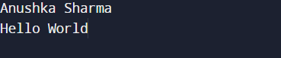

WAP to add two numbers

#include <stdio.h>

int main()

{

printf("Anushka Sharma \n");

int a,b,res;

printf("Enter two numbers \n");

scanf("%d",&a);

scanf("%d",&b);

res=a+b;

printf("Sum of %d and %d=%d",a,b,res);

return 0;

}

OUTPUT

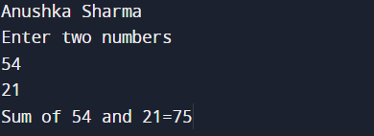

WAP to find area of circle

#include <stdio.h>

int main()

{

printf("Anushka Sharma \n");

float a,area;

printf("Enter radius of circle \n");

scanf("%f",&a);

area=3.1415*a*a;

printf("Area of circle:%f",area);

return 0;

}

OUTPUT

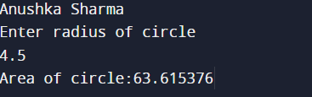

WAP to divide two numbers

#include <stdio.h>

int main()

{

printf("Anushka Sharma \n");

float a,b,res;

printf("Enter two numbers \n");

scanf("%f",&a);

scanf("%f",&b);

res=a/b;

printf("Sum of %f and %f=%f",a,b,res);

return 0;

}

OUTPUT

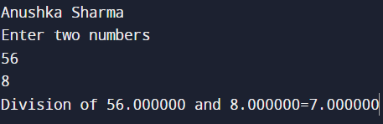

WAP to print ASCII value

#include <stdio.h>

int main()

{

printf("Anushka Sharma \n");

char c;

int ch;

printf("Enter character \n");

scanf("%c",&c);

ch=(int)(c);

printf("ASCII value of %c:%d",c,ch);

return 0;

}

OUTPUT

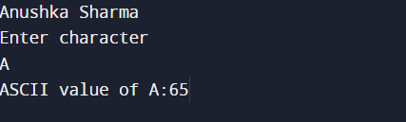

WAP to multilpy two floating numbers

#include <stdio.h>

int main()

{

printf("Anushka Sharma \n");

float a,b,res;

printf("Enter two numbers \n");

scanf("%f",&a);

scanf("%f",&b);

res=a*b;

printf("Multiplication of %f and %f=%f",a,b,res);

return 0;

}

OUTPUT

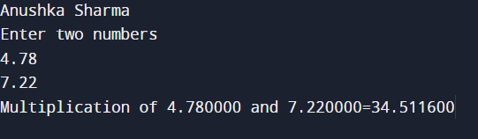

WAP to swap two variables using third variable

#include <stdio.h>

int main()

{

printf("Anushka Sharma \n");

int a,b,c;

printf("Enter two numbers \n");

scanf("%d",&a);

scanf("%d",&b);

printf("1st number:%d",a);

printf("\n");

printf("2nd number:%d",b);

printf("\n");

c=a;

a=b;

b=c;

printf("1st number:%d",a);

printf("\n");

printf("2nd number:%d",b);

return 0;

}

OUTPUT

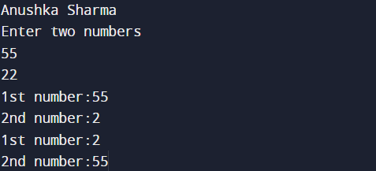

WAP to swap two variables without using third variable

#include <stdio.h>

int main()

{

printf("Anushka Sharma \n");

int a,b;

printf("Enter two numbers \n");

scanf("%d",&a);

scanf("%d",&b);

printf("1st number:%d",a);

printf("\n");

printf("2nd number:%d",b);

printf("\n");

a=a+b;

b=a-b;

a=a-b;

printf("1st number:%d",a);

printf("\n");

printf("2nd number:%d",b);

return 0;

}

OUTPUT

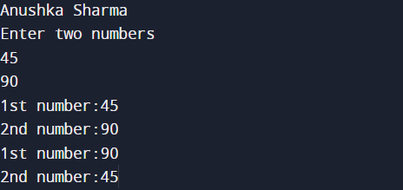

WAP to swap three variables without using extra variable

#include <stdio.h>

int main()

{

printf("Anushka Sharma \n");

int a,b,c;

printf("Enter three numbers \n");

scanf("%d",&a);

scanf("%d",&b);

scanf("%d",&c);

printf("1st number:%d",a);

printf("\n");

printf("2nd number:%d",b);

printf("\n");

printf("3rd number:%d",c);

printf("\n");

a=a+b+c;

b=a-(b+c);

c=a-(b+c);

a=a-(b+c);

printf("1st number:%d",a);

printf("\n");

printf("2nd number:%d",b);

printf("\n");

printf("3rd number:%d",c);

return 0;

}

OUTPUT

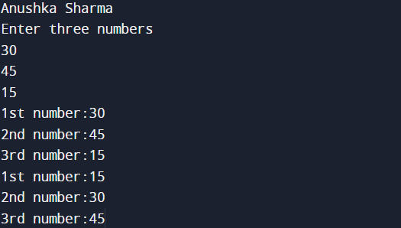

WAP to find area of Rectangle

#include <stdio.h>

int main()

{

printf("Anushka Sharma \n");

float l,b,area;

printf("Enter length and breadth \n");

scanf("%f",&l);

scanf("%f",&b);

area=l*b;

printf("Area of Rectangle:%f",area);

return 0;

}

OUTPUT

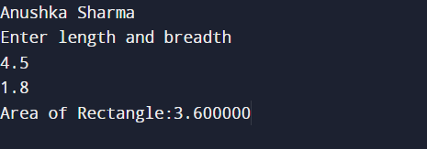

WAP to find area of Square

#include <stdio.h>

int main()

{

printf("Anushka Sharma \n");

float a,area;

printf("Enter side of square \n");

scanf("%f",&a);

area=a*a;

printf("Area of square:%f",area);

return 0;

}

OUTPUT

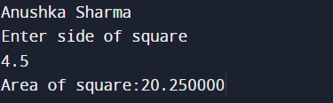

WAP to find area of Triangle

#include <stdio.h>

int main()

{

printf("Anushka Sharma \n");

float height,base,area;

printf("Enter base and height \n");

scanf("%f",&base);

scanf("%f",&height);

area=0.5*base*height;

printf("Area of Triangle:%f",area);

return 0;

}

OUTPUT

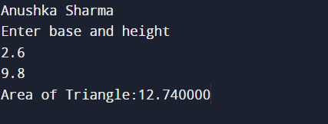

WAP to find area and volume of cube

#include <stdio.h>

int main()

{

printf("Anushka Sharma \n");

float a,area,vol;

printf("Enter side \n");

scanf("%f",&a);

area=6*a*a;

vol=a*a*a;

printf("Area of Cube:%f",area);

printf("\n");

printf("Volume of Cube:%f",vol);

return 0;

}

OUTPUT

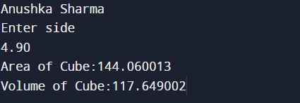

WAP to find area and volume of cuboid

#include <stdio.h>

int main()

{

printf("Anushka Sharma \n");

float l,b,h,area,vol;

printf("Enter sides of cuboid \n");

scanf("%f",&l);

scanf("%f",&b);

scanf("%f",&h);

area=2*(l*b+b*h+h*l);

vol=l*b*h;

printf("Area of Cuboid:%f",area);

printf("\n");

printf("Volume of Cuboid:%f",vol);

return 0;

}

OUTPUT

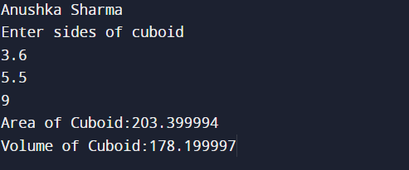

WAP to find largest number using logical AND operator

#include <stdio.h>

int main()

{

int a,b,c,val;

printf("Enter all values \n");

scanf("%d",&a);

scanf("%d",&b);

scanf("%d",&c);

if((a>b)&&(a>c))

printf("Largest number:%d",a);

if((b>a)&&(b>c))

printf("Largest number:%d",b);

if((c>a)&&(c>b))

printf("Largest number:%d",c);

return 0;

}

OUTPUT

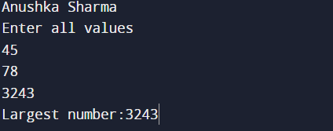

WAP to show left shift

#include <stdio.h>

int main()

{

printf("Anushka Sharma \n");

int a,val,res;

res=1;

printf("Enter the value to shift \n");

scanf("%d",&a);

printf("Enter the number of places to shift left \n");

scanf("%d",&val);

for(int i=0;i<val;i++)

{

res*=2;

}

res=res*a;

printf("After Left Shift:%d",res);

return 0;

}

OUTPUT

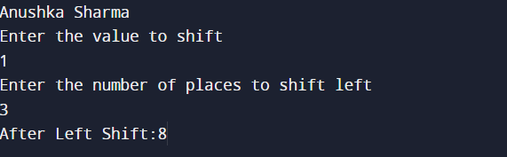

WAP to show right shift

#include <stdio.h>

int main()

{

printf("Anushka Sharma \n");

int a,val,res;

res=1;

printf("Enter the value to shift \n");

scanf("%d",&a);

printf("Enter the number of places to shift left \n");

scanf("%d",&val);

for(int i=0;i<val;i++)

{

res*=2;

}

res=res/a;

printf("After Right Shift:%d",res);

return 0;

}

OUTPUT

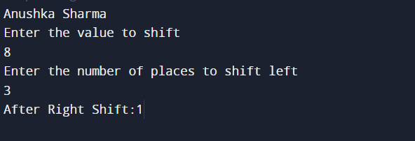

WAP to perform pre increment and decrement

#include <stdio.h>

int main()

{

printf("Anushka Sharma \n");

int a1,a2;

printf("Enter first value \n");

scanf("%d",&a1);

printf("Enter second value \n");

scanf("%d",&a2);

printf("Original Values:%d %d",a1,a2);

printf("\n");

a1=++a1;

a2=--a2;

printf("Pre Increament value:%d",a1);

printf("\n");

printf("Pre Decrement value:%d",a2);

return 0;

}

OUTPUT

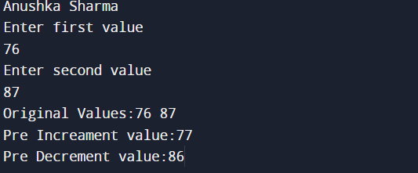

WAP to perform post increment and decrement

#include <stdio.h>

int main()

{

printf("Anushka Sharma \n");

int a1,a2;

printf("Enter first value \n");

scanf("%d",&a1);

printf("Enter second value \n");

scanf("%d",&a2);

printf("Original Values:%d %d",a1,a2);

printf("\n");

a1=a1++;

a2=a2--;

printf("Post Increament value:%d",a1);

printf("\n");

printf("Post Decrement value:%d",a2);

return 0;

}

OUTPUT

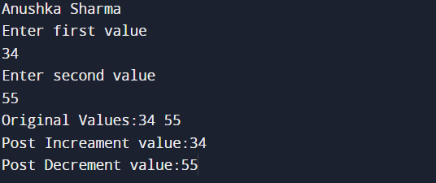

WAP to check divisibility by 9 or 7 using Logical OR

#include <stdio.h>

int main()

{

printf("Anushka Sharma \n");

int a1;

printf("Enter value \n");

scanf("%d",&a1);

if((a1%9==0)||(a1%7==0))

printf("Divisible by 9 or 7 \n");

else

printf("Not divisible by either of the two");

return 0;

}

OUTPUT

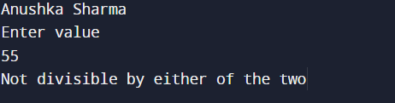

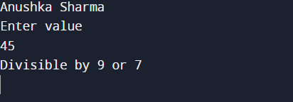

WAP to identify gender by single character and print full gender

#include <stdio.h>

int main()

{

printf("Anushka Sharma \n");

char c;

printf("Enter the Character \n");

scanf("%c",&c);

if((c=='M')||(c=='m'))

printf("MALE \n");

else if((c=='F')||(c=='f'))

printf("FEMALE \n");

else

printf("WRONG INPUT");

return 0;

}

OUTPUT

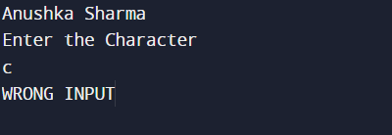

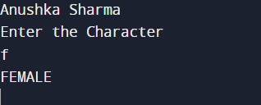



WAP to count number of digits

#include <stdio.h>

int main()

{

int n;

printf("Enter number:");

scanf("%d",&n);

int count;

int d;

count=0;

while(n!=0)

{

d=n%10;

count++;

n=n/10;

}

printf("Number of digits:%d",count);

return 0;

}

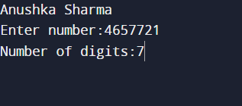

WAP to print all natural numbers in reverse (from n to 1)

#include <stdio.h>

int main()

{

printf("Anushka Sharma \n");

int n;

printf("Enter limit:");

scanf("%d",&n);

int i;

for(i=n;i>0;i--)

{

printf("%d\t",i);

}

return 0;

}

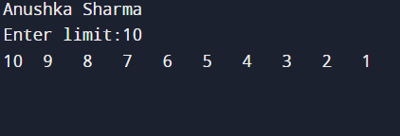

WAP to print all alphabets

#include <stdio.h>

int main()

{

printf("Anushka Sharma \n");

char i,i1;

for(i=65;i<=90;i++)

{

printf("%c\t",i);

}

printf("\n");

for(i1=97;i1<=122;i1++)

{

printf("%c\t",i1);

}

return 0;

}

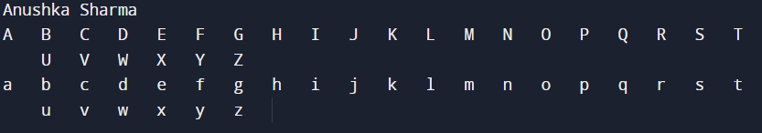

WAP to print all natural numbers from 1 to n

#include <stdio.h>

int main()

{

printf("Anushka Sharma \n");

int i;

int n;

printf("Enter limit:");

scanf("%d",&n);

for(i=1;i<=n;i++)

{

printf("%d\t",i);

}

return 0;

}

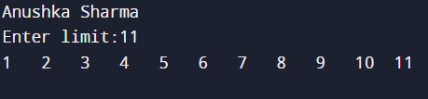

WAP to print all even numbers from 1 to 100

#include <stdio.h>

int main()

{

printf("Anushka Sharma \n");

int i;

for(i=1;i<=100;i++)

{

if(i%2==0)

printf("%d \t",i);

}

return 0;

}

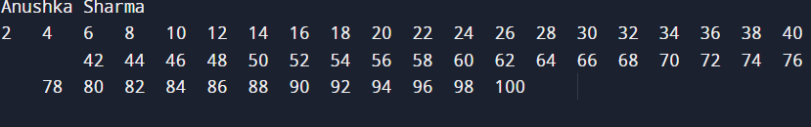

WAP to print all odd numbers from 1 to 100

#include <stdio.h>

int main()

{

printf("Anushka Sharma \n");

int i;

for(i=1;i<=100;i++)

{

if(i%2==1)

printf("%d \t",i);

}

return 0;

}

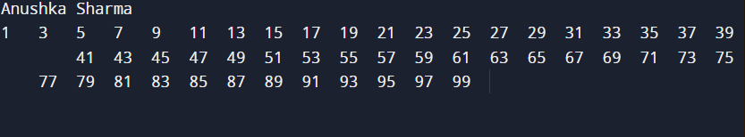

WAP to find sum of all natural numbers between 1 to n

#include <stdio.h>

int main()

{

int n;

printf("Anushka Sharma \n");

printf("Enter limit:");

scanf("%d",&n);

printf("\n");

int i;

int sum=0;

for(i=1;i<=n;i++)

{

sum=sum+i;

}

printf("Sum=%d",sum);

return 0;

}

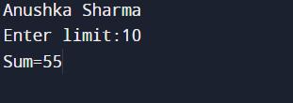

WAP to find sum of all even natural numbers between 1 to n

#include <stdio.h>

int main()

{

int n;

printf("Anushka Sharma \n");

printf("Enter limit:");

scanf("%d",&n);

printf("\n");

int i;

int sum=0;

for(i=1;i<=n;i++)

{

if(i%2==0)

sum=sum+i;

}

printf("Sum=%d",sum);

return 0;

}

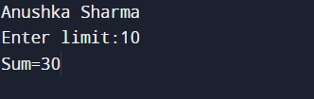

WAP to find sum of all odd natural numbers between 1 to n

#include <stdio.h>

int main()

{

int n;

printf("Anushka Sharma \n");

printf("Enter limit:");

scanf("%d",&n);

printf("\n");

int i;

int sum=0;

for(i=1;i<=n;i++)

{

if(i%2==1)

sum=sum+i;

}

printf("Sum=%d",sum);

return 0;

}

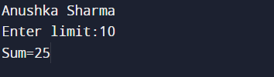

WAP to print multiplication table of any number

#include <stdio.h>

int main()

{

int n;

printf("Anushka Sharma \n");

printf("Enter a number:");

scanf("%d",&n);

printf("\n");

int i;

int s;

for(i=1;i<=10;i++)

{

s=1;

s=n*i;

printf("%d * %d= %d",n,i,s);

printf("\n");

}

return 0;

}

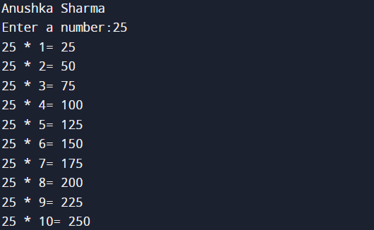

WAP to find largest number using logical AND operator

// Online C compiler to run C program online

#include <stdio.h>

int main()

{

int l,n,m;

printf("Anushka Sharma \n");

printf("Enter 3 numbers:");

scanf("%d",&l);

scanf("%d",&m);

scanf("%d",&n);

printf("\n");

if ((l>m)&&(l>n))

printf("LARGEST NUMBER IS %d",l);

else if((m>n)&&(m>l))

printf("LARGEST NUMBER IS %d",m);

else

printf("LARGEST NUMBER IS %d",n);

return 0;

}

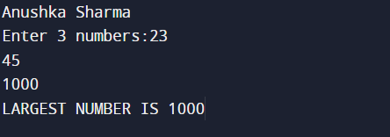

WAP to input positive integer from user and perform left shift

#include <stdio.h>

#include<math.h>

int main()

{

float k;

int l,m;

int a;

printf("Anushka Sharma \n");

printf("Enter a number:");

scanf("%d",&l);

printf("\n");

printf("Enter number of places to shift:");

scanf("%d",&m);

printf("\n");

k=pow(2,m);

a=(int)(l*k);

printf(" %d << %d= %d",l,m,a);

return 0;

}

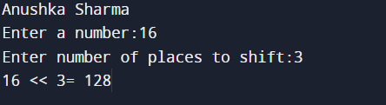

WAP to input a positive number and perform right shift

// Online C compiler to run C program online

#include <stdio.h>

#include<math.h>

int main()

{

float k;

int l,m;

int a;

printf("Anushka Sharma \n");

printf("Enter a number:");

scanf("%d",&l);

printf("\n");

printf("Enter number of places to shift:");

scanf("%d",&m);

printf("\n");

k=pow(2,m);

a=(int)(l/k);

printf(" %d >> %d= %d",l,m,a);

return 0;

}

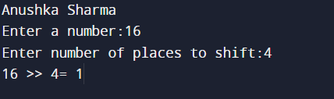

WAP to find first and last digit of a number

#include <stdio.h>

int main() {

int n,f,l;

printf("Enter number:");

scanf("%d",&n);

printf("\n");

l=n%10;

while(n>10)

{

n=n/10;

}

f=n;

printf("LAST DIGIT:%d",l);

printf("\n");

printf("FIRST DIGIT:%d",f);

return 0;

}

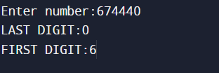

WAP to find sum of first and last digit of a number

#include <stdio.h>

int main()

{

printf("ANUSHKA SHARMA \n");

int n,f,l,sum;

printf("Enter number:");

scanf("%d",&n);

printf("\n");

l=n%10;

while(n>10)

{

n=n/10;

}

f=n;

printf("LAST DIGIT:%d",l);

printf("\n");

printf("FIRST DIGIT:%d",f);

sum=f+l;

printf("\n");

printf("SUM OF FIRST AND LAST DIGIT:%d",sum);

return 0;

}

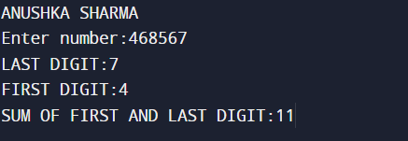

WAP to swap first and last digit of a number

#include <stdio.h>

#include <math.h>

int main()

{

printf("ANUSHKA SHARMA");

printf("\n");

int num, swappedNum;

int firstDigit, lastDigit, digits;

printf("Enter any number: ");

digits=0;

scanf("%d", &num);

printf("\n");

int n;

n=num;

while(n!=0)

{

digits++;

n=n/10;

}

digits-=1;

lastDigit = num % 10;

firstDigit = (int)(num / pow(10, digits));

swappedNum = lastDigit;

swappedNum *= (int) pow(10, digits);

swappedNum += num % ((int) pow(10, digits));

swappedNum -= lastDigit;

swappedNum += firstDigit;

printf("Original number = %d", num);

printf("\n");

printf("Number after swapping first and last digit: %d", swappedNum);

return 0;

}

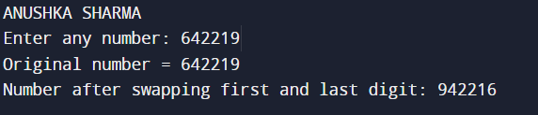

WAP to calculate sum of digits of a number

#include <stdio.h>

#include <math.h>

int main()

{

printf("ANUSHKA SHARMA");

printf("\n");

int num,sum;

sum=0;

printf("ENTER NUMBER:");

scanf("%d",&num);

printf("\n");

int t;

t=num;

while(t>0)

{

int d= t%10;

sum=sum+d;

t=t/10;

}

printf("SUM OF DIGITS:%d",sum);

return 0;

}

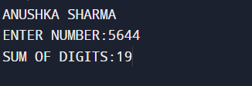

WAP to input a number and print it in letters

#include<stdio.h>

#include<string.h>

int main()

{

printf("ANUSHKA SHARMA");

char n[10];

printf("\nEnter a number-");

scanf("%s",&n);

printf("\n");

int l=strlen(n);

for(int i=0;i<l;i++)

{

if(n[i]=='1')

printf("\tONE");

else if(n[i]=='0')

printf("\tZERO");

else if(n[i]=='3')

printf("\tTHREE");

else if(n[i]=='2')

printf("\tTWO");

else if(n[i]=='4')

printf("\tFOUR");

else if(n[i]=='5')

printf("\tFIVE");

else if(n[i]=='6')

printf("\tSIX");

else if(n[i]=='7')

printf("\tSEVEN");

else if(n[i]=='8')

printf("\tEIGHT");

else

printf("\tNINE");

}

return 0;

}

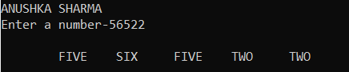

WAP to calculate product of digits of a number

#include <stdio.h>

#include <math.h>

int main()

{

printf("ANUSHKA SHARMA");

printf("\n");

int num,p;

p=1;

printf("ENTER NUMBER:");

scanf("%d",&num);

printf("\n");

int t;

t=num;

while(t>0)

{

int d= t%10;

p=p*d;

t=t/10;

}

printf("PRODUCT OF DIGITS:%d",p);

return 0;

}

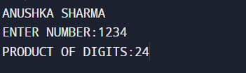

WAP to enter a number and print its reverse

#include <stdio.h>

#include <math.h>

int main()

{

printf("ANUSHKA SHARMA");

printf("\n");

int num,rev;

rev=0;

printf("ENTER NUMBER:");

scanf("%d",&num);

printf("\n");

int t;

t=num;

while(t>0)

{

int d= t%10;

rev=rev*10+d;

t=t/10;

}

printf("REVERSE OF NUMBERS:%d",rev);

return 0;

}

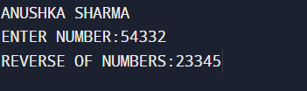

WAP to check if a given number is palindrome or not

#include <stdio.h>

#include <math.h>

int main()

{

printf("ANUSHKA SHARMA");

printf("\n");

int num,rev;

rev=0;

printf("ENTER NUMBER:");

scanf("%d",&num);

printf("\n");

int t;

t=num;

while(t>0)

{

int d= t%10;

rev=rev*10+d;

t=t/10;

}

if(rev==num)

printf("NUMBER IS PALINDROME");

else

printf("NUMBER IS NOT PALINDROME");

return 0;

}

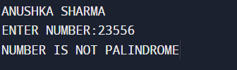

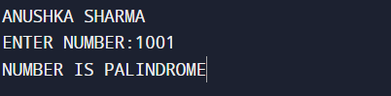

WAP to find frequency of each digit in a number

#include <stdio.h>

#include <math.h>

int main()

{

printf("ANUSHKA SHARMA");

printf("\n");

int num,freq;

printf("ENTER NUMBER:");

scanf("%d",&num);

printf("\n");

int t;

for(int i=0;i<10;i++)

{

t=num;

freq=0;

while(t>0)

{

int d=t%10;

if(d==i)

freq++;

t=t/10;

}

printf("FREQUENCY OF %d is %d",i,freq);

printf("\n");

}

return 0;

}

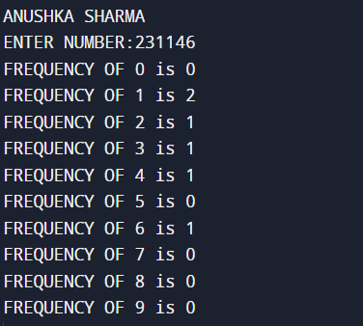

WAP to find power of a number using for loop

#include <stdio.h>

int main()

{

printf("ANUSHKA SHARMA");

printf("\n");

int num,p;

int a;

a=1;

int t;

printf("ENTER NUMBER:");

scanf("%d",&num);

printf("\n");

t=num;

printf("ENTER THE POWER YOU WANT TO RAISE THE NUMBER TO:");

scanf("%d",&p);

printf("\n");

for(int i=1;i<=p;i++)

{

a=a*num;

}

printf(" %d raise to power %d is %d",t,p,a);

printf("\n");

return 0;

}

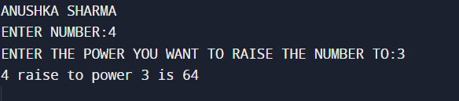

WAP to find all factors of a number

#include <stdio.h>

int main()

{

printf("ANUSHKA SHARMA");

printf("\n");

int num;

printf("ENTER NUMBER:");

scanf("%d",&num);

printf("\n");

printf("FACTORS OF THE NUMBER");

printf("\n");

for(int i=1;i<=num;i++)

{

if(num%i==0)

printf("%d\n",i);

}

return 0;

}

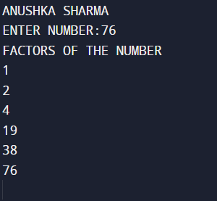

WAP to calculate factorial of the number

#include <stdio.h>

int main()

{

printf("ANUSHKA SHARMA");

printf("\n");

int num,fac;

fac=1;

printf("ENTER NUMBER:");

scanf("%d",&num);

printf("\n");

for(int i=1;i<=num;i++)

{

fac=fac*i;

}

printf("FACTORIAL OF THE NUMBER:%d",fac);

return 0;

}

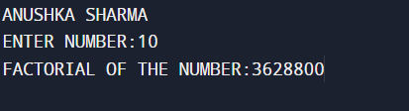

WAP to find HCF of two numbers

#include <stdio.h>

int main()

{

int m,n;

printf("ANUSHKA SHARMA\n");

printf("Enter 2 numbers\n");

scanf("%d",&m);

scanf("%d",&n);

int min;

min=(m>n) ? n:m;

int h;

h=1;

int i;

for(i=2;i<=min;i++)

{

if((n%i==0)&&(m%i==0))

h=i;

}

printf("HCF OF %d and %d is %d",m,n,h);

return 0;

}

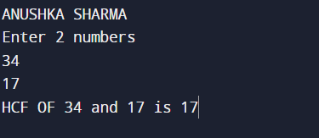

WAP to find LCM of 2 numbers

#include <stdio.h>

int main()

{

int m,n;

printf("ANUSHKA SHARMA\n");

printf("Enter 2 numbers\n");

scanf("%d",&m);

scanf("%d",&n);

int max;

max=(m<n) ? n:m;

int h;

h=1;

int i;

while(1)

{

if((max%n==0)&&(max%m==0))

{

printf("LCM OF %d and %d is %d",m,n,max);

break;

}

max++;

}

return 0;

}

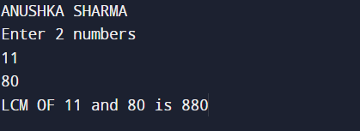

WAP to check whether number is prime or not

#include <stdio.h>

int main()

{

int n;

printf("ANUSHKA SHARMA\n");

printf("Enter a number\n");

scanf("%d",&n);

int c;

c=0;

for(int i=2;i<n;i++)

{

if(n%i==0)

{

c++;

}

}

if(c==0)

printf("NUMBER IS PRIME");

else

printf("NUMBER IS NOT PRIME");

return 0;

}

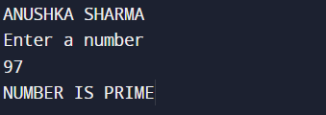

WAP to print all prime numbers from 1 to n

#include <stdio.h>

int main()

{

int n;

printf("ANUSHKA SHARMA\n");

printf("Enter limit\n");

scanf("%d",&n);

int count;

printf("PRIME NUMBERS BETWEEN 1 TO %d\n",n);

for(int i=2;i<=n;i++)

{ count=0;

for(int j=2;j<i;j++)

{

if(i%j==0)

count++;

}

if(count==0)

printf("%d\n",i);

}

return 0;

}

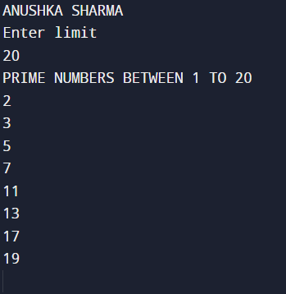

WAP to find sum of all prime numbers between 1 to n

#include <stdio.h>

int main()

{

int n;

printf("ANUSHKA SHARMA\n");

printf("Enter limit\n");

scanf("%d",&n);

int count;

int sum;

sum=0;

printf("PRIME NUMBERS BETWEEN 1 TO %d\n",n);

for(int i=2;i<=n;i++)

{ count=0;

for(int j=2;j<i;j++)

{

if(i%j==0)

count++;

}

if(count==0)

{

printf("%d\n",i);

sum=sum+i;

}

}

printf("SUM OF ALL PRIME NUMBERS IS %d",sum);

return 0;

}

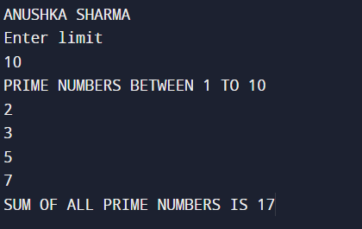

WAP to find all prime factors of a number

#include <stdio.h>

int main()

{

int n;

printf("ANUSHKA SHARMA\n");

printf("Enter a number \n");

scanf("%d",&n);

int count;

int t;

t=n;

printf("PRIME FACTORS ARE\n");

for(int i=2;i<=t;i++)

{

if(t%i==0)

{

count=0;

for(int j=2;j<i;j++)

{

if(i%j==0)

count++;

}

if(count==0)

{

printf("%d\n",i);

}

}

}

return 0;

}

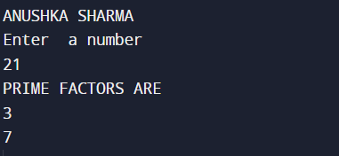

WAP to check if number if Armstrong number or not

#include <stdio.h>

int main()

{

int n;

printf("ANUSHKA SHARMA\n");

printf("Enter a number \n");

scanf("%d",&n);

int count;

count=0;

int t;

t=n;

int t1;

t1=n;

int sum;

sum=0;

while(t>0)

{

count++;

t=t/10;

}

while(t1>0)

{

int d=t1%10;

int k=(int)pow(d,count);

sum=sum+k;

t1=t1/10;

}

if(sum==n)

printf("ARMSTRONG NUMBER");

else

printf("NOT ARMSTRONG NUMBER");

return 0;

}

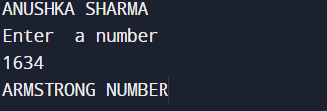

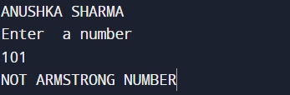

WAP to print all Armstrong number between 1 and n

#include <stdio.h>

#include<math.h>

int main()

{

int n;

printf("ANUSHKA SHARMA\n");

printf("Enter a limit \n");

scanf("%d",&n);

int count;

int t;

int t1;

int i;

int sum;

for( i=1;i<=n;i++)

{

sum=0;

count=0;

t=i;

t1=i;

while(t>0)

{

count++;

t=t/10;

}

while(t1>0)

{

int d=t1%10;

int k=(int)pow(d,count);

sum=sum+k;

t1=t1/10;

}

if(sum==i)

printf("%d\n",i);

}

return 0;

}

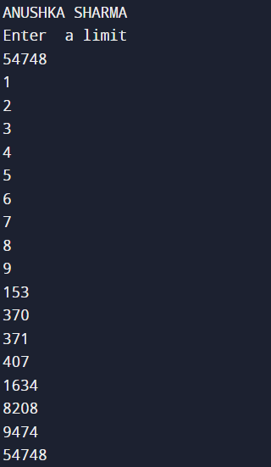

WAP to check if a number is Perfect number or not

#include <stdio.h>

#include<math.h>

int main()

{

int n;

printf("ANUSHKA SHARMA\n");

printf("Enter a number \n");

scanf("%d",&n);

int i;

int sum;

sum=0;

for( i=1;i<n;i++)

{

if(n%i==0)

sum=sum+i;

}

if(sum==n)

printf("PERFECT NUMBER");

else

printf("NOT PERFECT NUMBER");

return 0;

}

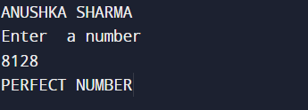

WAP to print all Perfect numbers between 1 and n

#include <stdio.h>

#include<math.h>

int main()

{

int n;

printf("ANUSHKA SHARMA\n");

printf("Enter limit \n");

scanf("%d",&n);

int i,j;

int sum;

for( i=2;i<=n;i++)

{

sum=0;

for( j=1;j<i;j++)

{

if(i%j==0)

sum=sum+j;

}

if(sum==i)

printf("%d\n",i);

}

return 0;

}

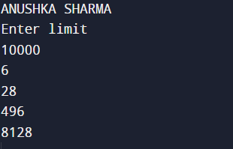

WAP to check if number is Strong or not

#include <stdio.h>

int main()

{

int i, Num, num, lastDigit, sum;

long fact;

printf(“ANUSHKA SHARMA”);

printf("Enter any number to check Strong number: ");

scanf("%d", &num);

Num = num;

sum = 0;

while(num > 0)

{

lastDigit = num % 10;

fact = 1;

for(i=1; i<=lastDigit; i++)

{

fact = fact * i;

}

sum = sum + fact;

num = num / 10;

}

if(sum ==Num)

{

printf("%d is STRONG NUMBER",Num);

}

else

{

printf("%d is NOT STRONG NUMBER", Num);

}

return 0;

}

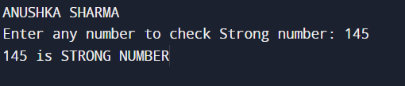

WAP to print all Strong numbers between 1 to n

#include <stdio.h>

int main()

{

int i, j, cur, lastDigit, end;

int fact, sum;

printf("ANUSHKA SHARMA\n");

printf("Enter upper limit: ");

scanf("%d", &end);

printf("All Strong numbers between 1 to %d are:\n", end);

for(i=1; i<=end; i++)

{

cur = i;

sum = 0;

while(cur > 0)

{

fact = 1ll;

lastDigit = cur % 10;

for( j=1; j<=lastDigit; j++)

{

fact = fact * j;

}

sum += fact;

cur /= 10;

}

if(sum == i)

{

printf("%d\n", i);

}

}

return 0;

}

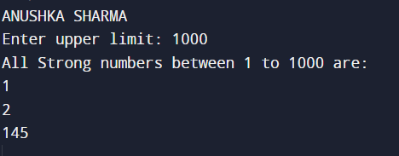

WAP to convert Binary to Octal

#include <stdio.h>

int binaryToOctal(long long binaryNumber) {

int octalNumber = 0, decimalNumber = 0, base = 1;

while (binaryNumber != 0) {

int remainder = binaryNumber % 10;

decimalNumber += remainder * base;

binaryNumber /= 10;

base *= 2;

}

int octalDigit, place = 1;

while (decimalNumber != 0) {

octalDigit = decimalNumber % 8;

octalNumber += octalDigit * place;

decimalNumber /= 8;

place *= 10;

}

return octalNumber;

}

int main() {

long binaryNumber;

printf("ANUSHKA SHARMA");

printf("\nEnter a binary number: ");

scanf("%ld", &binaryNumber);

long long temp = binaryNumber;

while (temp != 0) {

int digit = temp % 10;

if (digit != 0 && digit != 1) {

printf("\nInvalid binary number.\n");

return 1;

}

temp /= 10;

}

int octalNumber = binaryToOctal(binaryNumber);

printf("\nOctal equivalent: %d\n", octalNumber);

return 0;

}

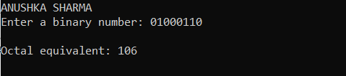

WAP to convert Binary to Decimal

#include <stdio.h>

int binaryToDecimal(long binaryNumber) {

int decimalNumber = 0, base = 1;

while (binaryNumber != 0) {

int remainder = binaryNumber % 10;

decimalNumber += remainder * base;

binaryNumber /= 10;

base *= 2;

}

return decimalNumber;

}

int main() {

long binaryNumber;

printf("ANUSHKA SHARMA");

printf("\nEnter a binary number: ");

scanf("%ld", &binaryNumber);

long long temp = binaryNumber;

while (temp != 0) {

int digit = temp % 10;

if (digit != 0 && digit != 1) {

printf("\nInvalid binary number.\n");

return 1;

}

temp /= 10;

}

int decimalNumber = binaryToDecimal(binaryNumber);

printf("\nDecimal equivalent: %d\n", decimalNumber);

return 0;

}

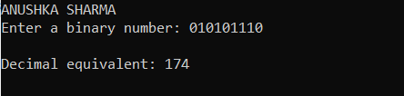

WAP to convert binary to Hexadecimal

#include <stdio.h>

#include <math.h>

void binaryToHexadecimal(long binaryNumber) {

int hexadecimalNumber[1000];

int i = 0;

int decimalNumber = 0, base = 1;

while (binaryNumber != 0) {

int remainder = binaryNumber % 10;

decimalNumber += remainder * base;

binaryNumber /= 10;

base *= 2;

}

while (decimalNumber != 0) {

int remainder = decimalNumber % 16;

if (remainder < 10) {

hexadecimalNumber[i] = remainder + '0';

} else {

hexadecimalNumber[i] = remainder + 'A' - 10;

}

i++;

decimalNumber /= 16;

}

printf("Hexadecimal equivalent: ");

for (int j = i - 1; j >= 0; j--) {

printf("%c", hexadecimalNumber[j]);

}

printf("\n");

}

int main() {

long binaryNumber;

printf("ANUSHKA SHARMA");

printf("\nEnter a binary number: ");

scanf("%ld", &binaryNumber);

long temp = binaryNumber;

while (temp != 0) {

int digit = temp % 10;

if (digit != 0 && digit != 1) {

printf("Invalid binary number.\n");

return 1;

}

temp /= 10;

}

binaryToHexadecimal(binaryNumber);

return 0;

}

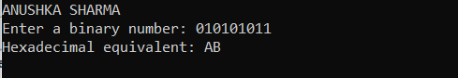

WAP to convert Octal to binary

#include <stdio.h>

long octalToBinary(int octalNumber) {

long long binaryNumber = 0;

int base = 1;

while (octalNumber != 0) {

int remainder = octalNumber % 10;

octalNumber /= 10;

for (int i = 0; i < 3; ++i) {

binaryNumber += (remainder % 2) * base;

remainder /= 2;

base *= 10;

}

}

return binaryNumber;

}

int main() {

int octalNumber;

printf("ANUSHKA SHARMA");

printf("\nEnter an octal number: ");

scanf("%d", &octalNumber);

int temp = octalNumber;

while (temp != 0) {

int digit = temp % 10;

if (digit < 0 || digit > 7) {

printf("\nInvalid octal number.\n");

return 1;

}

temp /= 10;

}

long binaryNumber = octalToBinary(octalNumber);

printf("\nBinary equivalent: %ld\n", binaryNumber);

return 0;

}

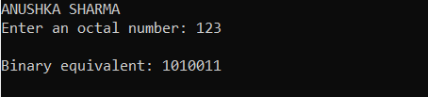

WAP to convert octal to decimal

#include <stdio.h>

int octalToDecimal(int octalNumber) {

int decimalNumber = 0, base = 1;

while (octalNumber != 0) {

int remainder = octalNumber % 10;

decimalNumber += remainder * base;

octalNumber /= 10;

base *= 8;

}

return decimalNumber;

}

int main() {

int octalNumber;

printf("ANUSHKA SHARMA");

printf("\nEnter an octal number: ");

scanf("%d", &octalNumber);

int temp = octalNumber;

while (temp != 0) {

int digit = temp % 10;

if (digit < 0 || digit > 7) {

printf("Invalid octal number.\n");

return 1;

}

temp /= 10;

}

int decimalNumber = octalToDecimal(octalNumber);

printf("\nDecimal equivalent: %d\n", decimalNumber);

return 0;

}

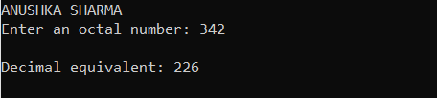

WAP to convert octal to hexadecimal

#include <stdio.h>

#include <math.h>

void octalToHexadecimal(int octalNumber) {

int decimalNumber = 0, base = 1;

while (octalNumber != 0) {

int remainder = octalNumber % 10;

decimalNumber += remainder * base;

octalNumber /= 10;

base *= 8;

}

int hexadecimalNumber[1000];

int i = 0;

while (decimalNumber != 0) {

int remainder = decimalNumber % 16;

if (remainder < 10) {

hexadecimalNumber[i] = remainder + '0';

} else {

hexadecimalNumber[i] = remainder + 'A' - 10;

}

i++;

decimalNumber /= 16;

}

printf("\nHexadecimal equivalent: ");

for (int j = i - 1; j >= 0; j--) {

printf("%c", hexadecimalNumber[j]);

}

printf("\n");

}

int main() {

int octalNumber;

printf("ANUSHKA SHARMA");

printf("\nEnter an octal number: ");

scanf("%d", &octalNumber);

int temp = octalNumber;

while (temp != 0) {

int digit = temp % 10;

if (digit < 0 || digit > 7) {

printf("\nInvalid octal number.\n");

return 1;

}

temp /= 10;

}

octalToHexadecimal(octalNumber);

return 0;

}

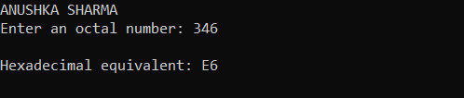

WAP to convert decimal to binary

#include <stdio.h>

long decimalToBinary(int decimalNumber) {

long binaryNumber = 0;

int remainder, base = 1;

while (decimalNumber > 0) {

remainder = decimalNumber % 2;

binaryNumber += remainder * base;

decimalNumber /= 2;

base *= 10;

}

return binaryNumber;

}

int main() {

int decimalNumber;

printf("ANUSHKA SHARMA");

printf("\nEnter a decimal number: ");

scanf("%d", &decimalNumber);

long binaryNumber = decimalToBinary(decimalNumber);

printf("\nBinary equivalent: %ld\n", binaryNumber);

return 0;

}

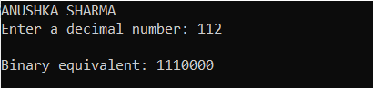

WAP to convert decimal to octal

#include <stdio.h>

long decimalToOctal(int decimalNumber) {

long octalNumber = 0;

int remainder, base = 1;

while (decimalNumber > 0) {

remainder = decimalNumber % 8;

octalNumber += remainder * base;

decimalNumber /= 8;

base *= 10;

}

return octalNumber;

}

int main() {

int decimalNumber;

printf("ANUSHKA SHARMA");

printf("\nEnter a decimal number: ");

scanf("%d", &decimalNumber);

long octalNumber = decimalToOctal(decimalNumber);

printf("Octal equivalent: %ld\n", octalNumber);

return 0;

}

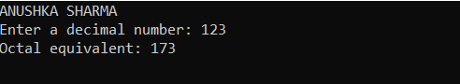

WAP to convert decimal to hexadecimal

#include <stdio.h>

void decimalToHexadecimal(int decimalNumber) {

char hexadecimalNumber[100];

int i = 0;

while (decimalNumber > 0) {

int remainder = decimalNumber % 16;

if (remainder < 10) {

hexadecimalNumber[i] = remainder + '0';

} else {

hexadecimalNumber[i] = remainder + 'A' - 10;

}

i++;

decimalNumber /= 16;

}

printf("\nHexadecimal equivalent: ");

for (int j = i - 1; j >= 0; j--) {

printf("%c", hexadecimalNumber[j]);

}

printf("\n");

}

int main() {

int decimalNumber;

printf("ANUSHKA SHARMA");

printf("\nEnter a decimal number: ");

scanf("%d", &decimalNumber);

decimalToHexadecimal(decimalNumber);

return 0;

}

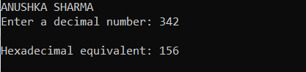

WAP to convert Hexadecimal to binary

#include <stdio.h>

#include <string.h>

void hexToBinary(char hexNumber[]) {

char binaryNumber[1000];

int i, j = 0, decimalNumber = 0, remainder;

for (i = strlen(hexNumber) - 1; i >= 0; i--) {

int digit;

if (hexNumber[i] >= '0' && hexNumber[i] <= '9') {

digit = hexNumber[i] - '0';

} else if (hexNumber[i] >= 'A' && hexNumber[i] <= 'F') {

digit = hexNumber[i] - 'A' + 10;

} else if (hexNumber[i] >= 'a' && hexNumber[i] <= 'f') {

digit = hexNumber[i] - 'a' + 10;

} else {

printf("Invalid hexadecimal digit: %c\n", hexNumber[i]);

return;

}

decimalNumber += digit * (1 << (4 * (strlen(hexNumber) - 1 - i)));

}

while (decimalNumber > 0) {

remainder = decimalNumber % 2;

binaryNumber[j++] = remainder + '0';

decimalNumber /= 2;

}

printf("\nBinary equivalent: ");

for (i = j - 1; i >= 0; i--) {

printf("%c", binaryNumber[i]);

}

printf("\n");

}

int main() {

char hexNumber[100];

printf("ANUSHKA SHARMA");

printf("\nEnter a hexadecimal number: ");

scanf("%s", hexNumber);

hexToBinary(hexNumber);

return 0;

}

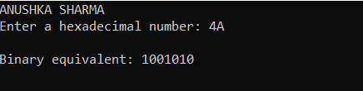

WAP to convert hexadecimal to octal

#include <stdio.h>

#include <string.h>

int hexToDecimal(char hexNumber[]) {

int decimalNumber = 0, base = 1;

for (int i = strlen(hexNumber) - 1; i >= 0; i--) {

int digit;

if (hexNumber[i] >= '0' && hexNumber[i] <= '9') {

digit = hexNumber[i] - '0';

} else if (hexNumber[i] >= 'A' && hexNumber[i] <= 'F') {

digit = hexNumber[i] - 'A' + 10;

} else if (hexNumber[i] >= 'a' && hexNumber[i] <= 'f') {

digit = hexNumber[i] - 'a' + 10;

} else {

printf("\nInvalid hexadecimal digit: %c\n", hexNumber[i]);

return -1;

}

decimalNumber += digit * base;

base *= 16;

}

return decimalNumber;

}

void decimalToOctal(int decimalNumber) {

int octalNumber = 0, base = 1;

while (decimalNumber > 0) {

int remainder = decimalNumber % 8;

octalNumber += remainder * base;

decimalNumber /= 8;

base *= 10;

}

printf("\nOctal equivalent: %d\n", octalNumber);

}

int main() {

char hexNumber[100];

printf("ANUSHKA SHARMA");

printf("\nEnter a hexadecimal number: ");

scanf("%s", hexNumber);

int decimalNumber = hexToDecimal(hexNumber);

if (decimalNumber != -1) {

decimalToOctal(decimalNumber);

}

return 0;

}

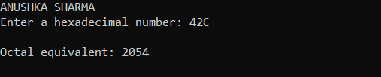

WAP to convert hexadecimal to decimal

#include <stdio.h>

#include <string.h>

int hexToDecimal(char hexNumber[]) {

int decimalNumber = 0, base = 1;

for (int i = strlen(hexNumber) - 1; i >= 0; i--) {

int digit;

if (hexNumber[i] >= '0' && hexNumber[i] <= '9') {

digit = hexNumber[i] - '0';

} else if (hexNumber[i] >= 'A' && hexNumber[i] <= 'F') {

digit = hexNumber[i] - 'A' + 10;

} else if (hexNumber[i] >= 'a' && hexNumber[i] <= 'f') {

digit = hexNumber[i] - 'a' + 10;

} else {

printf("\nInvalid hexadecimal digit: %c\n", hexNumber[i]);

return -1;

}

decimalNumber += digit * base;

base *= 16;

}

return decimalNumber;

}

int main() {

char hexNumber[100];

printf("ANUSHKA SHARMA");

printf("\nEnter a hexadecimal number: ");

scanf("%s", hexNumber);

int decimalNumber = hexToDecimal(hexNumber);

printf("\nDecimal Equivalent-%d",decimalNumber);

return 0;

}

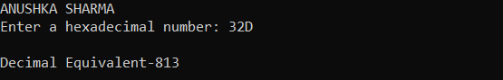

WAP to print Fibonacci sequence upto n terms

#include <stdio.h>

int main() {

printf("ANUSHKA SHARMA\n");

int i, n;

int t1 = 0, t2 = 1;

int nextTerm = t1 + t2;

printf("Enter the number of terms: ");

scanf("%d", &n);

printf("Fibonacci Series: %d %d ", t1, t2);

for (i = 3; i <= n; ++i) {

printf("%d\t", nextTerm);

t1 = t2;

t2 = nextTerm;

nextTerm = t1 + t2;

}

return 0;

}

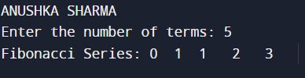

Write a C program to find the roots of quadratic equations.

#include <math.h>

#include <stdio.h>

int main()

{

printf("ANUSHKA SHARMA");

double a, b, c, discriminant, root1, root2, realPart, imagPart;

printf("\nEnter coefficients a, b and c: ");

scanf("%lf %lf %lf", &a, &b, &c);

discriminant = b * b - 4 * a * c;

if (discriminant > 0)

{

root1 = (-b + sqrt(discriminant)) / (2 * a);

root2 = (-b - sqrt(discriminant)) / (2 * a);

printf("\nroot1 = %.2lf and root2 = %.2lf", root1, root2);

}

else if (discriminant == 0)

{

root1 = root2 = -b / (2 * a);

printf("\nroot1 = root2 = %.2lf;", root1);

}

else

{

realPart = -b / (2 * a);

imagPart = sqrt(-discriminant) / (2 * a);

printf("\nroot1 = %.2lf+%.2lfi and root2 = %.2f-%.2fi", realPart, imagPart, realPart, imagPart);

}

return 0;

}

OUTPUT

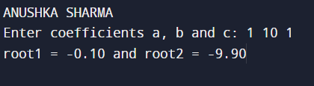

WAP to calculate area of figures using functions

#include <stdio.h>

float areaofTriangle(float h1,float b1)

{

return 0.5*h1*b1;

}

float areaofSq(float s)

{

return s*s;

}

float areaofrect(float l,float b)

{

return l*b;

}

float areaofcir(float r)

{

return 3.14*r*r;

}

int main()

{

int n;

float area,x,y;

printf("Enter 1 for triangle, 2 for Square,3 for Rectangle and 4 for circle:-");

scanf("%d",&n);

if(n==1)

{

printf("Enter height and base of Triangle\n");

scanf("%f %f",&x,&y);

area=areaofTriangle(x,y);

}

else if(n==2)

{

printf("Enter side of Square\n");

scanf("%f",&x);

area=areaofSq(x);

printf("AREA OF SQUARE IS %f",area);

}

else if(n==3)

{

printf("Enter length and breadth of Rectangle\n");

scanf("%f %f",&x,&y);

area=areaofrect(x,y);

printf("AREA OF RECTANGLE IS %f",area);

}

else if(n==4)

{

printf("Enter radius of Circle\n");

scanf("%f ",&x);

area=areaofcir(x);

printf("AREA OF CIRCLE IS %f",area);

}

else

printf("\n WRONG INPUT");

return 0;

}

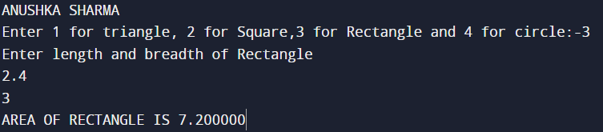

WAP to add two matrices

#include<stdio.h>

int main()

{

int s,t,A[100][100],B[100][100];

printf("ENTER SIZE OF MATRIXES:");

scanf("%d\n",&s);

scanf("%d\n",&t);

printf("Enter elements of 1st matrix\n");

for(int i=0;i<s;i++)

{

for(int j=0;j<t;j++)

{

scanf("%d",&A[i][j]);

}

}

printf("Enter elements of 2nd matrix\n");

for(int a=0;a<s;a++)

{

for(int b=0;b<t;b++)

{

scanf("%d",&B[a][b]);

}

}

int C[100][100];

for(int i=0;i<s;i++)

{

for(int j=0;j<t;j++)

{

C[i][j]=A[i][j]+B[i][j];

}

}

for(int i=0;i<s;i++)

{

for(int j=0;j<t;j++)

{

printf("%d\t",C[i][j]);

}

printf("\n");

}

return 0;

}

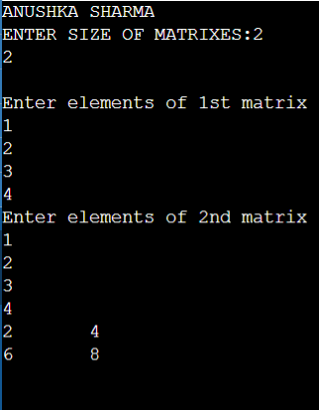

WAP to find one’s complement

include<stdio.h>

int main()

{

printf(“ANUSHKA SHARMA\n”);

char s[100];

printf(“Enter the binary number\n”);

scanf(“%s”,&s);

int t=(int)s;

int c;

c=0;

while(t>0)

{

c++;

t=t/10;

}

printf(“ONE’S COMPLEMENT:”);

for(int i=0;i<c;i++)

{

if(s[i]==0)

printf(“1”);

else

printf(“0”);

}

}

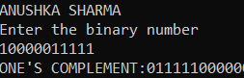

WAP to find two’s complement

#include<stdio.h>

#include<stdlib.h>

#define SIZE 8

int main(){

printf("ANUSHKA SHARMA");

int i, carry = 1;

char num[SIZE + 1], one[SIZE + 1], two[SIZE + 1];

printf("\nEnter the binary number-");

scanf("%s",&num);

for(i = 0; i < SIZE; i++){

if(num[i] == '0'){

one[i] = '1';

}

else if(num[i] == '1'){

one[i] = '0';

}

}

one[SIZE] = '\0';

printf("\nOnes' complement of binary number %s is %s",num, one);

for(i = SIZE - 1; i >= 0; i--){

if(one[i] == '1' && carry == 1){

two[i] = '0';

}

else if(one[i] == '0' && carry == 1){

two[i] = '1';

carry = 0;

}

else{

two[i] = one[i];

}

}

two[SIZE] = '\0';

printf("\nTwo's complement of binary number %s is %s",num, two);

return 0;

}

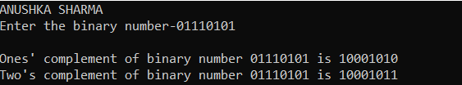

WAP to find Maximum of 2 numbers

#include<stdio.h>

int main()

{

int n1,n2;

printf(“ANUSHKA SHARMA”);

printf(“\nEnter 2 numbers-”);

scanf(“%d”,&n1);

scanf(“%d”,&n2);

if(n1>n2)

printf(“Greatest number is %d”,n1);

else

printf(“Greatest number is %d”,n2);

return 0;

}

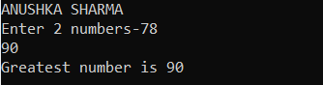

WAP to find Maximum of 3 numbers

#include<stdio.h>

int main()

{

int n1,n2,n3;

printf(“ANUSHKA SHARMA”);

printf(“\nEnter 3 numbers-”);

scanf(“%d”,&n1);

scanf(“%d”,&n2);

scanf(“%d”,&n3);

if(n1>n2)

{

if(n1>n3)

printf(“\nGreatest number is %d”,n1);

else

printf(“\nGreatest number is %d”,n3);

}

else

{  
 if(n2>n3)

printf(“\nGreatest number is %d”,n2);

else

printf(“\nGreatest number is %d”,n3);

return 0;

}

}

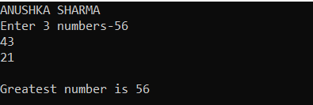

WAP to check if number is positive,negative or zero.

#include<stdio.h>

int main()

{

int n;

printf(“ANUSHKA SHARMA”);

printf(“\nEnter a number”);

scanf(“%d”,&n);

if(n>0)

printf(“\nPOSITIVE NUMBER”);

else if(n<0)

printf(“\NEGATIVE NUMBER”);

else

printf(“\n ZERO ENTERED”);

return 0;

}

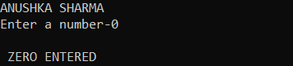

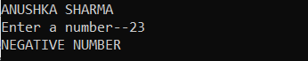

WAP to check if a number is Divisible by 5 and 11 or not.

#include<stdio.h>

int main()

{

printf(“ANUSHKA SHARMA”);

int n;

printf(“\nEnter a number-”);

scanf(“%d”,&n);

if(n%5==0&&n%11==0)

printf(“\n%d is divisible by both 5 and 11”,n);

else

printf(“\n%d is not divisible by both 5 and 11”,n);

return 0;

}

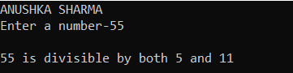

WAP to check if number is even or odd.

#include<stdio.h>

int main()

{

printf(“ANUSHKA SHARMA”);

int n;

printf(“\nENTER A NUMBER-”);

scanf(“%d”,&n);

if(n%2==0)

printf(“NUMBER IS EVEN”);

else

printf(“NUMBER IS ODD”);

return 0;

}

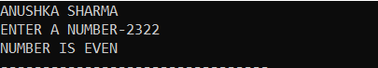

WAP to check if entered year is leap year or not

#include<stdio.h>

int main()

{  
int y;

printf(“ANUSKHA SHARMA”);

printf(“\nEnter the year-”);

scanf(“%d”,&y);

if(y%100==0)

{

if(y%40==0)

printf(“\nLEAP YEAR”);

else

printf(“\nNOT LEAP YEAR”);

}

else

{

if(y%4==0)

printf(“\nLEAP YEAR”);

else

printf(“\nNOT LEAP YEAR”);

}

return 0;

}

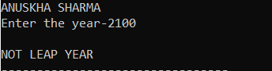

WAP to check if entered character is alphabet or not

#include<stdio.h>

int main()

{  
char c;

printf(“ANUSHKA SHARMA”);

printf(“\nEnter a Character-”);

scanf(“%c”,&c);

if((c<=90&&c>=65)||(c<=122&&c>=97))

printf(“\nThe character is alphabet”);

else

printf(“\nThe character is not alphabet”);

return 0;

}

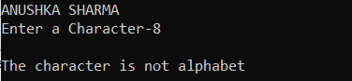

WAP to check whether entered character is vowel or consonant

#include<stdio.h>

int main()

{

char c;

printf(“ANUSHKA SHARMA”);

printf(“\nEnter an Alphabet”);

scanf(“%c”,&c);

if(c==‘a’||c== ‘e’||c== ‘i’||c== ‘o’||c== ‘u’|| c==‘A’||c== ‘I’||c== ‘O’||c== ‘E’|| c==‘U’)

printf(“CHARACTER IS A VOWEL”);

else

printf(“CHARACTER IS A CONSONANT”);

return 0;

}

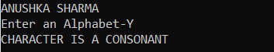

WAP to check if entered character is alphabet,digit or special character

#include<stdio.h>

int main()

{

printf(“ANUSHKA SHARMA”);

char c;

printf(“\nENTER THE CHARACTER-”);

scanf(“%c”,&c);

if(c<58&&c>47)

printf(“\nCHARACTER IS DIGIT”);

else if((c<=90&&c>=65)||(c<=122&&c>=97))

printf(“\nCHARACTER IS AN ALPHABET”);

else

printf(“\nCHARACTER IS SPECIAL CHARACTER”);

return 0;

}

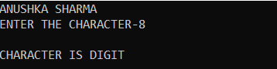

WAP to check is entered character is in Lower Case or in Upper Case

#include<stdio.h>

int main()

{

char c;

printf(“ANUSHKA SHARMA”);

printf(“\nEnter an Alphabet”);

scanf(“%c”,&c)

if(c>64&&c<91)

printf(“\nCharacter is in Upper case”);

else

printf(“\n Character is Lower case”);

return 0;

}

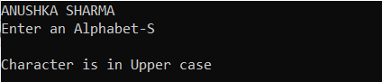

WAP to input a week number and print week day

#include<stdio.h>

int main()

{

printf(“ANUSHKA SHARMA”);

int d;

printf(“\nEnter week day”);

scanf(“%d”,&d);

if (d==1)

printf(“\nMONDAY”);

else if (d==2)

printf(“\nTUESDAY”);

else if (d==3)

printf(“\nWEDNESDAY”);

else if (d==4)

printf(“\nTHURSDAY”);

else if (d==5)

printf(“\nFRIDAY”);

else if (d==6)

printf(“\nSATURDAY”);

else if(d==7)

printf(“\nSUNDAY”);

else

printf(“\nINVALID INPUT”);

return 0;

}

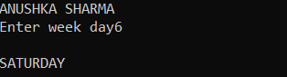

WAP to input month number and print number of days in that month

#include<stdio.h>

int main()

{

printf(“ANUSHKA SHARMA”);

int n;

printf(“\nEnter Month Number”);

scanf(“%d”,&n);

if(n==1)

printf(“\n31 Days”);

if(n==1)

printf(“\n29 Days in Leap Year 28 Days in Non-Leap Year”);

else if(n==3)

printf(“\n31 Days”);

else if(n==4)

printf(“\n30 Days”);

else if(n==5)

printf(“\n31 Days”);

else if(n==6)

printf(“\n30 Days”);

else if(n==7)

printf(“\n31 Days”);

else if(n==8)

printf(“\n31 Days”);

else if(n==9)

printf(“\n30 Days”);

else if(n==10)

printf(“\n31 Days”);

else if(n==11)

printf(“\n30 Days”);

else if(n==12)

printf(“\n31 Days”);

else

printf(“\nInvalid Input”);

return 0;

}

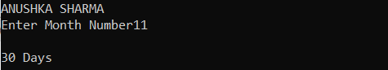

WAP to calculate Profit and loss

#include<stdio.h>

int main()

{

printf(“ANUSHKA SHARMA”);

int sp,cp;

printf(“\nEnter Selling price and Cost price”);

scanf(“%d”,&sp);

scanf(“%d”,&cp);

if(cp>sp)

{

printf(“\nLOSS INCURRED OF ₹%d”,cp-sp);

}

else if(sp>cp)

printf(“\nPROFIT GAINED OF ₹%d”,sp-cp);

else

printf(“\nNO PROFIT NO LOSS”);

return 0;

}

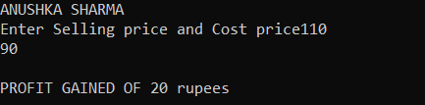

WAP to input all Angles of Triangle and check whether Triangle is Valid or not

#include<stdio.h>

int main()

{

printf(“ANUSHKA SHARMA”);

int a,b,c;

printf(“\nEnter all 3 Angles”);

scanf(“%d %d %d”,&a,&b,&c);

if(a+b+c==180)

printf(“\nVALID TRIANGLE”);

else

printf(“\n INVALID TRIANGLE”);

return 0;

}

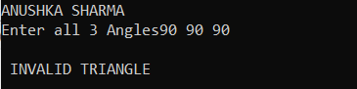

WAP to input all sides of Triangle and check if it is valid or not

#include<stdio.h>

int main()

{

printf(“ANUSHKA SHARMA”);

int a,b,c;

printf(“\nEnter all 3 Sides”);

scanf(“%d %d %d”,&a,&b,&c);

if(a+b>c&&b+c>a&&a+c>b)

printf(“\nVALID TRIANGLE”);

else

printf(“\n INVALID TRIANGLE”);

return 0;

}

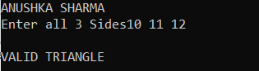

WAP to check if triangle is Equilateral,Isosceles or Scalene

#include<stdio.h>

int main()

{

printf(“ANUSHKA SHARMA”);

int a,b,c;

printf(“Enter sides of Triangle”);

scanf(“%d %d %d”,&a,&b,&c);

if(a==b&&b==c&&c==a)

printf(“\nEquilateral Triangle”);

else if ((a==b&&a!=c)||(a==c&&a!=b)||(b==c&&b!=a))

printf(“\nIsosceles Triangle”);

else

printf(“\nScalene Triangle”);

return 0;

}

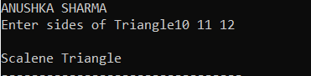

WAP to input marks of 5 subjects Physics,Chemistry ,Biology ,Maths and Computer and calculate percentage and grade accordingly

Percentage>=90% Grade A

Percentage>=80% Grade B

Percentage>=70% Grade C

Percentage>=60% Grade D

Percentage>=40% Grade E

Percentage<40% Grade F

#include<stdio.h>

int main()

{

printf("ANUSHKA SHARMA");

float p,c,m,b,cs;

printf("\nEnter Marks of all 5 subjects-");

scanf("%f %f %f %f %f",&p,&c,&m,&b,&cs);

float per;

char g;

per=p+c+m+b+cs;

per=(per*100)/500;

if(per>=90)

g='A';

else if(per>=80&&per<90)

g='B';

else if(per>=70&&per<80)

g='C';

else if(per>=60&&per<70)

g='D';

else if(per>=40&&per<60)

g='E';

else

g='F';

printf("\nPERCENTAGE-:%f GRADE-:%c",per,g);

return 0;

}

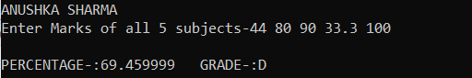

Electricity Bill

#include<stdio.h>

int main()

{

printf("ANUSHKA SHARMA");

int u;

float bill=0.0;

printf("\nEnter Units Consumed-");

scanf("%d",&u);

if(u<=50)

{

bill=u*0.5;

bill=bill+0.2*bill;

}

else if(u<151)

{

bill=50*0.5+(u-50)*0.75;

bill=bill+0.2*bill;

}

else if(u<251)

{

bill=50*0.5+100*0.75+(u-150)*1.20;

bill=bill+0.2*bill;

}

else

{

bill=50*0.5+100*.75+100*1.20+(u-250)*1.5;

bill=bill+bill*0.2;

}

printf("\nTOTAL BILL is %f",bill);

return 0;

}

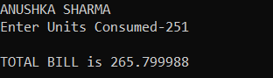

Salary Calculation

#include<stdio.h>

int main()

{

printf("ANUSHKA SHARMA");

int u;

float hra,da;

float ts=0.0;

printf("\nEnter Basic Salary-");

scanf("%d",&u);

if(u<=10000)

{

ts=u+0.2*u+0.8*u;

}

else if(u<=20000&&u>10000)

{

ts=u+u*0.25+0.9*u;

}

else

{

ts=u+0.3*u+0.95*u;

}

printf("\nTOTAL SALARY is %f",ts);

return 0;

}

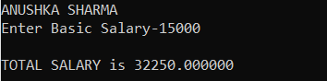

WAP to convert specified days into years,weeks and days.

#include<stdio.h>

int main()

{

printf("ANUSHKA SHARMA");

int days,years,weeks;

printf("\nEnter Days-");

scanf("%d",&days);

years=days/365;

weeks=(days%365)/7;

days=days-(years*365)-(weeks*7);

printf("\nYEARS=%d WEEKS=%d DAYS=%d",years,weeks,days);

return 0;

}

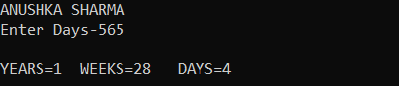

WAP to print pyramid star pattern

#include<stdio.h>

int main()

{

int i,space,r,k;

k=0;

printf("ANUSHKA SHARMA\n");

printf("Enter number of rows");

scanf("%d",&r);

printf("\n");

for(i=1;i<=r;i++,k=0)

{

for(space=1;space<=r-i;++space++)

{

printf(" ");

}

while(k!=2*i-1)

{

printf("*");

++k;

}

printf("\n");

}

return 0;

}

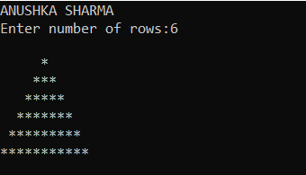

WAP to print hollow pyramid pattern

#include<stdio.h>

int main()

{

int i,space,r,k;

k=0;

printf("ANUSHKA SHARMA\n");

printf("Enter number of rows:");

scanf("%d",&r);

printf("\n");

for(i=1;i<=r;i++,k=0)

{

for(space=1;space<=r-i;++space)

{

printf(" ");

}

if(i!=r)

{

while(k!=2*i-1)

{

if(k==0||k==(2*i-2))

{

printf("*");

}

else

printf(" ");

++k;

}

}

else

{

while(k!=2*i-1)

{

printf("*");

++k;

}

}

printf("\n");

}

return 0;

}

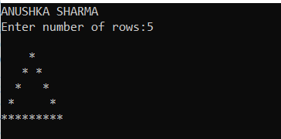

WAP to print inverted pyramid star pattern

#include <stdio.h>

int main()

{

int r, i, j, space;

printf("ANUSHKA SHARMA\n");

printf("Enter number of rows:");

scanf("%d",&r);

printf("\n");

for (i = r; i >= 1; --i)

{

for (space = 0;

space < r - i; ++space)

printf(" ");

for (j = i; j <= 2 * i - 1; ++j)

printf("* ");

for (j = 0; j < i - 1; ++j)

printf("* ");

printf("\n");

}

return 0;

}

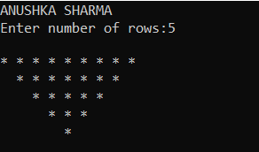

WAP to print hollow inverted pyramid star pattern

#include <stdio.h>

void pattern_fun(int row)

{

for (int j = 1; j <= row; j++)

{

for (int sp = 1; sp <= j - 1; sp++)

{

printf(" ");

}

int last_col = (row * 2 - (2 * j - 1));

for (int k = 1; k <= last_col; k++)

{

if (j == 1 || k == 1)

printf("*");

else if (k == last_col)

printf("*");

else

printf(" ");

}

printf("\n");

}

}

int main()

{

int row ;

printf("ANUSHKA SHARMA\n");

printf("Enter number of rows:");

scanf("%d",&row);

printf("\n");

pattern_fun(row);

return 0;

}

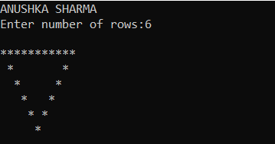

WAP to print diamond pattern

#include <stdio.h>

int main()

{

int n, c, k, space = 1;

printf("ANUSHKA SHARMA\n");

printf("Enter number of rows\n");

scanf("%d", &n);

space = n - 1;

for (k = 1; k <= n; k++)

{

for (c = 1; c <= space; c++)

printf(" ");

space--;

for (c = 1; c <= 2*k-1; c++)

printf("*");

printf("\n");

}

space = 1;

for (k = 1; k <= n - 1; k++)

{

for (c = 1; c <= space; c++)

printf(" ");

space++;

for (c = 1 ; c <= 2*(n-k)-1; c++)

printf("*");

printf("\n");

}

return 0;

}

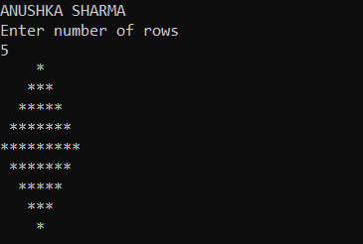

WAP to print number patterns

NUMBER PATTERN 1

#include <stdio.h>

int main()

{

printf("ANUSHKA SHARMA\n");

int r,c;

int k=1;

printf ("ENTER NUMBER OF ROWS AND COLUMNS:");

scanf("%d",&r);

scanf("%d",&c);

for(int i=i;i<=r;i++)

{

for(int j=1;j<=c;j++)

printf("%d",k);

printf("\n");

}

return 0;

}

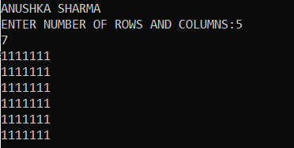

NUMBER PATTERN 2

#include <stdio.h>

int main()

{

printf("ANUSHKA SHARMA\n");

int r,c;

int k=1;

int l=0;

printf ("ENTER NUMBER OF ROWS AND COLUMNS:");

scanf("%d",&r);

scanf("%d",&c);

for(int i=i;i<=r;i++)

{

for(int j=1;j<=c;j++)

{

if(i%2==1)

printf("%d",k);

else

printf("%d",l);

}

printf(“\n”);

}

return 0;

}

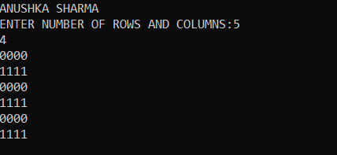

NUMBER PATTERN 3

#include <stdio.h>

int main()

{

printf("ANUSHKA SHARMA\n");

int r,c;

int k=1;

int l=0;

printf ("ENTER NUMBER OF ROWS AND COLUMNS:");

scanf("%d",&r);

scanf("%d",&c);

for(int i=i;i<=r;i++)

{

for(int j=1;j<=c;j++)

{

if(j%2==0)

printf("%d",k);

else

printf("%d",l);

}

printf("\n");

}

return 0;

}

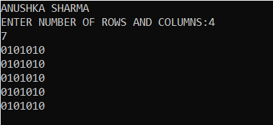

WAP to read n number of values in an array C and display them in reverse order

#include <stdio.h>

int main()

{

int i,n,a[100];

printf("Input the number of elements to store in the array :");

scanf("%d",&n);

printf("Input %d number of elements in the array :\n",n);

for(i=0;i<n;i++)

{

printf("element - %d : ",i);

scanf("%d",&a[i]);

}

printf("\nThe values store into the array are : \n");

for(i=0;i<n;i++)

{

printf("% 5d",a[i]);

}

printf("\n\nThe values store into the array in reverse are :\n");

for(i=n-1;i>=0;i--)

{

printf("% 5d",a[i]);

}

printf("\n\n");

return 0;

}

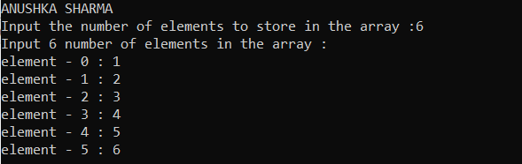

WAP to find sum of all elements of array

#include <stdio.h>

int main()

{

printf("ANUSHKA SHARMA\n");

int n,m,a[100][100];

printf("Input size of the array :");

scanf("%d",&n);

scanf("%d",&m);

printf("\n ENTER VALUES");

for(int i=0;i<n;i++)

{

for (int j=0;j<m;j++)

scanf("%d",&a[i][j]);

}

int sum=0;

for(int i=0;i<n;i++)

{

for(int j=0;j<m;j++)

sum=sum+a[i][j];

}

printf("SUM OF ALL ELEMENTS:%d",sum);

return 0;

}

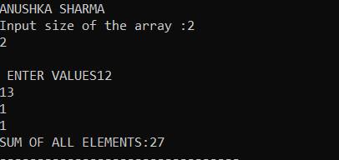

WAP to find maximum and minimum element of array

#include<stdio.h>

int main()

{

int m, n, largest, smallest;

printf("ANUSHKA SHARMA\n");

int largrowloc, largcolumnloc, smallrowloc, smallcolumnloc;

printf("Enter number of row and column: ");

scanf("%d %d",&m,&n);

int arr[m][n], i, j;

for(i=0;i<m;i++)

{

for(j=0;j<n;j++)

{

printf("Enter arr[%d][%d]: ",i,j);

scanf("%d", &arr[i][j]);

}

printf("\n");

}

printf("Entered 2D Array:\n");

for(i=0;i<m;i++)

{

for(j=0;j<n;j++)

{

printf("%d\t",arr[i][j]);

}

printf("\n");

}

largest=arr[0][0];

smallest=arr[0][0];

for(i=0;i<m;i++)

{

for(j=0;j<n;j++)

{

if(largest<arr[i][j])

{

largest=arr[i][j];

largrowloc=i;

largcolumnloc=j;

}

if(smallest>arr[i][j])

{

smallest=arr[i][j];

smallrowloc=i;

smallcolumnloc=j;

}

}

}

printf("\n");

printf("Largest element in array is %d \n", largest);

printf("Smallest element in array is %d\n", smallest);

return 0;

}

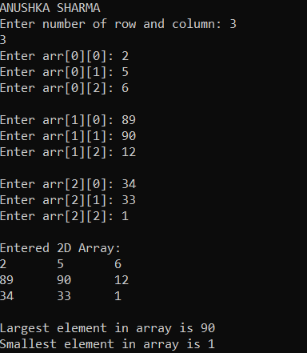

WAP to merge two arrays sorted in descending order

#include <stdio.h>

int main()

{

printf("ANUSHKA SHARMA\n");

int n1,n2,n3;

int a[100], b[100], c[200];

printf("Enter the size of first array: ");

scanf("%d",&n1);

printf("Enter the array elements: ");

for(int i = 0; i < n1; i++)

scanf("%d", &a[i]);

printf("Enter the size of second array: ");

scanf("%d",&n2);

printf("Enter the array elements: ");

for(int i = 0; i < n2; i++)

scanf("%d", &b[i]);

n3 = n1 + n2;

for(int i = 0; i < n1; i++)

c[i] = a[i];

for(int i = 0; i < n2; i++)

c[i + n1] = b[i];

printf("The merged array: ");

for(int i = 0; i < n3; i++)

printf("%d ", c[i]);

printf("\nFinal array after sorting: ");

for(int i = 0; i < n3; i++){

int temp;

for(int j = i + 1; j < n3; j++) {

if(c[i] > c[j]) {

temp = c[i];

c[i] = c[j];

c[j] = temp;

}

}

}

for(int i = 0; i < n3 ; i++)

printf(" %d ",c[i]);

return 0;

}

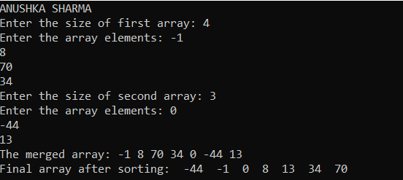

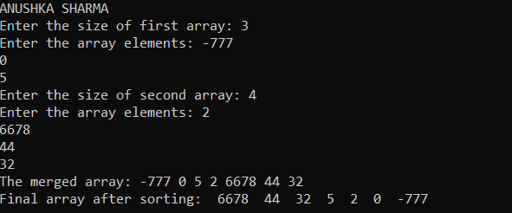

WAP to separate odd and even elements in different arrays

#include <stdio.h>

int main()

{

printf("ANUSHKA SHARMA\n");

int r,c;

int a[100][100], o[100], e[100];

printf("Enter the size of array: ");

scanf("%d",&r);

scanf("%d",&c);

printf("Enter the array elements: ");

for(int i = 0; i < r; i++)

{

for(int j = 0; j < c; j++)

scanf("%d", &a[i][j]);

}

int odd,even;

odd=0;

even=0;

for(int i = 0; i < r; i++)

{

for(int j = 0; j <c; j++)

{

if(a[i][j]%2==0)

{

e[even]=a[i][j];

even++;

}

else

{

o[odd]=a[i][j];

odd++;

}

}

}

for(int i = 0; i <odd; i++)

{

printf("ODD ELEMENTS:%d",o[i]);

printf("\n");

}

for(int i = 0; i <even; i++)

{

printf("EVEN ELEMENTS:%d",e[i]);

printf("\n");

}

return 0;

}

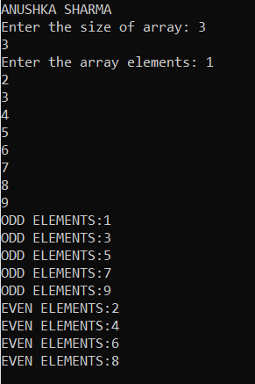

Write a C program to search for an element in an array. Display the position of the element.

#include <stdio.h>

int main ()

{

printf("ANUSHKA SHARMA");

int num[20];

int a, n,c;

c=0;

printf("\nEnter number of elements in an array:-");

scanf("%d", &n);

printf("\nEnter the elements-");

for (int i = 0; i < n; i++)

{

scanf("%d", &num[i]);

}

printf("\nEnter number to be found-");

scanf("%d",&a);

printf("\nThe Array is:");

for (int i = 0; i < n; ++i)

{

printf("\t%d", num[i]);

}

for (int i = 0; i < n; i++)

{

if(a==num[i])

{

c++;

printf("\n %d is found at %d",a,i+1);

}

}

if(c==0)

printf("\nNumber not found");

return 0;

}

OUTPUT

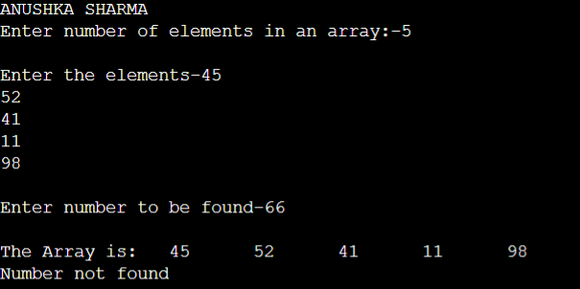

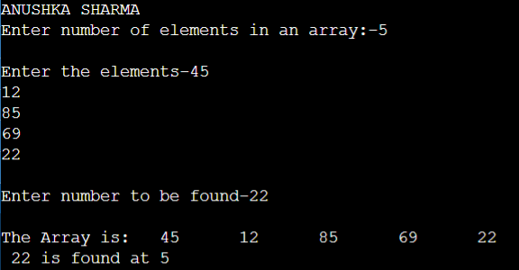

WAP to perform switch case in Arrays

#include <stdio.h>

int main()

{

printf("ANUSHKA SHARMA\n");

int r,c,ch;

int a[100][100], b[100][100];

printf("Enter the size of array: ");

scanf("%d",&r);

scanf("%d",&c);

int c1[r][c];

int c3[r][c];

int c2[r][c];

int transpose[r][c];

printf("Enter the 1st array elements: ");

for(int i = 0; i < r; i++)

{

for(int j = 0; j < c; j++)

scanf("%d", &a[i][j]);

}

printf("Enter the 2nd array elements: ");

for(int i = 0; i < r; i++)

{

for(int j = 0; j < c; j++)

scanf("%d", &b[i][j]);

}

printf("Enter 1 for displaying the array, 2 for multiplication of array,3 for addition,4 for subtraction and 5 for transpose\n");

scanf("%d",&ch);

switch (ch)

{

case 1:

for(int i=0;i<r;i++)

{

for (int j=0;j<c;j++)

{

printf("%d\t",a[i][j]);

}

printf("\n");

}

for(int i=0;i<r;i++)

{

for (int j=0;j<c;j++)

{

printf("%d\t",b[i][j]);

}

printf("\n");

}

break;

case 2:

for(int i=0; i < r; i++)

{

for(int j=0; j < c; j++)

{

c1[i][j] = 0;

for (int k = 0; k < c; k++)

{

c1[i][j] += a[i][k] * b[k][j];

}

}

}

for(int i=0;i<r;i++)

{

for (int j=0;j<c;j++)

{

printf("%d\t",c1[i][j]);

}

printf("\n");

}

break;

case 3:

for(int i=0; i<r; i++)

{

for(int j=0; j<c; j++)

{

// add & store to matrix C

c2[i][j] = a[i][j] + b[i][j];

}

}

for(int i=0;i<r;i++)

{

for (int j=0;j<c;j++)

{

printf("%d\t",c2[i][j]);

}

printf("\n");

}

break;

case 4:

for(int i=0; i<r; i++)

{

for(int j=0; j<c; j++)

{

// add & store to matrix C

c3[i][j] = a[i][j] - b[i][j];

}

}

for(int i=0;i<r;i++)

{

for (int j=0;j<c;j++)

{

printf("%d\t",c3[i][j]);

}

printf("\n");

}

break;

case 5:

for (int i = 0; i < r; i++) {

for (int j = 0; j < c; j++) {

transpose[i][j] = a[j][i];

}

}

for(int i=0;i<r;i++)

{

for (int j=0;j<c;j++)

{

printf("%d\t",transpose[i][j]);

}

printf("\n");

}

}

}

