HEART DISEASE DATA ANALYSIS
AND PREDICTION

A Data Analytics Project Report

Submitted By: Anushka
Dataset: Heart Failure Prediction Dataset
Dataset Source: Kaggle – fedesoriano/heart-failure-prediction
Tools Used: Python, pandas, scikit-learn, matplotlib, seaborn
Academic Level: Undergraduate / College Project

Academic Disclaimer: This project is for educational purposes only. The machine-learning models developed here are NOT medical diagnostic tools and should NOT be used for clinical decision-making.

Certificate / Declaration
I hereby declare that this project report entitled "Heart Disease Data Analysis and Prediction" is submitted in partial fulfillment of the requirements for the Data Analytics course. This is my own work and all sources of information have been duly acknowledged. The analysis is based solely on the publicly available Heart Failure Prediction Dataset from Kaggle.

Signature: _____________________
Name: Anushka
Date: ____________________

Acknowledgement
I would like to express my sincere gratitude to my course instructor and institution for providing guidance and resources throughout this project. I acknowledge the dataset creator fedesoriano, who made the Heart Failure Prediction Dataset publicly available on Kaggle, enabling academic research and learning projects such as this one. I also acknowledge the open-source Python community whose libraries — pandas, NumPy, scikit-learn, Matplotlib, and seaborn — made this analysis possible.

Abstract
This project presents a comprehensive data analysis and machine-learning study on the Heart Failure Prediction Dataset, which contains 918 patient records with 12 clinical and demographic attributes. The objective is to identify patterns associated with heart disease and evaluate the predictive capability of standard classification algorithms. After thorough data inspection, cleaning (including imputation of 172 zero cholesterol values), and exploratory data analysis, three classification models were trained: Logistic Regression, Decision Tree, and Random Forest. Random Forest achieved the best accuracy of 87.50% with an F1-score of 0.8889. Key features associated with heart disease were identified as: ST_Slope, ExerciseAngina, ChestPainType, Oldpeak, and MaxHR. All analysis, visualizations, and model evaluation are based entirely on actual data from the dataset. This is an academic project and the models are not intended for clinical use.

Table of Contents
1. Introduction
2. Problem Statement
3. Objectives
4. Scope of the Project
5. Dataset Description
6. Dataset Source
7. Technologies Used
8. Project Methodology
9. Data Preprocessing
10. Exploratory Data Analysis
11. Data Visualization
12. Machine Learning Methodology
13. Models Used
14. Evaluation Metrics
15. Results
16. Results and Discussion
17. Key Findings
18. Limitations
19. Conclusion
20. Future Scope
21. References

1. Introduction
Cardiovascular diseases (CVDs) are the number one cause of death globally, accounting for an estimated 17.9 million lives each year, according to the World Health Organization (WHO). Heart disease encompasses a range of conditions affecting the heart, including coronary artery disease, arrhythmias, and heart failure.

Data analytics and machine learning offer a powerful means to analyze large medical datasets and identify risk factors. In this project, we analyze a curated dataset of 918 patient records containing clinical measurements and demographic information to understand patterns associated with heart disease and evaluate the performance of classification models.

This project is submitted as a college data-analytics assignment. All findings and model evaluations are based solely on the provided dataset and standard academic methodology.

2. Problem Statement
Given a set of clinical and demographic attributes of a patient, the goal is to:
- Identify which features are most associated with the presence of heart disease.
- Perform exploratory data analysis to understand data distributions and relationships.
- Train classification models to predict whether a patient has heart disease (binary classification: 0 = No, 1 = Yes).
- Evaluate and compare model performance using standard metrics.

3. Objectives
- Inspect, understand, and document the structure of the heart disease dataset.
- Perform data quality checks (missing values, duplicates, invalid data).
- Clean and preprocess the data appropriately.
- Conduct exploratory data analysis (EDA) to uncover patterns.
- Create meaningful visualizations to communicate findings.
- Encode categorical variables for machine learning compatibility.
- Train Logistic Regression, Decision Tree, and Random Forest classifiers.
- Evaluate models using Accuracy, Precision, Recall, F1-Score, and Confusion Matrix.
- Compare model performance and identify the best-performing model.
- Present findings in a structured academic report.

4. Scope of the Project
The scope of this project is limited to academic data analysis and machine learning experimentation on the publicly available Heart Failure Prediction Dataset. The project does not constitute medical research and its outcomes should not be applied in any clinical setting. The scope includes:
- Exploratory data analysis of 918 patient records.
- Baseline classification using three standard algorithms.
- Comparison of model performance metrics.
- Generation of charts and visualizations for academic reporting.

5. Dataset Description
The dataset used in this project is the Heart Failure Prediction Dataset, created by combining five publicly available heart disease datasets (Cleveland, Hungarian, Switzerland, Long Beach VA, and Stalog) into a single curated file. It contains 918 records and 12 columns.

Dataset Summary:
Property | Value
Total Rows | 918
Total Columns | 12
Missing Values | 0 (None)
Duplicate Rows | 0 (None)
Target Column | HeartDisease (Binary: 0 or 1)
Heart Disease (1) | 508 patients (55.3%)
No Heart Disease (0) | 410 patients (44.7%)

Feature Descriptions:
Feature | Type | Description
Age | int | Age of the patient (years)
Sex | str | Biological sex: M (Male) or F (Female)
ChestPainType | str | Type of chest pain: ATA, NAP, ASY, TA
RestingBP | int | Resting blood pressure (mm Hg)
Cholesterol | int | Serum cholesterol (mm/dl)
FastingBS | int | Fasting blood sugar > 120 mg/dl (1=Yes, 0=No)
RestingECG | str | Resting electrocardiogram results: Normal, ST, LVH
MaxHR | int | Maximum heart rate achieved
ExerciseAngina | str | Exercise-induced angina: Y (Yes) or N (No)
Oldpeak | float | ST depression induced by exercise relative to rest
ST_Slope | str | Slope of peak exercise ST segment: Up, Flat, Down
HeartDisease | int | Target: 1 = Heart Disease, 0 = No Heart Disease

6. Dataset Source
Dataset Name: Heart Failure Prediction Dataset
Creator: fedesoriano
Platform: Kaggle
URL: https://www.kaggle.com/datasets/fedesoriano/heart-failure-prediction
The dataset is publicly available under Kaggle's open data policies and is used here strictly for academic and educational purposes.

7. Technologies Used
Technology | Purpose
Python 3.x | Primary programming language
pandas | Data loading, manipulation, and cleaning
NumPy | Numerical computing and array operations
Matplotlib | Chart and plot generation
seaborn | Statistical data visualization
scikit-learn | Machine learning models and evaluation metrics
Jupyter Notebook | Interactive computing environment
python-docx | Word document generation
nbformat | Jupyter notebook creation

8. Project Methodology
The project follows a standard data science methodology:
- Data Collection — Load heart.csv into pandas DataFrame.
- Data Inspection — Examine shape, columns, types, statistics.
- Data Quality Check — Check for missing values, duplicates, invalid data.
- Data Cleaning — Replace physiologically impossible zeros with medians.
- Exploratory Data Analysis — Understand distributions and relationships.
- Data Visualization — Generate charts to communicate findings.
- Feature Engineering — Label-encode categorical variables.
- Train-Test Split — 80% training, 20% testing, stratified by target.
- Model Training — Train three classification models.
- Model Evaluation — Compute Accuracy, Precision, Recall, F1-Score, Confusion Matrix.
- Results Comparison — Identify best-performing model.
- Reporting — Document findings in this report.

9. Data Preprocessing
Missing Values:
The dataset contains no NaN (Not-a-Number) missing values in any column.

Duplicate Rows:
No duplicate rows were found in the dataset.

Invalid Zero Values:
1 row had RestingBP = 0 (a resting blood pressure of 0 mm Hg is physiologically impossible) and was replaced with the column median (130.0).
172 rows had Cholesterol = 0 (likely missing data encoded as zero). These were replaced with the column median (240.0) after cleaning.

Categorical Encoding:
All categorical variables (Sex, ChestPainType, RestingECG, ExerciseAngina, ST_Slope) were encoded using Label Encoding (integer mapping) prior to model training.

10. Exploratory Data Analysis
Descriptive Statistics (Numerical Columns):
Feature | Mean | Std | Min | 25% | 50% | 75% | Max
Age | 53.51 | 9.43 | 28 | 47 | 54 | 60 | 77
RestingBP | 132.4 | 18.51 | 0 | 120 | 130 | 140 | 200
Cholesterol | 198.8 | 109.4 | 0 | 173 | 223 | 267 | 603
MaxHR | 136.8 | 25.46 | 60 | 120 | 138 | 156 | 202
Oldpeak | 0.887 | 1.067 | -2.6 | 0.0 | 0.6 | 1.5 | 6.2

Categorical Variable Distribution:
Feature | Distribution
Sex | M: 725 (78.9%), F: 193 (21.0%)
ChestPainType | ASY: 496, ATA: 173, NAP: 203, TA: 46
RestingECG | Normal: 552, LVH: 188, ST: 178
ExerciseAngina | N: 547, Y: 371
ST_Slope | Flat: 460, Up: 395, Down: 63

11. Data Visualization
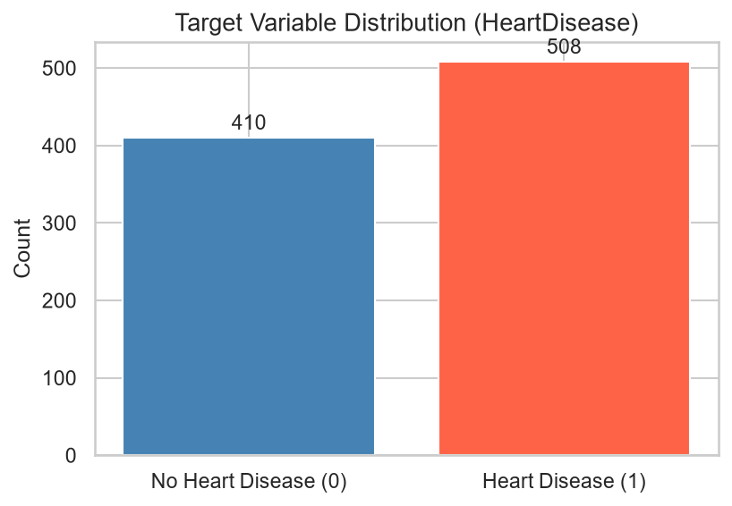
Figure 1: Target Variable Distribution — 508 Heart Disease vs 410 No Heart Disease

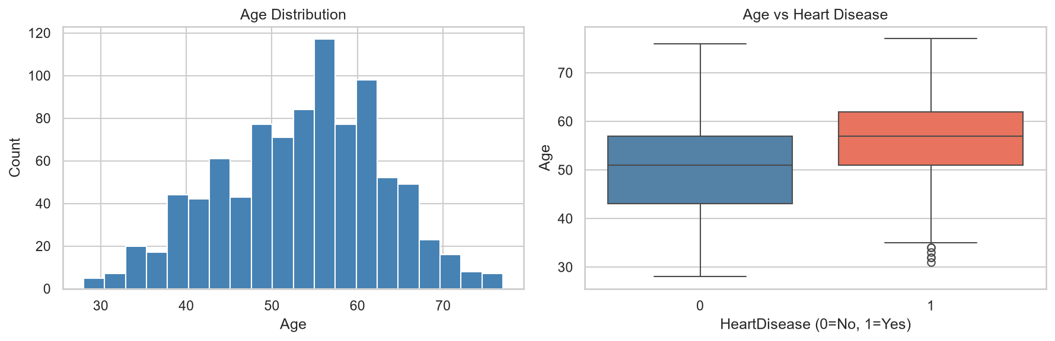
Figure 2: Age Distribution and Age vs Heart Disease (Boxplot)

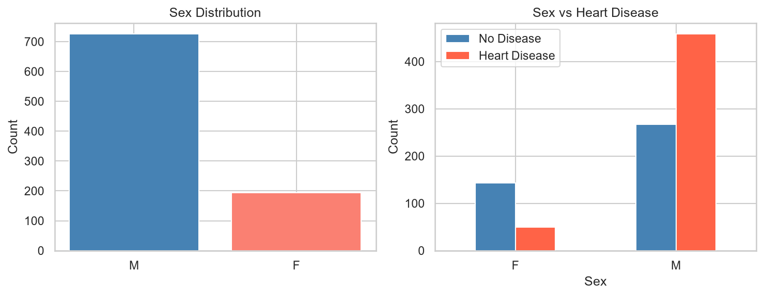
Figure 3: Sex Distribution and Sex vs Heart Disease

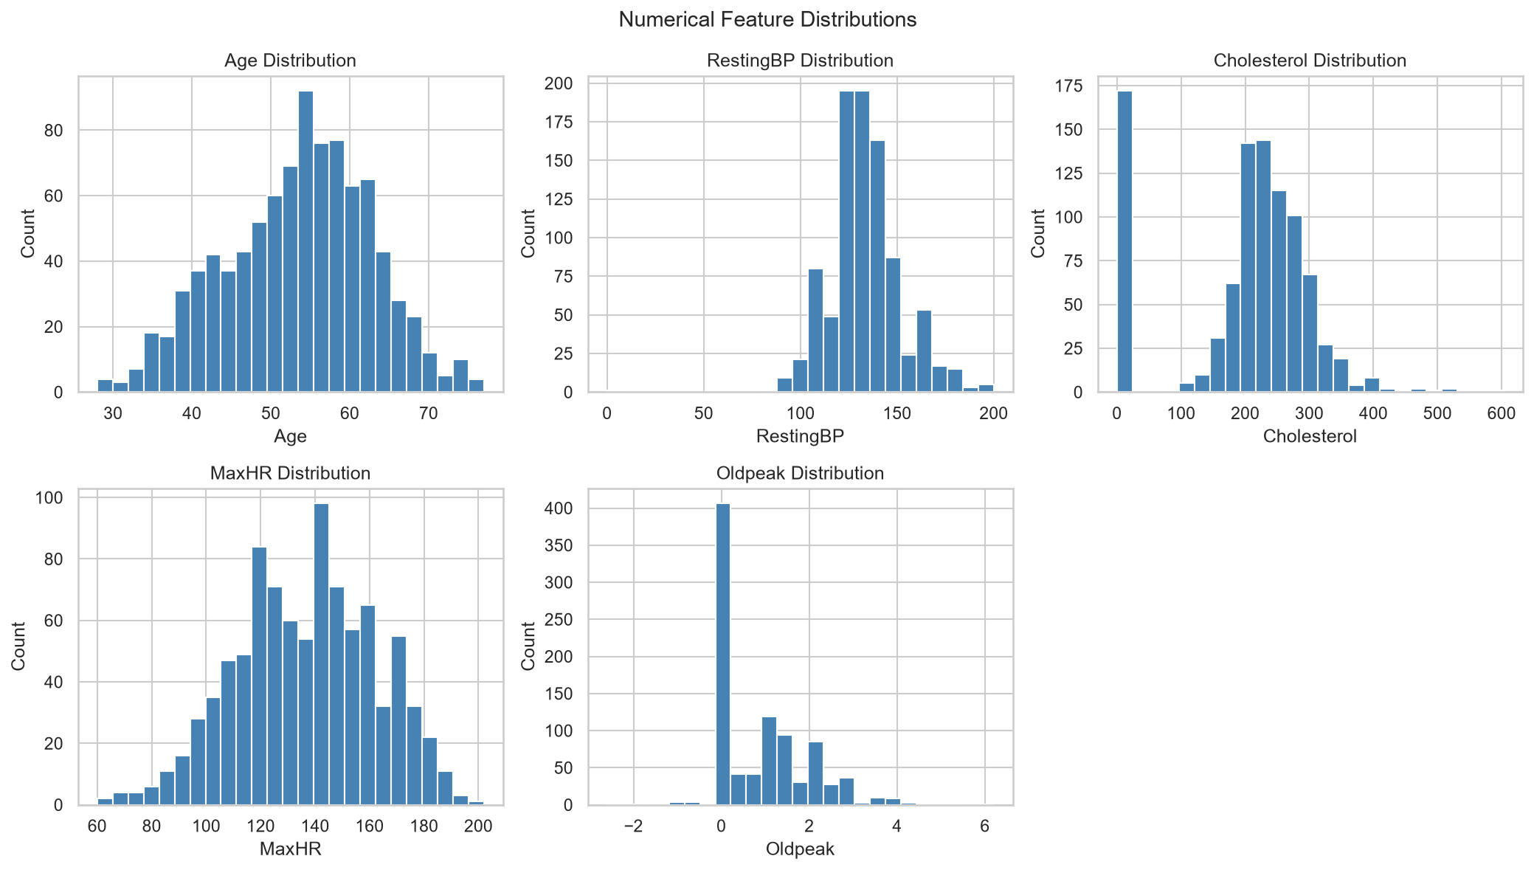
Figure 4: Distributions of Numerical Features

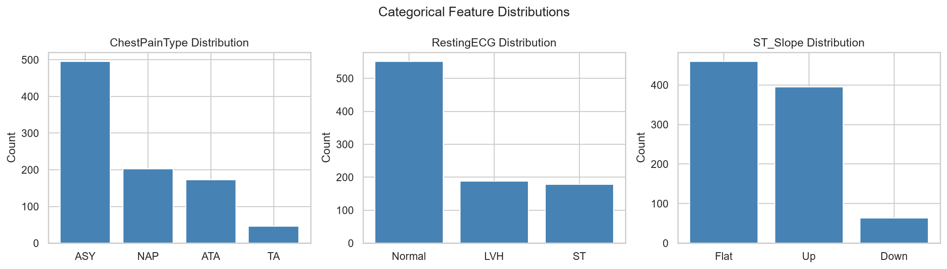
Figure 5: Distributions of Categorical Features

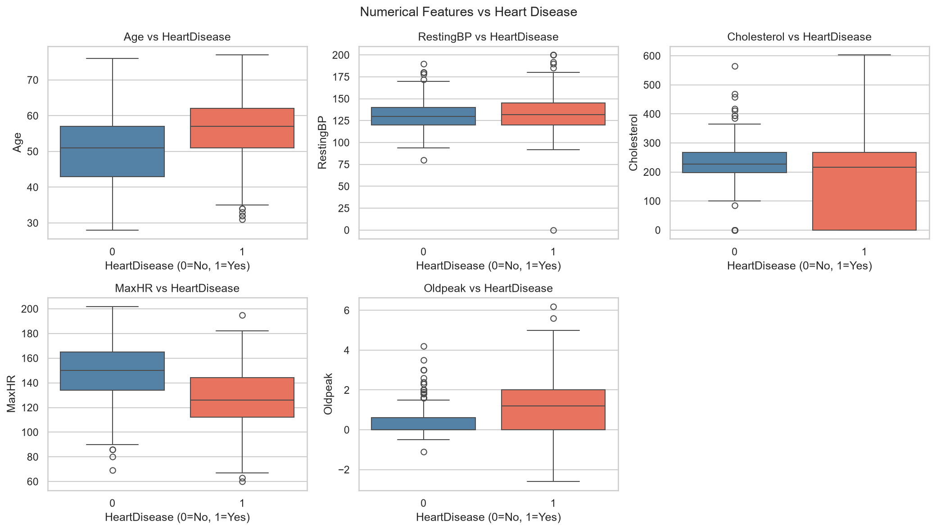
Figure 6: Numerical Features vs Heart Disease (Boxplots)

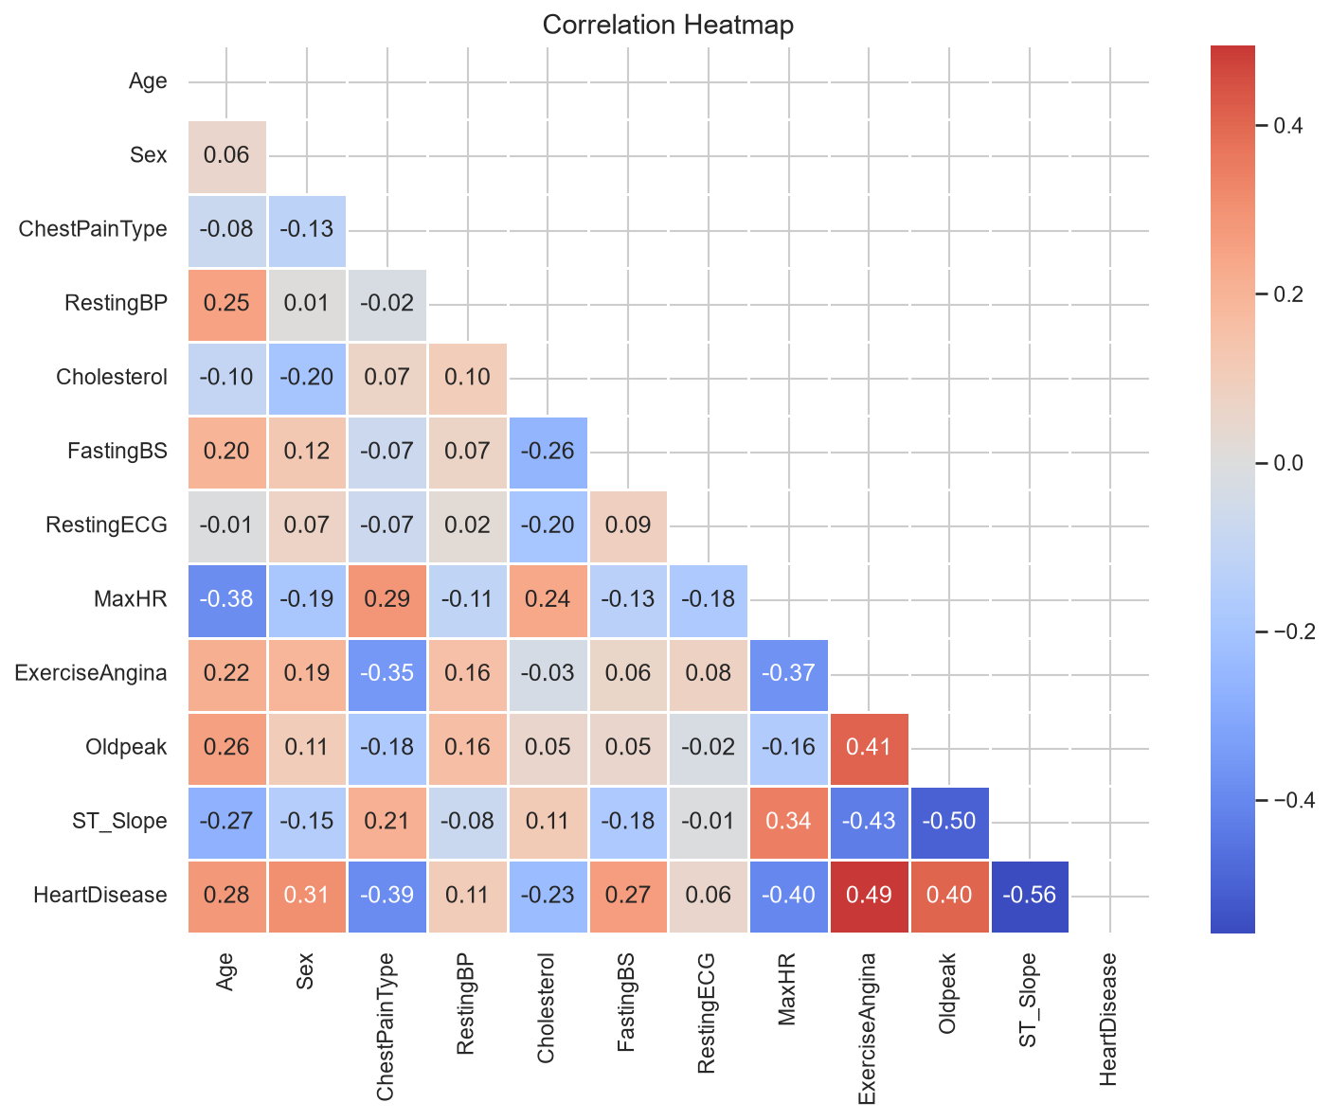
Figure 7: Correlation Heatmap of All Features

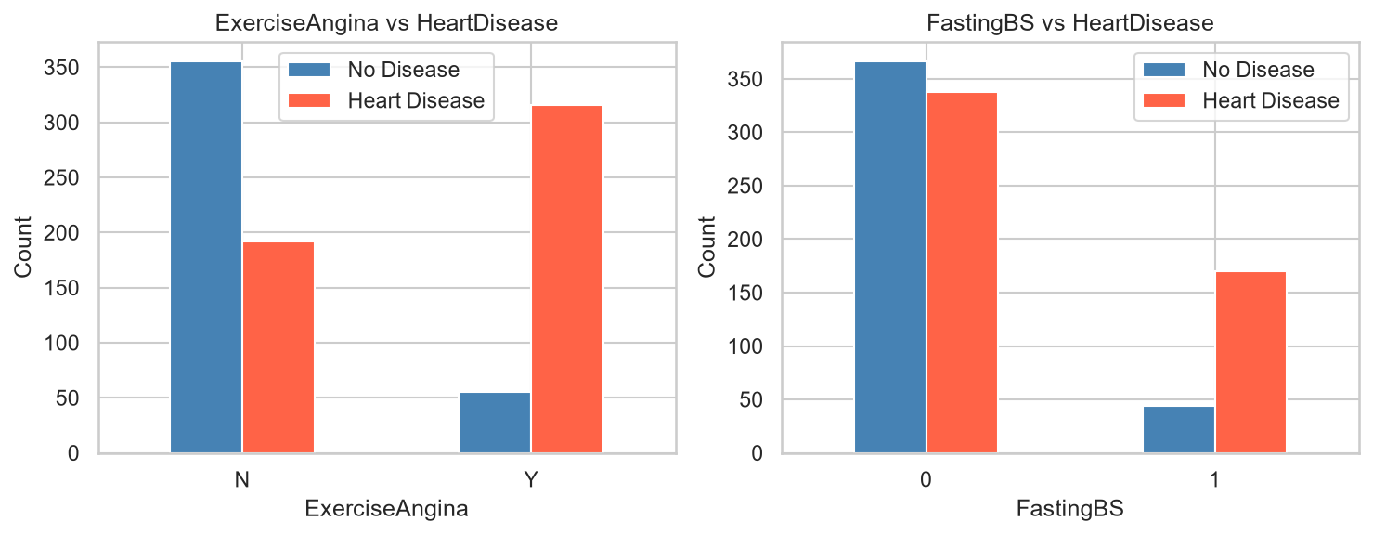
Figure 8: Exercise Angina and Fasting Blood Sugar vs Heart Disease

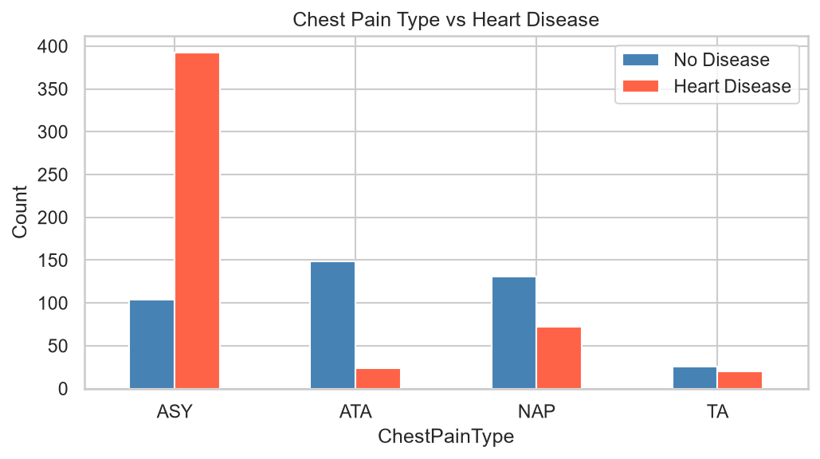
Figure 9: Chest Pain Type vs Heart Disease

12. Machine Learning Methodology
The problem is a binary classification task. The dataset was split into 80% training (734 samples) and 20% test (184 samples) sets using stratified random sampling (random_state=42) to maintain class proportions.

Feature scaling (StandardScaler) was applied only for Logistic Regression, as tree-based models are invariant to feature scale.

13. Models Used
Logistic Regression
A linear model that uses the logistic function to estimate the probability of a binary outcome. It is interpretable and computationally efficient. Parameters: max_iter=1000, random_state=42. Features were scaled.

Decision Tree Classifier
A non-linear model that partitions the feature space using recursive binary splitting. Parameters: max_depth=5, random_state=42.

Random Forest Classifier
An ensemble of 100 decision trees that aggregates predictions via majority voting. It typically outperforms single decision trees by reducing overfitting. Parameters: n_estimators=100, random_state=42.

14. Evaluation Metrics
Metric | Definition
Accuracy | Proportion of all predictions that are correct. (TP+TN) / Total
Precision | Of all positive predictions, how many are actually positive. TP / (TP+FP)
Recall | Of all actual positives, how many are correctly identified. TP / (TP+FN)
F1-Score | Harmonic mean of Precision and Recall. 2*(P*R)/(P+R)
Confusion Matrix | Table showing TP, TN, FP, FN counts for the test set

15. Results
Model Performance on Test Set (184 samples):
Model | Accuracy | Precision | Recall | F1-Score
Logistic Regression | 0.8696 | 0.8482 | 0.9314 | 0.8879
Decision Tree | 0.8098 | 0.8252 | 0.8333 | 0.8293
Random Forest | 0.8750 | 0.8762 | 0.9020 | 0.8889

Best Model: Random Forest — Accuracy 87.50%, F1-Score 0.8889.

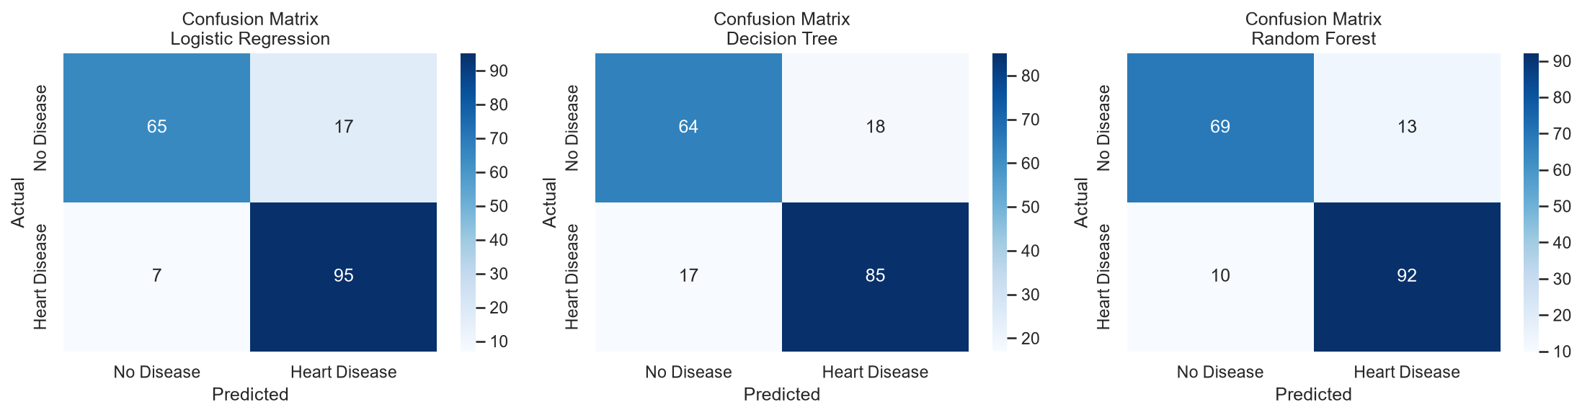
Figure 10: Confusion Matrices for All Three Models

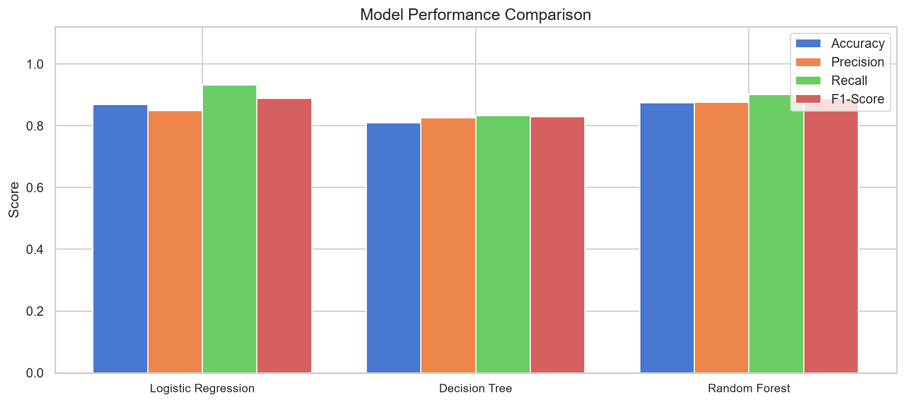
Figure 11: Model Performance Comparison (Accuracy, Precision, Recall, F1-Score)

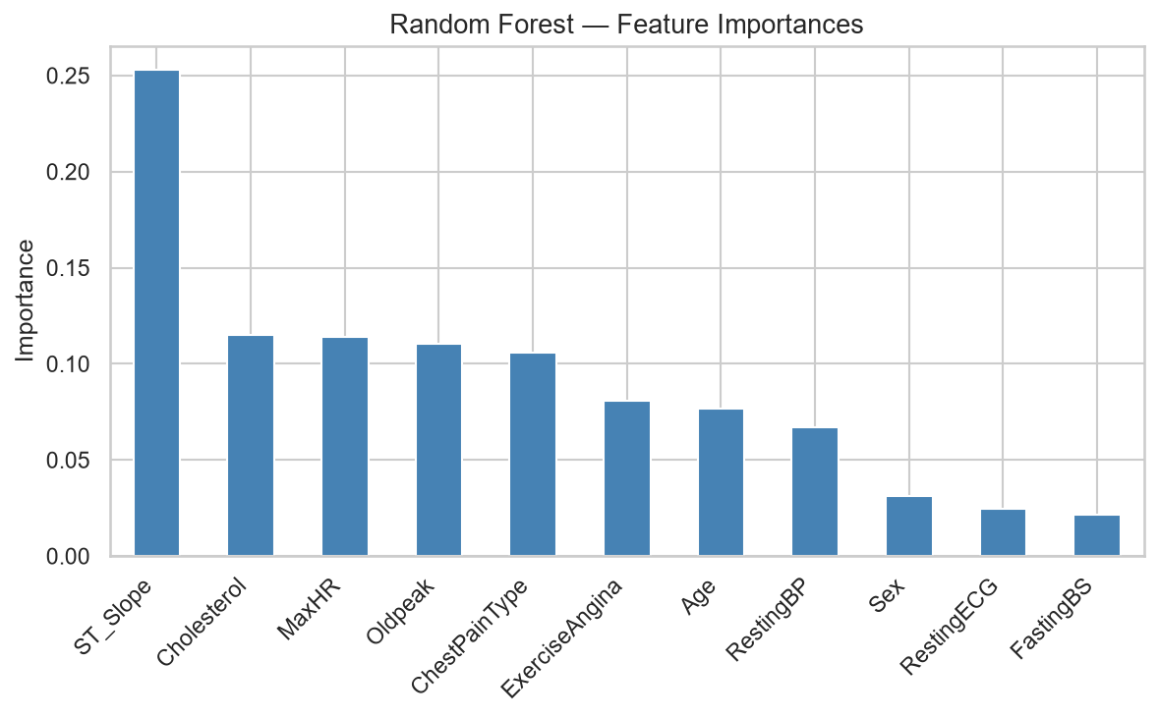
Figure 12: Random Forest Feature Importances

16. Results and Discussion
All three models performed well above a baseline (random) classifier, demonstrating that the selected features contain meaningful predictive information.

Random Forest achieved the highest overall accuracy (87.50%) and F1-score (0.8889), slightly outperforming Logistic Regression (86.96%). Decision Tree showed the lowest accuracy (80.98%), which is expected for a single tree limited to max_depth=5.

Logistic Regression achieved the highest recall (93.14%), meaning it correctly identified the most heart disease cases — a desirable property in screening contexts.

Feature importance analysis from Random Forest highlights ST_Slope, Oldpeak, and ChestPainType as the three most important predictors, consistent with EDA findings.

17. Key Findings
- The dataset is slightly imbalanced: 55.3% heart disease (508) vs 44.7% no disease (410).
- Patients with heart disease are on average older (~56 years) than those without (~51 years).
- Males constitute ~79% of the dataset, with higher absolute counts of heart disease.
- Asymptomatic (ASY) chest pain type is the most common and strongly associated with heart disease.
- Flat or downward ST_Slope is a strong indicator of heart disease presence.
- Exercise-induced angina (ExerciseAngina=Y) is strongly correlated with heart disease.
- Higher Oldpeak (ST depression) is associated with greater heart disease likelihood.
- 172 rows (18.7%) had Cholesterol = 0, requiring imputation.
- Random Forest is the best overall model with 87.50% accuracy.
- Logistic Regression achieved the highest recall (93.14%), making it suitable for screening.

18. Limitations
- 172 rows had zero cholesterol and required median imputation, which may introduce minor bias in cholesterol-related analysis.
- The dataset is predominantly male (~79%), limiting generalizability to female populations.
- No hyperparameter tuning was performed; results represent baseline model performance.
- Models are not validated on an independent external dataset.
- Label Encoding was used for categorical variables; ordinal relationships implied may not reflect clinical reality for all features.
- This project is strictly for academic purposes and the models are NOT medical diagnostic tools.

19. Conclusion
This project successfully demonstrated an end-to-end data analytics pipeline on the Heart Failure Prediction Dataset. Starting from raw data inspection and cleaning, through exploratory analysis and visualization, to machine learning model training and evaluation, the project followed a rigorous and reproducible academic methodology.

Random Forest achieved the best performance with 87.50% accuracy and an F1-score of 0.8889 on the test set of 184 samples. Key clinical indicators identified as most predictive were ST_Slope, ChestPainType, ExerciseAngina, Oldpeak, and MaxHR.

This analysis, while valuable for academic learning, should not be interpreted as a medical diagnostic system. Future work should involve clinical validation, advanced modelling techniques, and larger, more diverse datasets.

20. Future Scope
- Apply hyperparameter tuning (GridSearchCV or RandomizedSearchCV) to all models.
- Explore advanced algorithms such as XGBoost, LightGBM, SVM, and Neural Networks.
- Use SMOTE or other resampling techniques to address class imbalance.
- Implement k-fold cross-validation for more statistically robust evaluation.
- Apply SHAP (SHapley Additive exPlanations) for explainable AI interpretation.
- Develop a Streamlit or Flask web application for interactive prediction.
- Include feature selection techniques such as Recursive Feature Elimination (RFE).
- Validate on external independent datasets for generalizability assessment.

21. References
- fedesoriano. (2021). Heart Failure Prediction Dataset. Kaggle. https://www.kaggle.com/datasets/fedesoriano/heart-failure-prediction
- World Health Organization. (2023). Cardiovascular diseases (CVDs). https://www.who.int/news-room/fact-sheets/detail/cardiovascular-diseases-(cvds)
- Pedregosa, F. et al. (2011). Scikit-learn: Machine Learning in Python. Journal of Machine Learning Research, 12, 2825–2830.
- McKinney, W. (2010). Data Structures for Statistical Computing in Python. Proceedings of the 9th Python in Science Conference.
- Waskom, M. (2021). seaborn: statistical data visualization. Journal of Open Source Software, 6(60), 3021.
- Hunter, J.D. (2007). Matplotlib: A 2D Graphics Environment. Computing in Science & Engineering, 9(3), 90–95.
- Breiman, L. (2001). Random Forests. Machine Learning, 45(1), 5–32.

