**DBMS Mini-project Synopsis**

Division: 1

Batch: T2

Group members:

Anushka Tadphale (111903019)

Haripriya Saraswat (111903034)

1. **Problem statement:**

To create a database management application to maintain the records of a library.

Technologies used:

Frontend: Python(Tkinter)

Backend: Python

Database: MySQL

1. **Objectives:**

A lot of data regarding books is to be stored and maintained properly for the well functioning of a library. This includes metadata about a particular book (the author, publication, number of copies available, genre, etc), details of persons who have borrowed the book, dates of issuing, etc. There needs to be a proper system to manage this data and the transactions done on it. The objectives to be accomplished are:

* To develop a schema for efficient handling of the data.
* To create different interfaces for user and admin
* To provide the admin the facility to add new books, discard existing books from the records, etc
* To provide user a simple interface to see the books available, borrow or search for a book, etc.

1. **Functional requirements:**

* Provide login screen. There should be separate login for admin and user(student).
* Identify users and admins based on their unique ids. (login details for each is to be stored with password and thus validate the login process)
* Users can view different available books and issue them.
* User can add one or more books to his/her favourites list.
* Admin can add or delete books
* Data of Book( unique code, name, author, publisher, location in library, keyword or genre) to be made available

1. **ER Diagram:**

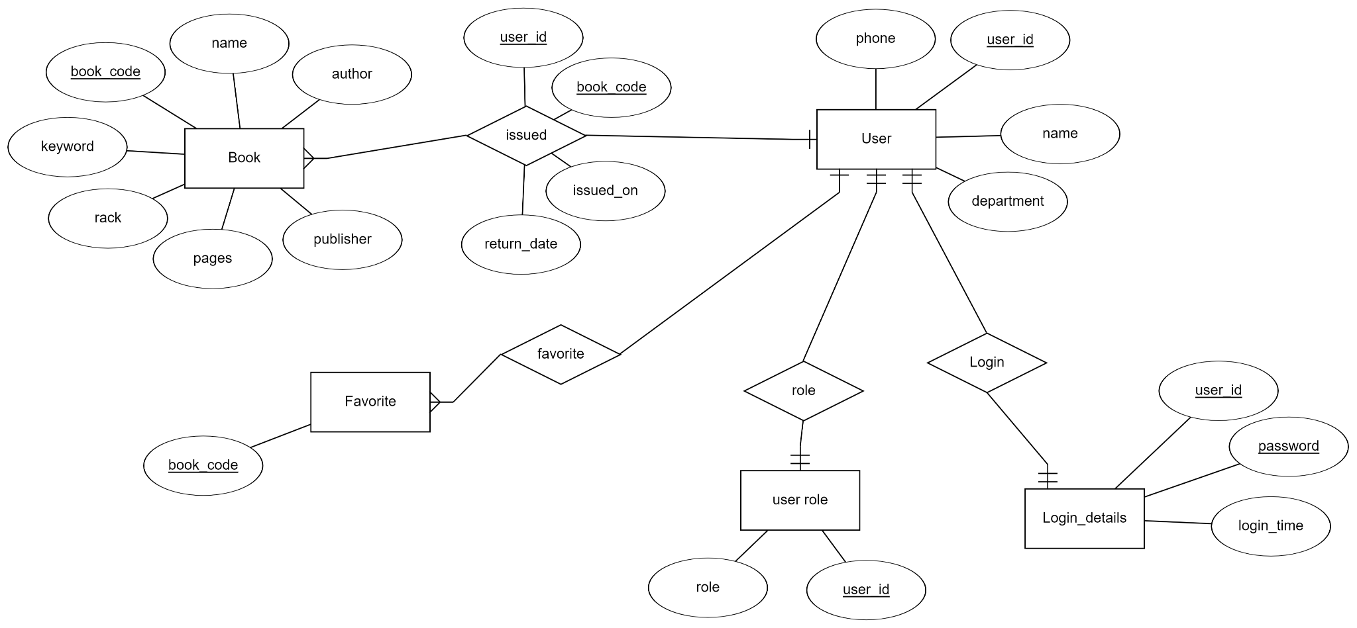

1. **Relational schemas:**

Book(book_code, name, author, publisher, pages, keyword, rack, issued)

Issue(user_id, book_code, issued_on, return_date)

User(user_id, role, name, dept, phone)

Login_details(user_id, password, login_time)

Favorite(user_id, book_code)

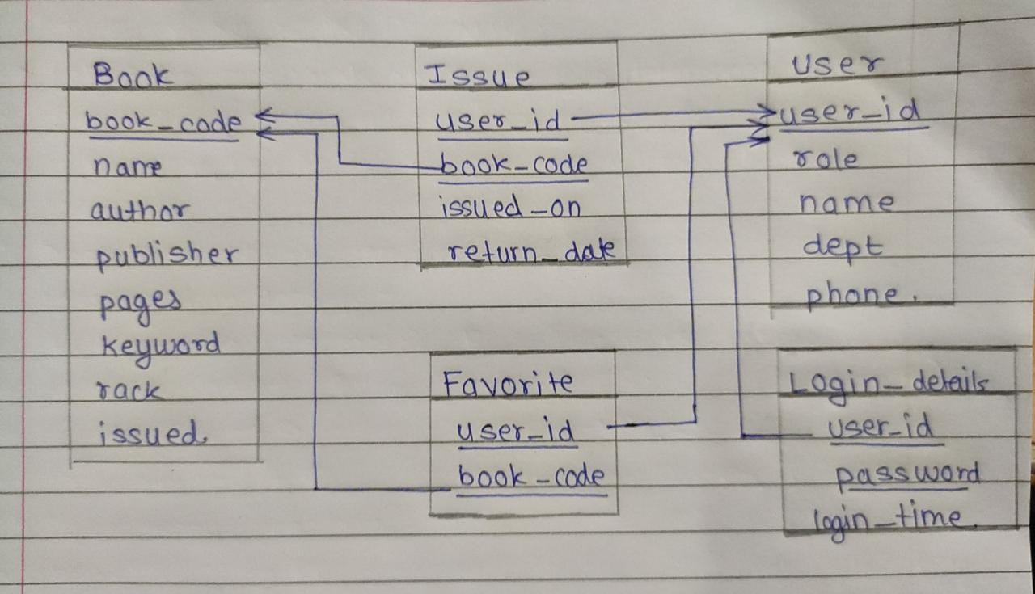

1. **Set of Functional dependencies that must hold on each table.**

(User)user_id → name, dept, role, phone

(Login_details)user_id → password

(Book) book_code → name, author

1. **Each table has to be normalized upto 3NF.**

**Normalised as BCNF and hence satisfy the third normal form(3NF)**