STUDENT PROJECT REPORT
Exploratory Data Analysis
on a Cars Dataset

Details | Information
Student Name | ANUSHKA KIRAN GUNDALE
Batch / Class | October (B)
Submission Date | 19/11/2026
Project Type | Individual project
Dataset | CAR DETAILS FROM CAR DEKHO (1).csv
Dataset Source | https://www.kaggle.com/datasets/nehalbirla/vehicle-dataset-from-cardekho

1. Objective
The objective of this project is to understand a used-car dataset through Exploratory Data Analysis (EDA). The work inspects the dataset, checks data quality, removes duplicate and missing records where applicable, calculates summary statistics, and uses charts to explore patterns in selling price, fuel type, vehicle year, kilometres driven, transmission, and seller type.

Main Questions Explored
- Which fuel type and car name appear most frequently?
- What does the selling-price distribution look like?
- How are vehicle year and kilometres driven related to selling price?
- How do selling prices differ by transmission and seller type?
- Are there potential price outliers and relationships among numerical variables?

2. Dataset Overview
The notebook loads a CSV file named CAR DETAILS FROM CAR DEKHO (1).csv. The initial dataset contains 4,340 rows and 8 columns. Each row represents a car listing with details such as name, year, selling price, kilometres driven, fuel, seller type, transmission, and owner category.
Column | Meaning | Data type in notebook
name | Car name / model | Categorical (object)
year | Year of manufacture | Numerical (int64)
selling_price | Selling price in rupees | Numerical (int64)
km_driven | Kilometres driven | Numerical (int64)
fuel | Fuel type | Categorical (object)
seller_type | Type of seller | Categorical (object)
transmission | Manual or automatic | Categorical (object)
owner | Previous-owner category | Categorical (object)

Variable grouping: Numerical variables are year, selling_price, and km_driven. Categorical variables are name, fuel, seller_type, transmission, and owner.
Sample records include Maruti 800 AC (2007, ₹60,000, 70,000 km), Maruti Wagon R LXI Minor (2007, ₹135,000, 50,000 km), and Hyundai Verna 1.6 SX (2012, ₹600,000, 100,000 km).

3. Data Quality and Cleaning
The notebook checked missing values, duplicate rows, and data types before cleaning. No missing values were found in the initial dataset. However, 763 duplicate rows were identified. The notebook removed duplicate rows and then applied dropna() to remove any rows with missing values.
Check / stage | Result
Rows before cleaning | 4,340
Columns before cleaning | 8
Missing values before cleaning | 0
Duplicate rows before cleaning | 763
Rows after cleaning | 3,577
Rows removed | 763
Missing values after cleaning | 0
Duplicate rows after cleaning | 0

Cleaning decision: Duplicate rows were removed so repeated identical records would not be counted more than once. The notebook did not delete price outliers automatically; it identified potential outliers for inspection. This avoids removing unusual but possibly valid car listings without further evidence.

4. Descriptive Analysis
After cleaning, the dataset contains 3,577 records. The numerical summary from the notebook is shown below.
Statistic | Year | Selling price (₹) | Kilometres driven
Count | 3,577 | 3,577 | 3,577
Mean | 2012.96 | 473,912.54 | 69,250.55
Median (50%) | 2013 | 350,000 | 60,000
Minimum | 1992 | 20,000 | 1
Maximum | 2020 | 8,900,000 | 806,599
Standard deviation | 4.25 | 509,301.80 | 47,579.94

The mean selling price (about ₹4.74 lakh) is higher than the median price (₹3.50 lakh), suggesting that some high-priced cars raise the average. Kilometres driven also varies widely, from 1 km to 806,599 km.

5. Categorical Summary and Visual EDA
The categorical summaries show that Diesel is the most frequent fuel category, Individual is the most frequent seller type, Manual is the most frequent transmission, and First Owner is the most frequent owner category.
Variable | Most frequent category | Count
Car name | Maruti Swift Dzire VDI | 54
Fuel | Diesel | 1,800
Seller type | Individual | 2,832
Transmission | Manual | 3,265
Owner | First Owner | 2,218

Chart 1. Car Selling Price Distribution
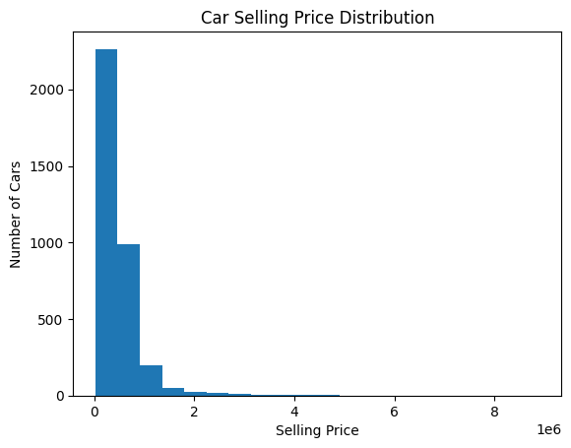
Observation: The histogram displays the distribution of selling prices. Together with the summary statistics, the higher mean than median suggests a right-skewed distribution, with a smaller number of expensive cars.

Chart 2. Cars by Fuel Type
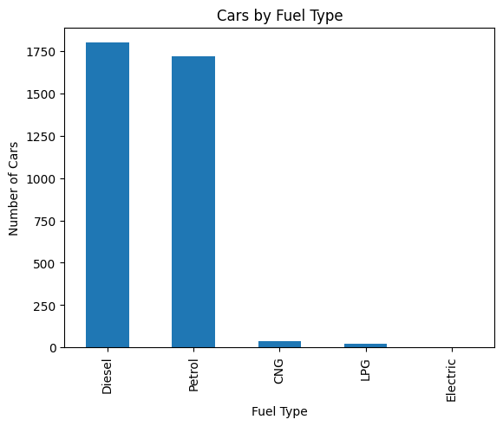
Observation: Diesel (1,800) and Petrol (1,717) account for most cleaned records. CNG (37), LPG (22), and Electric (1) are much less common in this dataset.

6. Visual EDA — Category and Outlier Analysis

Chart 3. Top 10 Car Names
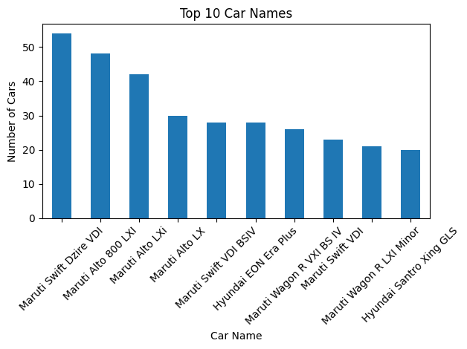
Observation: Maruti Swift Dzire VDI is the most common car name in the cleaned dataset, with 54 records. Several other frequently listed models are also Maruti models.

Chart 4. Box Plot of Car Selling Prices
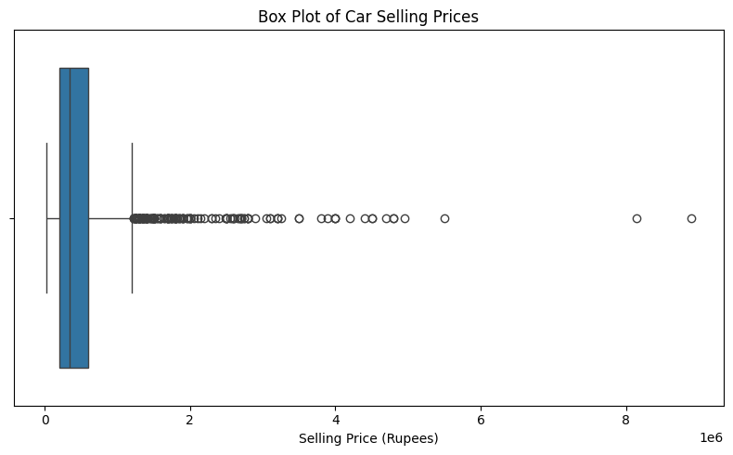
Observation: Using the IQR rule, the notebook calculated a lower limit of −₹400,000 and an upper limit of ₹1,200,000. It identified 170 potential price outliers. The negative lower limit is a mathematical threshold, not a realistic car price; the flagged records are above the upper limit. These records were retained rather than automatically deleted.
7. Visual EDA — Relationships

Chart 5. Vehicle Year vs Selling Price
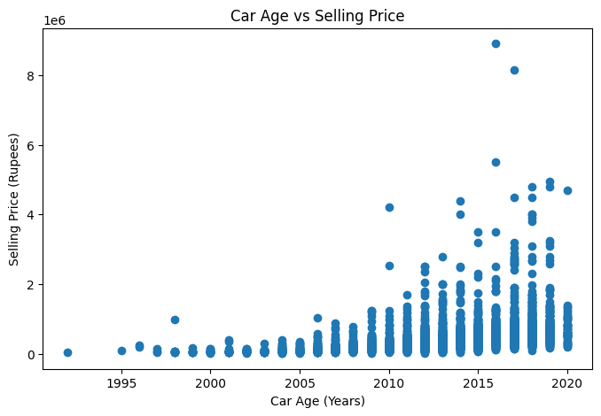
Observation: The scatter plot compares manufacturing year with selling price. The notebook reports a positive correlation of approximately 0.424 between year and selling price, indicating a moderate positive linear association. Newer model years tend to be associated with higher prices, though individual prices vary.

Chart 6. Kilometres Driven vs Selling Price
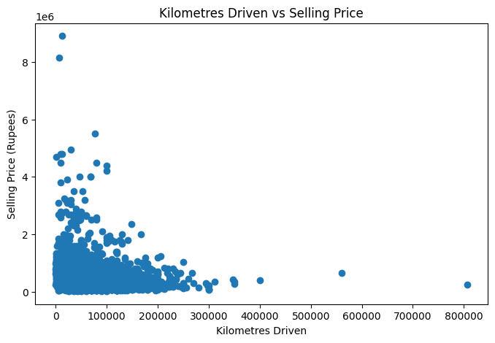
Observation: The scatter plot allows the relationship between distance driven and price to be inspected. The notebook does not print a numerical correlation for these two variables, so no exact correlation strength is claimed here.

Chart 7. Selling Price by Transmission Type
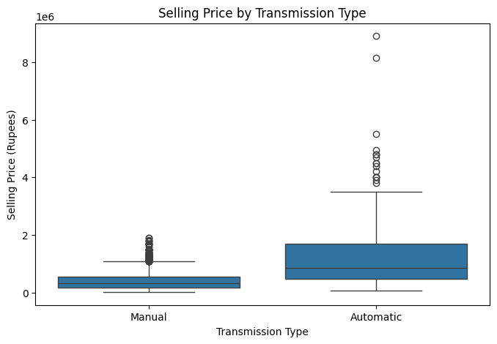
Observation: The box plot compares manual and automatic car prices. The notebook reports an average selling price of about ₹12.75 lakh for automatic cars and ₹3.97 lakh for manual cars. These are group averages in this dataset and do not establish that transmission alone causes the price difference.

Chart 8. Correlation Heatmap
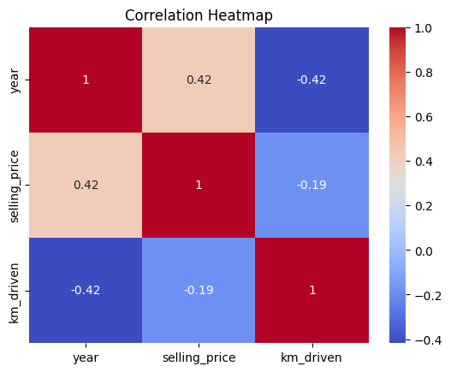
Observation: The heatmap displays pairwise correlations among year, selling_price, and km_driven. The strongest stated numeric finding in the notebook is the positive correlation of 0.424 between year and selling price. Correlation indicates association, not cause and effect.

8. Key Findings
The following findings are supported by the notebook’s cleaned data and printed results:
- Most common car name: Maruti Swift Dzire VDI, with 54 records.
- Most common fuel type: Diesel, with 1,800 records, followed by Petrol with 1,717.
- Average selling price: Approximately ₹473,913; the median is ₹350,000, so the mean is higher than the median.
- Average distance driven: Approximately 69,251 km, with a wide range across listings.
- Year and price association: The correlation between year and selling price is approximately +0.424.
- Transmission group averages: Automatic cars have a higher average selling price than manual cars in this dataset (about ₹12.75 lakh vs ₹3.97 lakh).
- Potential price outliers: 170 records lie above the IQR upper threshold of ₹12 lakh.

Limitations
- The notebook does not specify the original URL or publisher from which the CSV was downloaded; this should be added if known.
- The dataset is a set of car listings and may not represent every car in the market.
- Some categories are rare, such as Electric fuel (one record), so averages for them are based on very few observations.
- The notebook uses year as the x-axis in the chart titled “Car Age vs Selling Price”; technically, it plots the manufacturing year, not calculated age.
- Outliers were flagged but not investigated record-by-record. Correlation and group averages show associations only.

9. Conclusion
This project used Exploratory Data Analysis to examine 4,340 initial car records and produce a cleaned dataset of 3,577 rows after removing 763 duplicate rows. The analysis summarised numerical and categorical variables and included eight charts covering price distribution, fuel categories, common car names, price outliers, relationships with year and kilometres driven, transmission groups, and numerical correlations. The results show that Diesel and Petrol listings dominate the dataset, the average selling price is higher than the median, and vehicle year has a positive association with selling price. The work also demonstrates why data cleaning, chart observations, and cautious interpretation are important. Future work could calculate actual vehicle age, examine additional factors, and verify the original dataset source.
Submission note: This report summarises the notebook rather than reproducing the full code, as required by the assignment PDF.

