**Face-Recognition-Attendance-Management-System**

A python GUI integrated attendance system using face recognition to take attendance.

In this python project, we have made an attendance system which takes attendance by using face recognition technique. We have also integrated it with GUI (Graphical user interface) so it can be easy to use by anyone. GUI for this project is also made on python using tkinter.

### Code Requirements

* Install Opencv (pip install opencv-contrib-python)
* Tkinter (Available in python)
* PIL (pip install Pillow)
* Pandas (pip install pandas)
* Install MySQL (pip install MySQL-python)
* Install MySqlConnector (pip install mysql-connector-python)
* csv, Numpy, etc. for other purposes

**FEATURES:**

1. Easy to use with interactive GUI support.
2. Password protection for admin to view registered students.
3. Creates CSV file for details of students on registration.
4. Creates a new CSV file everyday for attendance and marks attendance with proper subject and time.
5. Displays live attendance updates for the day on the main screen in tabular format with Enrollment Number, name and time.

### What steps you have to follow

* Create **Details**, **Attendance, TrainingImage**, and **TrainingImageLabel** folder in a project.
* Open a AMS_Run.py
* Run AMS_Run.py file by opening Command Prompt and type python AMS_Run.py.

### Project Structure

* After run you need to give your face data to system so enter your Enrollment Number and Name in box than click on Take Images button.
* It will collect 200 images of your faces, it save a images in TrainingImage folder.
* After that we need to train a model (for training a model click on Train Image button).
* It will take 1-2 minutes for training.
* After training click on Automatic Attendance ,then enter the subject name to mark the attendance in that particular subject, it can fill attendance by your face using our trained model (model will save in TrainingImageLabel )
* It will create .csv file of attendance according to subject and date inside the Attendance folder named in subject_date format (e.g. JAVA_10_04_2023).
* You can store data in database (install mysql workbench), change the DB name according to your in AMS_Run.py.
* Manually Fill Attendance Button in UI is to fill the attendance manually (without face recognition), it's also create a .csv and store in a database i.e. inside Manually Attendance folder which is present inside Attendance folder.
* Admin can check the Attendance Status by entering the correct username and password

### Screenshots

### Basic UI

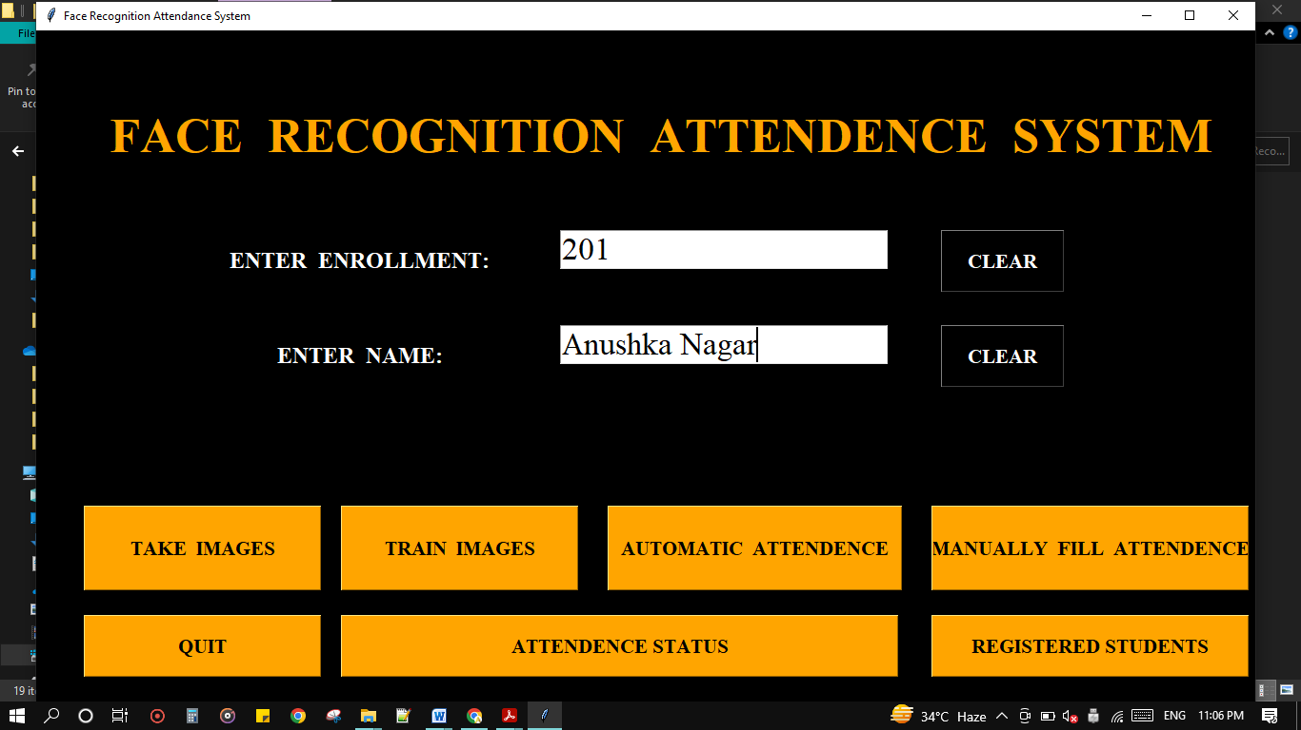

### Take Images

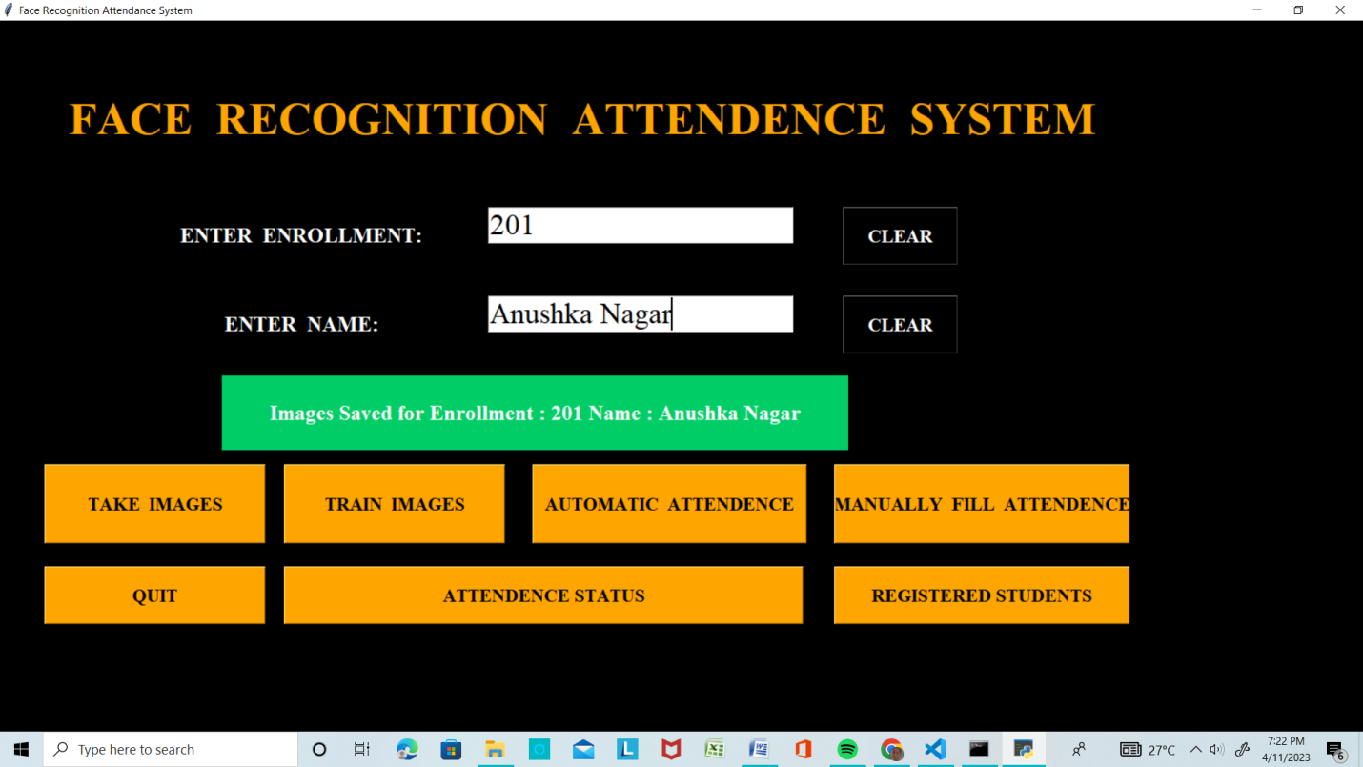

### Train Images

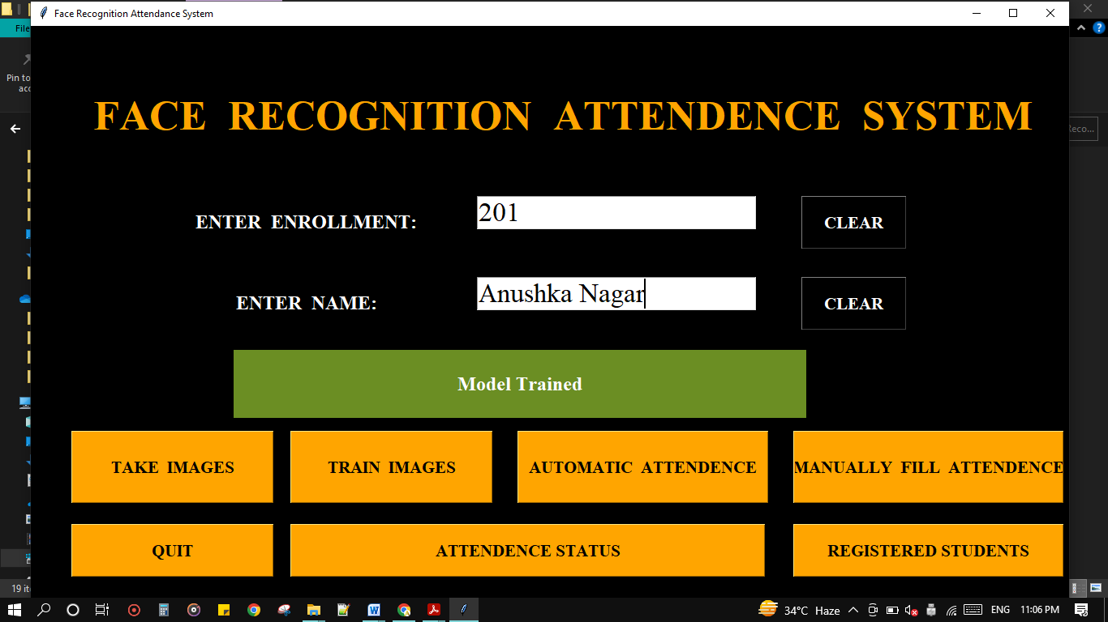

### Automatic Attendance

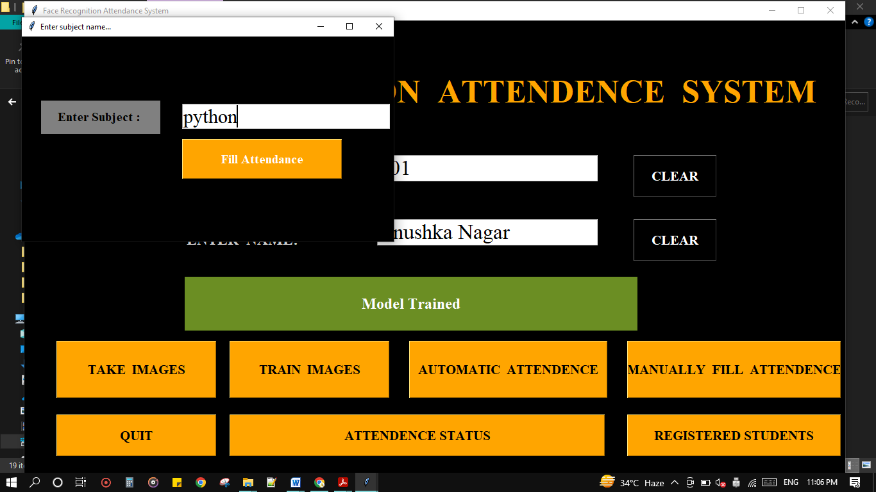

### When it Recognizes me

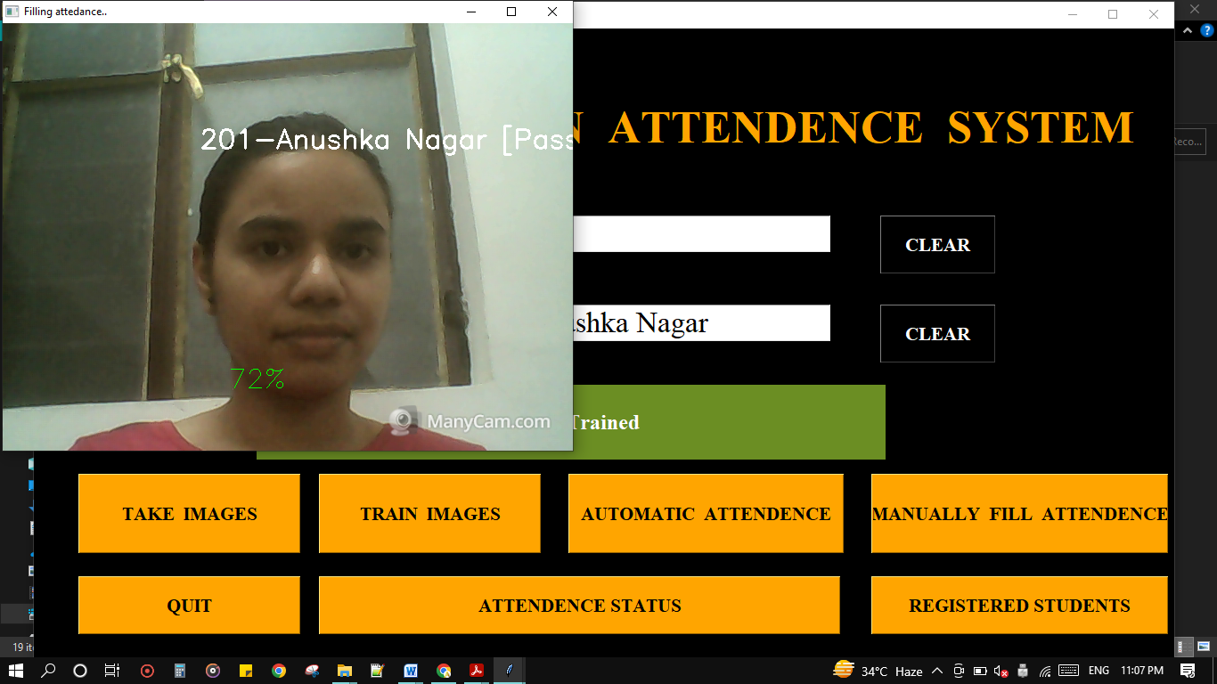

### While filling automatic attendance

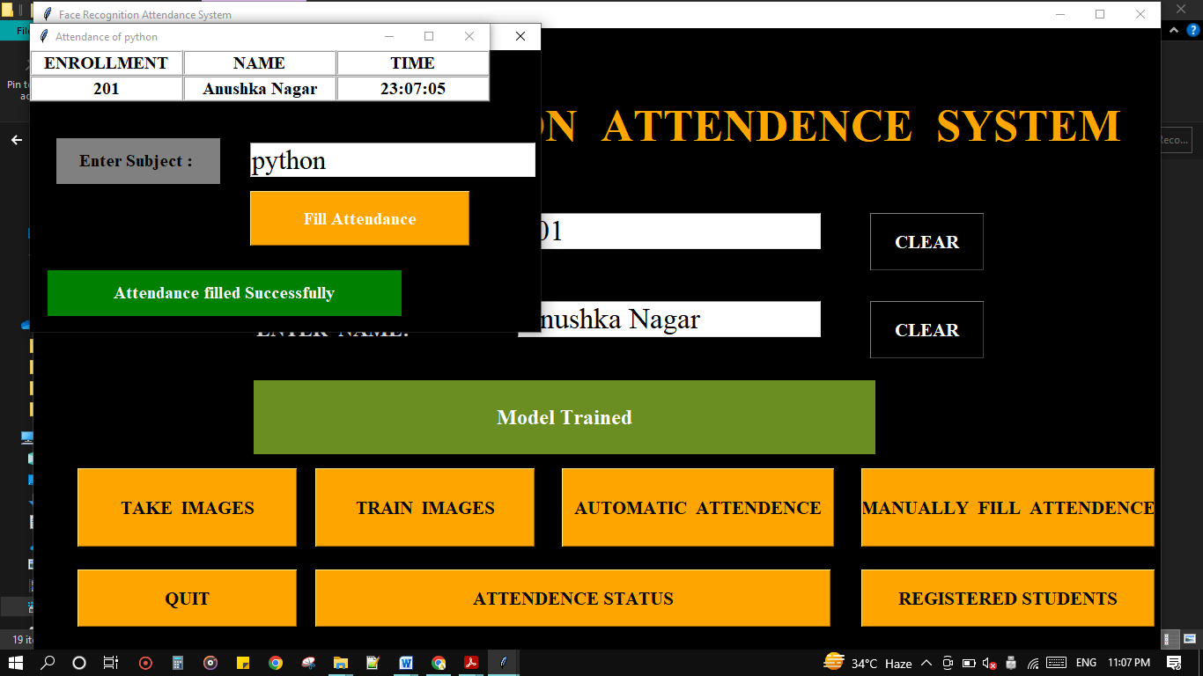

### Manually attendance filling UI

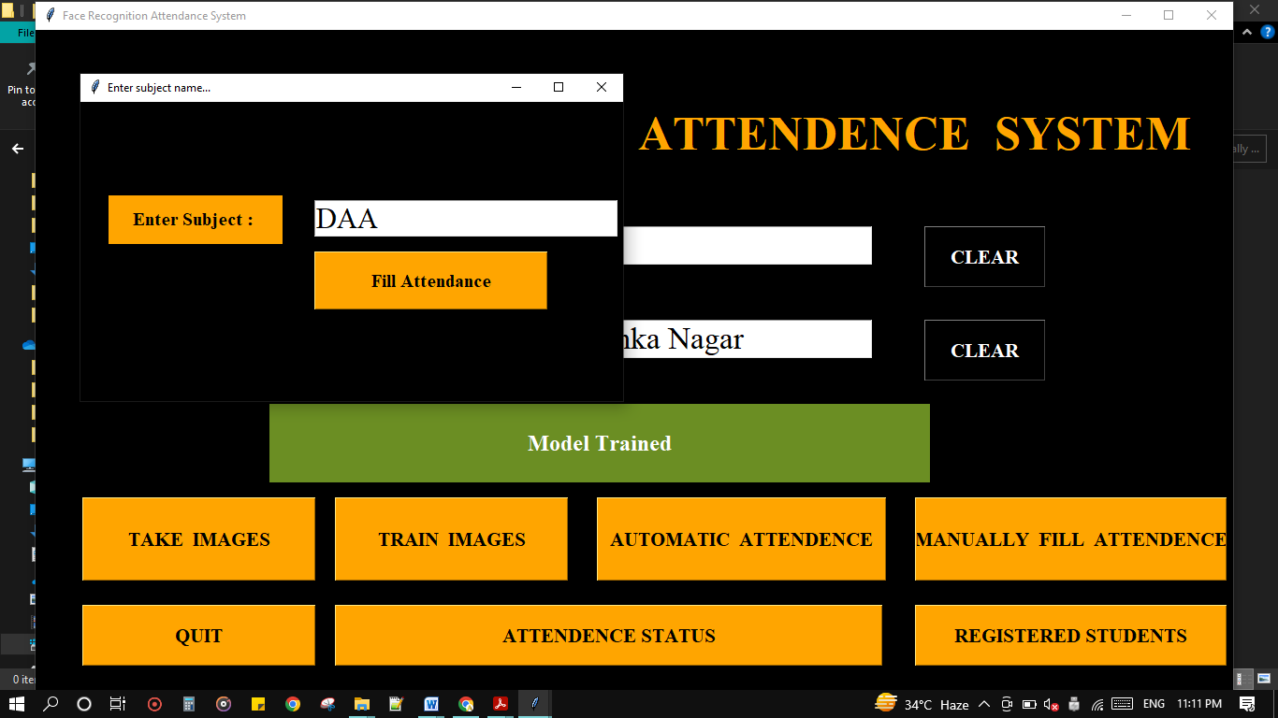

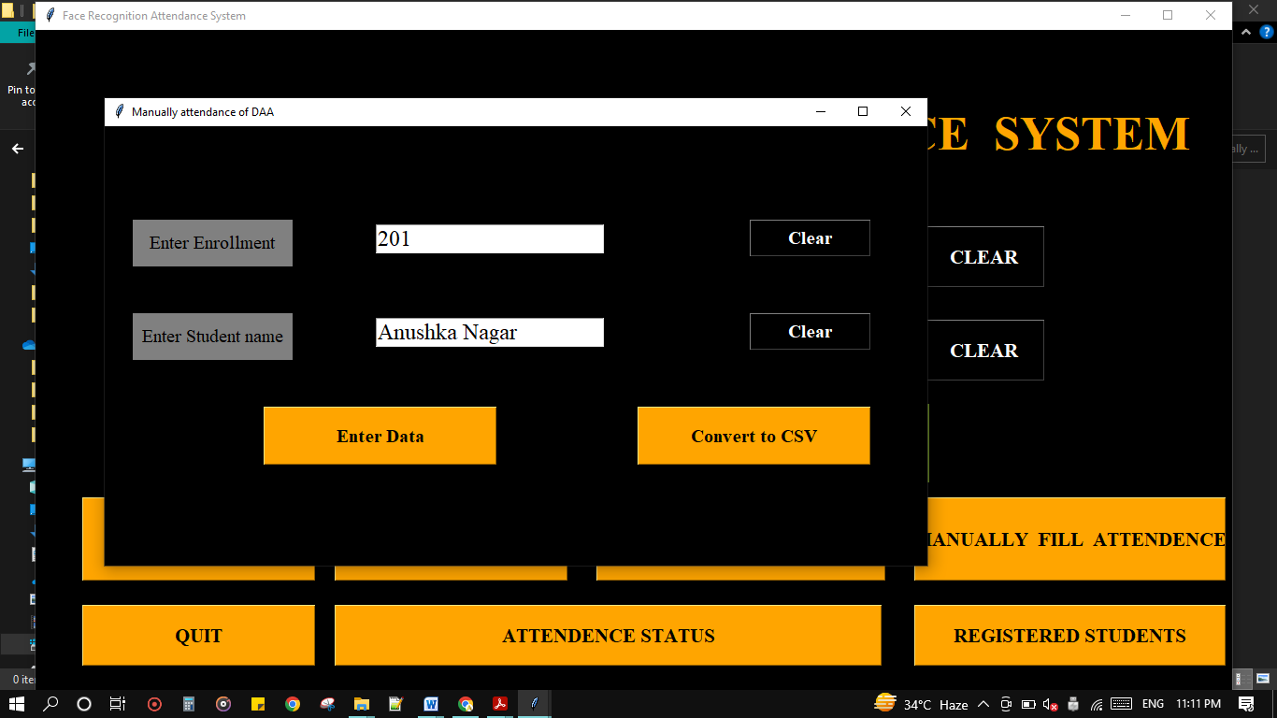

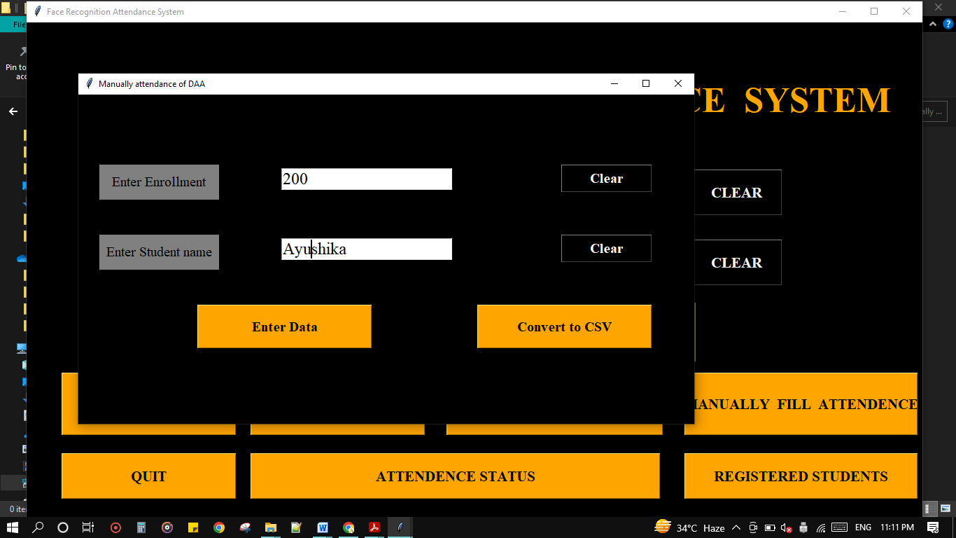

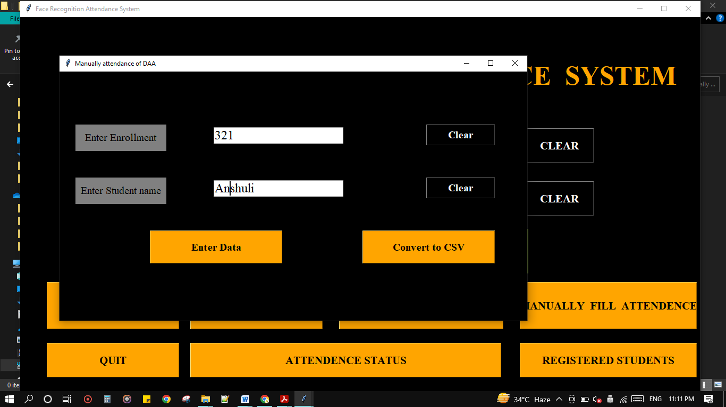

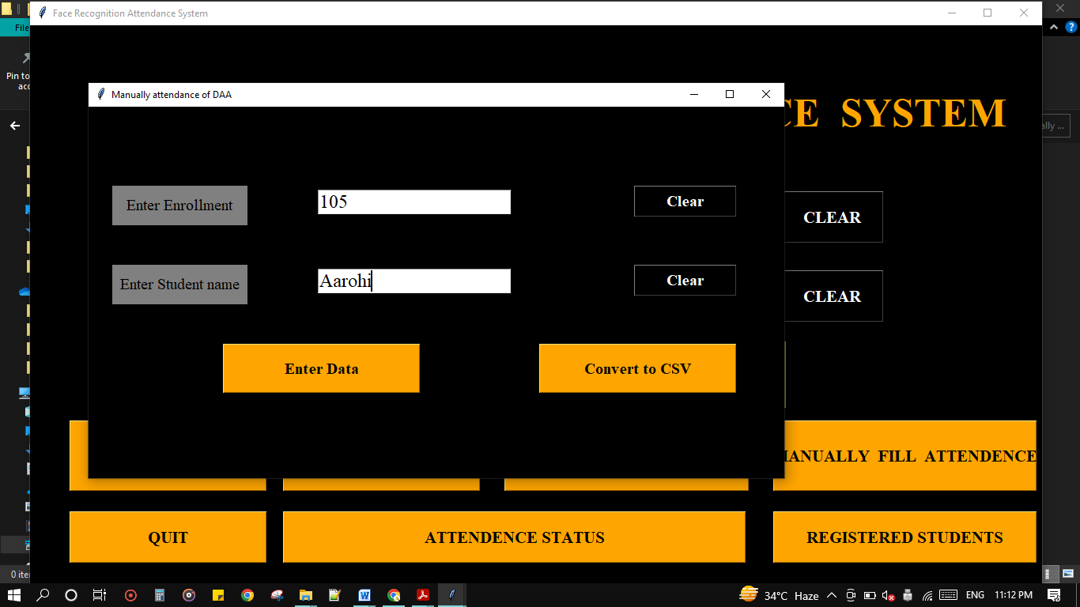

### When it fill’s a attendance

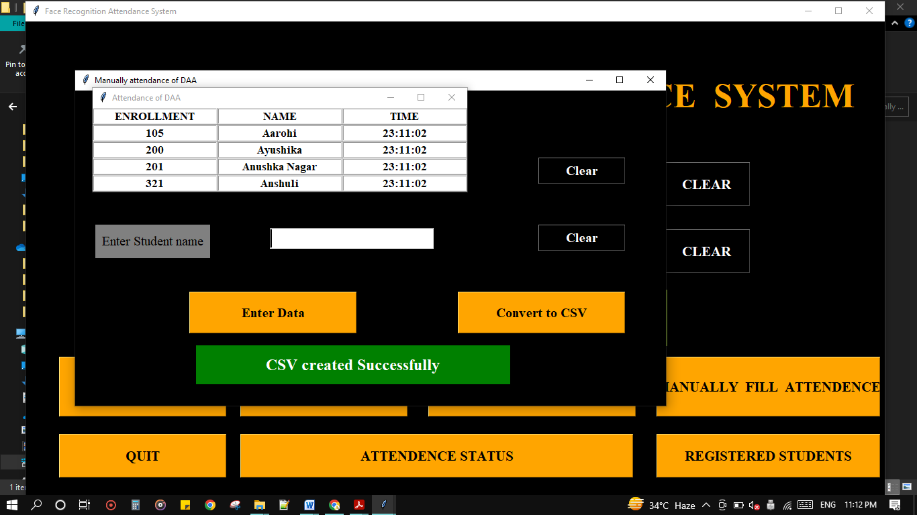

### Registered Students: for admin purpose only where admin can view the details of registered students.

### C:\Users\91735\Desktop\ss\Screenshot (220).png

### C:\Users\91735\Desktop\ss\Screenshot (221).png

### Testing

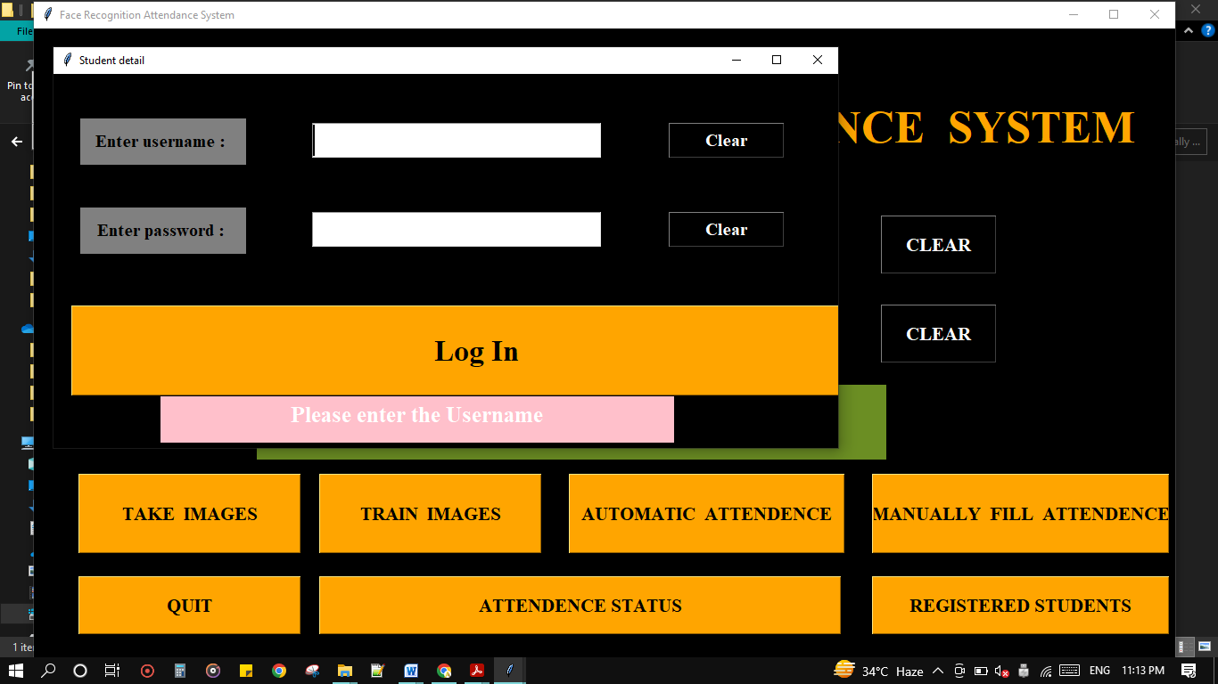

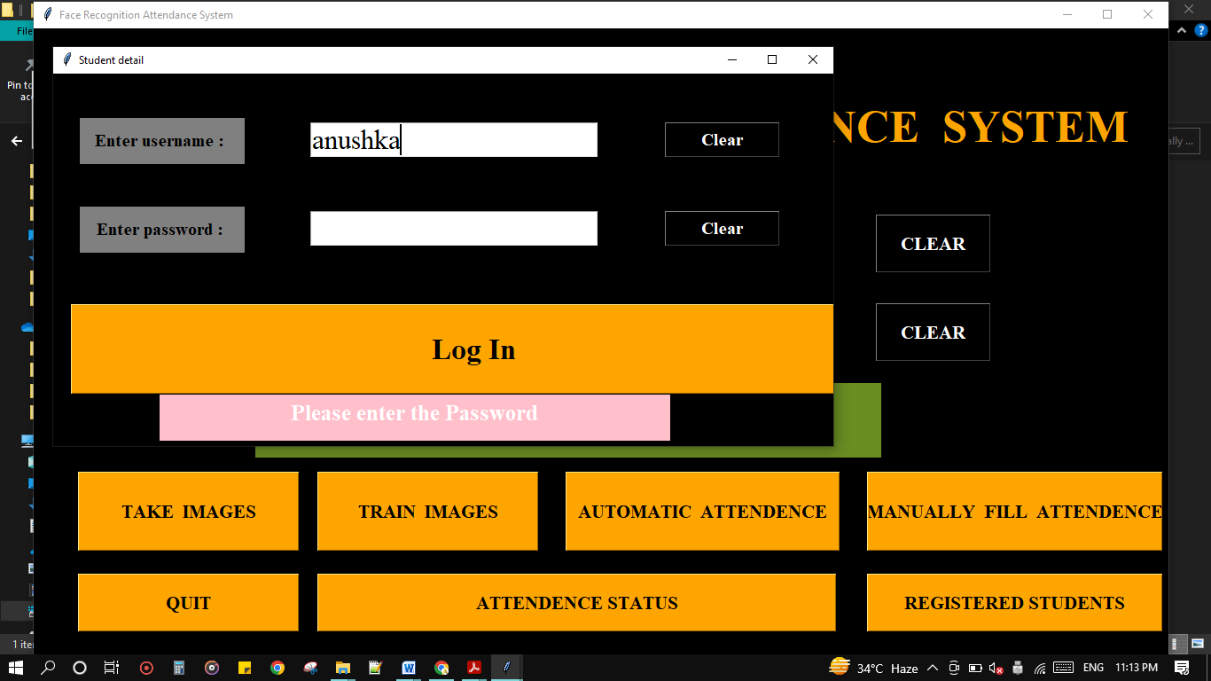

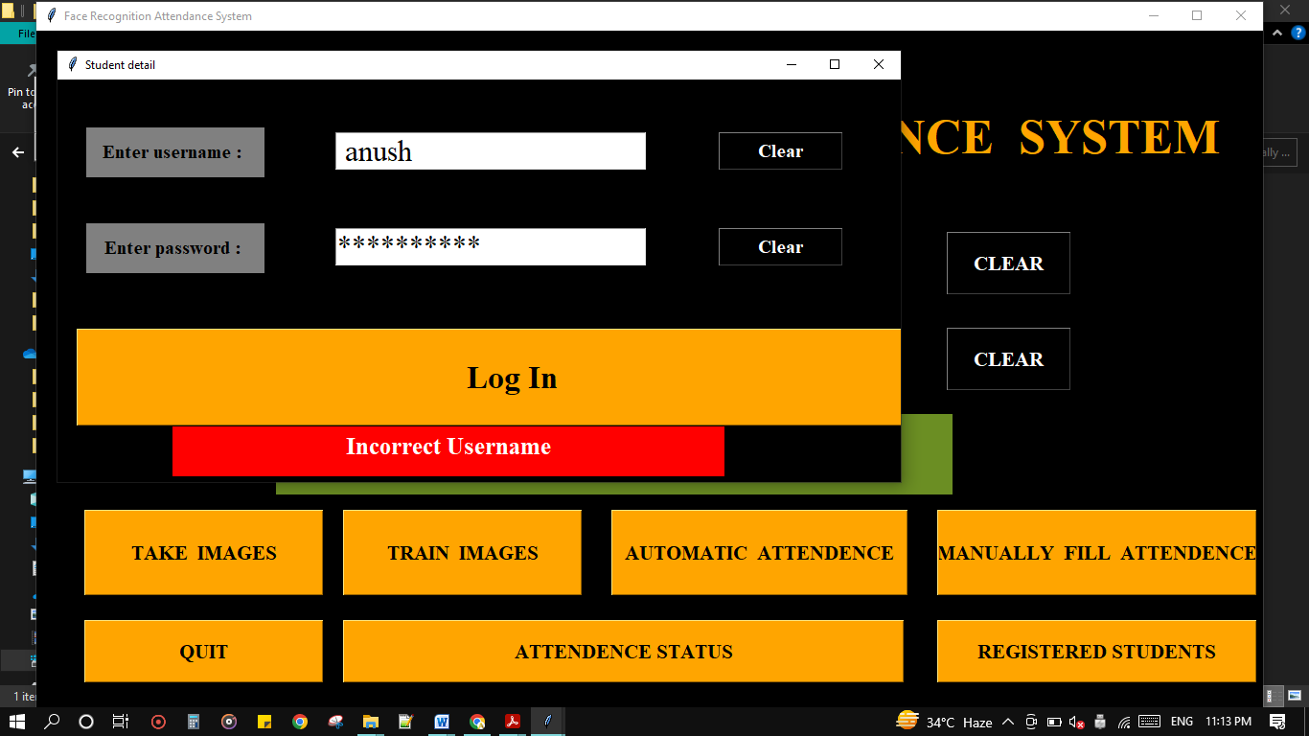

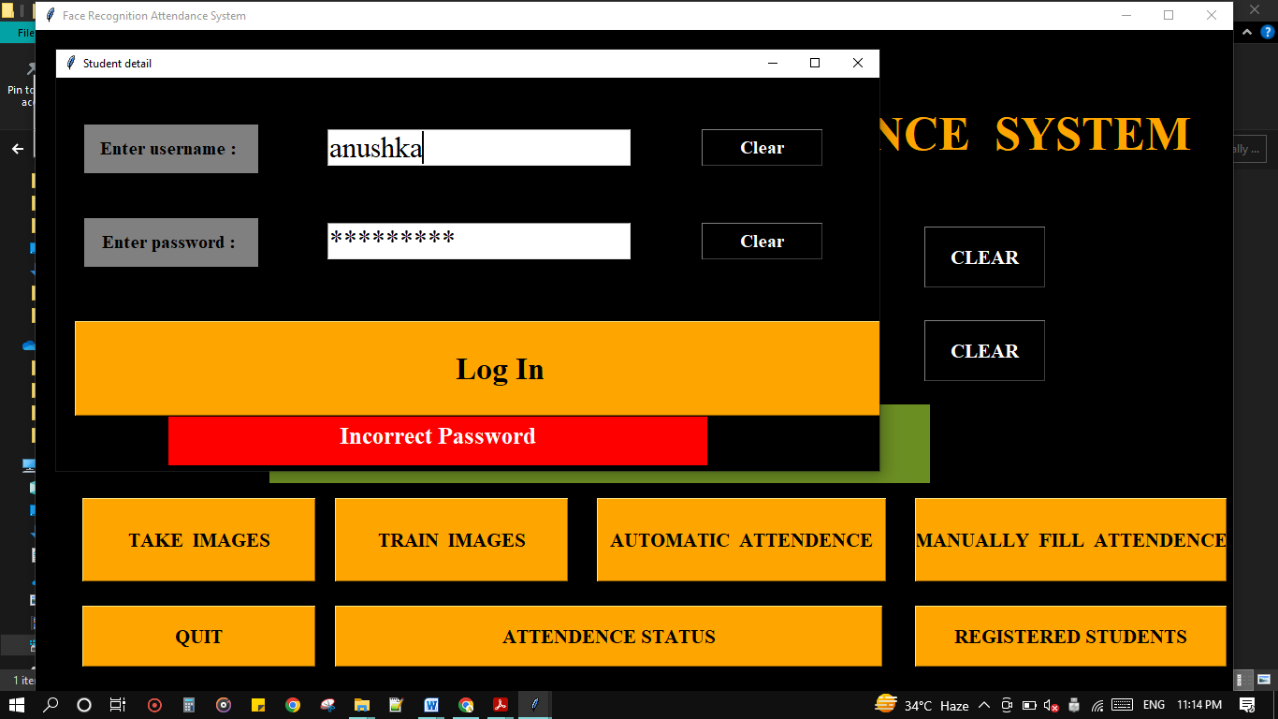

### Automatic Attendance Sheet

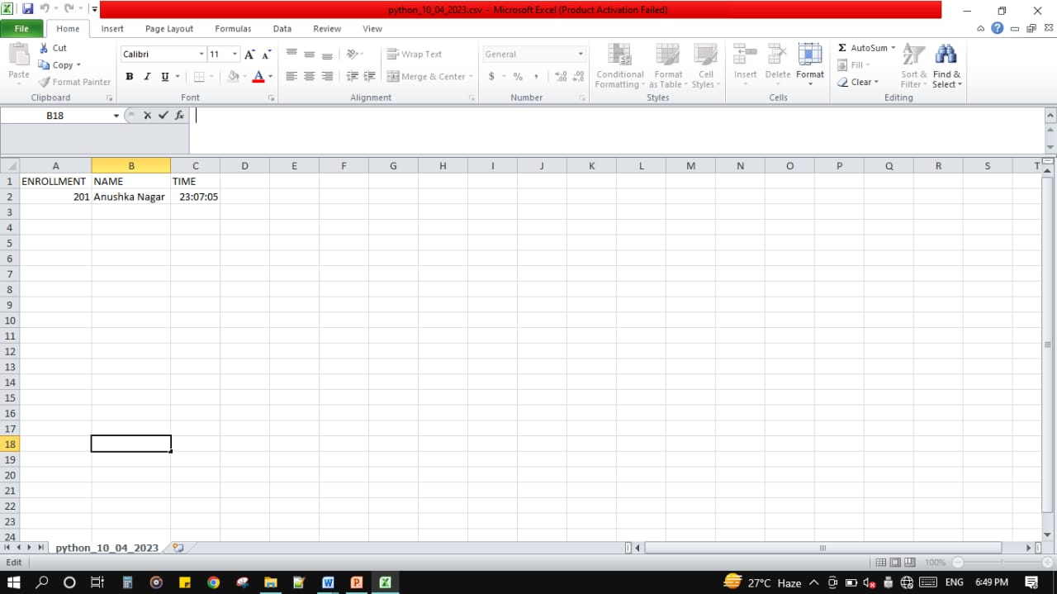

### Manual Attendance Sheet

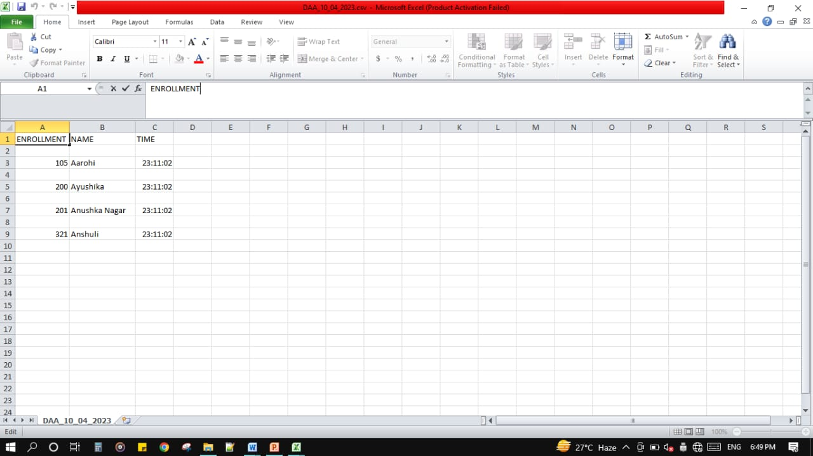

### Notes

* It will require high processing power(I have 8 GB RAM)
* Noisy image can reduce the accuracy, so quality of images should be good.