Land cover maps from Sentinel-1 radar alone
A Sentinel-1-only U-Net for six-class land cover, with a monthly-change prototype

Anushka Sawant
MSc Applied Data Science and Artificial Intelligence, Deep Learning course project (solo)
SRH Hochschule Heidelberg
November 2026
Abstract
I built a model that draws a six-class land cover map from Sentinel-1 radar alone. Radar sees through cloud and works at night, so the map can be made for any place, in any month. The six classes are Tree cover, Grass/shrub, Cropland, Built-up, Bare and Water. The model is a U-Net with a ResNet-34 encoder. I trained it on 21 regions over 2021 to 2024 and averaged three seeds. I then tested it on 39 regions it never saw, in 2025 and 2026, so the test is held out in space and in time. On that test it reaches a pooled mIoU of 0.540 in 2025 and 0.562 in 2026. Against the independent Esri map for 2021 it reaches 0.668. Built-up and Water come out well; Grass/shrub and Bare are the weak classes. I changed one thing at a time and picked the model on validation only. Yearly radar statistics were the one input change that clearly helped, while a bigger encoder, other label sources and more training data did not. A Streamlit prototype turns a latitude, a longitude and a start month into twelve monthly maps with class shares and month-to-month change, and warns when a place looks unlike the training data.

Submission links
Everything below is part of the submission. The code, notebooks and prototype are in a public GitHub repository; the dataset, the trained weights and the screen recording are large or binary, so they are shared through the links in the table.
Item | Where to find it
Code repository (public) | github.com/AnushkaSDBI/sentinel1-lulc
Notebooks with saved outputs | GitHub: notebooks/
Dataset: Sentinel-1 and labels, 67 regions | Google Drive
Trained weights: 3-seed ensemble and ood_reference.json | Google Drive
Demo video: the prototype on five urban and rural areas | Google Drive
All submission files in one folder | Google Drive

Contents
1. Introduction
2. Data
2.1 Model input
2.2 Labels
2.3 Independent reference maps
2.4 Regions, years and splits
2.5 Class distribution and imbalance
2.6 A quirk in the input
3. Preprocessing
4. Method
4.1 Architecture and input stack
4.2 Loss, imbalance and early stopping
4.3 Sampling, seeds and smoothing
5. Experiments and model selection
5.1 Filling the last month of the year
6. Results
6.1 Training behaviour
6.2 Headline result: held out in space and time
6.3 Per-class performance and class confusion
6.4 Seasonal stability
6.5 Change, and a noise floor for it
6.6 Borders
7. Prototype
7.1 How shares and change are computed
7.2 Telling the user when to be careful
7.3 Case study: Heidelberg against independent maps
8. Critical discussion
9. Conclusion
References

1. Introduction
Land cover maps are used for farming, water, cities and climate work. Most of them come from optical satellites like Sentinel-2, which cannot see through cloud. Many parts of the world are cloudy for a large part of the year, so an optical map is often weeks old. Sentinel-1 is a radar satellite. It sends its own microwave signal and measures the echo, so it works in any weather and in the dark. My question was simple and practical: how good a land cover map can I draw from Sentinel-1 radar on its own?
The project has three parts: a trained model, a prototype and this report. The prototype takes a latitude, a longitude and a start month, and returns twelve monthly land cover maps for that place, each with the share of the area in every class and the change from one month to the next.
I set three limits on purpose, because they make the result harder to reach and more honest to report.
- Radar only. The model gets no optical image, no elevation and no weather data. Only Sentinel-1 VV and VH backscatter go in. This is the whole point, because a radar-only map is available in any weather.
- Many places, not one. The model has to work across cities and rural land on several continents. A model that only works near one city would be easy to build and not very useful.
- Honest testing. I split the data by region, never by random tile. Neighbouring tiles look almost the same, so a random split leaks and gives a score that is too high. Splitting by whole regions stops that.
I report mIoU and the IoU of every class, not just accuracy. Accuracy is ruled by the large, easy classes. A model that calls a whole desert Bare scores high accuracy and is useless, while mIoU shows up the weak classes that actually matter.

2. Data

2.1 Model input
The input is Sentinel-1 GRD imagery in two polarisations, VV and VH, in decibels. For each month I take the median of all scenes over the area, which gives one clean image per month and cuts down the random speckle. All of it comes from Google Earth Engine, from the COPERNICUS/S1_GRD collection.

2.2 Labels
The labels come from Dynamic World, which gives a land cover class for each Sentinel-2 scene. I map its classes to six: Tree cover, Grass/shrub, Cropland, Built-up, Bare and Water. Flooded vegetation and snow or ice are left out for now, and pixels with no label are ignored in training. Dynamic World is itself a model, so it is noisy. My model therefore learns from imperfect labels, and the scores measure agreement with them, not agreement with surveyed ground truth. I say this plainly because it shapes how the numbers should be read.

2.3 Independent reference maps
Two other maps are never used for training and act only as checks: ESA WorldCover 2021 and Esri Annual Land Cover (2017 to 2025). They let me compare the 2021 maps against sources the model has never touched. This is the strongest check in the project, because agreement there cannot be explained by label leakage.

2.4 Regions, years and splits
The dataset covers cities and rural tiles across several continents and climates. The splits are by whole region, and boxes in different splits never overlap. The shipped model trains on 2021 to 2024 and is tested on 2025 and 2026, which are regions and years it has never seen.
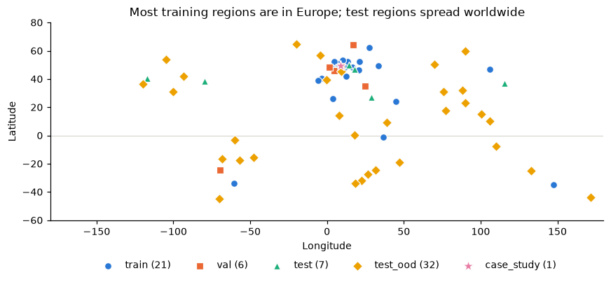
Figure 1. The 67 regions by split. Most training regions are in Europe; the test and out-of-distribution regions are spread worldwide, which makes the test demanding.
Table 1. Dataset splits. Test and out-of-distribution regions are never used for training or for choosing the model.
Split | City regions | Rural regions | Total | Years
Train | 10 | 11 | 21 | 2021-2024
Validation | 2 | 4 | 6 | 2024
Test (in-distribution) | 2 | 5 | 7 | 2025-2026
Test (out-of-distribution) | 3 | 29 | 32 | 2025-2026
Case study (Heidelberg) | 1 | 0 | 1 | 2021

The 39 held-out test regions (7 in-distribution and 32 out-of-distribution) take in arid, boreal, tropical and southern-hemisphere land that is unlike most of the training set. So the headline numbers are measured under genuinely hard conditions, not on easy ground.

2.5 Class distribution and imbalance
The classes are far from balanced. Built-up holds almost half of the labelled training pixels, because many training regions are cities, while Water, Bare and Grass/shrub are rare. I deal with this in the loss and in the sampling (Section 4), and it is the reason I use per-class IoU, not accuracy, as the main metric.
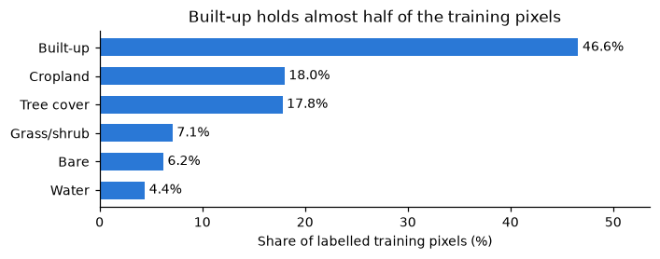
Figure 2. Share of labelled pixels per class in the training regions. Built-up dominates, which is why I use class-weighted loss and region-balanced sampling.

2.6 A quirk in the input
Sentinel-1B stopped working in December 2021, so the number of radar scenes per month dropped afterwards. The median was about 10 scenes per month in 2021, 5 in 2022 to 2024, 6 in 2025 and 10 in 2026. A model trained only on the data-rich 2021 therefore learns from cleaner monthly medians than it later meets. This explains a real pattern in the results (Section 6), and it is a concrete reason to train across several years rather than one.

3. Preprocessing
Most of the radar preprocessing happens inside Earth Engine, which does thermal-noise removal, radiometric calibration and geometric terrain correction, and converts the backscatter to decibels. I add no spatial speckle filter, because the monthly median already handles speckle and a spatial filter blurs the class borders. I also do not apply radiometric terrain flattening, which is the one gap I am aware of: steep terrain keeps a slope-dependent brightness bias.
Normalisation and patching. Each polarisation is standardised with statistics taken from the training split only, so nothing leaks from validation or test. The images are cut into 256 by 256 pixel patches on a shared grid, and an index of valid patches skips tiles that are mostly unlabelled or off the swath.
Label matching. Sentinel-1 and Dynamic World for a region come from one Earth Engine request onto one 2400 by 2400 pixel UTM grid at 10 m, so the image and the labels share pixel positions exactly. The script checks Earth Engine's pixel geometry against the target grid before it downloads, and overlay checks confirm the alignment.
Augmentation and splits. Training uses horizontal and vertical flips and 90-degree rotations, which are safe for top-down radar and do not distort the backscatter. The splits are by region, with an automatic overlap check so that no training box touches a validation or test box.

4. Method
The model reads three monthly radar images and predicts the land cover of the middle month. I kept every part standard on purpose. The work is in the input design and in the way I test, not in a clever architecture.

4.1 Architecture and input stack
The network is a U-Net with a ResNet-34 encoder that starts from ImageNet weights. The input stack holds a three-month window (the target month and its two neighbours), each with VV and VH, plus a set of yearly statistic channels that describe how each pixel behaves over the whole year, such as the lowest and highest VV, the spread of VH, and the share of months with very low backscatter. These give the network seasonal context that a single month cannot. The yearly statistics were the one input change that clearly helped.

4.2 Loss, imbalance and early stopping
The loss is a class-weighted cross-entropy (with integer labels and an ignore index for unlabelled pixels, the sparse form) plus a Dice term that helps the rare classes. The class weights follow inverse frequency, so Water and Bare are not drowned out by Built-up. Early stopping watches the validation mIoU of the EMA weights, with a patience of five epochs, and keeps the best checkpoint, up to twelve epochs.

4.3 Sampling, seeds and smoothing
I draw the same number of patches from every region, so large regions do not take over the training. This matters because the rural tiles are small by pixel count but are exactly the kind of area the model is judged on. I train three models with different seeds and average their class probabilities, which both lifts the score and shows the run-to-run spread. In the prototype I smooth the predictions with a three-month majority filter, which roughly halves false month-to-month flips on stable land with no retraining. All seeds are fixed and every setting sits in one config file, so a run can be repeated. The repository ships with 178 tests that pass.

5. Experiments and model selection
I changed one thing at a time and compared the variants on the validation regions only, with three seeds each. The spread between seeds is about 0.01 to 0.03 mIoU, so I treat any gap smaller than that as noise. The test regions were never used to choose anything.
Table 2. Main ablation on validation (2021 data), mean and standard deviation over three seeds.
Variant | What changed | Val mIoU | Std
V0 | Encoder trained from scratch, one month | 0.466 | 0.010
V1 | ImageNet encoder, one month (baseline) | 0.597 | 0.008
V7 | V2 plus speckle augmentation | 0.633 | 0.003
V5 | Three-month window plus yearly statistics | 0.639 | 0.019
V12 | Window, yearly stats, balanced sampling (shipped) | 0.646 | 0.010

What helped. A pretrained encoder was the big one, +0.13 mIoU over training from scratch. A three-month window added about 0.02, and the yearly statistics added a further clear gain. With region-balanced sampling these give V12, the model I shipped.
What did not help. A larger ResNet-50 encoder, other losses, stronger regularisation and training on WorldCover labels all failed to beat V12 on validation. Extra rural training tiles raised Grass/shrub by about 0.05 but cost Water, cities and Cropland, and a radar-coherence input gave a gain inside the seed spread. I shipped none of them. My reading is that the ceiling here is set by the radar signal and the noisy annual labels, not by the size of the network or the amount of data.

5.1 Filling the last month of the year
The prototype is used on recent months, and the last month of a window can have no month after it. At inference I fill a missing neighbour month with the nearest month towards the centre, so a month that has not happened yet never reaches the model as a blank input. Training is unchanged. On the 2026 test this lifted the pooled score from 0.557 to 0.562, and the gain is largest in the last real month, which is exactly where the blank input used to hurt.
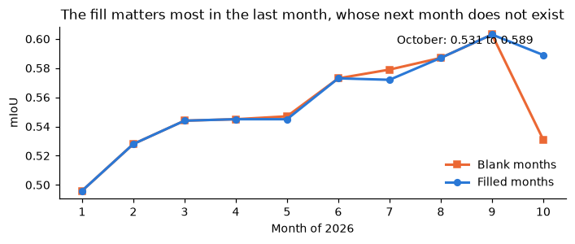
Figure 3. The input fix on 2026. Filling the missing neighbour month (blue) matches the blank input (orange) through most of the year and is clearly better in October, the last month with data.

6. Results

6.1 Training behaviour
Training is short and steady. The validation mIoU climbs quickly and then flattens, and early stopping keeps the best EMA checkpoint. For the shipped four-year model the best epochs were 11 to 12 across the three seeds, with validation mIoU of 0.613 to 0.617, so the seeds agree closely.
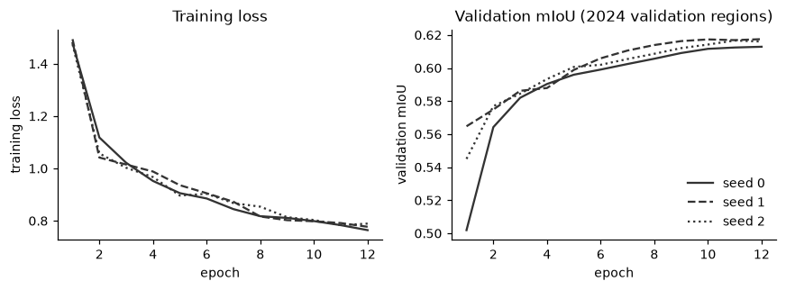
Figure 4. Training loss and validation mIoU per epoch for the three seeds of the shipped model. The loss falls smoothly and the validation mIoU flattens; the three seeds track each other.

6.2 Headline result: held out in space and time
The shipped model is a three-seed ensemble trained on 2021 to 2024 and tested on 39 regions it never saw, in 2025 and 2026. This is the number that matters for the prototype, which is used on recent months.
Table 3. Pooled mIoU of the shipped model against Dynamic World of the same year, with 95% bootstrap intervals over regions.
Test | Reference map | Pooled mIoU (95% interval) | OA
2025, 39 unseen regions | Dynamic World 2025 | 0.540 (0.468 to 0.615) | 0.723
2026, 39 unseen regions | Dynamic World 2026 | 0.562 (0.493 to 0.634) | 0.744
2021, 38 regions (space-only holdout) | Dynamic World 2021 | 0.532 (0.446 to 0.627) | 0.712
2021, 9 regions with independent maps | Esri 2021 (independent) | 0.668 (0.524 to 0.716) | 0.843

Two things stand out. First, the model scores higher against the independent Esri map (0.668) than against Dynamic World, which suggests Dynamic World is the noisier reference, so the model is not just copying its training signal. Second, the 2025 and 2026 scores hold up on regions and years the model never saw, which is the real test for a tool that runs on recent data.

6.3 Per-class performance and class confusion
Per-class IoU on the 2026 test shows where radar is strong. Built-up is recovered very well (IoU 0.845), because buildings and smooth streets give a clear radar response; Tree cover (0.599) and Water (0.588) follow, then Cropland (0.554). The weak classes are Bare (0.416) and Grass/shrub (0.367). The confusion matrix below says why: short vegetation, bare soil and cropland between harvests give similar backscatter, so the model mixes them. Grass/shrub leaks into Tree and Cropland, Bare leaks into Grass/shrub, and Water is sometimes read as Cropland on narrow rivers.
Table 4. Per-class IoU and F1 on the 2021 test against Dynamic World (all regions pooled).
Class | IoU | F1 | Precision | Recall
Built-up | 0.833 | 0.909 | 0.936 | 0.883
Tree cover | 0.563 | 0.720 | 0.661 | 0.791
Cropland | 0.511 | 0.677 | 0.610 | 0.759
Water | 0.478 | 0.646 | 0.901 | 0.504
Bare | 0.455 | 0.625 | 0.722 | 0.551
Grass/shrub | 0.350 | 0.518 | 0.493 | 0.546

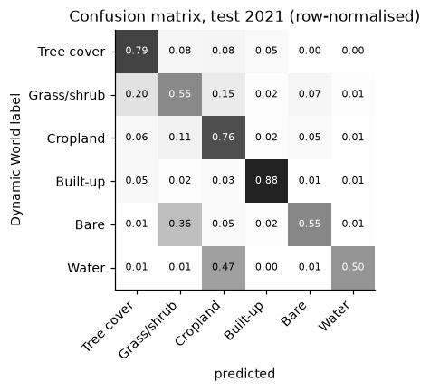
Figure 5. Confusion matrix on the 2021 test, row-normalised. The diagonal is the recall of each class. The off-diagonal cells show the radar confusions: Grass/shrub into Tree, Bare into Grass/shrub, and Water into Cropland.

6.4 Seasonal stability
Because the prototype makes one map per month, month-to-month stability matters. The pooled mIoU moves only a little across the year, with a shallow dip in spring, when fields are bare or just planted, and a peak in late summer and early autumn. The model is seasonally steady rather than tuned to one part of the year.
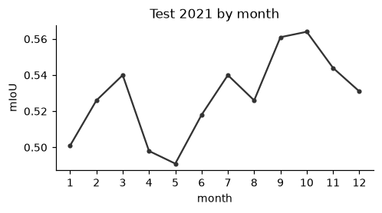
Figure 6. Pooled mIoU by calendar month on the 2021 test. The change across the year is small, with a spring dip and an autumn peak.

6.5 Change, and a noise floor for it
The prototype reports change, so I measured how much change the model invents on land that two independent maps agree is stable. On those pixels the raw model flips class between months for 2.61% of pixels, and three-month smoothing cuts this to 1.00%. Dynamic World itself flips 6.79% on the same pixels, so the model is already steadier than its own training source. I use the 1% figure as a noise floor: a change below it in a monthly map is not evidence of real change.
Table 5. Apparent change on pixels both annual maps call stable (2021, mean over 9 regions).
Source | Pixels flipping class between months
Dynamic World (training source) | 6.79%
This model, raw | 2.61%
This model, 3-month smoothing | 1.00%

6.6 Borders
The one weakness in how the maps look is that the class borders are soft. I tried five ways to sharpen them under a rule I fixed before the run: boundary F1 had to rise without costing mIoU. Test-time augmentation and Gaussian stitching changed nothing, a CRF sharpened the edges on paper but lowered boundary F1, and an object vote and a graph head both hurt. A full-resolution output branch gave the largest boundary gain, and even that was only 0.011 at a cost in mIoU. My reading is that most of the softness comes from the radar itself (about 20 m on the ground) and from the fuzzy labels, not from a choice I can fix, so I kept the simpler model.
Table 6. Border-sharpening experiments against the V12 baseline (validation 2024). None met the rule I set beforehand.
Method | mIoU | Boundary F1 | Verdict
V12 baseline | 0.613 | 0.402 | reference
Test-time augmentation | 0.615 | 0.403 | no real change
Gaussian stitching | 0.614 | 0.402 | no change
CRF (mild / strong) | 0.613-0.614 | 0.358-0.386 | worse edges
Full-resolution branch | 0.609 | 0.413 | best F1, lower mIoU

7. Prototype
The prototype is a Streamlit app. The user enters a latitude, a longitude and a start month. The app then downloads the Sentinel-1 scenes for that place from Earth Engine, builds the monthly median images, runs the three-seed model for twelve months, smooths over three months, and shows the twelve maps over a satellite basemap with an opacity slider and a legend that uses the ESA WorldCover colours.

7.1 How shares and change are computed
For each month the app counts the pixels in every class among the valid pixels and reports the percentage of the area in each class. Month-to-month change and the first-to-last change are given in percentage points. Change is computed only on pixels that are valid in all twelve months, so missing data can never show up as land-use change. The app also shows the class of a clicked pixel across the twelve months, a stacked-area chart of the shares, a first-versus-last change map, and a table against the independent maps with a Dynamic World ceiling, a majority-class baseline and a confusion matrix against Esri.

7.2 Telling the user when to be careful
Two features help a reader judge the output instead of trusting it blindly. A confidence layer shows where the ensemble is unsure, and an area warning fires when the place looks unlike the training regions, from the stored out-of-distribution reference. The rank correlation between confidence and accuracy is 0.50, so I treat the warning as a rough flag, not a promise, but it does steer the user away from the regions where the model is weakest.

7.3 Case study: Heidelberg against independent maps
As a check I ran the prototype on Heidelberg for 2021, the city I held out as the case study, and compared the result against WorldCover and Esri, neither of which the model ever trained on. The built-up core, the Neckar river and the forest around the city are all placed correctly, and the class shares follow the independent maps closely. This is the kind of check the brief asks for: an independent map, not used in training, confirming the output.
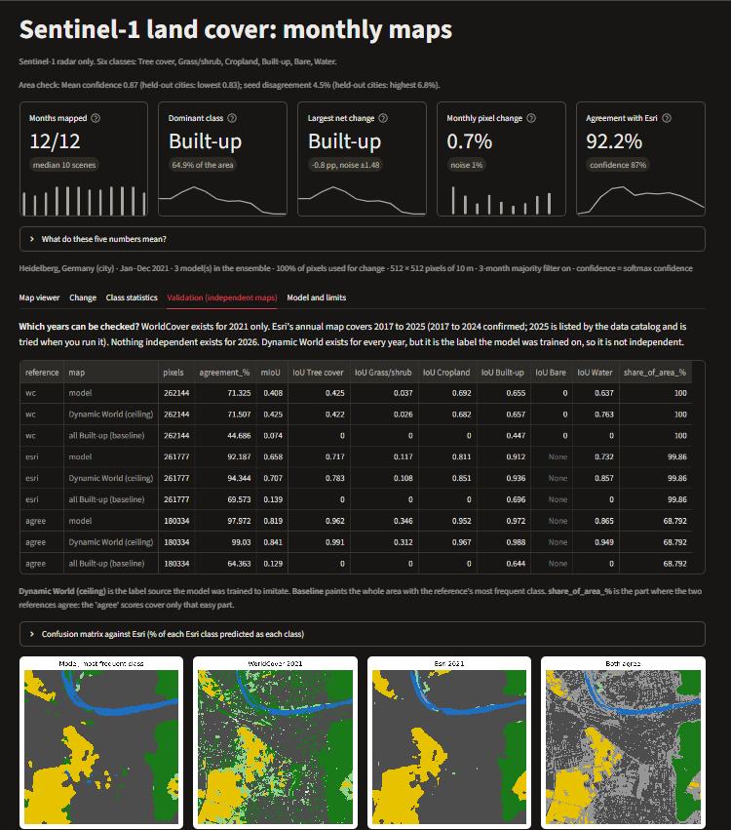
Figure 7. Heidelberg 2021: the prototype's validation view. The per-class table and the four maps (model, WorldCover 2021, Esri 2021, and where both agree) check the radar-only output against independent maps the model never trained on. The city, the Neckar river and the surrounding forest are placed correctly.

8. Critical discussion
The results above are strong for a radar-only model, and they come with clear limits. I put them in one place rather than repeating them through the report.
- Monthly maps have no ground truth. The labels are annual, so a single month cannot be scored. I can only measure stability, which is why the noise floor in Section 6.5 matters: it tells the user how much change to ignore.
- Labels are a model, not survey truth. The scores measure agreement with Dynamic World, and for 2025 and 2026 there is no independent map, so those two years read a little high. The 2021 comparison against Esri is the firmer ground.
- Radar confuses some classes. Grass/shrub, Cropland and Bare give similar backscatter, and Grass/shrub is the weakest class in every test. This is a limit of a single radar band, not a training mistake.
- Extreme climates are hard. The lowest-scoring regions, the Great Basin, Iceland, Patagonia, the Kazakh steppe and the Sahel, are dry or cold places far from the training data, where the radar signal barely moves and the reference maps are themselves unreliable. The area warning is built to flag exactly these.
- Change can be inflated by error. Change is built from per-pixel classifications, so a classification error can look like change. The smoothing and the all-twelve-months rule cut this down, and the measured noise floor bounds what is left.
- Terrain and scene count. I did not apply radiometric terrain flattening, so steep terrain carries a brightness bias, and the drop in Sentinel-1 scenes per month after 2021 is a real effect that training across several years is meant to absorb.

9. Conclusion
A plain U-Net with a pretrained ResNet-34 encoder can make usable six-class land cover maps from Sentinel-1 radar alone. Built-up and Water come out well, Tree cover and Cropland are fair, and the model holds up on 39 regions and two years it never saw, with a pooled mIoU of 0.540 in 2025 and 0.562 in 2026, and 0.668 against an independent map for 2021. The lessons matter as much as the score: yearly statistics and training over several years helped, while a bigger network, other labels and more data did not, so the limit is the radar signal and the annual labels. The prototype turns the model into twelve monthly maps for any place and start month, with shares, change in percentage points, a comparison against independent maps and an honest warning for unfamiliar terrain. With more time I would add an independent map for 2025, compare against a denser radar source, and try labels finer than the annual products used here.

References
[1] ESA / Copernicus. Sentinel-1 GRD, Interferometric Wide-swath mode. Accessed through Google Earth Engine, COPERNICUS/S1_GRD.
[2] Brown, C. F. et al. (2022). Dynamic World, near real-time global 10 m land use land cover mapping. Scientific Data, 9, 251. Google Earth Engine, GOOGLE/DYNAMICWORLD/V1.
[3] Zanaga, D. et al. (2021). ESA WorldCover 10 m 2021. Used as an independent reference map only.
[4] Karra, K. et al. (2021). Esri Annual Land Cover (Sentinel-2, 10 m), 2017 to 2025. Used as an independent reference map only.
[5] Ronneberger, O., Fischer, P., Brox, T. (2015). U-Net: Convolutional Networks for Biomedical Image Segmentation. MICCAI.
[6] He, K. et al. (2016). Deep Residual Learning for Image Recognition (ResNet). CVPR.
[7] Iakubovskii, P. Segmentation Models PyTorch. Open-source library used for the U-Net and ResNet-34 implementation.
[8] Claude (Anthropic), Claude Code. AI assistant used to help with code review, drafting this report and laying out the figures. 2026. https://claude.ai

