**Project -> Full Stack Java Developer Capstone Project**

1. **ICIN Bank**

This Project is Developed by Anushka Sharma. This project is hosted on the git repository : <https://github.com/AnushkaSharma9/Capstone-Project-ICIN-Online-Banking.git>

* 1. **PROJECT DESCRIPTION**

This application is designed and developed as an Online Banking Web Application where the back-end is developed using Sprint Boot Framework and front-end is developed by using Angular. This system allows ICIN Bank admin to provide net banking facilities for end users, such as Registration, Login, Account transactions, Transfers, Saving details, Requesting cheque books, etc. The admin user is able retrieve transactions as well as block user. The user can register or login into the application , they can deposit or withdraw money from their account, view transactions, and balance in the primary and savings account. Transfer funds between different and add recipients, request cheque books for different accounts.

**1.1.2 TECH STACK**

* MySQL
* Eclipse
* Spring boot Framework
* Core Java Concepts - Object Oriented Programming (OOPS) Concepts such as

Classes and Objects.

* JDBC template
* HTML - Hyper Text Markup Language
* CSS - Cascading Style Sheets
* Angular 2
* Jenkins
* Docker
* AWS EC2 instance

1. **FLOW CHART OF THE APPLICATION**

The below given picture depicts the flow of the Project :

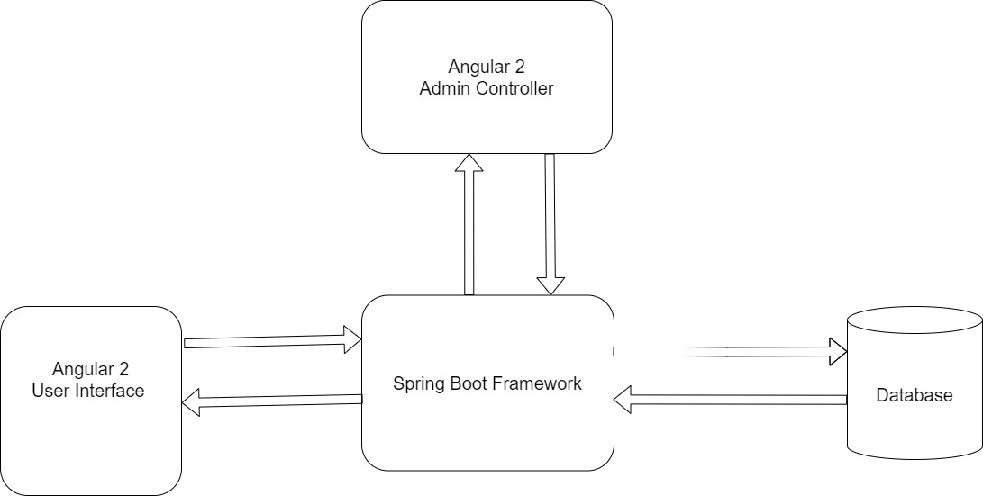

**FIG 1 - FLOW CHART OF THE PROJECT**

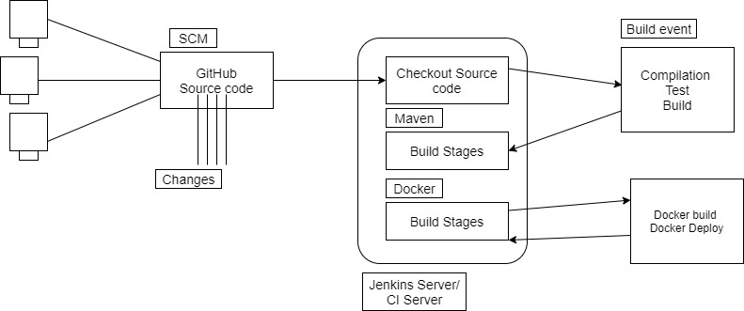

**FIG 1 - FLOW CHART OF THE DEPLOYMENT**

1. **PROJECT USER STORIES : (Agile and Scrum)**

* As a user I want an ICIN bank Online Banking web Application for end users.
* As a user I want an ICIN bank Online Banking web Application in which I can retrieve transaction for end users.
* As a user I want an ICIN bank Online Banking web Application in which I can block an end user.
* As a user I want an ICIN bank Online Banking web Application in which end user can register into the application.
* As a user I want an ICIN bank Online Banking web Application in which end user can login into the application.
* As a user I want an ICIN bank Online Banking web Application in which end user can deposit and withdraw from the account in the application.
* As a user I want an ICIN bank Online Banking web Application in which end user can view transaction and balance in the primary and savings account in the application.
* As a user I want an ICIN bank Online Banking web Application in which end user can transfer funds between different accounts and add recipients in the application.
* As a user I want an ICIN bank Online Banking web Application in which end user can request cheque books for different accounts in the application.
* As a developer I want to develop an ICIN bank Online Banking web Application for end users as well as Admin user.
* As a developer I want to develop an ICIN bank Online Banking web Application in which Admin user can retrieve transaction for end users.
* As a developer I want to develop an ICIN bank Online Banking web Application in which Admin user can block an end users.
* As a developer I want to develop an ICIN bank Online Banking web Application in which end user can register into the application.
* As a developer I want to develop an ICIN bank Online Banking web Application in which end user can login into the application.
* As a developer I want to develop an ICIN bank Online Banking web Application in which end user can deposit and withdraw from the account in the application.
* As a developer I want to develop an ICIN bank Online Banking web Application in which end user can view transaction and balance in the primary and savings account in the application.
* As a developer I want to develop an ICIN bank Online Banking web Application in which end user can transfer funds between different accounts and add recipients in the application.
* As a developer I want to develop an ICIN bank Online Banking web Application in which end user can request cheque books for different accounts in the application.

1. **SPRINTS**

**Sprint 1**

* Understanding the problem statement of the project .
* Creating the flow chart of the application.

**Sprint 2**

* Creating Spring Boot Project.
* Adding necessary dependencies.
* Creating Controller, Model, DAO, Exception, Service, and ServiceImpl packages needed.
* Writing Hibernate to connect with the database MySQL.

Testing at each step for different user inputs.

**Sprint 3**

* Downloading Angular2 for making the front end of the application.
* Adding various folders to achieve the front-end for making the application user-friendly
* In these folders adding .html, .css, .ts , as well as .spec.ts.
* Connecting to the backend.
* Running the application on a port.

**Sprint 4**

* Creating AWS EC2 instance.
* Downloading MobaXterm.
* Downloading Jenkins and Docker in MobaXterm.
* Deploying the application on Jenkins and docker server.
* Creating the Specification document for deploying the project.
* Testing at each step for different user inputs.
* Pushing the code to the GitHub

1. **PROJECT GIT REPOSITORIES**
2. Link to the GitHub Repository : <https://github.com/AnushkaSharma9/Capstone-Project-ICIN-Online-Banking.git>
3. clone git : <https://github.com/AnushkaSharma9/Capstone-Project-ICIN-Online-Banking.git>
4. Screen Shot of GitHub :

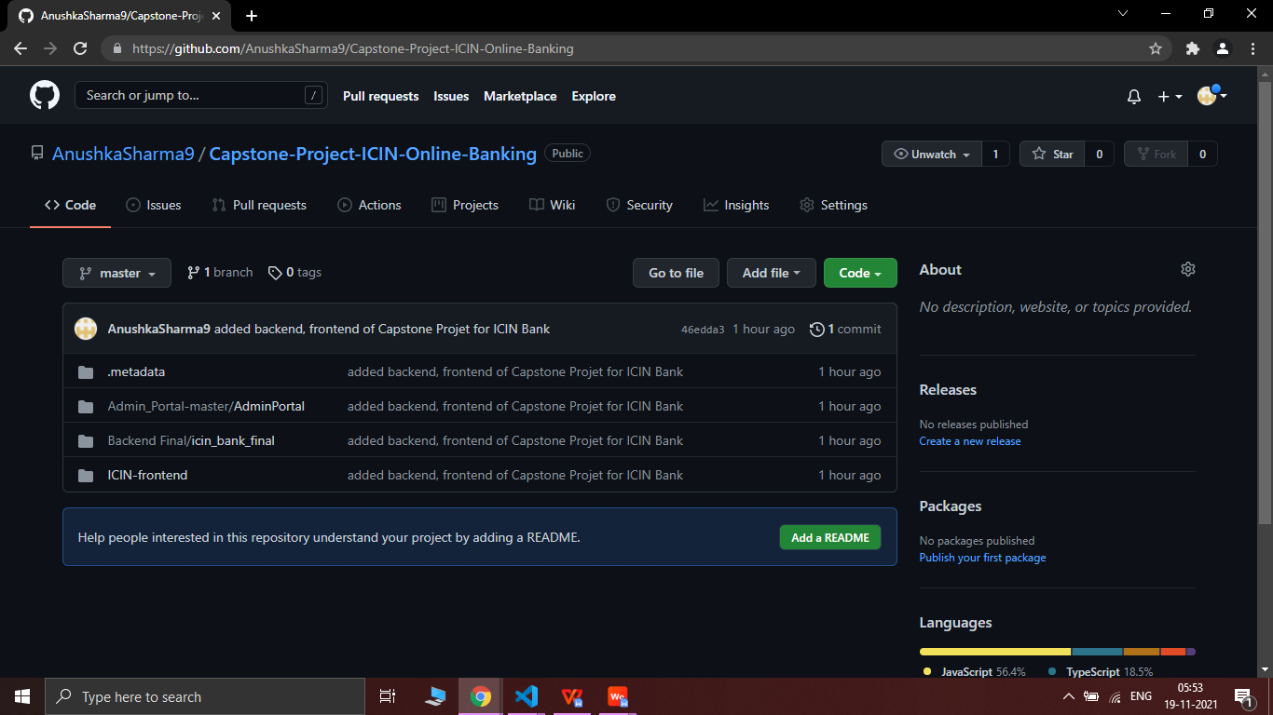

1. How to run Project :

4.1. clone project

clone git : git clone <https://github.com/AnushkaSharma9/Capstone-Project-ICIN-Online-Banking.git>

4.2. open Capstone-Project-ICIN-Online-Banking->Backend Final->icin_bank_final->src->main->java->com->icin

right click on icin_bank_final -> Run as -> Spring Boot App

* Name of Project->>**icin_bank_final**

4.3 ICIN-frontend -

* Open VS Code in this folder
* Run command in VS Code in terminal as ‘ng serve’, to start the ICIN interface for user on port http://localhost/4200.

4.4 Admin_Portal-master/AdminPortal -

* Open VS Code in this folder
* Run command in VS Code in terminal as ‘ng serve --port 4201’, to start the Admin Controller for user on port http://localhost/4201.
* **DIRECTORY STRUCTURE / PACKAGE**

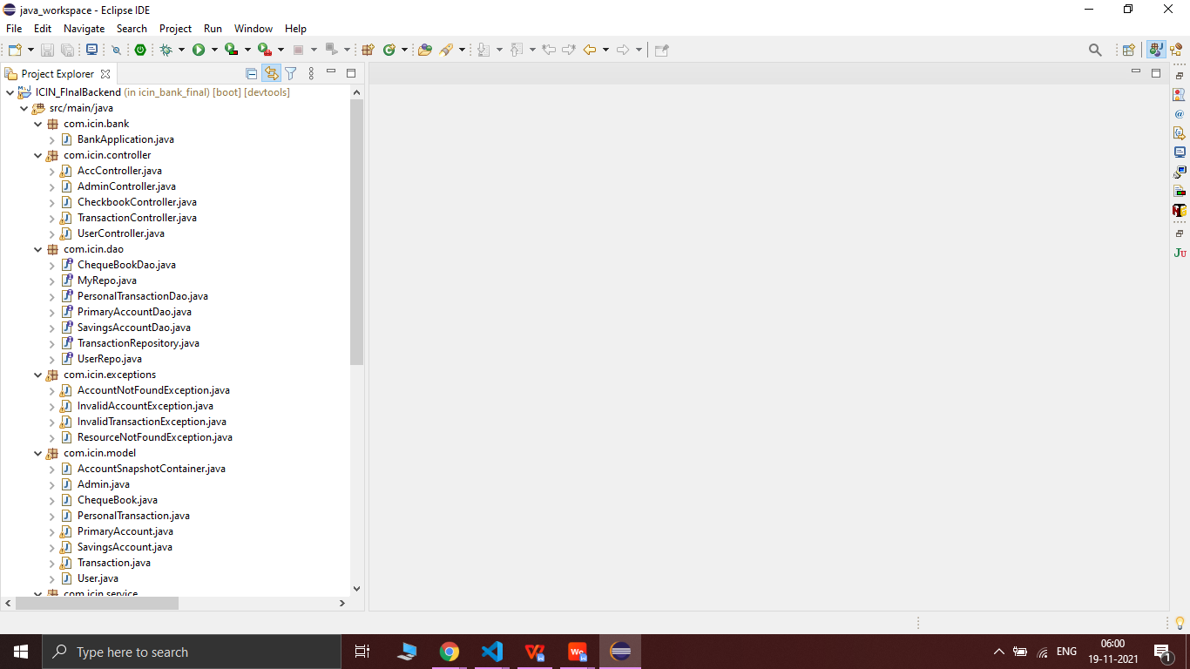

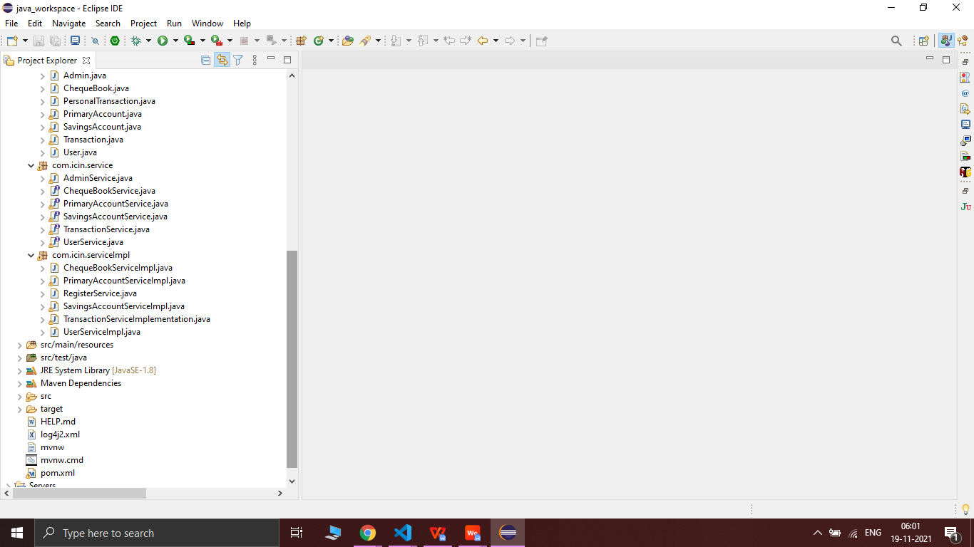

* **SCREENSHOTS OF OUTPUT**
* **SCREENSHOTS OF USER / ICIN PORTAL**

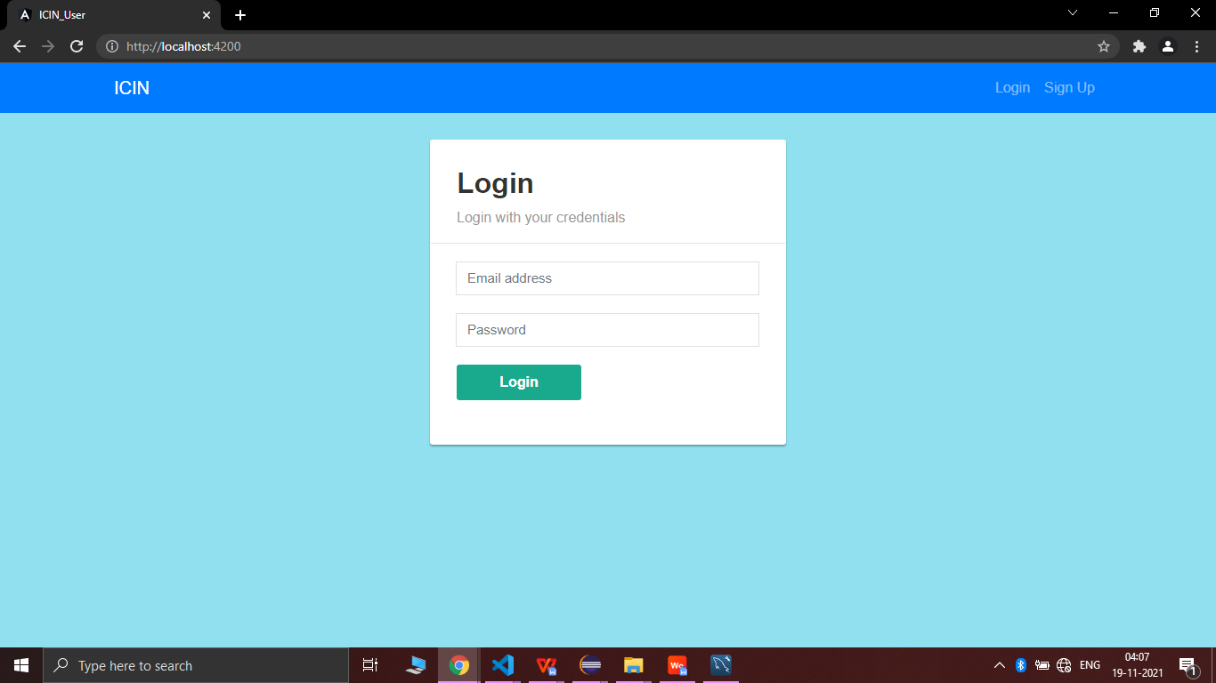

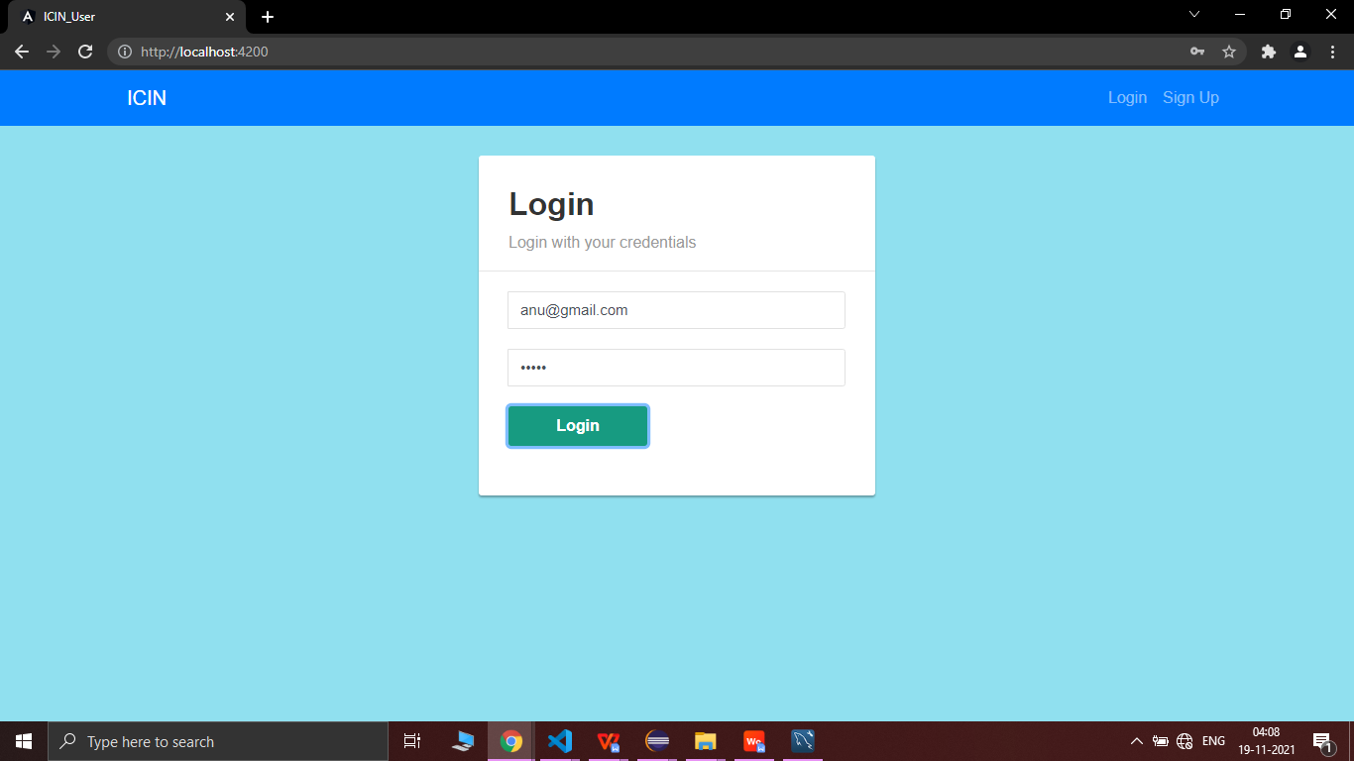

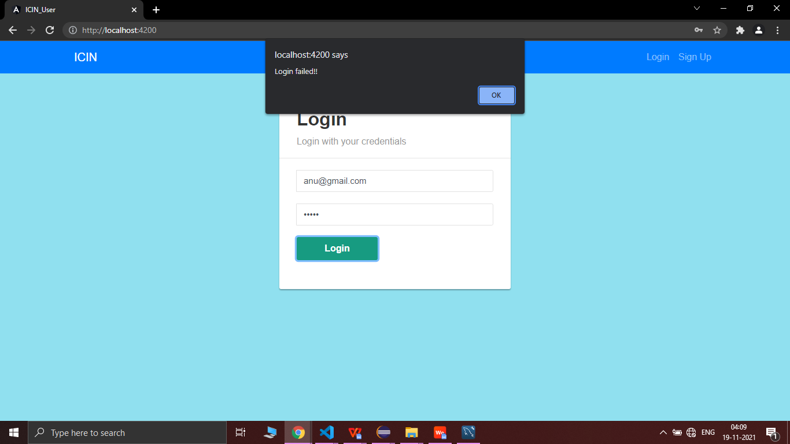

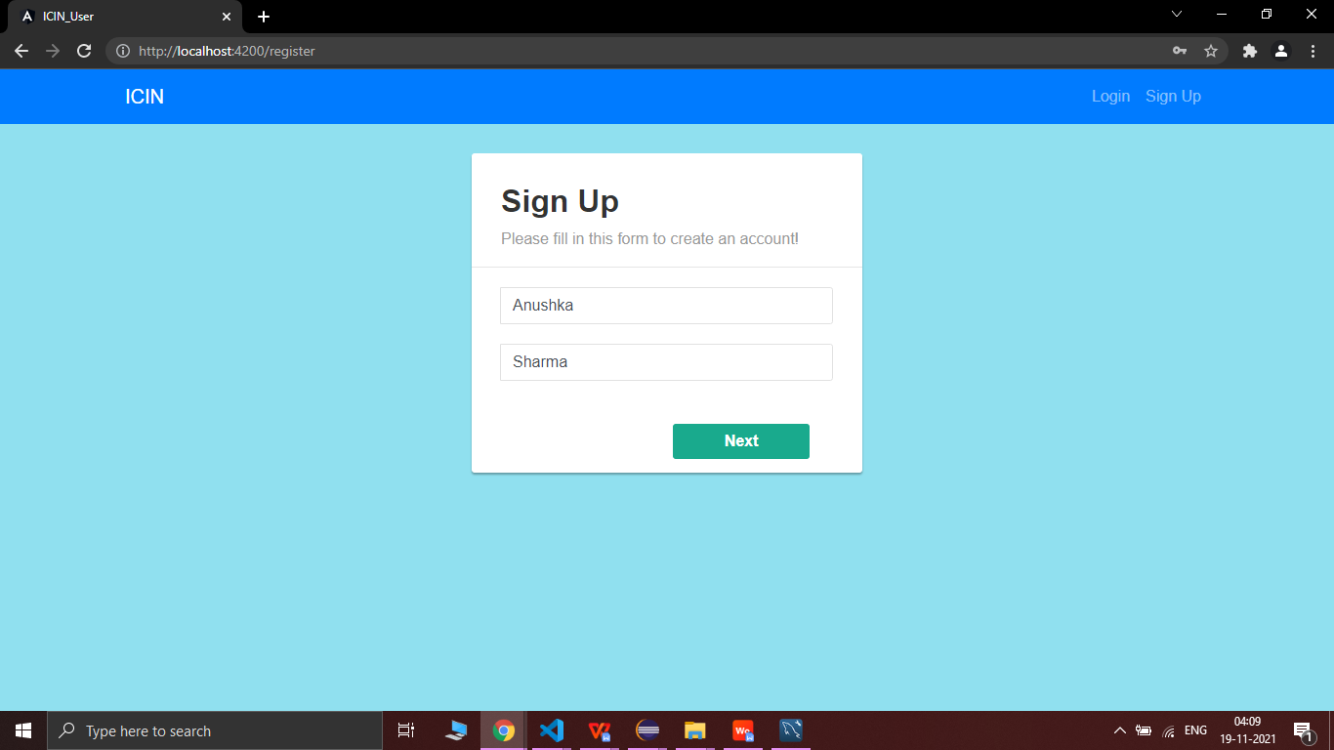

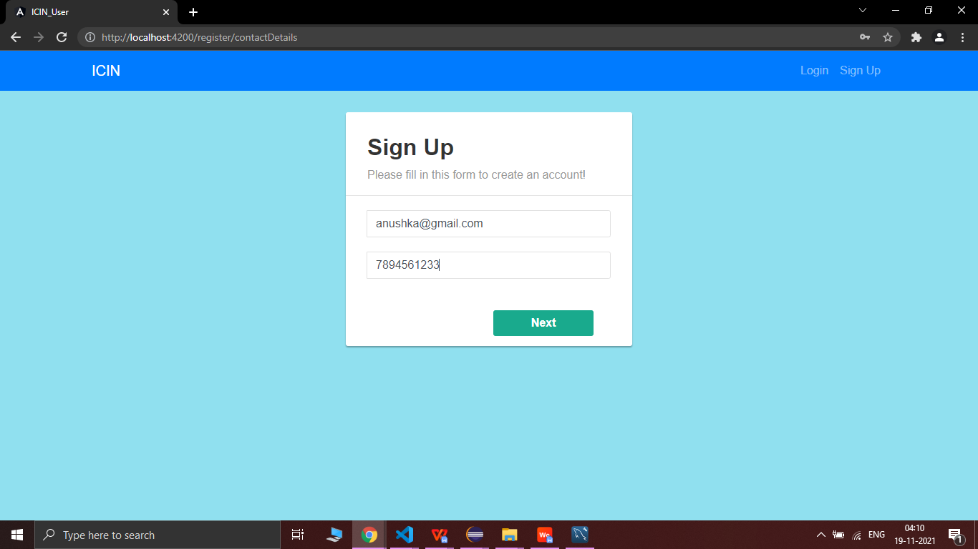

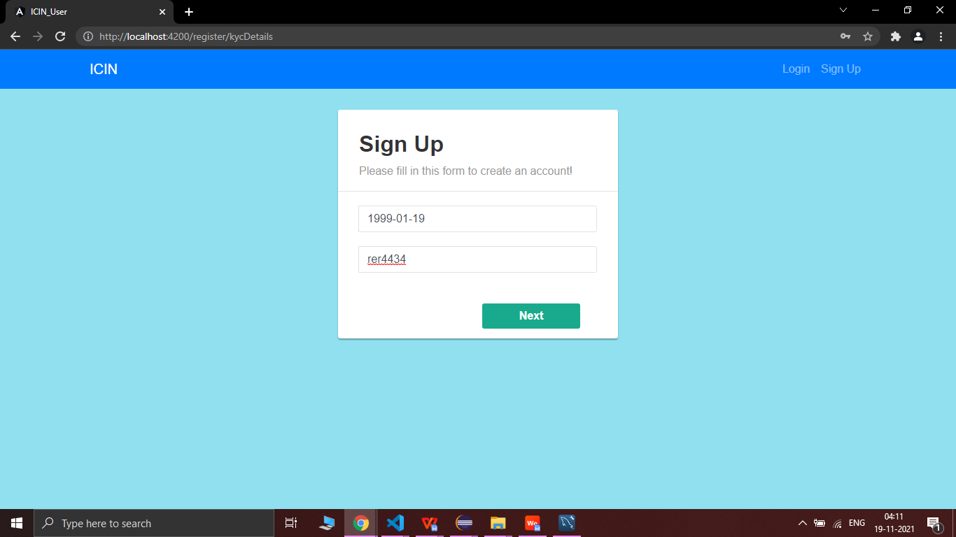

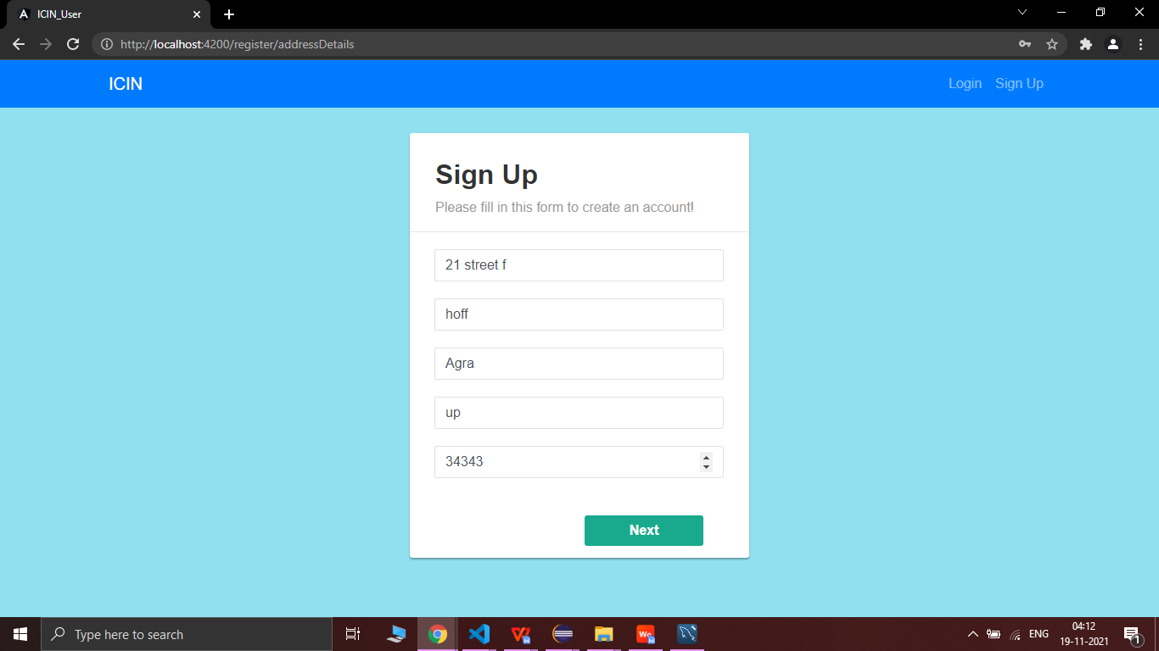

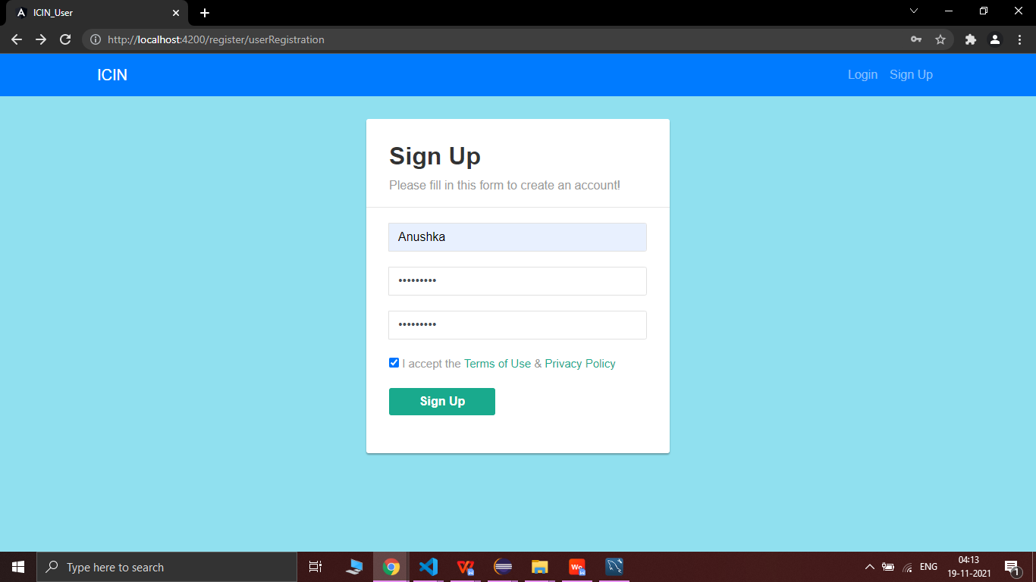

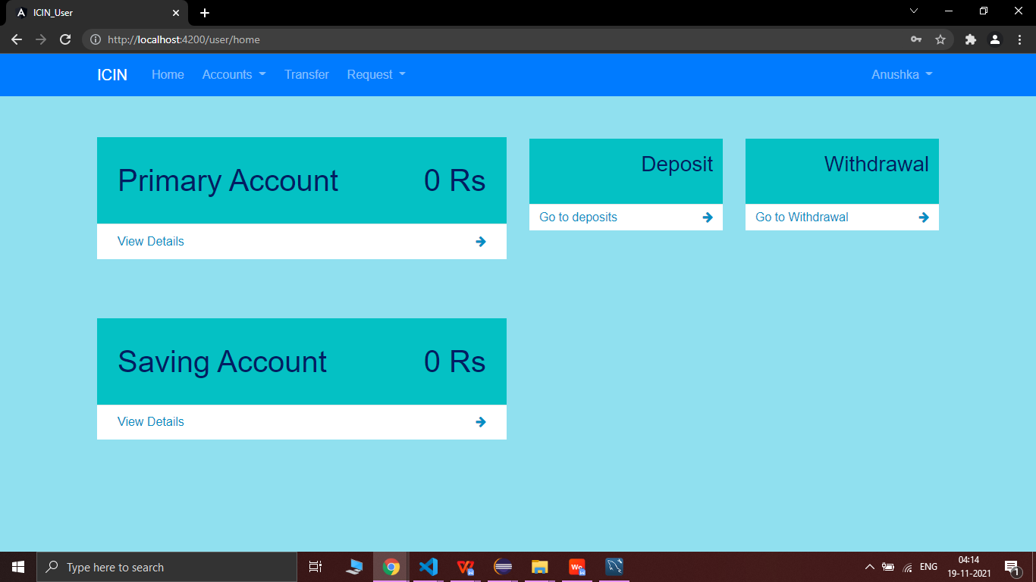

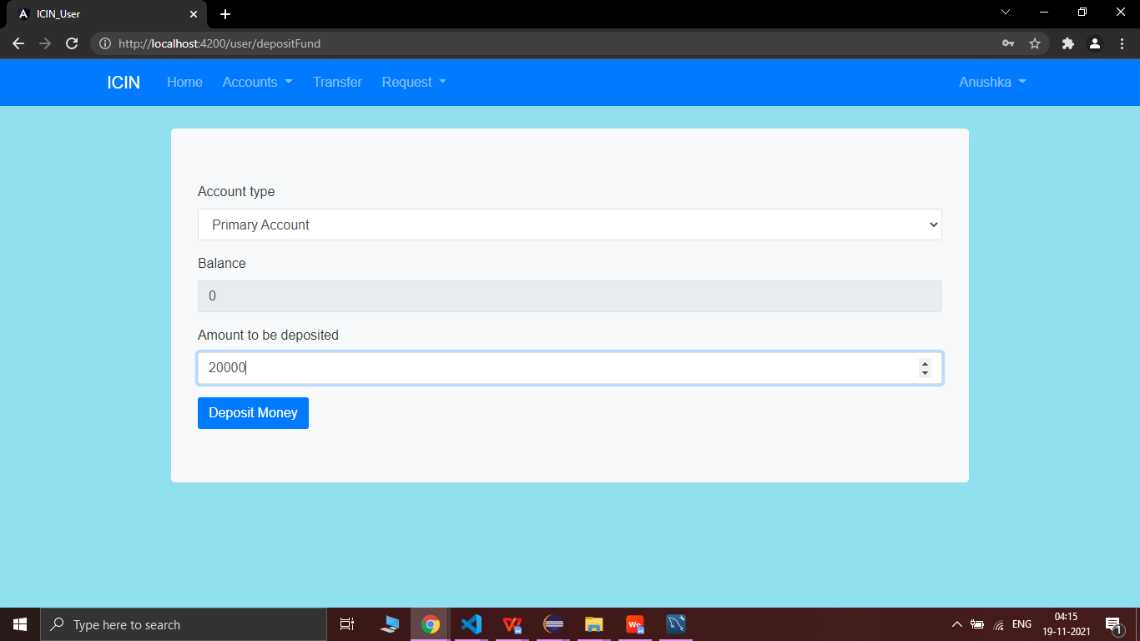

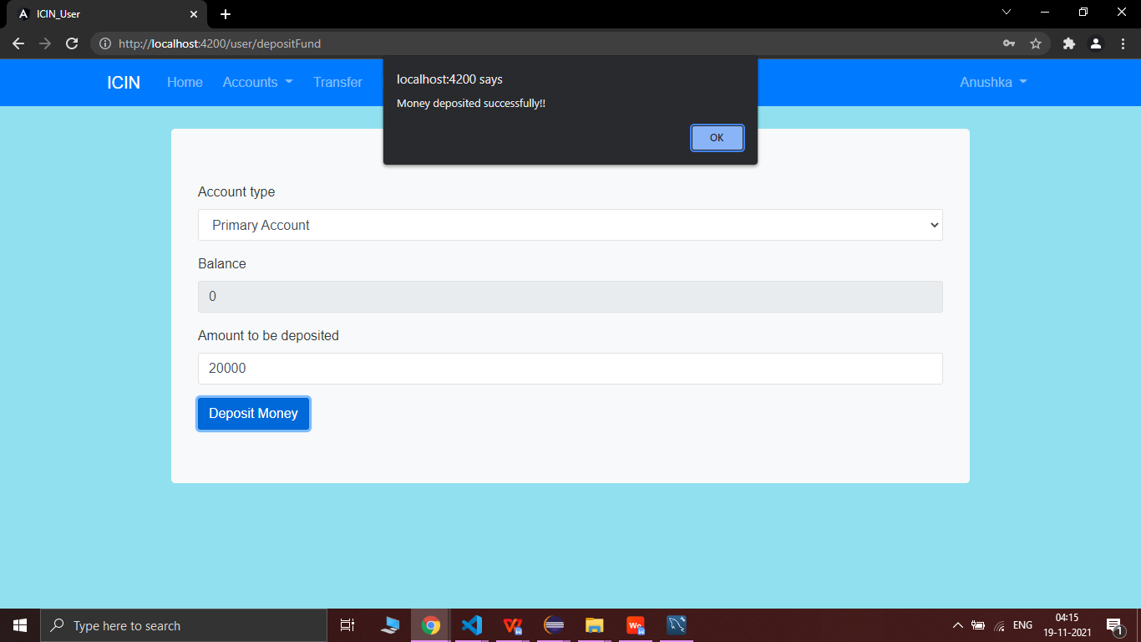

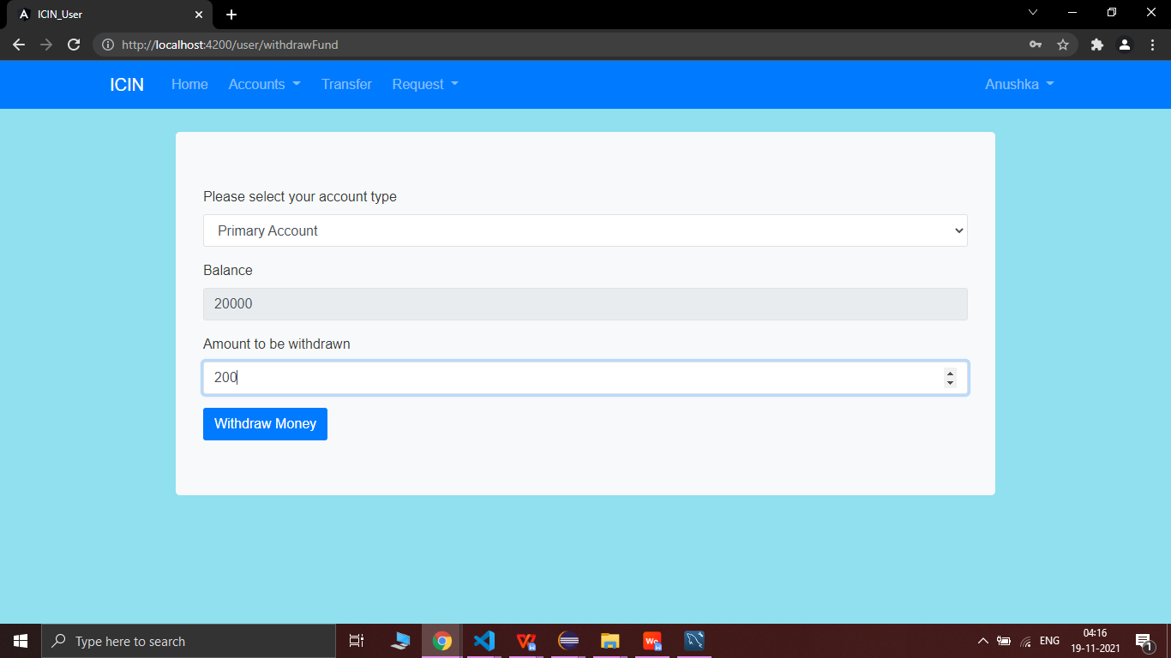

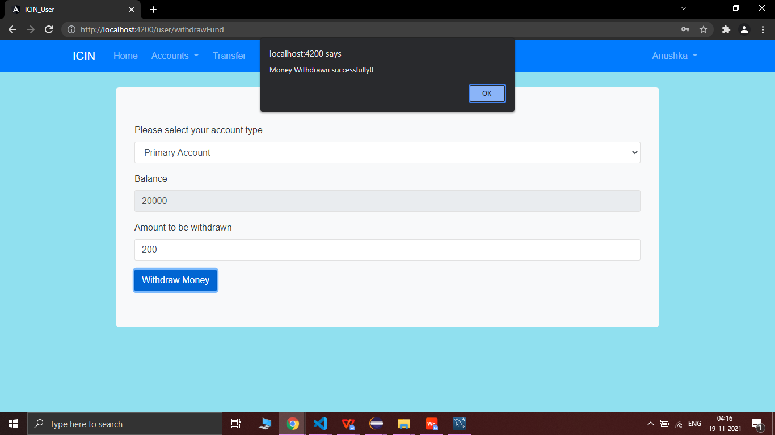

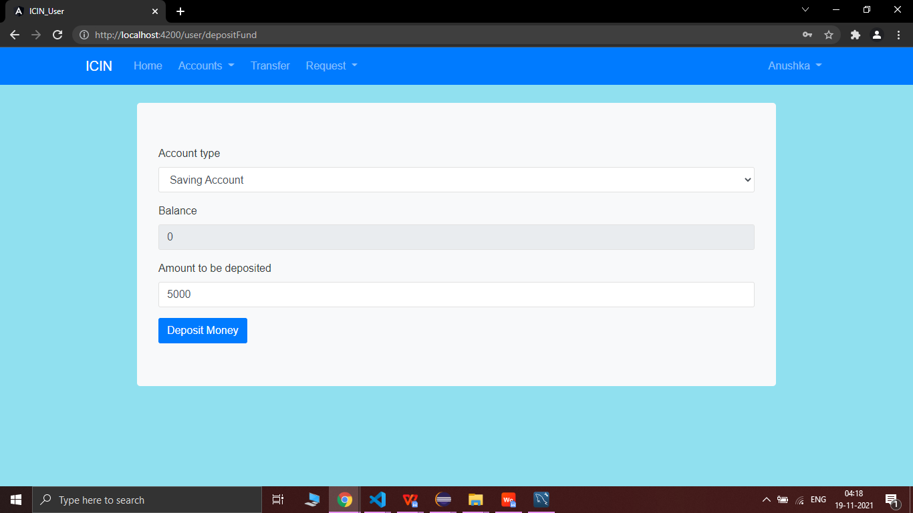

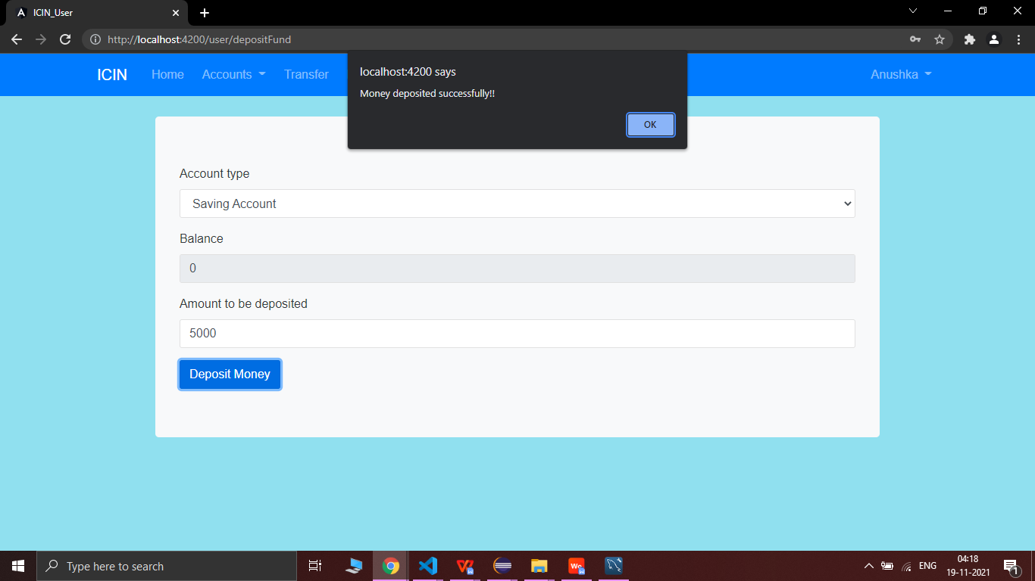

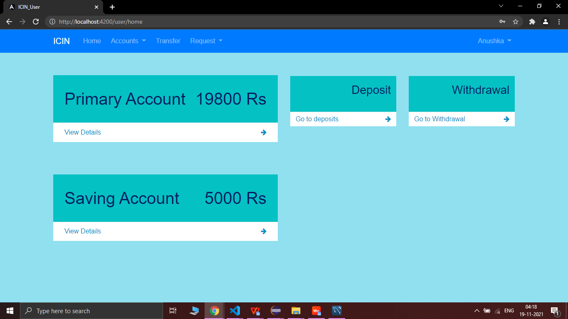

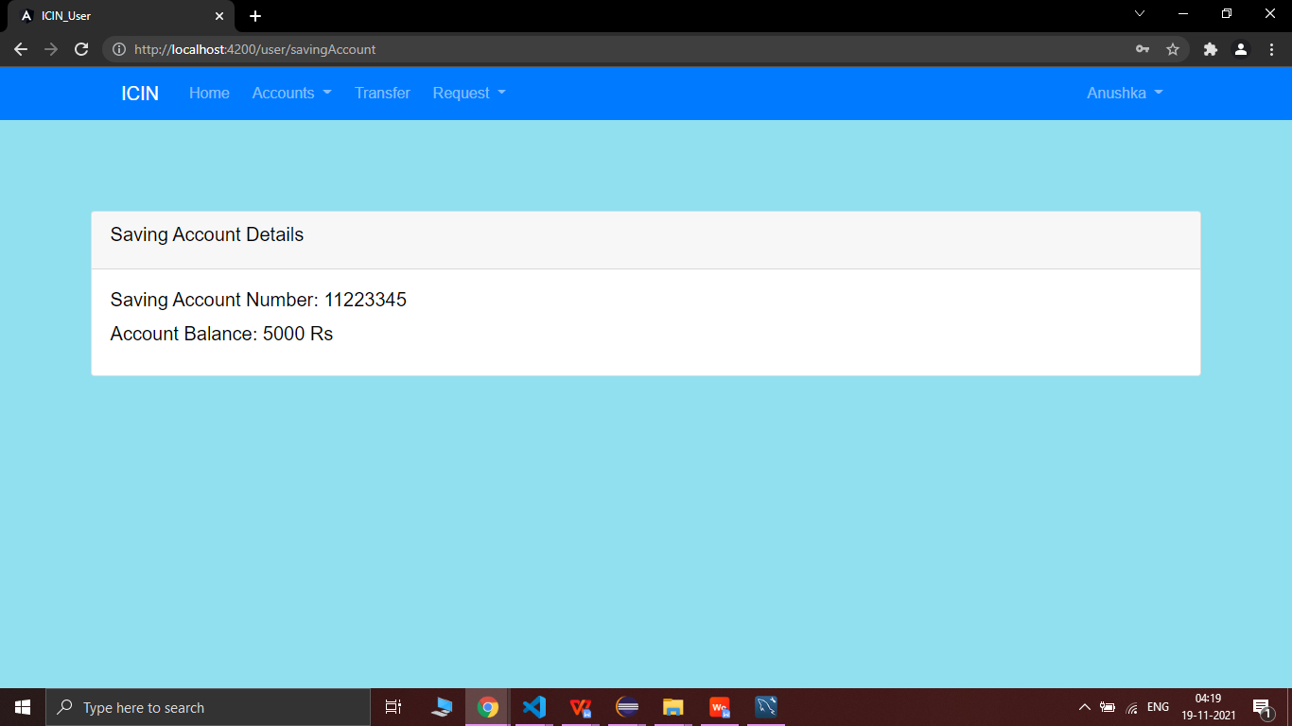

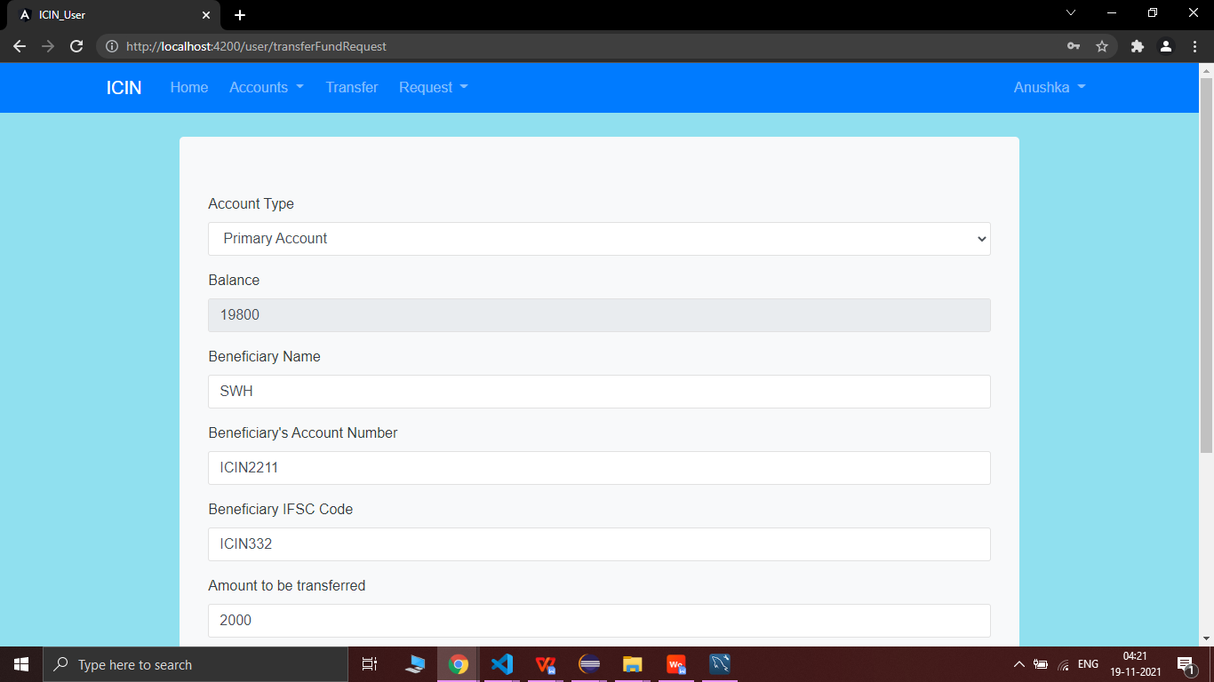

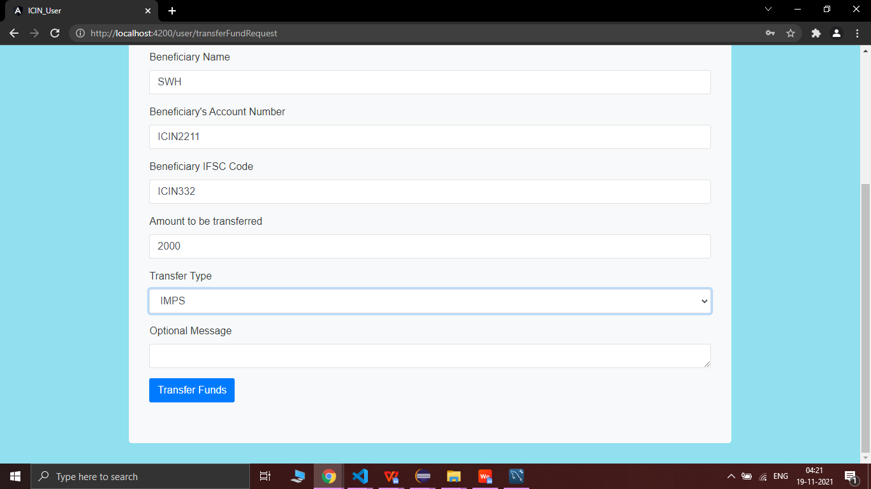

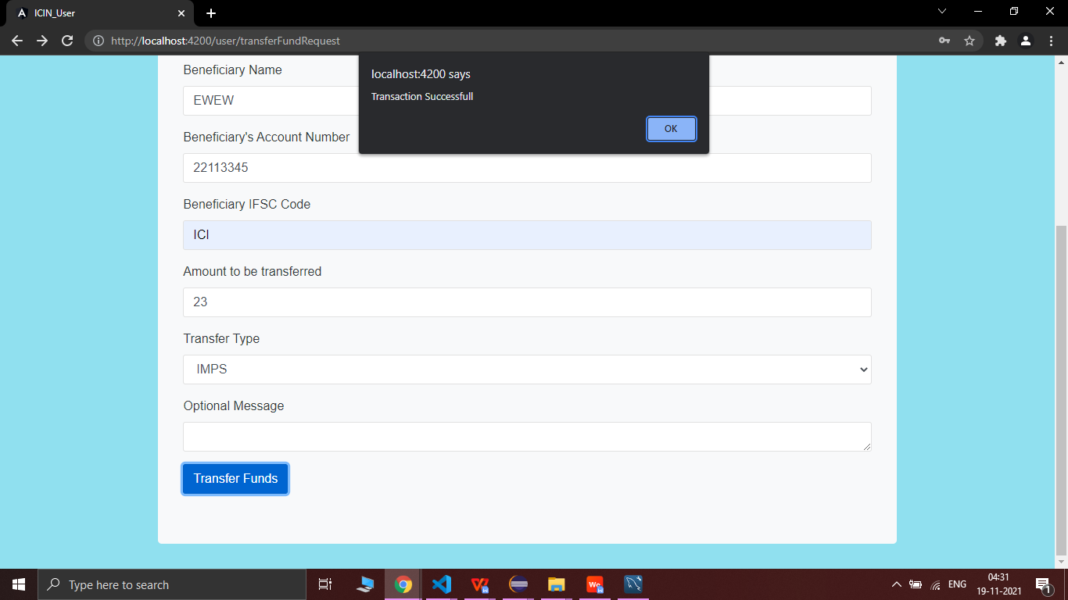

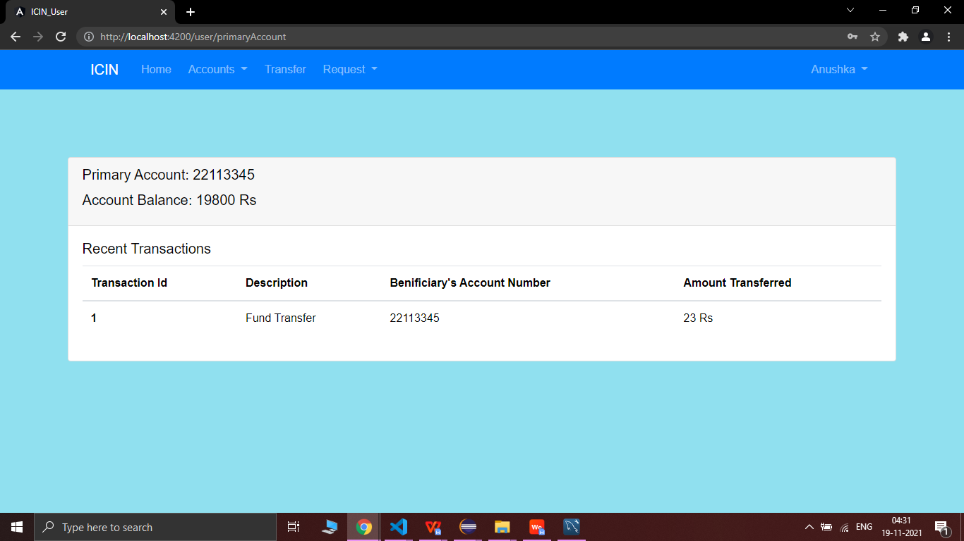

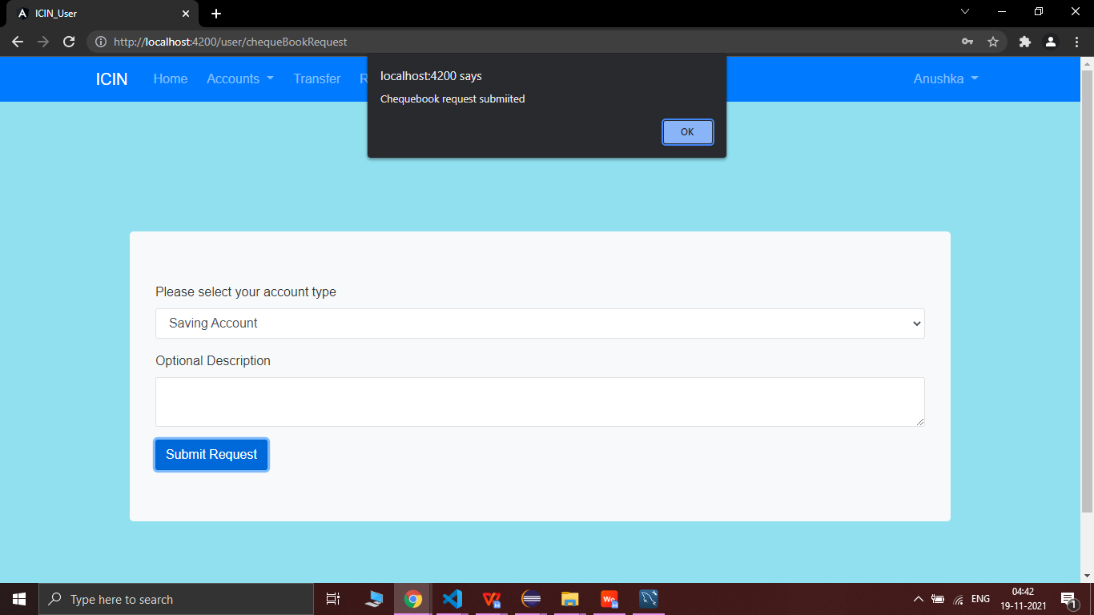

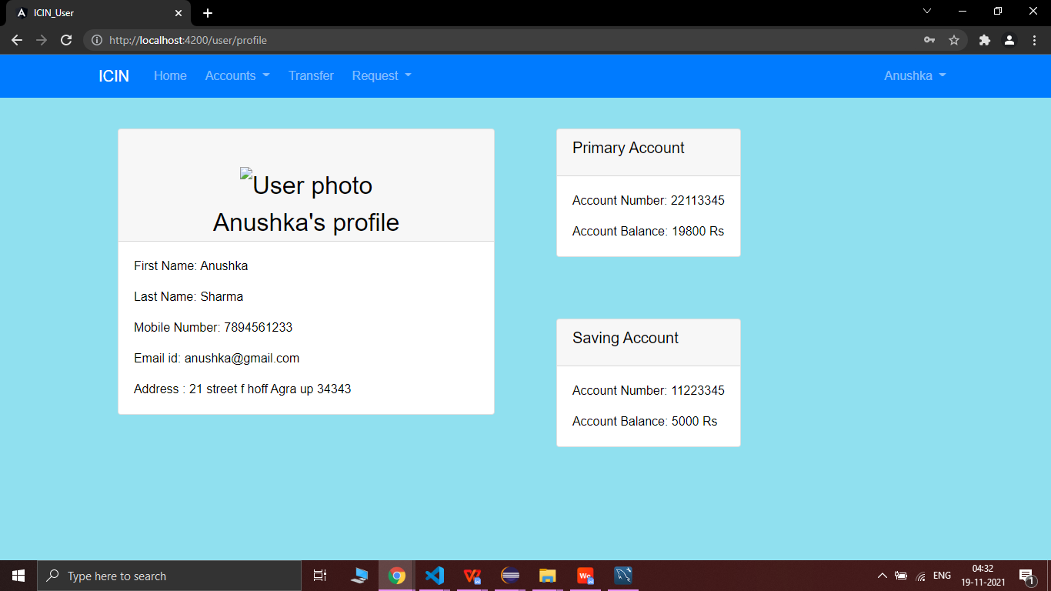

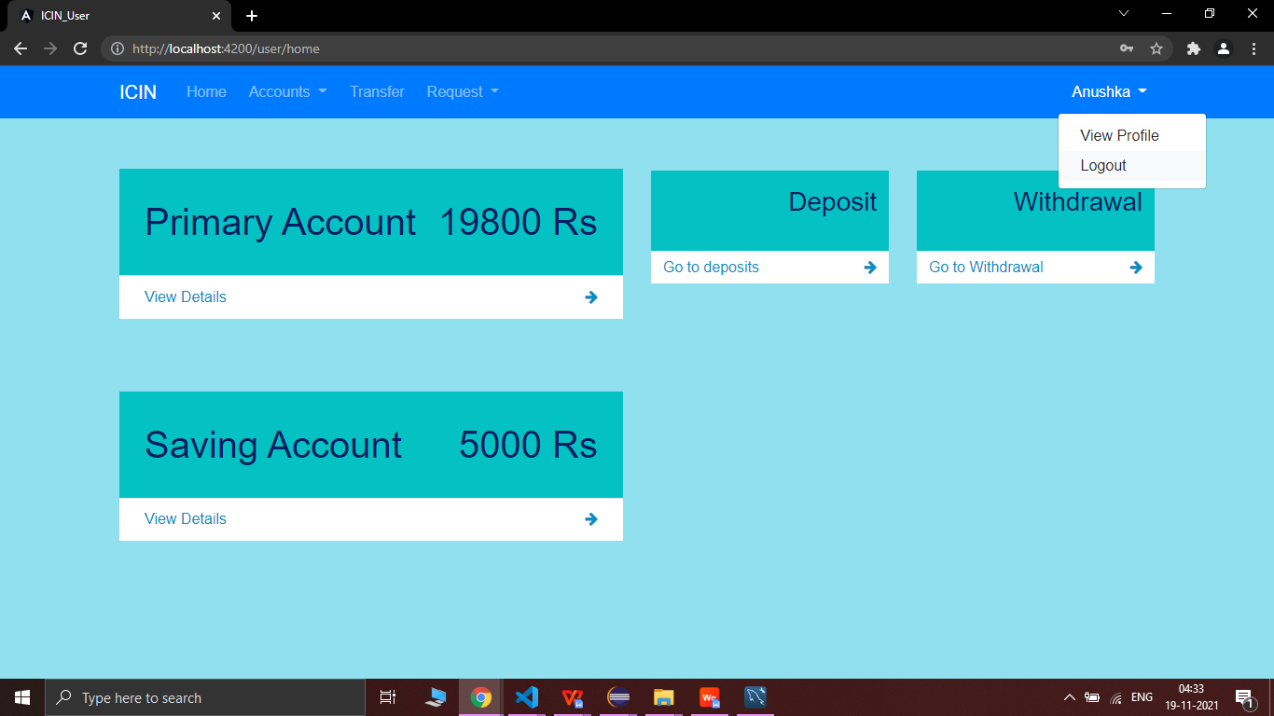

* **SCREENSHOTS OF ADMIN PORTAL**

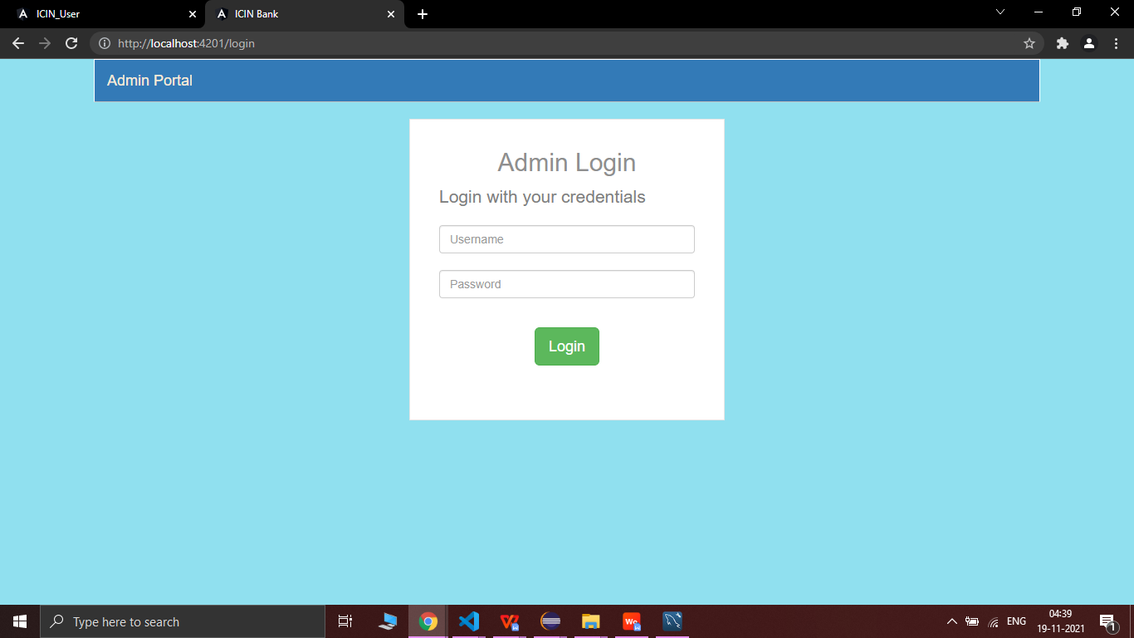

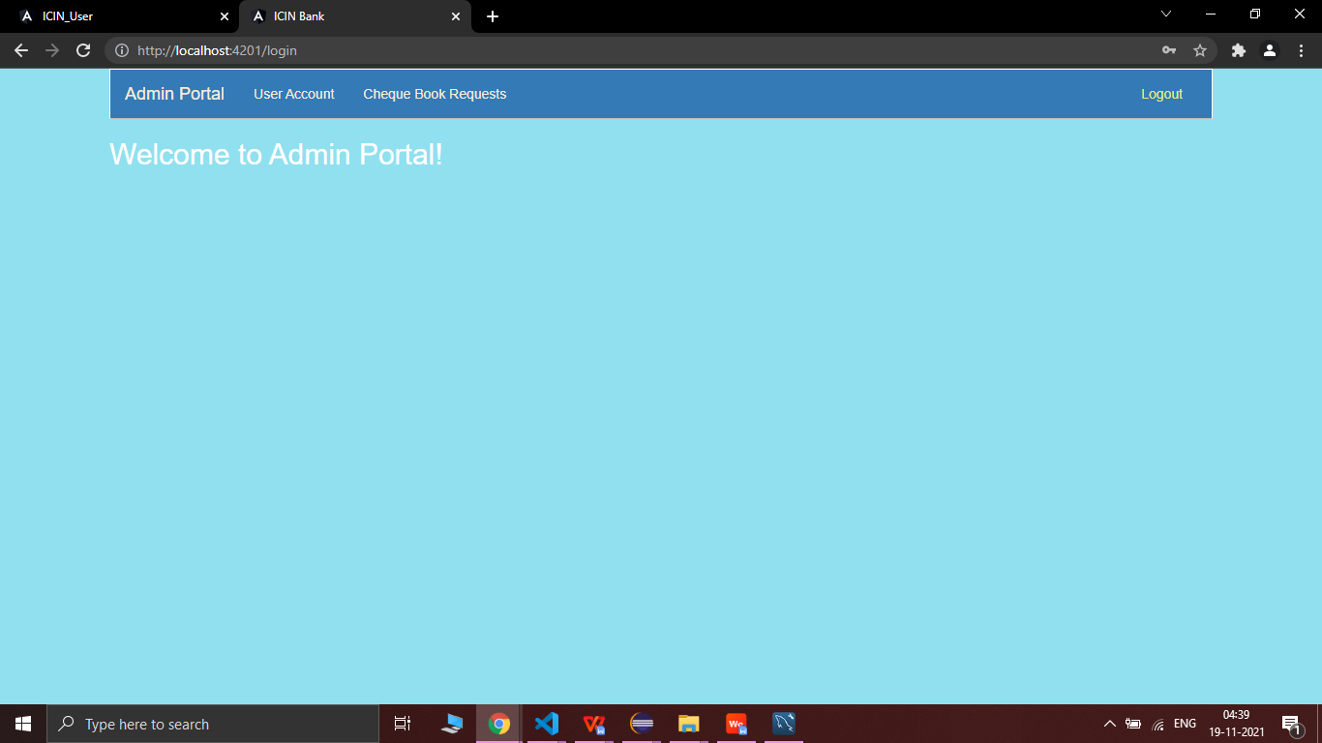

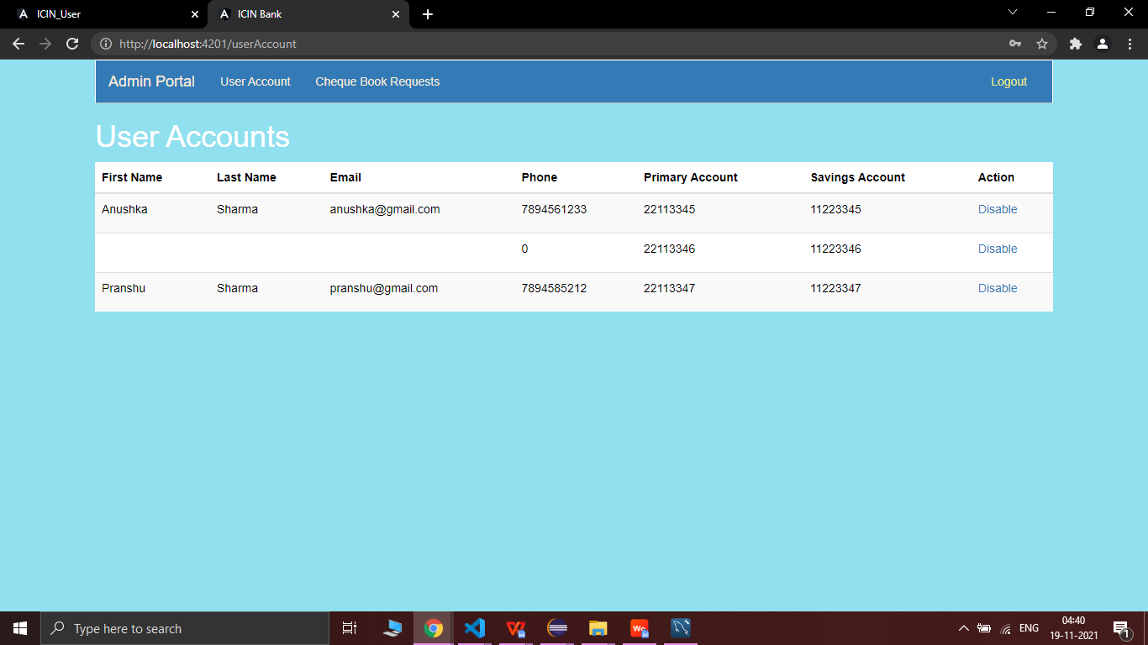

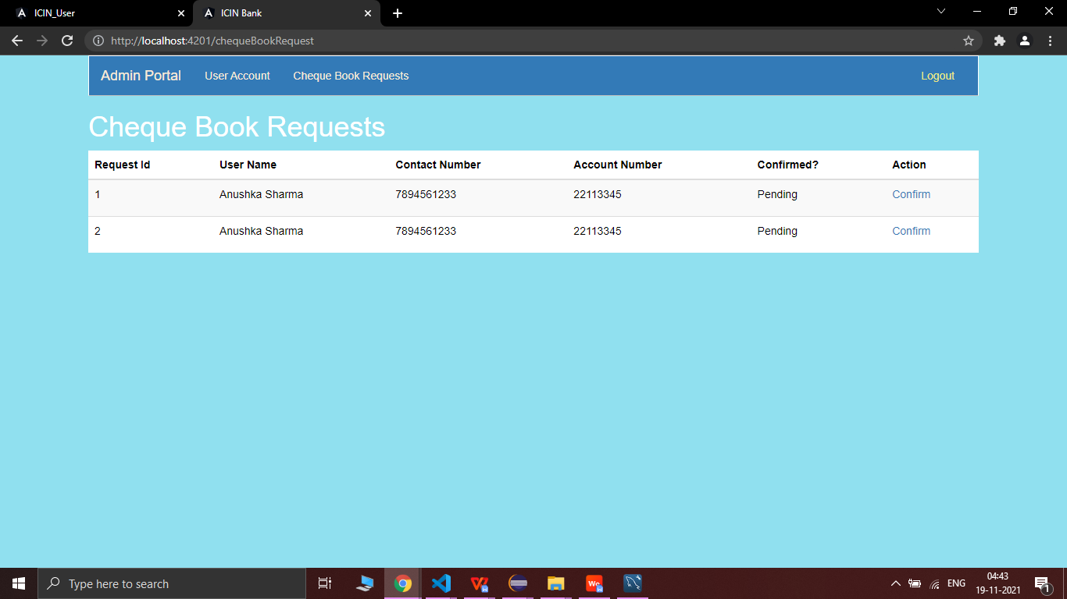

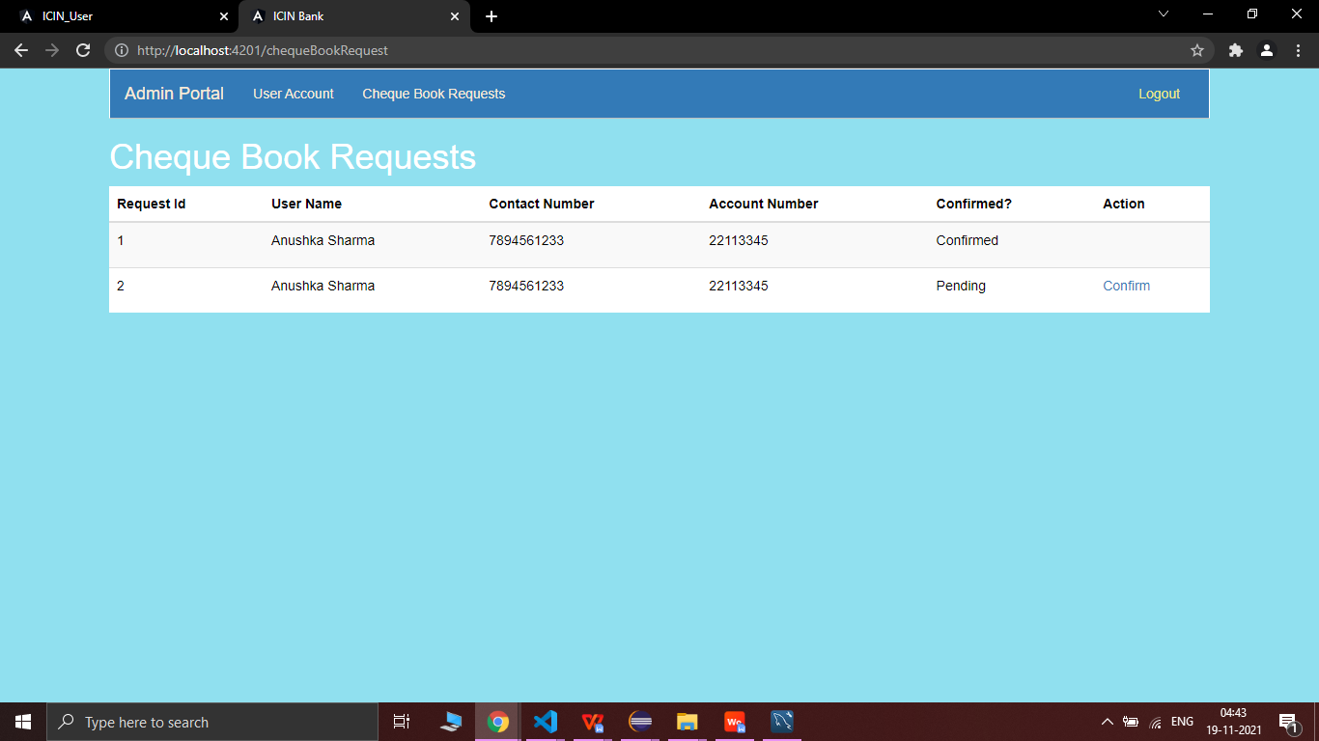

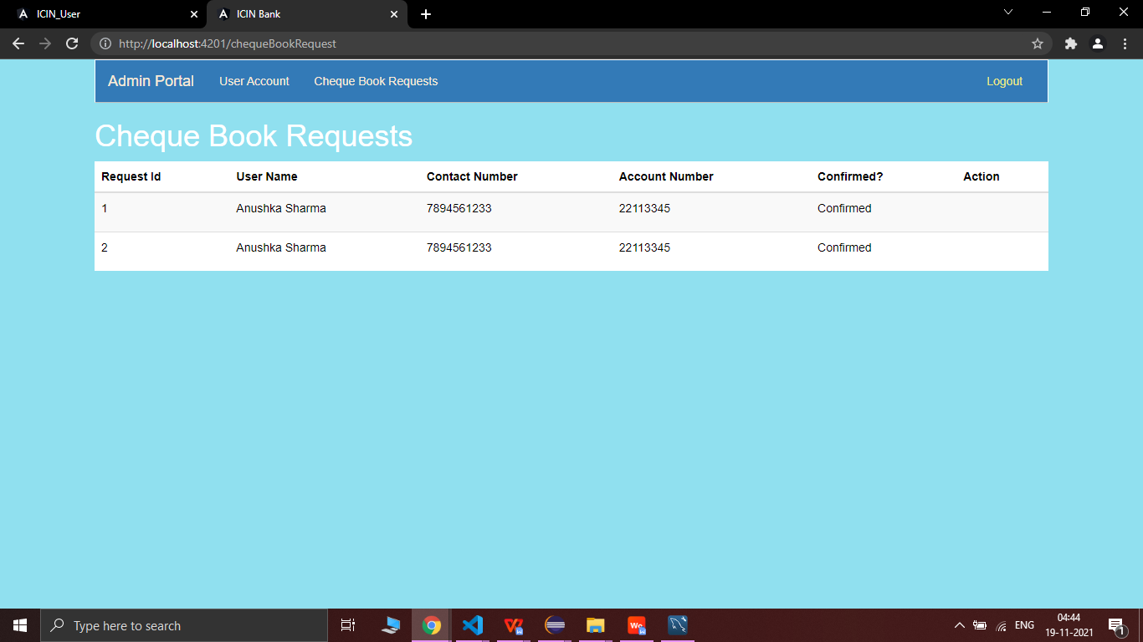

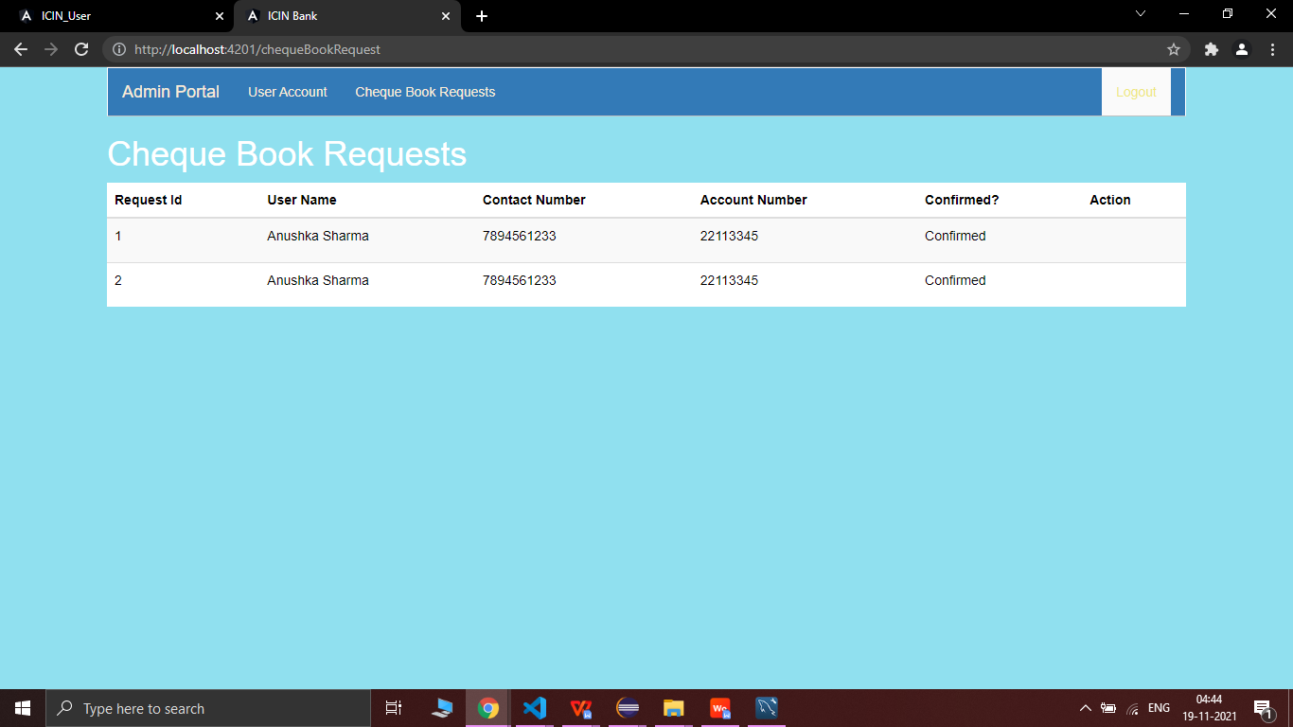

* **SCREENSHOTS OF DATABASE**

