**WEEK-4**

Task-1

We made an account on moqups using our college mail.

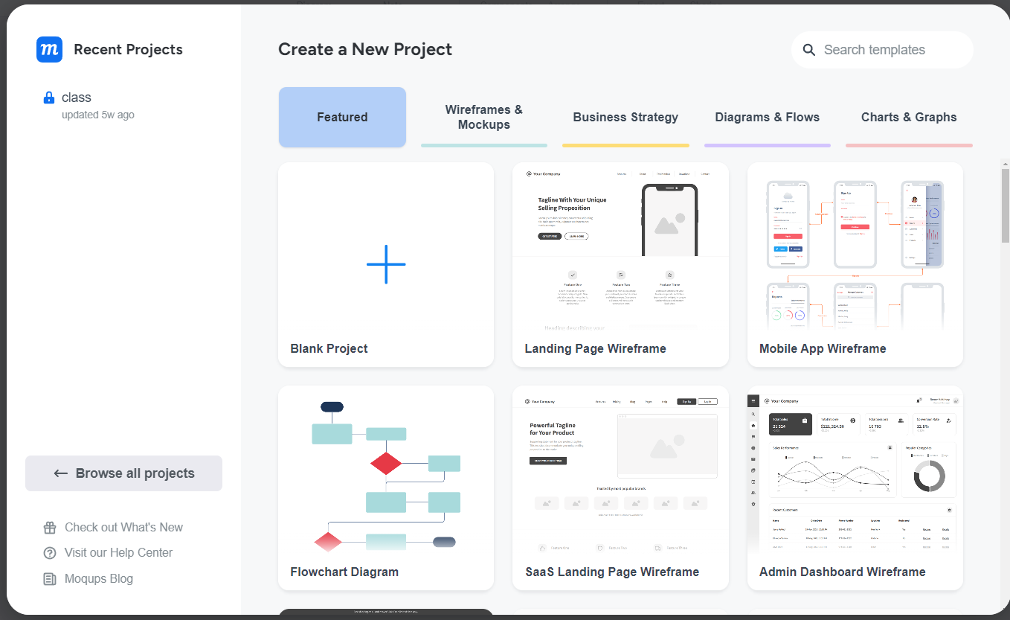Then started creating a new project.

Then checked for stencils pages and images.

Now moving on to the page setting:

We set the width and height of the page 800*700.

