

**A Brief Report on Setting Up Git and Managing Repositories**

Submitted By: Anushka Thapa

Level 3, Section ‘A’

Student ID: 23085188

Submitted To: Sumanta Silwal

Module: Internet Technology

**Introduction:** Git is one of the most widely used version control systems due to its flexibility and robustness. This report aims to provide a comprehensive guide for new users on setting up Git and managing repositories.

**Objective:** This report has these following steps:

* Downloading and installing Git.
* Setting up a Git repository.
* Adding files to the repository.
* Making changes to files and committing them.
* Configuring user information.
* Understanding branching and merging.
* Addressing common issues and providing tips for working with Git.

**TASK - 1**

**Step-by-Step Guide:**

* 1. Downloading Git from: https://git-scm.com/ (Version 2.43.0)
  2. Install Git (Installation Guide: <https://www.youtube.com/watch?v=SWYqp7iY_Tc>)
  3. Then after the installation create a folder in Desktop with name “L3” and Right Click on folder L3 and Select Git Bash Here. You will see this in the screen.

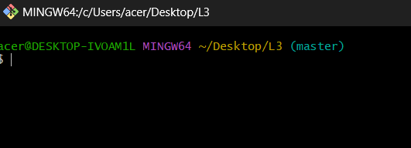

* 1. The next step is to check the git version by using the command *git --version*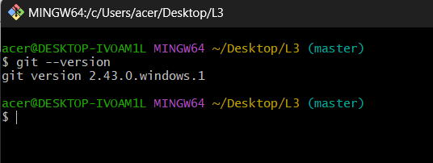
  2. In the next step, we added files with these commands: *touch index.html, touch about.html and touch resources.txt.*

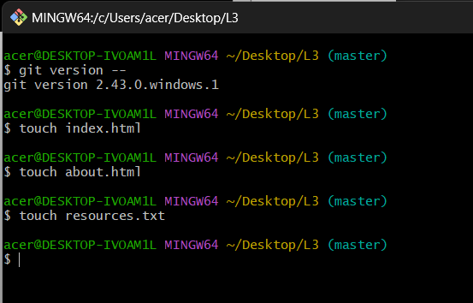

* 1. After adding the files check your folder and you will see these files.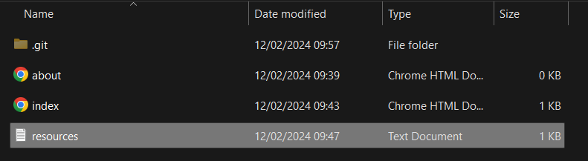
  2. Then we open our file index.html in notepad or notepad++ and add lines of code and save it.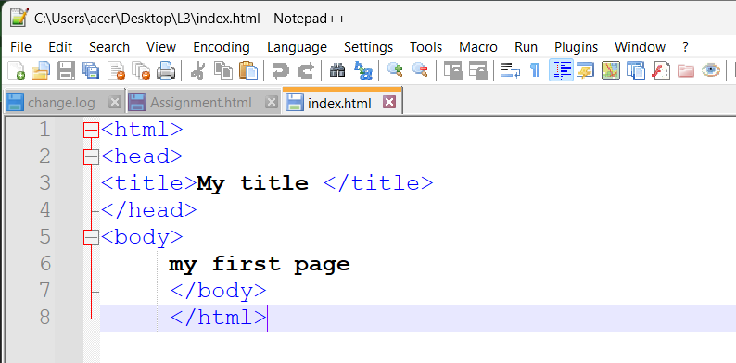
  3. Open resources.txt and write your name and save this file.
  4. Then, we initialize a Git repository/working directory by using *git init* command and when we check our folder, we see .git folder and within this folder we find Git Related Folders and files.

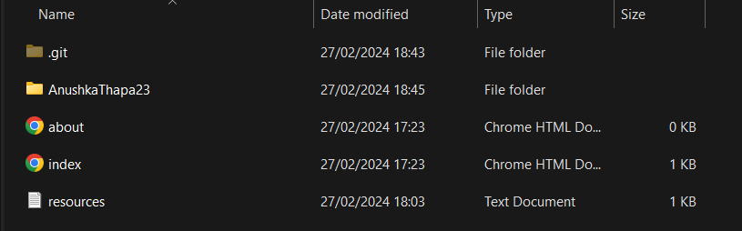

* 1. In this step, we configure our username and email by using these commands

• git config --global user.name ‘Anushka Thapa’

• git config --global user.email ‘tanushka23@tbc.edu.np’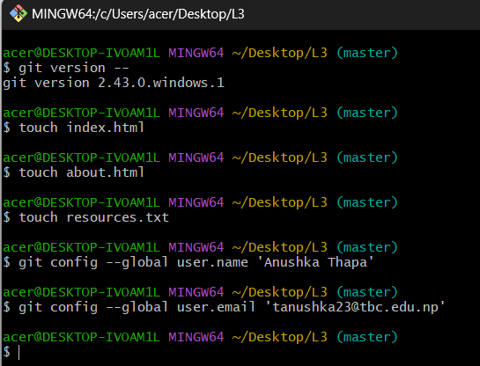

* 1. Then we check the status of working directory by using *git status* command.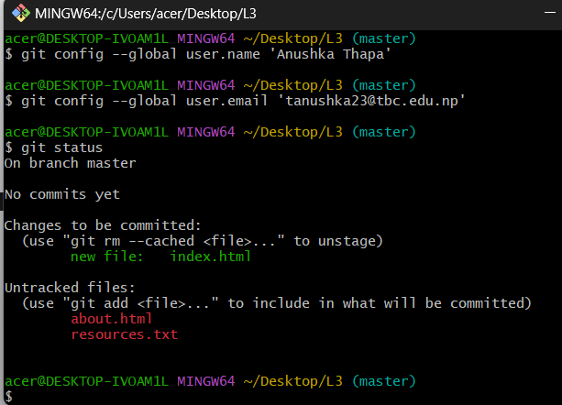
  2. Add file or files (by using git add index.html / git add .command).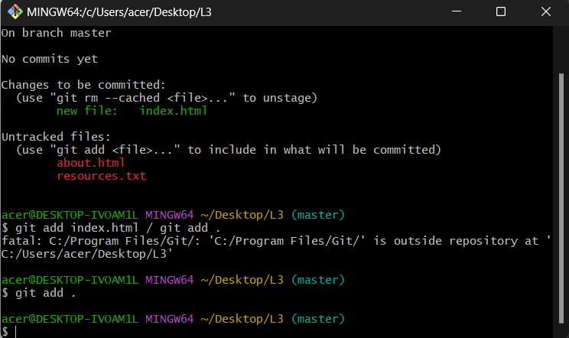
  3. Check status of working directory. 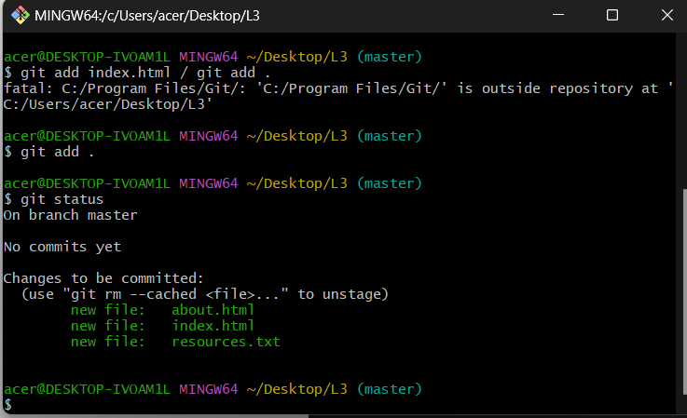
  4. Commit changes in your working directory.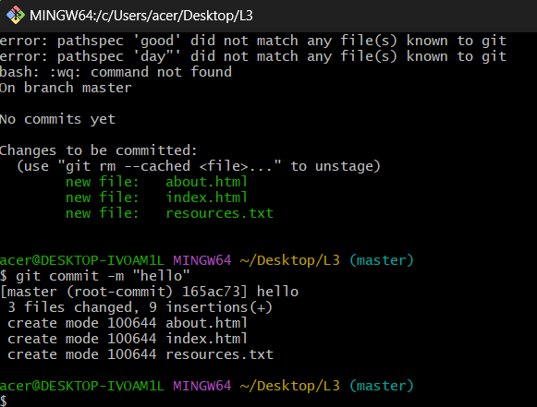
  5. After all commit, Check Status of Working directory (This will show you message like nothing to commit, working tree clean).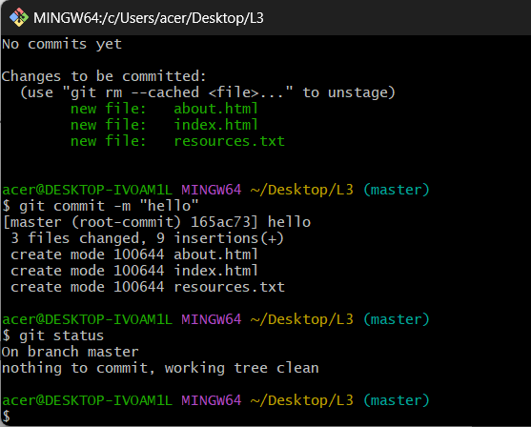
  6. Make changes to resources.txt. Add few names of your friends.



* 1. Check with git status, it will show (changes not staged for commit).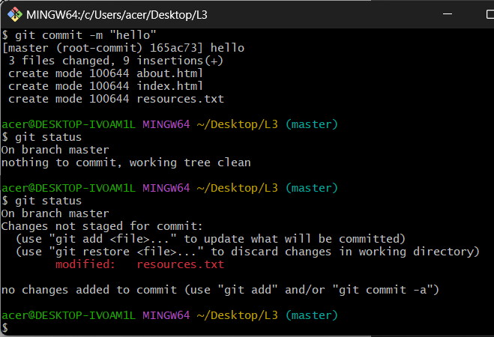
  2. Add file or files.
  3. Commit changes in your working directory with commit message by using the command *git commit -m ‘Changed resouces.txt’.*

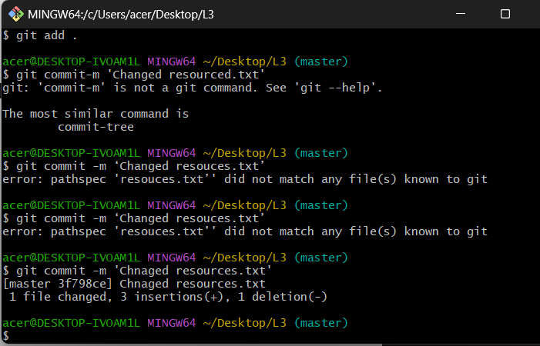

20. Check with git status, it will show ‘changes not staged for commit’.

21. View commit history.

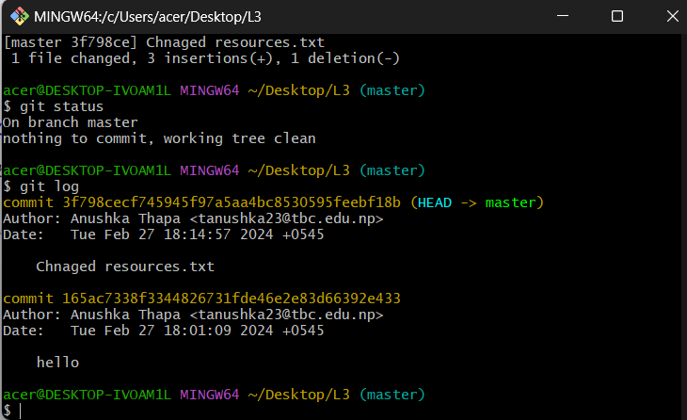

**TASK – 2**

1. Create an account on github.com
2. Use Git Bash and follow these commands:

• git remote

• git remote add origin <https://github.com/AnushkaThapa23/AnushkaThapa23.git>

• git remote

• git push -u origin master

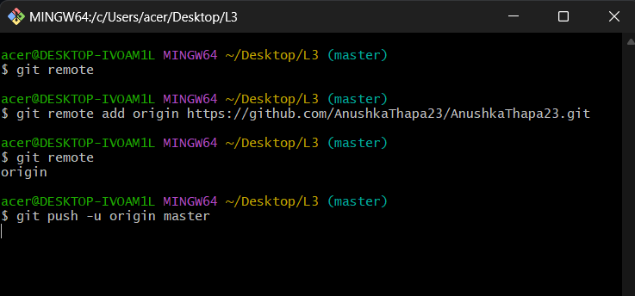

After this git takes you to the GitHub login page where you enter your GitHub username/email and password. And when you refresh your repository page you see your added files.

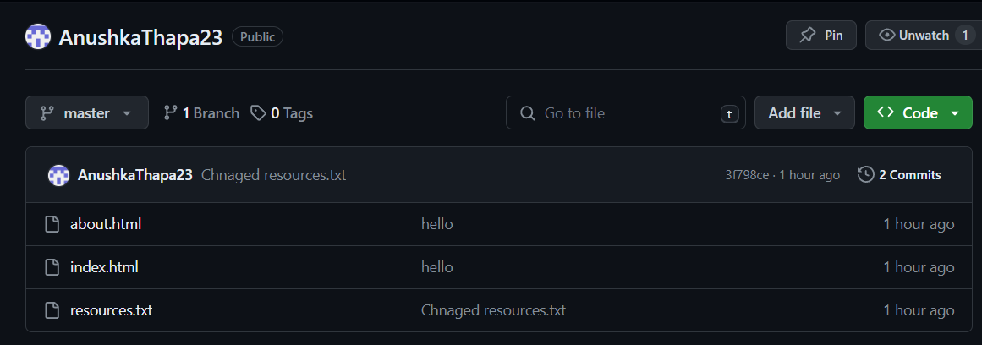

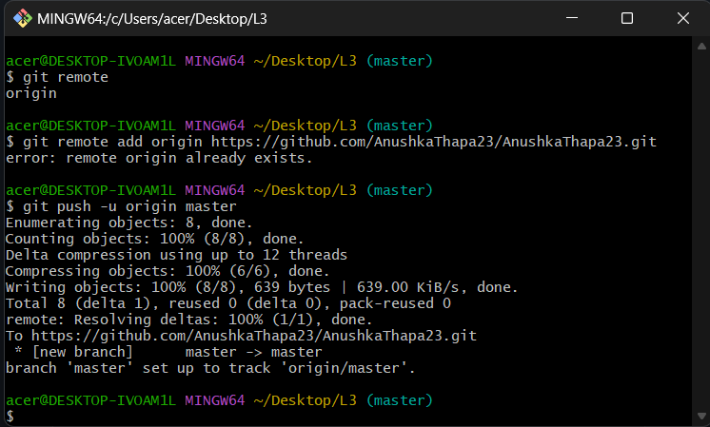

1. Clone GitHub Repository (*by using git clone https://github.com/AnushkaThapa23/AnushkaThapa23.git*)

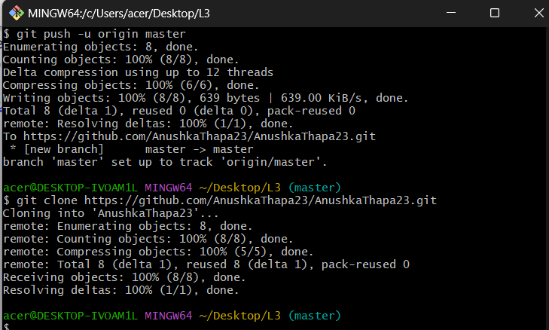

**Conclusion:**

Setting up Git and managing repositories is a fundamental skill for software development. This report helps to provide new users with understanding of Git's basic functions. By following this, users can effectively use Git for version control and collaboration in their projects.