**WEEK-8**

**Task-1**

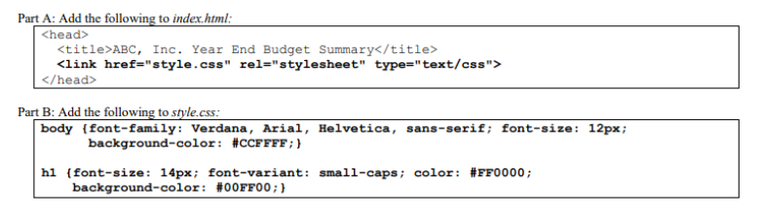

Code-

Explanation- This HTML code creates a webpage titled "ABC, Inc. Year End Budget Summary". It includes a link to an external CSS file named "style.css" for styling purposes. The body of the webpage contains the text "Today is a good day!!".

Output-

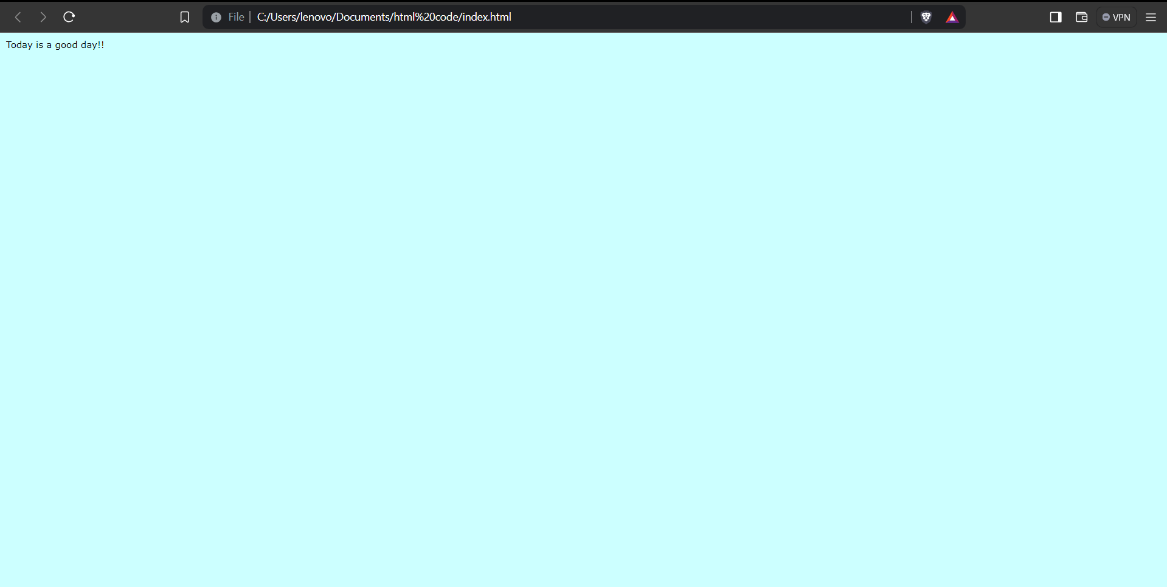

**Task-2**

Code-

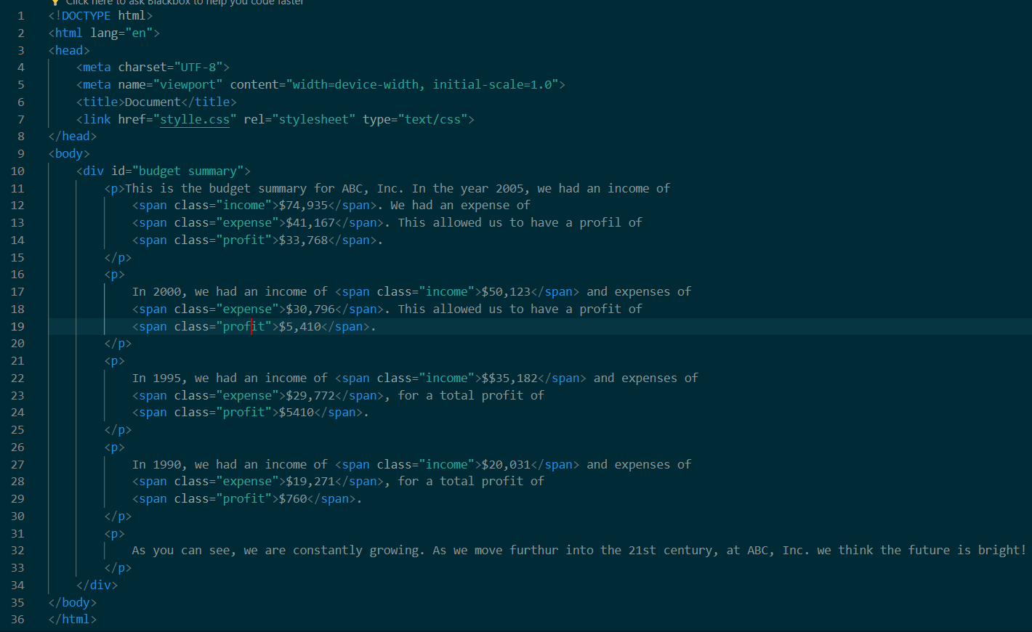

Explanation- This HTML code creates a document displaying the budget summary for ABC, Inc. across different years. It includes income, expenses, and profits for the years 2005, 2000, 1995, and 1990. Each financial figure is styled differently using classes, such as "income", "expense", and "profit". The styling for the document is defined in an external CSS file named "stylle.css".

Output-

**Task-3**

Code-

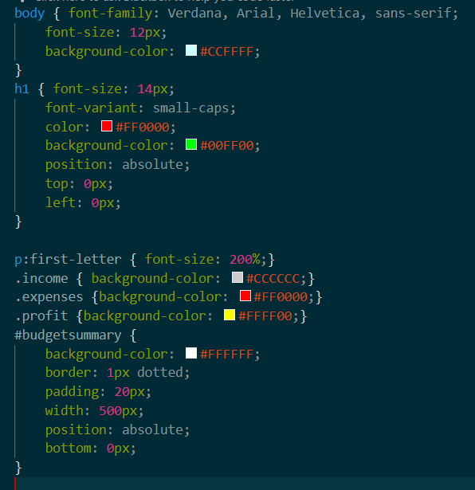

Output-

**Task-4**

Code-

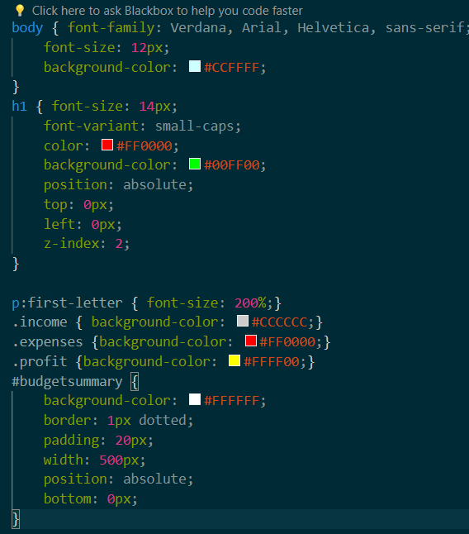

Explanation- This CSS code sets the styling for various elements of an HTML document. It defines the font family and size for the body text, sets background colors for the body and headings, positions the heading at the top left corner of the page, and specifies the z-index to control stacking order. It also styles the first letter of paragraphs, sets background colors for elements with specific classes (income, expenses, profit), and styles a div element with the id "budgetsummary" by specifying background color, border, padding, width, and absolute positioning at the bottom of the page.

Output-

