**WEEK-9**

**Task-1**

Reproduce the following table using CSS positioning (relative or absolute) instead of <table>

Code-

Explanation- This HTML code creates a webpage layout featuring columns and colored blocks. The columns are styled with CSS to have a fixed width and height, positioned absolutely on the page. Each column contains a heading text in bold. Additionally, there are three colored blocks styled as div elements: blue, yellow, and red. The blue block includes a numbered list, while the yellow and red blocks contain single letters. Lastly, there is a green block with an unordered list. The CSS styling includes drop shadows for aesthetic appeal. Overall, this code showcases a simple webpage layout with styled columns and colored blocks containing various content types.

Output-

**Task 2 –**

Write the appropriate CSS to change the presentation of the webpage to that shown in figure below. The new page layout includes a header section, two columns (one for navigation menu and one for the main content) and a footer section.

Code-

Explanation- This HTML code creates a webpage layout for "Stinky Pete's Pirate Tavern." The layout includes a header, left navigation bar, right navigation bar, and footer. The header features the tavern's name in a large font. The left navigation bar contains links to different sections of the tavern. The right navigation bar provides information about the tavern, including an image, text description, and address. The footer displays copyright information and a contact email address. Each section is styled with CSS to have specific colors, borders, and positioning.

Output-

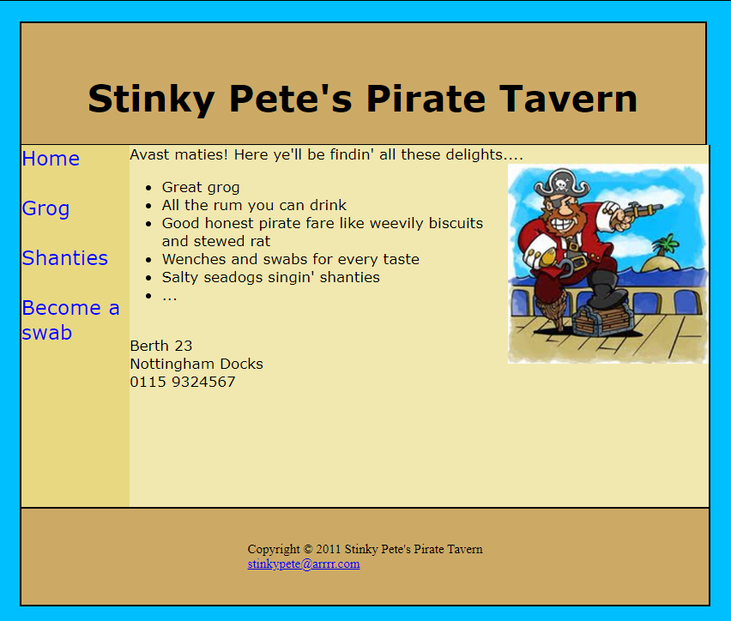

**Task-3**

Code-

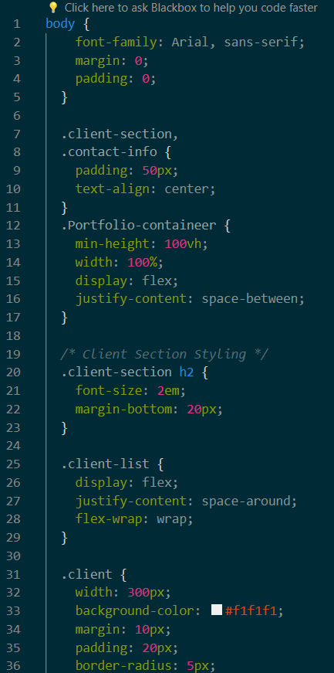

Explanation- This HTML code uses CSS for styling. The CSS styles define the layout, colors, and alignment of various elements such as the header, client section, and footer. Additionally, it applies styles to the navigation bar, images, text, and overall design of the webpage.

Output-

