**WEEK-6**

**Exercise-1**

Design a web page using four different image files ‘image1.jpg’, ‘image2.jpg’, ‘image3.jpg’ and ‘image4.png’ according to the following specifications.

• Use a border 5px for ‘image1.jpg’.

• Resize the width and height of ‘image2.jpg’ 100 pixels each. Use anchor tag on this image and open original image.

• Align ‘image3.jpg” to either left or right side • Leave space of 50px horizontally and vertically in ‘image4.png’

• align the text with respect to the images to obtain the appropriate output.

Code-

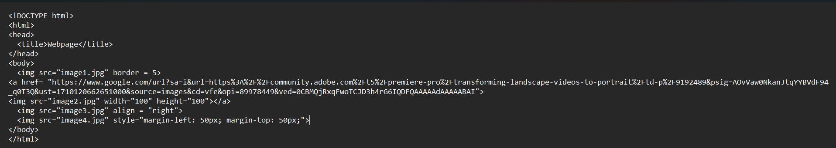

Explanation- This HTML code creates a webpage with four images. The <img> tag is used to insert images into the page. The page was made according to the given instructions.

Output-

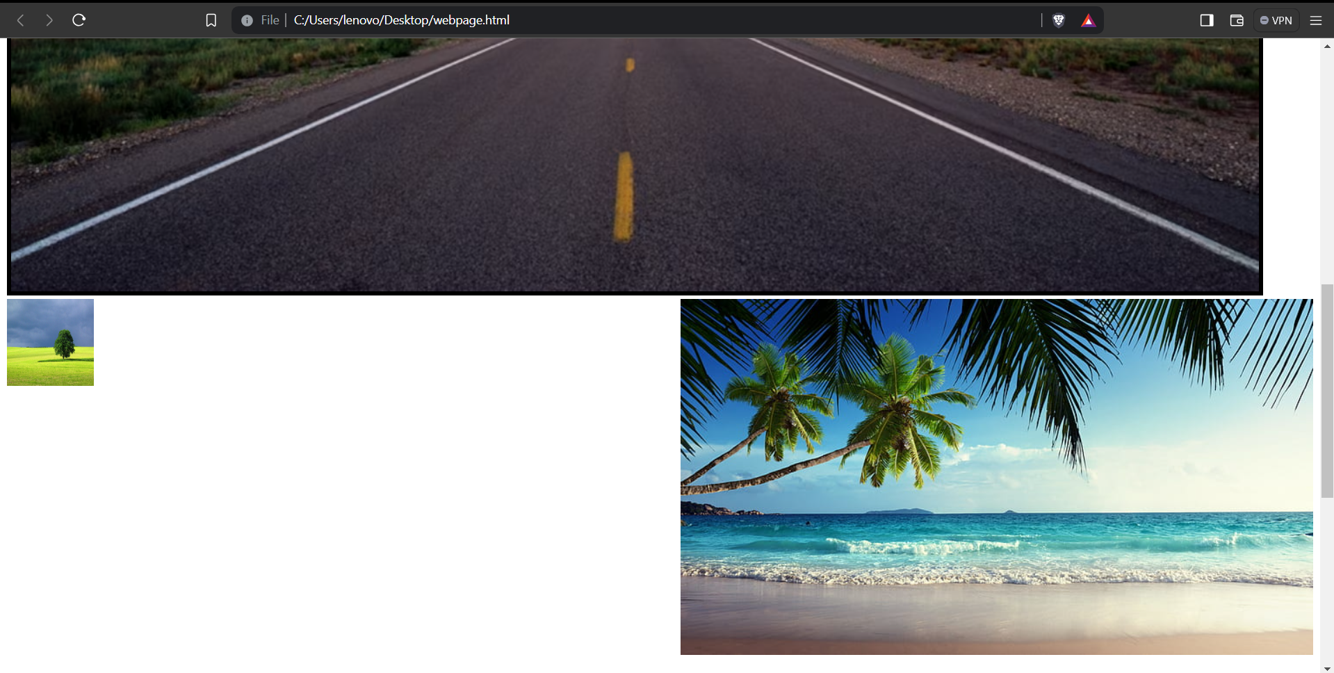

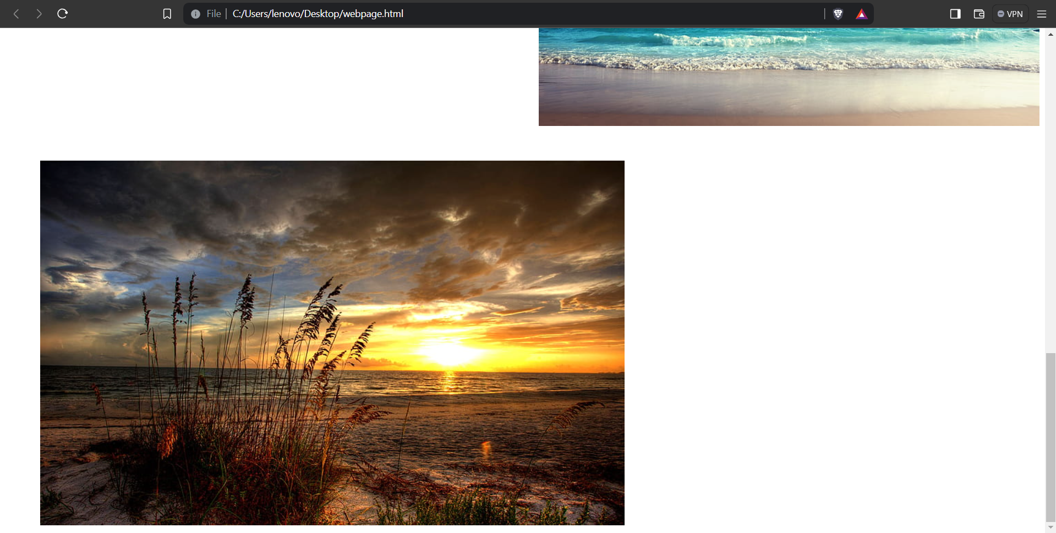

**Exercise-2**

Create a document home.html with two links to an external document (about.html). The first link should lead to the beginning of the about.html. The second link should lead to a particular section Contact information in the about.html. home.html should also contain a google logo of size 400px X 100px. On clicking this image, it should redirect to www.google.com [Note: Make your own design and content]

Code-

Output-

When clicking on the google image it takes us to google.com

**Exercise-3**

Create a Web page giving the following Bus details.

Place a border for the table and use cell padding to present the cell data with clarity. Align the table in the center of the screen. Use a caption saying ‘Bus Sewa Time Table and Fare List’.

Code-

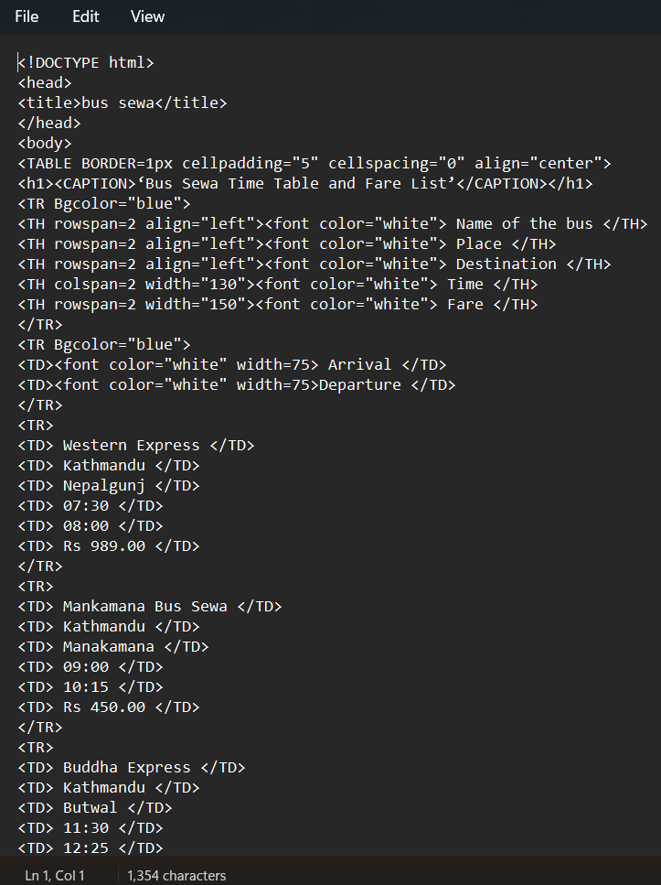

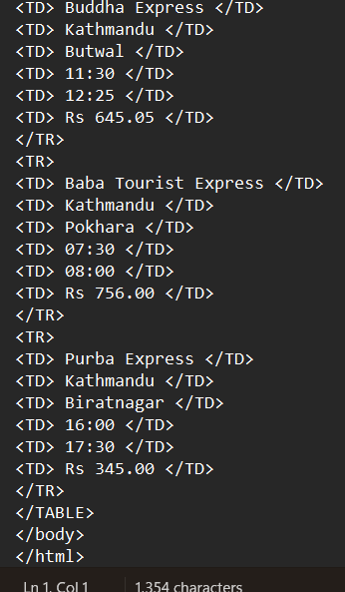

Explanation- This HTML code creates a table displaying the schedule and fare list for various bus services. **<TABLE>**: This tag defines a table in HTML. **<**CAPTION>: This tag specifies the caption (title) of the table. <TR>: This tag defines a table row. <TH>: This tag defines a table header cell, typically used for column headings. <TD>: This tag defines a table data cell, used for regular data. Rowspan specifies the number of rows a table cell should span vertically and Colspan specifies the number of columns a table cell should span horizontally. These tags are essential for structuring and formatting tables in HTML documents, making them readable and organized for users.

Output-

