**Asian_Cluster1.csv.txt_Finalresults.txt**

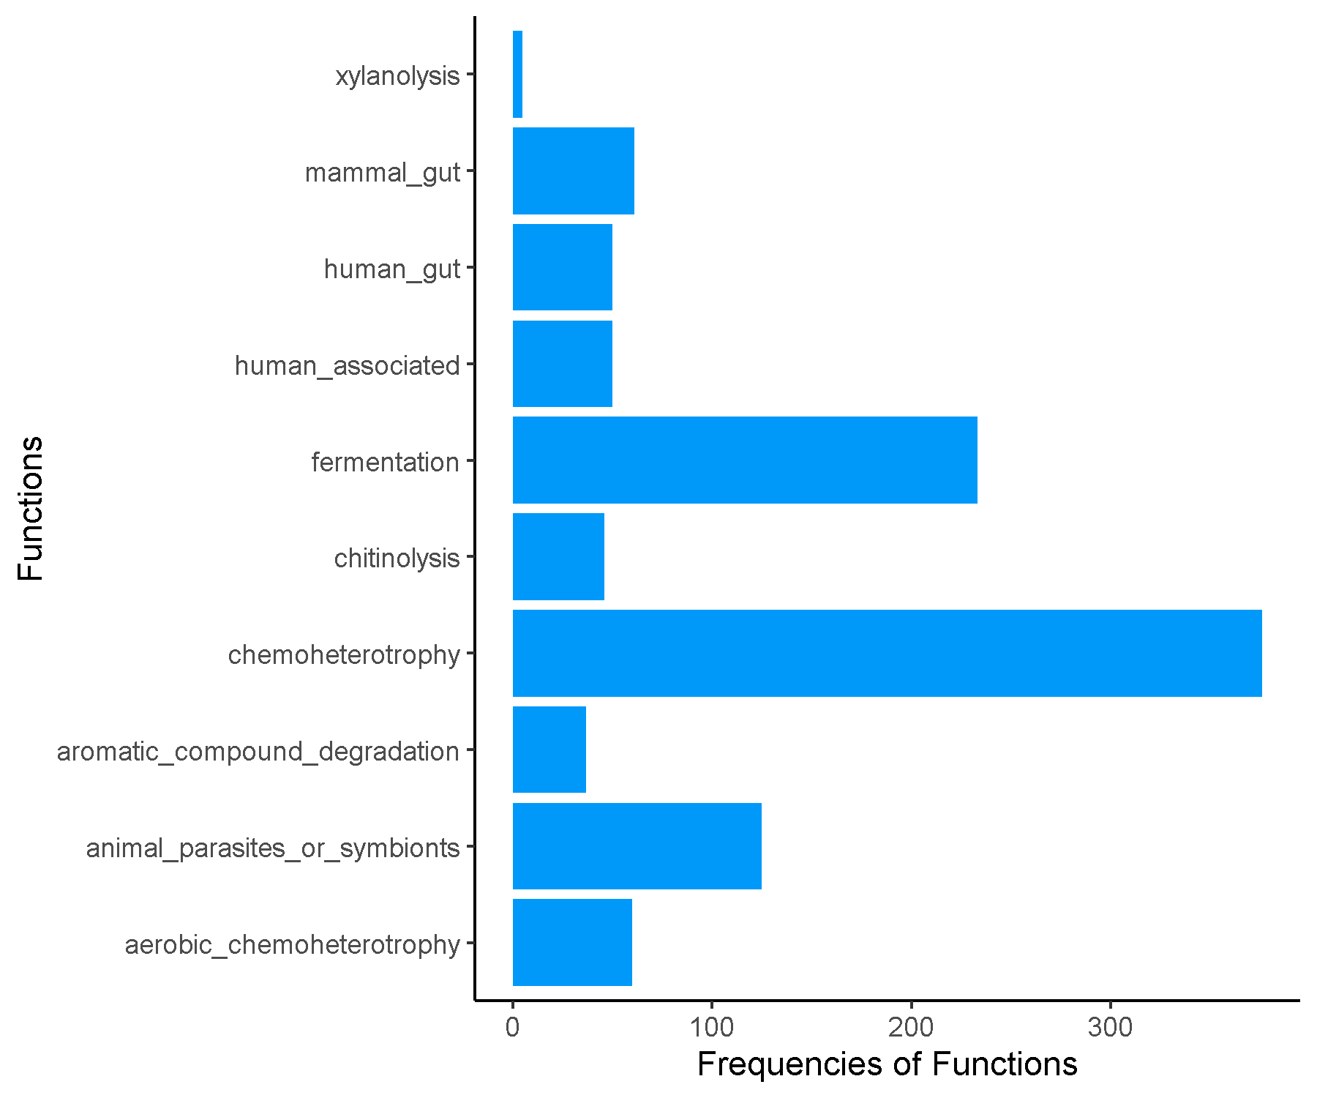

**Asian_Cluster2.csv.txt_Finalresults.txt**

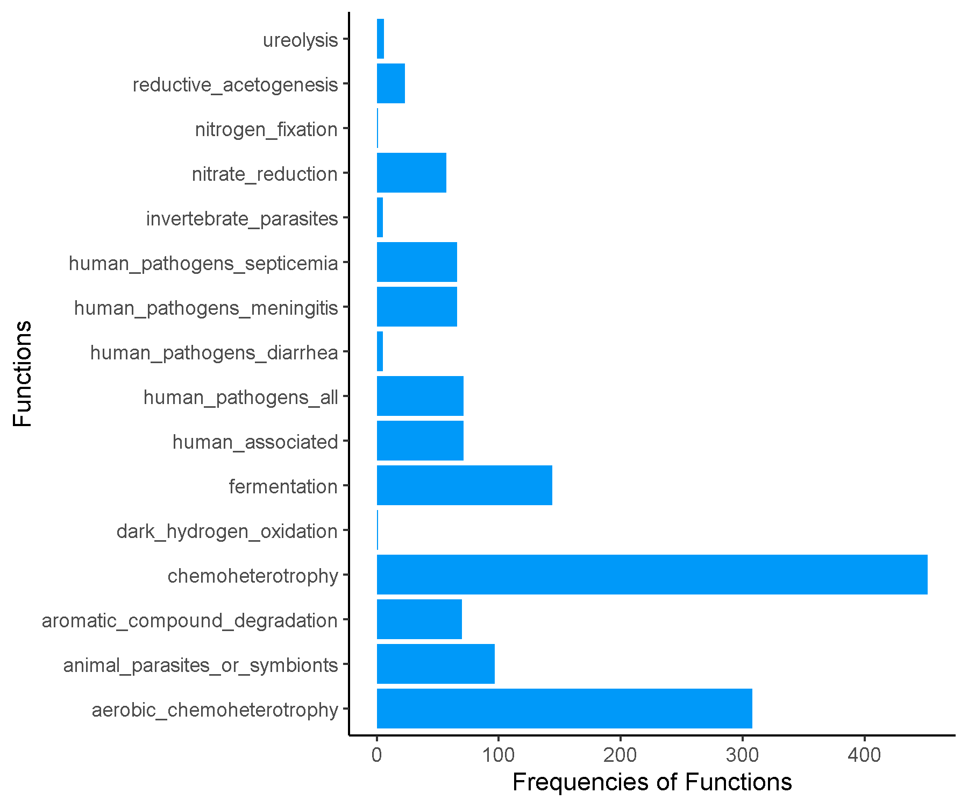

**Asian_Cluster3.csv.txt_Finalresults.txt**

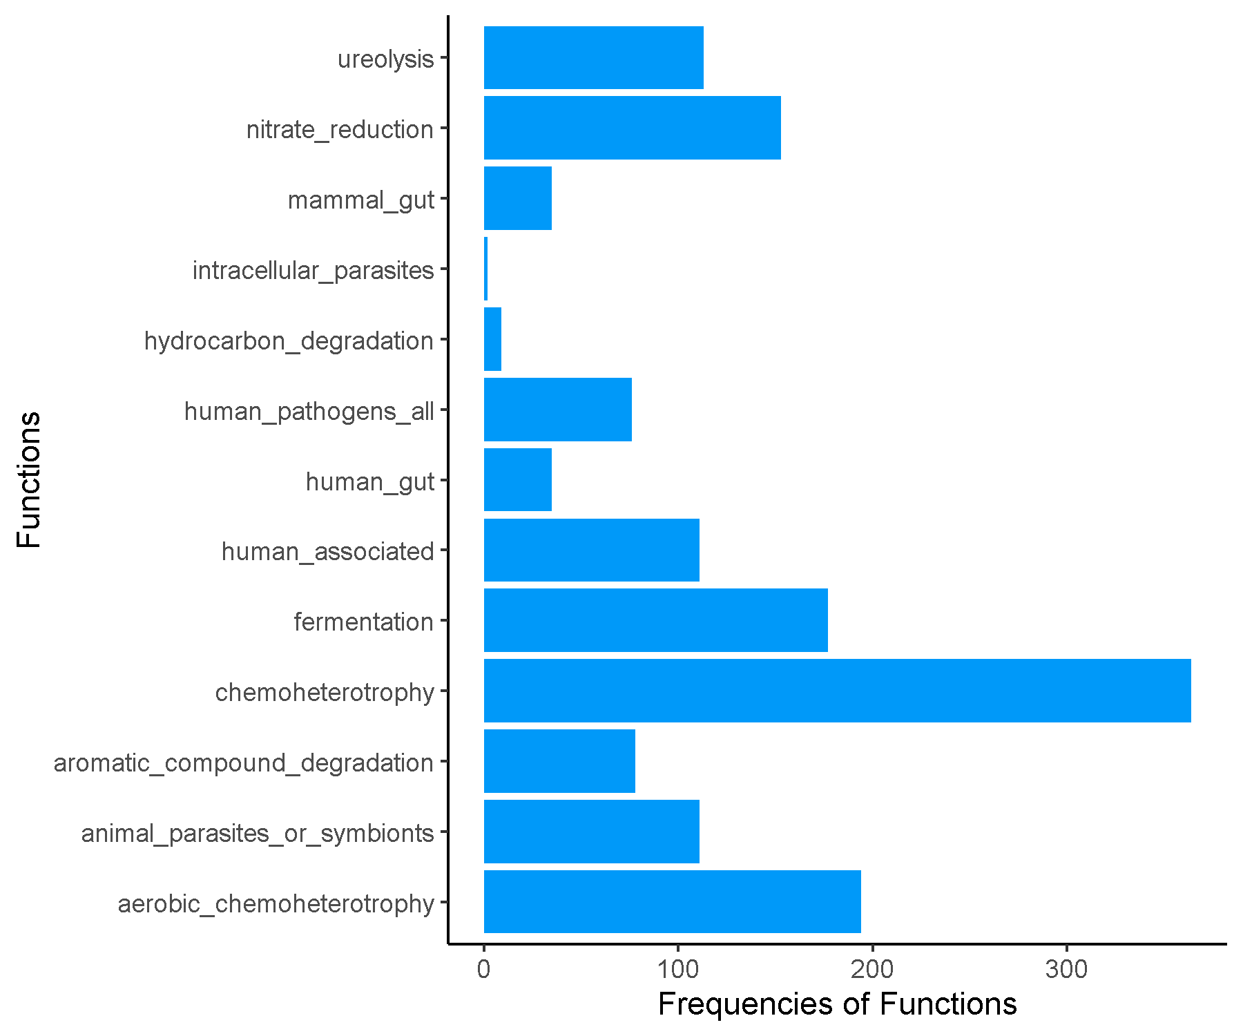

**Asian_Cluster4.csv.txt_Finalresults.txt**

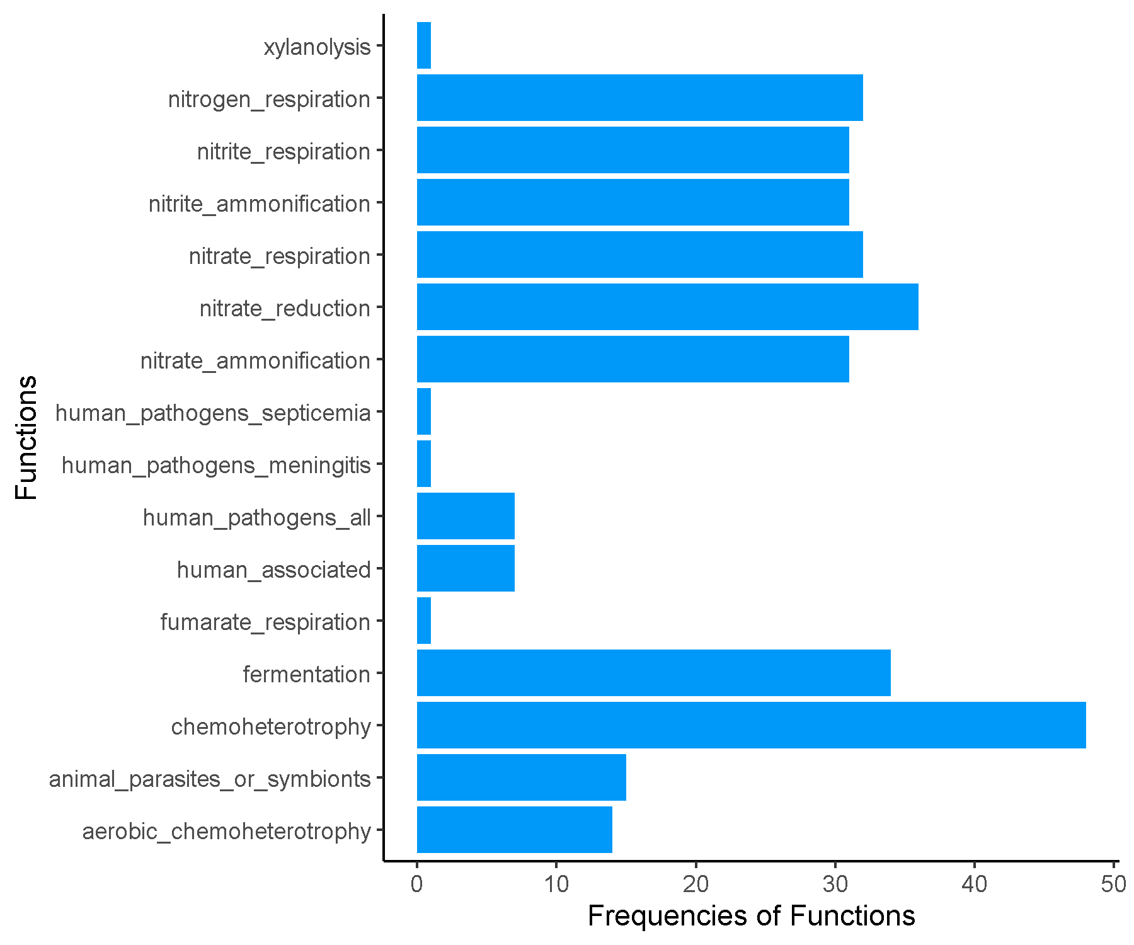

**Early_Cluster1.csv.txt_Finalresults.txt**

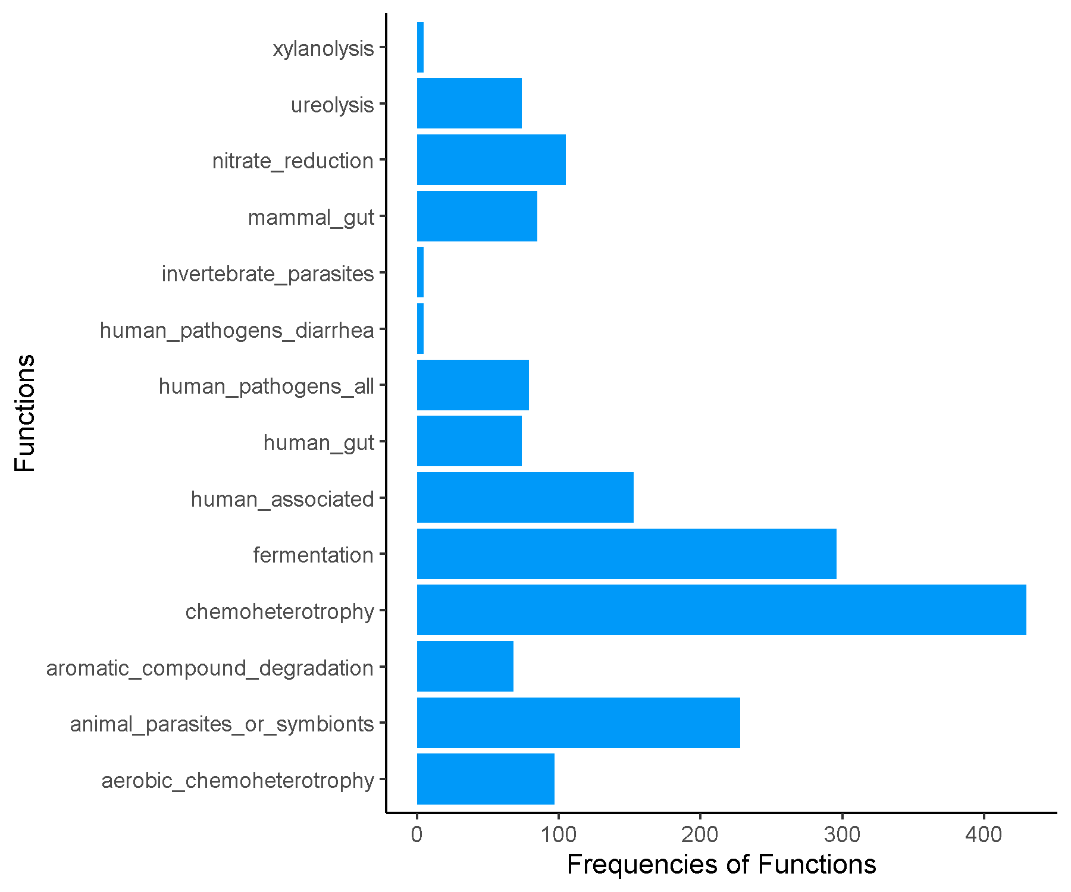

**Early_Cluster3.csv.txt_Finalresults.txt**

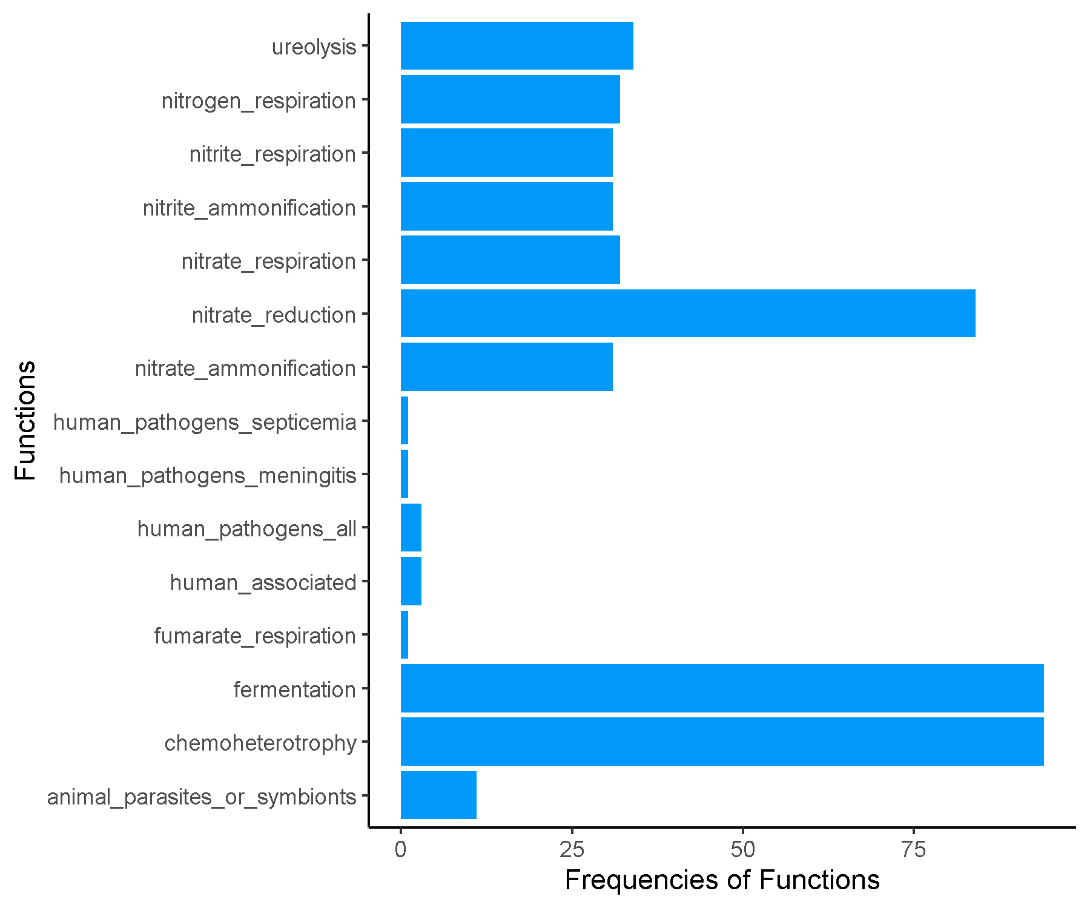

**Early_Cluster4.csv.txt_Finalresults.txt**

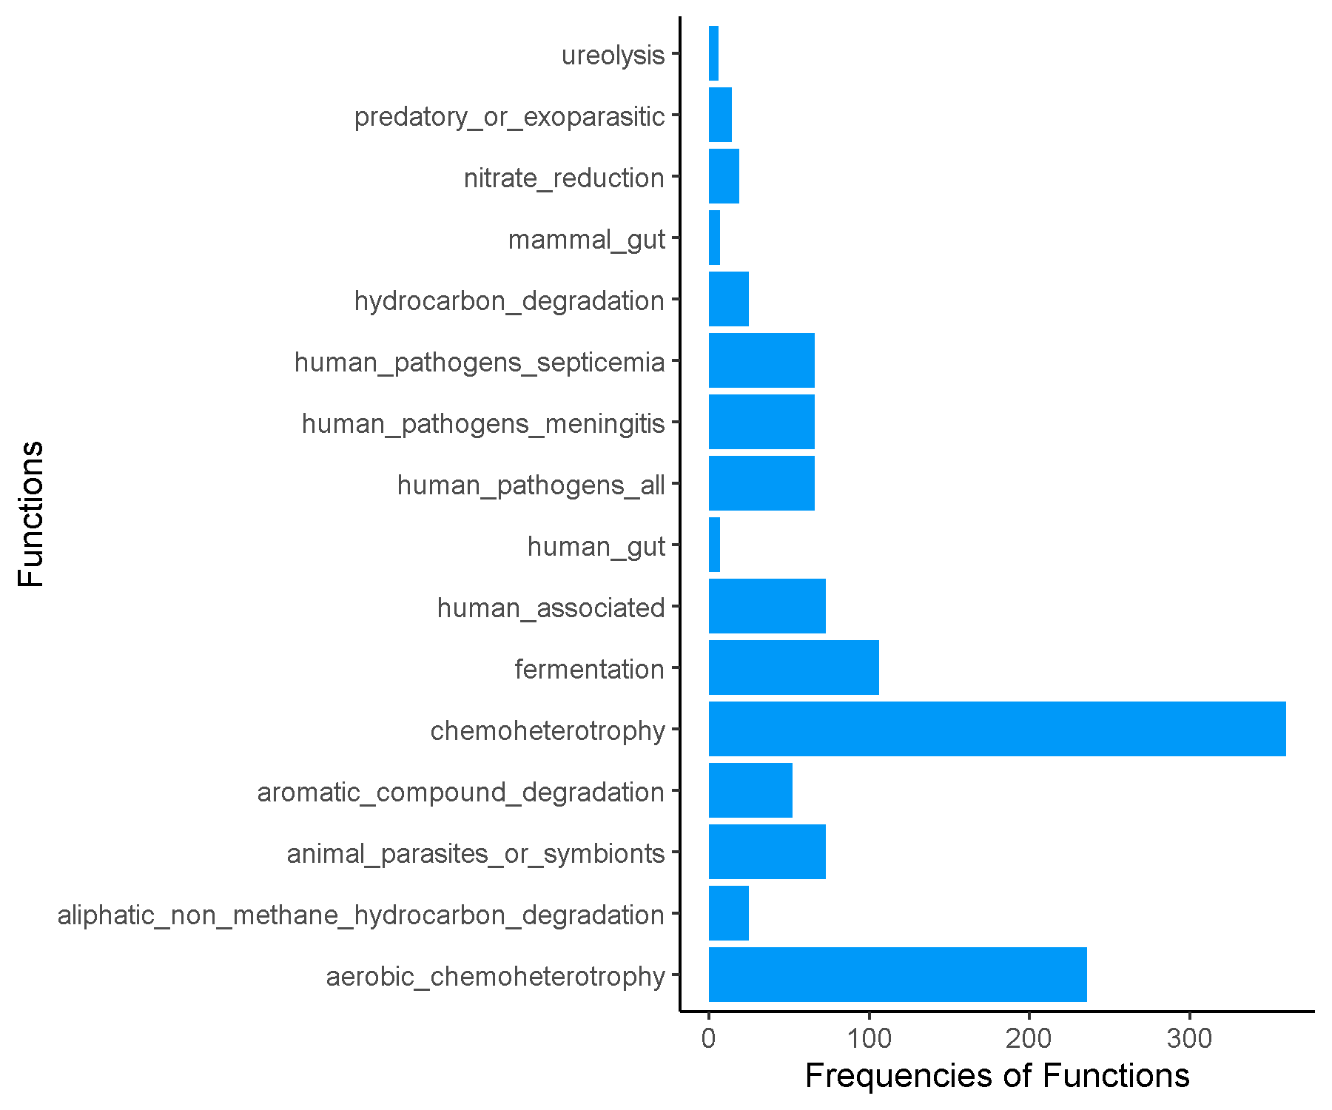

**Early_Cluster5.csv.txt_Finalresults.txt**

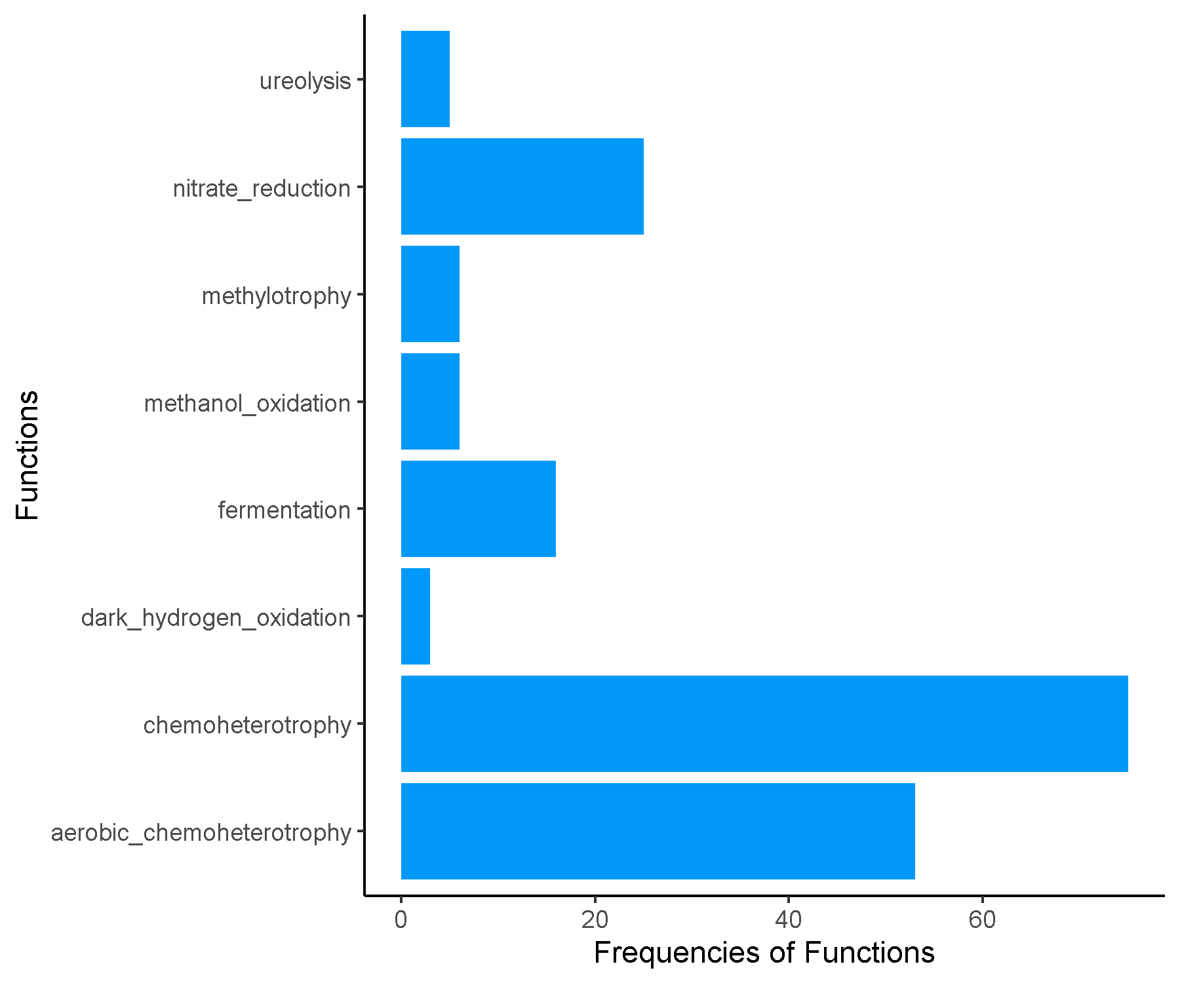

**Early_Cluster6.csv.txt_Finalresults.txt**

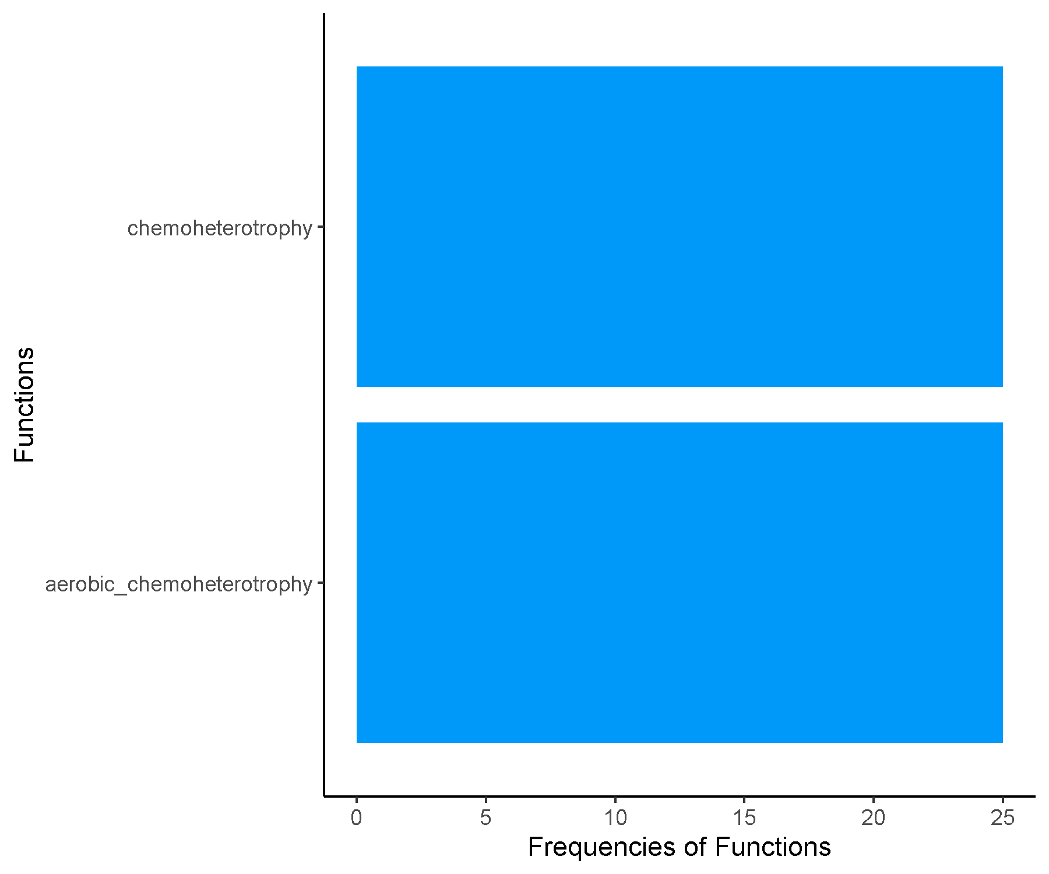

**FRFRC_Cluster1.csv.txt_Finalresults.txt**

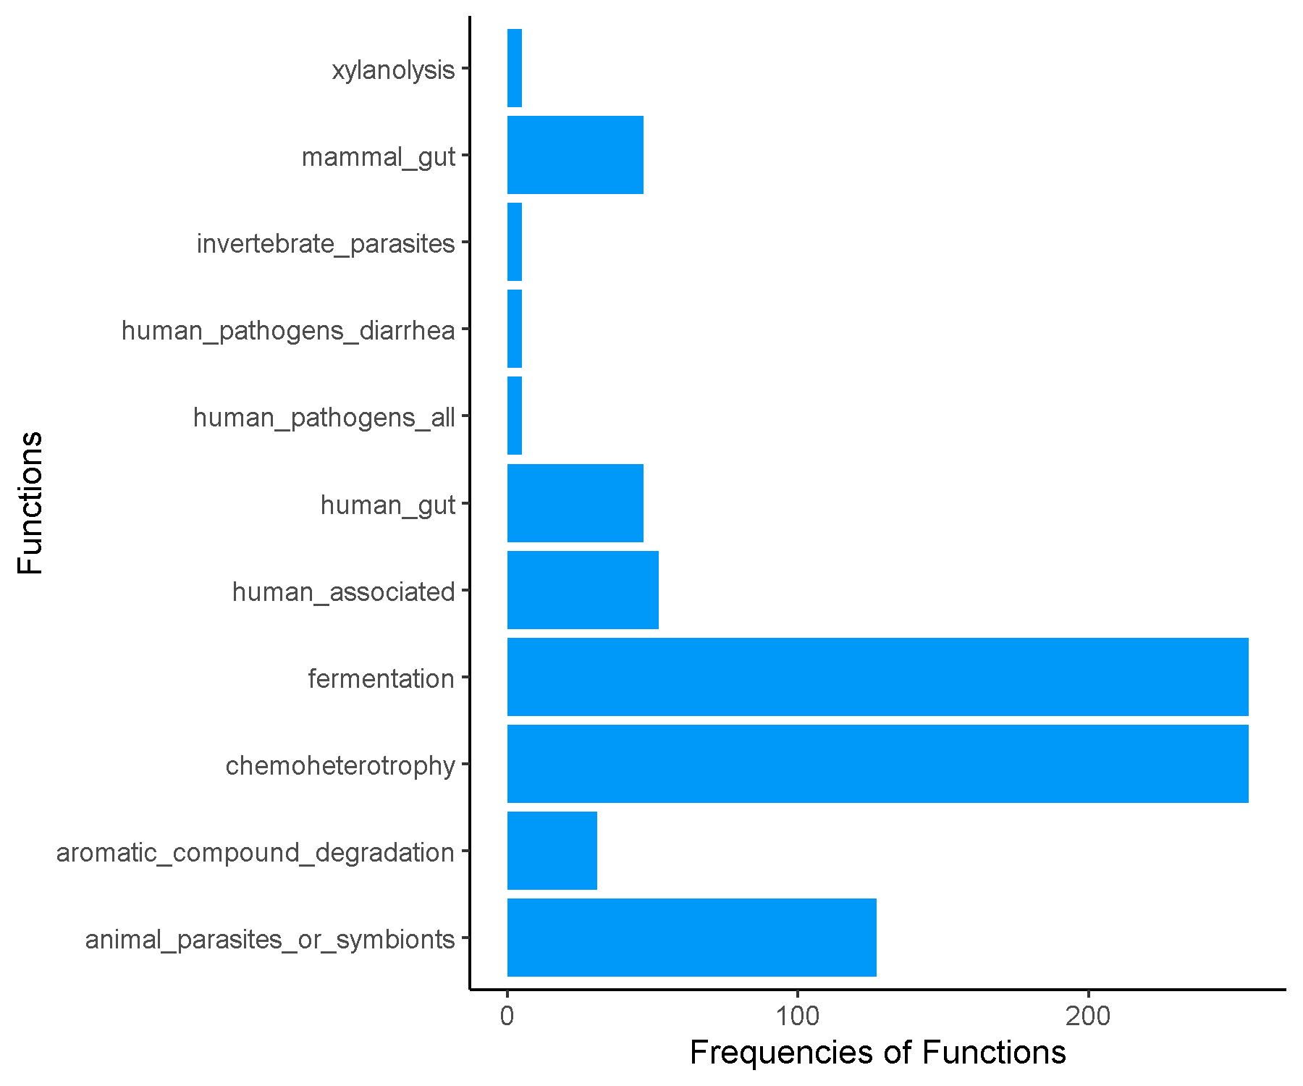

**FRFRC_Cluster2.csv.txt_Finalresults.txt**

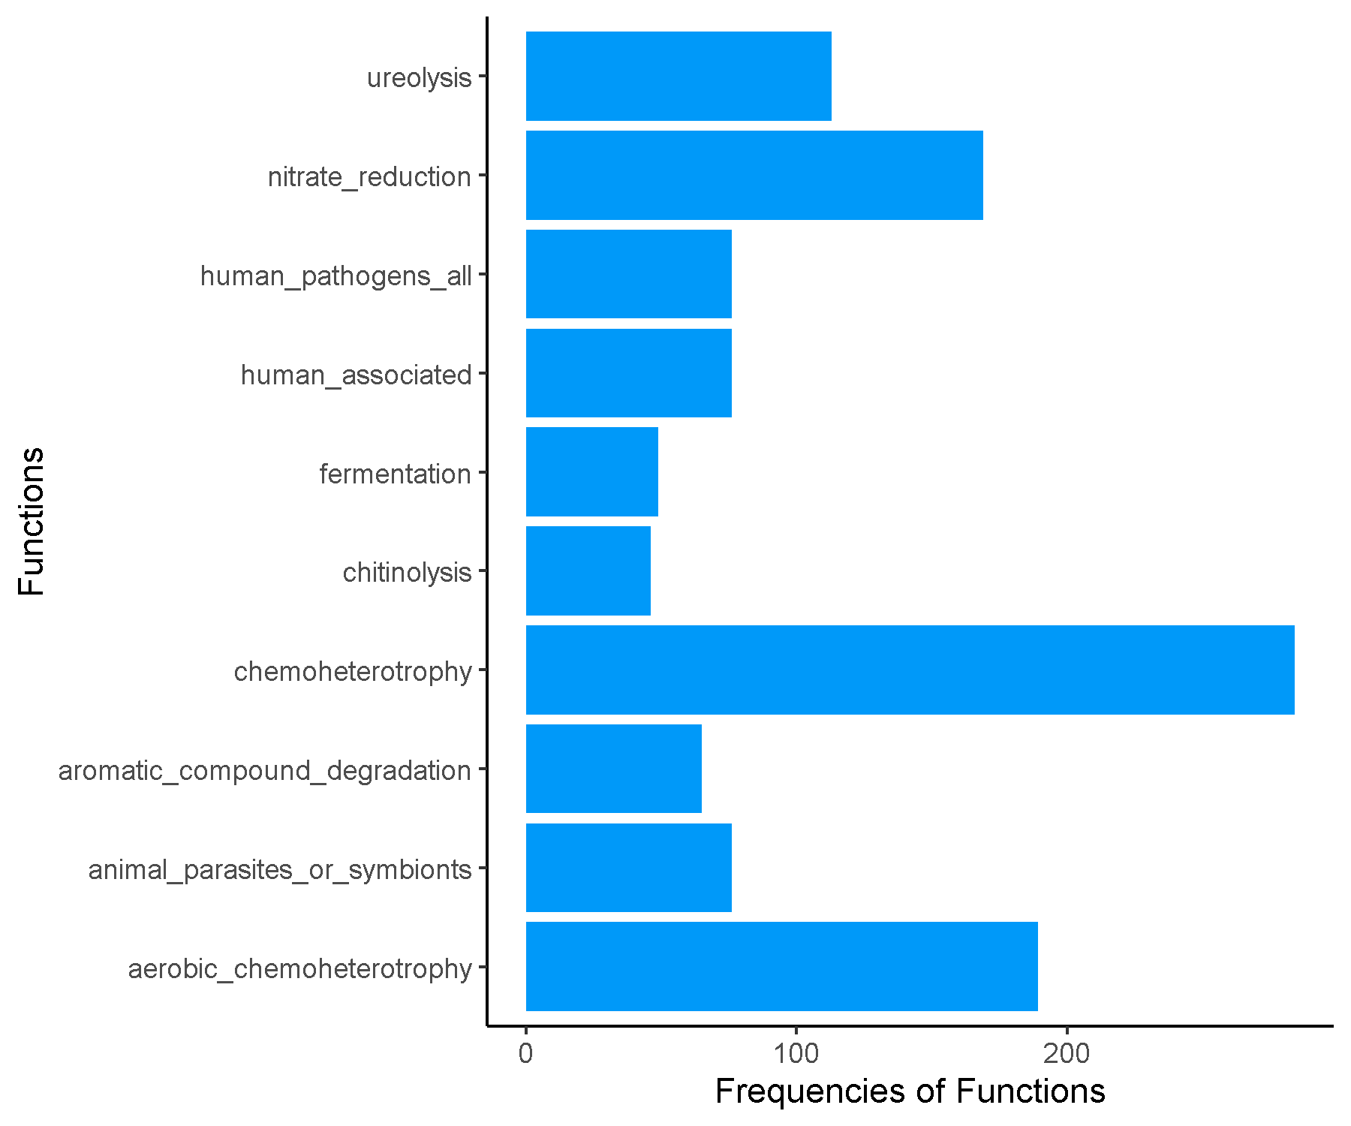

**FRFRC_Cluster3.csv.txt_Finalresults.txt**

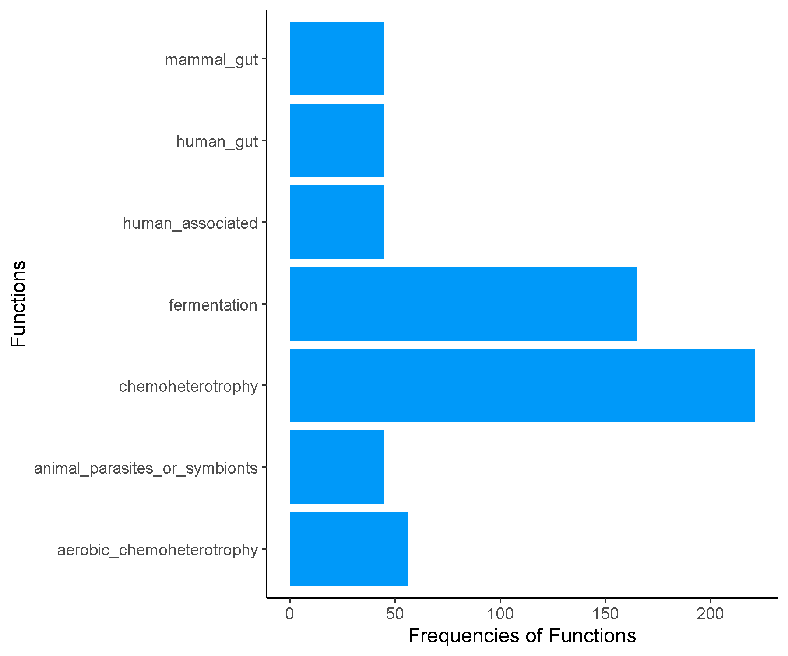

**FRFRC_Cluster4.csv.txt_Finalresults.txt**

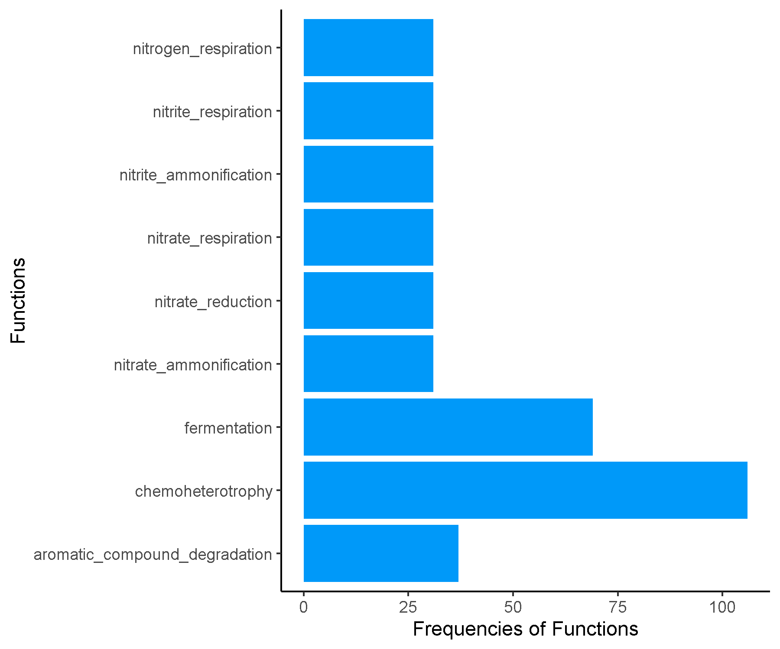

**FRFRC_Cluster5.csv.txt_Finalresults.txt**

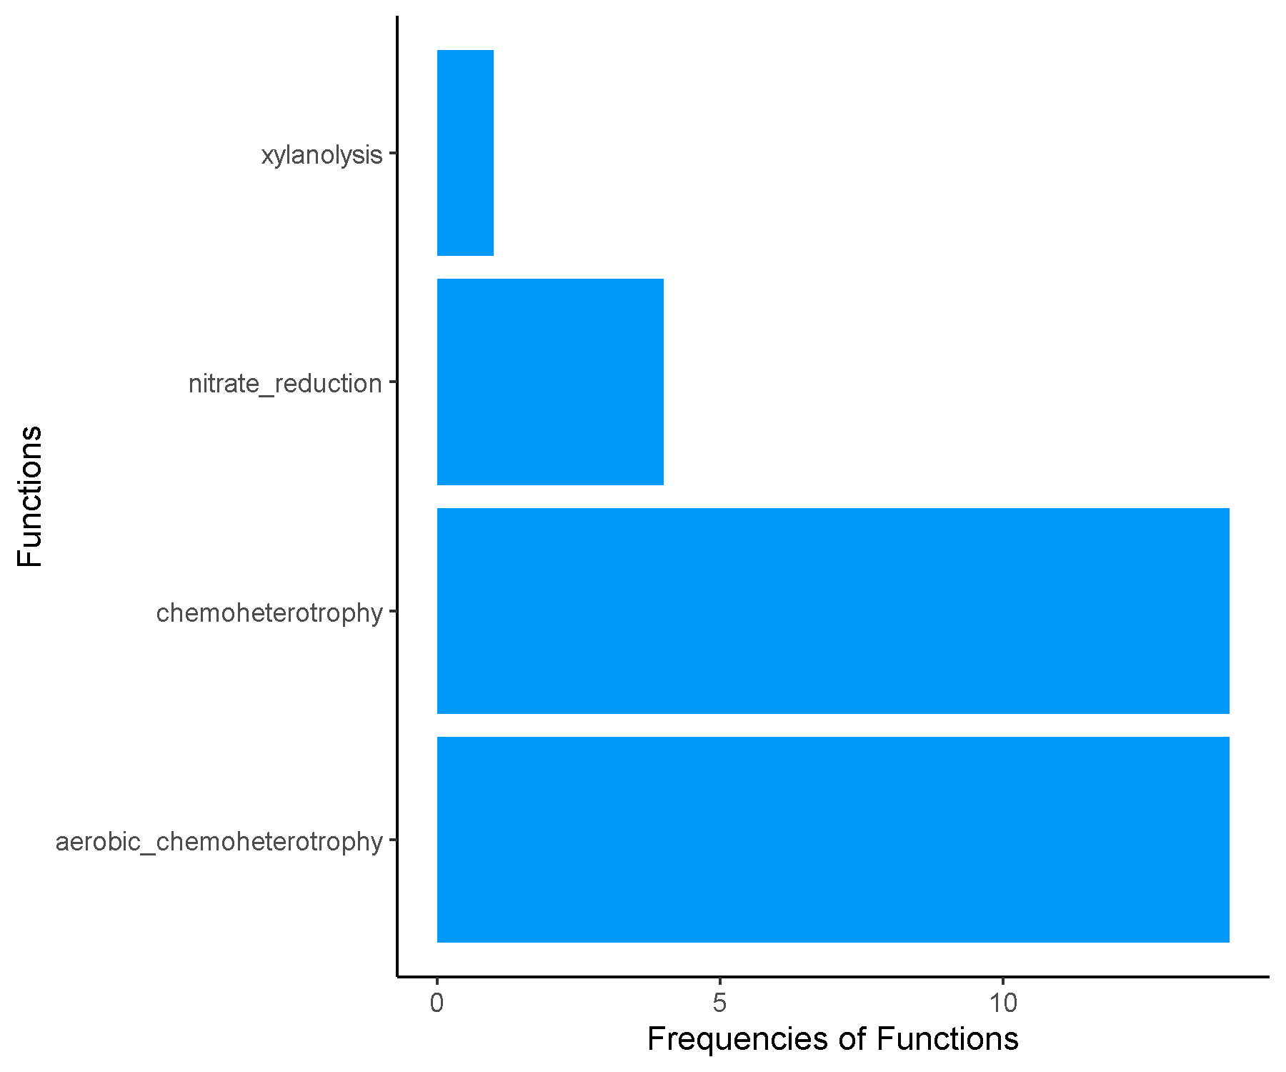

**FRFRC_Cluster6.csv.txt_Finalresults.txt**

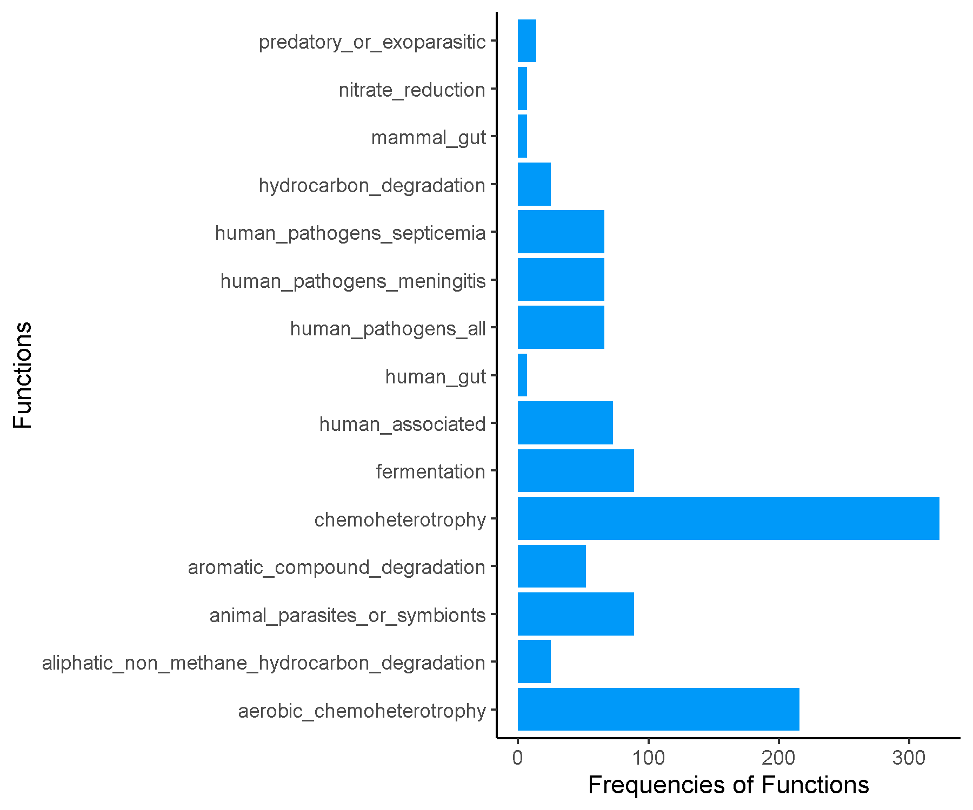

**JRJRC_Cluster1.csv.txt_Finalresults.txt**

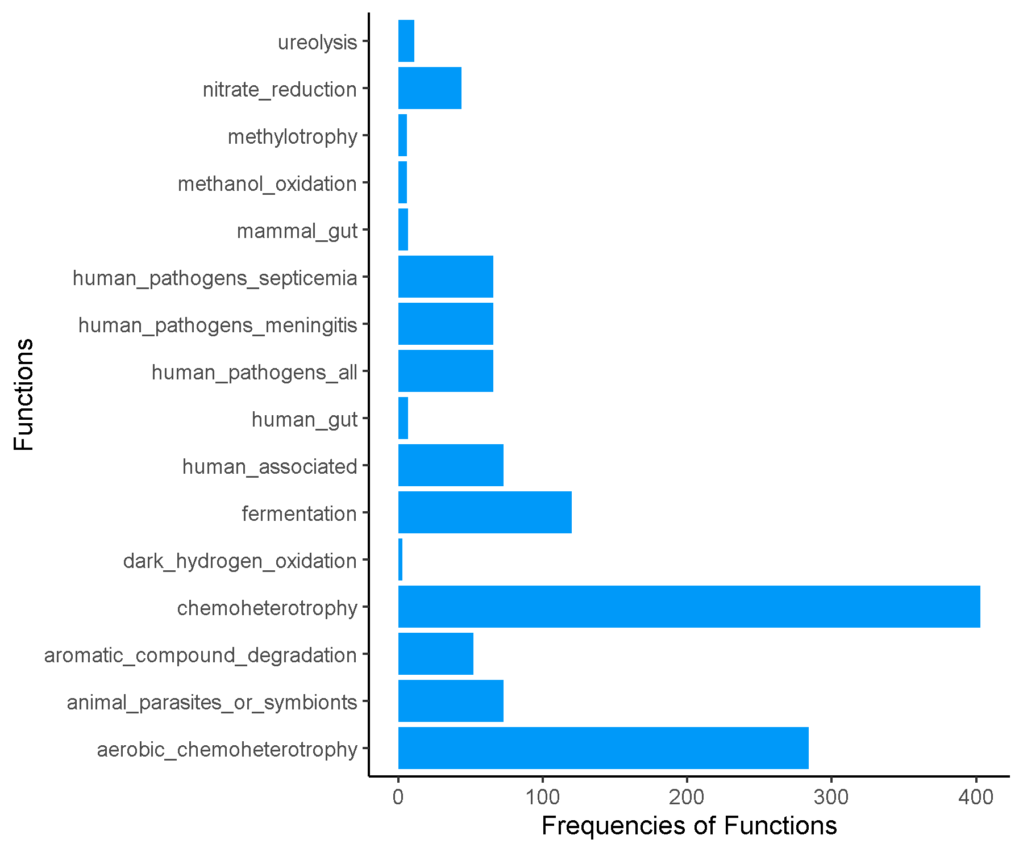

**JRJRC_Cluster2.csv.txt_Finalresults.txt**

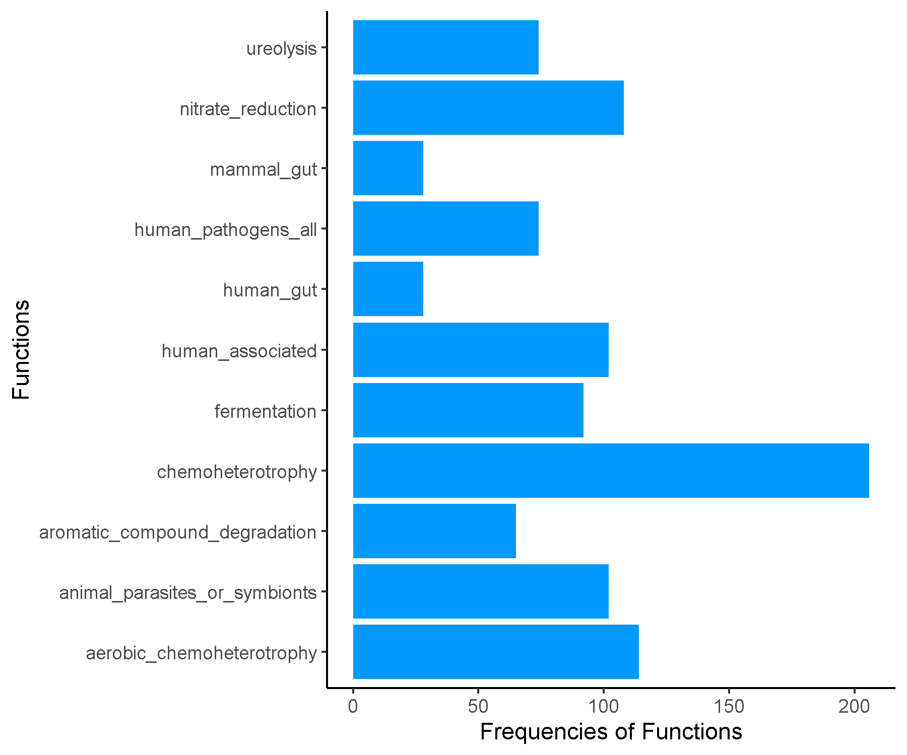

**JRJRC_Cluster3.csv.txt_Finalresults.txt**

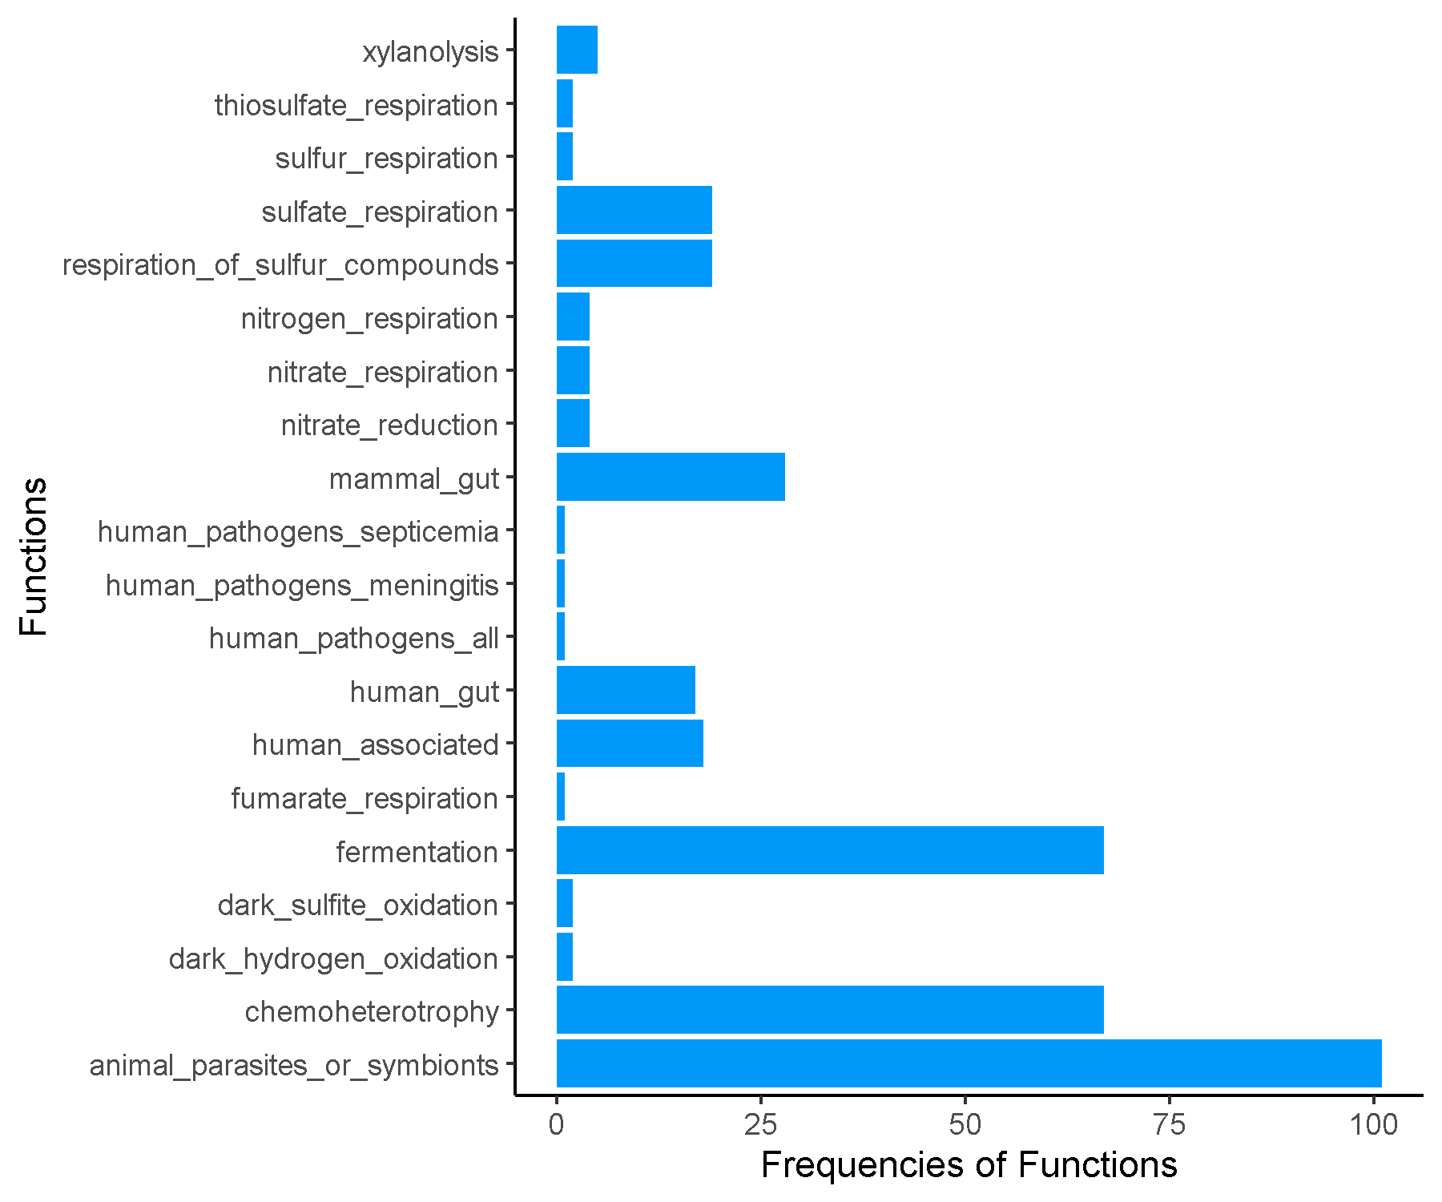

**JRJRC_Cluster4.csv.txt_Finalresults.txt**

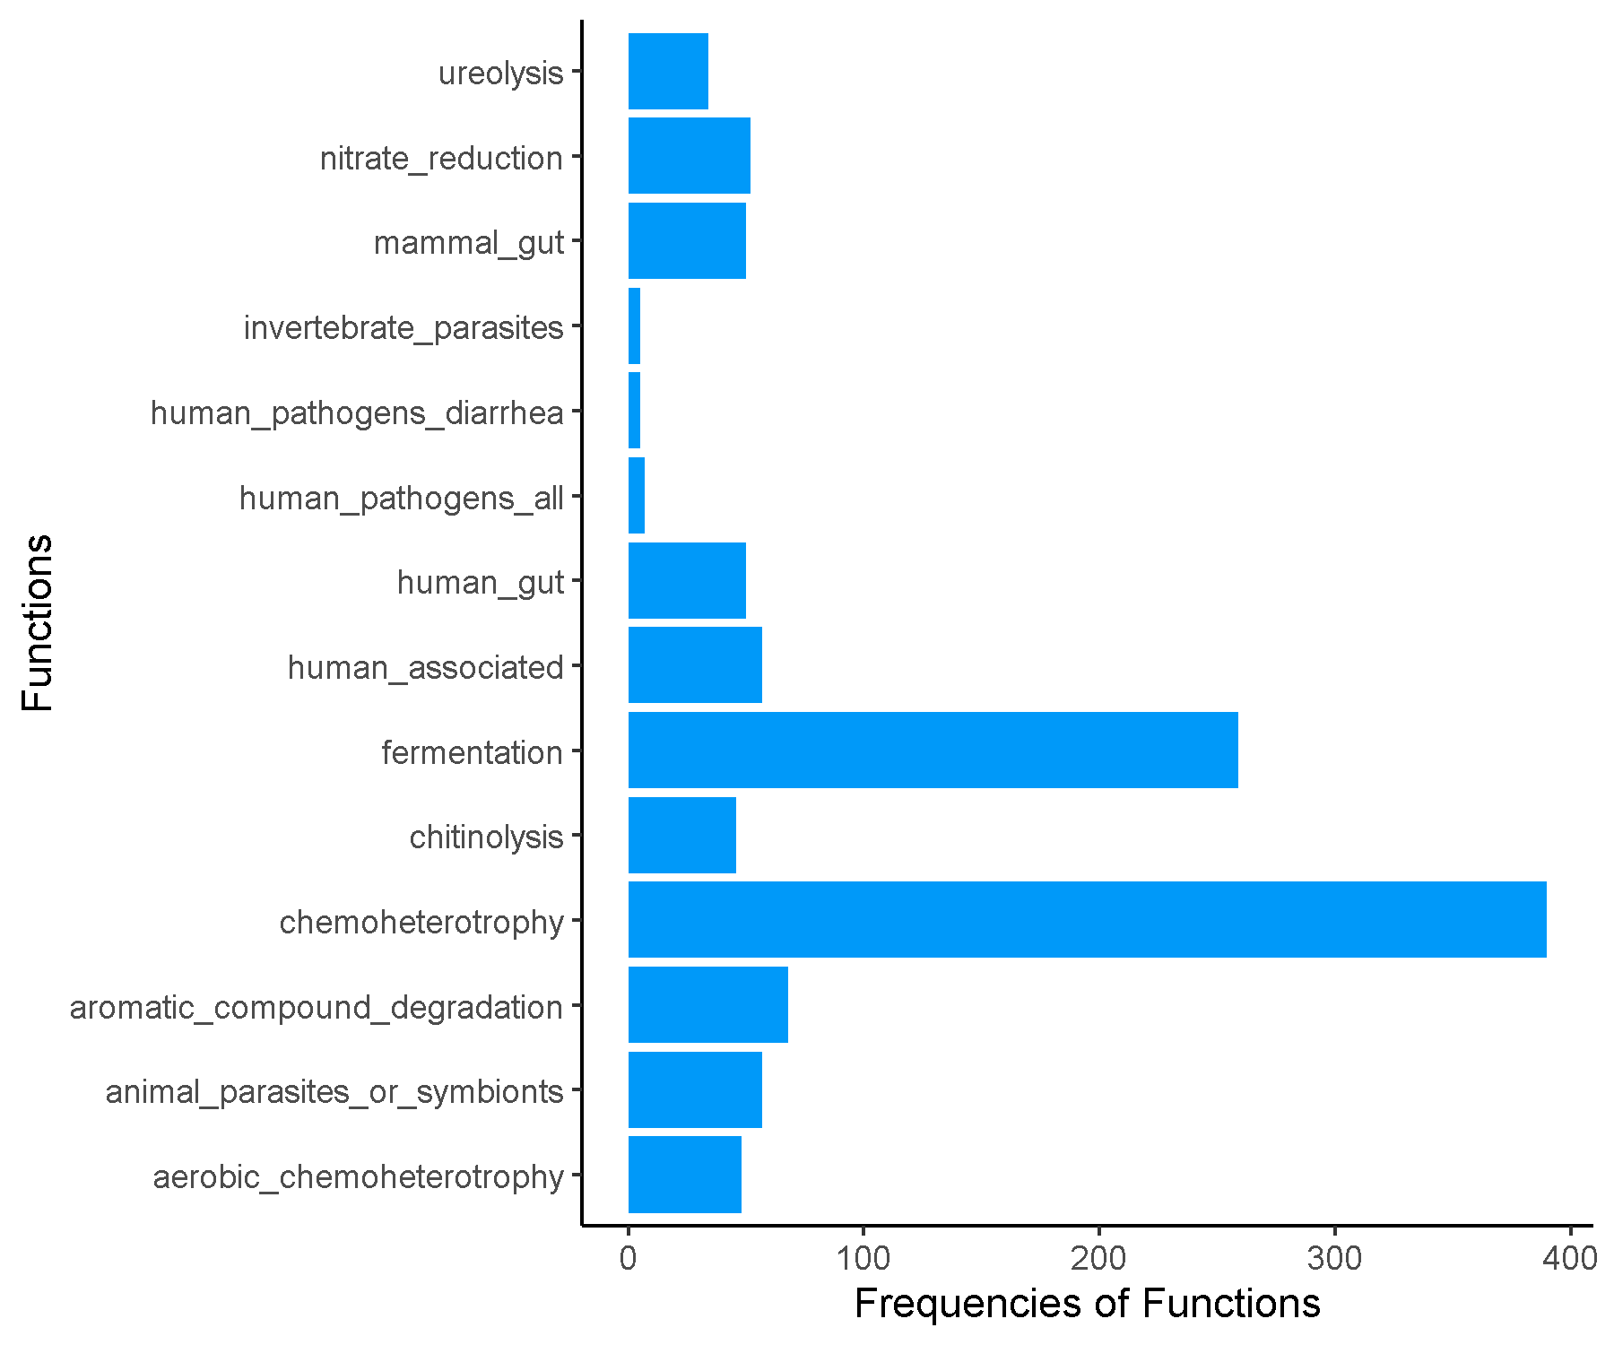

**JRJRC_Cluster6.csv.txt_Finalresults.txt**



**JRJRC_Cluster7.csv.txt_Finalresults.txt**

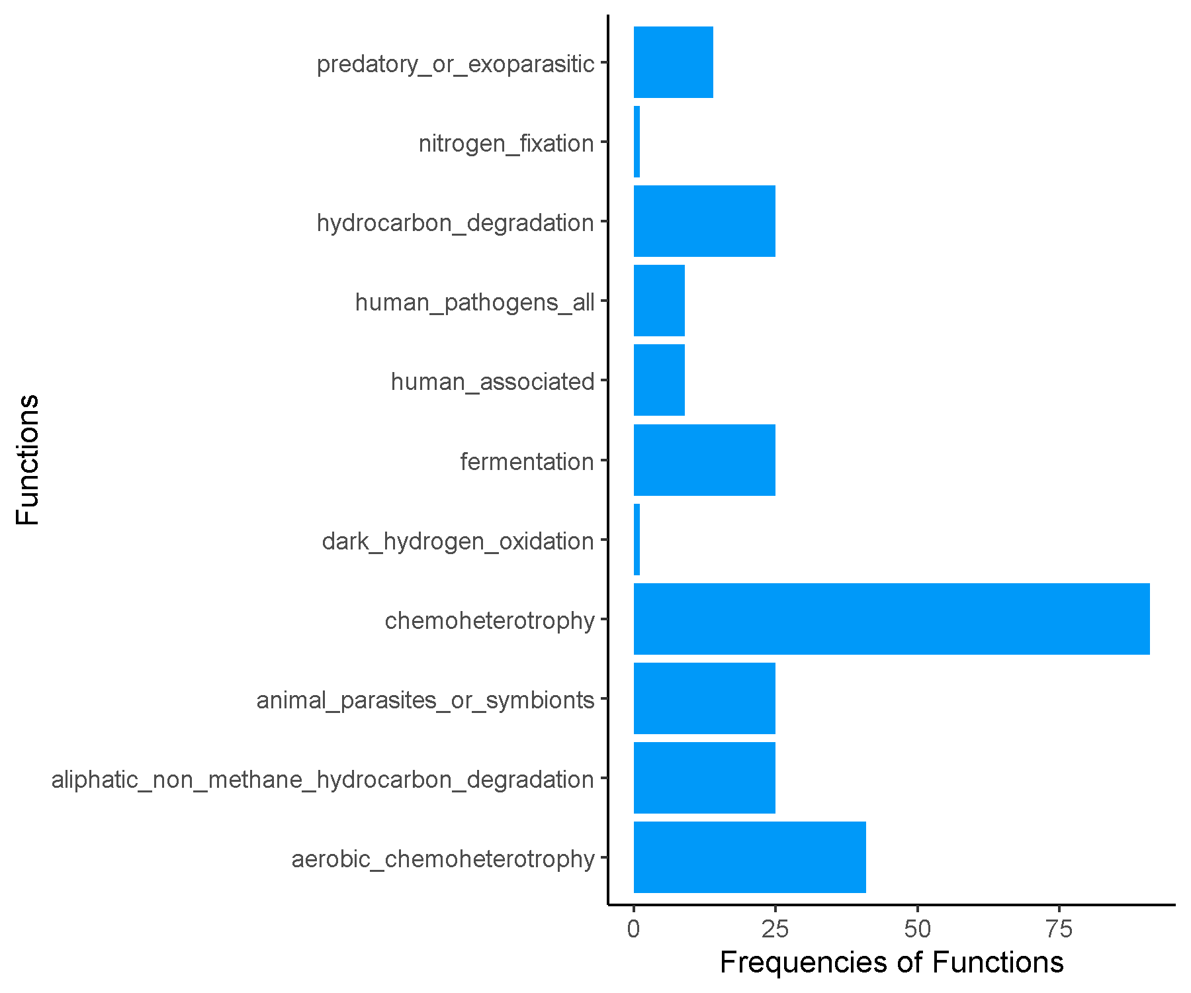

**Late_Cluster1.csv.txt_Finalresults.txt**

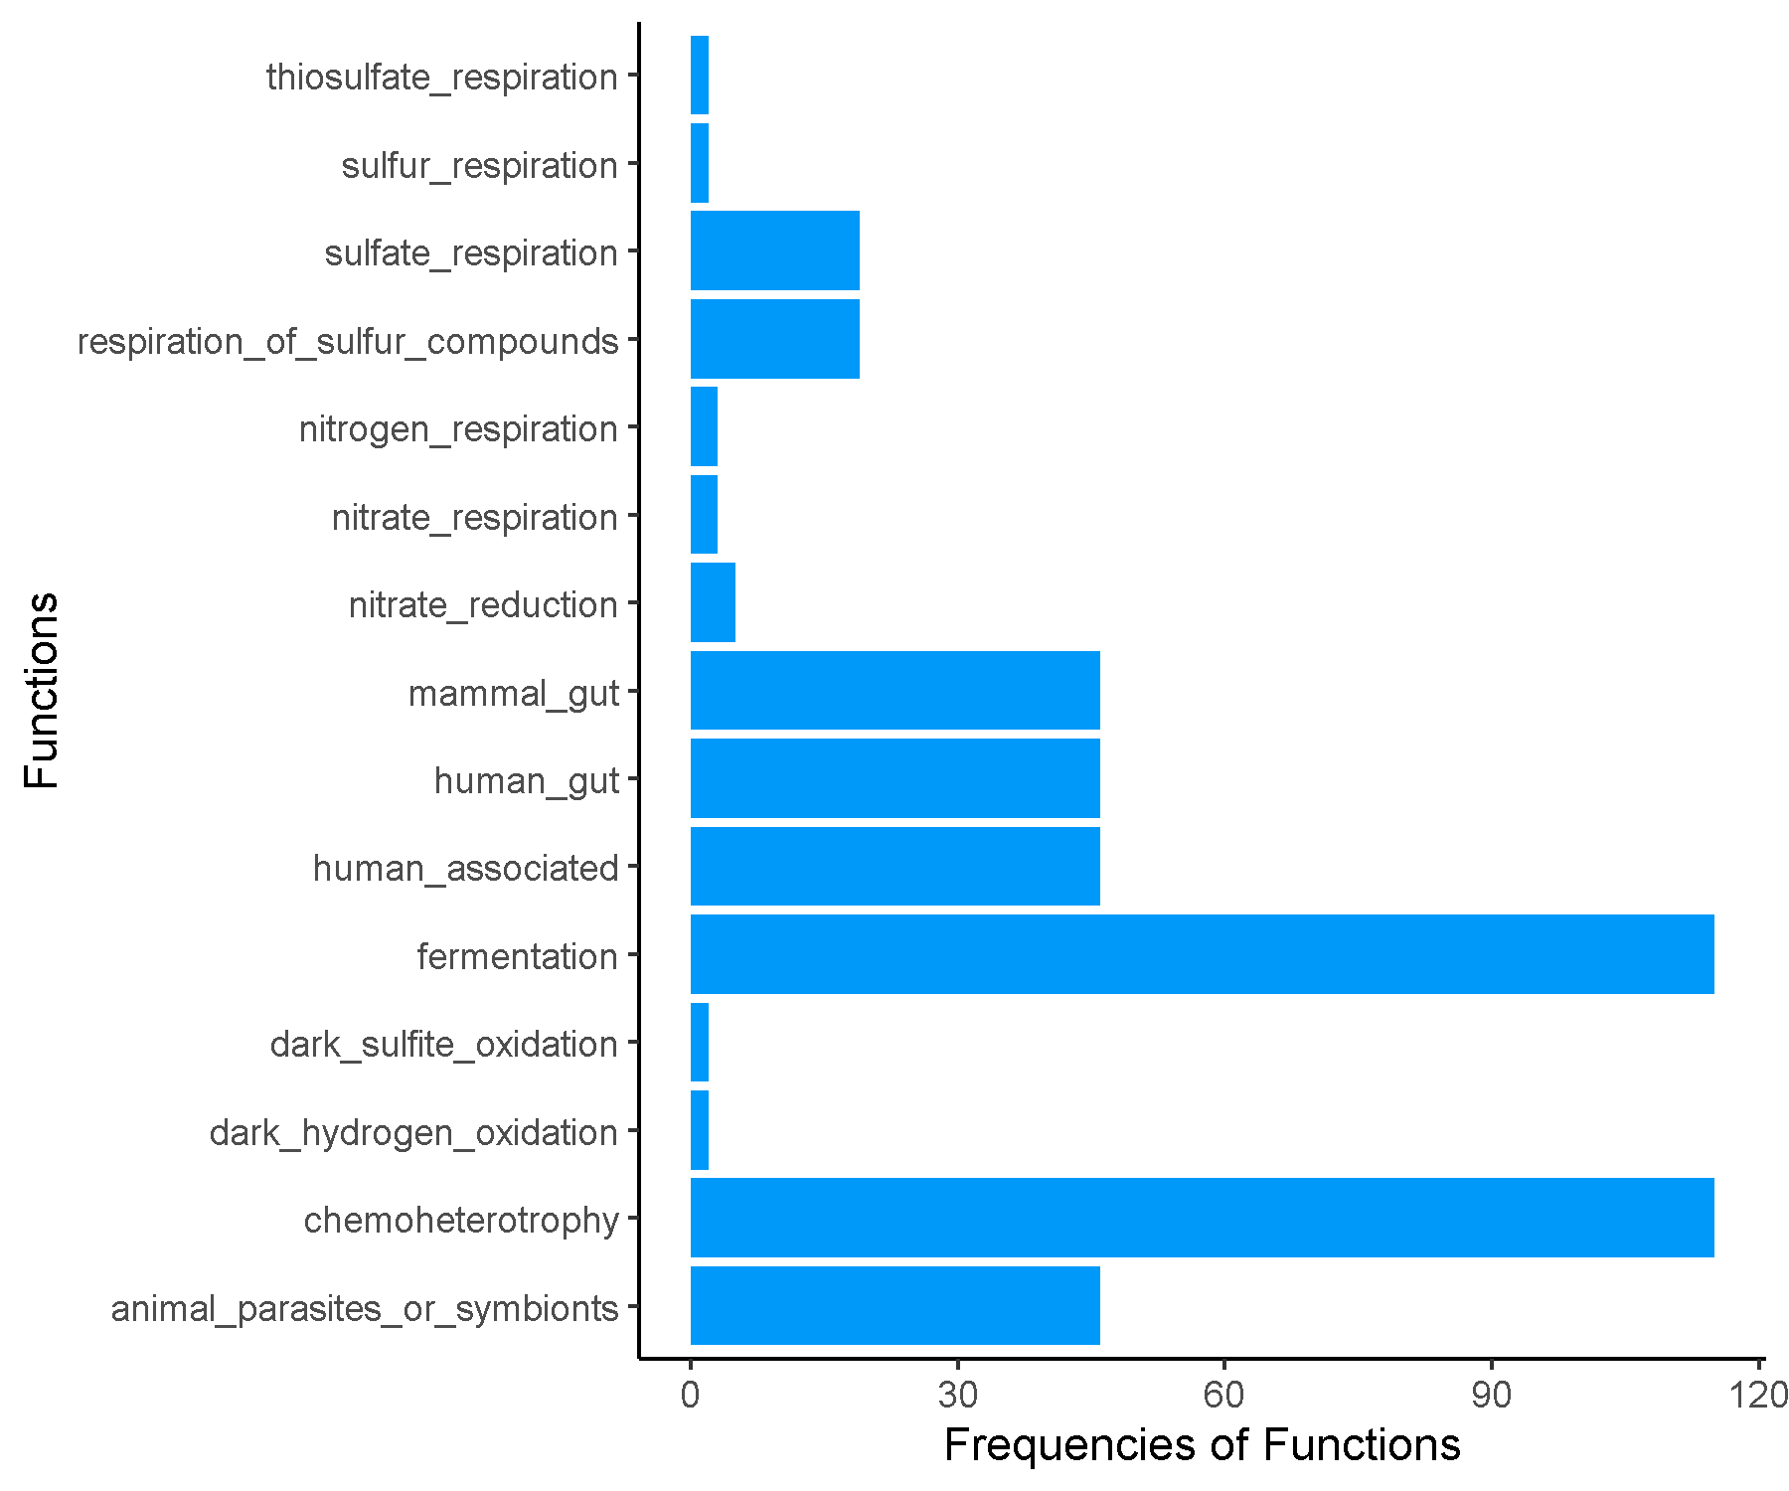

**Late_Cluster2.csv.txt_Finalresults.txt**

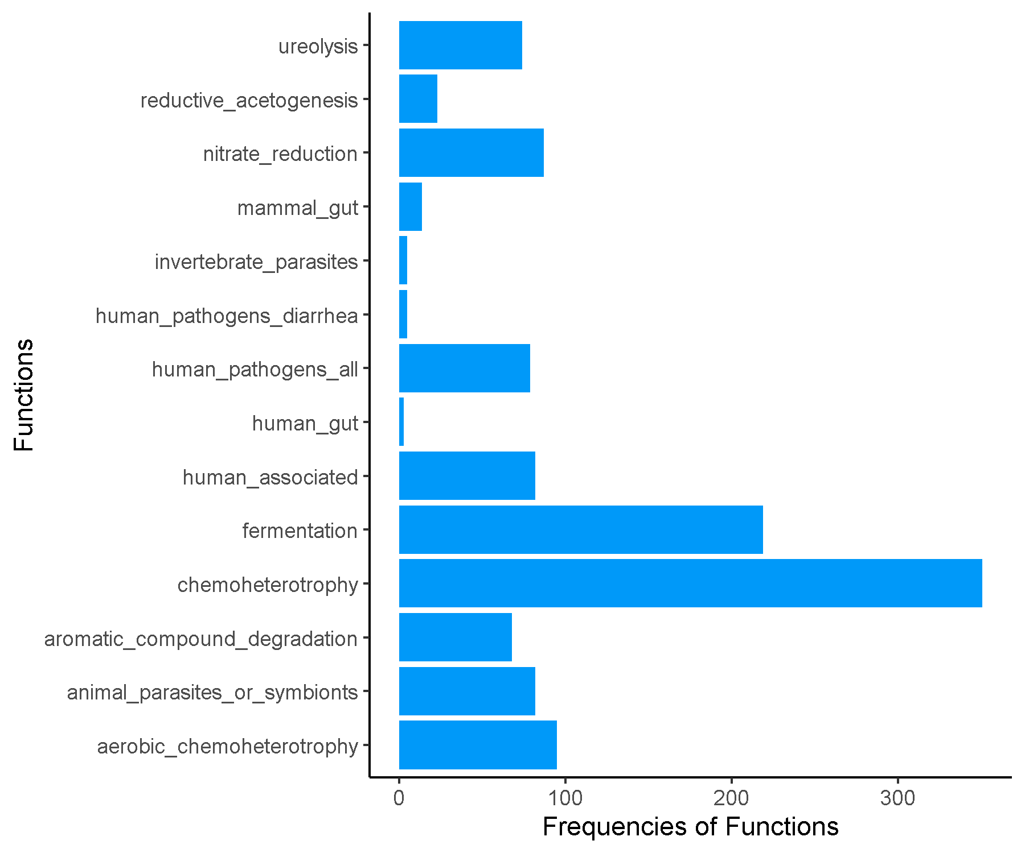

**Late_Cluster3.csv.txt_Finalresults.txt**

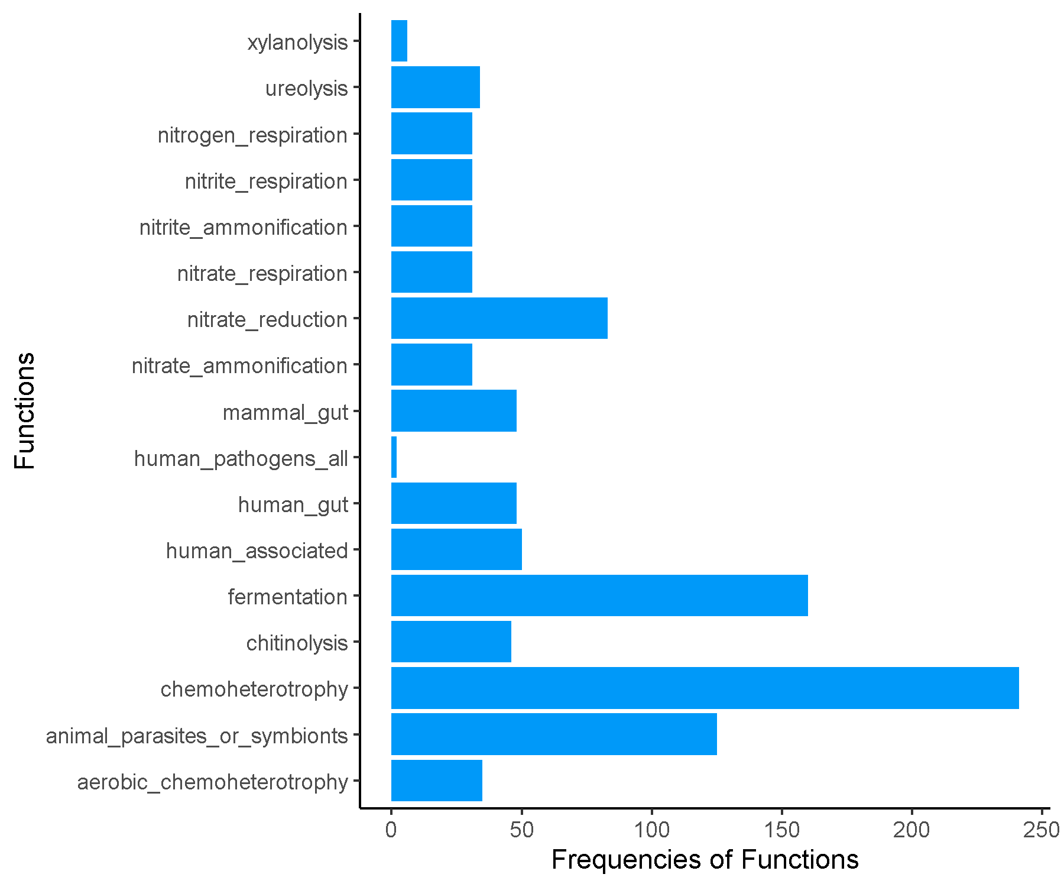

**Late_Cluster4.csv.txt_Finalresults.txt**

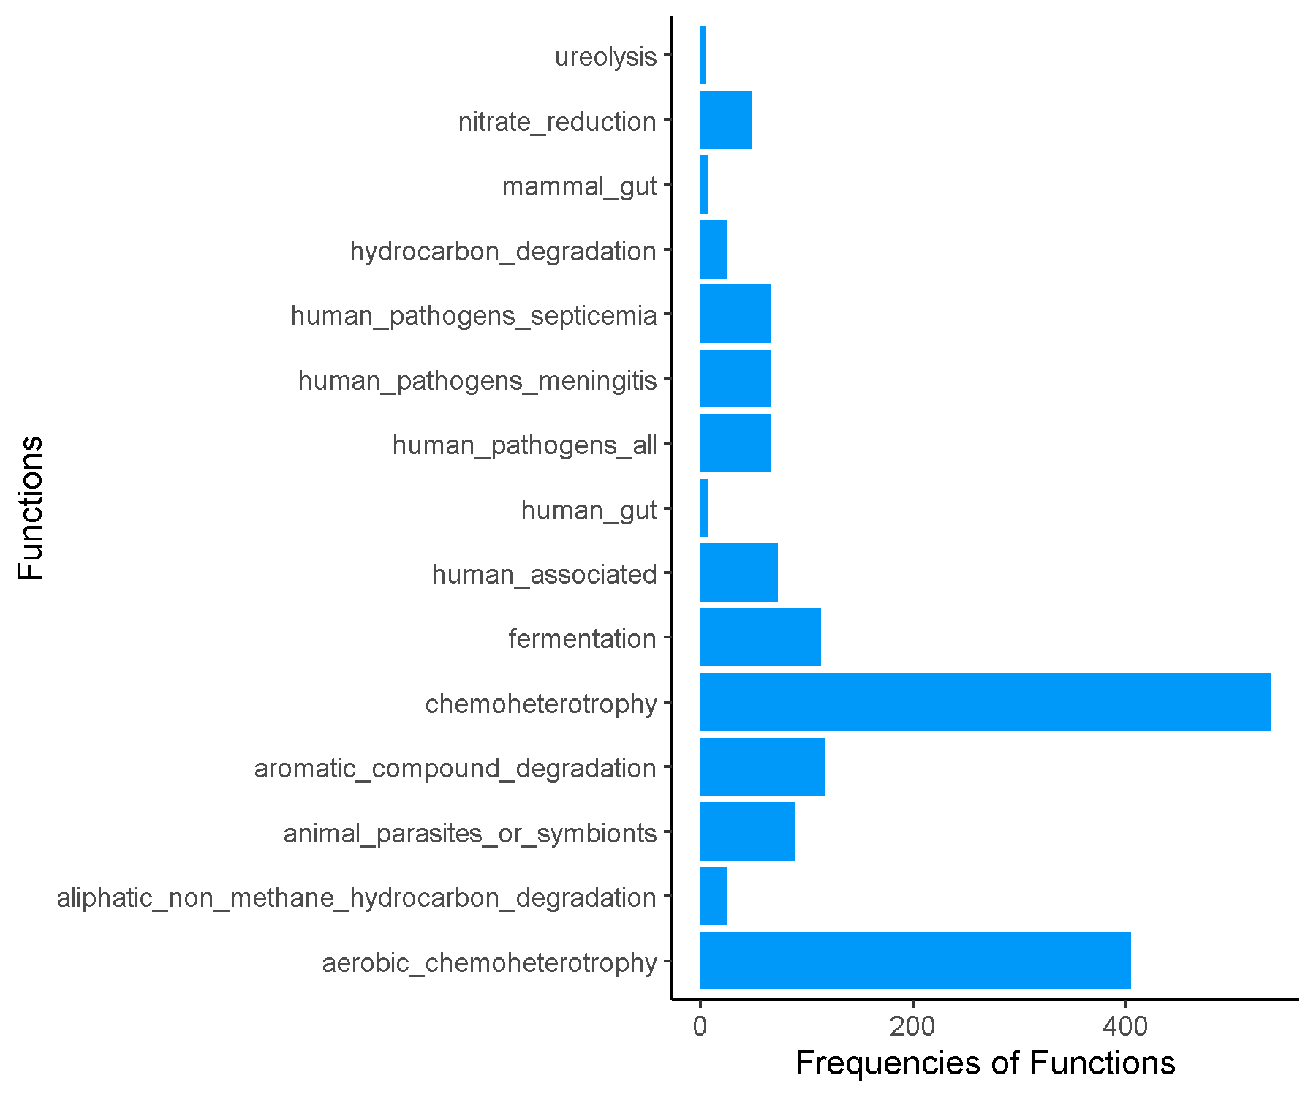

**Mid_Cluster1.csv.txt_Finalresults.txt**

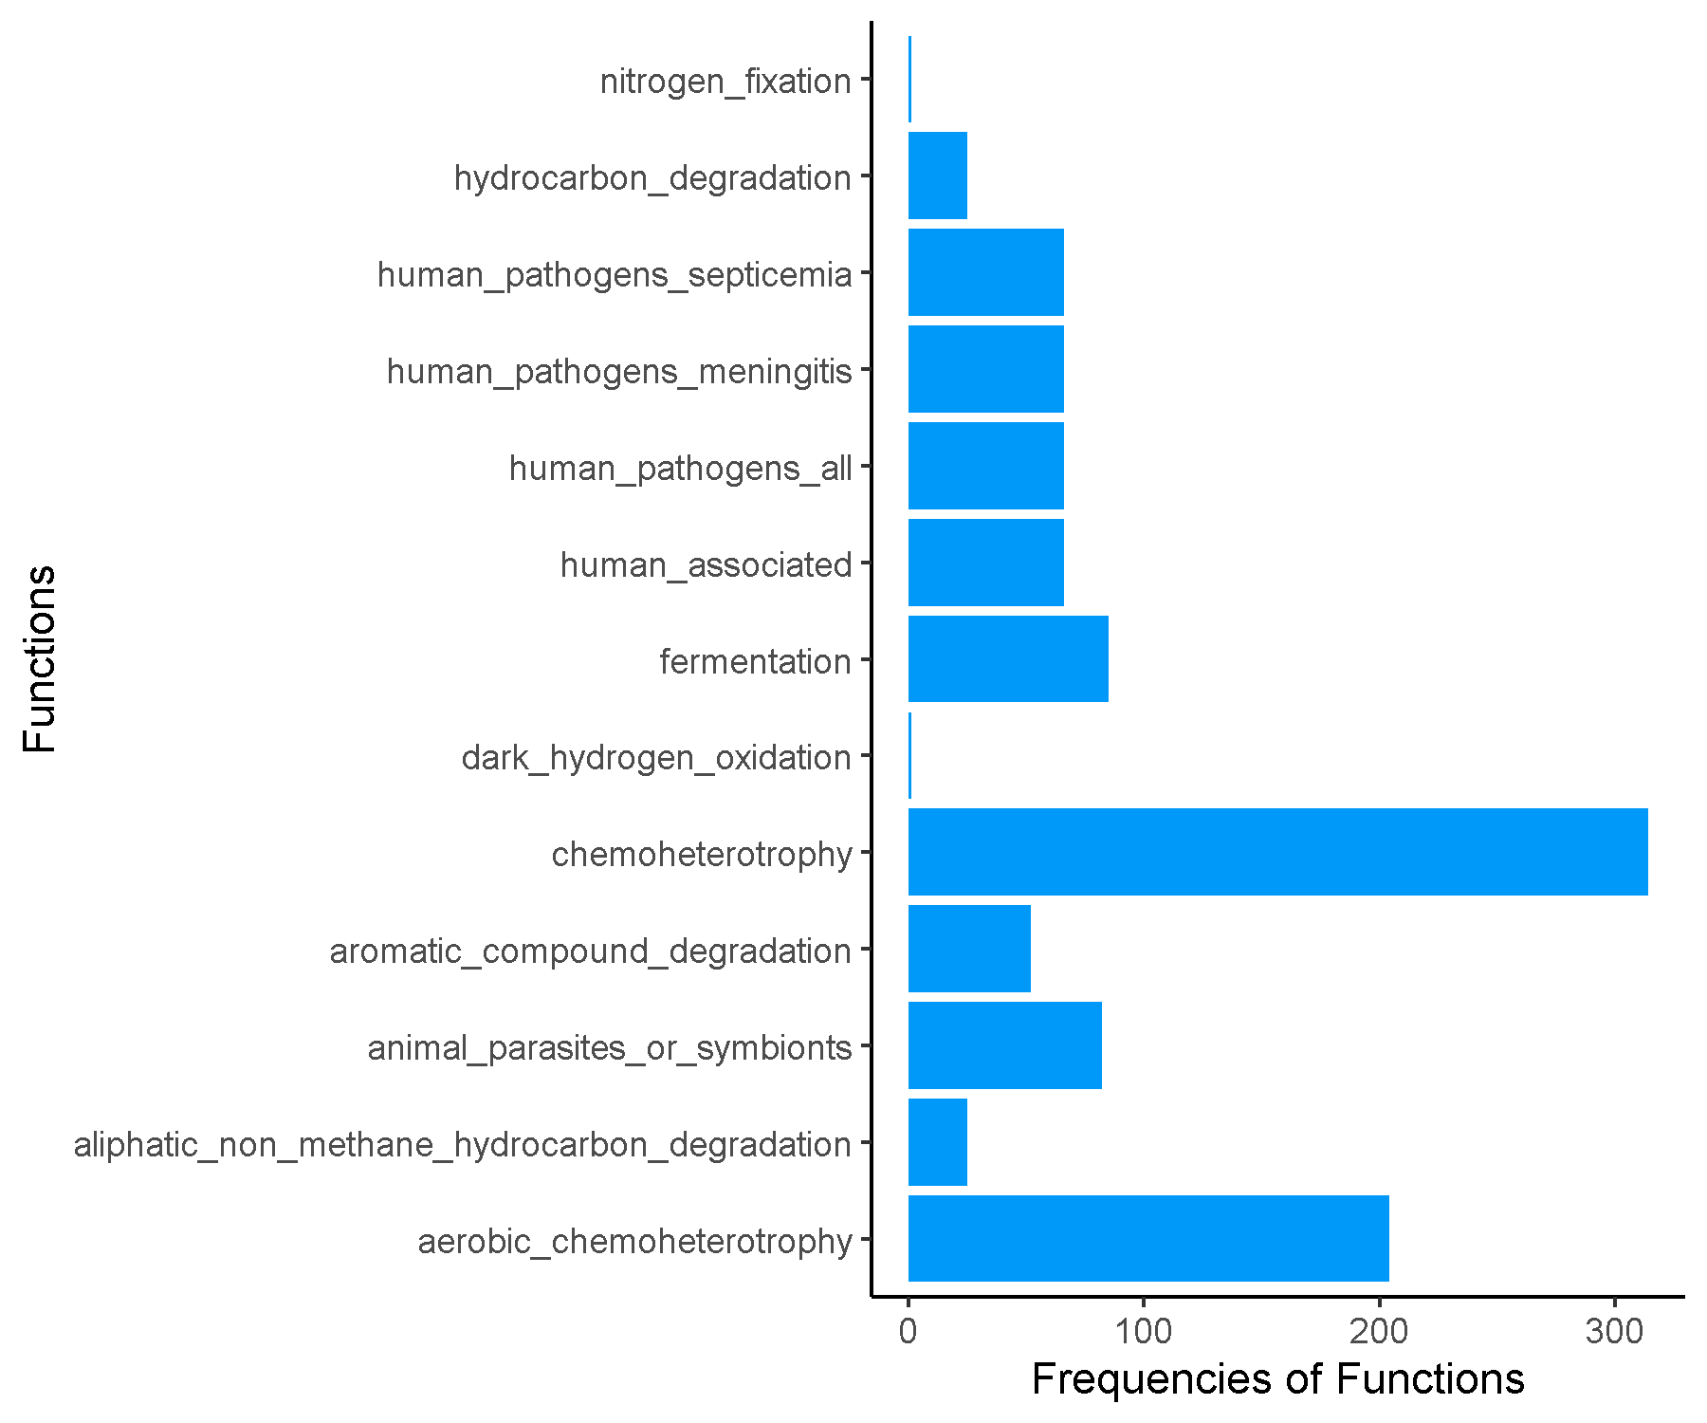

**Mid_Cluster2.csv.txt_Finalresults.txt**

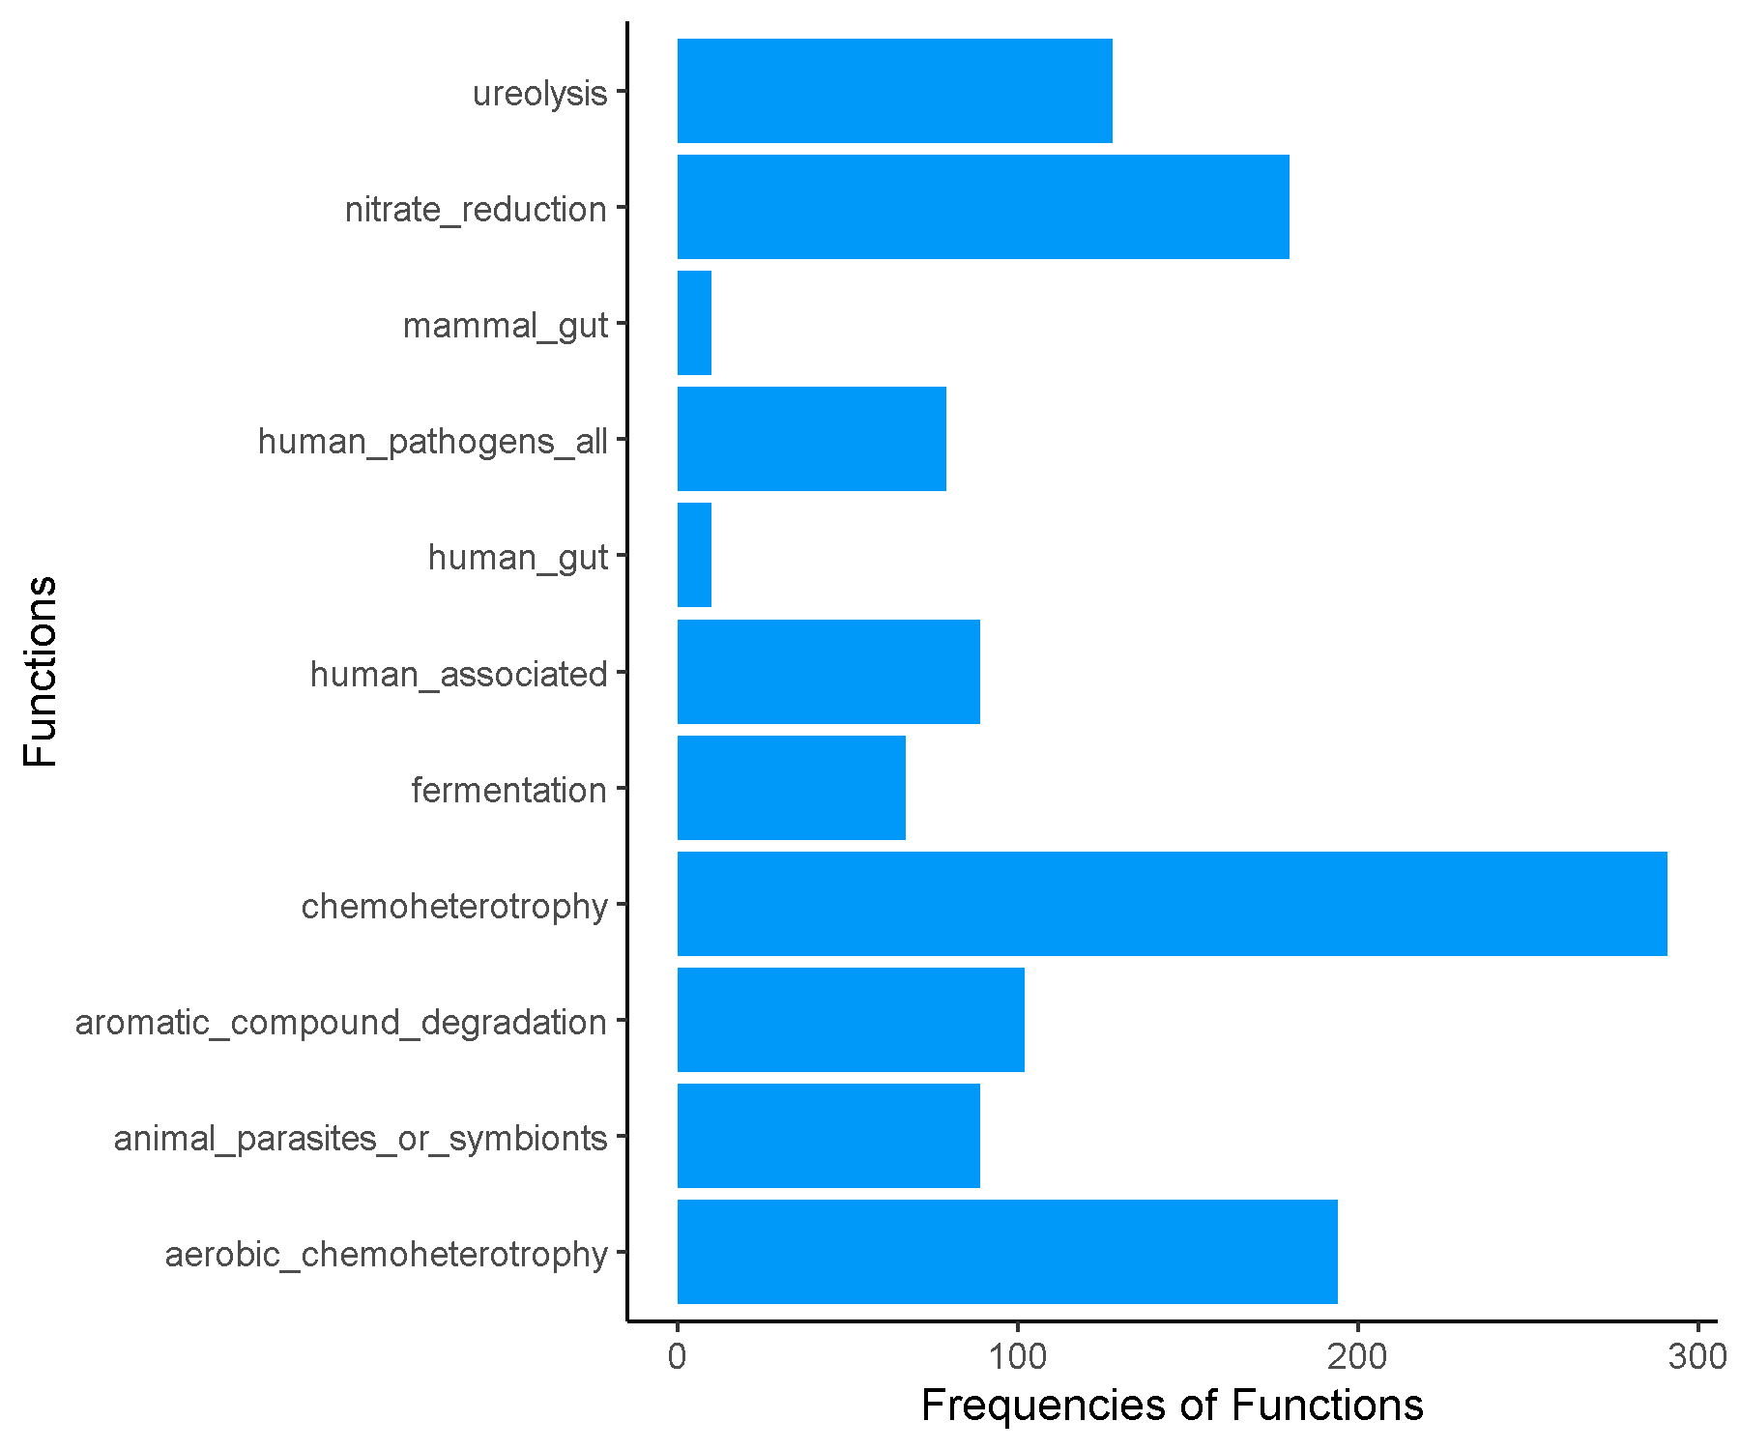

**Mid_Cluster3.csv.txt_Finalresults.txt**

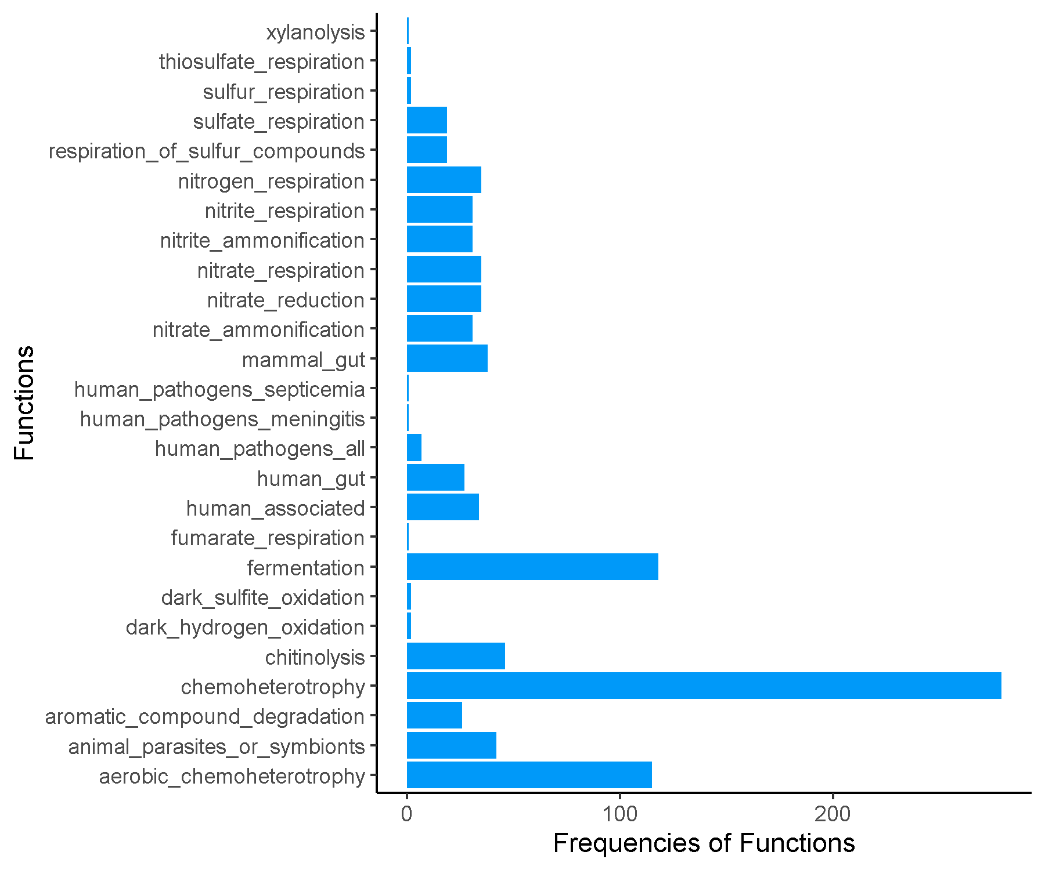

**Mid_Cluster4.csv.txt_Finalresults.txt**

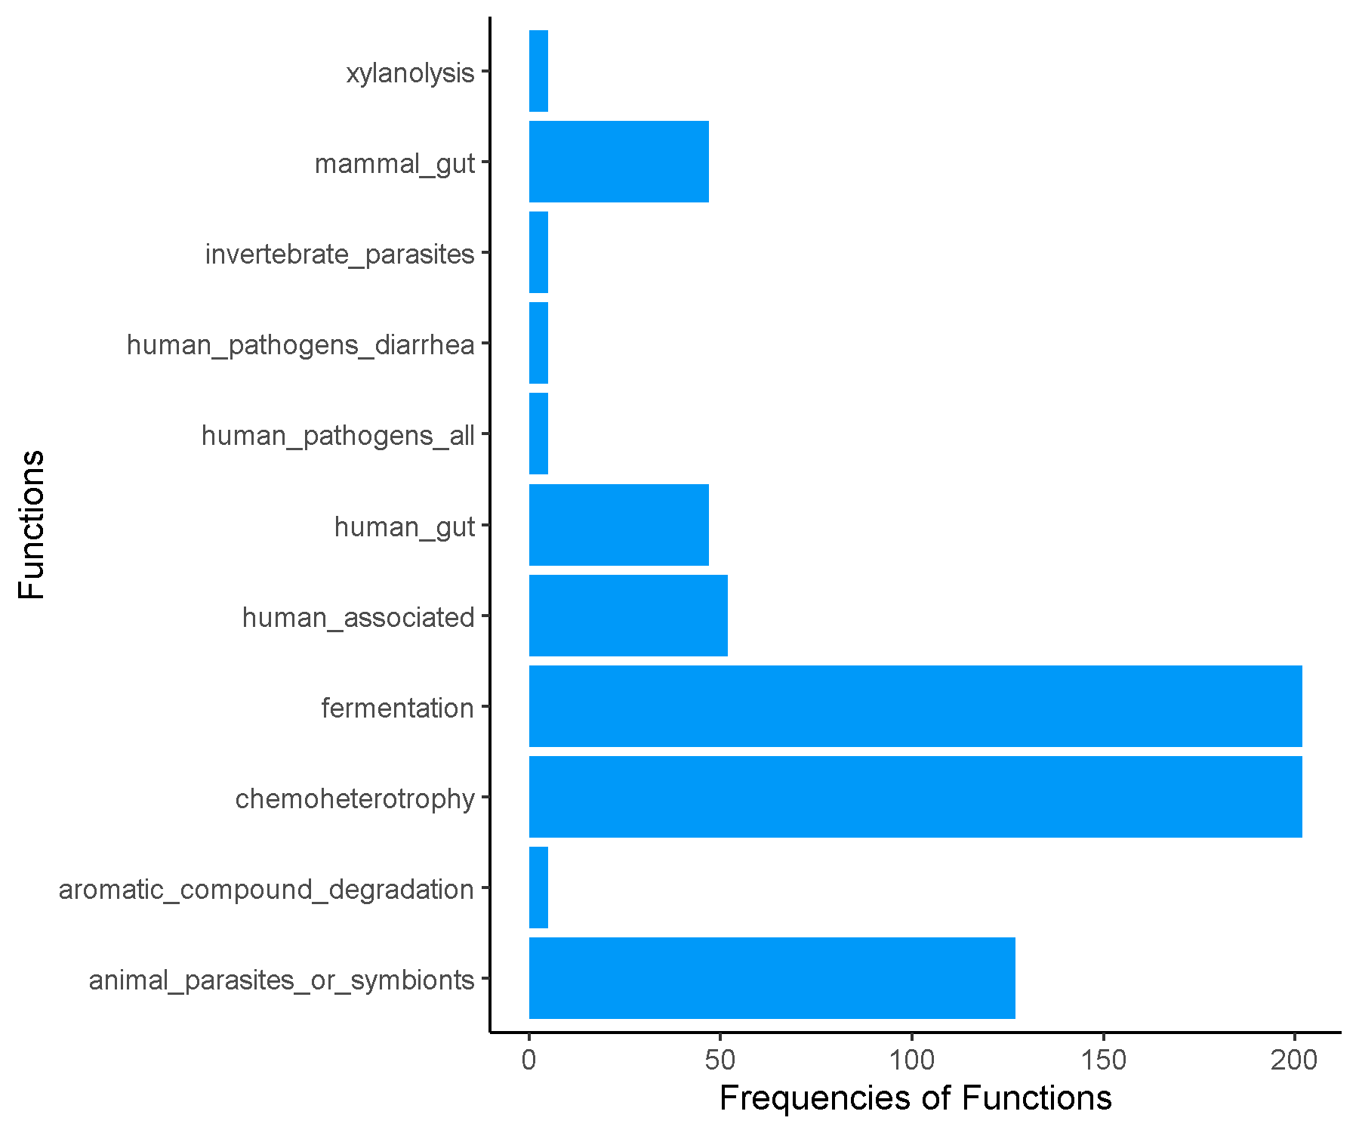

**Mid_Cluster5.csv.txt_Finalresults.txt**

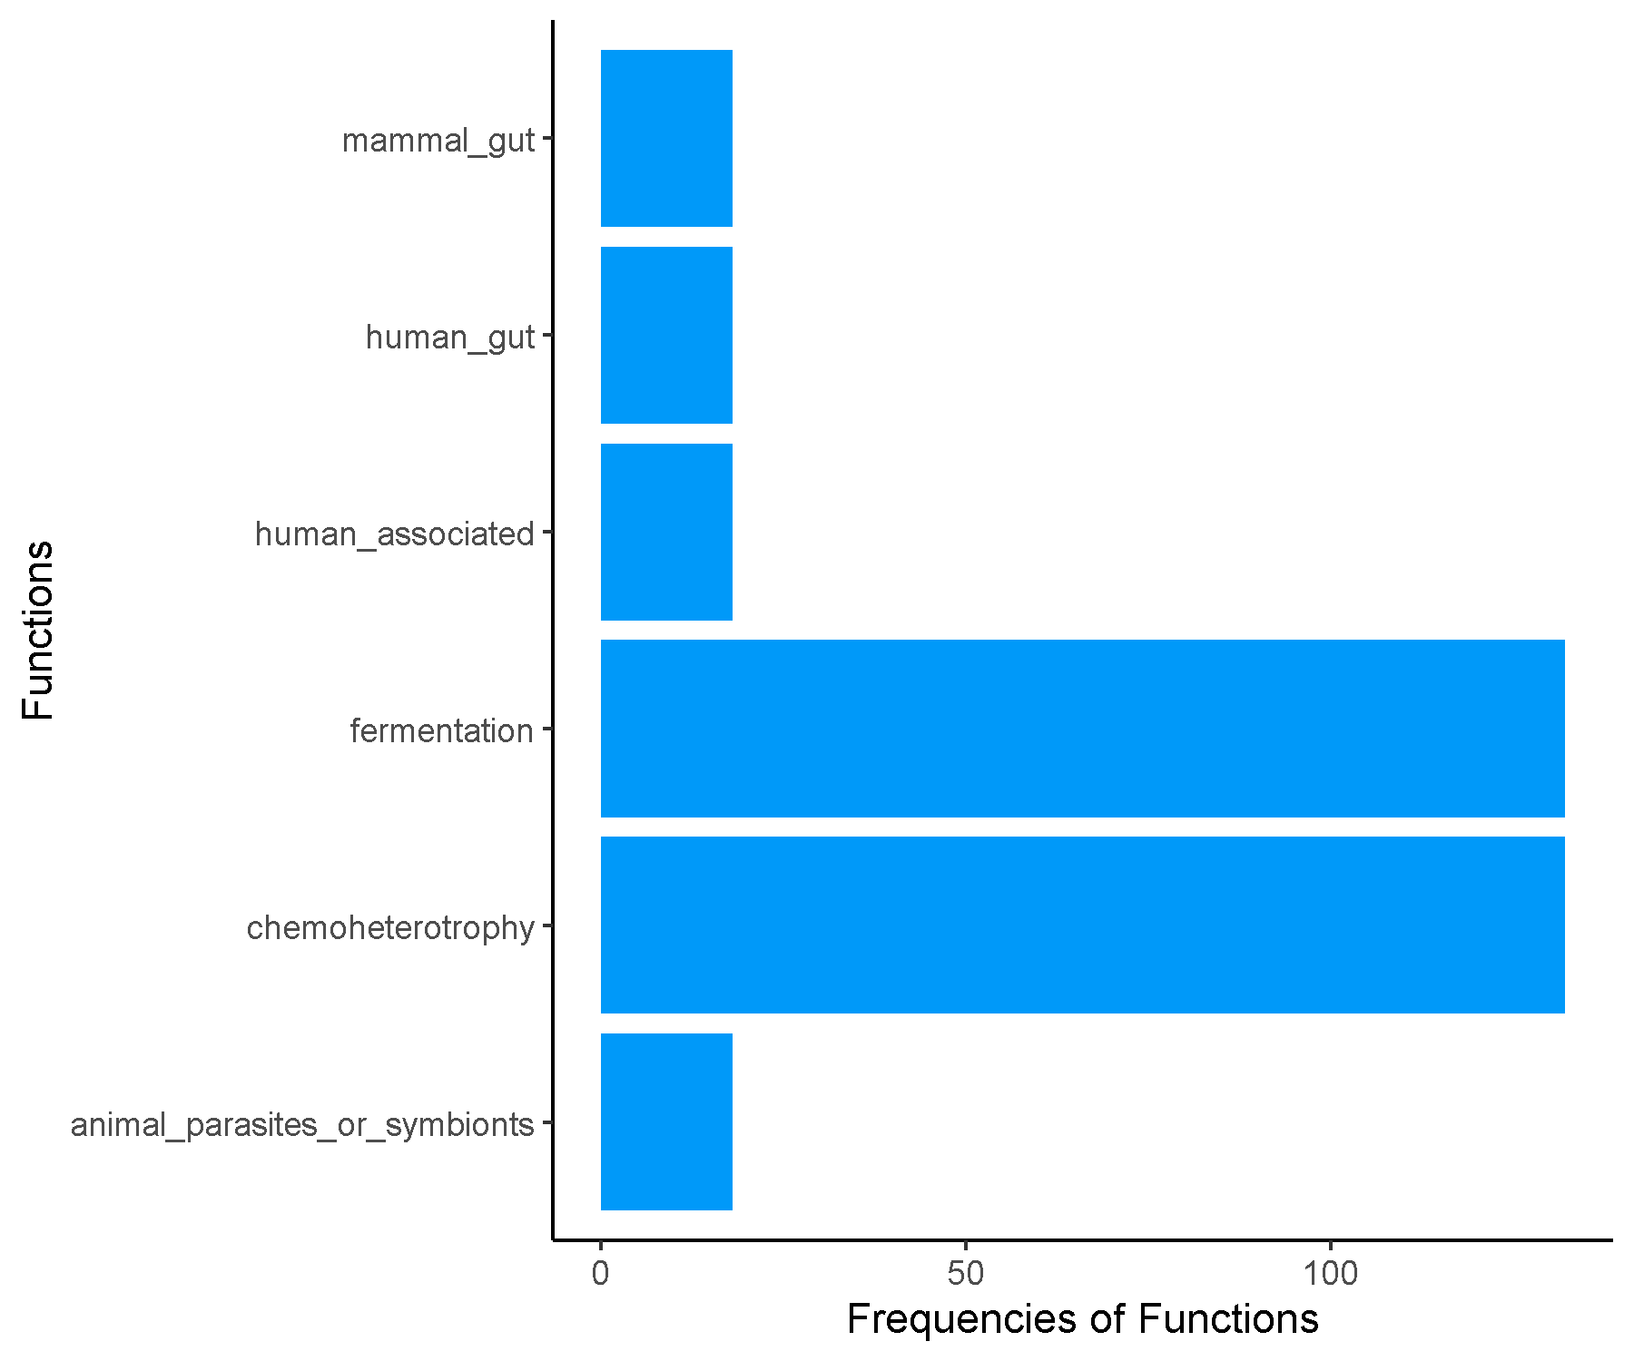

**Spring_Asian_Cluster1.csv.txt_Finalresults.txt**

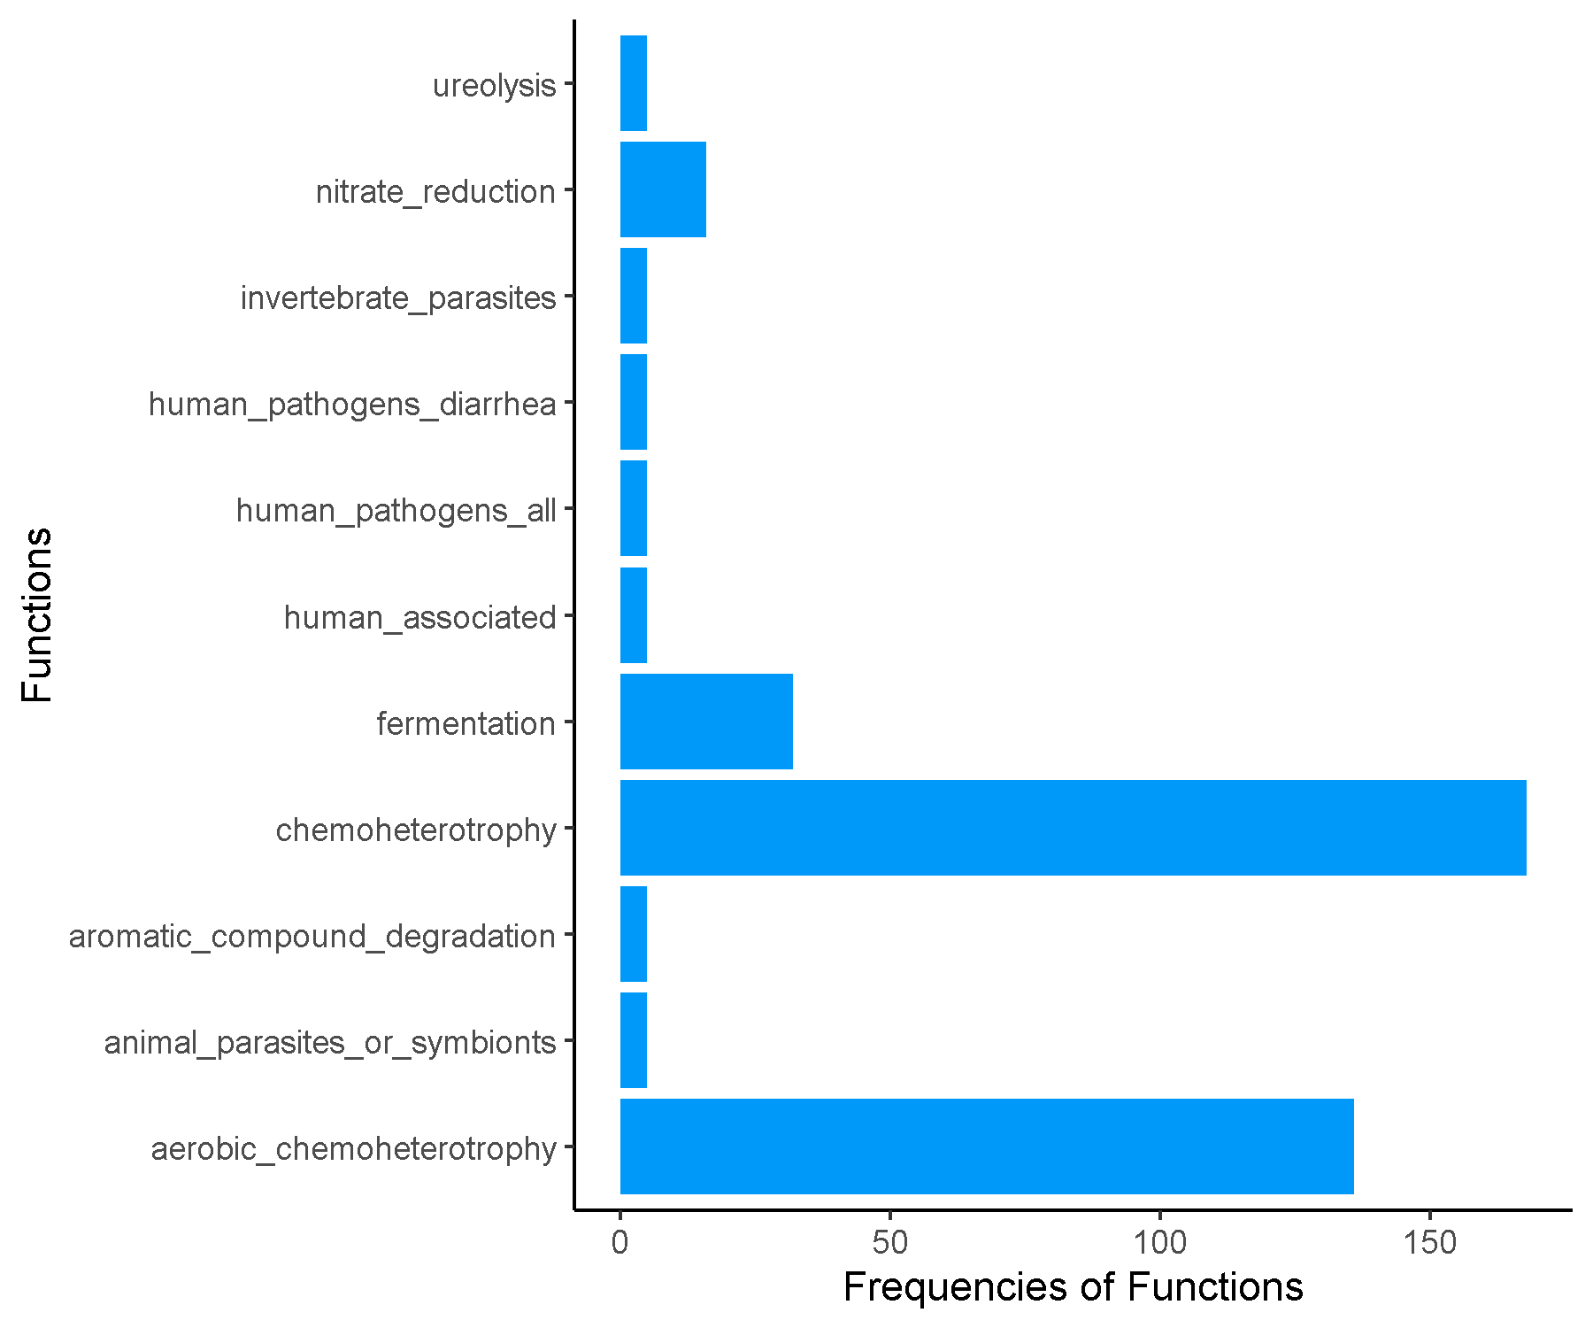

**Spring_Asian_Cluster2.csv.txt_Finalresults.txt**

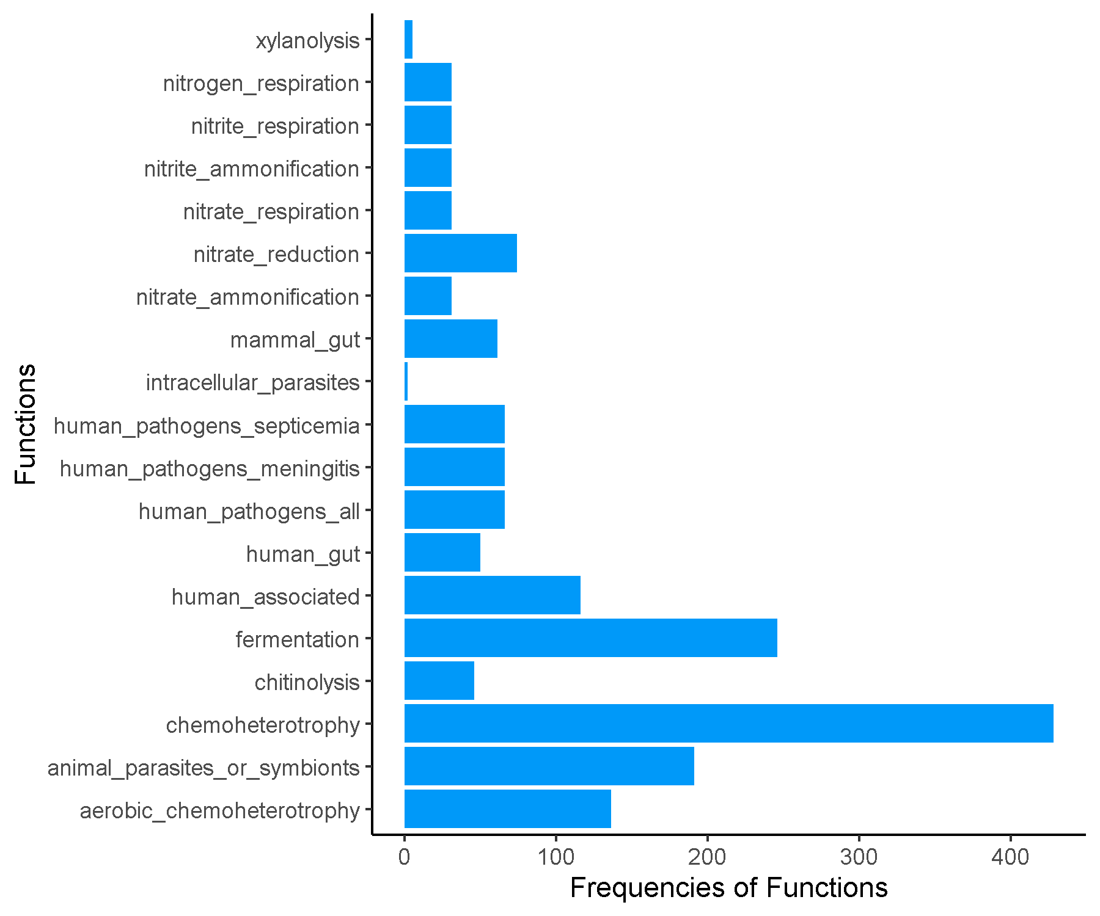

**Spring_Asian_Cluster3.csv.txt_Finalresults.txt**

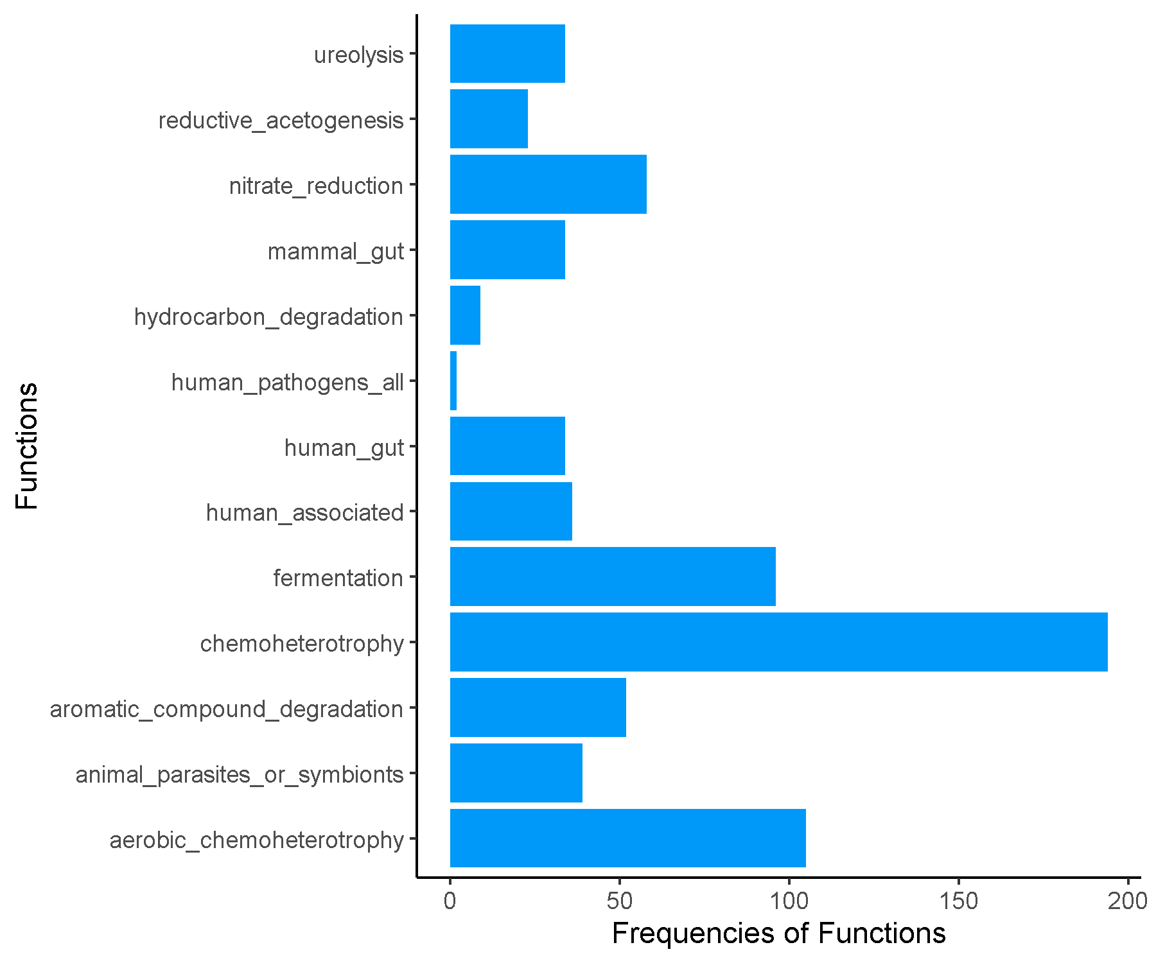

**Spring_Asian_Cluster4.csv.txt_Finalresults.txt**

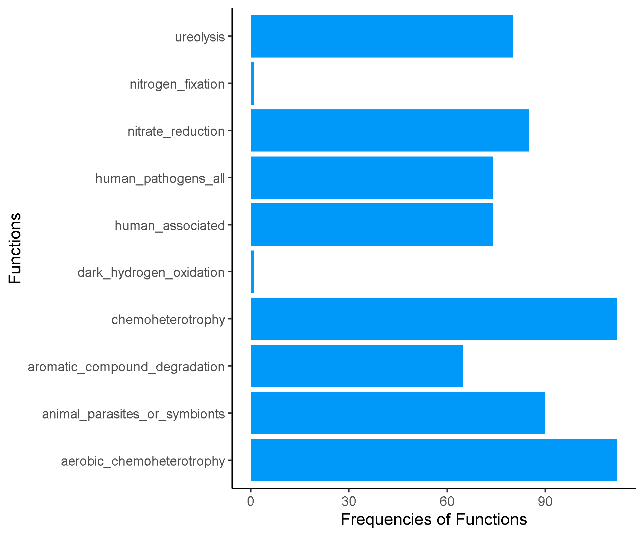

**Spring_Asian_Cluster5.csv.txt_Finalresults.txt**

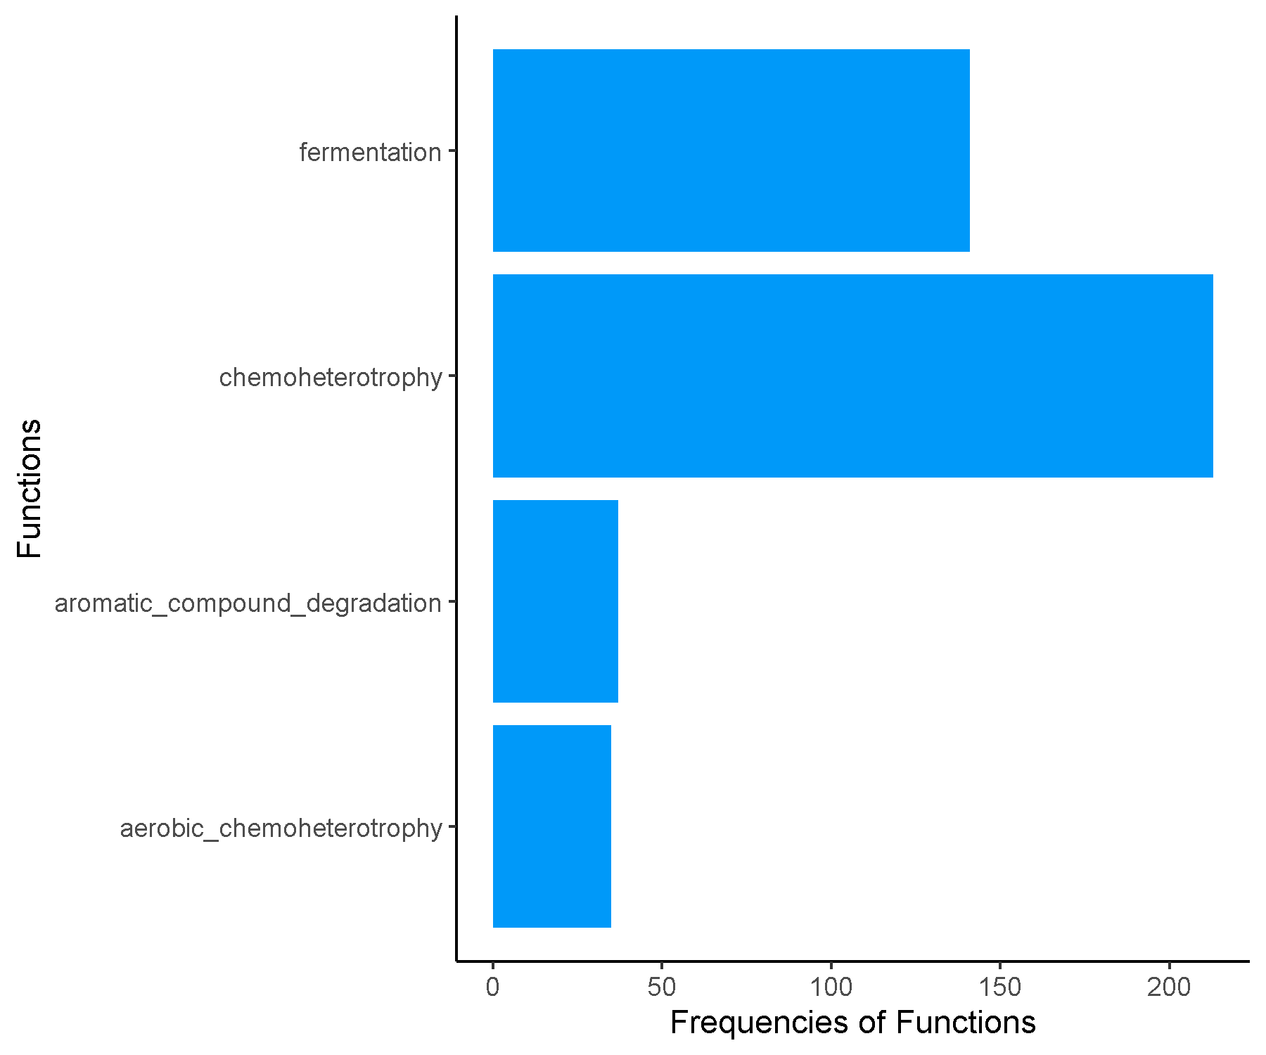

**Spring_Asian_Cluster6.csv.txt_Finalresults.txt**

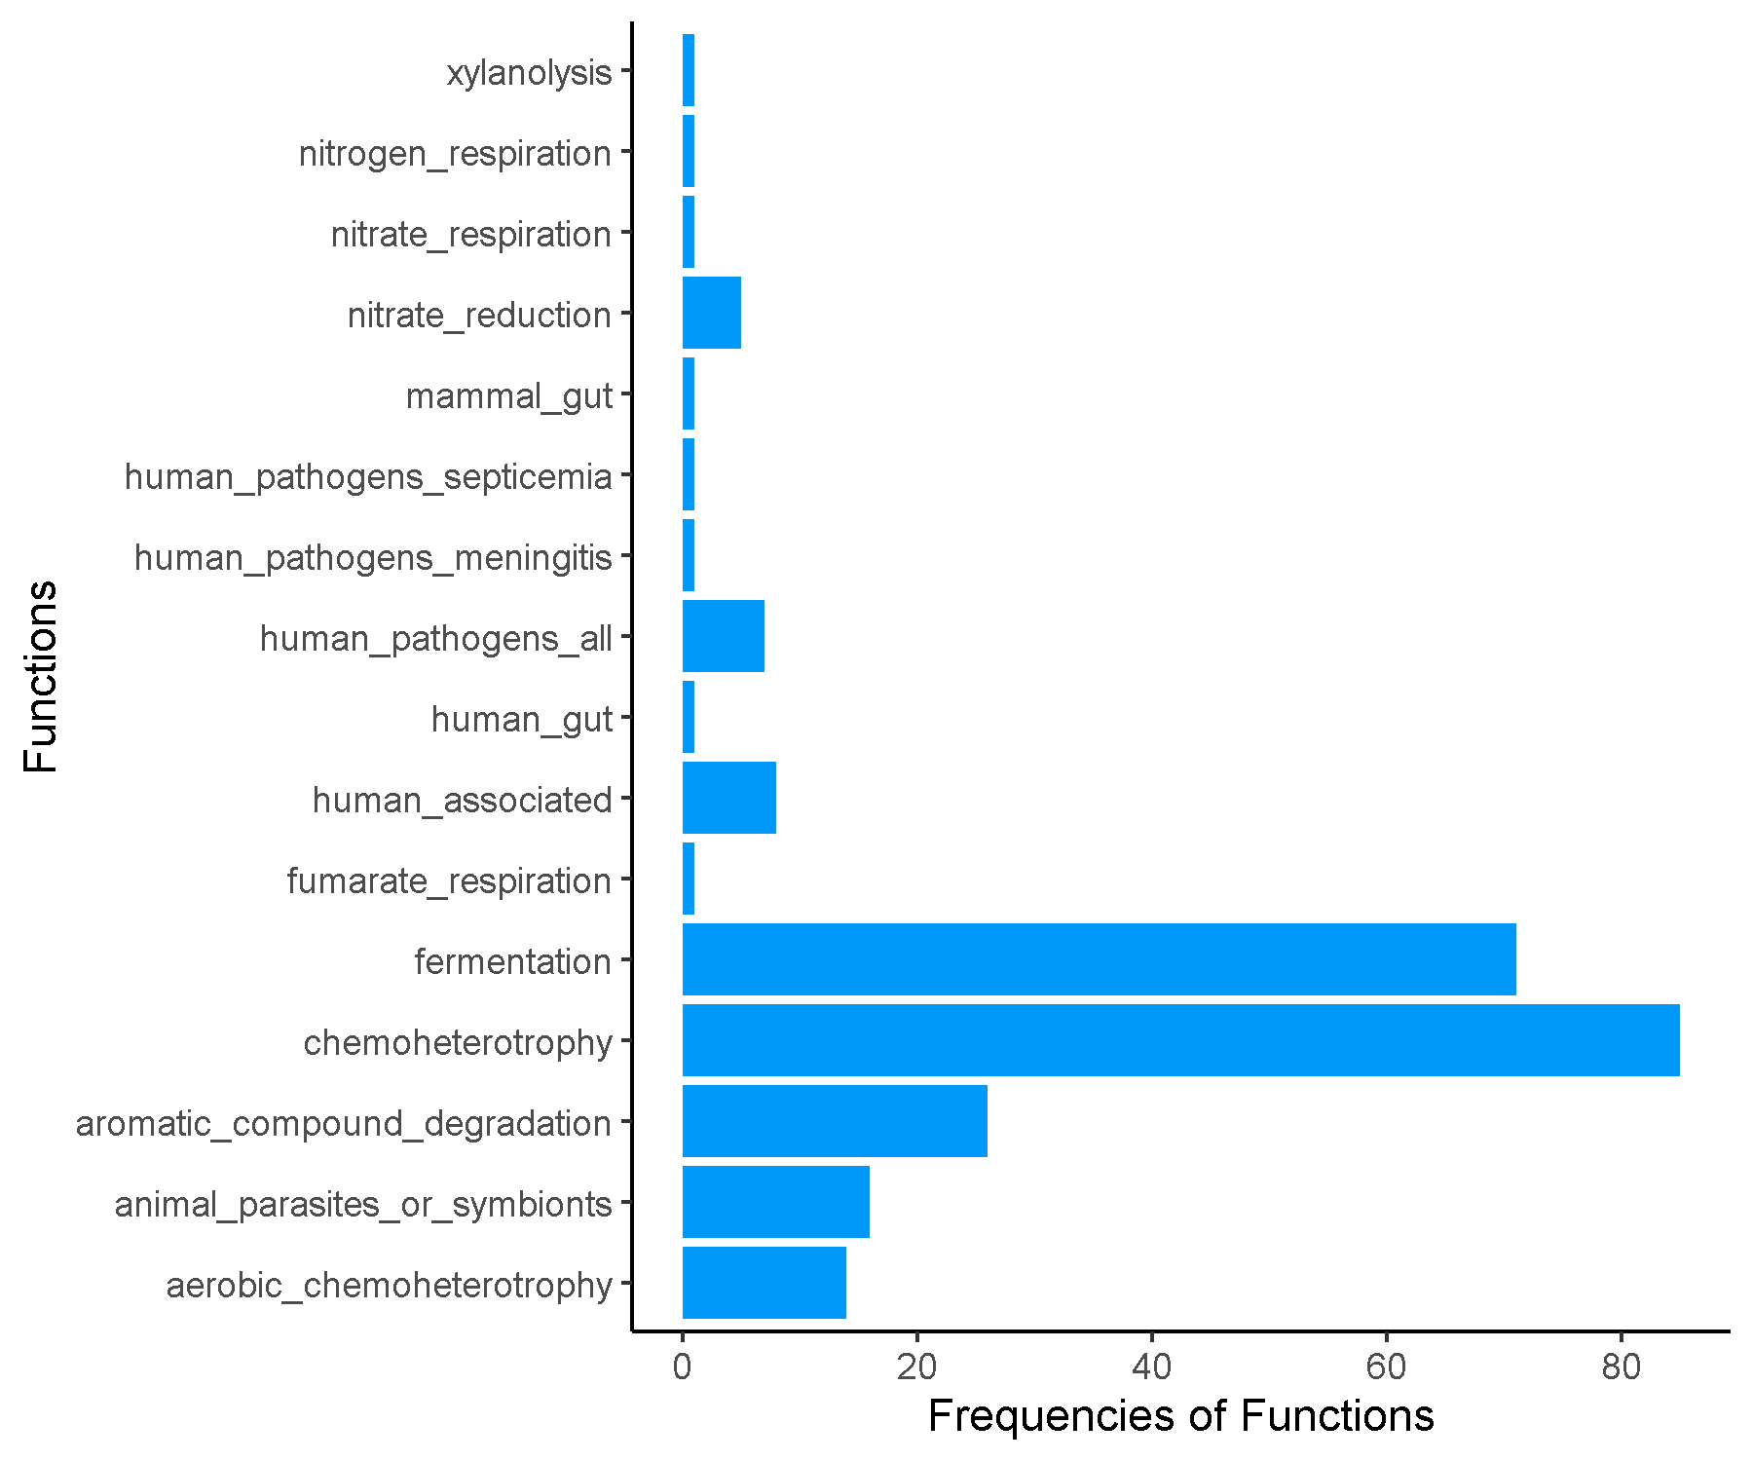

**Spring_Asian_Cluster7.csv.txt_Finalresults.txt**

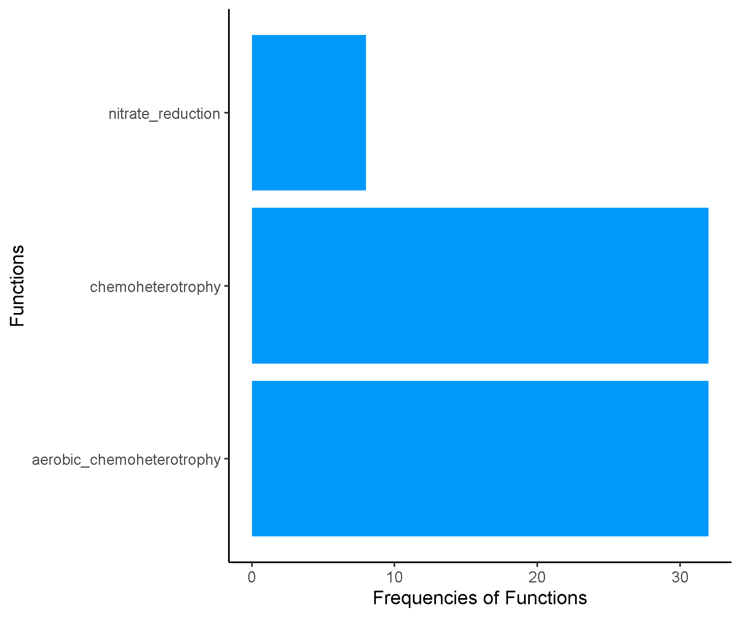

**Spring_Early_Cluster1.csv.txt_Finalresults.txt**

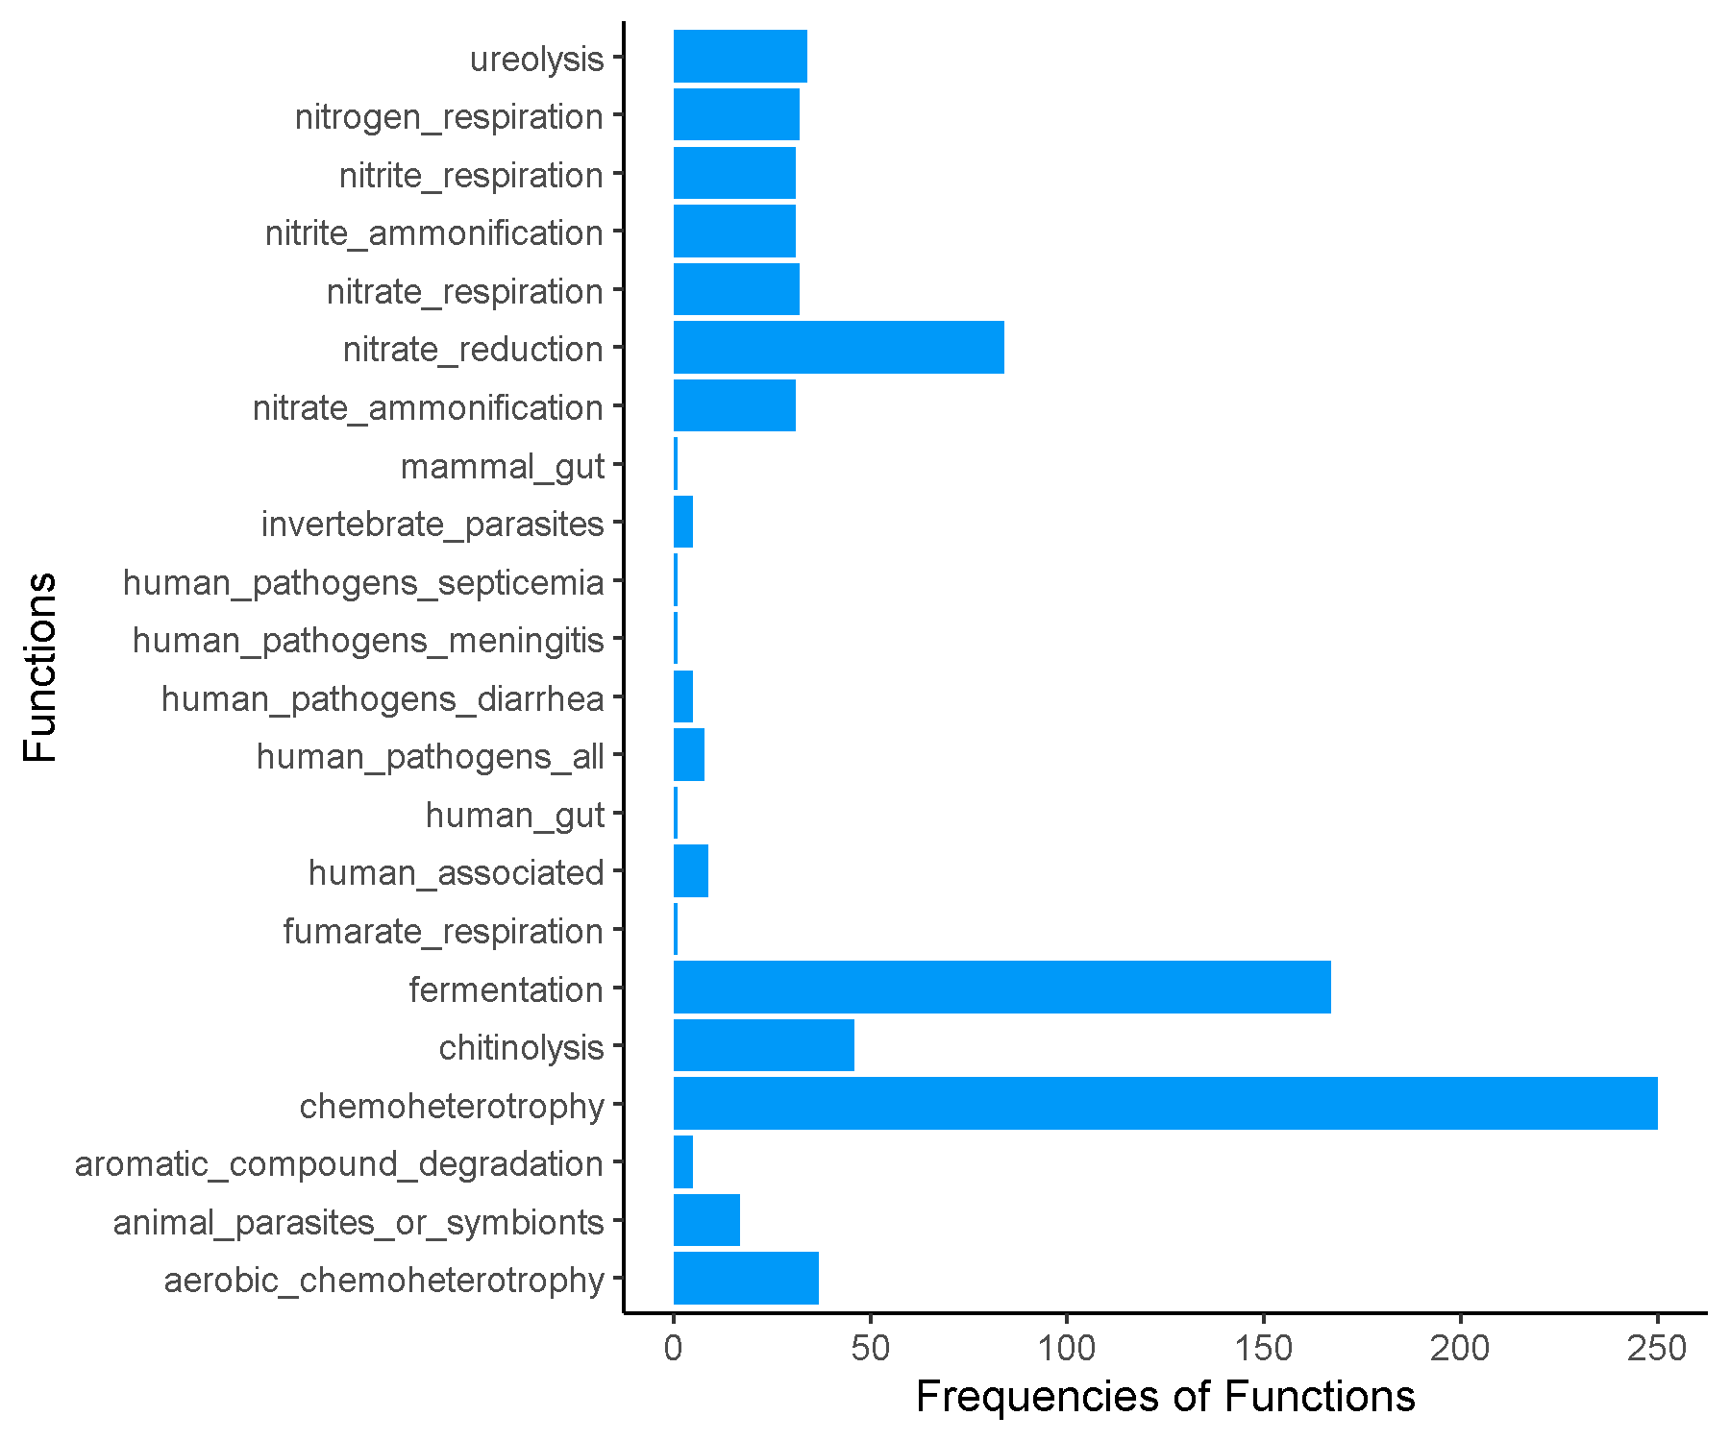

**Spring_Early_Cluster2.csv.txt_Finalresults.txt**

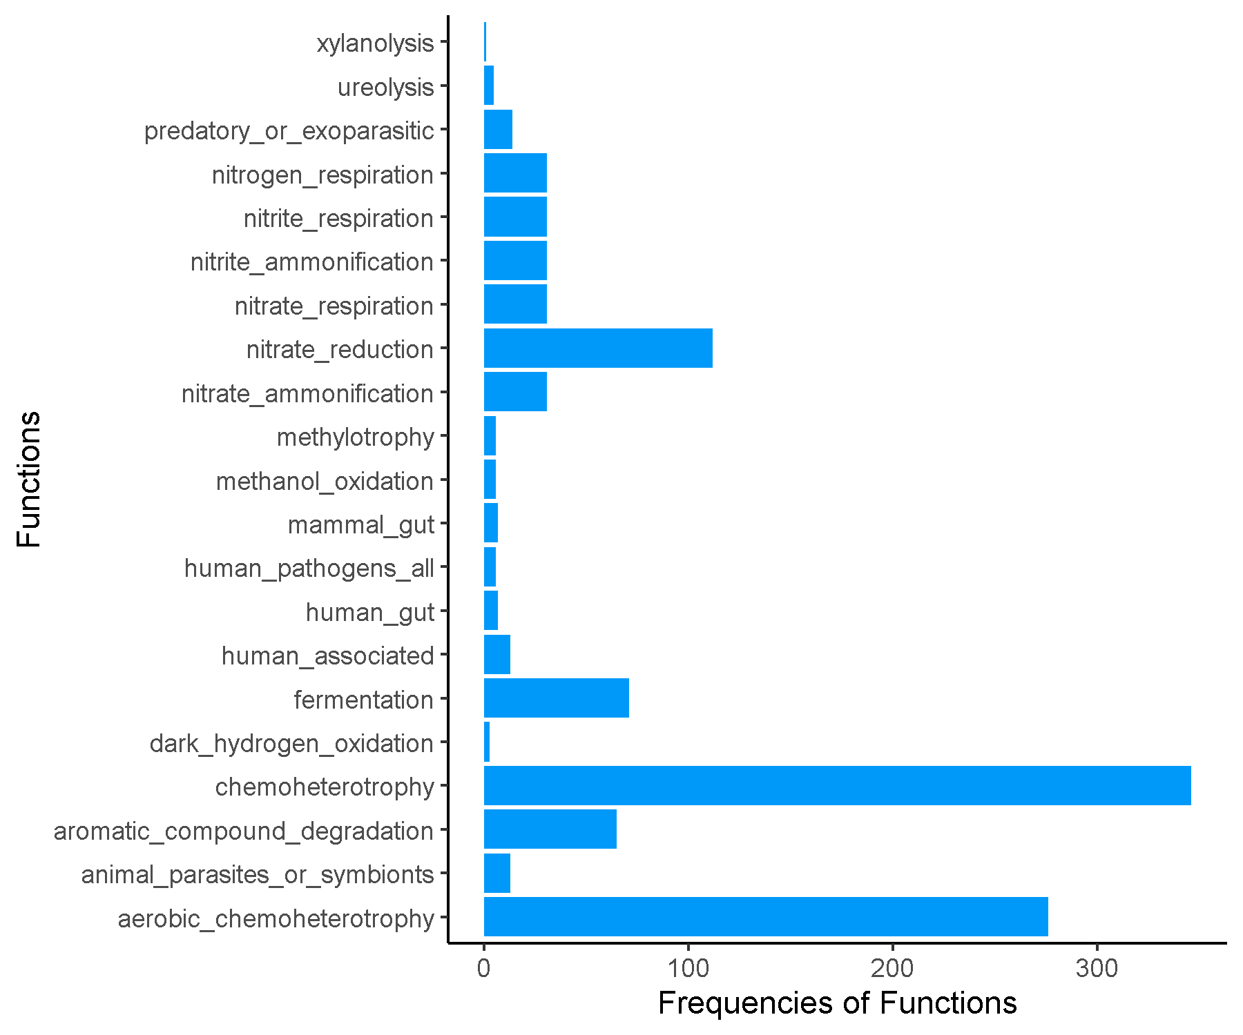

**Spring_Early_Cluster3.csv.txt_Finalresults.txt**

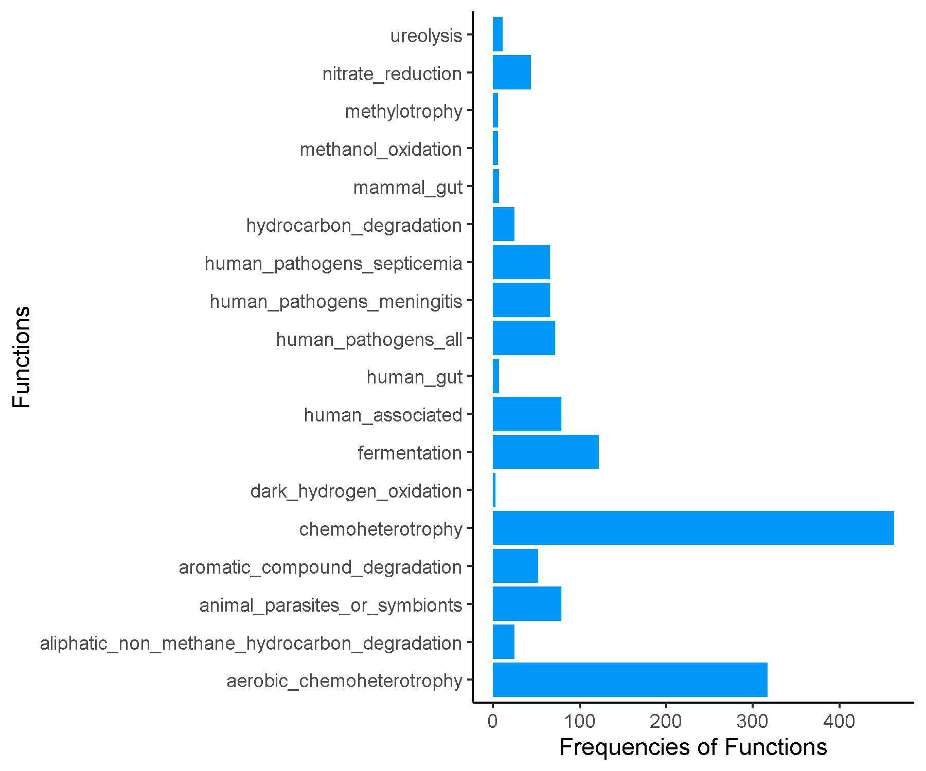

**Spring_Early_Cluster4.csv.txt_Finalresults.txt**

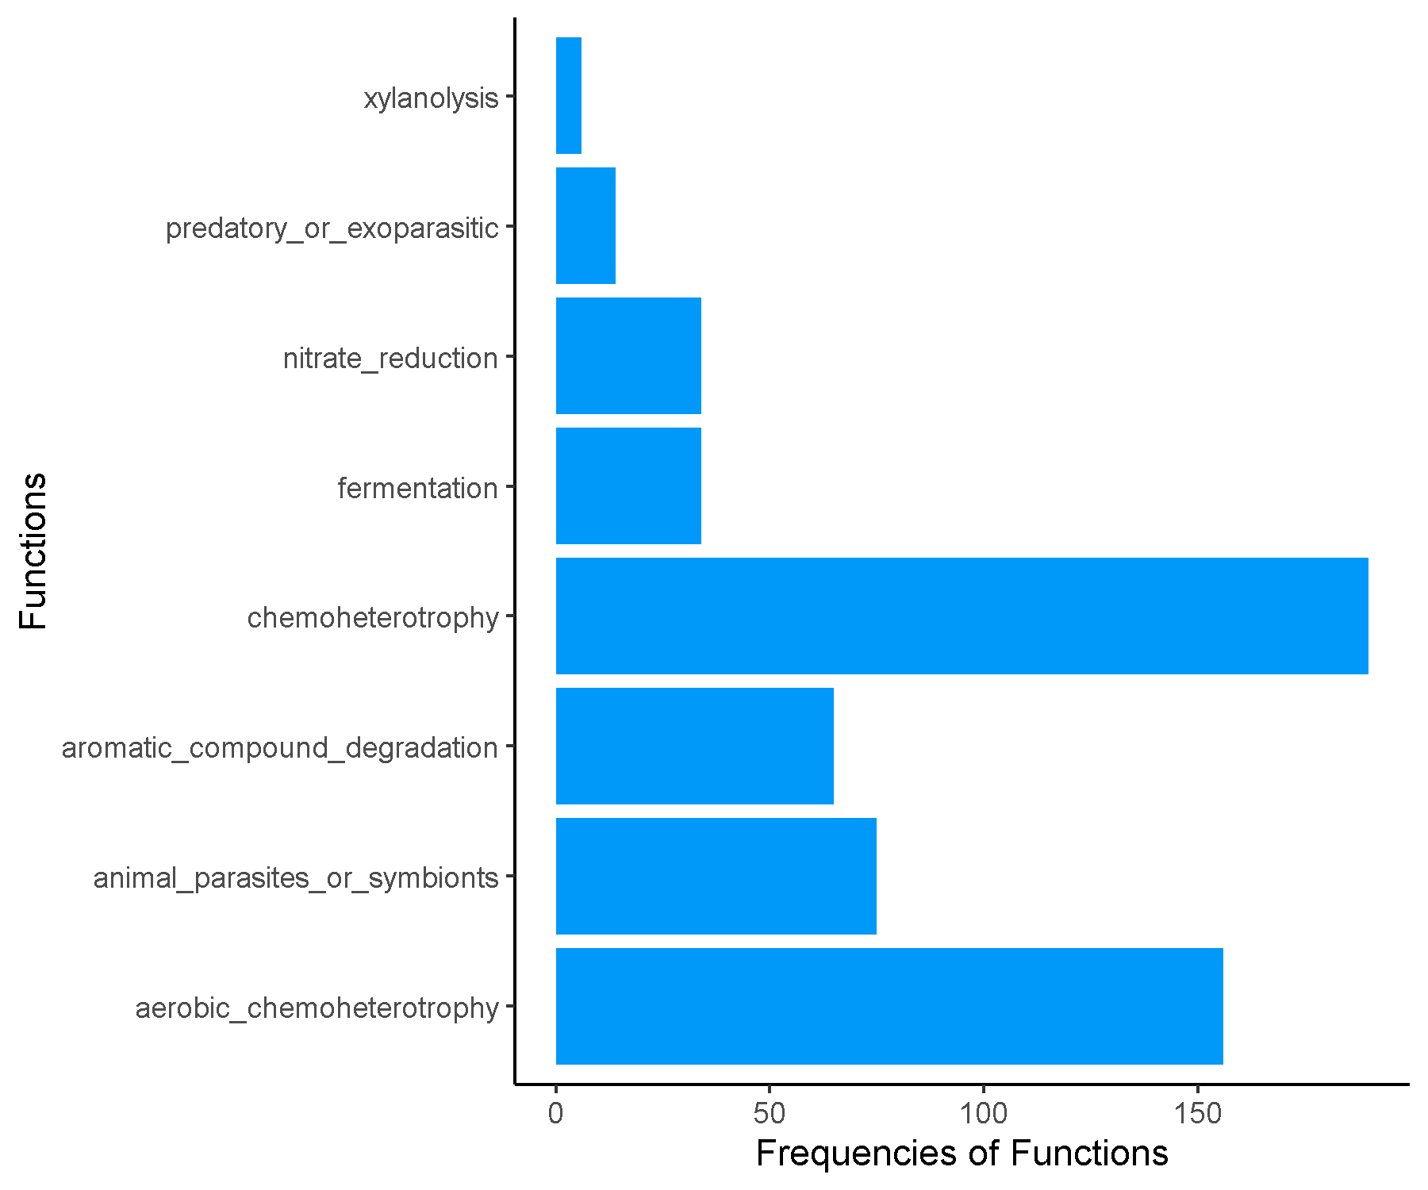

**Spring_Early_Cluster5.csv.txt_Finalresults.txt**

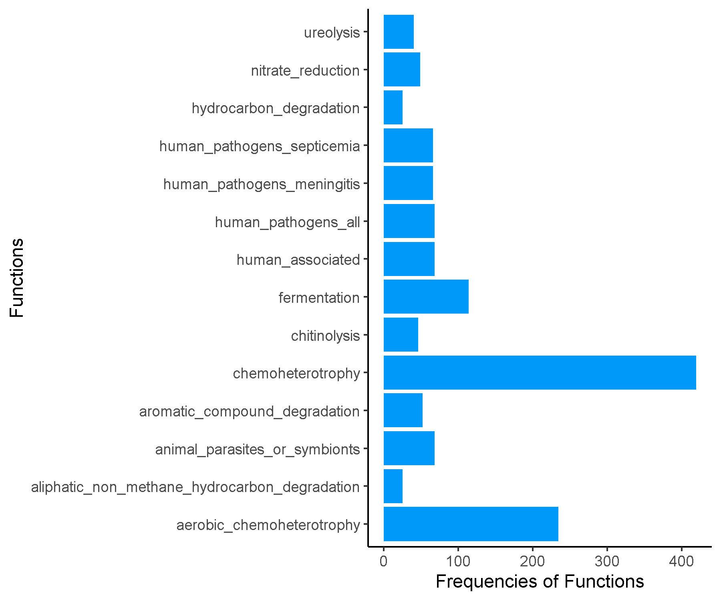

**Spring_Early_Cluster6.csv.txt_Finalresults.txt**

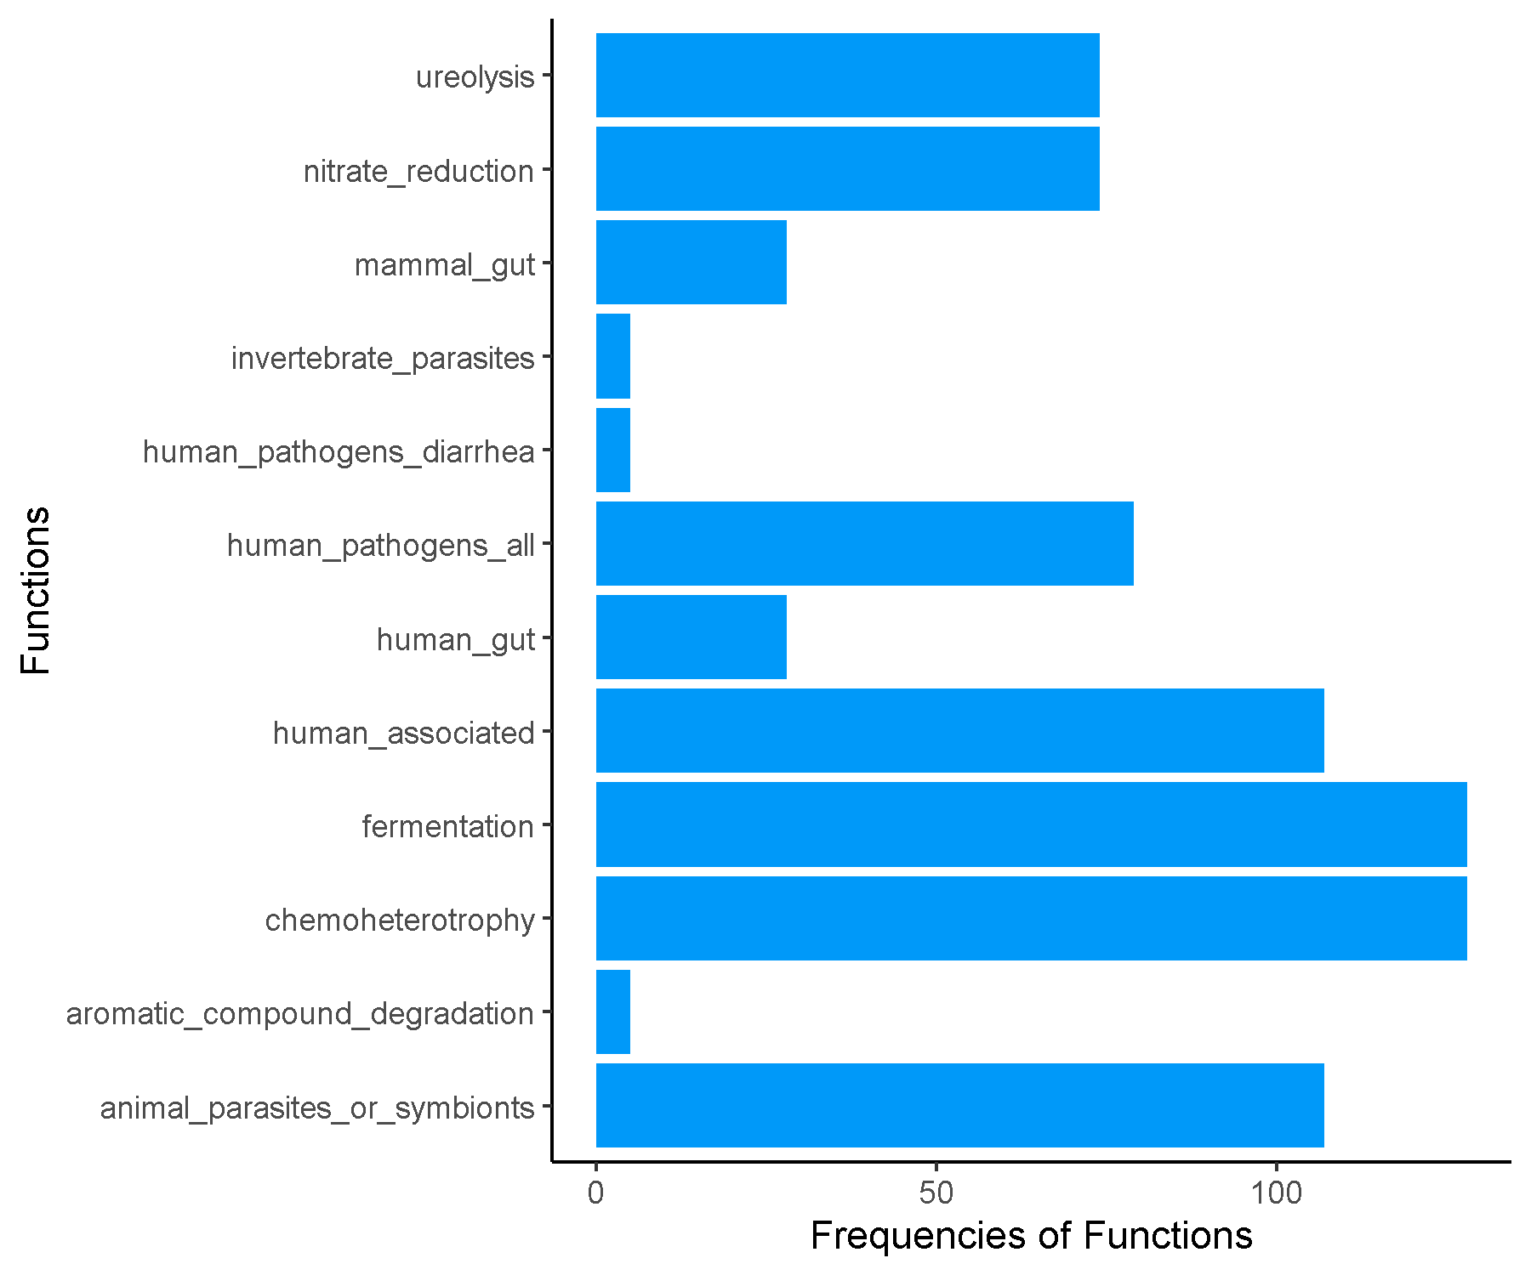

**Spring_Early_Cluster7.csv.txt_Finalresults.txt**

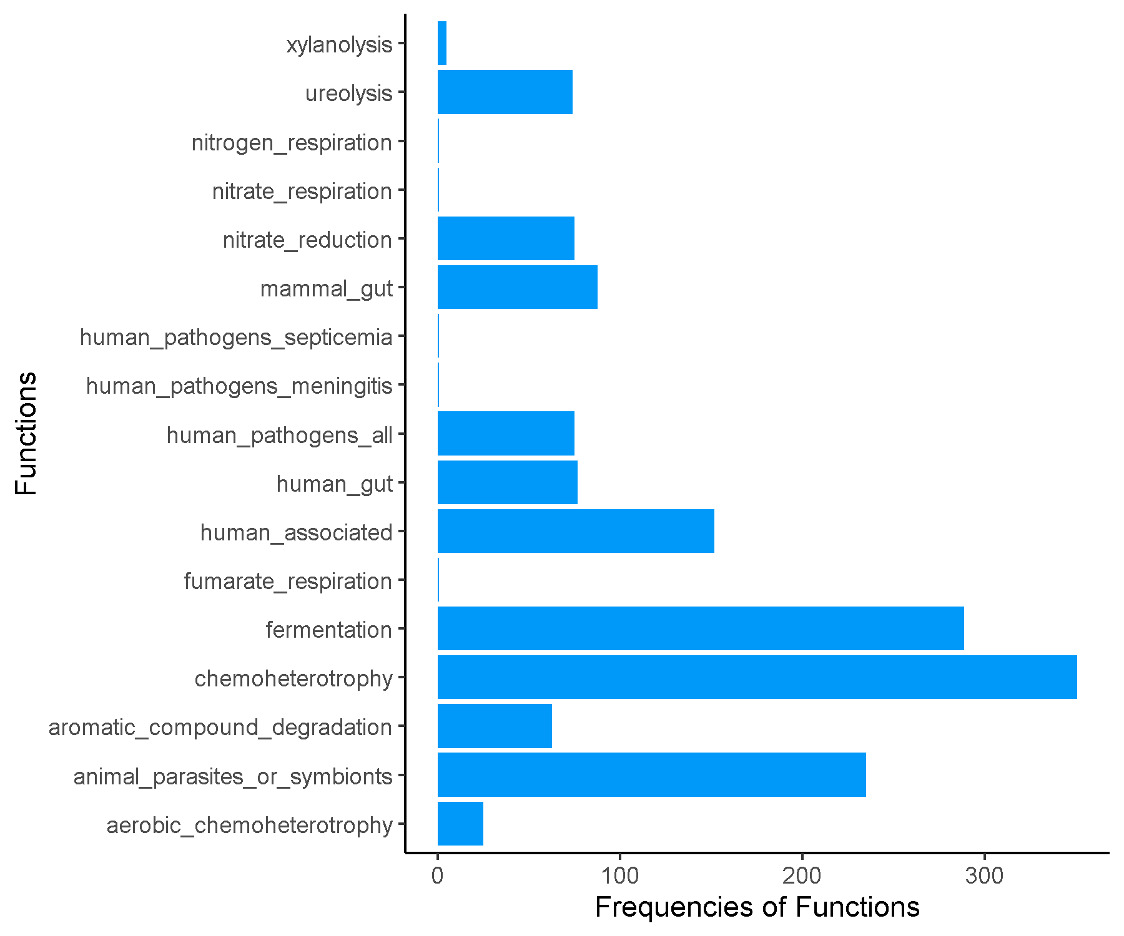

**Spring_Early_Cluster8.csv.txt_Finalresults.txt**

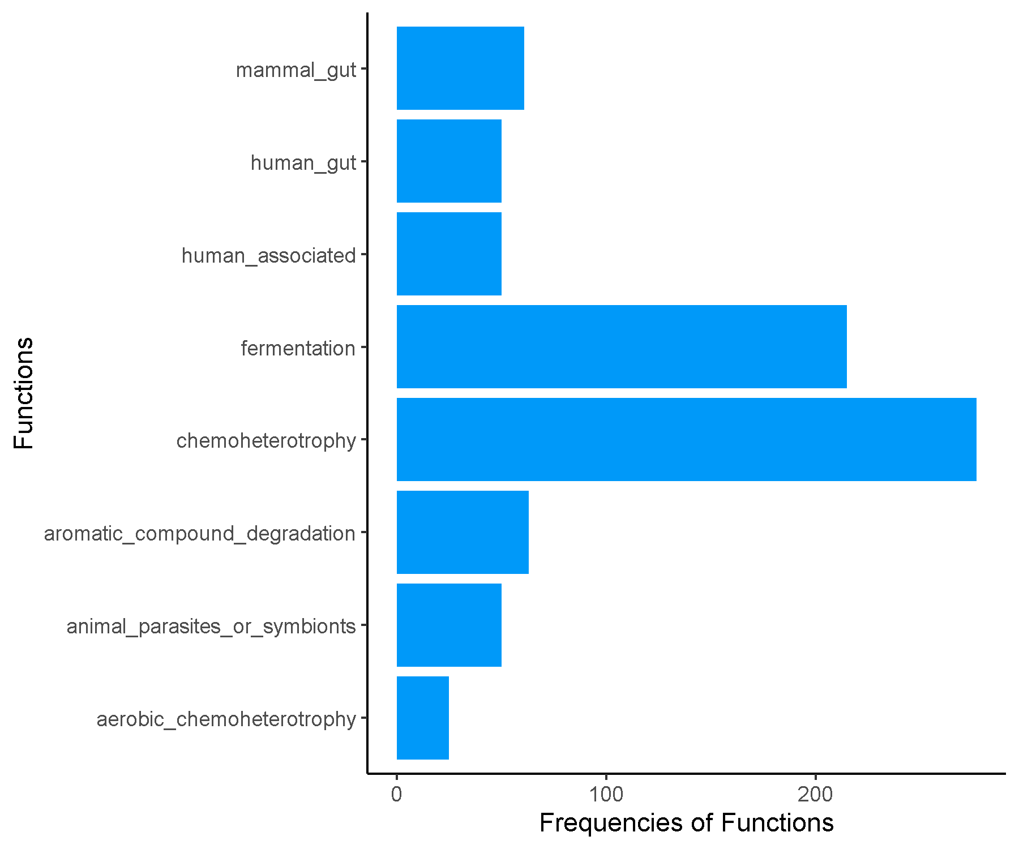

**Spring_FRFRC_Cluster1.csv.txt_Finalresults.txt**

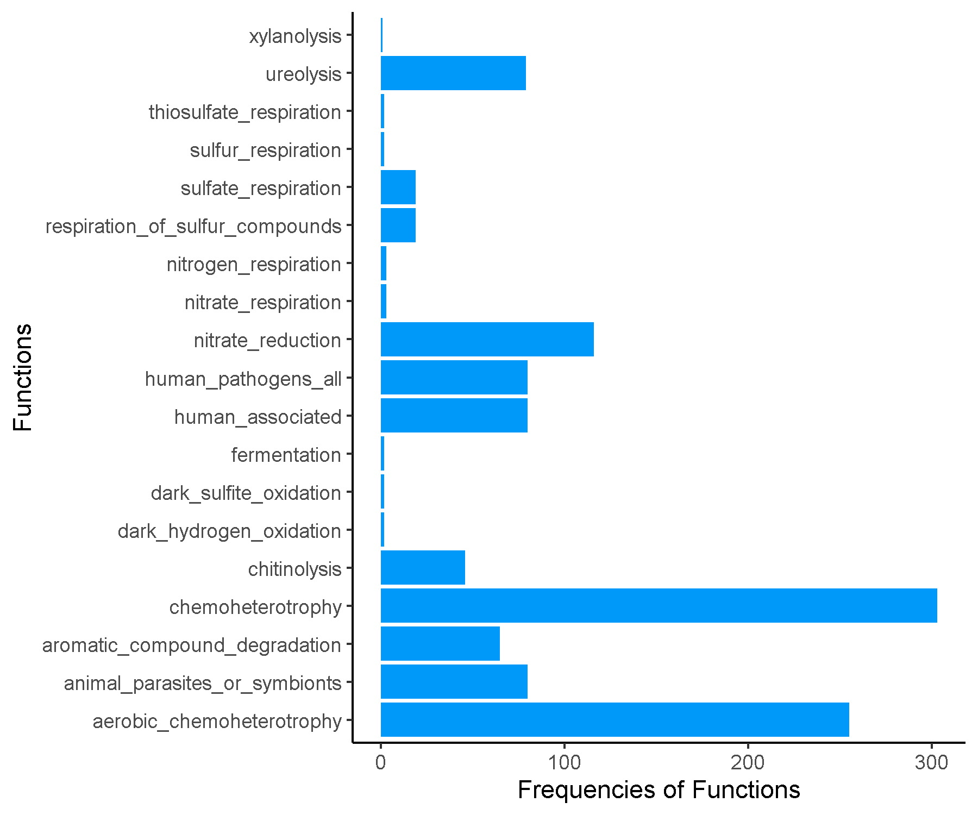

**Spring_FRFRC_Cluster2.csv.txt_Finalresults.txt**

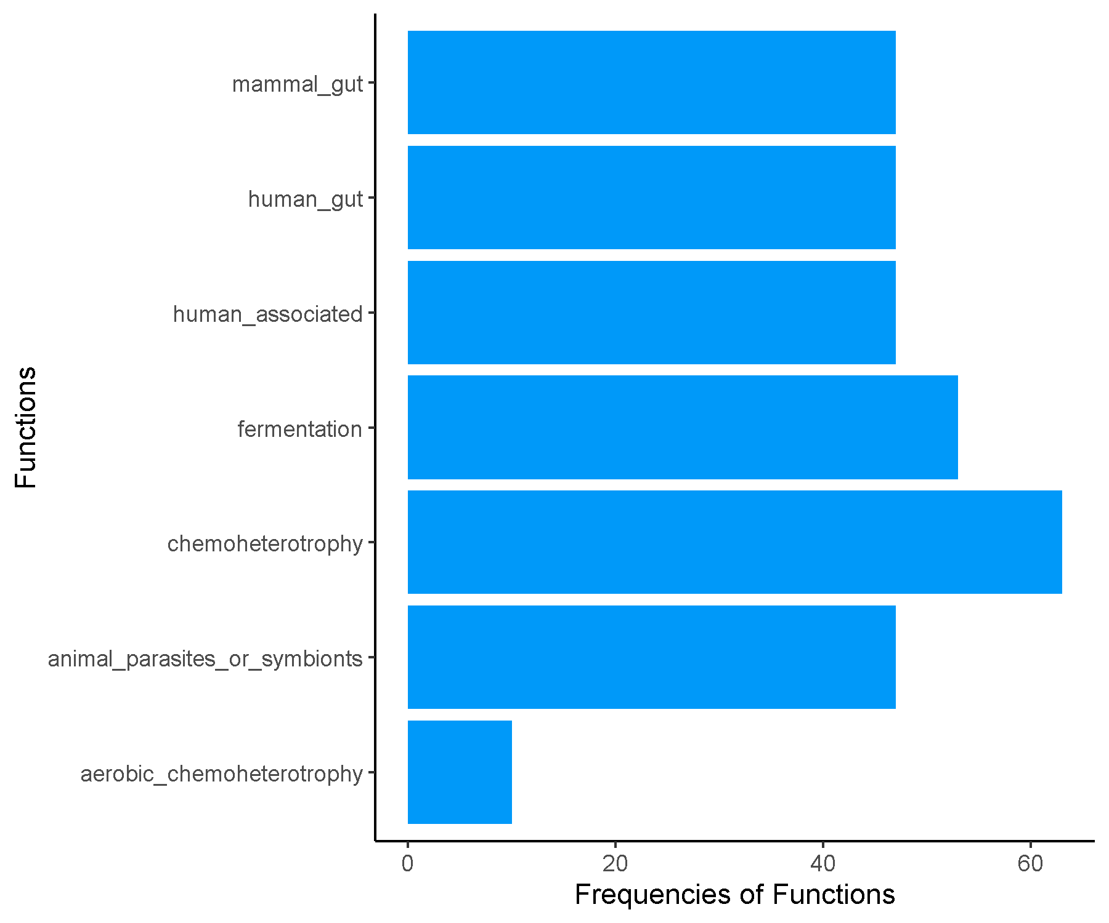

**Spring_FRFRC_Cluster3.csv.txt_Finalresults.txt**

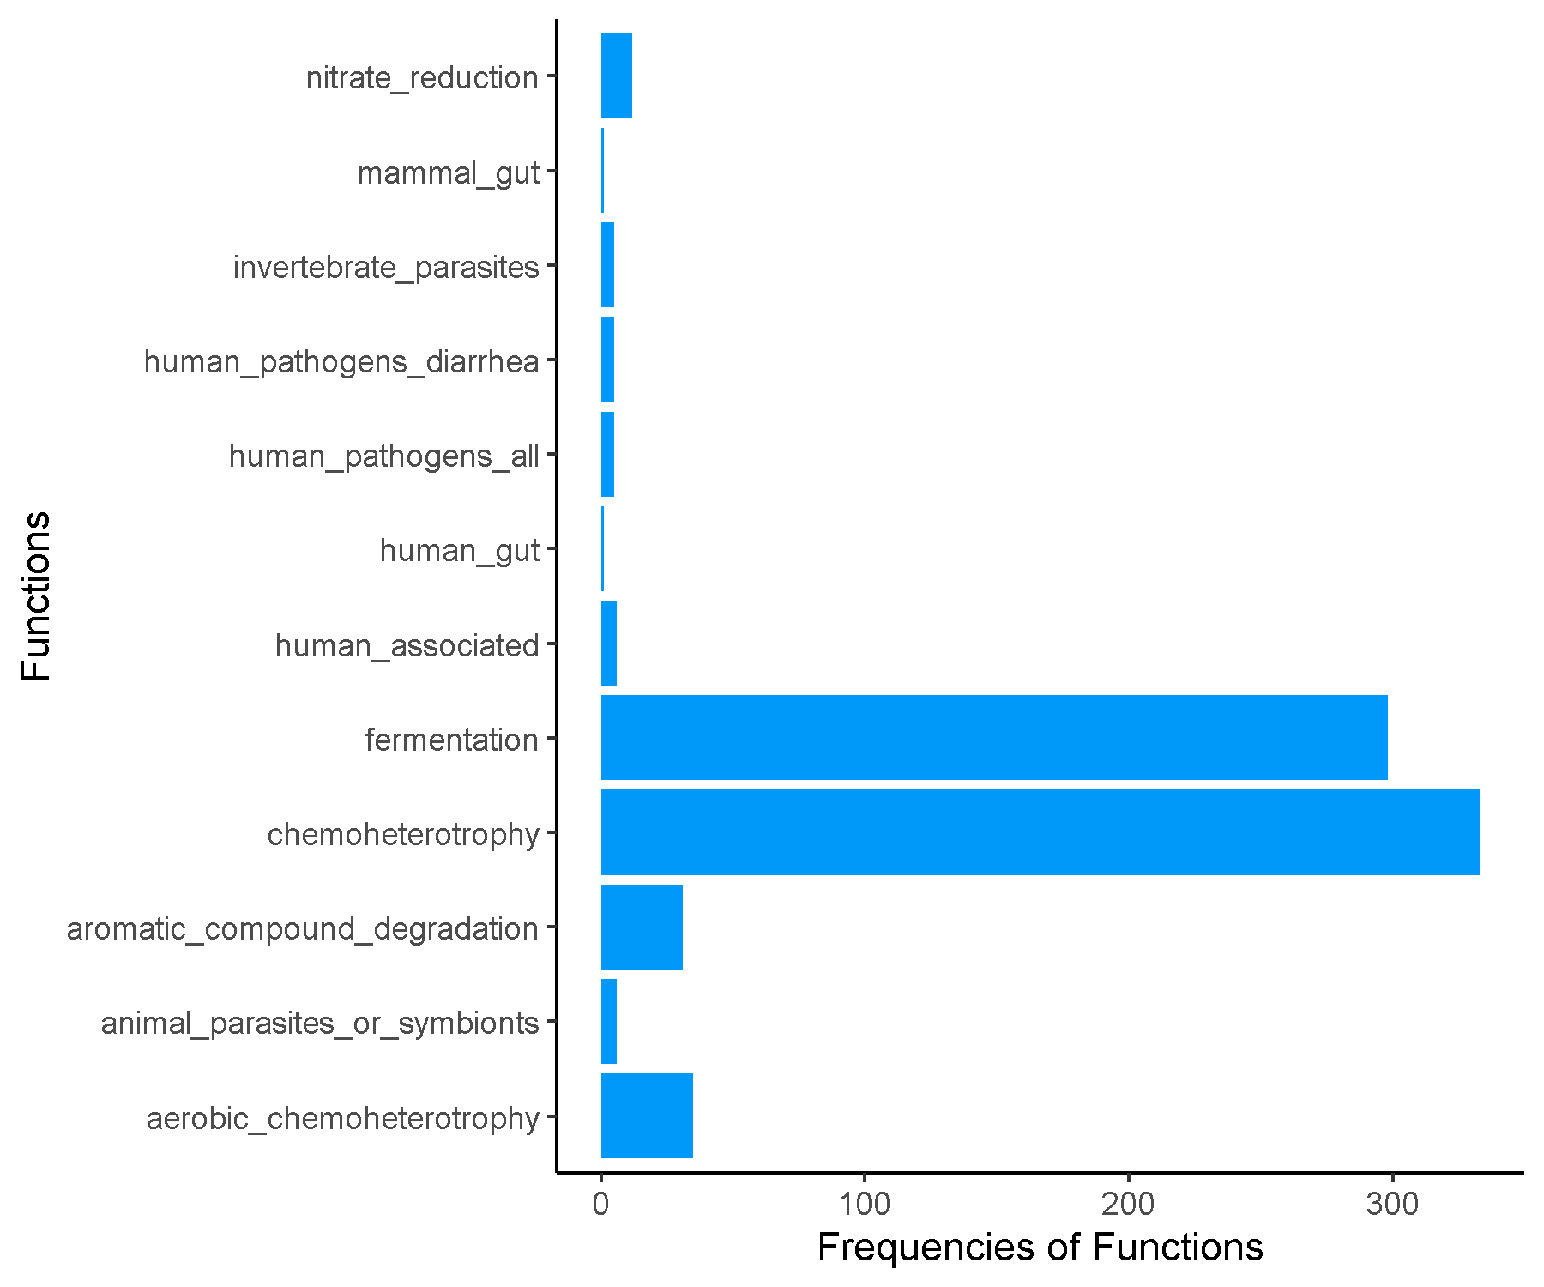

**Spring_FRFRC_Cluster4.csv.txt_Finalresults.txt**

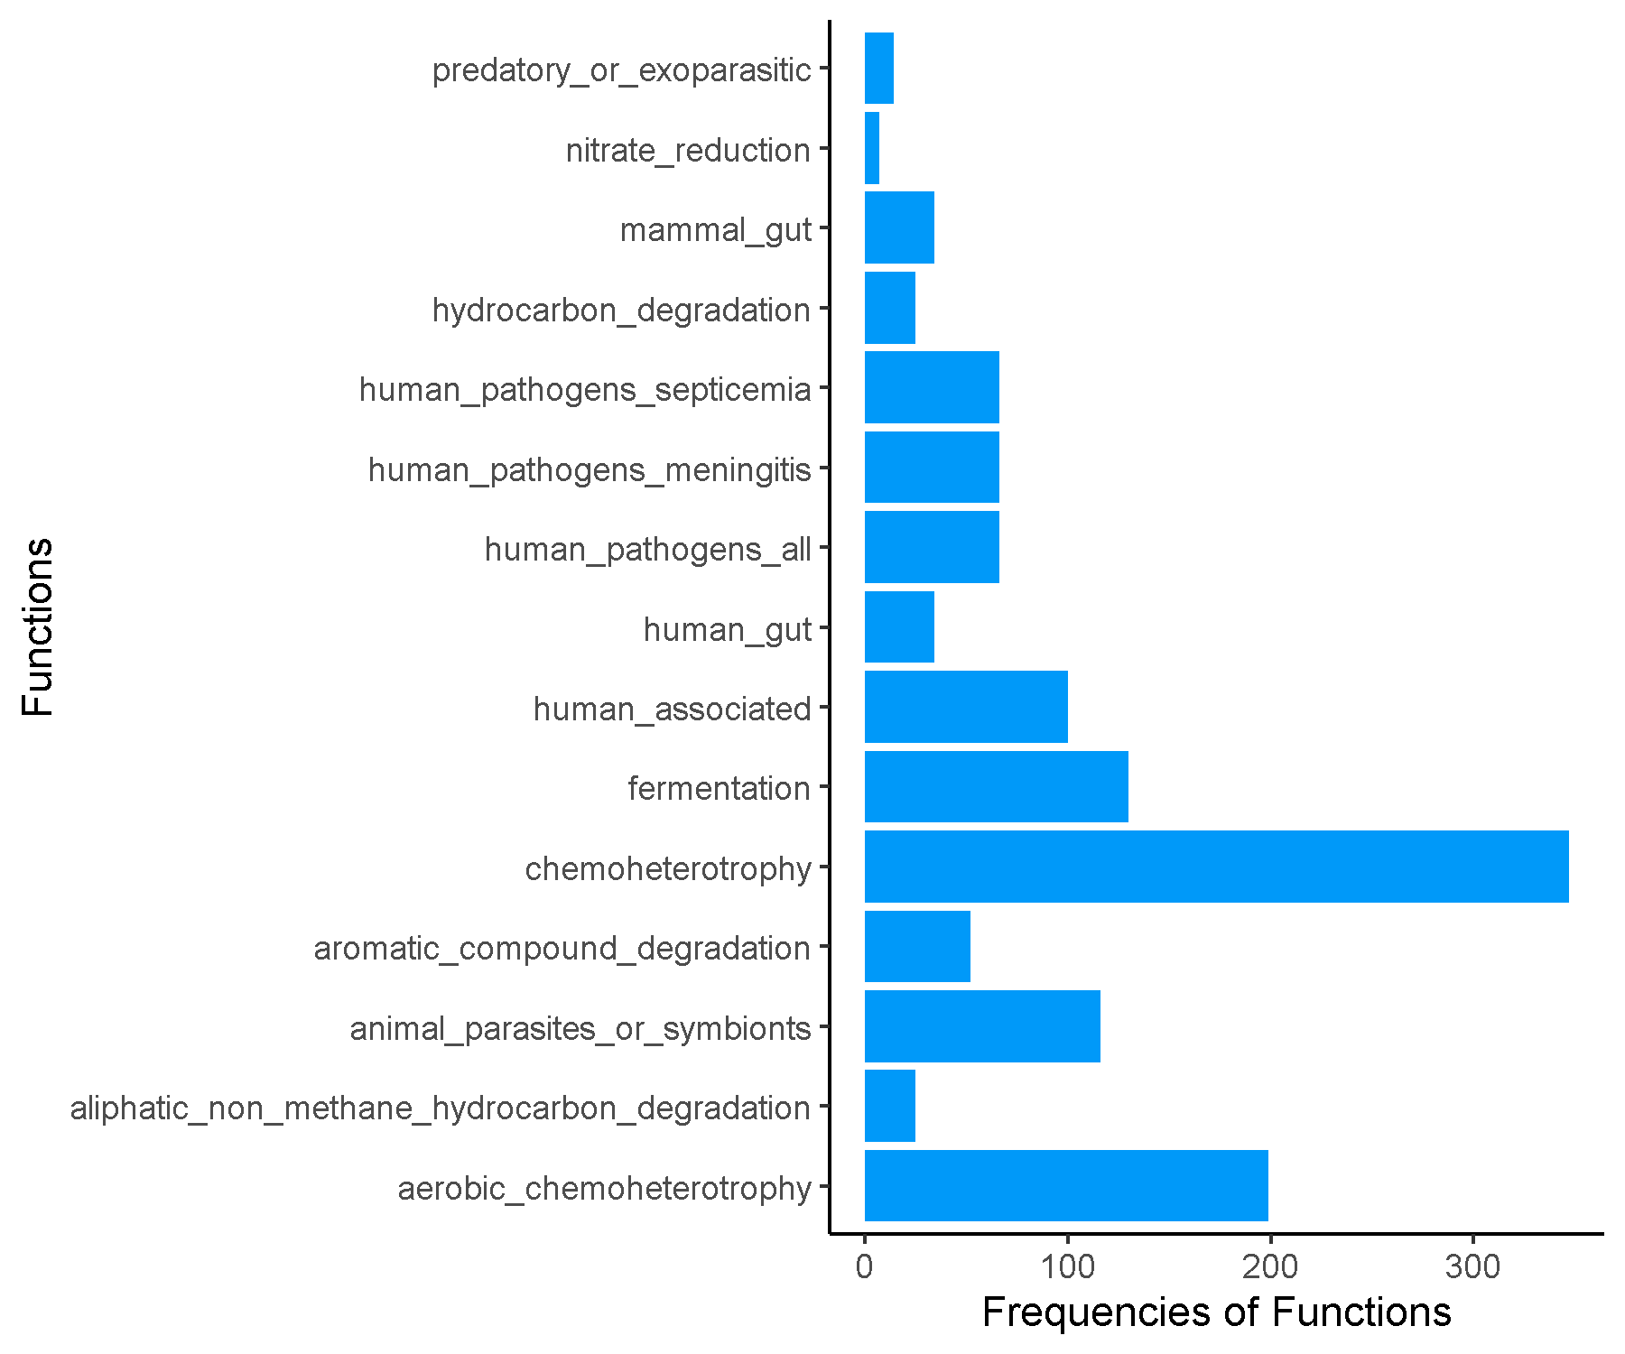

**Spring_FRFRC_Cluster5.csv.txt_Finalresults.txt**

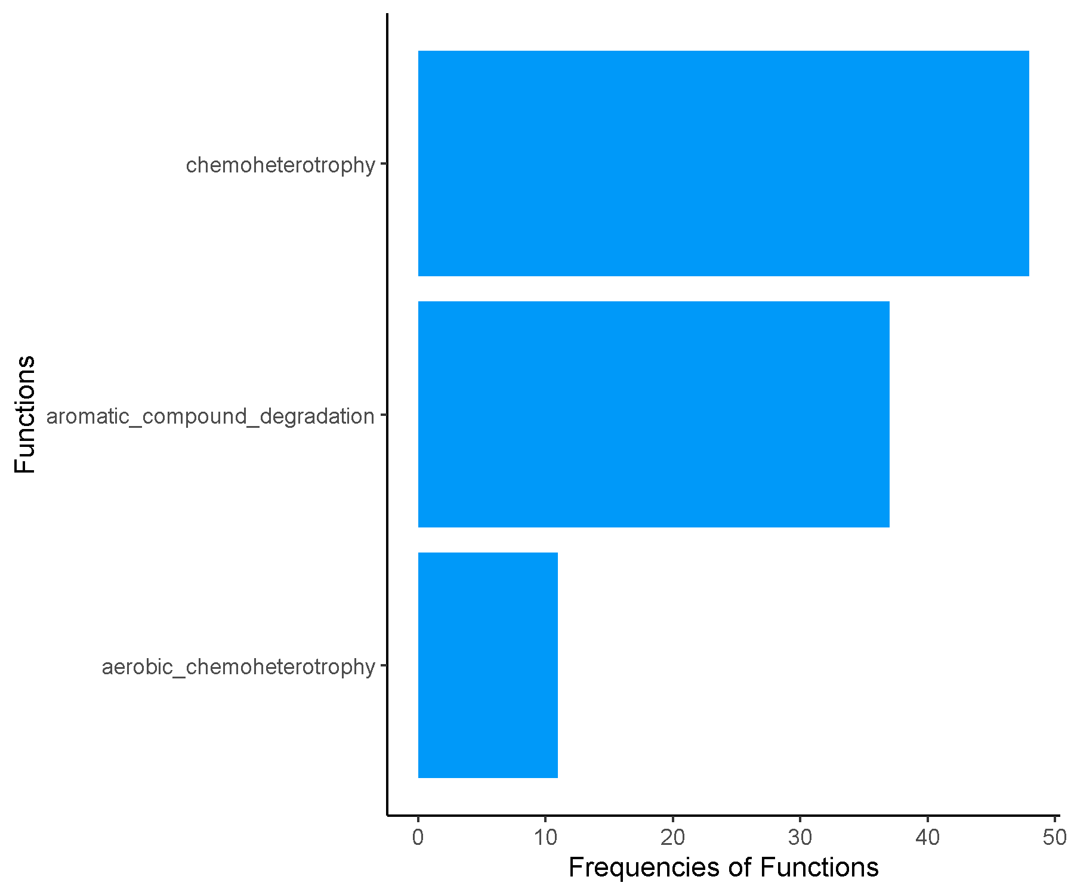

**Spring_FRFRC_Cluster6.csv.txt_Finalresults.txt**

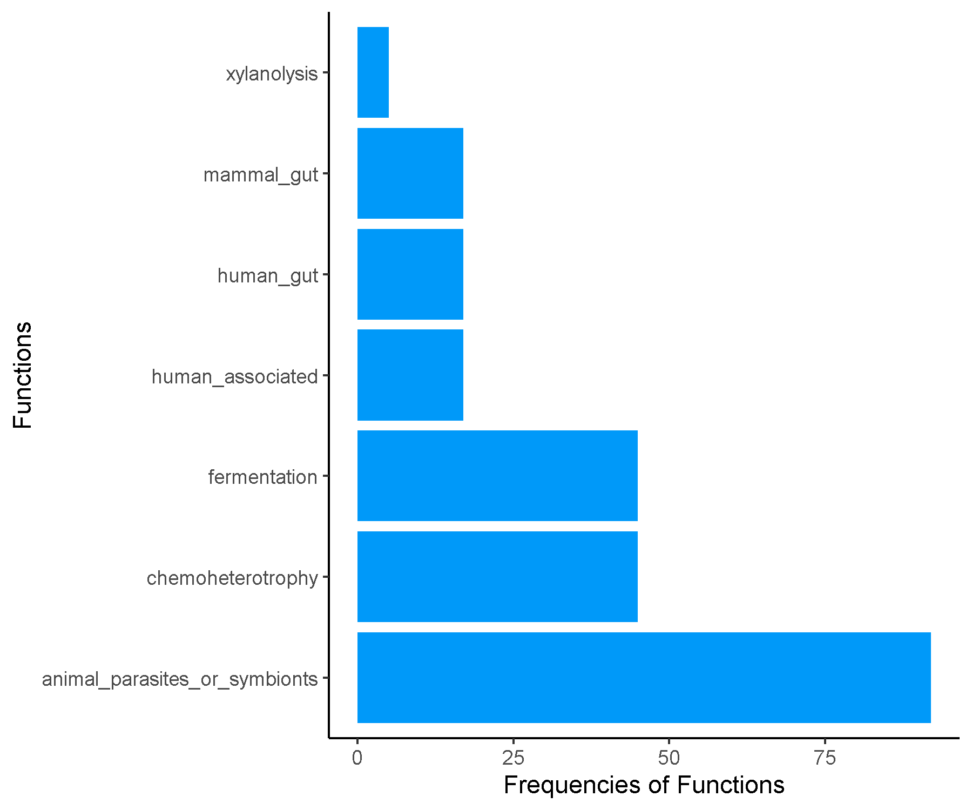

**Spring_FRFRC_Cluster7.csv.txt_Finalresults.txt**

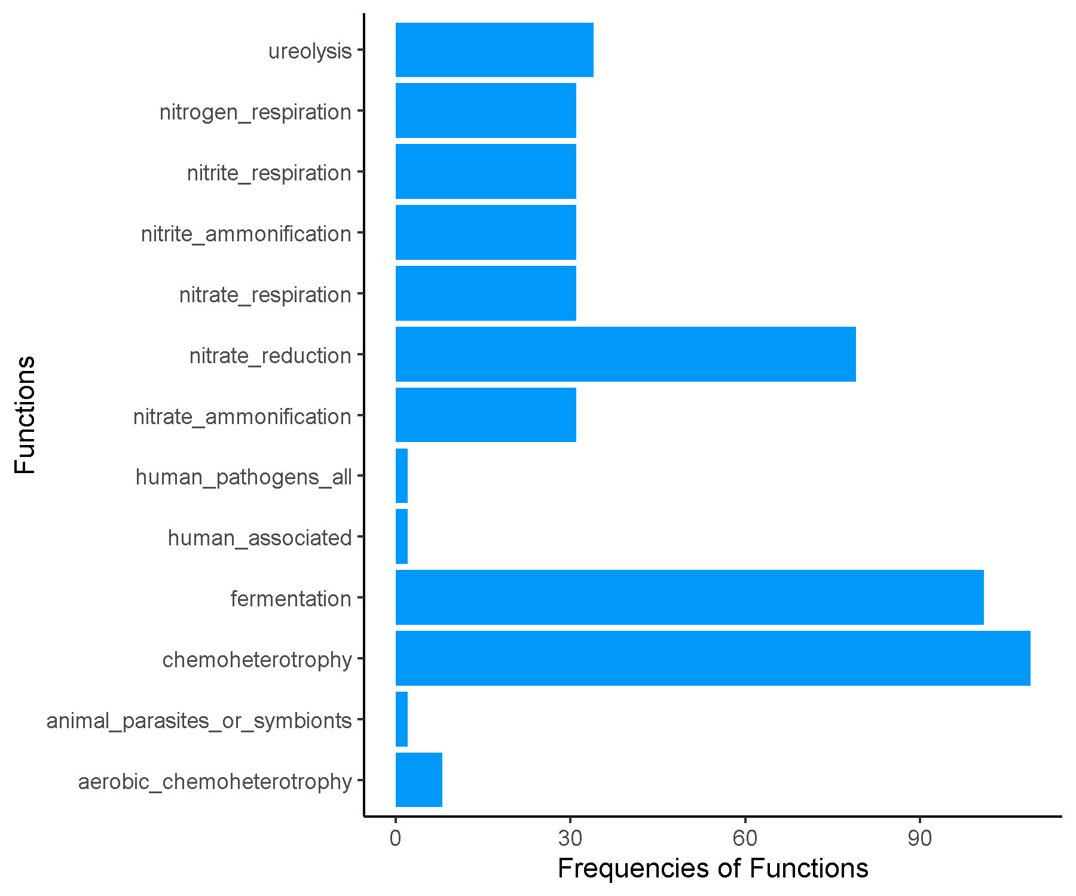

**Spring_JRJRC_Cluster1.csv.txt_Finalresults.txt**

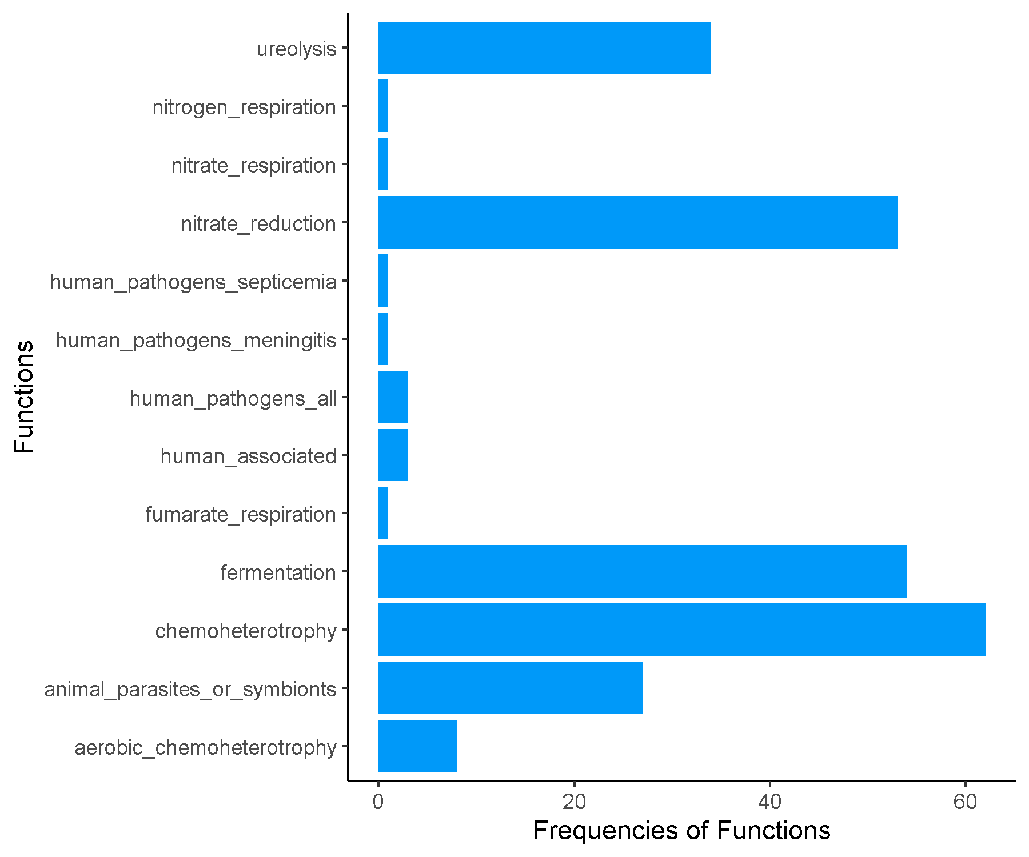

**Spring_JRJRC_Cluster2.csv.txt_Finalresults.txt**

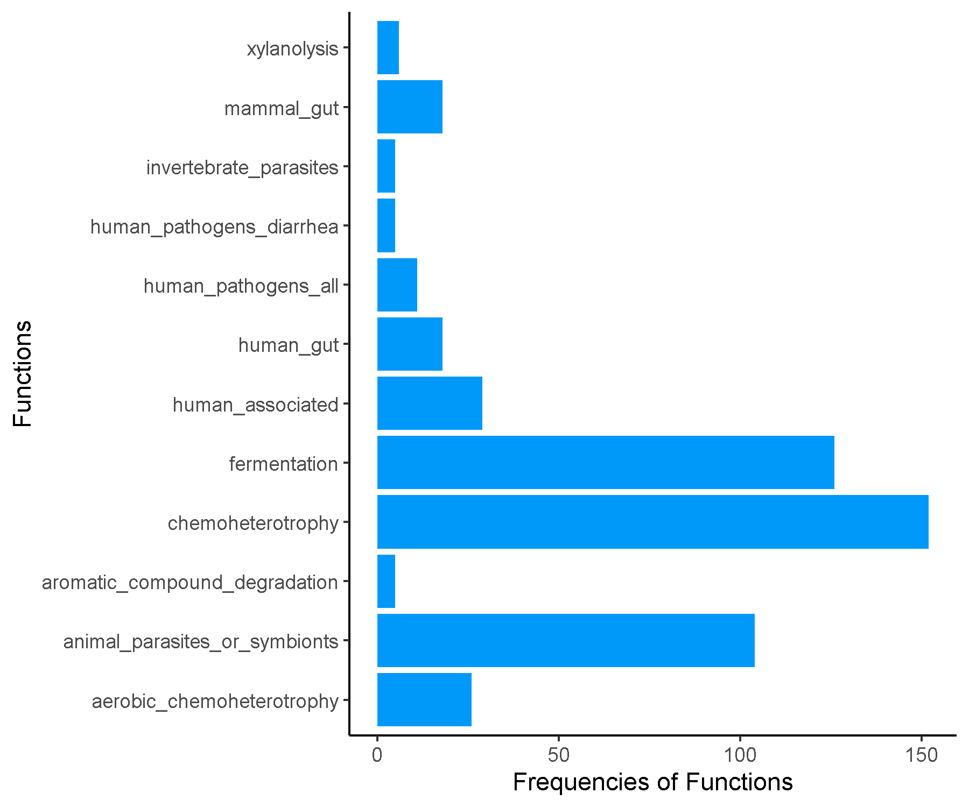

**Spring_JRJRC_Cluster3.csv.txt_Finalresults.txt**

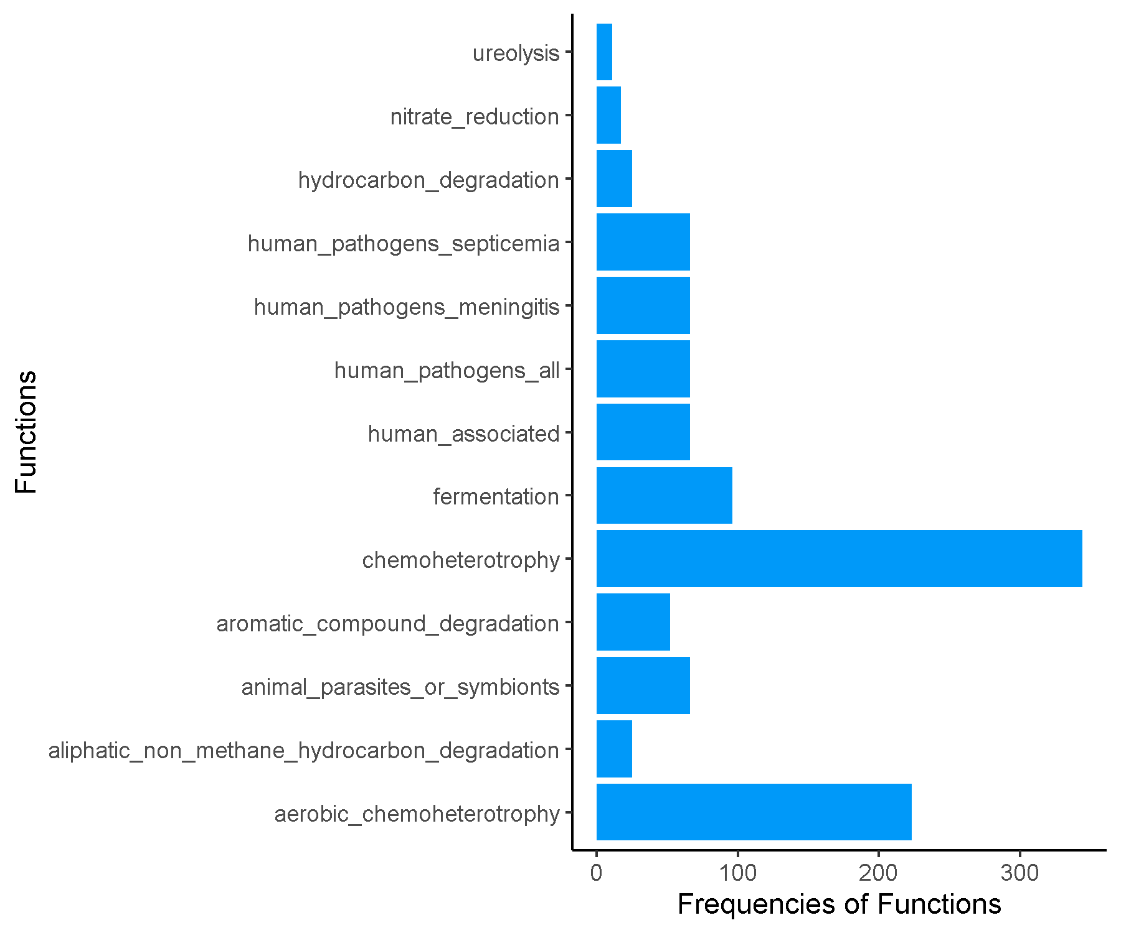

**Spring_JRJRC_Cluster4.csv.txt_Finalresults.txt**

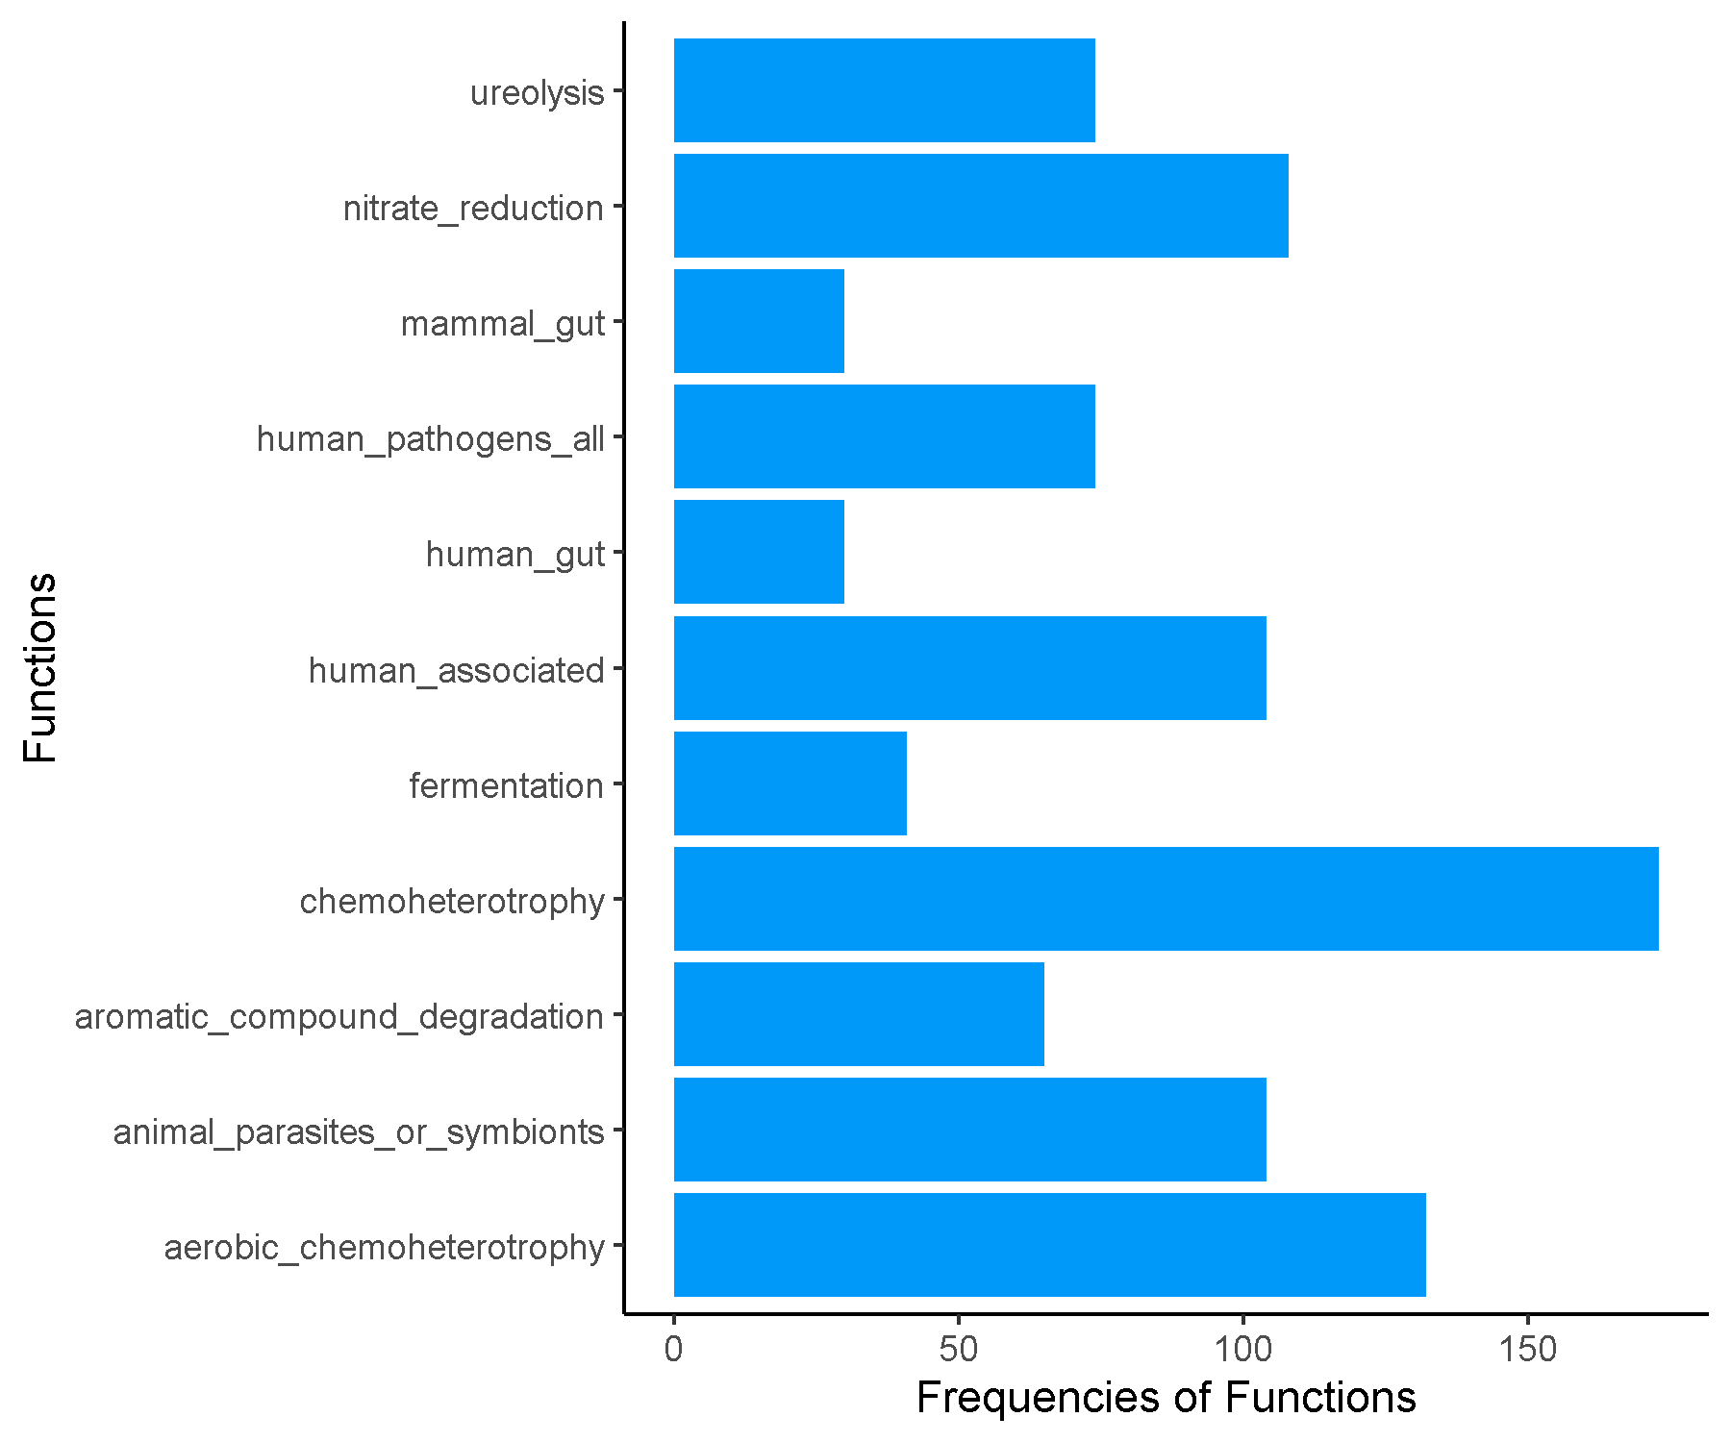

**Spring_JRJRC_Cluster5.csv.txt_Finalresults.txt**

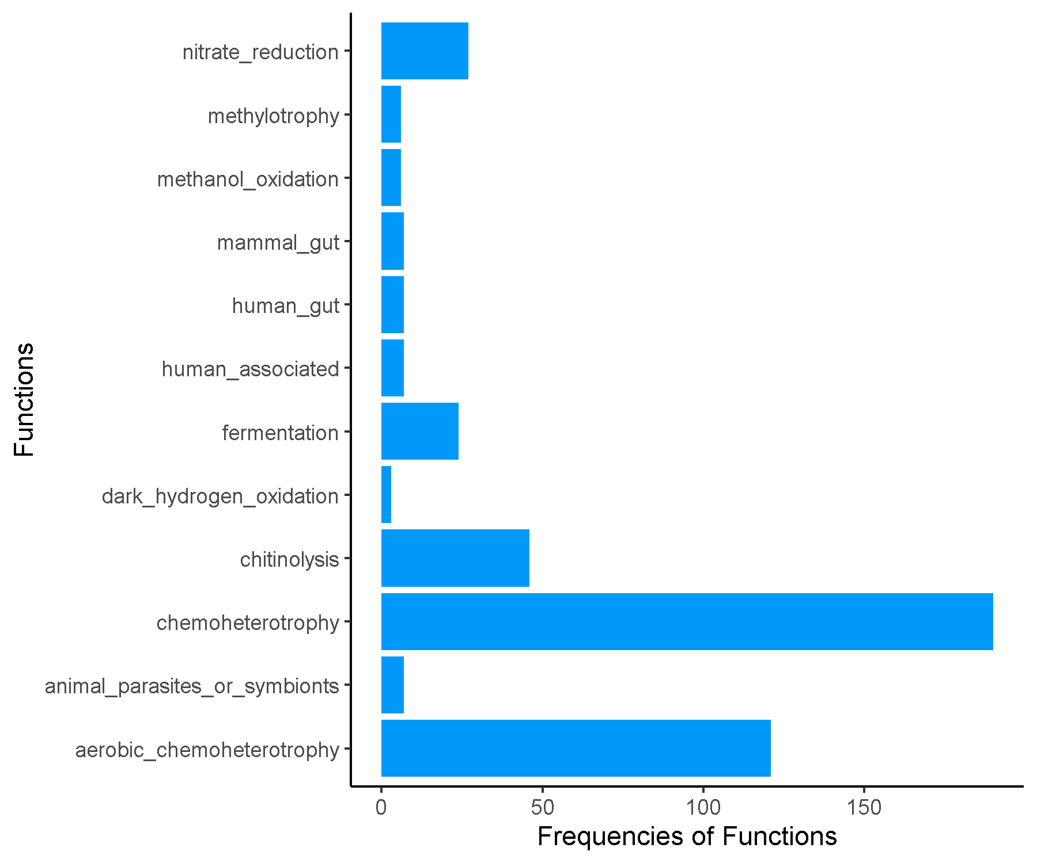

**Spring_JRJRC_Cluster6.csv.txt_Finalresults.txt**

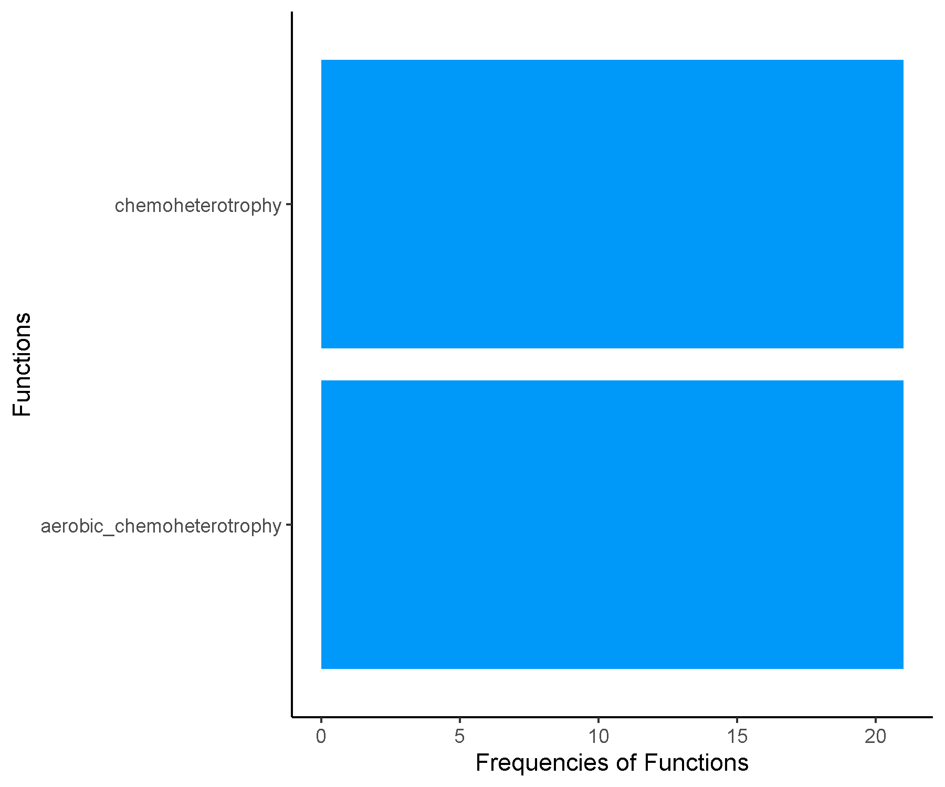

**Spring_JRJRC_Cluster7.csv.txt_Finalresults.txt**

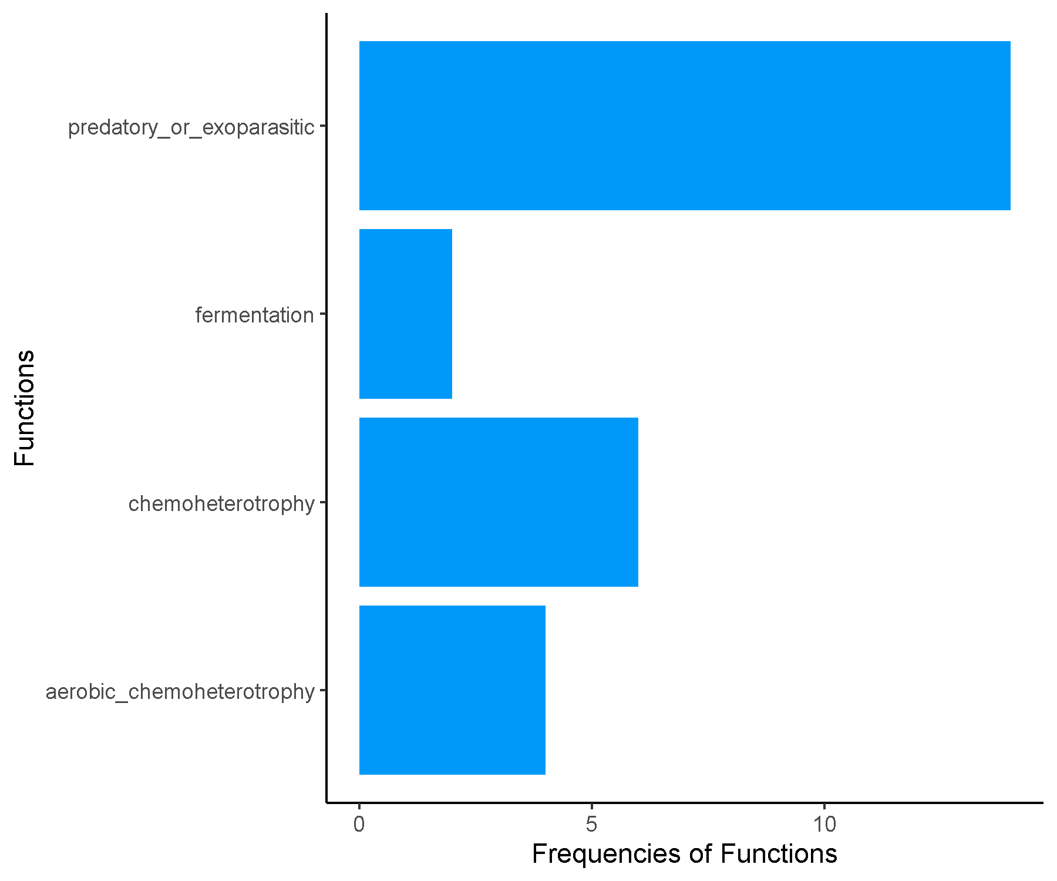

**Spring_JRJRC_Cluster8.csv.txt_Finalresults.txt**

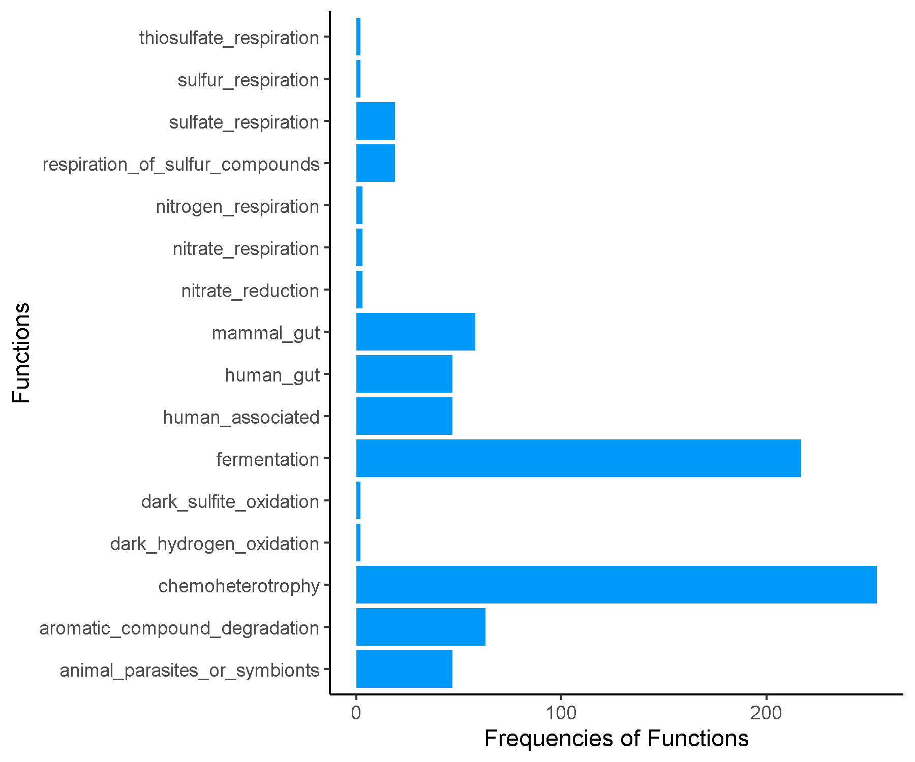

**Spring_JRJRC_Cluster9.csv.txt_Finalresults.txt**

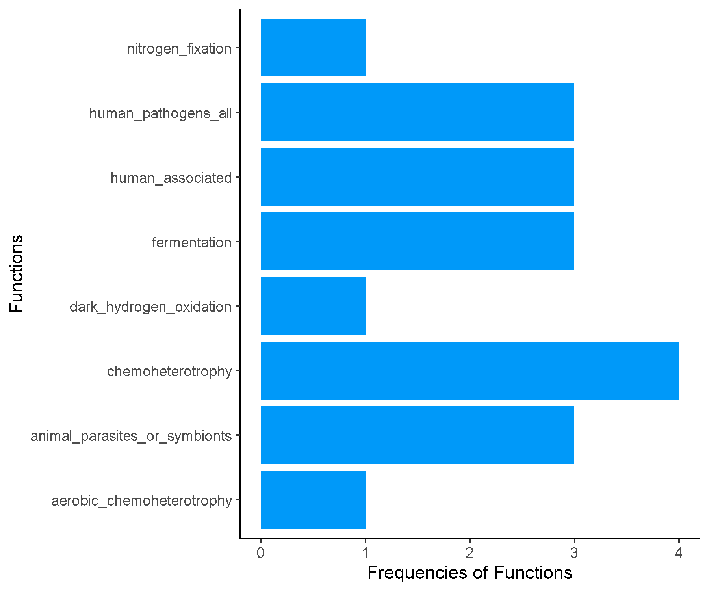

**Spring_Late_Cluster1.csv.txt_Finalresults.txt**

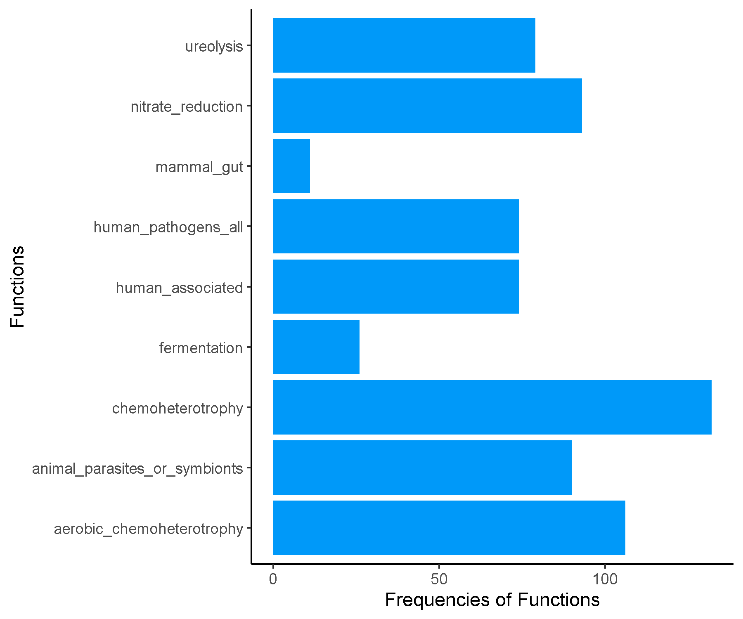

**Spring_Late_Cluster10.csv.txt_Finalresults.txt**

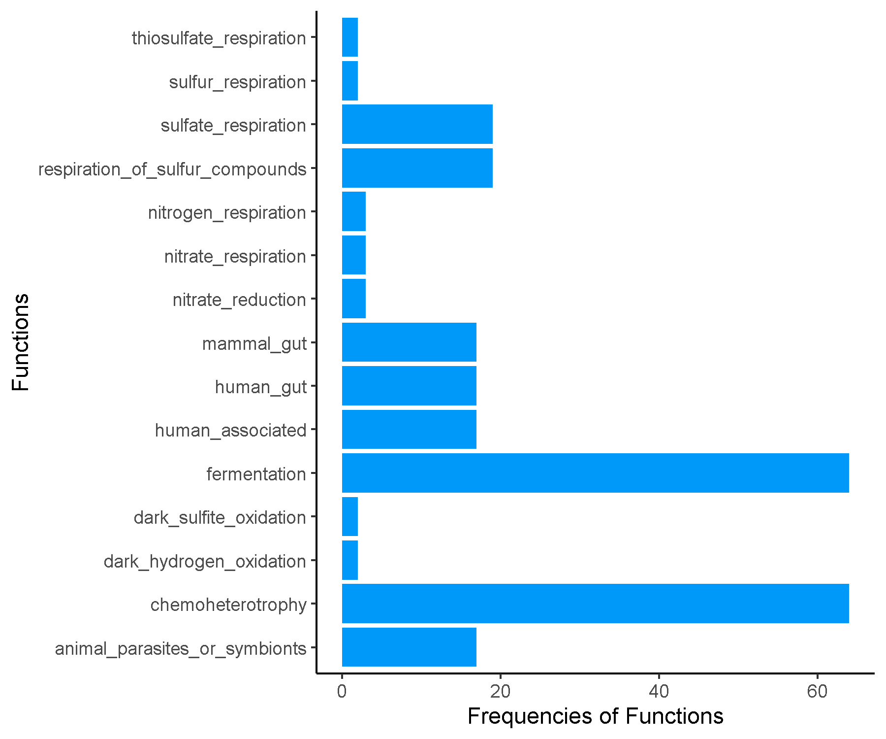

**Spring_Late_Cluster11.csv.txt_Finalresults.txt**

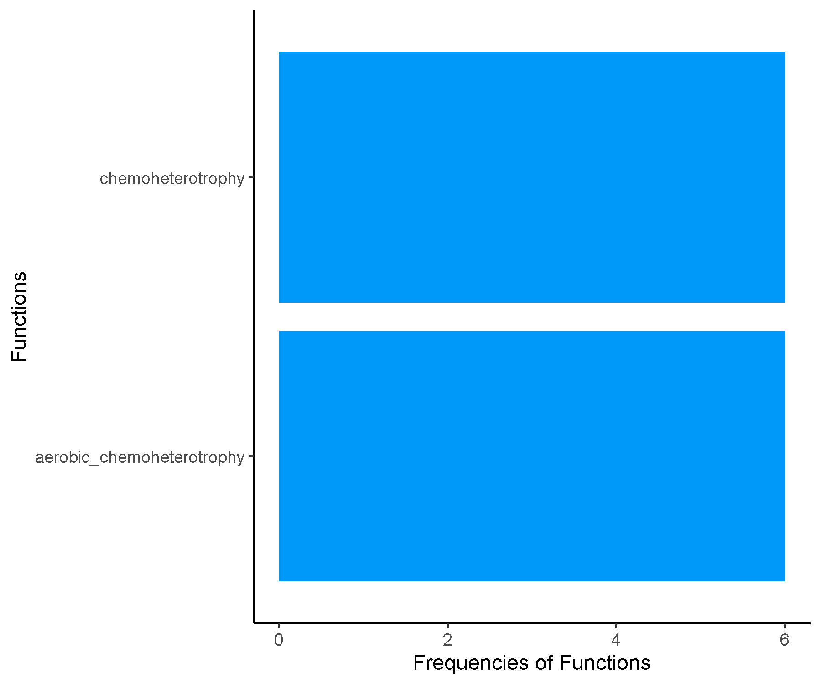

**Spring_Late_Cluster2.csv.txt_Finalresults.txt**

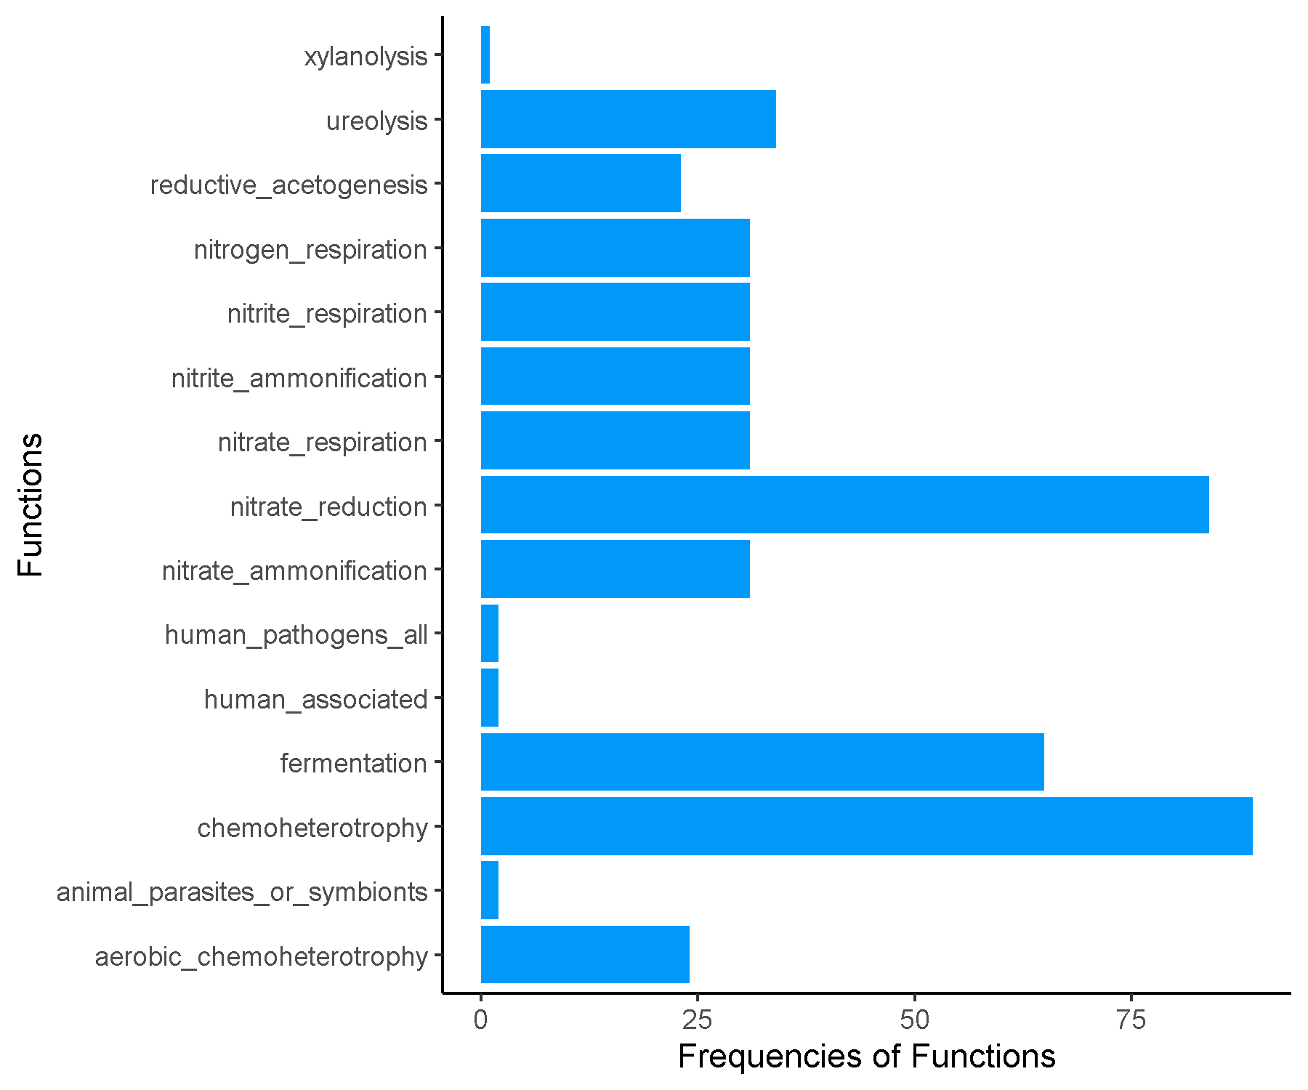

**Spring_Late_Cluster3.csv.txt_Finalresults.txt**

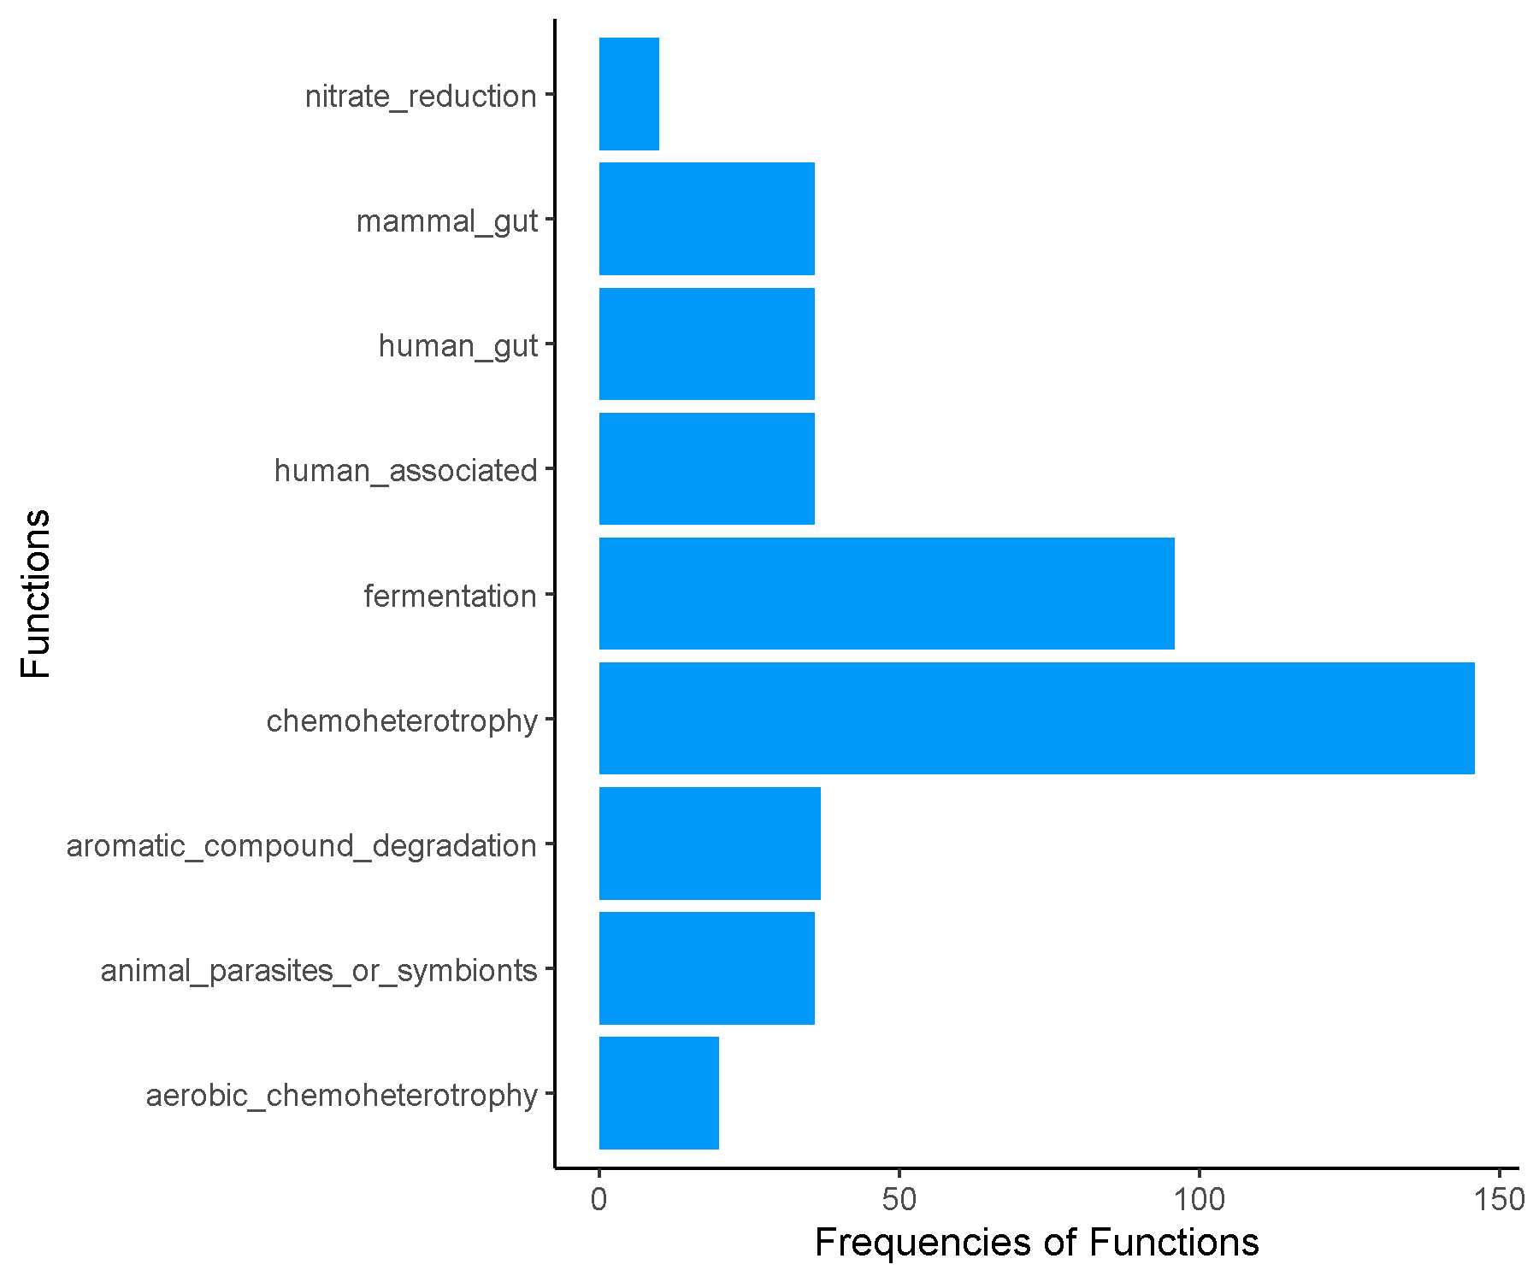

**Spring_Late_Cluster4.csv.txt_Finalresults.txt**

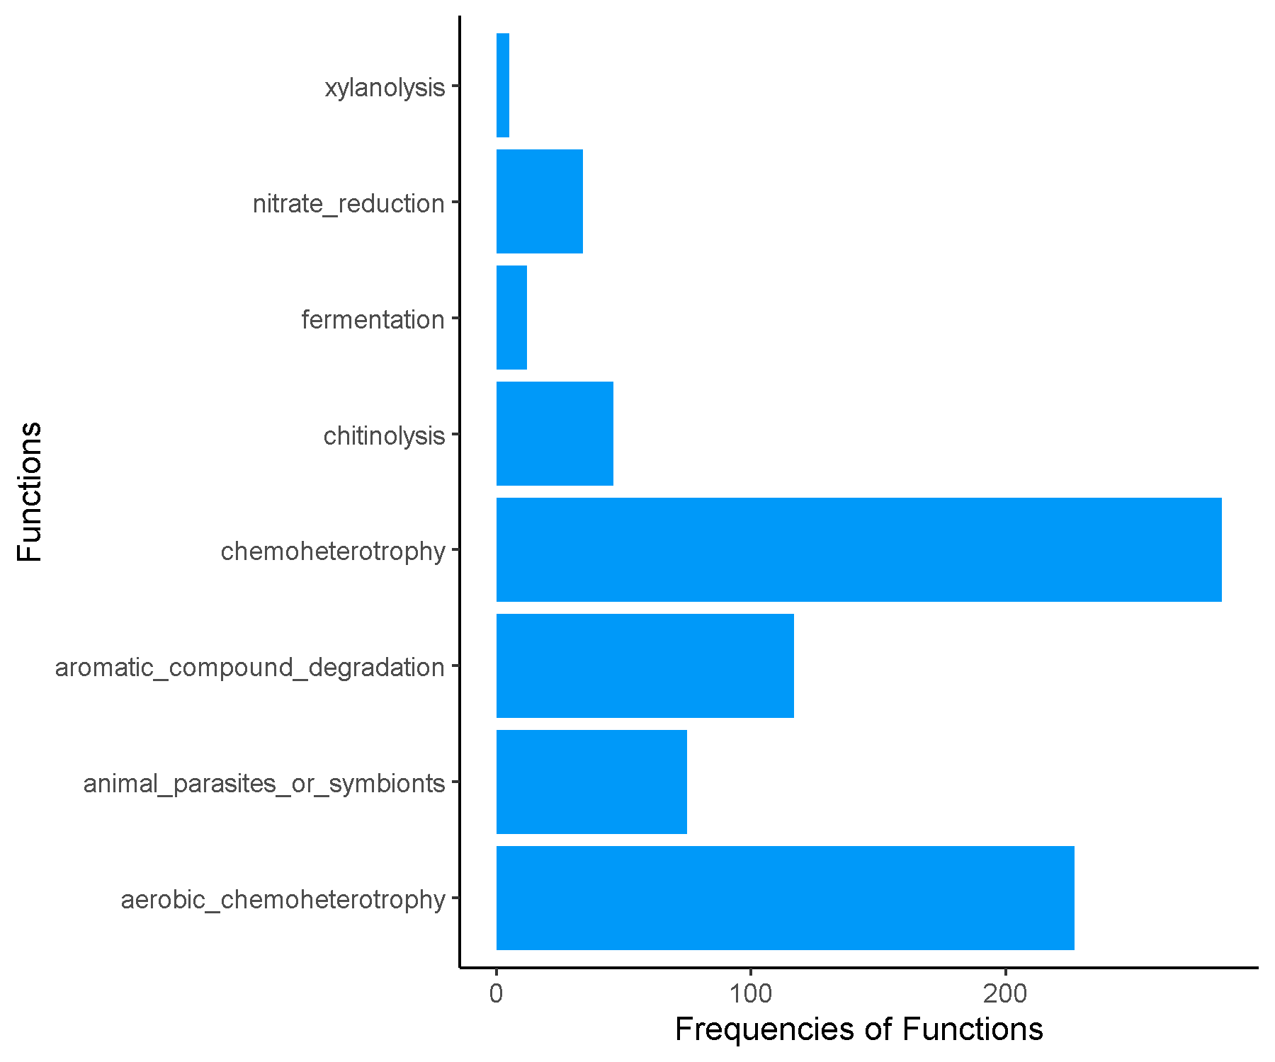

**Spring_Late_Cluster5.csv.txt_Finalresults.txt**

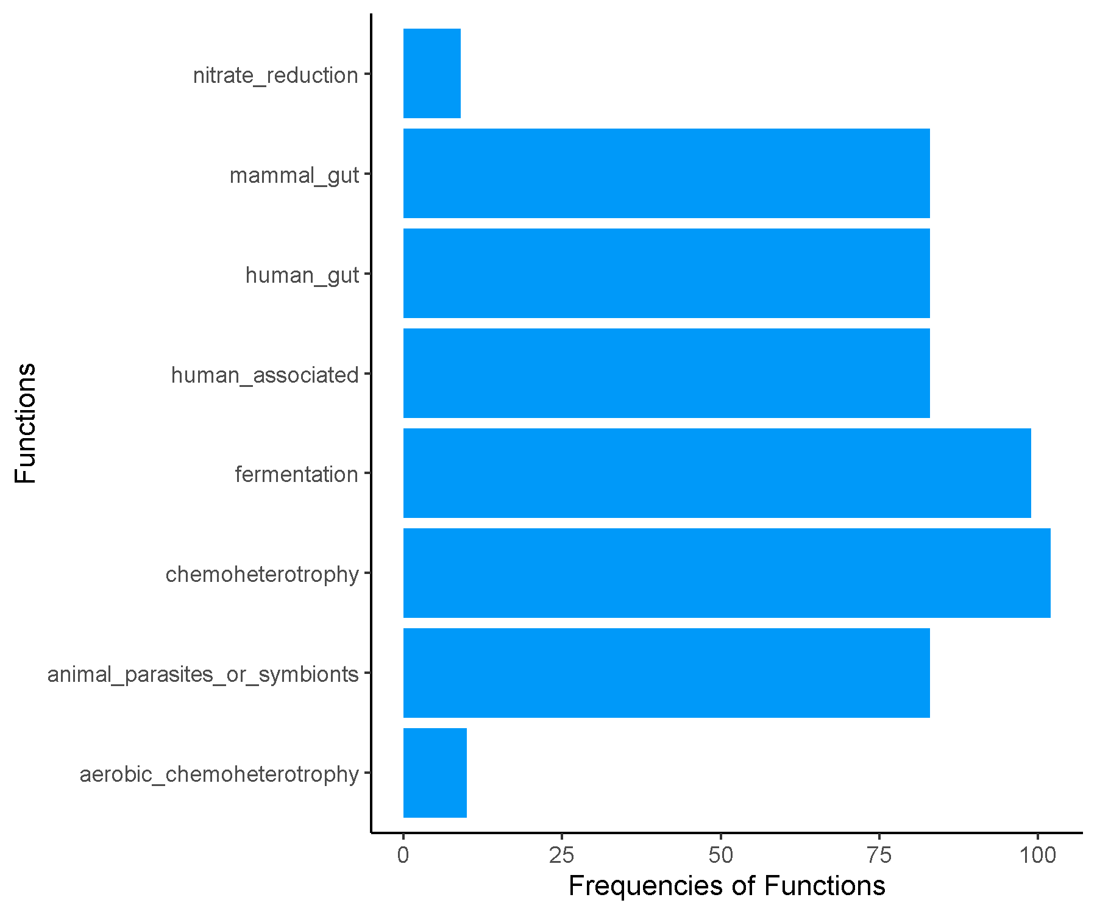

**Spring_Late_Cluster6.csv.txt_Finalresults.txt**

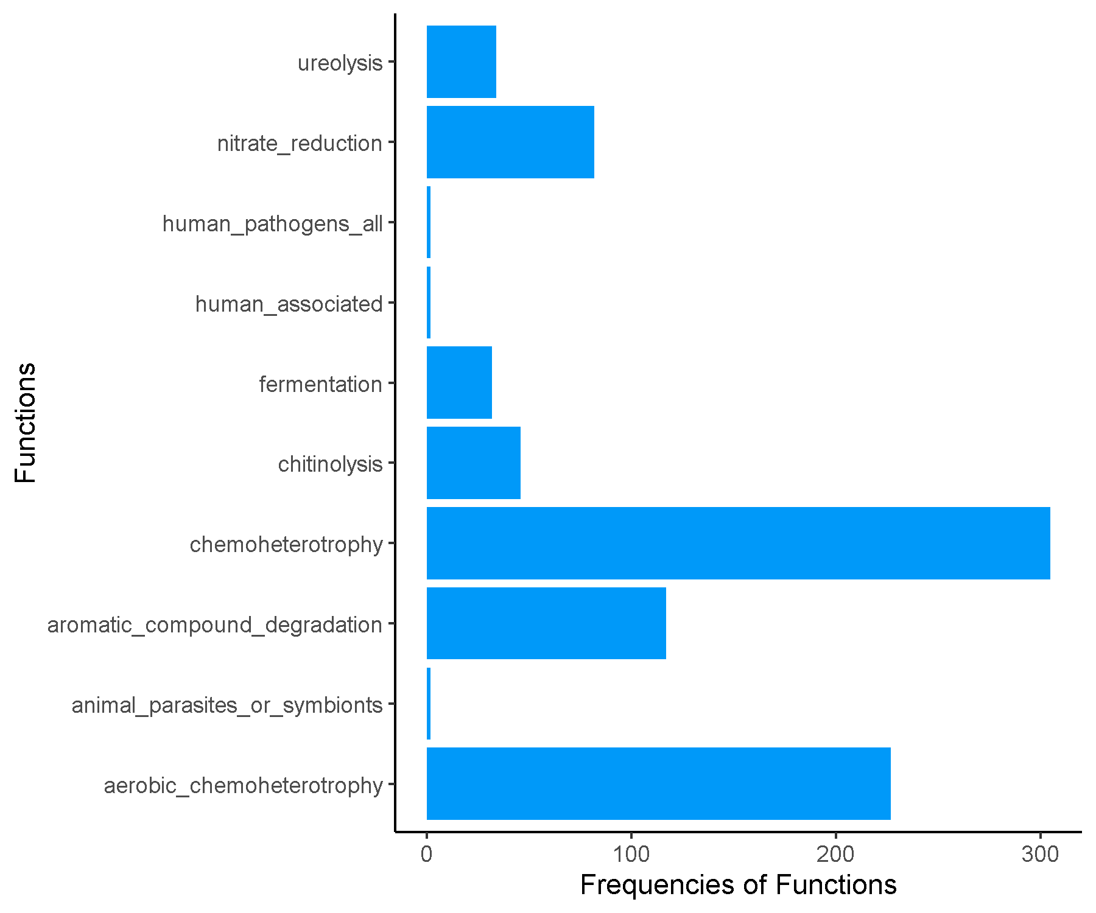

**Spring_Late_Cluster7.csv.txt_Finalresults.txt**

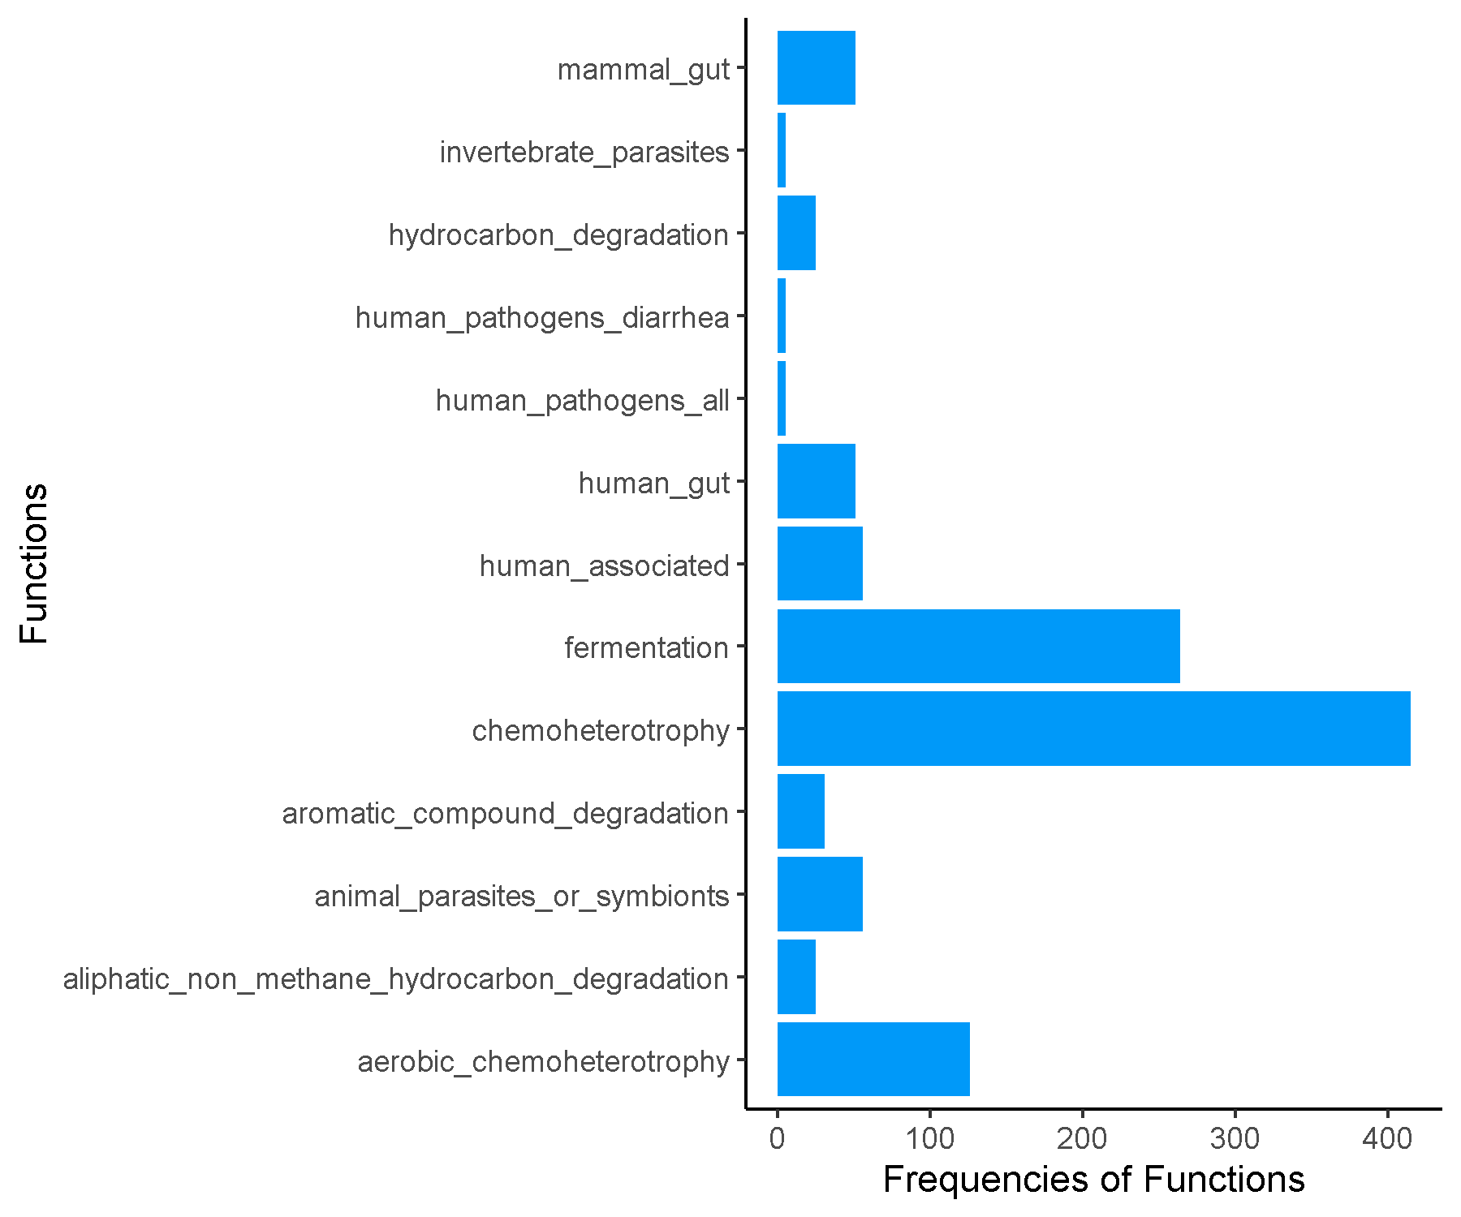

**Spring_Late_Cluster8.csv.txt_Finalresults.txt**

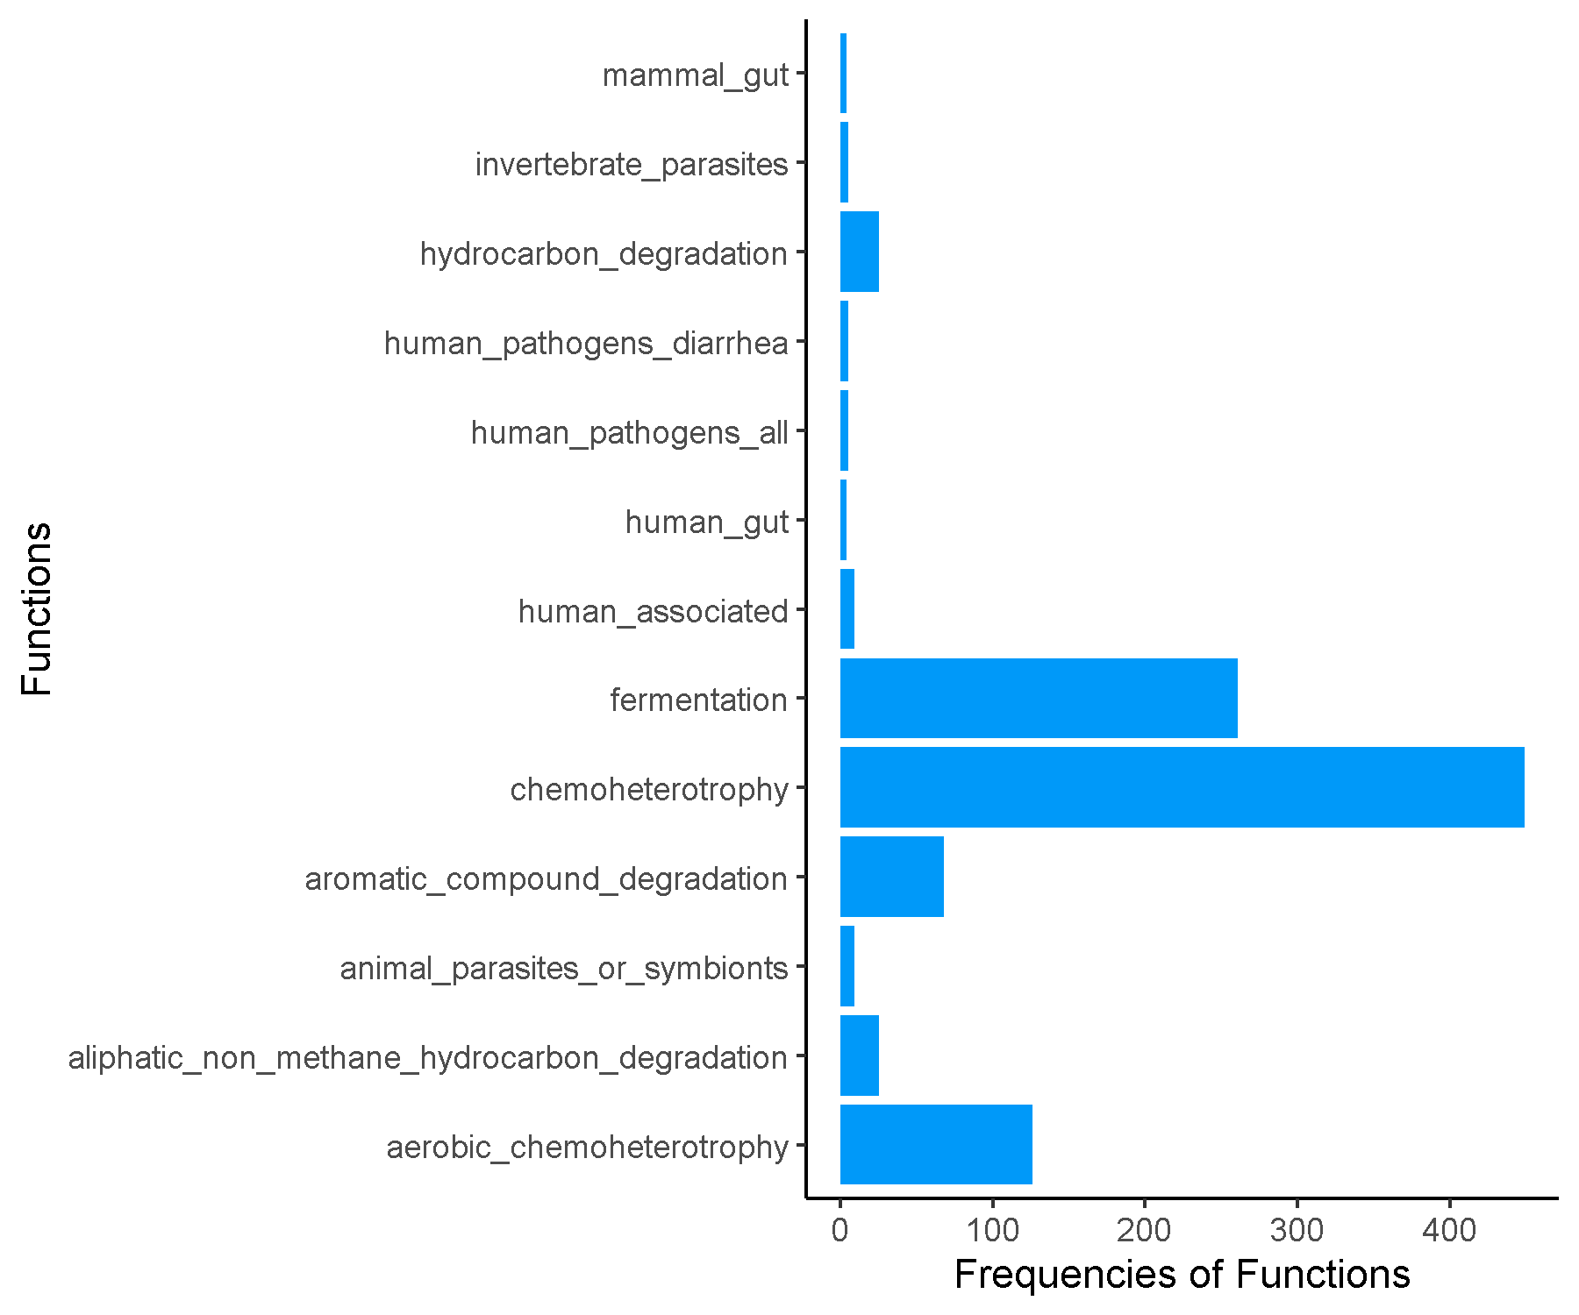

**Spring_Late_Cluster9.csv.txt_Finalresults.txt**

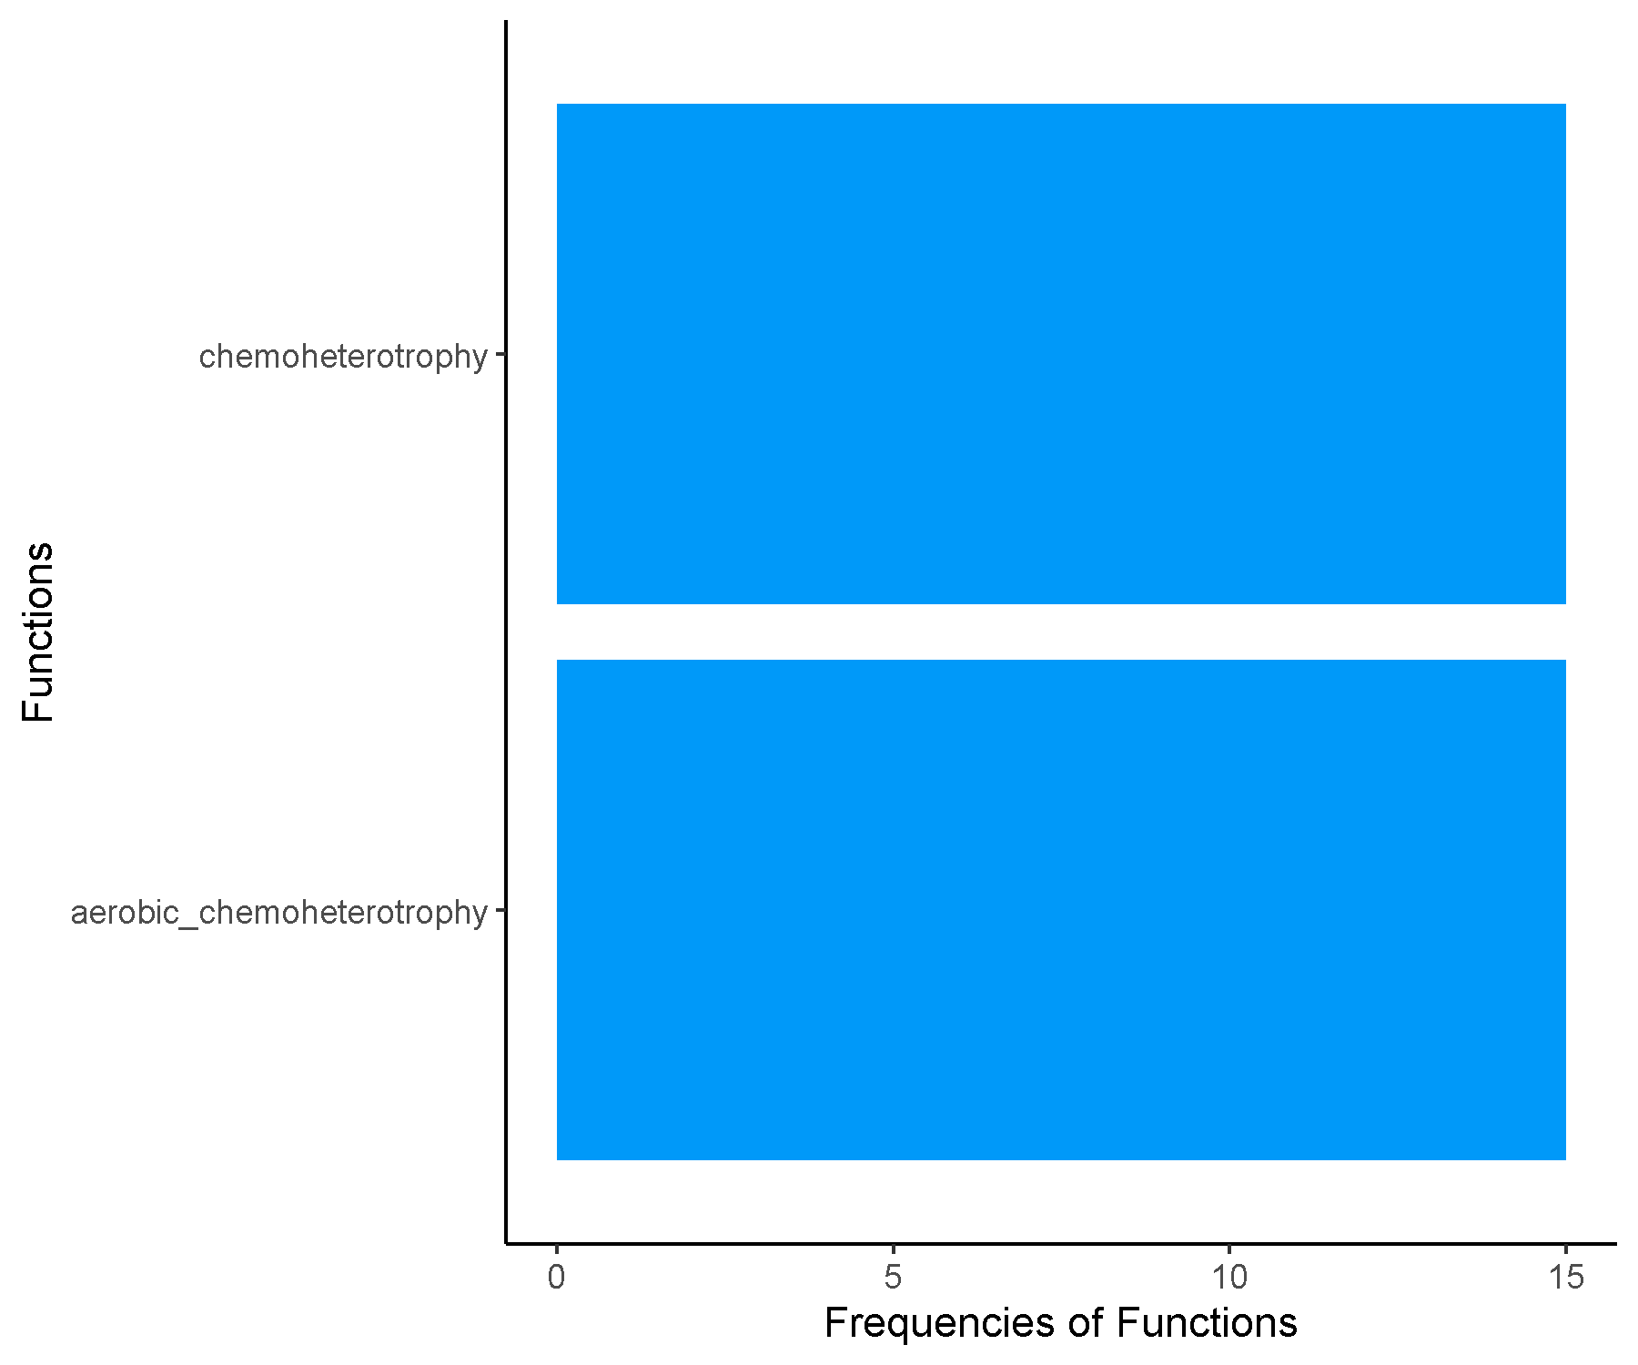

**Spring_Mid_Cluster1.csv.txt_Finalresults.txt**

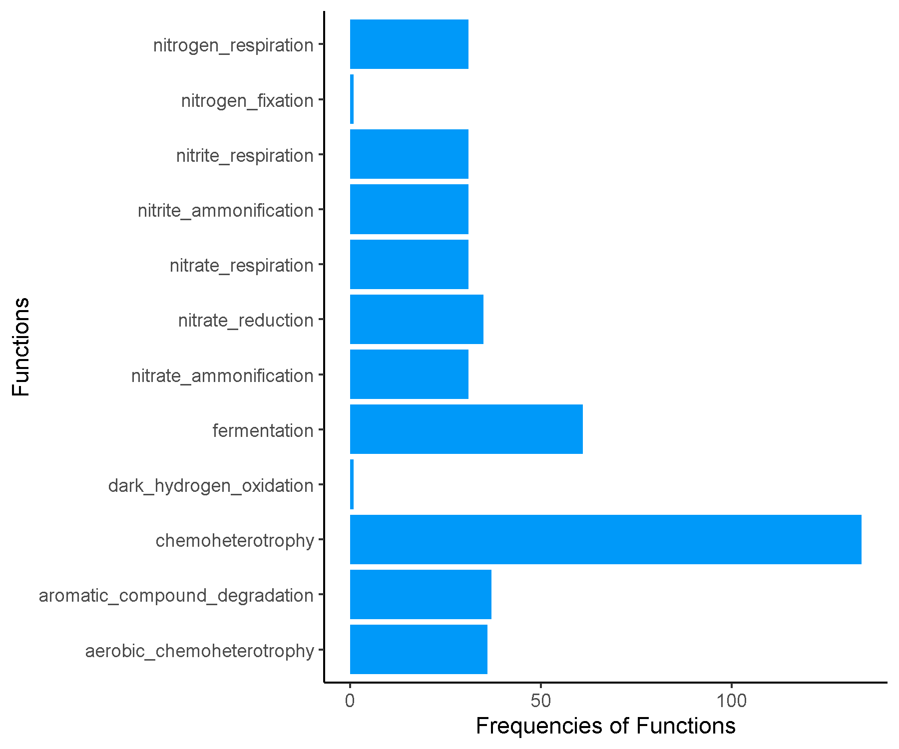

**Spring_Mid_Cluster10.csv.txt_Finalresults.txt**

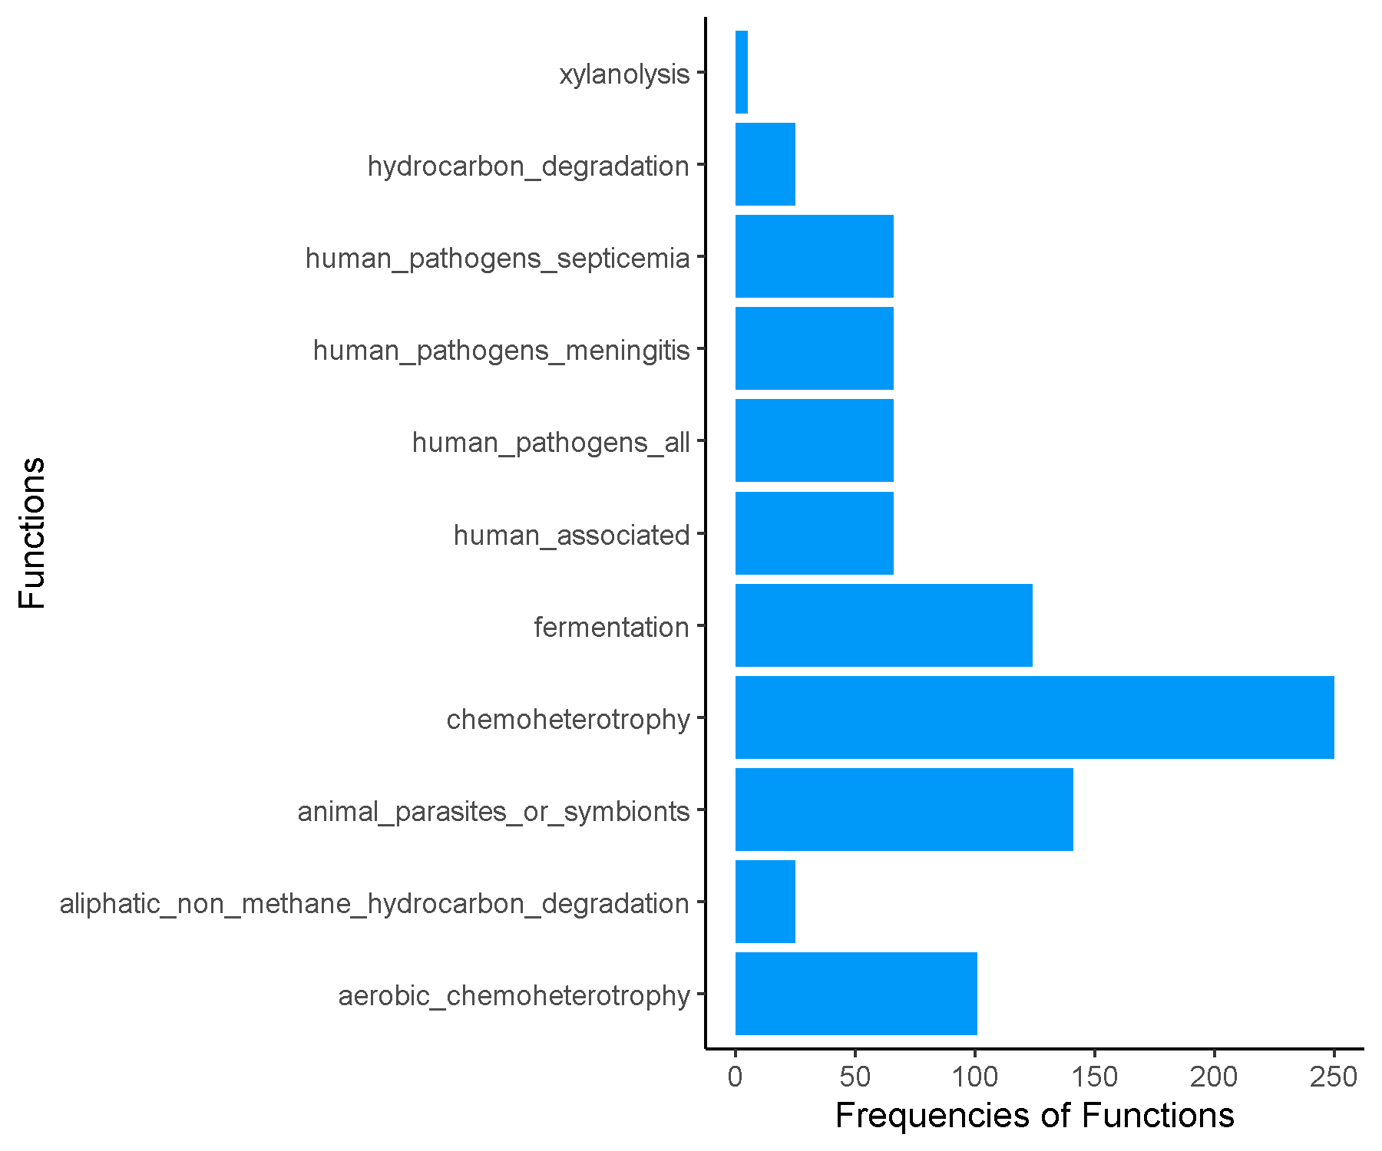

**Spring_Mid_Cluster11.csv.txt_Finalresults.txt**

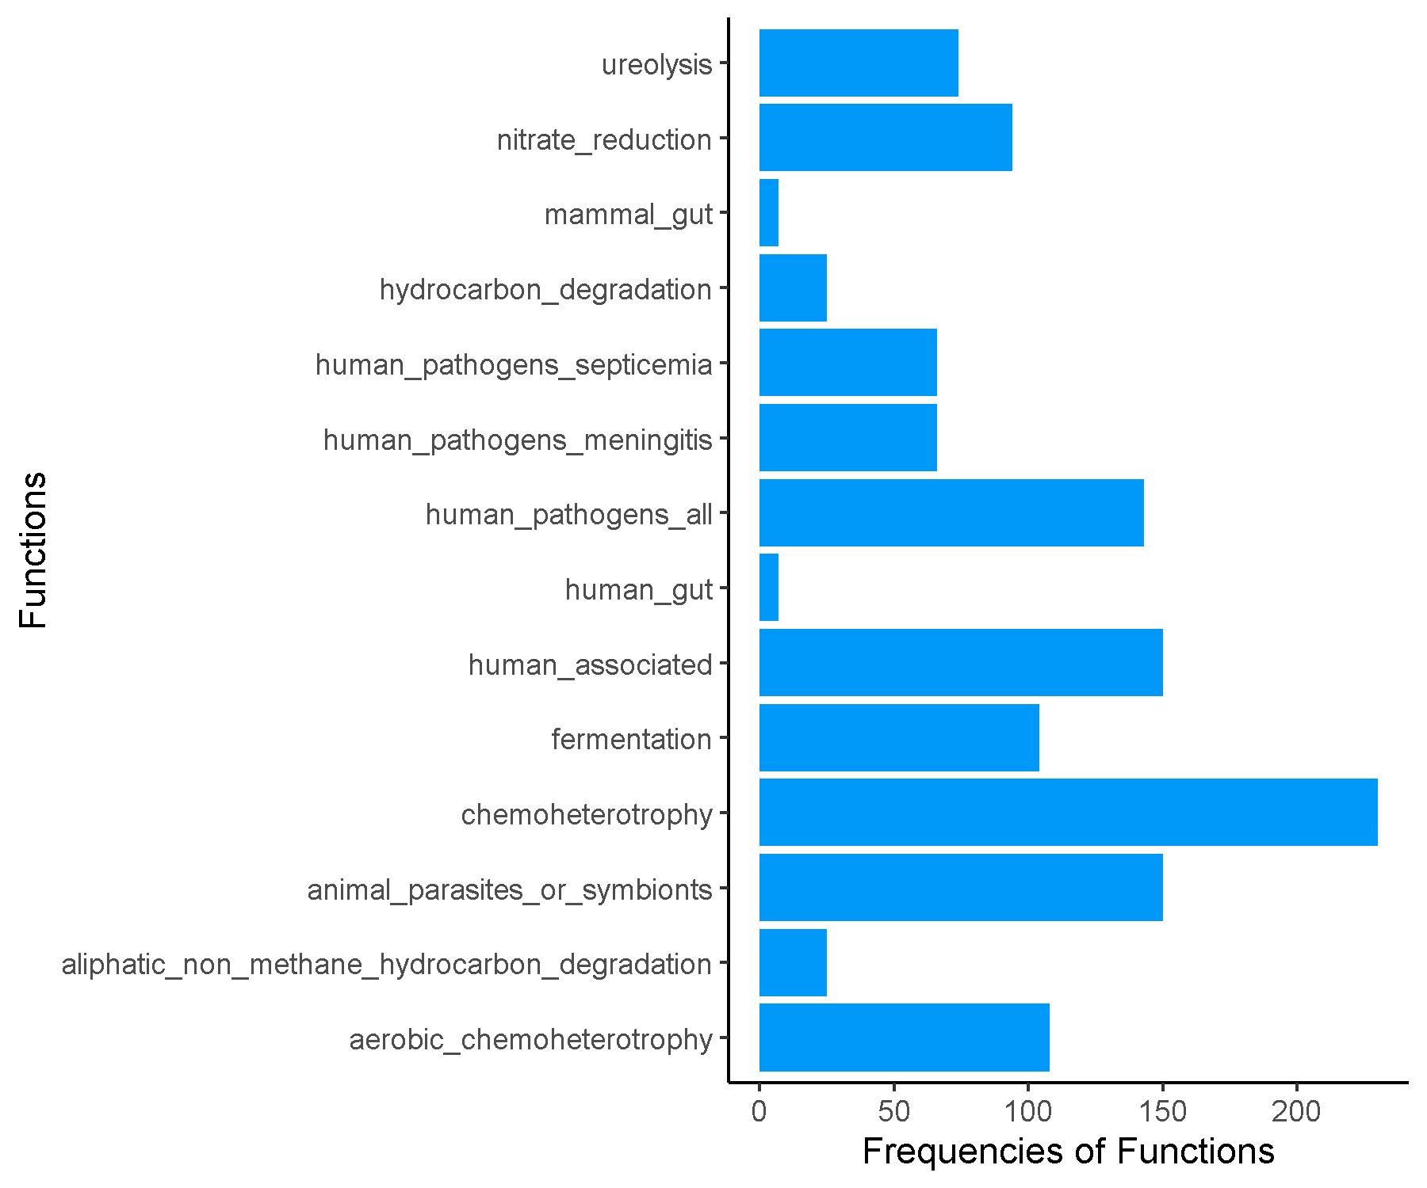

**Spring_Mid_Cluster12.csv.txt_Finalresults.txt**

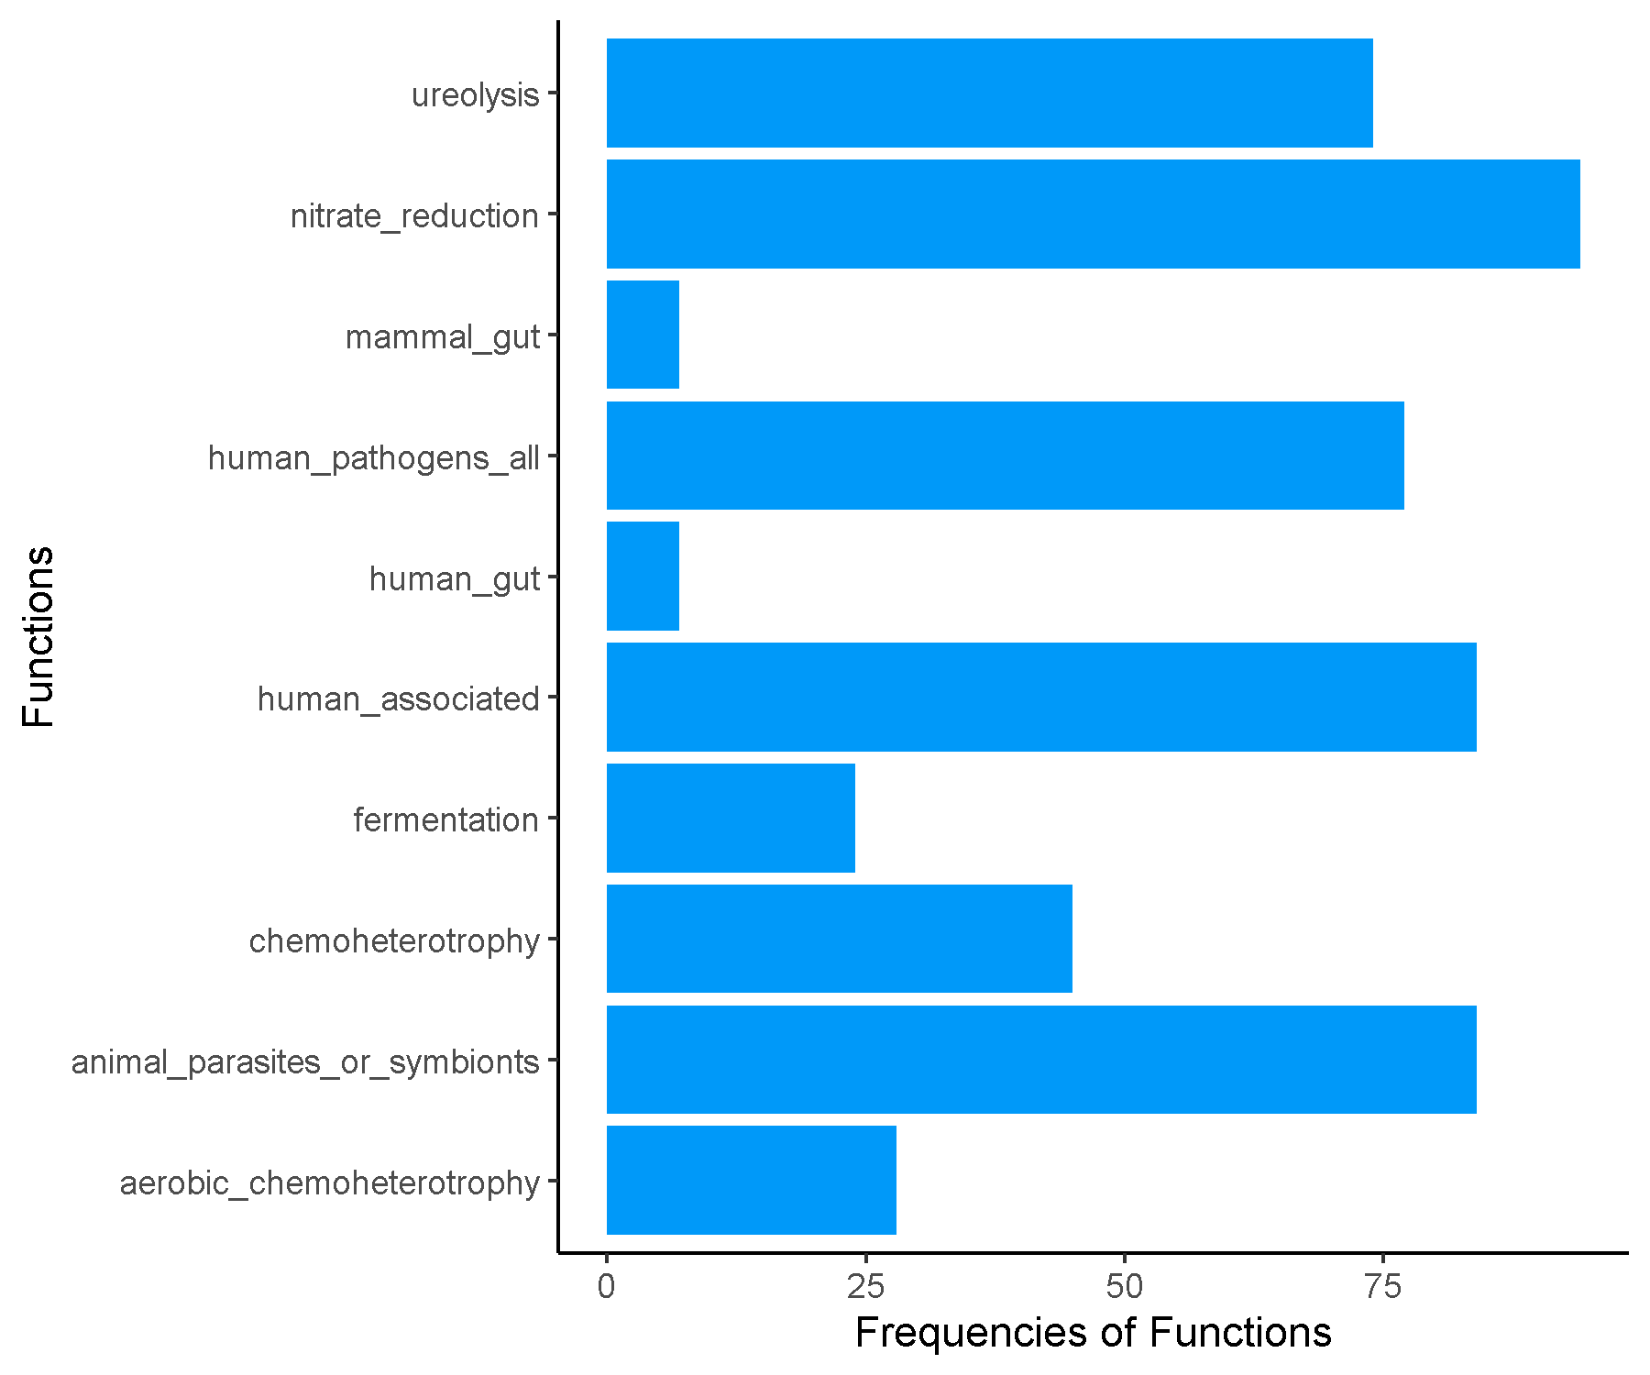

**Spring_Mid_Cluster13.csv.txt_Finalresults.txt**

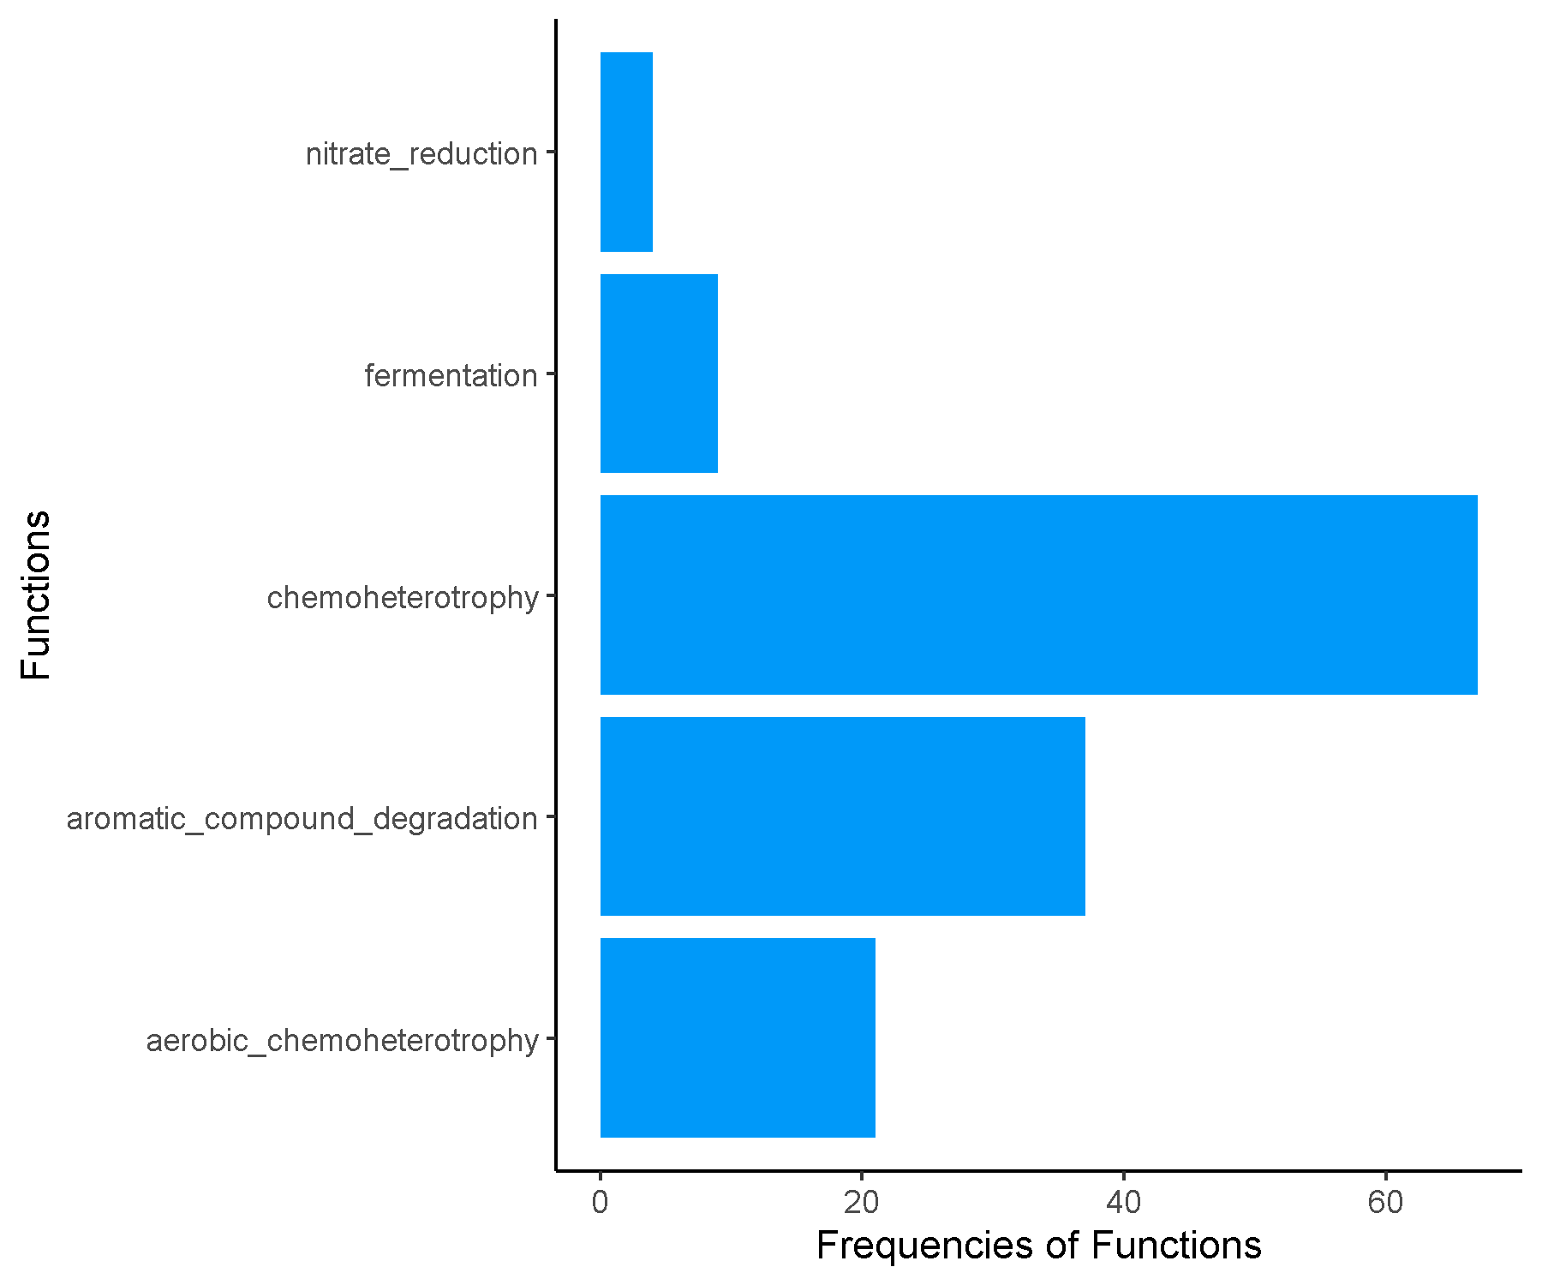

**Spring_Mid_Cluster14.csv.txt_Finalresults.txt**

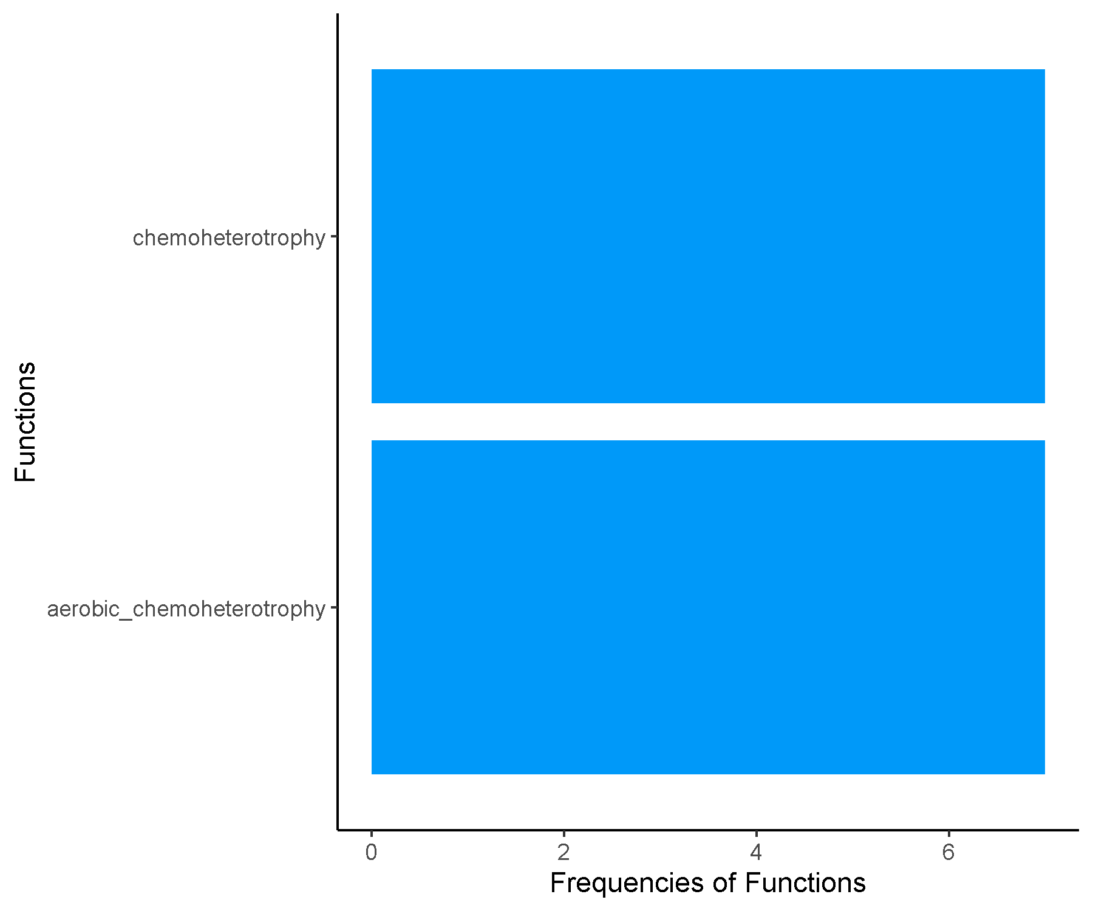

**Spring_Mid_Cluster2.csv.txt_Finalresults.txt**

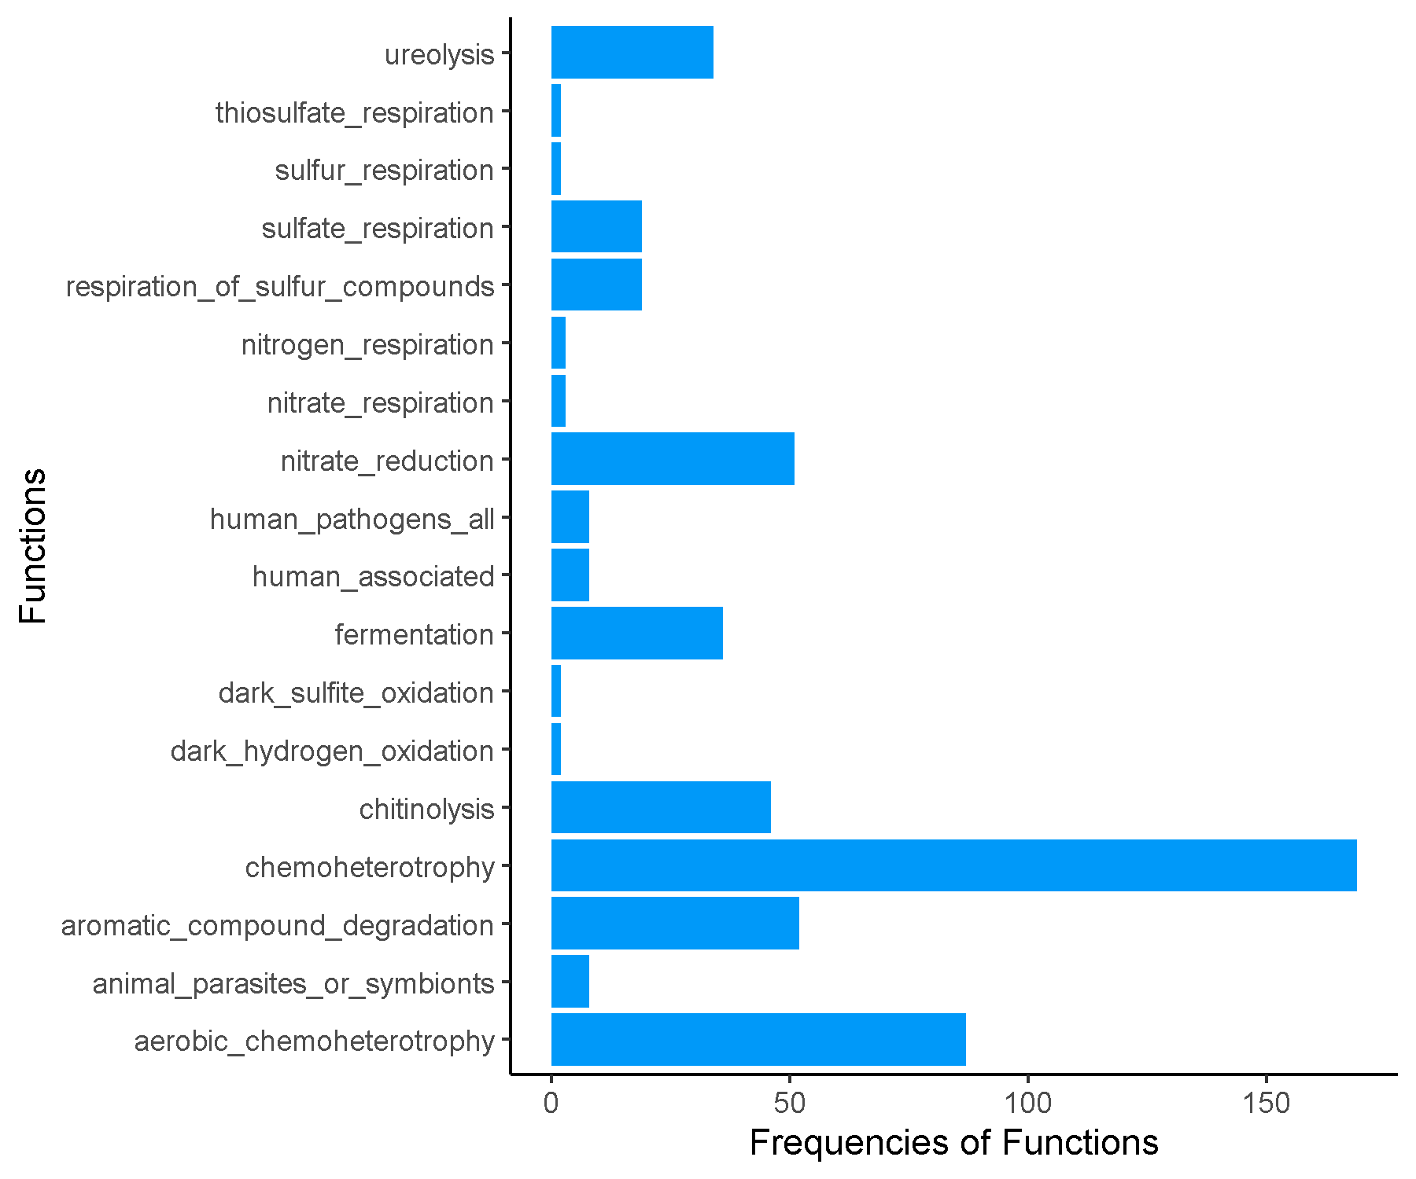

**Spring_Mid_Cluster3.csv.txt_Finalresults.txt**

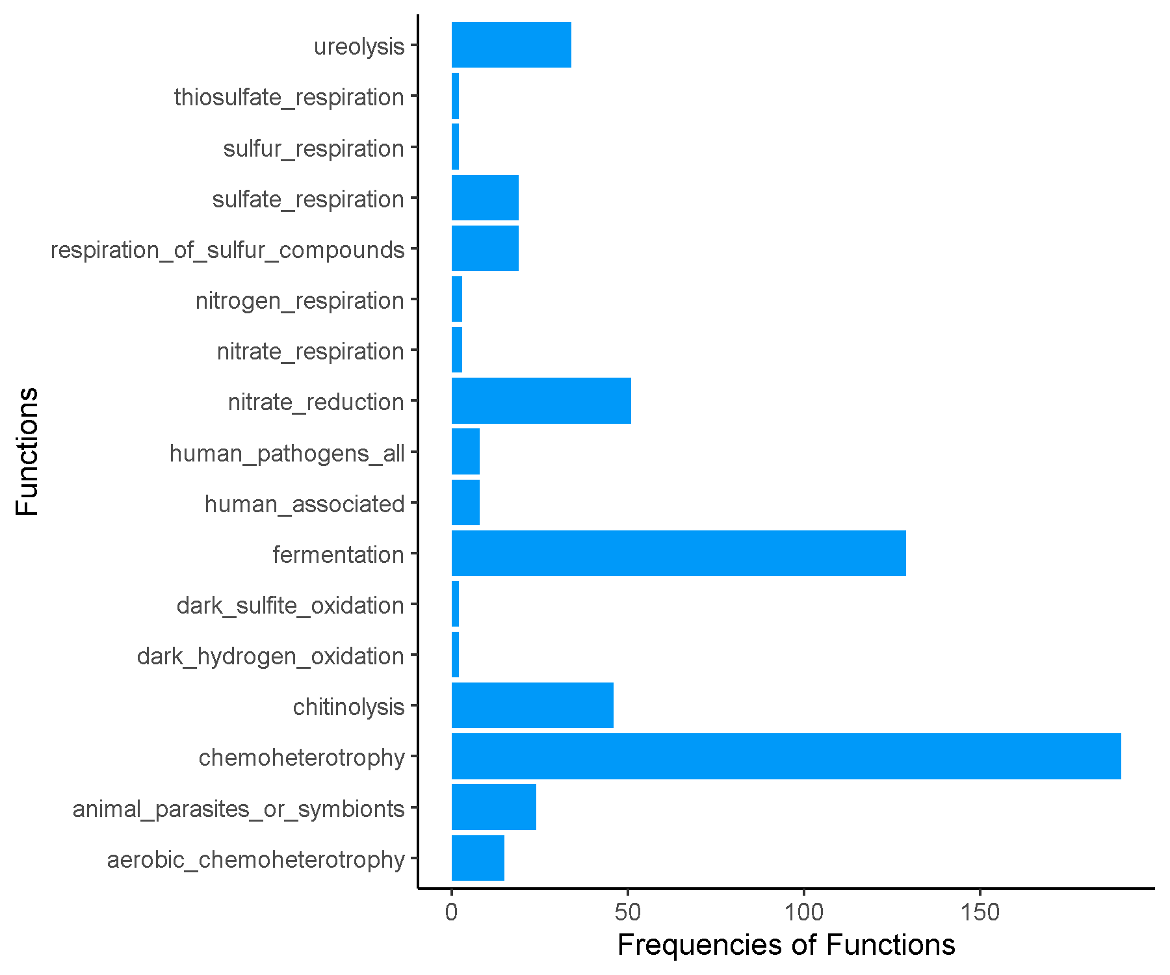

**Spring_Mid_Cluster4.csv.txt_Finalresults.txt**

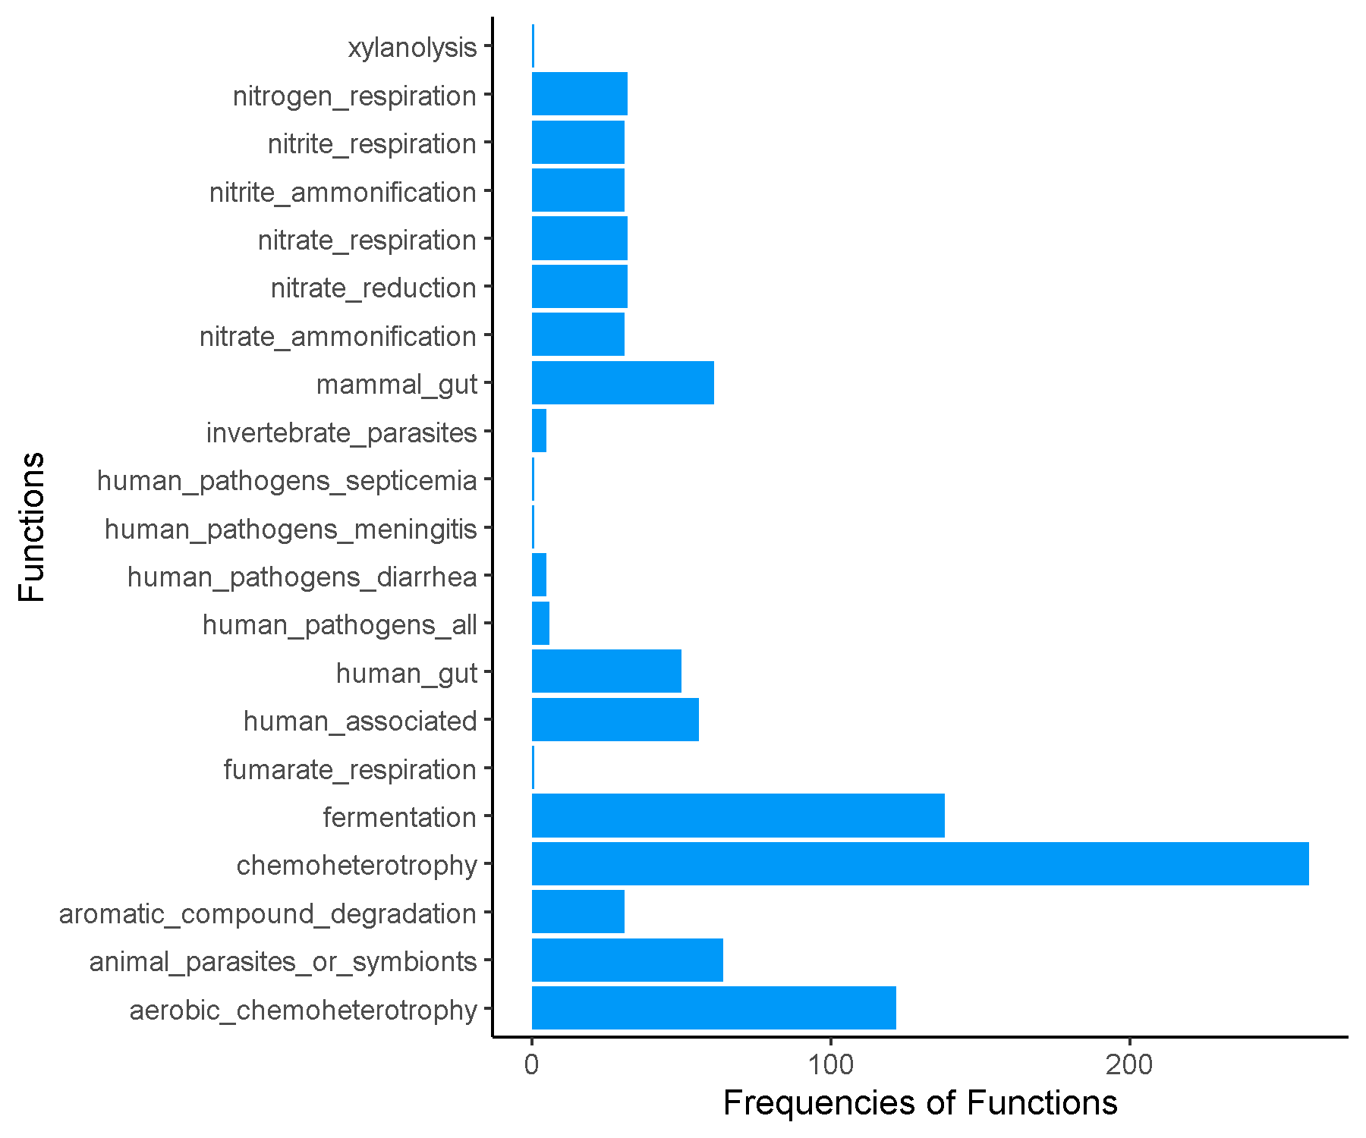

**Spring_Mid_Cluster5.csv.txt_Finalresults.txt**

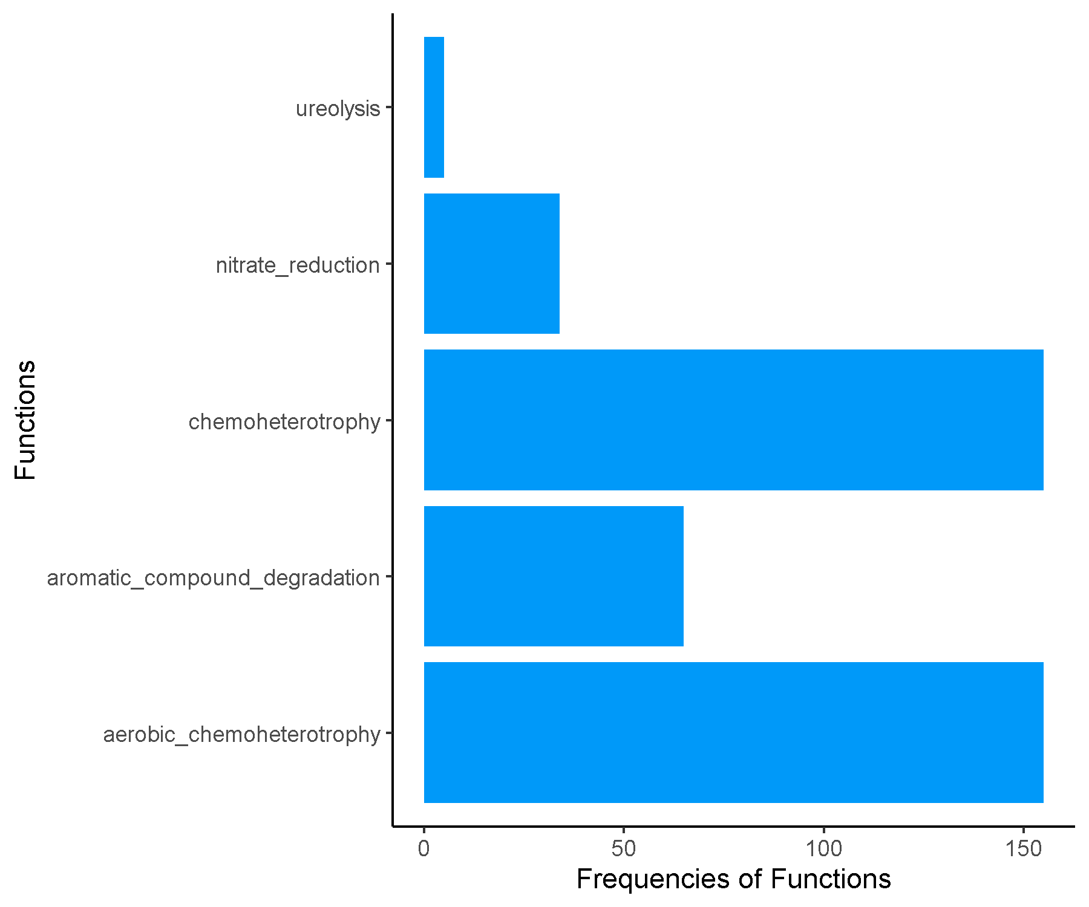

**Spring_Mid_Cluster6.csv.txt_Finalresults.txt**

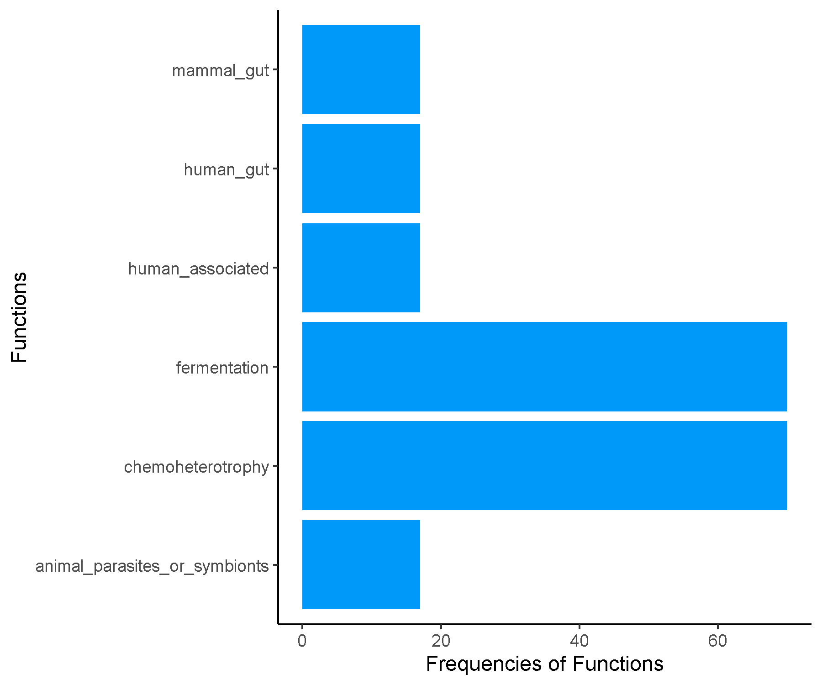

**Spring_Mid_Cluster7.csv.txt_Finalresults.txt**

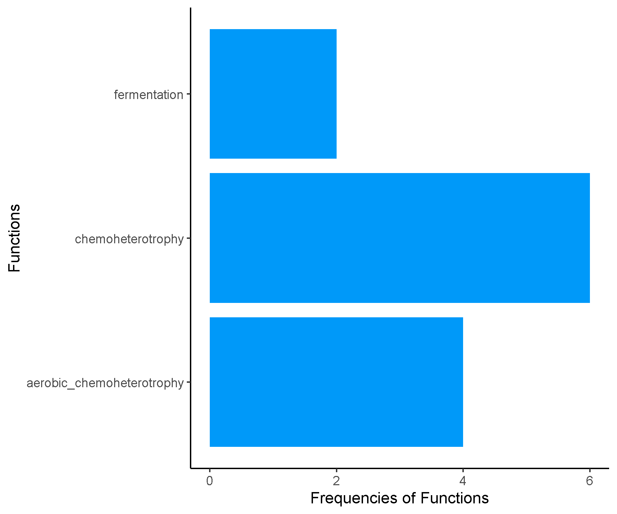

**Spring_Mid_Cluster8.csv.txt_Finalresults.txt**

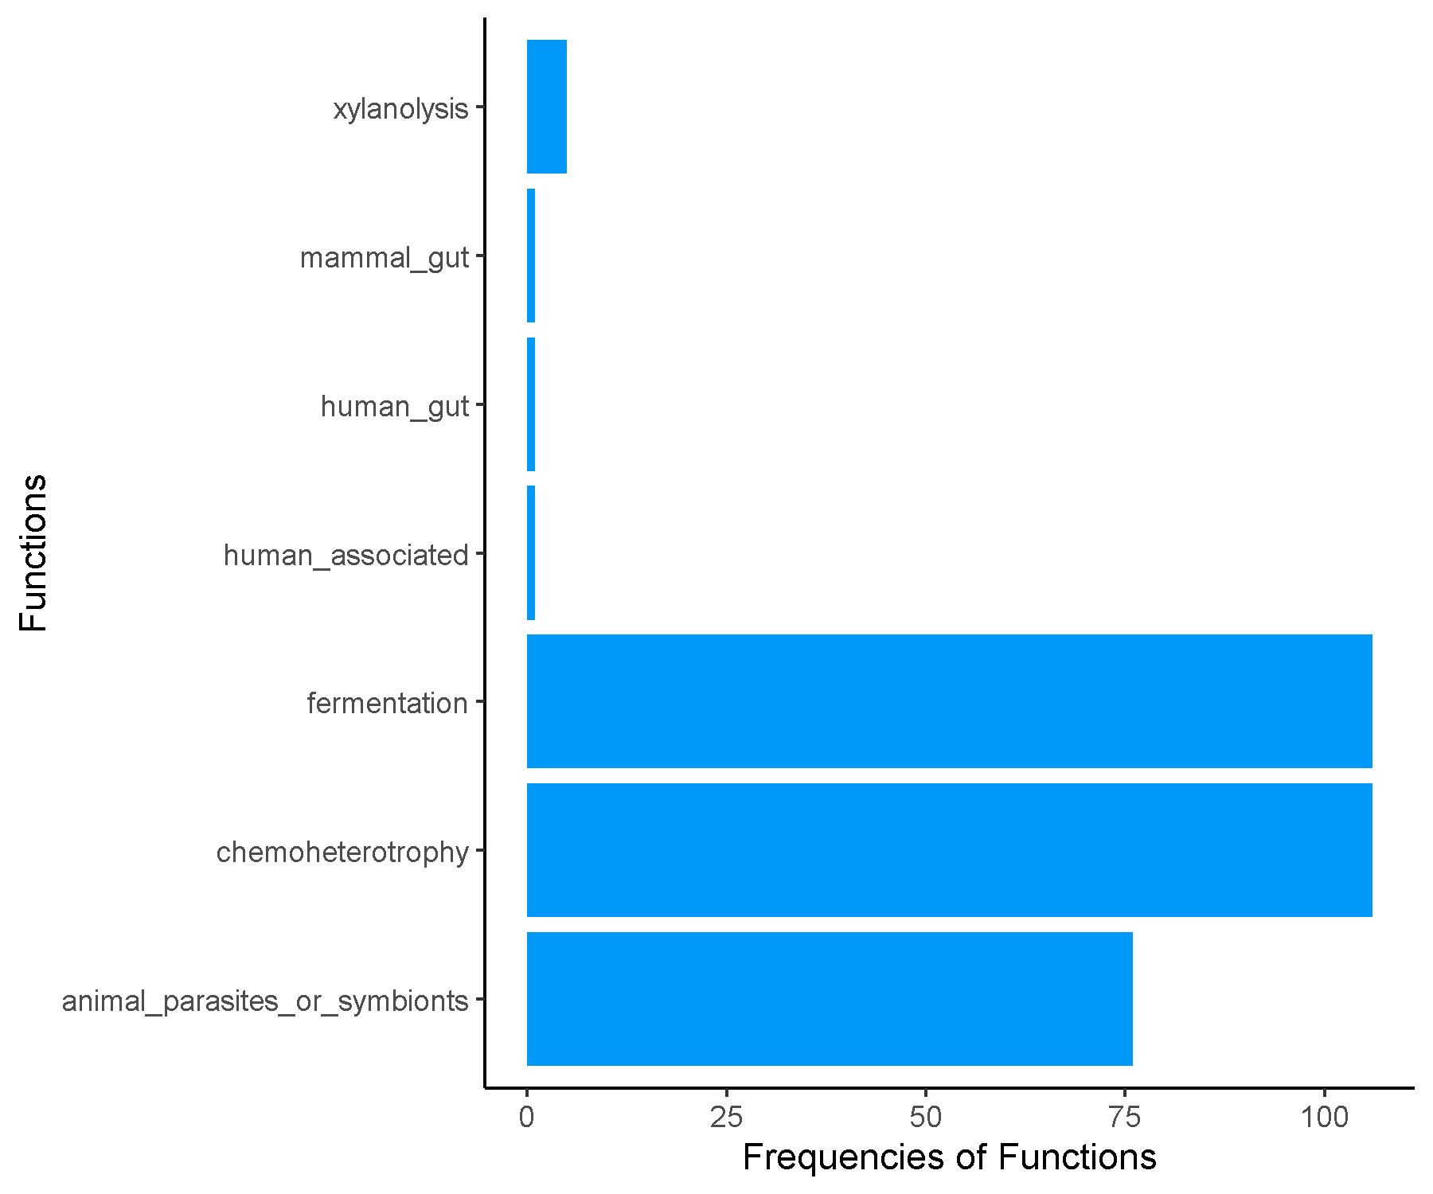

**Spring_Mid_Cluster9.csv.txt_Finalresults.txt**

