Data Cleaning, Statistical & Predictive Analysis in R

Dataset: Zomato Bangalore Restaurants

Prepared using R and RStudio

August 2026

1. Dataset Overview
The dataset used for this analysis is the Zomato Bangalore Restaurants dataset, a publicly available dataset containing information on restaurants listed on the Zomato platform in Bangalore, India. It was selected because it presents realistic data quality challenges commonly encountered in professional data analysis work, including missing values, multi-valued categorical fields, inconsistent text formatting, and a mix of numerical and categorical variables.
Source: Publicly available restaurant listings dataset (Zomato, Bangalore) via Kaggle
Original size: 7,105 rows and 12 columns
Variable types: A mix of numerical variables (rating, number of ratings, average cost for two) and categorical variables (restaurant type, cuisines, area, online order availability, table booking availability)

Original Columns
- restaurant name — name of the restaurant
- restaurant type — category such as Quick Bites, Casual Dining, Cafe (often multi-valued)
- rate (out of 5) — customer rating
- num of ratings — number of ratings received
- avg cost (two people) — approximate cost for two people dining
- online_order — whether online ordering is available (Yes/No)
- table booking — whether table booking is available (Yes/No)
- cuisines type — comma-separated list of cuisines served
- area / local address — location information

2. Tools and Environment
All data cleaning, transformation, and exploratory analysis was performed in R using RStudio. The following packages were used:
- tidyverse — core data manipulation (dplyr), import (readr), and visualization (ggplot2)
- janitor — cleaning column names
- fastDummies — one-hot encoding of categorical variables
- corrplot — correlation heatmap visualization

3. Data Import and Initial Inspection

Step 1: Load Required Packages
library(tidyverse)
library(janitor)
The tidyverse bundle provides the core toolkit for importing, cleaning, transforming, and visualizing data. janitor is used specifically for standardizing column names.

Step 2: Import the Dataset
zomato <- read_csv("zomato.csv")
read_csv() from the readr package was used instead of base R's read.csv() because it is faster, handles large files more efficiently, and preserves text columns as character type rather than converting them to factors by default.

Step 3: Initial Structure Check
dim(zomato)
glimpse(zomato)
head(zomato, 5)
summary(zomato)
Before any cleaning, the raw structure of the data was reviewed to identify data types, obvious inconsistencies, and the scale of missing values. This confirmed the dataset had 7,105 rows and 12 columns, with two redundant index columns left over from the original data export, messy column names containing spaces and parentheses, and missing values present in the rating and cost columns.

4. Data Cleaning Process

Step 4: Standardize Column Names
zomato <- zomato %>% clean_names()
Original column names such as "rate (out of 5)" and "avg cost (two people)" contained spaces and parentheses, making them difficult to reference in code. clean_names() converted all column names to a consistent snake_case format, e.g. rate_out_of_5 and avg_cost_two_people.

Step 5: Remove Redundant Columns
zomato <- zomato %>% select(-x1, -unnamed_0)
The dataset contained two leftover index columns (x1 and unnamed_0) carried over from a prior CSV export. These held no analytical value and were removed.

Step 6: Check for Duplicate Rows
sum(duplicated(zomato))
[1] 0
No duplicate rows were found, so no rows needed to be removed at this stage.

Step 7: Identify Missing Values
colSums(is.na(zomato))
restaurant_name restaurant_type rate_out_of_5 num_of_ratings avg_cost_two_people
0 0 68 0 57
online_order table_booking cuisines_type area local_address
0 0 0 0 0
Two columns contained missing values: rate_out_of_5 (68 missing) and avg_cost_two_people (57 missing). All other columns were complete.

Step 8: Handle Missing Values
Average cost was imputed using the median value of the column:
zomato <- zomato %>%
mutate(avg_cost_two_people = ifelse(
is.na(avg_cost_two_people),
median(avg_cost_two_people, na.rm = TRUE),
avg_cost_two_people
))
The median was chosen over the mean because cost data is typically right-skewed by a small number of very expensive restaurants, which would inflate a mean-based imputation. The median is more robust to this skew.
For rate_out_of_5, rather than imputing a value that could distort rating-based analysis, missing ratings were left as NA and instead flagged in a new column:
zomato <- zomato %>%
mutate(rating_missing_flag = is.na(rate_out_of_5))
This preserves transparency about which restaurants had no recorded rating, while allowing R's na.rm = TRUE argument to correctly exclude these rows from mean/summary calculations without any manual filtering.
colSums(is.na(zomato))
restaurant_name restaurant_type rate_out_of_5 num_of_ratings avg_cost_two_people
0 0 68 0 0
online_order table_booking cuisines_type area local_address
0 0 0 0 0
rating_missing_flag
0
Confirms avg_cost_two_people is now fully populated, while rate_out_of_5 retains its 68 true missing values by design.

Step 9: Trim Whitespace in Text Columns
zomato <- zomato %>%
mutate(across(where(is.character), str_trim))
Leading and trailing whitespace, a common artifact in scraped datasets, was removed from all character columns to prevent grouping and filtering errors later in the analysis.

Step 10: Split Multi-Valued Column: Cuisines
zomato <- zomato %>%
mutate(primary_cuisine = str_trim(str_split_i(cuisines_type, ",", 1)))
The cuisines_type column contained multiple comma-separated values per cell (e.g. "Fast Food, Beverages"). A new column, primary_cuisine, was created by extracting the first listed cuisine, producing a clean single-value field usable for grouping and visualization.
cuisines_type primary_cuisine
1 Fast Food Fast Food
2 Fast Food, Beverages Fast Food
3 Cafe, Beverages Cafe
4 Biryani, Mughlai, Chinese Biryani
5 BBQ, Continental, North Indian, Chinese, Beverages BBQ

Step 11: Split Multi-Valued Column: Restaurant Type
zomato <- zomato %>%
mutate(primary_restaurant_type = str_trim(str_split_i(restaurant_type, ",", 1)))
The restaurant_type column had the same multi-value issue (e.g. "Casual Dining, Bar"). It was resolved the same way, producing primary_restaurant_type.

Step 12: Clean Restaurant Name Artifacts
Restaurant names beginning with non-alphanumeric characters were inspected individually rather than stripped automatically:
zomato %>%
filter(str_detect(restaurant_name, "^[^A-Za-z0-9]")) %>%
select(restaurant_name)
Eight such names were found. Names beginning with "#" (e.g. #FeelTheROLL) were determined to be genuine stylistic branding and were left unchanged. Names beginning with the sequence '@ (e.g. '@ Biryani Central) were identified as data entry or scraping artifacts and removed:
zomato <- zomato %>%
mutate(restaurant_name = str_replace(restaurant_name, "^'@\\s*", ""))
This targeted approach preserved legitimate brand formatting while removing genuine data quality issues — an example of applying judgment rather than a blanket cleaning rule.

Step 13: Save the Cleaned Dataset
write_csv(zomato, "zomato_cleaned.csv")
A checkpoint copy of the cleaned dataset was saved before proceeding to outlier detection, transformation, and analysis.

5. Outlier Detection

Step 14: Detect Outliers Using the IQR Method
Q1 <- quantile(zomato$avg_cost_two_people, 0.25)
Q3 <- quantile(zomato$avg_cost_two_people, 0.75)
IQR_val <- Q3 - Q1
lower_bound <- Q1 - 1.5 * IQR_val
upper_bound <- Q3 + 1.5 * IQR_val

outliers_cost <- zomato %>%
filter(avg_cost_two_people < lower_bound | avg_cost_two_people > upper_bound)
nrow(outliers_cost)
[1] 661
The interquartile range (IQR) method flagged 661 rows (about 9.3% of the dataset) as statistical outliers in average cost. Rather than removing these immediately, the outliers were inspected further:
outliers_cost %>%
select(restaurant_name, restaurant_type, avg_cost_two_people) %>%
arrange(desc(avg_cost_two_people)) %>%
head(10)
restaurant_name restaurant_type avg_cost_two_people
Le Cirque Signature - The Leela Palace Fine Dining 6000
Royal Afghan - ITC Windsor Fine Dining 5000
Malties - Radisson Blu Lounge 4500
La Brasserie - Le Meridien Fine Dining 4100
Alba - JW Marriott Bengaluru Fine Dining 4000
Dakshin - ITC Windsor Fine Dining 4000
Dum Pukht Jolly Nabobs - ITC Windsor Fine Dining 4000
Edo Restaurant & Bar - ITC Gardenia Fine Dining 4000
Grill 99 - The Ritz-Carlton Fine Dining 4000
Jamavar - The Leela Palace Fine Dining 4000
Every high-cost outlier corresponded to a genuine luxury hotel or fine-dining restaurant (Leela Palace, JW Marriott, ITC Windsor, Ritz-Carlton). This confirmed the outliers reflect real business variation rather than data entry errors.
Decision: The outliers were retained rather than removed, since deleting them would discard legitimate pricing variation and bias the dataset toward budget and mid-range restaurants only. Instead, a flag column was added so these rows can be identified or segmented separately without losing information:
zomato <- zomato %>%
mutate(is_cost_outlier = avg_cost_two_people < lower_bound | avg_cost_two_people > upper_bound)
This decision reflects the principle that outlier detection should identify errors, not simply extreme-but-valid values, and that removing genuine variation would weaken rather than improve the analysis.

6. Data Transformation

Step 15: Normalization (Min-Max Scaling)
zomato <- zomato %>%
mutate(
rate_normalized = (rate_out_of_5 - min(rate_out_of_5, na.rm = TRUE)) /
(max(rate_out_of_5, na.rm = TRUE) - min(rate_out_of_5, na.rm = TRUE)),
cost_normalized = (avg_cost_two_people - min(avg_cost_two_people)) /
(max(avg_cost_two_people) - min(avg_cost_two_people))
)
rate_out_of_5 rate_normalized avg_cost_two_people cost_normalized
3.4 0.516 200 0.0268
3.9 0.677 400 0.0604
3.7 0.613 400 0.0604
2.7 0.290 550 0.0856
2.8 0.323 700 0.111
Rating and cost were rescaled to a common 0–1 range using min-max normalization. This is useful for comparing two variables that originally sit on very different numeric scales (ratings 1–5 versus cost ₹40–6,000), and would be a necessary step if these variables were later used together in a distance-based or machine learning model.

Step 16: Encoding Categorical Variables
Two encoding approaches were applied, matched to the type of categorical variable involved.

a) Binary Encoding
The online_order and table_booking columns are simple two-level (Yes/No) categorical variables, so they were converted directly to 0/1 numeric flags:
zomato <- zomato %>%
mutate(
online_order_encoded = ifelse(online_order == "Yes", 1, 0),
table_booking_encoded = ifelse(table_booking == "Yes", 1, 0)
)

b) One-Hot Encoding
The primary_restaurant_type column has many categories (e.g. Quick Bites, Casual Dining, Cafe, Bar), so binary encoding is not appropriate. Instead, one-hot encoding was applied using the fastDummies package, producing a separate binary column for each restaurant type:
install.packages("fastDummies")
library(fastDummies)

zomato_encoded <- dummy_cols(zomato, select_columns = "primary_restaurant_type",
remove_first_dummy = FALSE, remove_selected_columns = FALSE)
The one-hot encoded result was stored in a separate dataframe, zomato_encoded, to keep the main working dataset uncluttered while still making the encoded version available for any modeling that requires fully numeric categorical inputs.

7. Exploratory Data Analysis

Step 17: Correlation Analysis
numeric_data <- zomato %>% select(rate_out_of_5, num_of_ratings, avg_cost_two_people)
cor(numeric_data, use = "complete.obs")
rate_out_of_5 num_of_ratings avg_cost_two_people
rate_out_of_5 1.00 0.38 0.37
num_of_ratings 0.38 1.00 0.34
avg_cost_two_people 0.37 0.34 1.00
corrplot(cor(numeric_data, use = "complete.obs"), method = "color", addCoef.col = "black")
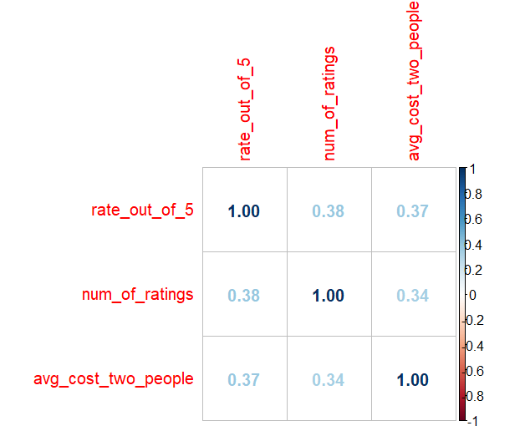
Figure 1: Correlation heatmap of rating, number of ratings, and average cost
All three pairwise correlations are positive but weak-to-moderate (0.34–0.38). Restaurants with more ratings tend to be rated marginally higher, and higher-cost restaurants tend to be rated marginally higher as well, but none of these relationships are strong. This indicates that rating, popularity, and price operate largely independently of one another in this dataset — a restaurant is not reliably "better" simply because it is more expensive or more reviewed.

Step 18: Distribution of Ratings
ggplot(zomato, aes(x = rate_out_of_5)) +
geom_histogram(binwidth = 0.2, fill = "steelblue", color = "white") +
labs(title = "Distribution of Ratings", x = "Rating", y = "Count")
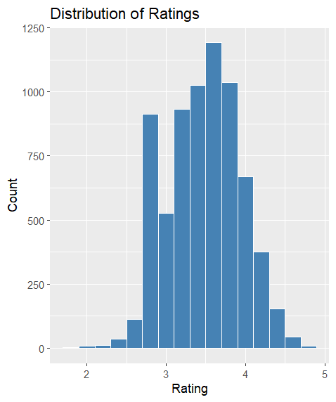
Figure 2: Distribution of restaurant ratings
Ratings follow an approximately bell-shaped distribution centered around 3.5–3.7, with a mild left skew. Very few restaurants receive ratings below 2.5 or above 4.5, indicating that most restaurants converge toward a "decent but not exceptional" rating range, with genuinely poor or outstanding ratings being comparatively rare.

Step 19: Cost Distribution by Restaurant Type
top_types <- zomato %>% count(primary_restaurant_type, sort = TRUE) %>% head(10)

zomato %>%
filter(primary_restaurant_type %in% top_types$primary_restaurant_type) %>%
ggplot(aes(x = primary_restaurant_type, y = avg_cost_two_people)) +
geom_boxplot(fill = "coral") +
coord_flip() +
labs(title = "Cost Distribution by Restaurant Type", x = "", y = "Avg Cost for Two")
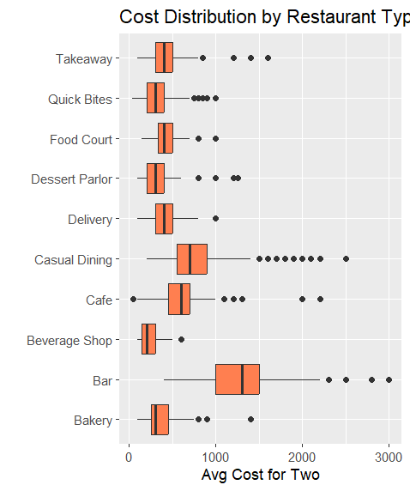
Figure 3: Average cost for two by restaurant type (top 10 most common types)
Cost varies substantially by restaurant type. Bar has by far the highest median cost and widest spread, followed by Casual Dining, which also has the most high-cost outliers, extending toward ₹3,000. Beverage Shop, Bakery, and Quick Bites form a cluster of low-cost, low-variance categories. Every category shows some high-cost outliers, consistent with the earlier finding that these reflect genuine premium establishments rather than data errors.

Step 20: Rating by Online Order Availability
ggplot(zomato, aes(x = online_order, y = rate_out_of_5)) +
geom_boxplot(fill = "lightgreen") +
labs(title = "Rating by Online Order Availability")
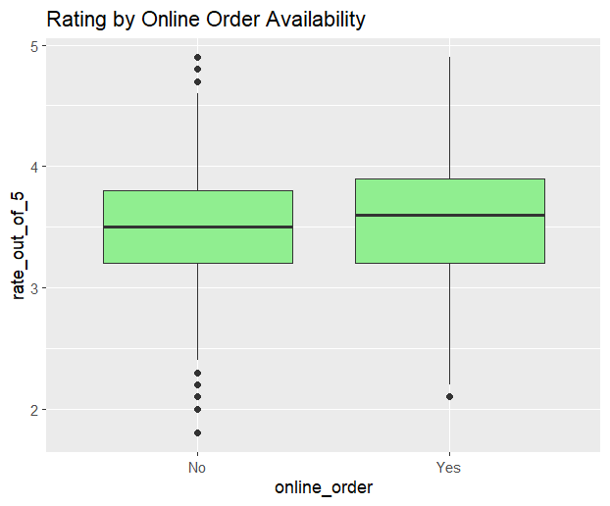
Figure 4: Rating distribution by online order availability
Restaurants offering online ordering show a slightly higher median rating (approximately 3.6) than those that do not (approximately 3.5), though the two distributions overlap heavily, indicating the effect is small. Restaurants without online ordering also show more low-rating outliers, while those with online ordering have almost none. This is consistent with the earlier correlation analysis: online order availability is only weakly associated with rating.

8. Statistical & Predictive Analysis
Building on the exploratory findings, this section adds a deeper statistical characterization of the ratings variable and develops predictive models to estimate a restaurant's rating from its cost, popularity, and service features.

8.1 Descriptive Statistics — Ratings Distribution
library(moments)

zomato %>%
summarise(
rating_mean = mean(rate_out_of_5, na.rm = TRUE),
rating_sd = sd(rate_out_of_5, na.rm = TRUE),
rating_skew = skewness(rate_out_of_5, na.rm = TRUE),
rating_kurtosis = kurtosis(rate_out_of_5, na.rm = TRUE),
cost_mean = mean(avg_cost_two_people),
cost_sd = sd(avg_cost_two_people)
)
rating_mean rating_sd rating_skew rating_kurtosis cost_mean cost_sd
1 3.51 0.463 -0.0629 2.46 ... ...
The mean rating (3.51) and standard deviation (0.463) confirm the tight clustering seen in the earlier histogram. Skewness of -0.063 indicates the distribution is essentially symmetric, with only a negligible left lean. A kurtosis value of 2.46 (below the normal-distribution benchmark of 3) indicates the distribution is slightly platykurtic — marginally flatter than a normal curve, with fewer extreme high or low ratings than a true normal distribution would produce. Together, these statistics formally confirm what the histogram suggested visually: ratings are consistent and centrally clustered, with few genuine extremes.

8.2 Predictive Modeling — Objective
A regression approach was used to predict the exact numeric rating (rate_out_of_5) of a restaurant using its cost, number of ratings, and service features (online ordering and table booking availability). Regression was chosen over classification because rating is a continuous variable, and predicting its exact value provides a more direct extension of the correlation analysis performed earlier, along with richer model diagnostics (R², RMSE, residual behavior).

Step 26: Train/Test Split
library(caret)

set.seed(123)
model_data <- zomato %>% filter(!is.na(rate_out_of_5))
split_index <- createDataPartition(model_data$rate_out_of_5, p = 0.8, list = FALSE)
train_data <- model_data[split_index, ]
test_data <- model_data[-split_index, ]
The cleaned dataset (excluding rows with missing ratings) was split into 80% training data and 20% test data. Evaluating the models on the held-out 20% ensures performance metrics reflect how well each model generalizes to restaurants it has not seen, rather than simply how well it fits the training data.

Step 27: Linear Regression Model
lm_model <- lm(
rate_out_of_5 ~ avg_cost_two_people + num_of_ratings +
online_order_encoded + table_booking_encoded,
data = train_data
)

predictions_lm <- predict(lm_model, test_data)
postResample(predictions_lm, test_data$rate_out_of_5)
RMSE Rsquared MAE
0.3939677 0.2586176 0.3188198
The linear regression model explains approximately 25.9% of the variance in rating (R² = 0.259) on the test set, with an average prediction error of about 0.32 rating points (MAE) and an RMSE of 0.394. This confirms the earlier correlation findings: cost, popularity, and service features have a real but limited linear relationship with rating, and a simple linear model can only partially explain rating variation.

Residual Diagnostics
par(mfrow = c(2,2))
plot(lm_model)
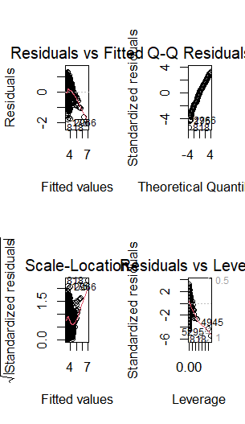
Figure 5: Linear regression diagnostic plots — Residuals vs Fitted, Normal Q-Q, Scale-Location, Residuals vs Leverage
The Residuals vs Fitted plot shows residuals scattered without a strong pattern, suggesting the linear relationship assumption is reasonably, though not perfectly, satisfied. The Q-Q plot shows some deviation from the diagonal at the tails, indicating the residuals are not perfectly normally distributed, most likely due to the bounded 1–5 rating scale compressing extreme predictions. The Scale-Location plot shows a relatively even spread of residuals across fitted values, suggesting no severe heteroscedasticity. A small number of high-leverage points appear in the Residuals vs Leverage plot but do not exceed common influence thresholds, so no observations were removed on this basis.

Step 29: Random Forest Model
library(randomForest)

rf_model <- randomForest(
rate_out_of_5 ~ avg_cost_two_people + num_of_ratings +
online_order_encoded + table_booking_encoded + primary_restaurant_type,
data = train_data, importance = TRUE
)

predictions_rf <- predict(rf_model, test_data)
postResample(predictions_rf, test_data$rate_out_of_5)
RMSE Rsquared MAE
0.3529569 0.4439161 0.2831043
The Random Forest model clearly outperforms linear regression: R² improves from 0.259 to 0.444 (explaining considerably more of the variance in rating), RMSE decreases from 0.394 to 0.353, and MAE decreases from 0.319 to 0.283. This indicates that the relationship between these predictors and rating is not purely linear, and a Random Forest is better able to capture non-linear interactions between cost, popularity, and restaurant type.

Step 30: Feature Importance
importance(rf_model)
varImpPlot(rf_model)
%IncMSE IncNodePurity
avg_cost_two_people 24.65284 70.895374
num_of_ratings 36.89580 237.737444
online_order_encoded 17.55307 8.909056
table_booking_encoded 24.10632 62.895626
primary_restaurant_type 20.06948 34.446894
num_of_ratings is the strongest predictor of rating by a clear margin (highest %IncMSE and IncNodePurity), followed by avg_cost_two_people and table_booking_encoded, which contribute roughly equally. online_order_encoded is the weakest predictor of the five, consistent with the earlier boxplot showing only a marginal difference in rating between restaurants with and without online ordering. This ranking reinforces that popularity (number of ratings) is a more informative signal of a restaurant's rating than price or any single service feature.

8.3 Model Comparison
Model | RMSE | R² | MAE
Linear Regression | 0.394 | 0.259 | 0.319
Random Forest | 0.353 | 0.444 | 0.283

The Random Forest model outperforms linear regression across all three evaluation metrics on the held-out test set. It achieves a lower RMSE and MAE (smaller average prediction error) and a substantially higher R² (explains more of the variance in rating). This is expected: Random Forest can capture non-linear relationships and interactions between predictors, such as cost mattering more for some restaurant types than others, which a linear model cannot represent. Random Forest is therefore the preferred model of the two for predicting restaurant rating from this feature set, though an R² of 0.44 also indicates that a meaningful portion of rating variation is driven by factors not captured in this dataset, such as food quality, service, and ambiance, which are not directly measured here.

9. Summary of Key Insights
- The dataset required meaningful cleaning: two junk index columns, 68 missing ratings, 57 missing costs, multi-valued categorical fields, and inconsistent restaurant name formatting.
- Missing values were handled using different strategies appropriate to each variable: median imputation for cost, and flagging (rather than imputing) for missing ratings, to avoid introducing artificial rating values.
- 661 statistical outliers in cost (9.3% of the data) were investigated and found to be genuine luxury/fine-dining restaurants rather than data errors, and were therefore retained and flagged rather than deleted.
- Rating, number of ratings, and average cost are only weakly correlated with one another (r = 0.34–0.38), showing that popularity and price are not strong predictors of restaurant quality in this dataset.
- Restaurant ratings cluster tightly around 3.5, with genuinely low or high ratings being rare.
- Cost varies significantly by restaurant type, with Bar and Casual Dining commanding the highest prices, while Beverage Shop, Bakery, and Quick Bites remain consistently low-cost.
- Online order availability has only a small, marginal association with rating, reinforcing that no single operational feature strongly predicts a restaurant's rating on its own.
- Ratings are statistically confirmed to be near-symmetric (skewness ≈ -0.06) and slightly flatter than normal (kurtosis ≈ 2.46), reinforcing that extreme ratings are rare.
- A Random Forest regression model predicts restaurant rating more accurately than linear regression (R² = 0.44 vs. 0.26), indicating the relationship between cost, popularity, and rating is meaningfully non-linear.
- Number of ratings is the single strongest predictor of rating, ahead of cost and service features, suggesting popularity is more informative of perceived quality than price alone.

10. Conclusion
This analysis demonstrates a complete, defensible data analysis workflow in R: from raw, messy CSV data through systematic handling of missing values, thoughtful outlier evaluation, normalization, categorical encoding, correlation-driven exploratory analysis, and finally statistical and predictive modeling. Rather than applying cleaning rules mechanically, each decision — including median imputation over mean, flagging rather than deleting missing ratings, and retaining rather than removing statistical outliers — was made based on inspection of the actual data and its business context. The predictive modeling phase further showed that while cost and service features have a real relationship with rating, a non-linear model (Random Forest) captures this relationship substantially better than a linear one, and that popularity, measured by number of ratings, is the most informative single predictor available in this dataset. The resulting cleaned dataset, statistical findings, and models provide a reliable foundation for any further analysis or reporting work on Zomato restaurant data.

