Retail Shop Billing System using C# and SQL

**PROBLEM STATEMENT**

The project aims to create a DMART billing system using C# and SQL. This system is designed to help manage customer, supplier, and product information, as well as generate bills for customers. The main objectives include creating a user-friendly interface to interact with the database, allowing users to view, edit, delete, and add records. The system should calculate and display the total cost, including taxes and discounts, and provide the ability to print bills.

**INTRODUCTION**

The project utilizes C# and SQL in Visual Studio to achieve the following functionalities:

1. **Login Page**: Users start with a login page where they enter a username and password. Successful login leads to the main menu. Also includes a button “Continue as User” directly leading to the billing page.

2. **Main Menu**: The main menu offers six primary actions:

* View Customers
* View Products
* View Suppliers
* Add Customer
* Add Product
* Add Supplier
* Two additional options: "Back" to return to the login page and "Go to Billings" to access the billing window.

3. **View Windows**: The "View" options for Customers, Products and Suppliers allow the user to see the respective tables. User can also edit or delete records in these windows.

4. **Add Windows**: User can input data to add new customers, products, or suppliers to the database.

5. **Message Box**: After editing, deleting, or adding any record, a message box is displayed. It is also displayed if any information block is empty or if any invalid data is put in the text boxes.

6. **Billing Window**: This window displays customer details (Name and ID) and billing date. The user can select products from the available products table and enter the quantity in the box, which is added to the bill table automatically. If the quantity entered is more than the items available, we get a message box displaying “The product is out of stock”. The system calculates and displays the sub-total. User then input GST and a discount, and the grand total is calculated and displayed. There is also a "View Bills" button to access stored bills, and a "Print" button to save and print the bill which gets displayed in the print dialog box.

**ER DIAGRAM AND TABLES**

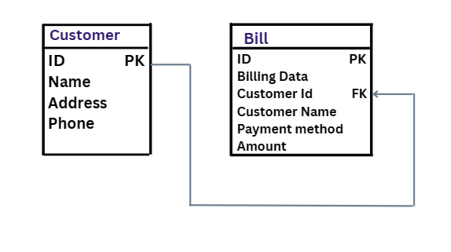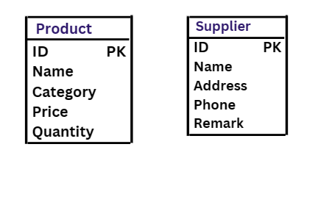

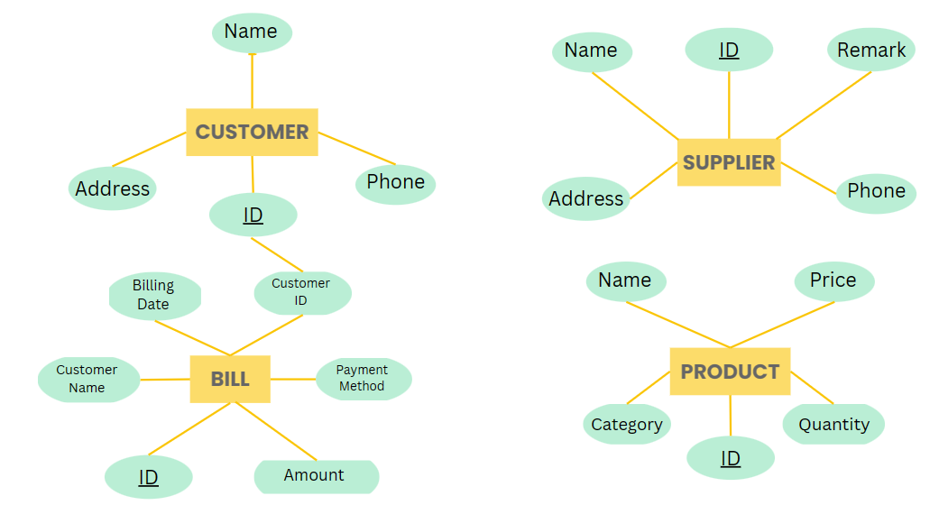

**OUTPUT (WINDOWS)**

1. **Login**

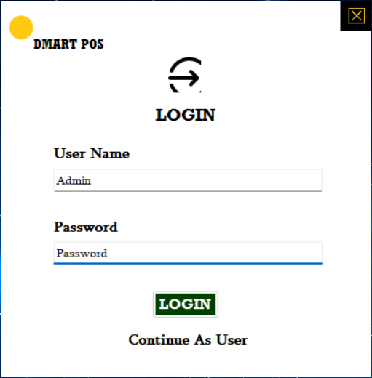

1. **Main Menu**

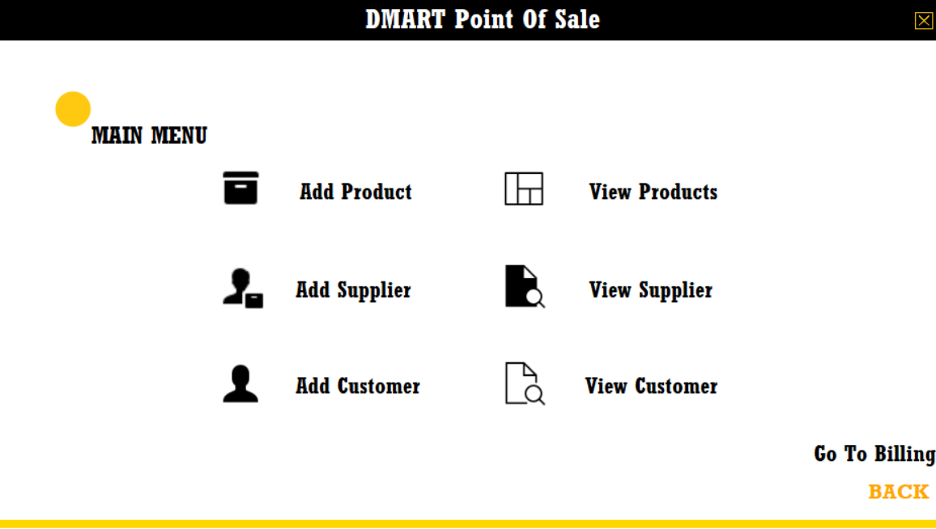

1. **Add windows**

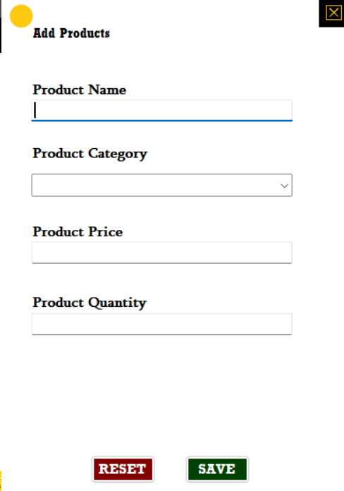 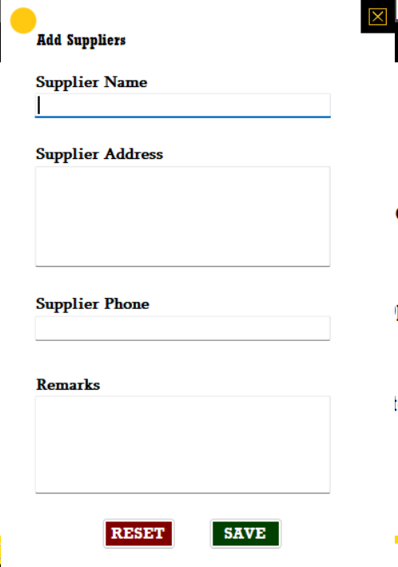 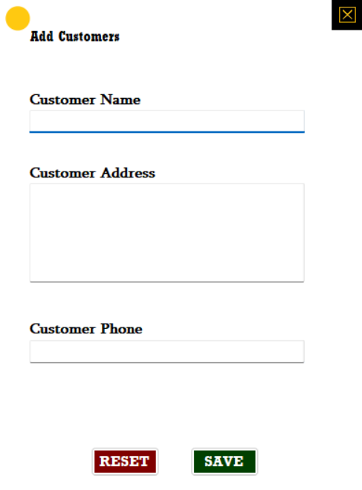

1. **View windows**

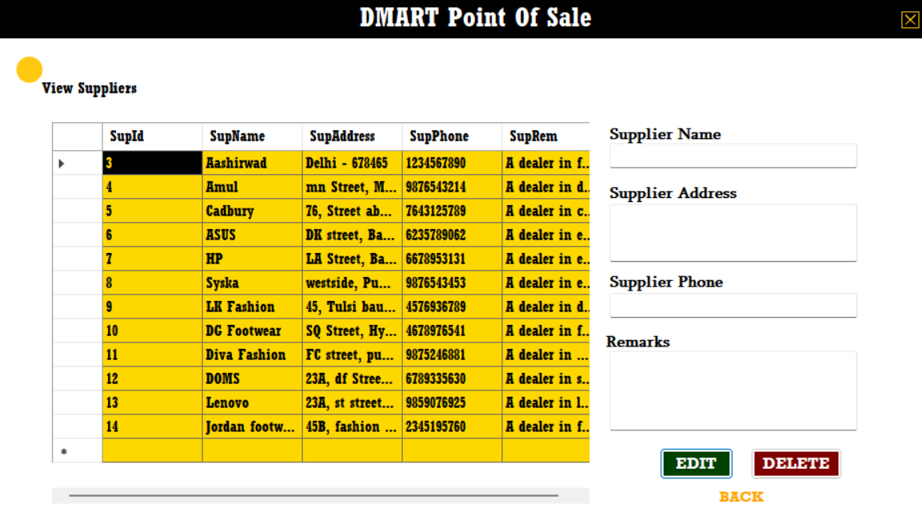 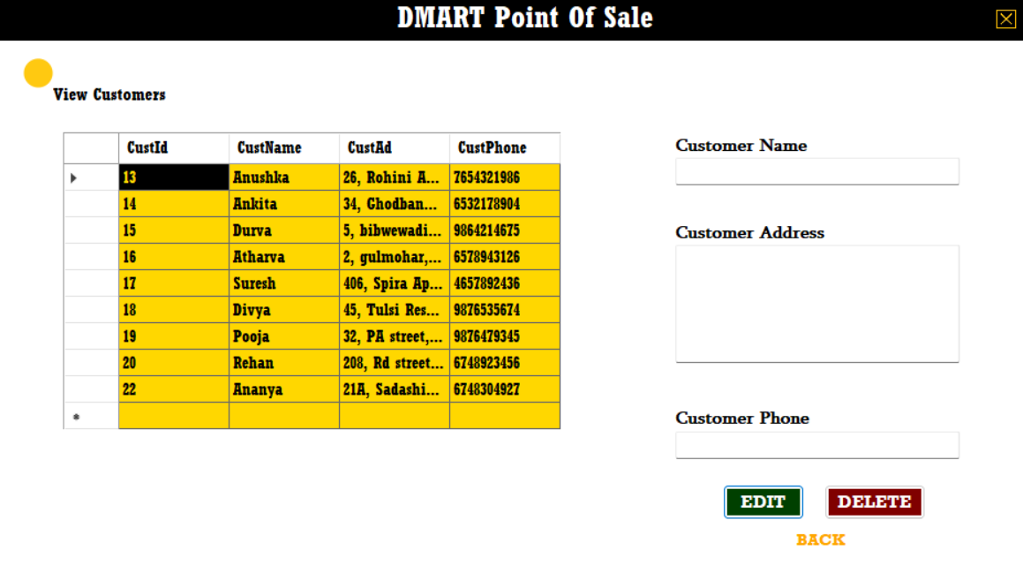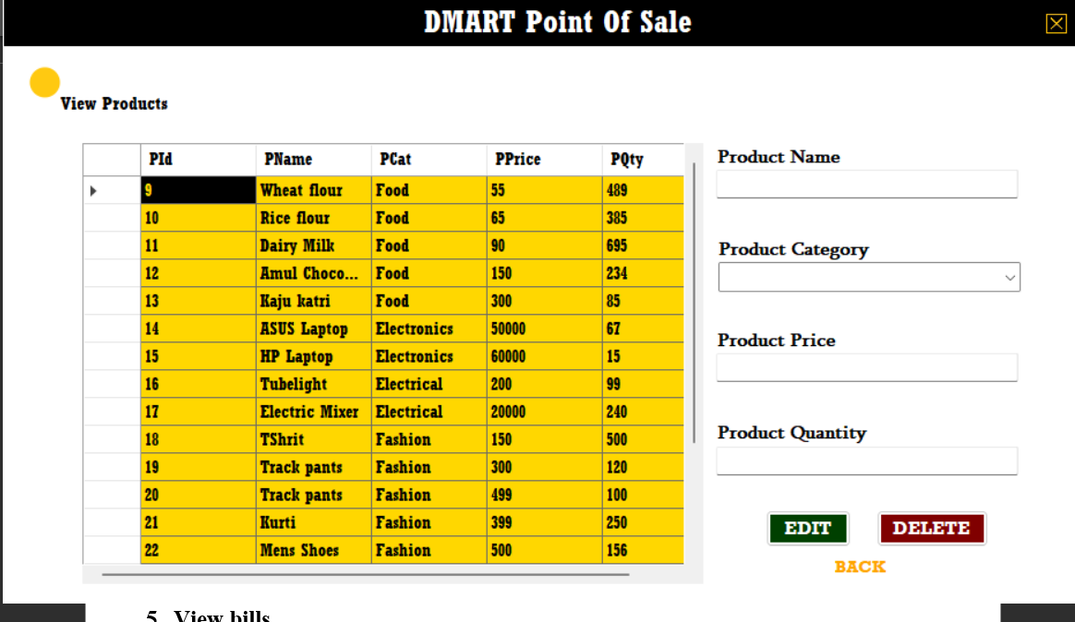

1. **View bills**

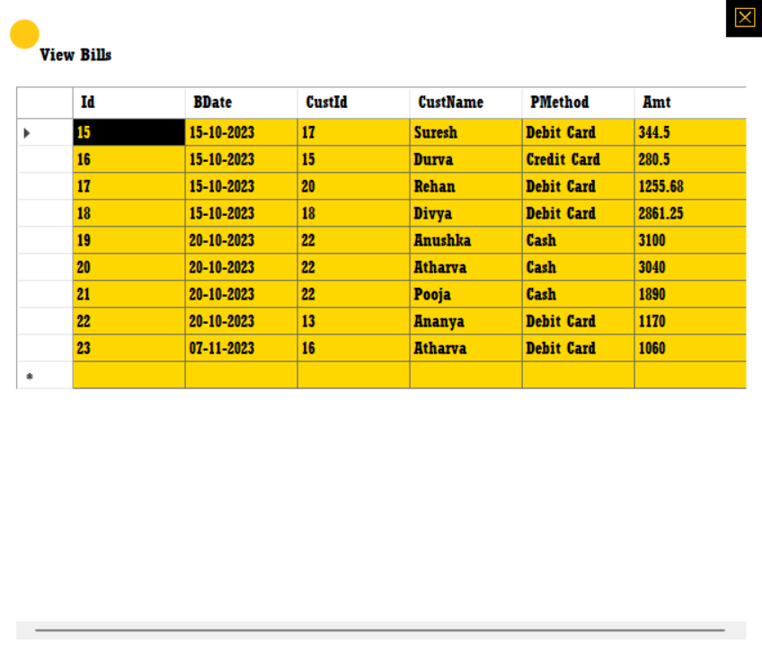

1. **Billing**

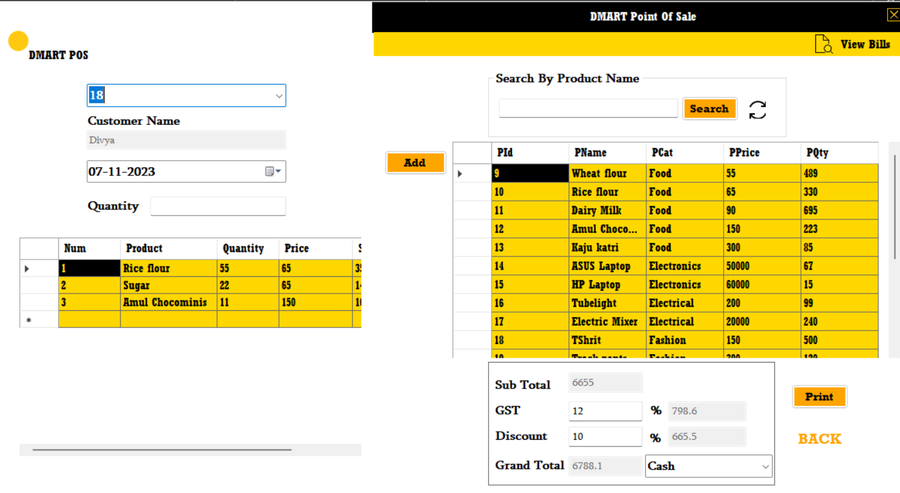

1. **Message boxes**

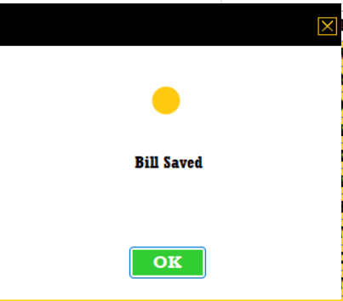 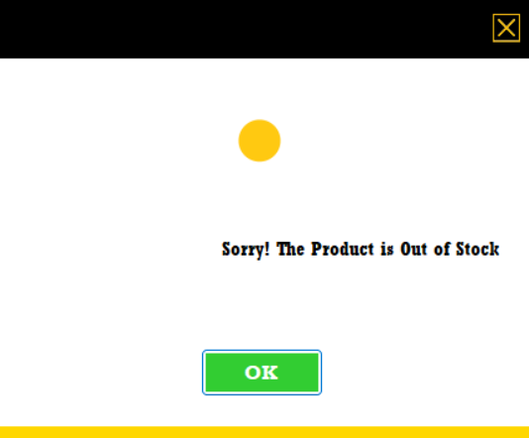

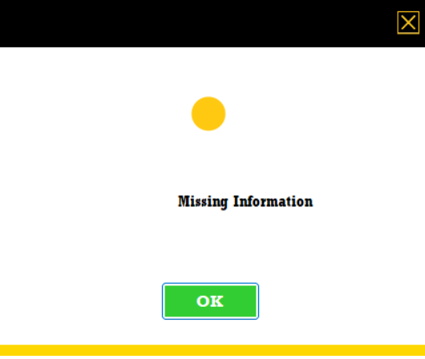 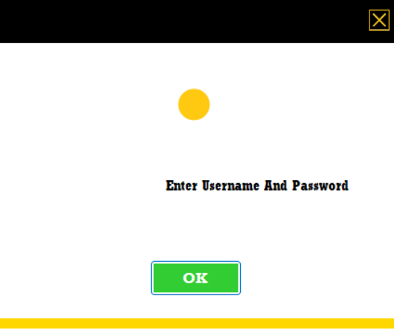

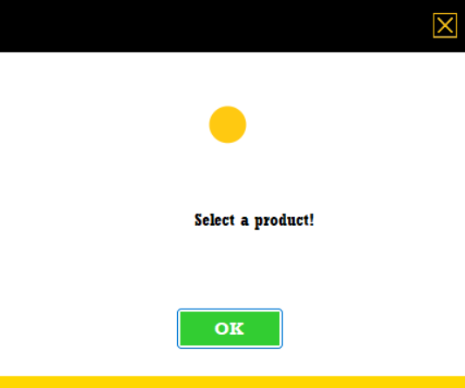 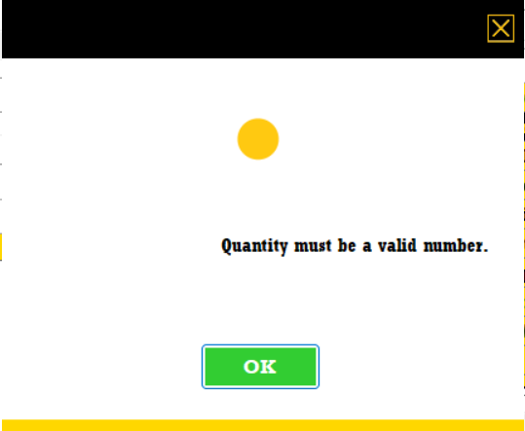

1. **Bill printed**

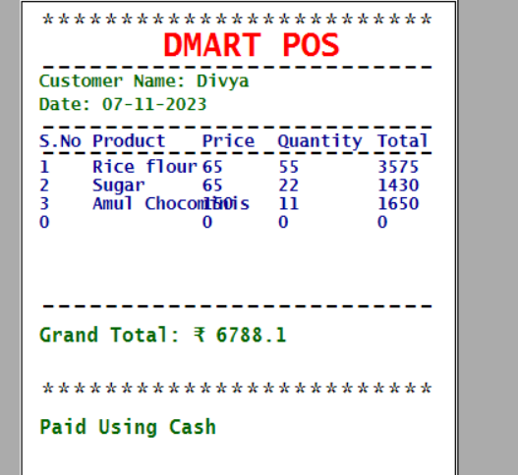

**VIDEO**

**D:\SEM 3\DBMS_CP\REC_PROJECT.mp4**

**CONCLUSION**

The Billing System project successfully addresses the need for a user-friendly application to manage customer, supplier, and product data and generate bills. It provides a smooth and efficient way to handle these tasks and ensures accurate billing calculations. Users can access the system with ease, make necessary updates, and generate professional bills for customers. It offers an intuitive interface and efficient functionalities, making it a valuable tool for businesses.

**FUTURE SCOPE**

The project has several potential future enhancements, including improved user authentication and security, barcode scanning and inventory management features, supplier and purchase order management, online payment processing, scalability, etc. These developments would make the system more versatile, efficient, and user-friendly, catering to a wider range of business needs and industries.

**REFERENCES**

[1] Jan, Saeed Ullah and Shah, Khalid and Mand, Niaz, Point of Sale System (February 24, 2023). http://dx.doi.org/10.2139/ssrn.4368998

[2] An Analysis of Point of Sales (POS) Information Systems in SMEs with The Black Box Testing and PIECES Method. (n.d.). *Journal of Business and Management*. https://doi.org/10.9790/487X-2209052025

[3] POS System (Shoe retails System) Documentation. (n.d.). *System Development*. https://doi.org/10.13140/RG.2.1.1816.5204

[4] Kim, Y. and Lim, J. (2011), "A POS system based on the remote client‐server model in the small business environment", *Management Research Review*, Vol. 34 No. 12, pp. 1334-1350. https://doi.org/10.1108/01409171111186432

[5] Lewis EC, Harper KM, Poirier LK, Gittelsohn J. Feasibility of using mobile point-of-sale technology in Baltimore City corner stores tracking sales: A brief report. J Public Health Res. 2021 Oct 29;11(1):2607. 10.4081/jphr.2021.2607. PMID: 34711045; PMCID: PMC8883529.