Q1. OpenStreetMap UX

(i) Benchmark Analysis
1. Target Users
Target users of OpenStreetMap include students, tourists, daily commuters, cyclists, pedestrians, delivery partners and people searching for nearby locations and services.
2. Existing Features
OpenStreetMap includes the following features:
1. Interactive maps for exploring geographical locations.
2. Zooming and panning to view different areas.
3. Search functionality for finding places and addresses.
4. Geographical information about roads, buildings and points of interest.
5. Open map data that can be used in location-based applications.

3. Selected Workflow
Selected workflow includes searching for nearby essential places like hospitals, libraries, restaurants and ATMs.
4. Observations and Evidence
Observation 1: Existing search workflow should be investigated to check how easy it is for a first-time user to find a particular category of nearby places.
Observation 2: Search results should be checked to check whether it is easy for users to compare different places and select the most suitable location.

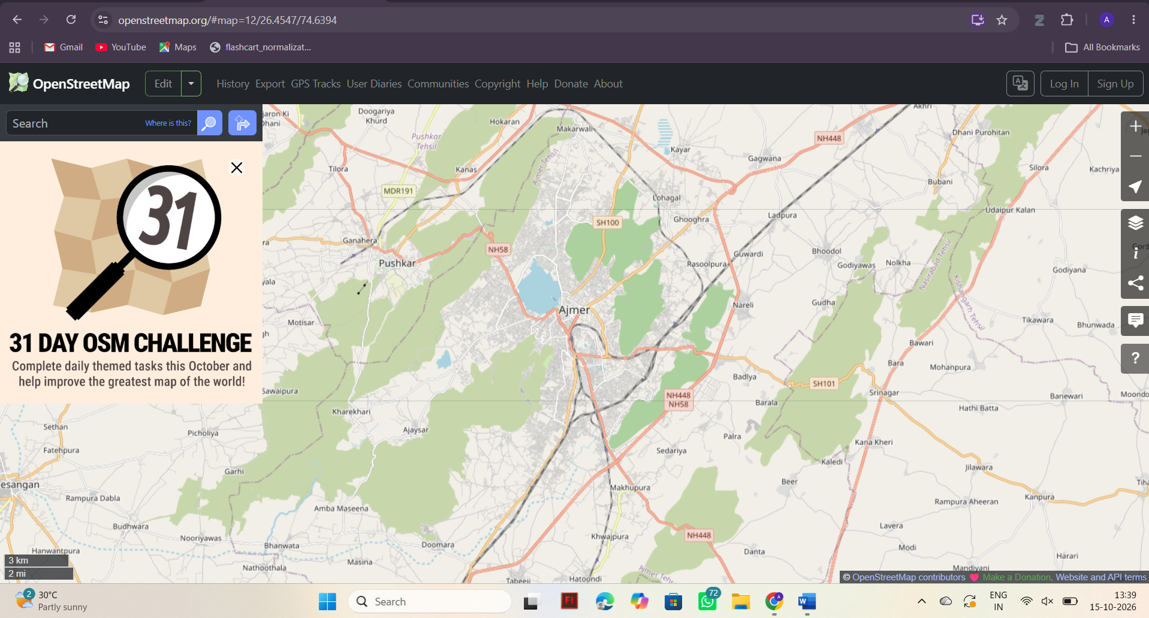
OpenStreetMap Search Interface

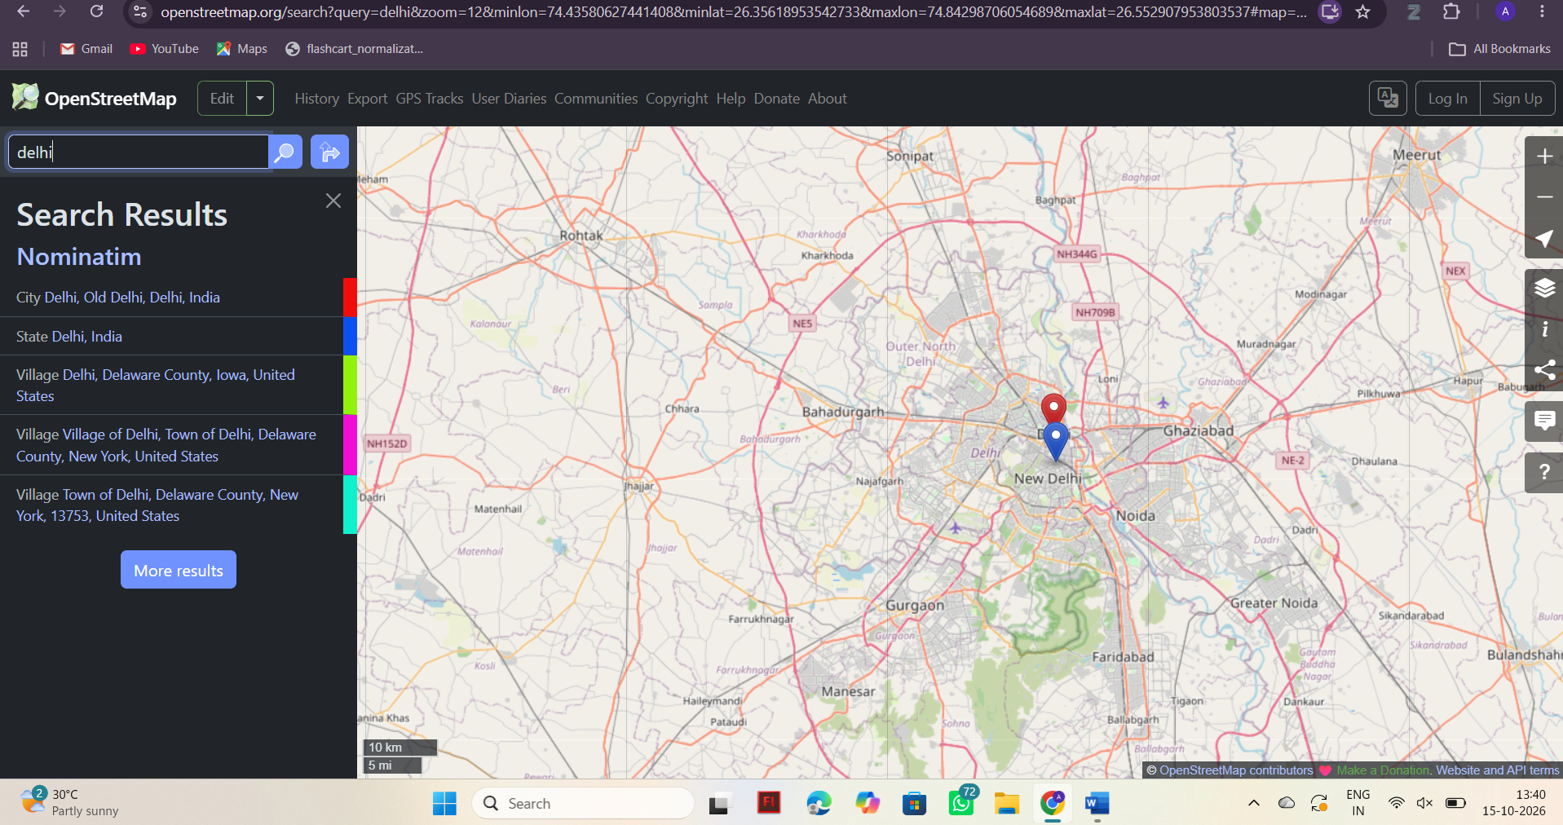
OpenStreetMap Search Results

(ii) Problem Definition
Problem Statement
Users searching for nearby essential services may find it difficult to identify relevant places and compare the available information efficiently. A focused interface with category-based search and clearly organised results can simplify the process of finding suitable locations.
Impact on Users
- Users may spend additional time searching for relevant places.
- Comparing different locations may require additional interactions.
- First-time users may need clearer search options.
- Mobile users may benefit from a simple and responsive interface.
Target User Group
Students and other people who want to find nearby essential services quickly.
Objective
To develop a responsive web application that simplifies nearby-place discovery through category-based search, organised results and clear feedback.

(iii) Innovative Solution
Proposed Solution: Nearby Finder
Nearby Finder is a responsive web application designed to help users find nearby essential services, such as hospitals, libraries, restaurants and ATMs etc that may make there daily life easier . It aims to simplify the process of searching for locations by providing category-based search, organised results and clear feedback.
Proposed Features
- Category-Based Search: Users can select a category such as hospitals, libraries, restaurants or ATMs to find relevant places.
- Location Search: Users can enter a location or search query to find places according to their requirements.
- Organised Search Results: Search results will be displayed in clear cards containing the available place name, address and relevant information.
- Responsive Interface: HTML5 and Tailwind CSS will be used to create a user-friendly interface suitable for desktop and mobile devices.
- Interactive Functionality: JavaScript events will handle form submission, category selection and search interactions.
- Fetch API and JSON Handling: The application will retrieve location data using an appropriate API and process the returned JSON response.
- Loading and Error Handling: The application will display a loading indicator while fetching data, an appropriate message when no results are found, and an error message if the request fails.
Difference from OpenStreetMap
OpenStreetMap provides a general-purpose map interface for exploring geographical locations. Nearby Finder focuses specifically on finding nearby essential services like hospital, stores etc for daily use. Category shortcuts, organised result cards and clear feedback are intended to make this particular workflow easier for users.
Feature-to-Technology Mapping
Feature | Technology Used
Page structure and search form | HTML5
Responsive layout and result cards | Tailwind CSS
Button clicks and form submission | JavaScript events
Input validation | JavaScript
Retrieving location data | Fetch API
Processing location information | JSON
Loading, error and empty states | JavaScript DOM manipulation

Expected Outcome
The proposed application is expected to simplify nearby-place discovery by providing relevant search options, clearly organised results and helpful feedback. Testing will be performed to verify the search functionality, form validation, data retrieval and error handling.
Conclusion
Nearby Finder proposes a focused improvement to the nearby-place discovery workflow of OpenStreetMap. By combining a responsive interface, category-based search, JavaScript interactivity and API-based data retrieval, the application aims to provide users with a simpler and more efficient way to find nearby essential services.

Source Code Implementation
1. HTML Code (index.html)

<!DOCTYPE html>
<html lang="en">
<head>
<meta charset="UTF-8">
<meta name="viewport" content="width=device-width, initial-scale=1.0">
<title>Nearby Finder | Discover Your City</title>
<link rel="stylesheet" href="style.css">
<link rel="stylesheet"
href="https://unpkg.com/leaflet@1.9.4/dist/leaflet.css">
<script src="https://unpkg.com/leaflet@1.9.4/dist/leaflet.js" defer></script>
<script src="script.js" defer></script>
</head>
<body>
<header class="navbar">
<a href="#" class="brand">⌖ Nearby<span>Finder</span></a>
<a href="#explore" class="nav-link">Explore places ↗</a>
</header>

<section class="hero">
<div class="hero-content">
<p class="eyebrow">DISCOVER YOUR NEIGHBOURHOOD</p>
<h1>Find places<br><span>worth discovering.</span></h1>
<p class="hero-description">
Explore hospitals, libraries, cafés, parks and more around your city.
</p>
<a class="primary-button" href="#explore">Start exploring ↓</a>
</div>
<div class="hero-art" aria-hidden="true">⌖</div>
</section>

<main class="container" id="explore">
<div class="section-heading">
<div>
<p class="eyebrow">YOUR CITY, YOUR WAY</p>
<h2>Where are you going?</h2>
</div>
<span class="data-badge">● Open map data</span>
</div>

<form id="searchForm" class="search-panel">
<label for="location">Search location</label>
<input id="location" name="location" type="text"
placeholder="e.g. Bengaluru, India"
minlength="2" maxlength="120" required>

<div class="fields">
<div>
<label for="category">Category</label>
<select id="category">
<option value="hospital">Hospitals</option>
<option value="library">Libraries</option>
<option value="restaurant">Restaurants</option>
<option value="cafe">Cafés</option>
<option value="atm">ATMs</option>
<option value="pharmacy">Pharmacies</option>
<option value="park">Parks</option>
</select>
</div>

<div>
<label for="radius">Search radius</label>
<select id="radius">
<option value="1000">1 km</option>
<option value="3000" selected>3 km</option>
<option value="5000">5 km</option>
<option value="10000">10 km</option>
</select>
</div>

<div>
<label for="sort">Sort by</label>
<select id="sort">
<option value="distance">Nearest first</option>
<option value="name">Name A–Z</option>
</select>
</div>
</div>

<button id="searchButton" type="submit">Find places ↗</button>
<p id="status" role="status" aria-live="polite">
Enter a location to discover nearby places.
</p>
</form>

<div class="section-heading results-heading">
<div>
<p class="eyebrow">YOUR DISCOVERIES</p>
<h2>Places to explore</h2>
</div>
<span id="resultCount" class="data-badge">0 places</span>
</div>

<div class="layout">
<section id="results" class="results">
<div class="empty-state">
<div class="empty-icon">⌖</div>
<h3>Your discoveries start here</h3>
<p>Search a location to see matching places.</p>
</div>
</section>

<section class="map-panel">
<div class="map-heading">
<h3>Explore the map</h3>
<span>Interactive</span>
</div>
<div id="map" aria-label="Map showing nearby places"></div>
<p class="attribution">
Map data © OpenStreetMap contributors
</p>
</section>
</div>
</main>

<footer>
<a href="#" class="brand footer-brand">⌖ Nearby<span>Finder</span></a>
<p>A student project for better place discovery.</p>
</footer>
</body>
</html>

2. CSS Styling (style.css)
The application uses Tailwind CSS utility classes for styling the landing page, search form, buttons and result cards. The layout is designed to be responsive and user-friendly on desktop and mobile devices.

@import url('https://fonts.googleapis.com/css2?family=DM+Sans:wght@400;500;600;700&family=Manrope:wght@400;500;600;700;800&display=swap');

:root {
--green: #24734f;
--dark-green: #164c36;
--light-green: #e9f4ec;
--cream: #f6f8f4;
--text: #26352c;
--muted: #758078;
--border: #e0e7df;
--white: #ffffff;
}

* {
margin: 0;
padding: 0;
box-sizing: border-box;
}

html {
scroll-behavior: smooth;
}

body {
font-family: 'DM Sans', sans-serif;
background: var(--cream);
color: var(--text);
line-height: 1.6;
}

a {
text-decoration: none;
}

/* NAVIGATION */

.navbar {
height: 76px;
padding: 0 7%;
display: flex;
justify-content: space-between;
align-items: center;
background: var(--white);
border-bottom: 1px solid var(--border);
}

.brand {
font-family: 'Manrope', sans-serif;
font-size: 23px;
font-weight: 800;
letter-spacing: -1px;
color: var(--dark-green);
}

.brand span {
color: var(--green);
}

.nav-link {
padding: 10px 17px;
border: 1px solid var(--border);
border-radius: 8px;
color: var(--dark-green);
font-size: 14px;
font-weight: 600;
transition: 0.2s;
}

.nav-link:hover {
background: var(--light-green);
}

/* HERO SECTION */

.hero {
min-height: 350px;
padding: 65px 8%;
position: relative;
overflow: hidden;
display: flex;
align-items: center;
background: linear-gradient(120deg, #164c36, #2b8058);
color: white;
}

.hero-content {
position: relative;
z-index: 1;
max-width: 720px;
}

.eyebrow {
margin-bottom: 10px;
color: var(--green);
font-size: 12px;
font-weight: 800;
letter-spacing: 1.7px;
}

.hero .eyebrow {
color: #c4e5d0;
}

.hero h1 {
margin-bottom: 15px;
font-family: 'Manrope', sans-serif;
font-size: clamp(36px, 5vw, 57px);
font-weight: 800;
line-height: 1.16;
letter-spacing: -2px;
}

.hero h1 span {
color: #d2ead9;
}

.hero-description {
margin-bottom: 27px;
color: #e4f0e8;
font-size: 16px;
}

.primary-button {
display: inline-block;
padding: 12px 21px;
border-radius: 8px;
background: white;
color: var(--dark-green);
font-weight: 700;
transition: 0.2s;
}

.primary-button:hover {
background: #e7f2e9;
transform: translateY(-2px);
}

.hero-art {
position: absolute;
right: 10%;
top: 15px;
color: rgba(255, 255, 255, 0.09);
font-size: 280px;
line-height: 1;
pointer-events: none;
}

/* MAIN CONTENT */

.container {
width: 86%;
max-width: 1200px;
margin: 48px auto 65px;
}

.section-heading {
margin-bottom: 23px;
display: flex;
align-items: center;
justify-content: space-between;
gap: 15px;
}

.section-heading h2 {
font-family: 'Manrope', sans-serif;
font-size: 27px;
line-height: 1.3;
letter-spacing: -0.7px;
}

.data-badge {
display: inline-block;
padding: 8px 13px;
border: 1px solid #d5e6d8;
border-radius: 30px;
background: var(--light-green);
color: var(--dark-green);
font-size: 12px;
font-weight: 700;
white-space: nowrap;
}

/* SEARCH FORM */

.search-panel {
margin-bottom: 45px;
padding: 26px;
background: var(--white);
border: 1px solid var(--border);
border-radius: 14px;
box-shadow: 0 7px 25px rgba(32, 65, 43, 0.05);
}

.search-panel label {
display: block;
margin-bottom: 7px;
color: #48564d;
font-size: 13px;
font-weight: 700;
}

.search-panel input,
.search-panel select {
width: 100%;
height: 47px;
padding: 0 13px;
border: 1px solid #dce3dc;
border-radius: 8px;
outline: none;
background: #fcfdfb;
color: var(--text);
font-family: inherit;
font-size: 14px;
transition: border-color 0.2s, box-shadow 0.2s;
}

.search-panel input:focus,
.search-panel select:focus {
border-color: var(--green);
box-shadow: 0 0 0 3px rgba(36, 115, 79, 0.10);
}

.search-panel input::placeholder {
color: #9aa39c;
}

.fields {
display: grid;
grid-template-columns: repeat(3, minmax(0, 1fr));
gap: 17px;
margin-top: 18px;
}

#searchButton {
margin-top: 20px;
min-height: 47px;
padding: 0 24px;
border: none;
border-radius: 8px;
background: var(--green);
color: white;
font-family: inherit;
font-size: 14px;
font-weight: 700;
cursor: pointer;
transition: 0.2s;
}

#searchButton:hover {
background: var(--dark-green);
transform: translateY(-1px);
}

#searchButton:disabled {
opacity: 0.65;
cursor: not-allowed;
transform: none;
}

#status {
margin-top: 16px;
padding: 11px 14px;
border-radius: 7px;
background: #f1f6f0;
color: #536a59;
font-size: 13px;
}

/* RESULTS */

.results-heading {
margin-bottom: 22px;
}

.layout {
display: grid;
grid-template-columns: minmax(0, 0.9fr) minmax(0, 1.1fr);
gap: 23px;
align-items: start;
}

.results {
display: flex;
flex-direction: column;
gap: 13px;
min-width: 0;
}

.results > * {
min-width: 0;
}

.results > div:not(.empty-state) {
padding: 19px;
background: white;
border: 1px solid var(--border);
border-radius: 11px;
transition: box-shadow 0.2s, transform 0.2s;
}

.results > div:not(.empty-state):hover {
transform: translateY(-2px);
box-shadow: 0 7px 22px rgba(32, 65, 43, 0.07);
}

.results h3 {
margin-bottom: 6px;
font-size: 16px;
}

.results p {
color: var(--muted);
font-size: 13px;
overflow-wrap: anywhere;
}

.results a {
color: var(--green);
font-size: 13px;
font-weight: 700;
}

.empty-state {
padding: 43px 20px;
border: 1px dashed #cad8cb;
border-radius: 12px;
background: #fbfcfa;
text-align: center;
}

.empty-icon {
margin-bottom: 10px;
color: var(--green);
font-size: 43px;
}

.empty-state h3 {
margin-bottom: 8px;
font-size: 17px;
}

.empty-state p {
color: var(--muted);
font-size: 13px;
}

/* MAP */

.map-panel {
min-width: 0;
padding: 14px;
background: white;
border: 1px solid var(--border);
border-radius: 13px;
box-shadow: 0 5px 20px rgba(32, 65, 43, 0.04);
}

.map-heading {
display: flex;
align-items: center;
justify-content: space-between;
gap: 10px;
margin-bottom: 13px;
}

.map-heading h3 {
font-size: 16px;
}

.map-heading span {
padding: 5px 9px;
border-radius: 20px;
background: var(--light-green);
color: var(--dark-green);
font-size: 11px;
font-weight: 700;
}

#map {
width: 100%;
height: 410px;
border-radius: 8px;
background: #e9eee8;
overflow: hidden;
}

.attribution {
padding-top: 10px;
color: var(--muted);
font-size: 11px;
}

/* FOOTER */

footer {
padding: 28px 7%;
display: flex;
justify-content: space-between;
align-items: center;
gap: 15px;
background: white;
border-top: 1px solid var(--border);
}

.footer-brand {
font-size: 19px;
}

footer p {
color: var(--muted);
font-size: 13px;
}

/* MOBILE RESPONSIVENESS */

@media (max-width: 850px) {
.container {
width: 90%;
}

.layout {
grid-template-columns: 1fr;
}

#map {
height: 350px;
}

.hero-art {
right: -20px;
font-size: 210px;
}
}

@media (max-width: 600px) {
.navbar {
height: 68px;
padding: 0 5%;
}

.brand {
font-size: 19px;
}

.nav-link {
padding: 8px 10px;
font-size: 12px;
}

.hero {
min-height: 330px;
padding: 48px 6%;
}

.hero h1 {
font-size: 38px;
letter-spacing: -1px;
}

.hero-description {
font-size: 14px;
}

.hero-art {
right: -40px;
top: 70px;
font-size: 150px;
}

.container {
width: 90%;
margin-top: 35px;
}

.section-heading {
align-items: flex-start;
}

.section-heading h2 {
font-size: 23px;
}

.data-badge {
font-size: 10px;
padding: 7px 9px;
}

.search-panel {
padding: 18px;
}

.fields {
grid-template-columns: 1fr;
gap: 14px;
}

#searchButton {
width: 100%;
}

footer {
flex-direction: column;
text-align: center;
}
}

3. JavaScript Functionality (script.js)
JavaScript will be used to implement form validation, event handling, Fetch API requests, JSON data processing, loading indicators, error messages and search result display.

"use strict";

const form = document.getElementById("searchForm");
const locationInput = document.getElementById("location");
const categoryInput = document.getElementById("category");
const radiusInput = document.getElementById("radius");
const sortInput = document.getElementById("sort");
const searchButton = document.getElementById("searchButton");
const statusText = document.getElementById("status");
const results = document.getElementById("results");
const resultCount = document.getElementById("resultCount");

let map = null;
let markerLayer = null;
let controller = null;
let requestNumber = 0;
let currentOrigin = null;
let currentPlaces = [];

const categories = {
hospital: { label: "Hospital", tag: '["amenity"="hospital"]' },
library: { label: "Library", tag: '["amenity"="library"]' },
restaurant: { label: "Restaurant", tag: '["amenity"="restaurant"]' },
cafe: { label: "Café", tag: '["amenity"="cafe"]' },
atm: { label: "ATM", tag: '["amenity"="atm"]' },
pharmacy: { label: "Pharmacy", tag: '["amenity"="pharmacy"]' },
park: { label: "Park", tag: '["leisure"="park"]' }
};

function setStatus(message, isError = false) {
statusText.textContent = message;
statusText.classList.toggle("error", isError);
}

function clearResults() {
results.replaceChildren();
resultCount.textContent = "0 places";
currentPlaces = [];
}

function initMap() {
if (typeof L === "undefined") {
setStatus("The map library could not load. Check your connection.", true);
return false;
}

if (!map) {
map = L.map("map").setView([28.6139, 77.2090], 12);

L.tileLayer("https://{s}.tile.openstreetmap.org/{z}/{x}/{y}.png", {
maxZoom: 19,
attribution: '&copy; <a href="https://www.openstreetmap.org/copyright">OpenStreetMap</a> contributors'
}).addTo(map);

markerLayer = L.layerGroup().addTo(map);
}

return true;
}

initMap();

async function getJSON(url, options = {}) {
const response = await fetch(url, options);

if (!response.ok) {
throw new Error("Map service error (" + response.status + "). Please try again later.");
}

return response.json();
}

async function geocode(place, signal) {
const url = new URL("https://nominatim.openstreetmap.org/search");

url.search = new URLSearchParams({
q: place,
format: "jsonv2",
limit: "1"
});

const data = await getJSON(url, { signal });

if (!Array.isArray(data) || data.length === 0) {
throw new Error("Location not found. Try a city or area name.");
}

const lat = Number(data[0].lat);
const lon = Number(data[0].lon);

if (!Number.isFinite(lat) || !Number.isFinite(lon)) {
throw new Error("Invalid coordinates received for this location.");
}

return { lat, lon, name: data[0].display_name };
}

function distanceKm(a, b, c, d) {
const rad = value => value * Math.PI / 180;
const dLat = rad(c - a);
const dLon = rad(d - b);

const h = Math.sin(dLat / 2) ** 2 +
Math.cos(rad(a)) * Math.cos(rad(c)) * Math.sin(dLon / 2) ** 2;

return 6371 * 2 * Math.atan2(Math.sqrt(h), Math.sqrt(1 - h));
}

async function getPlaces(origin, category, radius, signal) {
const tag = categories[category].tag;

const query = `
[out:json][timeout:25];
(
node${tag}(around:${radius},${origin.lat},${origin.lon});
way${tag}(around:${radius},${origin.lat},${origin.lon});
relation${tag}(around:${radius},${origin.lat},${origin.lon});
);
out center tags 60;
`;

const data = await getJSON(
"https://overpass-api.de/api/interpreter",
{
method: "POST",
headers: {
"Content-Type": "application/x-www-form-urlencoded;charset=UTF-8"
},
body: new URLSearchParams({ data: query }),
signal
}
);

if (!data || !Array.isArray(data.elements)) {
throw new Error("The place-data service returned invalid data.");
}

return data.elements.map(item => {
const lat = Number(item.lat ?? item.center?.lat);
const lon = Number(item.lon ?? item.center?.lon);

if (!Number.isFinite(lat) || !Number.isFinite(lon)) return null;

return {
name: item.tags?.name || "Unnamed place",
address: [
item.tags?.["addr:housenumber"],
item.tags?.["addr:street"],
item.tags?.["addr:suburb"],
item.tags?.["addr:city"]
].filter(Boolean).join(", ") || "Address unavailable",
lat,
lon,
distance: distanceKm(origin.lat, origin.lon, lat, lon)
};
}).filter(Boolean);
}

function mapURL(place) {
return "https://www.openstreetmap.org/?mlat=" +
encodeURIComponent(place.lat) + "&mlon=" +
encodeURIComponent(place.lon) + "#map=17/" +
encodeURIComponent(place.lat) + "/" + encodeURIComponent(place.lon);
}

function renderResults() {
results.replaceChildren();

const sorted = [...currentPlaces];

if (sortInput.value === "name") {
sorted.sort((a, b) => a.name.localeCompare(b.name));
} else {
sorted.sort((a, b) => a.distance - b.distance);
}

if (!sorted.length) {
const empty = document.createElement("div");
empty.className = "empty-state";

const title = document.createElement("h3");
title.textContent = "No places found";

const message = document.createElement("p");
message.textContent = "Try another category or increase the search radius.";

empty.append(title, message);
results.appendChild(empty);
}

sorted.forEach((place, index) => {
const card = document.createElement("article");
card.className = "place-card";

const title = document.createElement("h3");
title.textContent = place.name;

const address = document.createElement("p");
address.textContent = place.address;

const meta = document.createElement("div");
meta.className = "place-meta";

const type = document.createElement("span");
type.textContent = categories[categoryInput.value].label;

const distance = document.createElement("span");
distance.textContent = place.distance.toFixed(1) + " km away";

meta.append(type, distance);

const actions = document.createElement("div");
actions.className = "place-actions";

const link = document.createElement("a");
link.href = mapURL(place);
link.target = "_blank";
link.rel = "noopener noreferrer";
link.textContent = "View on map ↗";

const share = document.createElement("button");
share.type = "button";
share.textContent = "Share";

share.addEventListener("click", async () => {
const text = place.name + "\n" + mapURL(place);

try {
if (navigator.share) {
await navigator.share({ title: place.name, text });
} else if (navigator.clipboard && window.isSecureContext) {
await navigator.clipboard.writeText(text);
share.textContent = "Copied ✓";
} else {
window.prompt("Copy this place link:", text);
}
} catch (error) {
if (error.name !== "AbortError") {
window.prompt("Copy this place link:", text);
}
}
});

actions.append(link, share);
card.append(title, address, meta, actions);
results.appendChild(card);
});

resultCount.textContent = sorted.length +
(sorted.length === 1 ? " place" : " places");

if (initMap()) {
markerLayer.clearLayers();

L.marker([currentOrigin.lat, currentOrigin.lon])
.bindPopup("Searched location")
.addTo(markerLayer);

sorted.forEach(place => {
L.marker([place.lat, place.lon])
.bindPopup(document.createTextNode(place.name).textContent)
.addTo(markerLayer);
});

if (sorted.length) {
const points = [
[currentOrigin.lat, currentOrigin.lon],
...sorted.map(place => [place.lat, place.lon])
];

map.fitBounds(L.latLngBounds(points), { padding: [25, 25] });
} else {
map.setView([currentOrigin.lat, currentOrigin.lon], 13);
}

setTimeout(() => map.invalidateSize(), 100);
}
}

form.addEventListener("submit", async event => {
event.preventDefault();

const place = locationInput.value.trim();

if (place.length < 2) {
locationInput.setCustomValidity("Enter at least two characters.");
locationInput.reportValidity();
return;
}

locationInput.setCustomValidity("");

if (controller) controller.abort();

controller = new AbortController();
const activeController = controller;
const thisRequest = ++requestNumber;

clearResults();
searchButton.disabled = true;
searchButton.textContent = "Searching...";
setStatus("Searching for nearby places...");

try {
const origin = await geocode(place, activeController.signal);

if (thisRequest !== requestNumber) return;

currentOrigin = origin;

currentPlaces = await getPlaces(
origin,
categoryInput.value,
Number(radiusInput.value),
activeController.signal
);

if (thisRequest !== requestNumber) return;

renderResults();

setStatus(currentPlaces.length
? "Found " + currentPlaces.length + " nearby places."
: "No matching places found. Try another category or radius.");

} catch (error) {
if (error.name === "AbortError") return;

if (thisRequest !== requestNumber) return;

clearResults();
setStatus(error.message || "Search failed. Please try again.", true);

} finally {
if (thisRequest === requestNumber) {
searchButton.disabled = false;
searchButton.textContent = "Find places ↗";
controller = null;
}
}
});

sortInput.addEventListener("change", () => {
if (currentOrigin) renderResults();
});

categoryInput.addEventListener("change", () => {
setStatus("Category changed. Search again to update results.");
});

radiusInput.addEventListener("change", () => {
setStatus("Radius changed. Search again to update results.");
});

locationInput.addEventListener("input", () => {
locationInput.setCustomValidity("");
});

