MSE-1 DEVOPS

NAME- ANUSHKA SINGH
ROLL –NO : 202401100200074
CSE-A

1.GITHUB REPOSITORY: https://github.com/Anushkaaa02/github-skills-challenge
2.PULL REQUEST URL: https://github.com/Anushkaaa02/github-skills-challenge/pull/2

3.Screenshot showing the GitHub Actions workflows
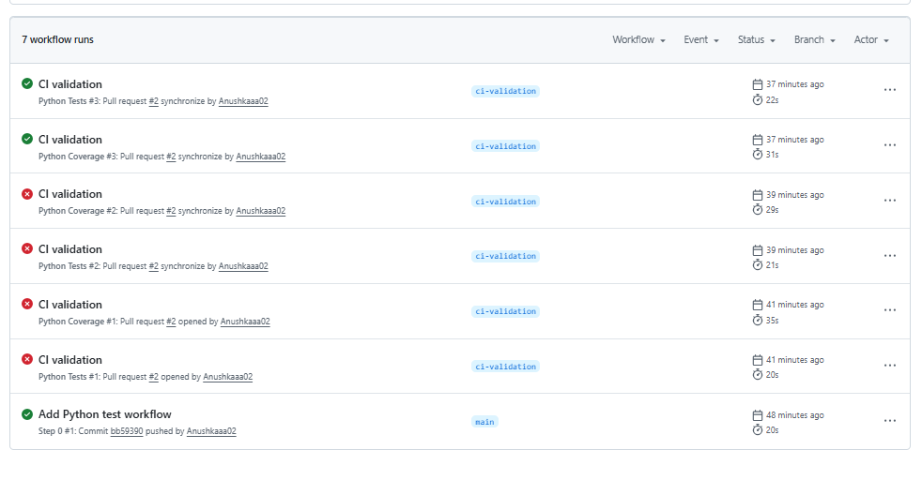

4. Screenshot showing a successful test workflow execution
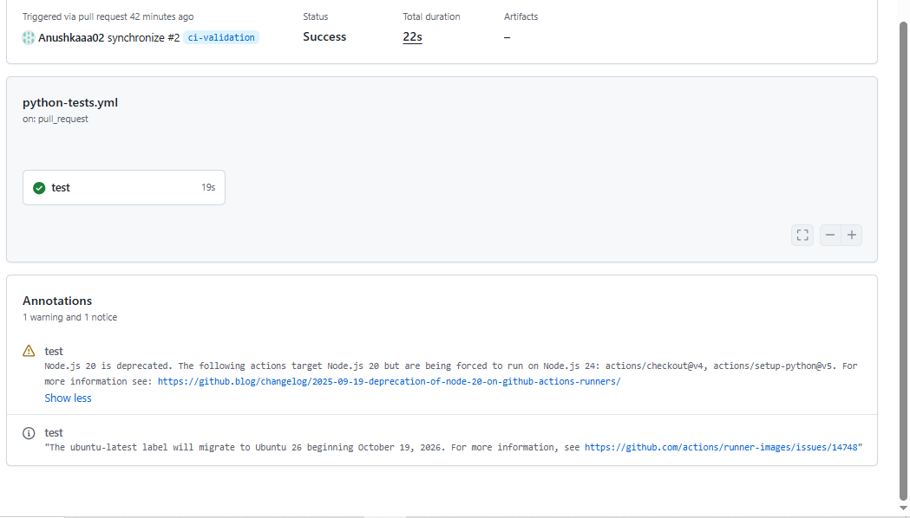

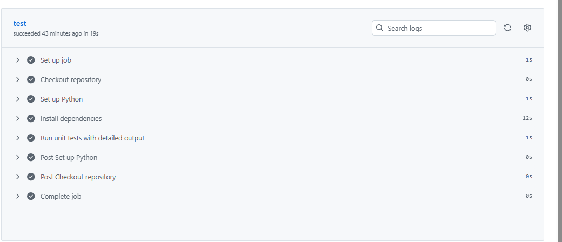

5. Screenshot showing the coverage result/comment on the pull request
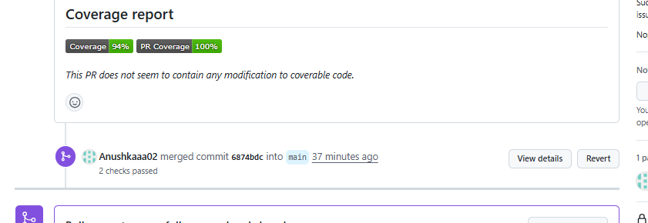

6. Screenshot showing the final repository/workflow files
