Game Design Document

Fill up the following document

1. Write the title of your project.

* Astromentional.

1. What is the goal of the game?

* This is an endless game. The goal is to survive in the game as long as the user can by defeating / killing monsters.

1. Write a brief story of your game.

The story of this game is that space monsters have declared a war

and it’s in the hands of the user or the protector to save universe

against these villains by destroying them in multiple background themes.

1. Which are the playing characters of this game?

* Playing characters are the ones who respond to the user based on the input from the user.
* Cars, monkeys, dinos, wizards, etc., are the playing characters in the game.

|  |  |  |
| --- | --- | --- |
| Number | Character Name | What can this character do? |
| 1 | Spaceship | This character will shoot and destroy monsters as the user will press space key. |
| 2 |  |  |
| 3 |  |  |
| 4 |  |  |
| 5 |  |  |
| 6 |  |  |
| 7 |  |  |
| 8 |  |  |

1. Which are the Non-Playing Characters of this game?

* Non-Playing characters are the ones that don't have an action or behaviour when the user interacts with the game.
* Hurdles, stones, bananas, coins, etc., are non-playing characters in the game.

|  |  |  |
| --- | --- | --- |
| Number | Character Name | What can this character do? |
| 1 | Monsters | They will enter the canvas at several intervals and move towards the player. If the player doesn’t destroy them, then they will demolish the user and the game will come to an end. |
| 2 |  |  |
| 3 |  |  |
| 4 |  |  |
| 5 |  |  |
| 6 |  |  |
| 7 |  |  |
| 8 |  |  |

Draw your imagination of this game. What does this game look like?

* Draw the game either on your computer or on paper.
* Add images of the game scenes to show each of the playing and non-playing characters at least once.

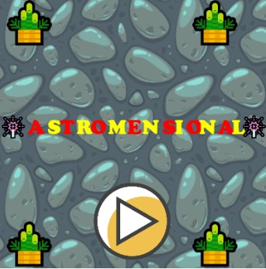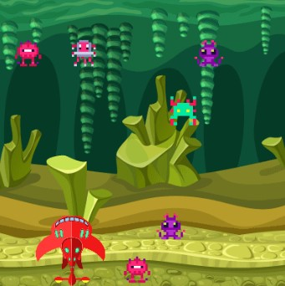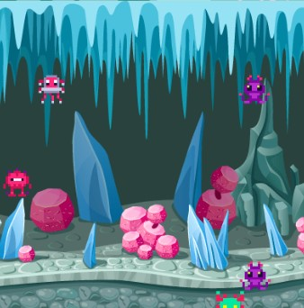

8. How do you plan to make your game engaging?

There are 3 things which I would like to mention here that will make the game more attractive or engaging:-

* There are 5 options from which the user can select any one spaceship.
* The background of the battlefield keeps changing depicting that it is a multi – dimensional war.
* Also, the welcome screen has been assigned some textures which keep changing until the user presses the play button.