

__________________________________________________________

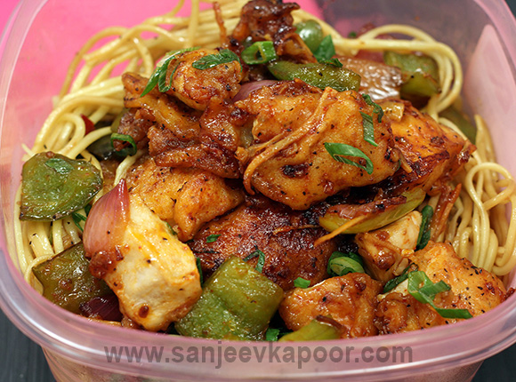INGREDIENTS

**Boneless chicken cut into cubes 400 grams**

**Red chilli powder 1 teaspoon**

**Green chillies halved and slit 2-3**

**Salt to taste**

**Crushed black peppercorns to taste**

**Ginger-garlic paste 1 tablespoon**

**Oil 1 tablespoon + to deep fry**

**Refined flour (Maida) ¼ cup**

**Cornflour/ corn starch ¼ cup + 1 tablespoon**

* + - **Garlic chopped 1 tablespoon**
    - **Onion cut into cubes 1 medium**
    - **Green capsicum diced 1½ medium**
    - **Tomato ketchup 1 tablespoon**
    - **Soy sauce 2 tablespoons**
* **Ginger cut into thin strips 1 inch**
* **Spring onion greens chopped 1-2 stalks**
* **Cooked vegetable noodles for serving**

Method

STEP – 1 **-** Take chicken cubes in a bowl. Add salt,

crushed peppercorns and ginger-garlic paste and

mix well.

STEP – 2 - Heat sufficient oil in a pan.

#### STEP – 3 - Take refined flour in another bowl. Add ¼

#### cup cornflour and some water and whisk well to make

#### a semi-thick slurry.

#### Step - 4 – Dip marinated chicken in the slurry. Slide in

#### hot oil and deep-fry till golden and crisp.

#### Step – 5 – Heat 1 tablespoon oil in a non-stick pan.

#### Add garlic and sauté till golden. Add onion and sauté

#### on high heat for 30 seconds.

#### Step – 6 – Add capsicum and mix. Add fried chicken

#### cubes and mix. Add soy sauce, tomato ketchup, salt,

#### crushed peppercorns and chilli powder and mix well.

#### Step – 7 – Add green chillies and ginger strips and

#### mix well.

#### Step – 8 - Take remaining cornflour in another bowl.

#### Add some water and mix well to make a smooth slurry.

#### Step – 9 - Add slurry to chicken mixture, mix and

#### cook till the mixture thickens. Add spring onion

#### greens, switch off heat and mix.

#### Step – 10 – Put some noodles on a serving plate. Put

#### the dry chilli chicken on top and SERVE HOT :)

#### (: !! ENJOY !! :)