VISVESVARAYA TECHNOLOGICAL UNIVERSITY
Jnana Sangama, Belagavi - 590 018, Karnataka
Project Title
PORT-OPTIMUS: AUTONOMOUS LOGISTICS & ENERGY GRID
A Report submitted in partial fulfillment of the requirements for the Course
Machine Learning Operations
(Course Code: 24AM6AEMLO)
In the Department of
Machine Learning
(UG Program: B.E. in Artificial Intelligence and Machine Learning)
By
Anushka Sinha - (USN: 1BM22AI016)
Semester & Section: VI
DEPARTMENT OF MACHINE LEARNING
B.M.S COLLEGE OF ENGINEERING
(An Autonomous Institute, Affiliated to VTU)
P.O. Box No. 1908, Bull Temple Road, Bengaluru - 560 019
A.Y 2025-26

B.M.S COLLEGE OF ENGINEERING
(An Autonomous Institute, Affiliated to VTU)
P.O. Box No. 1908, Bull Temple Road, Bengaluru - 560 019
DEPARTMENT OF MACHINE LEARNING
CERTIFICATE
This is to certify that Ms. Anushka Sinha bearing USN: 1BM22AI016 has satisfactorily presented the Course - Machine Learning Operations (24AM6AEMLO) with the title "Port-Optimus: Autonomous Logistics & Energy Grid" in partial fulfillment of academic curriculum requirements of the 6th semester UG Program - B.E. in Artificial Intelligence and Machine Learning in the Department of Machine Learning, BMSCE during A.Y. 2025-2026.
It is also stated that the base work and materials considered for completion of the said course are used only for academic purpose and not used in original form anywhere for award of any degree.

Student Signature: _______________________

Signature of the Faculty | Signature of the Head
Faculty Name | Dr. M. Dakshayini
Designation, Dept. of MEL, BMSCE | Prof. & Head, Dept. of MEL, BMSCE
External Examination
Examiner Name and Signature:
1. ___________________________
2. ___________________________

DECLARATION
I, Ms. Anushka Sinha bearing USN: 1BM22AI016, hereby declare that the project titled "Port-Optimus: Autonomous Logistics & Energy Grid" is an original work carried out by me. The work presented in this report has not been submitted elsewhere for any other degree, diploma, or certification.
I declare that all references and sources used in the report have been properly acknowledged and cited. No part of this report has been copied, plagiarized, or reproduced from another work without proper attribution.
Anushka Sinha - (USN: 1BM22AI016)

ACKNOWLEDGEMENT
I would like to express my deepest gratitude and sincere thanks to my faculty in the Department of Machine Learning, Bengaluru, for their keen interest and encouragement in guiding me and bringing the work to reality.
I am grateful to Dr. M. Dakshayini, Professor and Head, Department of Machine Learning, Bengaluru, for her valuable suggestions and advice throughout the work period.
I express my profound gratitude to the Hon'ble Management and Dr. Bheemsha Arya, Principal, BMSCE, Bengaluru, for providing the necessary facilities and an ambient environment to work.
I would like to thank all the staff of the Department of Machine Learning for their support and encouragement during the course of this project.
Last but not least, I thank my parents, family, and friends, without whose help and encouragement this work would have been impossible.
Anushka Sinha - (USN: 1BM22AI016)

ABSTRACT
Port-Optimus is a reinforcement learning and MLOps project for autonomous port logistics. The system simulates ship queues, electricity prices, battery level, truck availability, congestion, solar input, and safety risk. A granular Q-learning agent learns whether to perform Rapid Discharge, Buffered Move, or Idle/Charge operations.
The GitHub repository contains the simulator, training engine, MLOps logging module, Streamlit dashboard, FastAPI endpoint, Docker setup, GitHub Actions workflow, DVC scaffolding, deployment configuration, experiment logs, model artifact, and visual report assets. The project demonstrates a clean academic MLOps pipeline with reproducible training and dashboard-based evidence.
Results show improved throughput, lower wait penalty, and better safety behavior than a fixed baseline across normal and stressed port scenarios. The project maps to SDG 9, SDG 11, and SDG 12.

TABLE OF CONTENTS
CH. NO. | TITLE | PAGE NO.
 | Certificate | ii
 | Declaration | iii
 | Acknowledgement | iv
 | Abstract | v
1 | Introduction | 1
2 | System Architecture | 3
3 | Tools, MLOps and GitHub Evidence | 5
4 | Implementation, Testing and Results | 8
 | Conclusion and Future Work | 12
 | Rubric-Based Evaluation | 13
 | References | 14
 | Appendix A: SDG Mapping | 15

LIST OF FIGURES
Figure No. | Description | Page No.
2.1 | Port-Optimus architecture diagram | 3
3.1 | GitHub repository structure screenshot | 6
3.2 | GitHub Actions workflow runs screenshot | 7
3.3 | GitHub branches screenshot | 7
4.1 | Training workflow diagram | 8
4.2 | Metrics comparison chart | 9
4.3 | Streamlit dashboard screenshot | 10
4.4 | Core code evidence screenshots | 11

LIST OF ABBREVIATIONS
Abbreviation | Expansion
AI | Artificial Intelligence
API | Application Programming Interface
CI/CD | Continuous Integration / Continuous Deployment
DVC | Data Version Control
MLOps | Machine Learning Operations
RL | Reinforcement Learning
SDG | Sustainable Development Goal

CHAPTER 1 - INTRODUCTION

1.1 Background
Smart ports must coordinate ship queues, container movement, electric trucks, battery storage, grid prices, and congestion. A fixed dispatch rule is easy to implement but cannot adapt deeply when operating conditions change. Reinforcement learning is suitable because the agent can learn decisions through repeated interaction with a simulated port.

1.2 Problem Statement
Design an autonomous decision system that selects the best port action each hour: process containers rapidly, move them through an efficient buffer, or wait and charge. The solution must improve throughput while controlling energy cost, wait penalty, and safety risk.

1.3 Objectives
- Build a custom port simulation environment with queue, price, battery, trucks, hour, congestion, and solar input.
- Train and evaluate a Q-learning agent against a fixed baseline policy.
- Track experiment metadata, model path, and metrics for reproducibility.
- Provide a Streamlit dashboard, FastAPI endpoints, Docker setup, and GitHub Actions workflow.
- Document GitHub evidence, screenshots, results, rubric score, and SDG alignment.

1.4 Methodology
- Generate simulated 24-hour port episodes.
- Discretize the five-feature state vector.
- Train the Q-learning policy with epsilon-greedy exploration and decay.
- Compare RL performance with the baseline across normal and stress scenarios.
- Log results in metadata.json and results.csv and present evidence through dashboard/screenshots.

CHAPTER 2 - SYSTEM ARCHITECTURE
The architecture has five practical layers: simulation, learning engine, MLOps logging, service/dashboard layer, and repository automation. The simulator produces state transitions and rewards. The RL engine learns the dispatch policy. The MLOps layer records runs and metrics. Streamlit and FastAPI expose the system, while Docker and GitHub Actions support repeatability.
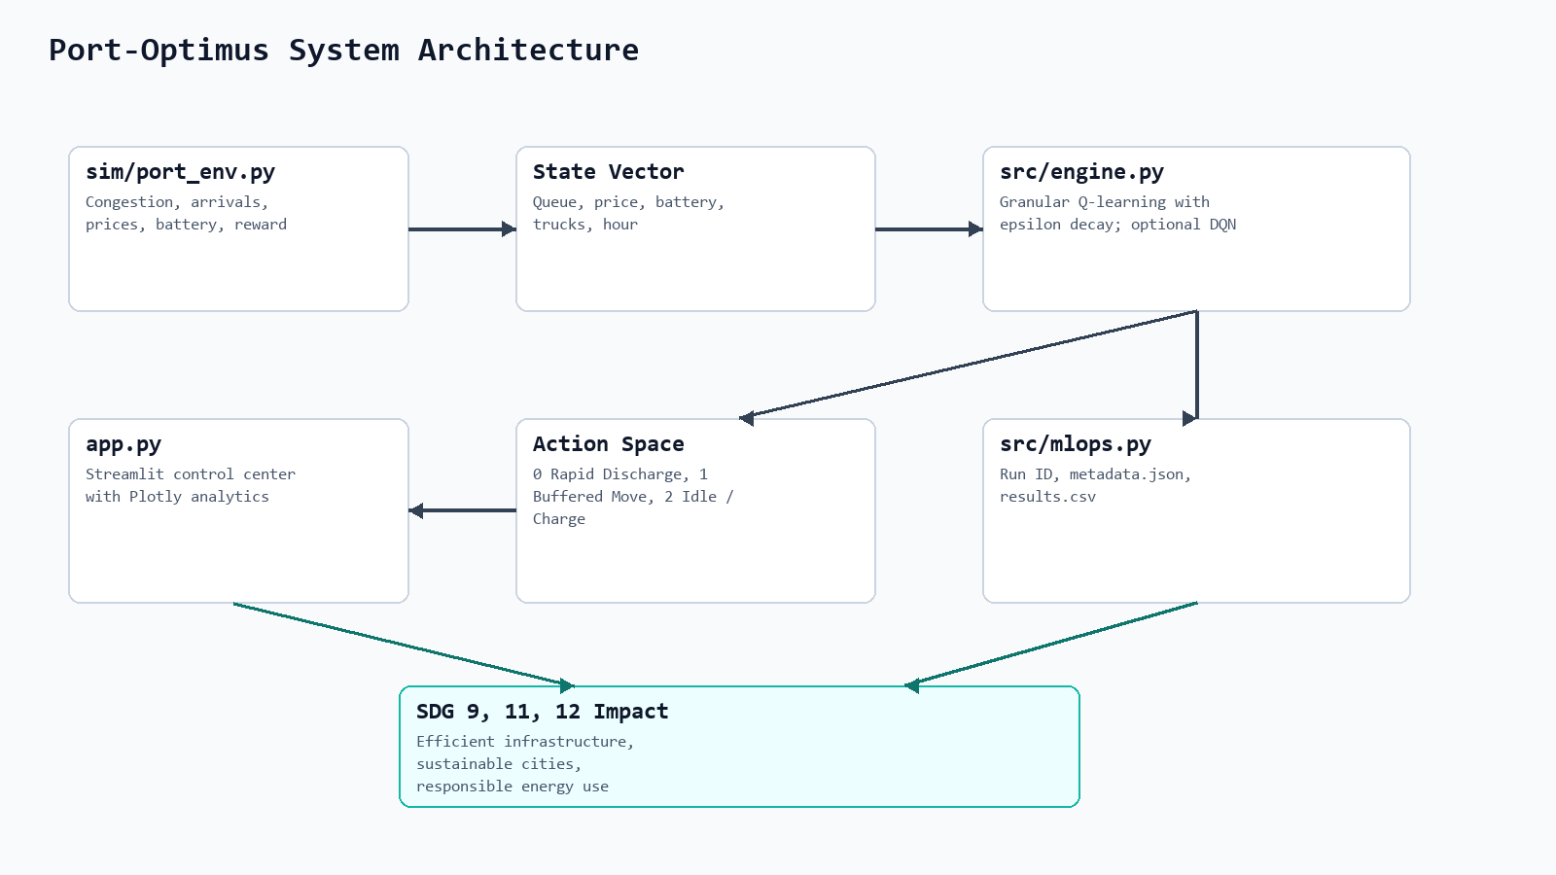
Figure 2.1: Port-Optimus architecture diagram.

2.1 Core Design
Design Element | Implementation | Purpose
State | Queue, price, battery, trucks, hour | Represents current port operating condition.
Actions | Rapid Discharge, Buffered Move, Idle/Charge | Controls throughput and energy behavior.
Reward | Processed units - energy cost - wait penalty | Balances productivity and sustainability.
Model | Granular Q-learning | Learns adaptive action values.
Baseline | Fixed human-style policy | Provides comparison benchmark.

2.2 Repository Modules
Module / File | Role
sim/port_env.py | Simulation, state transitions, reward, metrics.
src/engine.py | Q-learning agent, optional DQN, model save/load.
src/mlops.py | Run ID generation, metadata logging, CSV results.
src/train_port_optimus.py | Training and evaluation entry point.
app.py | Streamlit dashboard and analytics.
api.py | FastAPI service endpoints.
Dockerfile / docker-compose.yml | Containerized dashboard execution.
.github/workflows/train.yml | CI training and artifact upload.

CHAPTER 3 - TOOLS, MLOps AND GITHUB EVIDENCE

3.1 Modern Tools Used
Tool | Use | Evidence
Python, NumPy | Simulation and Q-learning implementation. | sim/ and src/ modules.
Streamlit, Plotly | Dashboard, radar chart, heatmap, live simulation. | app.py.
FastAPI, Uvicorn | API endpoints for prediction and metrics. | api.py.
GitHub Actions | Automated train workflow and artifact upload. | .github/workflows/train.yml.
Docker Compose | Portable dashboard deployment. | Dockerfile, docker-compose.yml.
DVC | Scaffold for model/experiment tracking. | .dvc, .dvcignore.
GitOps config | Versioned deployment metadata. | config/deployment.yaml.

3.2 GitHub Repository Evidence
The following screenshots were captured directly from the GitHub repository at high resolution to show repository structure, CI workflow history, and branch organization.
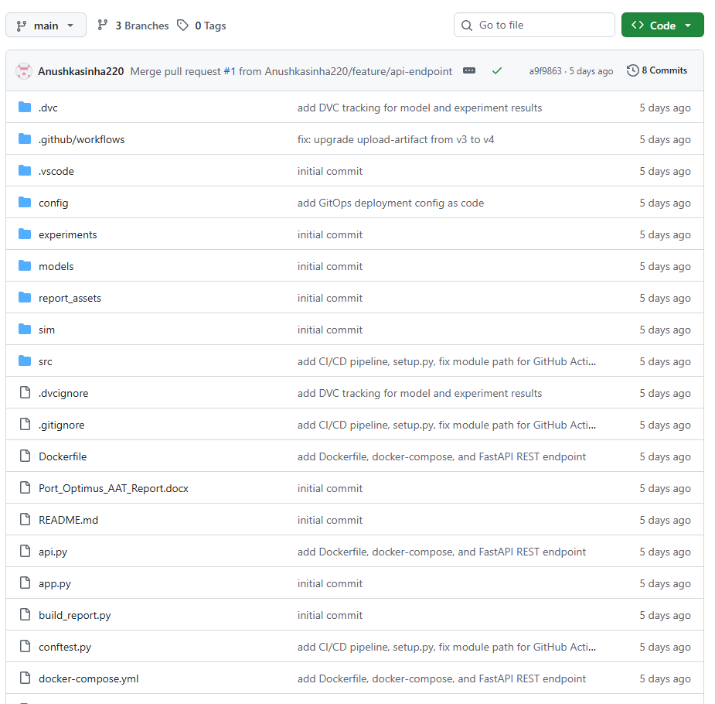
Figure 3.1: GitHub repository structure with DVC, config, experiments, models, src, sim, Docker, and API files.
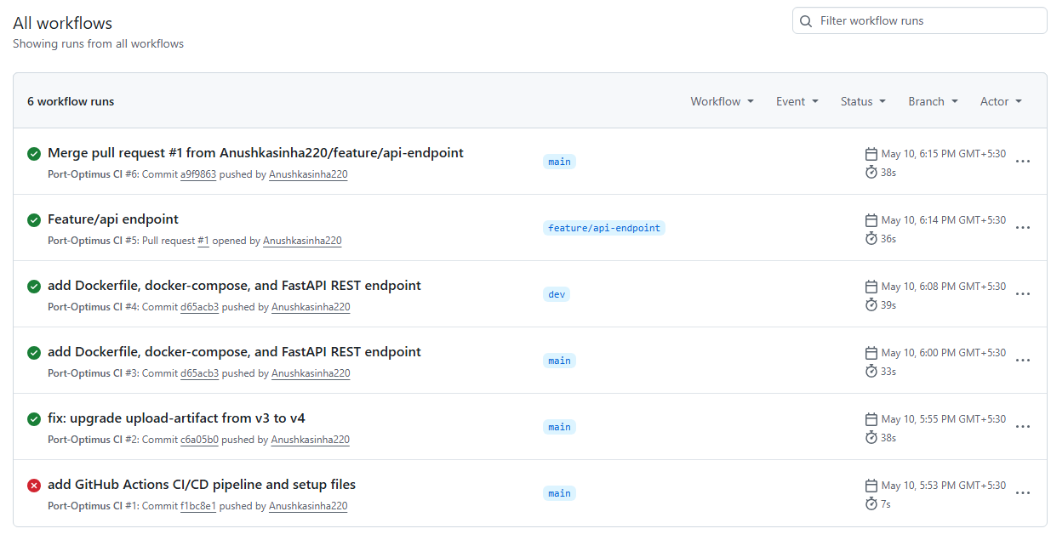
Figure 3.2: GitHub Actions workflow runs showing CI execution history.
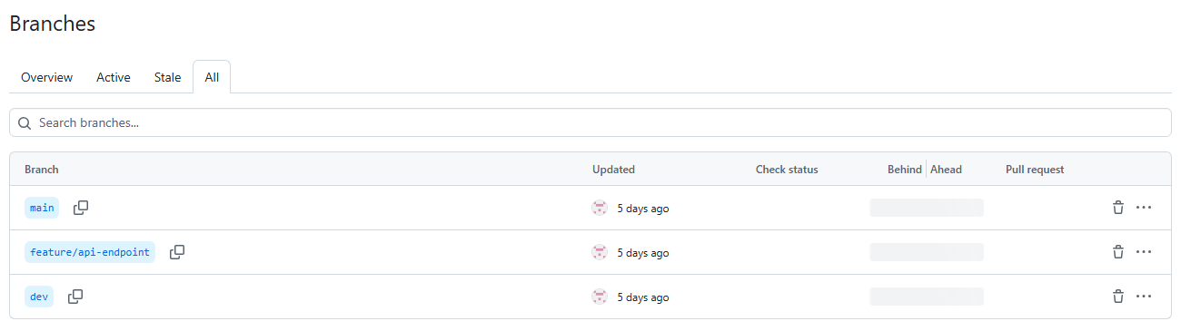
Figure 3.3: Branches view showing main, feature/api-endpoint, and dev branches.

CHAPTER 4 - IMPLEMENTATION, TESTING AND RESULTS

4.1 Implementation Summary
The implementation follows a compact MLOps loop: simulate port operations, train the RL policy, evaluate against a baseline, log experiment artifacts, expose results through a dashboard/API, and automate training through GitHub Actions.
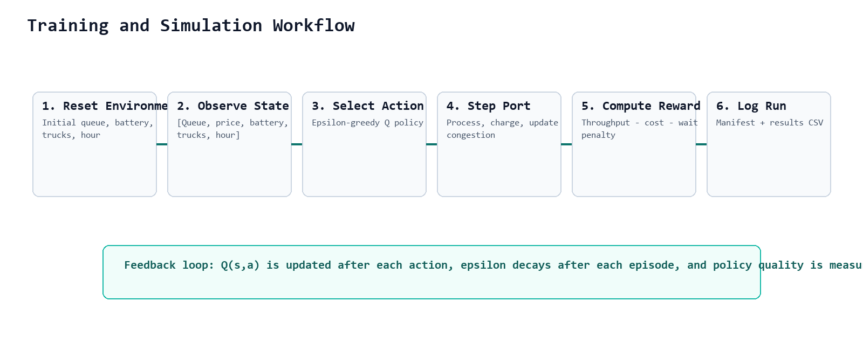
Figure 4.1: Training and simulation workflow.

4.2 Results
Scenario | RL Eff. | Base Eff. | RL Throughput | Base Throughput | Throughput Gain
Normal | 0.345 | 0.318 | 2.883 | 2.121 | 35.93%
Storm | 0.352 | 0.295 | 2.865 | 1.558 | 83.89%
Peak Season | 0.277 | 0.22 | 2.29 | 1.627 | 40.75%
Storm + Peak | 0.295 | 0.235 | 2.079 | 1.346 | 54.46%
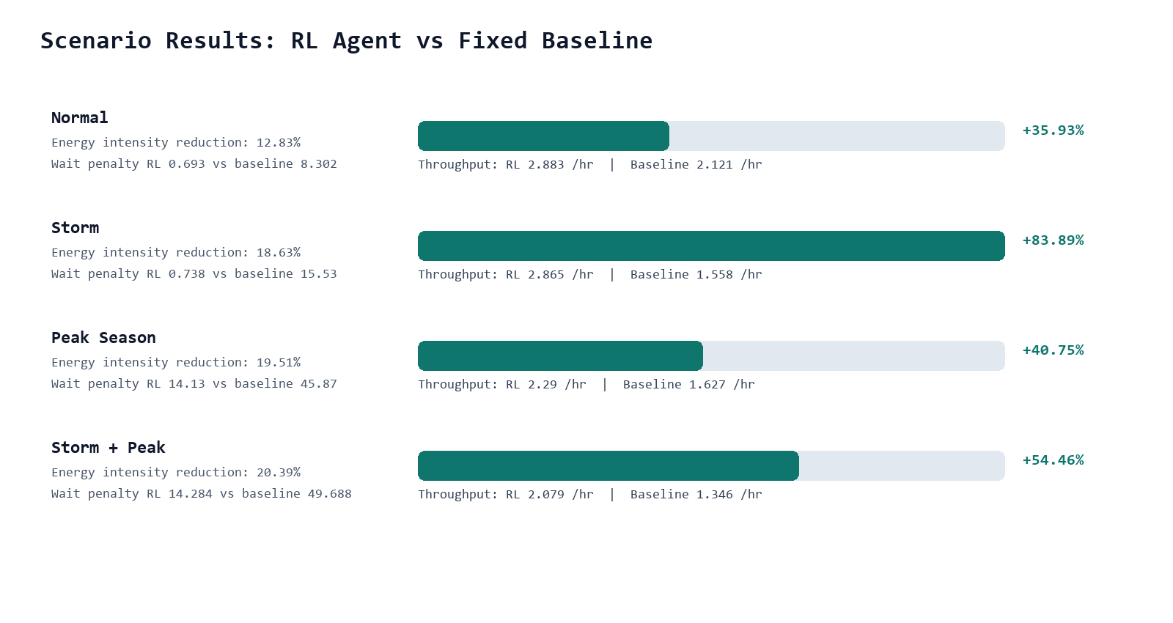
Figure 4.2: Scenario metrics comparison.
Experiment Evidence
experiments/results.csv contains 10 logged runs. The latest run ID visible in the local file is ALPHA-2026-010 with stress test Storm.

4.3 Dashboard and Code Evidence
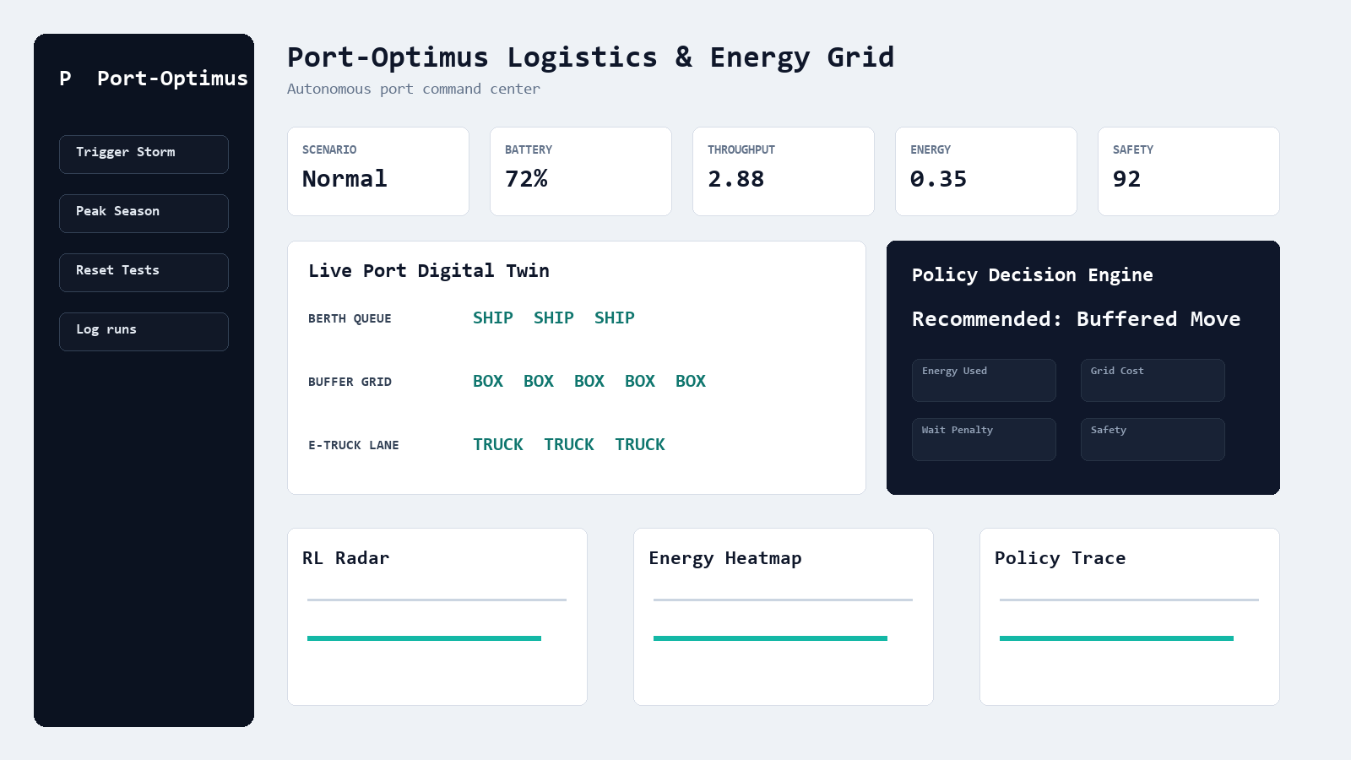
Figure 4.3: Streamlit dashboard screenshot.
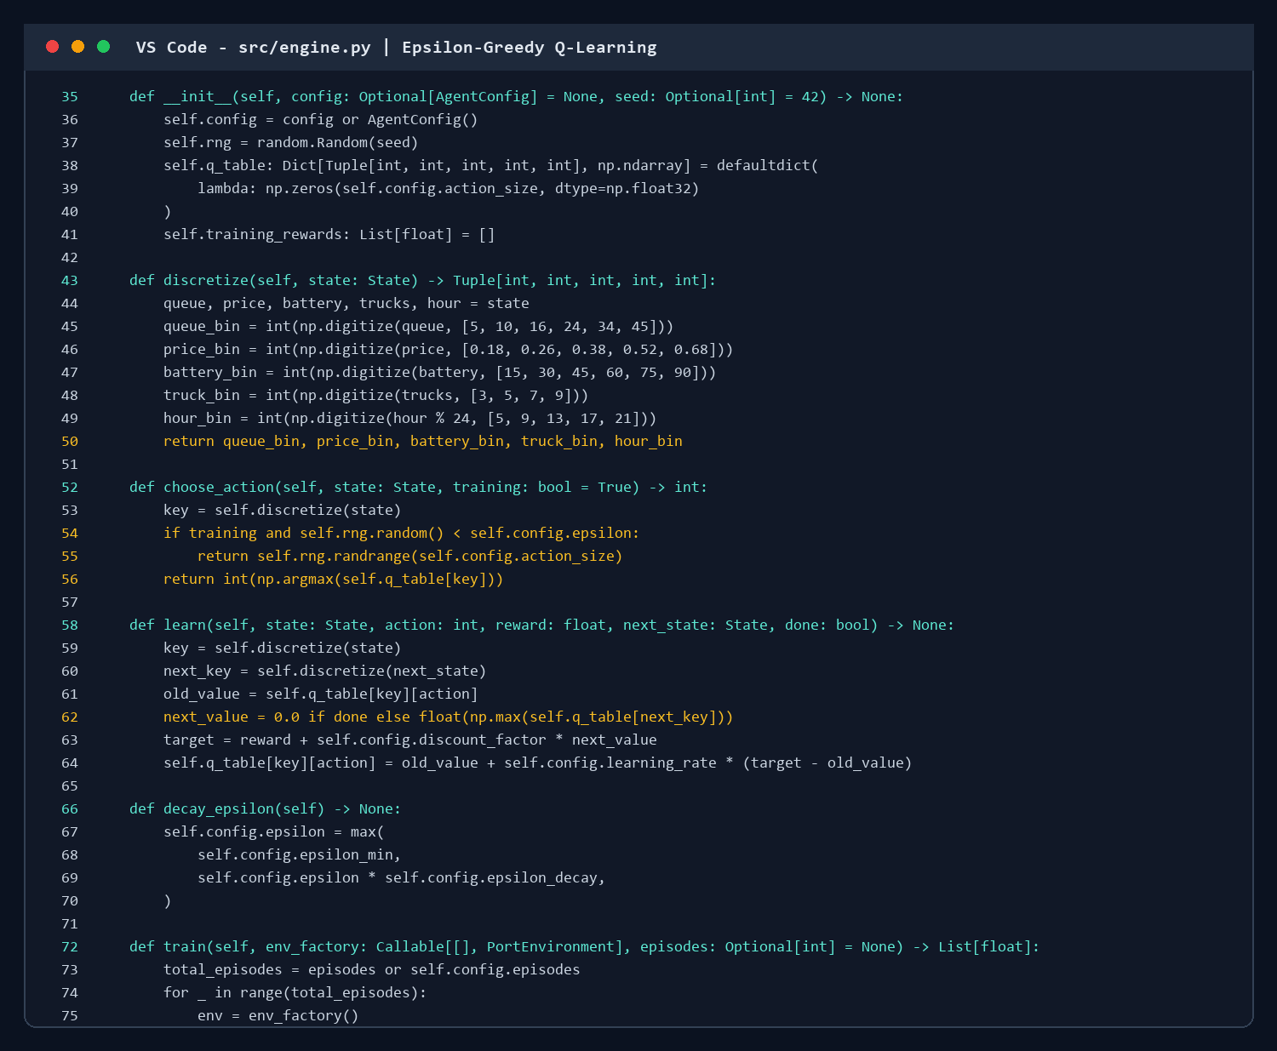
Figure 4.4: RL engine code evidence.
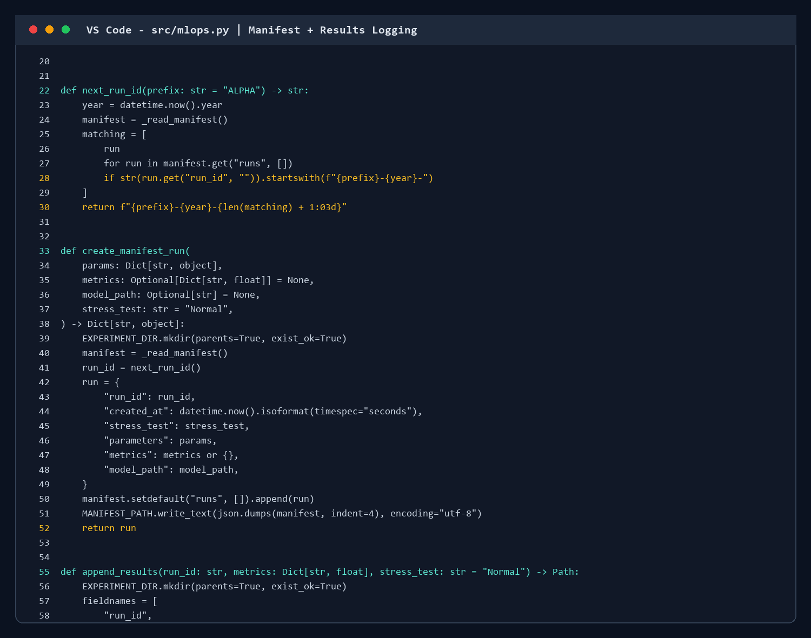
Figure 4.5: MLOps logging code evidence.

4.4 Testing and Limitations
Check | Status | Observation
Simulation smoke run | Passed | Environment produces complete metrics.
Short Q-learning run | Passed | Agent training/evaluation path executes.
GitHub Actions | Configured | Train workflow and artifact upload present.
Formal pytest suite | Needs work | conftest.py exists; dedicated tests should be added.

CONCLUSION AND FUTURE WORK
Port-Optimus is a clean academic MLOps project that connects reinforcement learning, experiment logging, dashboard visualization, API serving, CI automation, Docker deployment, DVC scaffolding, and GitHub-based collaboration evidence. The project demonstrates measurable improvement over a fixed baseline and presents a strong foundation for production-style ML operations.

Future Work
- Add a complete pytest suite for simulator, agent, API, and dashboard logic.
- Integrate MLflow for experiment tracking and model registry.
- Use a real DVC remote for versioned models, metrics, and generated artifacts.
- Add production monitoring for drift, action distribution, latency, and safety degradation.
- Extend GitOps from deployment YAML to full environment sync and rollback.

RUBRIC-BASED EVALUATION
Criteria | Evidence | Score | Remark
Problem Analysis & Design | Clear RL problem, constraints, architecture, SDG mapping. | 23/25 | Strong and well documented.
MLOps Automation | CI, Docker, custom logging, API, dashboard, DVC scaffold. | 19/25 | Good; MLflow/monitoring can improve.
Git & GitOps | Repo branches, PR, workflow runs, deployment YAML. | 21/25 | Clear GitHub evidence added.
Viva/Team Work | Coherent demo and explanation-ready report. | 18/25 | Depends on presentation.
Overall Score
Provisional score: 81/100. Main improvement areas: formal tests, MLflow registry, stronger monitoring, and complete GitOps deployment.

REFERENCES
- GitHub repository: https://github.com/Anushkasinha220/Port.git.
- Sutton, R. S., and Barto, A. G. Reinforcement Learning: An Introduction. MIT Press.
- Streamlit documentation: https://docs.streamlit.io/.
- FastAPI documentation: https://fastapi.tiangolo.com/.
- GitHub Actions documentation: https://docs.github.com/actions.
- Docker documentation: https://docs.docker.com/.
- DVC documentation: https://dvc.org/doc.
- United Nations Sustainable Development Goals documentation.

APPENDIX A: SUSTAINABILITY DEVELOPMENT GOALS (SDGs-Mapped)

SDG 9 - Industry, Innovation and Infrastructure
The project applies AI automation and MLOps to port infrastructure, showing how intelligent systems can improve industrial decision-making.

SDG 11 - Sustainable Cities and Communities
Smarter port dispatch reduces queue pressure and supports cleaner city-connected logistics.

SDG 12 - Responsible Consumption and Production
The reward design discourages wasteful high-cost energy use while maintaining operational throughput.

