PRATAP AI INNOVATIONS
Content Pipeline
The Operating Bible
Strategy, Operating Model & Build Approach

Purpose: The single source of truth for how Pratap AI turns expertise, founder perspective, customer questions, client work, and market signals into a consistent, lead-generating content engine.
Core principle: This is not a “post everywhere” machine. It is a content-to-pipeline engine.
Primary goal: Move qualified business owners, founders, and operators closer to an AI Readiness Call.
Audience: Founder, content operator, marketing, development, and automation teams.
Status: v3 — governing reference. Supersedes v1 and v2.

How to Use This Document
This is the governing reference for the content system. When a decision about content comes up — what to post, where, how risky it is, who approves it — the answer should be found here. Three rules keep it useful:
- The ICP section governs everything. Section 3 defines who we are for. Every topic, every post, every CTA is checked against it. If content doesn’t serve the ICP, it doesn’t ship.
- The approval lanes are non-negotiable. Section 9 defines what publishes automatically and what needs a human. When in doubt, escalate a lane — never downgrade one.
- It stays one document until it needs to split. This is the complete picture. Deeper specs (a technical build spec, a weekly operator playbook) are carved out of this later — but this remains the spine they reference.

THE PIPELINE IN ONE LINE
Research → Topic Scoring → Weekly Calendar → Anchor Content → Platform Repurposing → Quality Check → Approval / Auto Queue → Publishing → Lead Capture → Performance Review → back to Research

Contents

1. Executive Summary
The content system exists to do three things consistently:
- Build authority around practical AI and automation for businesses.
- Create trust through founder-led insight, useful education, and proof-based case studies.
- Generate qualified leads for AI Readiness Calls.

The pipeline runs in a continuous loop, and four changes define this version of the system:
The change | Why it matters
Approval-gated first, not auto-publish | Protects the brand. We learn what works under review, then automate only safe, proven templates.
Pratap-specific content pillars | Replaces the vague 33/33/33 split with pillars tied to what we actually sell.
Anchor-first content | One strong asset is built, then repurposed across platforms — sustainable volume without burnout.
ICP as the governing layer | Who we serve is elevated to the top of the system and checked at every stage.

THE ONE BIG SHIFT FROM EARLIER VERSIONS
Do not start by auto-publishing everything. Begin with approval-gated publishing, learn what works, then automate safe repeatable templates later. This protects the brand while still letting the system scale.

2. The Big Picture

2.1 What the system is meant to do
Turn Pratap AI’s expertise into a steady content engine that:
- Attracts business owners and operators.
- Educates them on practical AI use cases.
- Shows proof and implementation thinking.
- Builds trust in Pratap AI’s approach.
- Captures leads through soft CTAs.
- Feeds qualified conversations into the sales process.

2.2 The content philosophy
Every post must answer at least one of these questions. If it answers none, it doesn’t ship.
- Does this attract our ideal customer?
- Does this build trust in Pratap AI?
- Does this teach something useful?
- Does this connect to an offer or next step?
- Can this be repurposed?
- Can we support the claim with proof?

The full pipeline, end to end:
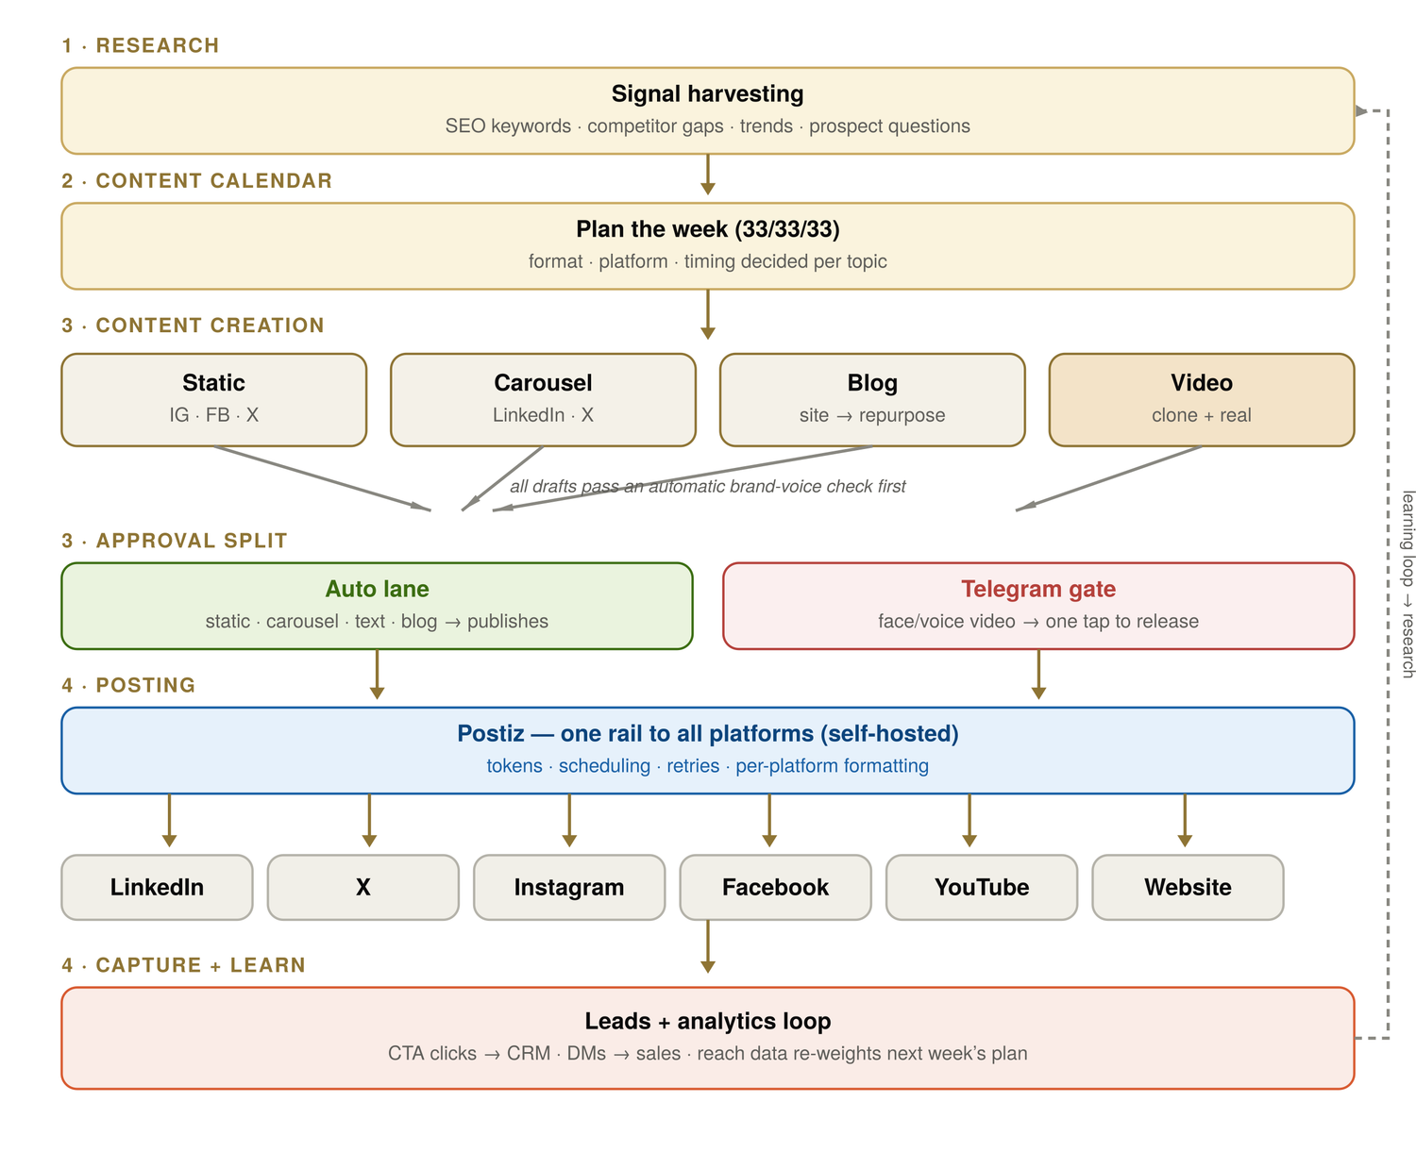
Figure 1 — The full pipeline, end to end. Every stage loops back into research.

THE GOVERNING SECTION

3. Ideal Customer Profile (ICP)
READ THIS BEFORE ANYTHING ELSE
The ICP is the spine of the entire content system. Every topic, post, hook, and CTA is checked against it. If a piece of content does not serve the people defined here, it does not ship — no matter how good it looks.

3.1 Two layers — used differently
We define two ICP layers. They are not two voices. We research both, but we write almost everything in the Primary voice. This protects the brand from drifting into the enterprise language we deliberately avoid.
Layer | What it is | How we use it
Primary ICP | Founder-led SMEs and service businesses with manual workflows. | The default voice. ~85% of content speaks directly to this layer.
Aspirational ICP | Larger SMEs, 100–500 employees, $2M–$20M, multiple teams. | Informs research and a few strategic posts — never the default tone.

The voice guardrail: the Aspirational layer brings in words like “governance,” “ROI and risk,” and “process mapping.” Those are research inputs, not our publishing voice. We do not serve enterprises, and our content should never sound like we do.

3.2 Primary ICP — who they are
Founder-led SMEs and service businesses that:
- Have manual workflows.
- Depend heavily on founder or operator memory.
- Use spreadsheets, WhatsApp, CRMs, and scattered tools.
- Know AI can help but do not know where to start.
- Want practical systems, not complex enterprise transformation.

The people we write for
Role | What they care about
Founder / Owner | Growth, control, speed, and visibility.
CEO / Managing Director | Efficiency, delegation, and better systems.
Operations Head | Process clarity, automation, and accountability.
Sales Head | Lead capture, follow-up, and CRM discipline.
Marketing Head | Content consistency and campaign execution.
Real Estate Operator | Lead flow, client follow-up, property data, team coordination.

3.3 Aspirational ICP — the stretch layer
Larger SMEs and growing companies that may have 100–500 employees, $2M–$20M revenue, multiple teams, and existing CRMs or ERPs. Content aimed here can sound more strategic — AI readiness, data readiness, workflow automation, internal tools — but it stays in our practical, founder-led register. We do not adopt procurement-speak to reach them.

3.4 Audience pain points → content angles
This table is the bridge from the ICP to the work. Each pain is a content angle waiting to be written.
Pain they feel | Content angle we own
Our work is scattered across too many tools. | Company OS / dashboard content.
We want AI but don’t know where to start. | AI readiness content.
Our team wastes time on repetitive tasks. | Automation workflow content.
Leads are falling through the cracks. | CRM + follow-up automation.
Our content is inconsistent. | AI-assisted content pipeline.
We have no visibility into operations. | Reporting and dashboards.
We tried tools but nothing connected. | Systems integration and workflow design.

4. Core Strategy

4.1 The main business goal
The content system generates qualified conversations that lead to AI Readiness Calls. The main metric is not impressions. It is:
Qualified conversations started.

Secondary metrics: website visits from content, CTA clicks, form submissions, DMs/comments with buying intent, discovery calls booked, email subscribers, and repeat engagement from target accounts.

4.2 The named offer
The primary offer remains the AI Readiness Call — a practical diagnostic for business owners who want to understand where AI saves time, which workflows to automate first, what systems are scattered, what data or process gaps need fixing, and what a simple AI roadmap looks like.
POSITIONING LINE
“We help founders identify the first 3–5 AI workflows worth automating — without overbuilding, overhiring, or adding unnecessary complexity.”

4.3 Funnel stages
Every content idea maps to one funnel stage, so the calendar always has a balance of reach and conversion.
Stage | Content job | Example
Awareness | Get the right people to notice Pratap AI. | 3 workflows every SME should automate first.
Education | Help them understand the problem and opportunity. | What an AI Readiness Audit actually checks.
Trust | Show Pratap AI’s thinking and credibility. | Founder lessons and behind-the-scenes build notes.
Consideration | Help buyers compare options and evaluate fit. | AI agency vs SaaS tool vs internal hire.
Conversion | Move serious prospects to a call. | Case studies, offer pages, workflow teardowns.
Retention | Educate existing clients and deepen value. | How-to guides, onboarding content, walkthroughs.

5. Content Pillars
v1 used Authority / Technical / Story — too vague. An earlier draft expanded to six pillars plus a separate five-way mix, which was too much to hold in one head and didn’t map cleanly. This version consolidates to four pillars, each with its own share of the mix — one clean taxonomy the calendar runs on.

Pillar | Share | Purpose | Example topic
Practical AI for Operators | 35% | Teach practical AI and automation use cases. | 3 workflows every SME should automate first.
Proof & Use Cases | 25% | Show credibility with real client work and systems. | How document processing went from hours to minutes.
Founder Build Notes | 25% | Humanize the brand; build trust in public. | What we learned building our own content pipeline.
AI Readiness & Offer | 15% | Prepare buyers and drive the call. | The 7 signs your business is ready for AI automation.

Note on trends: timely trend/opinion content is not its own pillar — it’s a lens applied within the four above, so we stay relevant without chasing news that doesn’t serve the ICP.

5.1 What to avoid
- Generic AI news with no business angle.
- Overhyped “AI will replace everyone” content.
- Pure motivational founder content with no business lesson.
- Tool listicles with no implementation insight.
- Case studies with invented or unsupported numbers.
- Posting the same copy everywhere.

6. Research Engine
Goal: never create from a blank page. The research engine runs weekly and produces a ranked list of topics, so creation always pulls from a queue.

6.1 Research sources
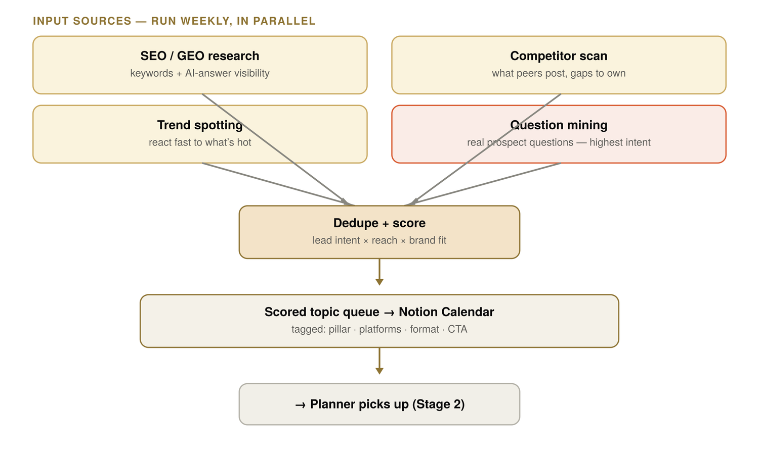
Figure 2 — Research: sources feed a scored, ranked topic queue.
Source | What it finds | Why it matters
SEO / GEO research | Google keywords and AI-search questions. | Long-term discovery.
Competitor scan | What AI agencies, consultants, and SaaS brands discuss. | Gaps and proven formats.
Trend spotting | Current AI/business topics on LinkedIn and X. | Timely posts.
Question mining | Real questions from comments, DMs, calls, WhatsApp. | Highest lead intent.
Reddit / community | Real pain points in business communities. | Unfiltered customer language.
Internal build notes | What Pratap AI is building internally. | Authentic founder content.
Client work | Real workflow problems and outcomes. | Proof and use-case content.

6.2 Question mining is the unfair advantage
A real question from a prospect is the strongest possible content signal — someone with money already told us their problem.
Prospect question | Content idea it becomes
Where should we start with AI? | The first 5 workflows to check in an AI Readiness Audit.
Can AI help with follow-ups? | How AI stops leads from slipping through the cracks.
Will this replace my team? | AI should remove repetitive work, not judgment.
How much does automation cost? | Why the first automation should be small and boring.

6.3 Reddit — research, not promotion
Reddit is for research, question mining, and helpful non-promotional participation. It is not an automated posting channel. Suggested communities: r/smallbusiness, r/Entrepreneur, r/SaaS, r/startups, r/RealEstateTechnology, r/marketing, r/sales, r/ArtificialIntelligence, r/automation.
Rule: answer the question first, never spam links, disclose affiliation when relevant. Reddit’s job is to discover real problems and the words customers use — not to sell.

7. Topic Scoring System
Scoring decides what gets made. It turns the research pile into a ranked queue and quietly enforces our honest-numbers rule — a topic we can’t prove scores lower and falls away.
THE FORMULA
Score = Lead intent × Reach potential × Brand fit × Proof available × Repurposing potential
Score each factor 1–5.

Factor | The question it asks
Lead intent | Is this close to a problem people pay to solve?
Reach potential | Is the topic likely to spread or get engagement?
Brand fit | Does it fit our practical, premium, founder-led voice?
Proof available | Do we have a real example, metric, screenshot, or experience?
Repurposing potential | Can this become blog + LinkedIn + X + carousel + email?

7.1 Priority bands
Total score | Action
20–25 | High priority — build this week.
15–19 | Good candidate — queue it.
10–14 | Use only if timely.
Below 10 | Drop or save for later.

7.2 Worked examples
Topic | I | R | B | P | Rp | Verdict
3 workflows every SME should automate first | 5 | 4 | 5 | 3 | 5 | High
AI agents will replace managers | 2 | 5 | 2 | 1 | 3 | Low
How we built our own content pipeline | 4 | 4 | 5 | 5 | 5 | High
What is AI readiness? | 5 | 3 | 5 | 4 | 5 | High
10 AI tools every founder needs | 2 | 4 | 3 | 1 | 4 | Medium

8. Content Calendar
Goal: turn the ranked queue into a weekly plan that is the single source of truth for everyone and every agent.

8.1 Calendar fields
Each row in the calendar carries: Date, Topic, Pillar, Funnel Stage, Platform, Format, Hook, CTA, Proof Needed, Risk Level, Approval Status, Postiz Status, and Performance.

8.2 Anchor-first content model
This is the engine of sustainable volume. Don’t create disconnected posts. Build one strong anchor asset first — a blog, founder essay, case study, workflow teardown, or video — then repurpose it everywhere.
Example — anchor topic: “3 workflows every SME should automate first.”
Platform | Repurposed form
Blog | Full SEO article (the anchor).
LinkedIn | Founder-led practical post.
X / Twitter | 7-part thread.
Instagram | 6-slide carousel.
Facebook | Warm educational post.
Reddit | Helpful answer to a relevant question.
Email | Short newsletter.
YouTube Short | 45-second script.

9. Content Creation System

9.1 Creation stages
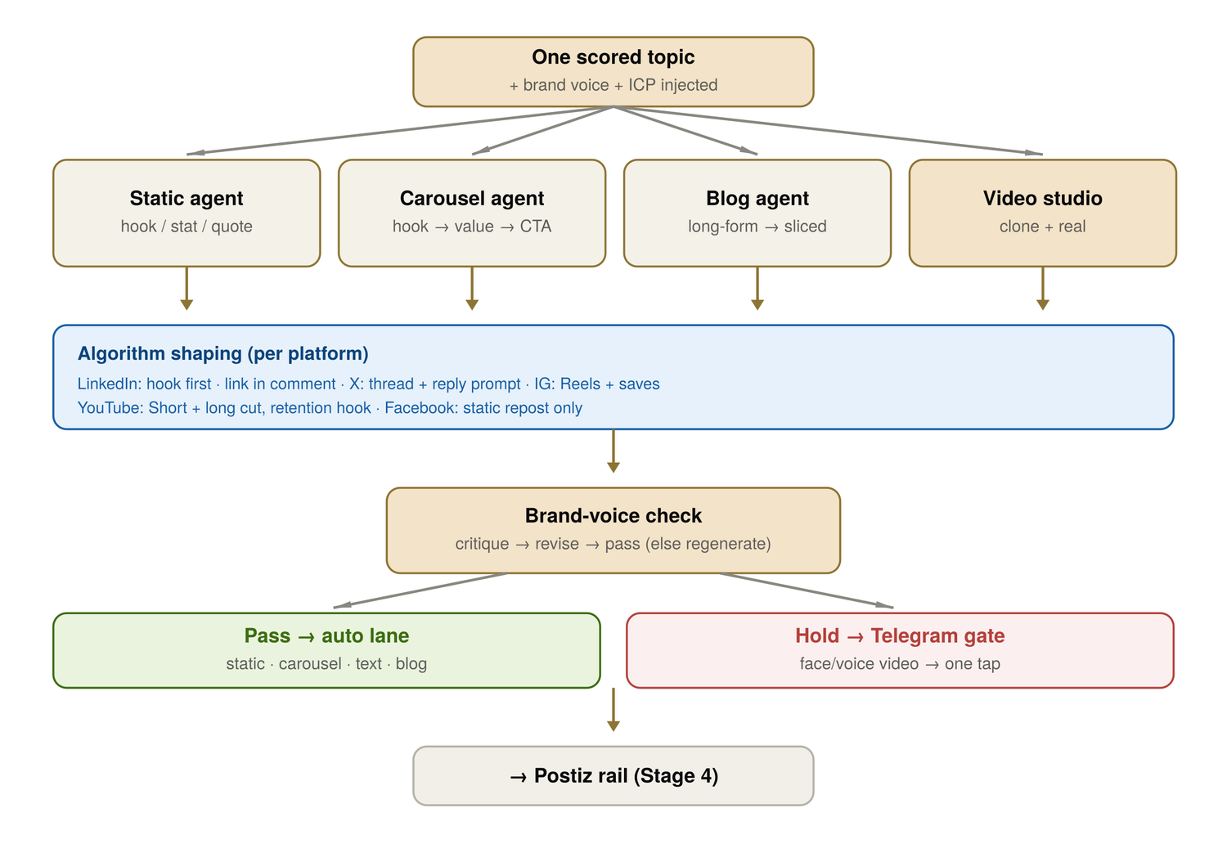
Figure 3 — Creation: one anchor topic fans into platform-native assets, all quality-checked.
Topic selected → brief generated → draft created → platform adaptation → visual direction → quality check → risk check → approval or auto queue.

9.2 Content agents
Each format has an agent. Every agent receives the same inputs: the topic, the ICP, and the brand voice rules. Default approval lane is set per agent (see Section 10).
Agent | Produces | Default lane
Blog / SEO Agent | Website articles, guides, FAQs. | Review
LinkedIn Agent | Founder-led posts and carousels. | Review
X Agent | Threads and short posts. | Auto / Review
Instagram Agent | Carousels, Reels scripts, captions. | Review
Static Creative Agent | Quote cards and stat graphics. | Auto (if template-based)
Video Studio | Talking-head, AI clone, Shorts. | Sensitive (founder)
Reddit Assistant | Helpful, community-safe answers. | Review / Sensitive
Email / Nurture Agent | Newsletter and follow-up content. | Review

9.3 Content brief template
Every piece starts from a brief: Topic, Pillar, Funnel stage, Target audience, Platform(s), Format, Core angle, Hook, CTA, Proof available, Risk level, Approval required, Key points, Source material, Draft direction, Tone, Visual style, Length, and Repurposing plan.

CRITICAL CONTROL

10. Approval & Risk System
This is the most important control in the system, and the biggest change from v1. v1 had two lanes (auto vs face/voice). That was too blunt — a brand-new positioning post or a client-results claim carries real risk even with no face in it. v2 uses three lanes. When in doubt, escalate a lane. Never downgrade one.

10.1 The three lanes
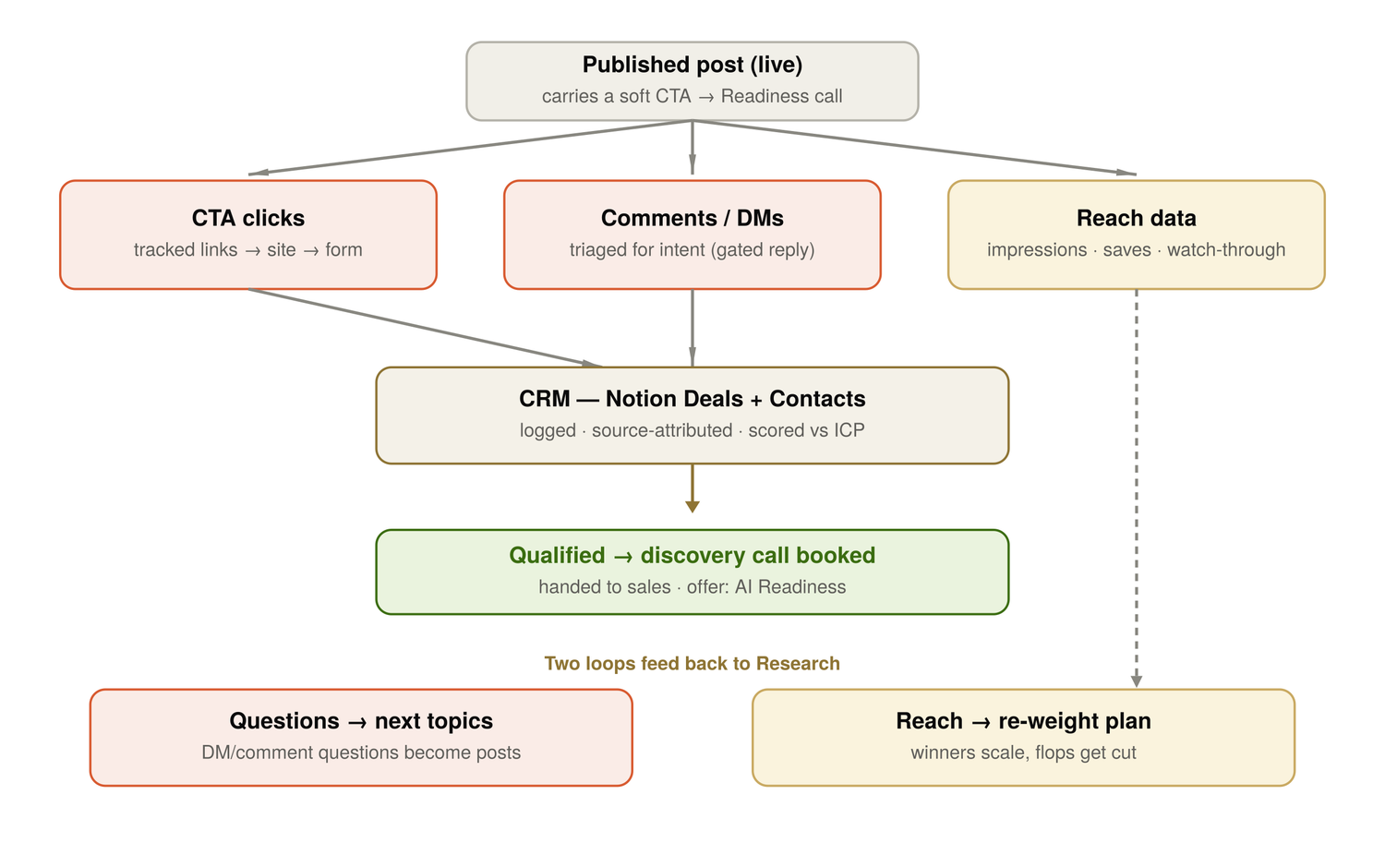
Figure 4 — Approval lanes and the lead-capture loop.
Lane | What goes here | Approval
Safe Auto | Template quote cards, repurposed approved content, simple reminders. | Auto after quality check.
Review | New LinkedIn posts, blogs, carousels, offer content, new positioning. | Batch approval.
Sensitive | Face/voice, client claims, metrics, controversial opinions, case studies. | Founder approval required.

10.2 Risk levels
Risk | Examples | Action
Low | Approved quote reused as graphic, generic tip, carousel from approved blog. | Auto queue.
Medium | New educational post, blog article, carousel, founder perspective. | Batch review.
High | Client results, revenue claims, face/voice, strong opinion, competitor comparison. | Founder approval.

10.3 Quality checklist
Before anything publishes:
- Brand voice — calm, practical, premium, no hype.
- Specificity — concrete examples, not vague claims.
- Proof — metrics and claims are supported.
- Audience fit — speaks to founders/operators/SMEs (check against Section 3).
- CTA — clear next step or soft action.
- Platform fit — native to the platform.
- Risk classification — correct approval lane.
- Formatting — clean, readable, no broken links.
- Repurposing — linked to an anchor topic where possible.

10.4 Brand voice rules
Rule | What it means
Outcome-first | Start with business value, not tool names.
Practical over theoretical | Explain what to do next.
Specific over generic | Use examples, workflows, numbers when real.
Calm authority | No hype, no fearmongering.
Peer-to-peer | Speak like a builder/operator, not a guru.
Proof-aware | Never invent metrics, clients, or results.
Simple language | Avoid jargon unless it improves clarity.

11. Platform Strategy

11.1 Channel priority
When effort is limited, spend it in this order. We start with the top three and scale the rest.
# | Channel | Role
1 | LinkedIn | B2B trust, founder authority, lead generation.
2 | Website / Blog | SEO, AI-search visibility, conversion assets.
3 | X / Twitter | Idea testing, AI/founder visibility, threads.
4 | Instagram | Visual trust, carousels, Reels.
5 | Reddit | Research and helpful participation (not auto-posting).
6 | Email | Nurture captured leads.
7 | YouTube | Long-term video authority, Shorts repurposing.
8 | Facebook | Low-effort repurposing, community-friendly posts.

11.2 Per-platform rules
Each platform rewards different behavior. We shape each post for its platform before it’s made — never the same copy everywhere.
Platform | What it rewards | So we…
LinkedIn | Dwell time, comments. Suppresses outbound links. | Strong first line; link in comments; optimize for comments; no hype.
X / Twitter | Reply velocity, native media. | Concise posts; threads for depth; end with a question; native media.
Website / Blog | Search and AI-answer visibility. | Clear title/meta; strong intro; examples; FAQ; CTA + internal links.
Instagram | Saves and shares. | Brand templates; clean slides; clear hierarchy; little text per slide.
Reddit | Genuine helpfulness. | Answer first; no link spam; disclose affiliation; mine real language.
YouTube | Retention, click-through. | Start with Shorts from existing content; don’t overinvest in production early.
Email | Relevance, one clear action. | One idea per email; one CTA; only after lead capture is in place.
Facebook | Low priority. | Repurpose only; slightly warmer tone; no heavy custom effort.

11.3 Example LinkedIn hooks
- “Most SMEs do not need an AI strategy. They need a workflow map.”
- “Before automating anything, ask this one question.”
- “The first AI workflow should be boring. That is usually a good sign.”

12. Publishing System

12.1 One rail
Use Postiz as the single publishing rail. One scheduler for all platforms means we avoid building six integrations, and it handles tokens, scheduling, retries, and the publishing UI — keeping our custom build focused on the intelligence: research, drafting, scoring, quality, and analytics.

12.2 Publishing states
Idea → Draft → QC Passed → Needs Approval → Approved → Queued in Postiz → Published → Performance Captured → Archived / Repurpose Again.

12.3 Failure handling
Failure | Response
Token expired | Alert operator.
Platform rejected media | Mark failed, provide fix reason.
Formatting issue | Return to draft.
Postiz API error | Retry once, then alert.
Approval missing | Do not publish.

13. Lead Capture & CRM Flow
Goal: turn attention into pipeline. This is the stage that makes the system lead generation, not vanity metrics.

13.1 Capture channels
Channel | Capture method | Destination
Website CTA | Form + UTM tracking. | CRM.
Blog CTA | AI Readiness Call link. | CRM.
LinkedIn comments | Manual / AI triage. | Reply queue + CRM.
LinkedIn DMs | Intent classification. | CRM.
X replies / DMs | Intent classification. | CRM.
Reddit replies | Manual review. | Research or CRM.
Email replies | Intent classification. | CRM.

13.2 UTM structure
Every link is tracked. Suggested format:
utm_source=linkedin&utm_medium=organic&utm_campaign=ai_readiness&utm_content=workflow_post_001

Fields: Source (linkedin, x, instagram, blog, reddit) · Medium (organic, email, community) · Campaign (ai_readiness, content_pipeline, crm_automation) · Content (post ID or slug).

13.3 Lead scoring
Score each lead 1–5 on: ICP fit, company size/revenue fit, problem urgency, engagement type, and buying intent.
High intent (route to call) | Low intent (nurture or ignore)
“Can you help us build this?” | “Great post.”
“How much would this cost?” | “Interesting.”
“We have this problem in our company.” | “AI is cool.”
“Can we speak?” / “Do you work with [industry]?” | Generic likes.

14. Analytics & Learning Loop
Two loops feed back into Research every week, so the system improves on its own.

14.1 Weekly review questions
- Which posts got the most qualified engagement?
- Which topics produced real questions?
- Which posts got reach but no buying intent?
- Which platform performed best?
- Which content pillar is underused?
- What should we double down on next week?
- What should we stop posting?
- What should become a blog, case study, or offer page?

14.2 Promotion rules
Signal | Action
High reach + high intent | Repurpose into blog, carousel, email.
High reach + low intent | Use for awareness; reduce volume.
Low reach + high intent | Improve hook/format and repost.
Low reach + low intent | Drop or archive.
Strong comment questions | Turn into next week’s topics.

15. Weekly Operating Cadence

15.1 The week
Day | Focus
Monday | Research, question mining, topic scoring.
Tuesday | Create anchor content: blog, founder post, or case study.
Wednesday | Repurpose into LinkedIn, X, Instagram, Facebook, Reddit, email.
Thursday | Quality check, approval, scheduling.
Friday | Engagement, replies, community participation, analytics review.
Weekend (optional) | Founder story, behind-the-scenes, light repurposing.

15.2 Output targets
Channel | Phase 1 | Phase 2
LinkedIn | 3 posts | 4–5 posts
X / Twitter | 3–5 posts or 1 thread | 5–10 posts
Blog | 1 article / 1–2 weeks | 1 article weekly
Instagram | 1 carousel | 2 carousels / Reels
Facebook | 1 repurposed post | 2 repurposed posts
Reddit | 2–3 helpful answers | 5 helpful answers
Email | Optional | 1 newsletter

16. Technical Build Approach

16.1 System components
Component | Job
Research collector | Pulls topics from SEO, competitors, X, LinkedIn, Reddit, comments.
Topic scorer | Scores ideas by intent, reach, brand fit, proof, repurpose potential.
Content calendar | Stores planned content and statuses.
Draft generator | Creates platform-native drafts.
QC agent | Checks brand voice, claims, formatting, risk.
Approval queue | Sends review items to Telegram / WhatsApp.
Postiz integration | Schedules approved posts.
CRM integration | Captures leads and conversations.
Analytics collector | Pulls post performance.
Weekly review agent | Recommends next week’s priorities.

16.2 Source of truth
Avoid creating another scattered system. Recommended structure — and if Notion is used, it is a convenient interface, not the only source of truth:
Layer | Home
Strategy docs | Obsidian / Markdown.
Drafts | Hermes content workspace / Obsidian.
Calendar | Pratap HQ or Notion as UI.
Approvals | Telegram / WhatsApp.
Publishing | Postiz.
CRM / leads | Pratap HQ / CRM.
Analytics | Pratap HQ dashboard.

16.3 Content data model
ContentItem fields: id, title, topic, pillar, funnel_stage, platform, format, status, risk_level, approval_status, owner, source_material, draft_url, asset_url, postiz_id, published_url, utm_url, cta, metrics, lead_count, created_at, published_at.

17. Suggested Build Order
Prove the content workflow before automating it. This is the “eval loop before autonomy” principle applied to content — we don’t scale a process we haven’t validated.
Phase | Build | Why here
1 | Manual weekly calendar + approval flow. | Proves strategy before automation.
2 | Postiz for LinkedIn + X first. | Start where buyers are.
3 | Blog-to-social repurposing workflow. | Durable content + social assets.
4 | Research engine + topic scoring. | Keeps the pipeline filled.
5 | Lead capture: UTM, forms, CRM, comment/DM triage. | Turns attention into pipeline.
6 | Safe auto-publishing for approved templates. | Automate only after quality is proven.
7 | Video studio + Telegram approval gate. | Highest complexity; build last.
8 | Analytics dashboard + weekly learning agent. | Completes the optimization loop.

17.1 The MVP
Build first: content calendar, topic scoring, LinkedIn + X drafting, blog repurposing, approval queue, Postiz scheduling, basic UTM tracking, weekly performance summary.
Do NOT build first: AI clone video, full auto-publishing, all six integrations, complex analytics, or a fully generative visual system.

18. Open Decisions
Decision | Options | Recommendation
Clone video tool | HeyGen (flexible) · Synthesia (corporate) · Real recording (highest trust). | Start with real short recordings. Add clone later for low-risk educational clips.
Static / carousel | Canva (fast, brand-safe) · Figma (more control) · Fully generative (drift risk). | Start with Canva/Figma templates. Use AI for copy and layout direction, not final visuals.
Automation level | Manual · Approval-gated · Semi-auto · Full auto. | Approval-gated to start. Semi-auto for approved templates in Phase 2. Never full-auto initially.

19. Final Recommendations

19.1 Keep
Research → Calendar → Creation → Posting loop · question mining as the core advantage · Postiz as the single rail · platform-specific formatting · AI Readiness Call as the main CTA · the video approval gate · building in phases.

19.2 The decisions baked into this version
Decision | Status here
Pillars | Consolidated to 4 (Section 5), with a one-to-one mix.
ICP | Elevated to a governing section (Section 3), two layers, one voice.
Reddit | Research/community only — not auto-posting.
Anchor-first | Adopted as the calendar model (Section 8).
Approval lanes | Three-lane risk model (Section 10).
Auto-publish | Off at the start; earned later for safe templates.
Tracking | UTM + CRM lead scoring (Section 13).
Cadence | Weekly cadence + performance review (Sections 14–15).
Visuals | Templates before fully generative.
Rollout | LinkedIn, Website, X first, then scale.

WHAT COMES NEXT — THE SPLIT
This document is the complete picture, and it stays the spine. Once the team starts building, carve two focused documents out of this one: a Strategy & Operator Playbook (founder + content operator — ICP, pillars, calendar, cadence) and a Technical Build Spec (dev + automation — components, data model, integrations, build order). Each reader gets only what they need; this bible remains the source they reference.

