PRODUCT PROPOSAL · DRAFT V0.1 · 29 SEP 2026

PRATAP Marketing OS
One place to plan, make, post and measure marketing. We start with content for Instagram, Facebook and LinkedIn, then add website traffic and paid ads.
For: team review and brainstorm
Client: Vijendra / PRATAP AI (one brand)
Status: plan approved, nothing built yet
How to review this document
- Read the 2-minute summary first. Every other section goes deeper on one part.
- Use Word comments (Review → New Comment) on any paragraph, diagram or table you want to question.
- Add your own ideas to the "Team ideas" table at the end, or on the live online board.

Contents
- 2-minute summary
- Who it's for
- The big picture
- A post's journey
- What the client can do
- Carousels & templates
- The Results page
- Under the hood
- What we reuse
- Growing into marketing
- Plan & timeline
- Running costs
- Risks & open questions
- How we'll know it works
- Brainstorm board
- Glossary

2-minute summary
The problem  Posting well takes too much time. You have to come up with ideas, write, design, post on three apps, then check three dashboards to see what worked. The client isn't technical and shouldn't need us for any of it. | The idea  One simple web app. AI does the heavy work: ideas, writing, images, videos. The client only picks, checks and approves. Everything is posted for them, and all the numbers come back to one page.
What v1 does  Ideas → posts for 3 platforms → images, carousels, reels → approve → auto-publish → a post-by-post Results table. The client's daily routine is about 10 minutes. | What v1 is not  No paid ads, website stats, multiple brands, comment inbox or X/blog posting yet. The design leaves room for these later.

We don't write a social media tool from scratch. We reuse Postiz (open source) for posting and scheduling, and extend our existing content engine, which already researches, scores ideas, writes drafts and checks facts.

Who it's for

The client (Vijendra)
- Opens one web page, only clicks, never types commands.
- Picks ideas, reads drafts, fixes a word or two, presses Approve.
- Checks Results to see which posts brought reach and leads.
- Can make new carousel styles by uploading an example he likes.

Our team
- Sets up the server, social accounts and brand voice once.
- Watches the Admin page for anything failing.
- Adds new "branches" later (website, ads), one at a time.

The big picture
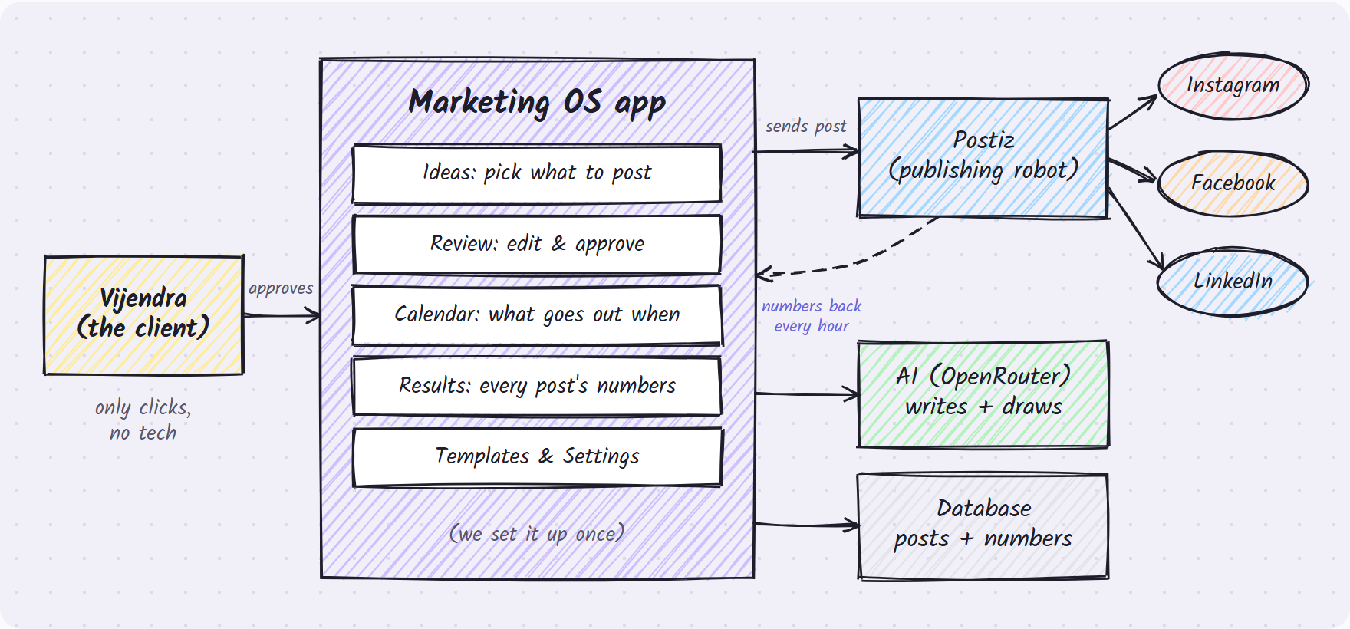
Our app is the only thing the client sees. Postiz does the posting in the background.

A post's journey
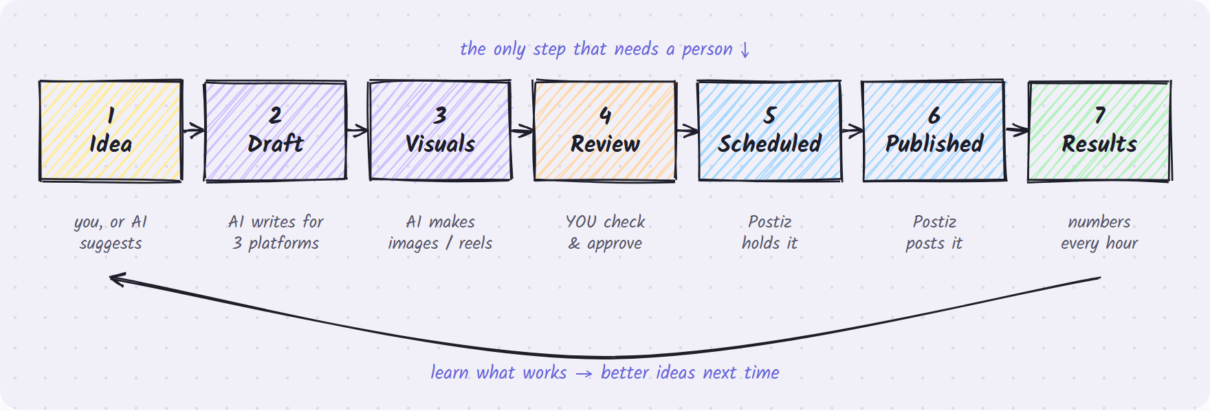
- Ideas come from the client (a thought or a link) or from "Suggest ideas", where the AI uses the brand's topics and what worked before.
- Drafts are written for each platform in the brand's voice. Every number or claim in a draft is flagged.
- Review is the only step that needs a person. Edit, pick a date, approve.
- Honest numbers rule: a post that says something like "40% faster" can't go out until someone attaches a proof link. This protects the brand.
- Results are pulled every hour, and they feed the next round of ideas.

What the client can do
IDEAS  Pick what to post  Add a thought or paste a link. Or press Suggest ideas. Each idea gets a score. Pick or skip.  Behind the scenes: existing research and scoring. The same link can't be added twice. | DRAFTS  Posts written for you  For each picked idea, AI writes a LinkedIn post, a Facebook post and an Instagram caption in the brand voice.  Behind the scenes: existing draft writer. The voice comes from the brand settings.
IMAGES  Pictures & carousels  A single image or a 2–10 slide carousel, made from a saved template chosen by its thumbnail.  Behind the scenes: our own layouts, or the AI image model. See the next section. | VIDEO  Voice & reels  Turn any approved post into a short vertical video with an AI voice and burned-in captions.  Behind the scenes: edge-tts (free voice) + ffmpeg, both on our server.
VIDEO  Clips from long videos  Upload a talk or podcast. Get 2–3 short captioned clips that go to Review like any other post.  Behind the scenes: faster-whisper transcript → AI picks highlights → ffmpeg cuts and crops. | REVIEW  Check & approve  See each post as it will look. Edit the text, swap the image, attach proof, pick a date and time, and approve.  Behind the scenes: all in the dashboard. The Telegram approval path is removed.
CALENDAR  What goes out when  A week or month list of scheduled and published posts. Move a post to another time.  Behind the scenes: Postiz holds the schedule. We only update the date. | RESULTS  Every post's numbers  One table with reach, likes, clicks, engagement % and leads for every post on every platform.  Behind the scenes: Postiz analytics, pulled hourly. See "The Results page".
SETTINGS
Brand & look
Brand voice, website link, hashtags, posting times, colours, fonts and logo. Shows which accounts are connected.
Behind the scenes: one brand settings row that every prompt reads.

Carousels & templates
A template is a saved style. The client sees a thumbnail. Behind it sit two plain-language prompts: how to write the slides and how they should look. Pick the thumbnail and those prompts are used.
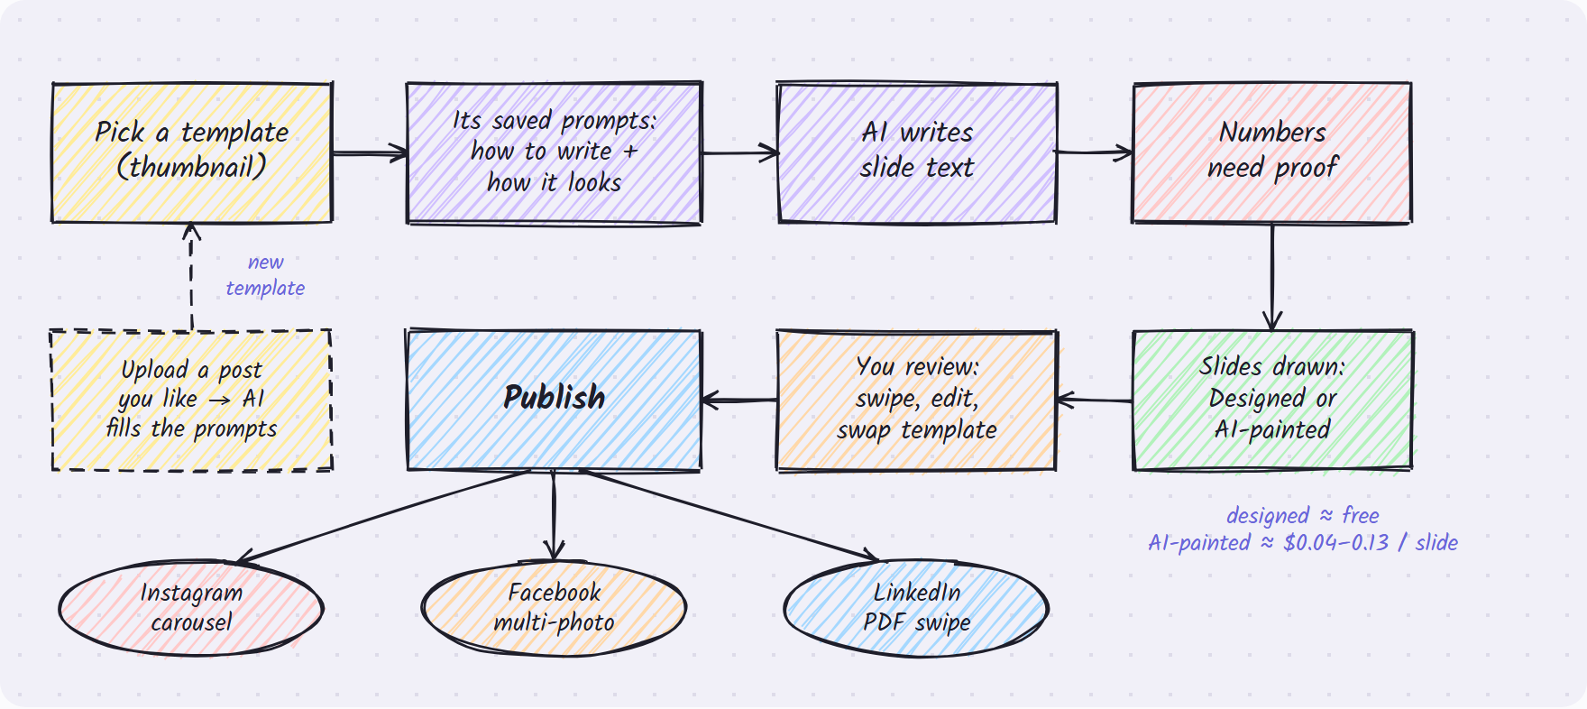

Two kinds, one system
- Designed: our own layouts with the brand's fonts and colours. The text is exact and it costs almost nothing. Six to start: Bold hook, Numbered tips, Myth vs Fact, Big stat or quote, Photo + caption, Before/After.
- AI-painted: the image model draws each whole slide from the look prompt and example images. Slide 1 is reused as a reference, so the slides match each other.

Rules the client doesn't have to think about
- Every topic and platform has a default template, which can be swapped in Review.
- Editing a template never changes old posts. Each post keeps a copy of the prompts it was made with.
- Instagram carousels have 2–10 slides, and all slides are the same size (square or 4:5).
- LinkedIn shows the slides as a swipeable PDF. Facebook shows a multi-photo post.

The Results page
The client asked for post-by-post detail, so this page is a table, not a wall of charts. It is the first piece of the "one place for all numbers" idea.
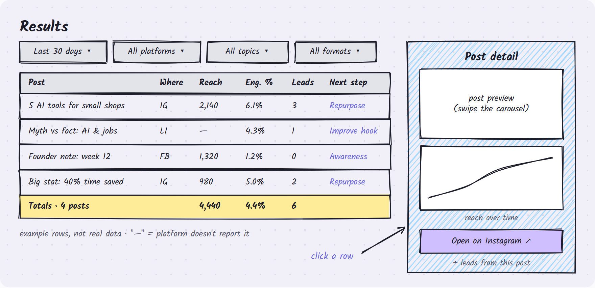

What's on it
- Filters: last 7, 30 or 90 days or custom dates; platform; topic; format.
- One row per post per platform: reach, views, likes, comments, shares, saves, link clicks, engagement %, leads.
- Next step in plain words: Repurpose, Improve hook, Awareness only or Archive.
- A totals row for whatever is filtered. Click any column to sort.
- Click a row to see the post, how its numbers grew, the leads it brought and a link to the live post.

How the numbers work
- Every hour we ask Postiz for each recent post's numbers and save a snapshot. That gives us the "grew over time" line.
- We check each post for 30 days: hourly in the first week, then once a day.
- Engagement % = (likes + comments + shares + saves) ÷ reach. If a platform doesn't report reach, we use views.
- "—" means the platform doesn't report that number. It is never shown as 0. For example, LinkedIn personal profiles give no reach.
- Leads are traced back to a post by the UTM tag on its link.

Under the hood
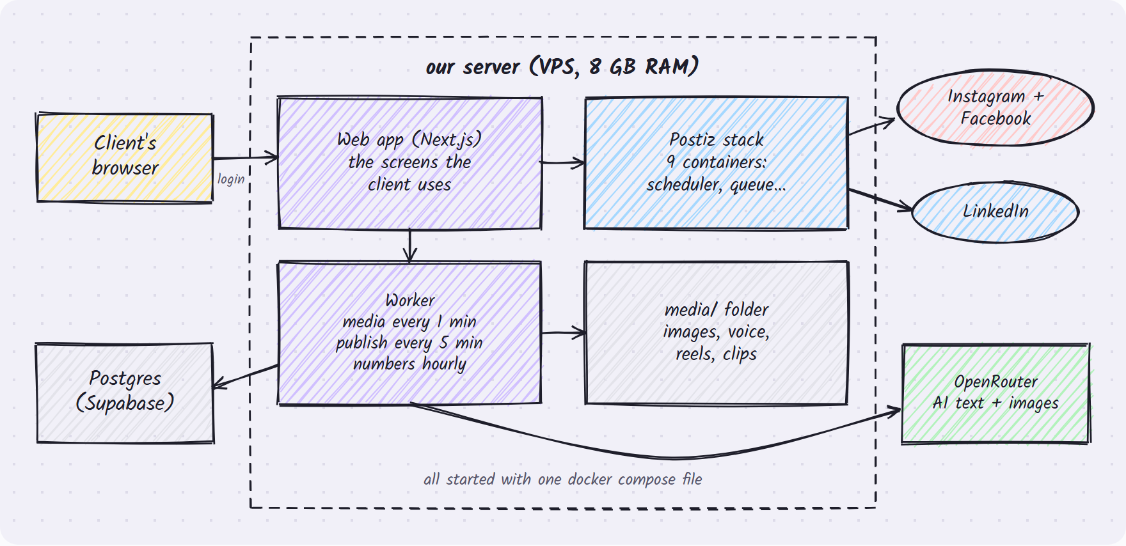

The main calls we make
What happens | We ask | Call | When
See which accounts are connected | Postiz | GET /public/v1/integrations | Settings page, and before scheduling
Upload an image or video | Postiz | POST /public/v1/upload | Just before scheduling
Schedule a post | Postiz | POST /public/v1/posts (type: schedule) | Every 5 minutes, for approved posts
Get a post's numbers | Postiz | GET /public/v1/analytics/post/:id | Hourly for 7 days, then daily until day 30
Write ideas, posts, slide text | OpenRouter (Claude Sonnet) | chat completions | Drafting and "Suggest ideas"
Draw an image or slide | OpenRouter (Gemini image) | POST /api/v1/images | Images and AI-painted slides
Make a voice-over | edge-tts, on our server | command line | Reels
Make or cut videos | ffmpeg, on our server | command line | Reels and clips
Turn speech into text | faster-whisper, on our server | command line | Clips from long videos

What we store
Table | Holds
ideas (topics, research inputs) | Thoughts, links and AI suggestions, with their scores | exists
posts (content items) | Each post's text, platform, status, date and Postiz id | exists, 2 new columns
claims | Every number or fact in a post, and its proof link | exists
metrics | Numbers snapshots per post, over time | exists
leads | People who reached out, and the post that brought them | exists
brand settings | Voice, links, hashtags, posting times, colours, fonts, logo | new
templates | Saved carousel and image styles with their prompts | new
media | Images, slides, voice and videos. It also works as the to-do list for the worker. | new

What we reuse from the 5 projects
We looked at ALwrity, LangChain's social-media-agent, AI-Content-Studio, Postiz and Universal-AI-Studio. They overlap a lot. For every feature we keep one way of doing it, so the code stays small and easy to fix. We take ideas, not their code, except for Postiz, which we run as it is.
Feature | We keep | Idea came from | We drop
Posting & scheduling | Postiz | postiz-app | The other four projects' posting code (one of them is fake)
Ideas & research | Our engine + "paste a link" + "Suggest ideas" | Our engine, social-media-agent, ALwrity | Paid search APIs
Writing posts | Our draft writer | Our engine | X threads (for now)
Approval | Dashboard only | — | Telegram, agent inbox
Images | OpenRouter images (same key as text) | — | Stability, Imagen and others
Carousels | Template system | New | Canva-style editor
Voice | edge-tts (free) | AI-Content-Studio | ElevenLabs, Gemini TTS
Reels & clips | ffmpeg + whisper on our server | AI-Content-Studio | Cloud video APIs
Numbers | Postiz analytics | postiz-app | Typing numbers in by hand

Growing into a full marketing platform
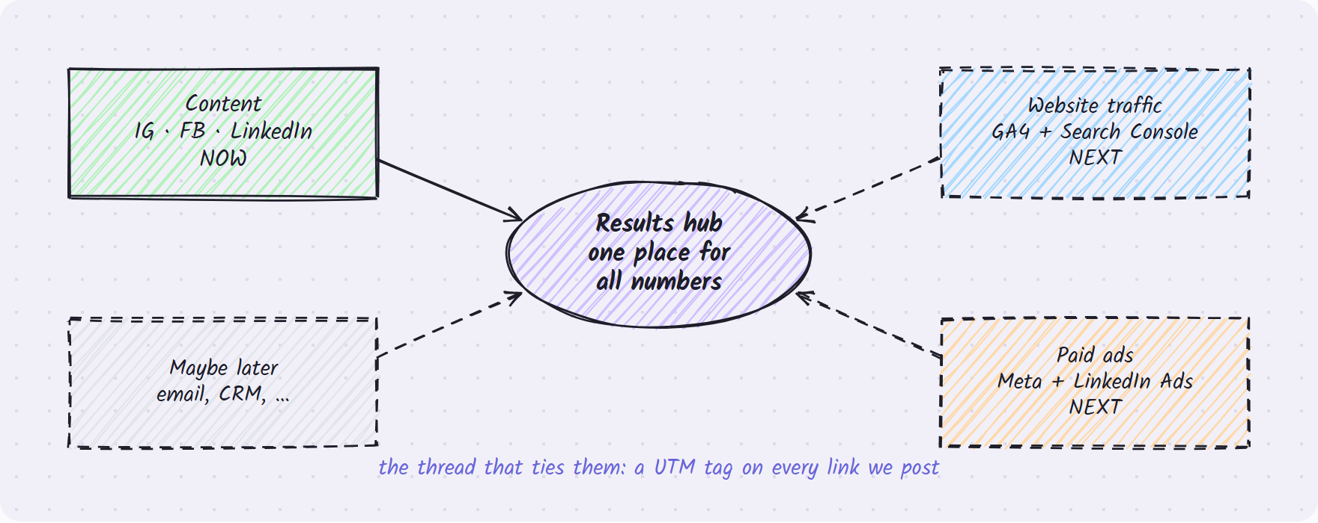
- Each new branch follows the same small recipe: one sync job + one table of daily numbers + one section on Results.
- Website traffic (Google Analytics + Search Console): visits, top pages, sign-ups, search clicks.
- Paid ads (Meta Ads + LinkedIn Ads): spend, cost per click, cost per lead, return on ad spend.
- Every link we post already has a UTM tag. Once Google Analytics is connected, a "Website visits" column appears on each post without any new tracking work.
- We are deliberately not building a big "connect anything" system yet. We'll decide on that when the second branch arrives.

Plan & timeline
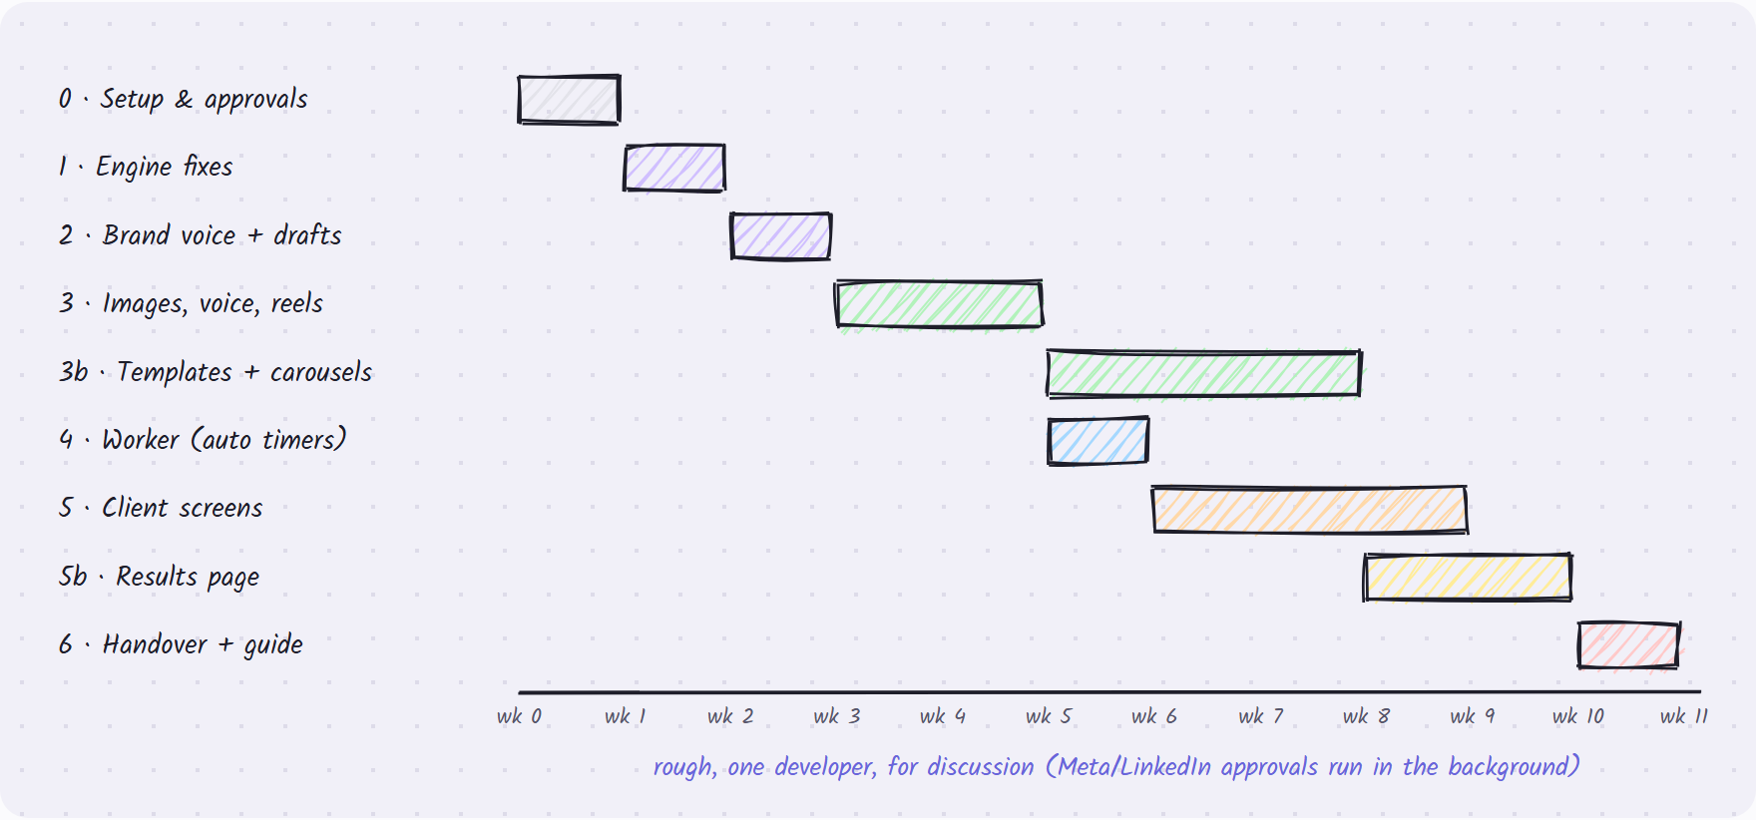
Phase | What gets done | Done when
0 · Setup | Server, Postiz, Meta and LinkedIn apps, connect the 3 accounts. The Meta app runs in development mode with Vijendra added, so we don't wait for Meta's review. | A test post goes out on all 3 platforms and its numbers come back
1 · Engine fixes | Steps run in order, real Postiz connection, publish at the chosen time, Telegram removed | An approved post is scheduled in Postiz
2 · Brand + drafts | Brand settings, drafts for LinkedIn, Facebook and Instagram, "paste a link" and "Suggest ideas" | Drafts read in the brand voice
3 · Media | Images, voice, reels, clips from long videos | A 1080×1920 reel with captions
3b · Templates | 6 layouts, AI-painted slides, "new from example", swap in Review | A 5-slide carousel posts on all 3 platforms
4 · Worker | Automatic timers replace the manual runs | Runs a full day with nobody touching it
5 · Client screens | Home, Ideas, Review, Calendar, Videos, Templates, Settings, and a password | The client finishes a day's routine using only clicks
5b · Results | Numbers sync, results table, row detail | Totals match the rows, "—" shows where data is missing
6 · Handover | Setup runbook and a one-page client guide | The client runs a week on his own

Running costs
These are estimates for about one post a day across the three platforms. We'll replace them with real numbers after the first month; OpenRouter reports the real cost of every AI call.
Item | Cost | Note
Server (VPS, 8 GB RAM) | $15–40 / month | Runs Postiz, the app, the worker and video tools
Postiz | $0 | Open source, runs on our own server
AI writing (OpenRouter) | ≈ $5–20 / month | Ideas, drafts, slide text
Designed slides | ≈ $0 | Drawn on our server
AI-painted slides | $0.04–0.13 / slide | A 5-slide carousel costs about $0.20–0.65. Each template shows its cost.
Voice, reels, clips | $0 | edge-tts, ffmpeg and whisper run on our server
Database | existing plan | The Supabase Postgres we already use
Total | ≈ $25–80 / month | Most of the spread comes from how many AI-painted slides are made

Risks & open questions
Risk | Level | What we do about it
Meta or LinkedIn slow to approve our apps | High | Start on day 1. Meta runs in development mode with the client added. A LinkedIn personal profile is quicker to set up than a company page.
Postiz doesn't return every number for every platform | Medium | Test it in setup week. The table shows "—" for missing numbers, and the columns are fixed based on what actually comes back.
The database can't be reached from the dev machine right now | Medium | The Supabase direct address fails to resolve. Switching to Supabase's "pooler" connection address should fix it.
AI-painted slides look different from each other | Medium | Slide 1 is reused as a reference for the rest. Designed templates are the safe default.
The proof rule slows the client down | Low | Only posts with numbers need proof, and proof is one field in Review.
Postiz licence (AGPL) | Low | Fine as long as we run it unchanged. If we ever change its code, we must share those changes.
Server too small | Low | Postiz needs about 4 GB and whisper needs more, so we start at 8 GB.

Questions for the team
- LinkedIn: post as Vijendra's personal profile, the company page, or both?
- How many posts a week per platform is the target? This sets the default schedule.
- Which one number matters most to the client: reach, clicks or leads? It becomes the default sort.
- Should the client get a WhatsApp or email nudge when drafts are waiting?
- Who replies to comments and DMs? That isn't part of v1.

How we'll know it works

Success measures
- The client runs a full week without calling us.
- The daily routine takes 10 minutes or less.
- Every approved post goes out on time on all 3 platforms.
- Numbers appear on Results within an hour of the platforms having them.
- Zero posts go out with unproven numbers.
- Every link carries a UTM tag, so every lead traces back to a post.

What we test before handover
- Automatic tests for the engine, the Postiz messages and the numbers maths.
- Each of the 6 layouts, with long and short text, and no overflow.
- One real carousel published on each platform.
- A long video turned into clips, and one clip published as a reel.
- A full walk-through on a phone and a laptop, using only clicks.

Brainstorm board
What should we add, change or cut? Post an idea and vote on others. Everyone who opens this page sees the same board.

Starter ideas, not in v1
- Follower growth per account
- Weekly summary by email
- Download results as CSV
- Best time to post suggestions
- A/B test two hooks for one post
- Comment & DM inbox
- Turn top posts into a blog or newsletter
- Post to X and the blog too
- AI avatar videos
- Watch what competitors post
- More than one brand

Team ideas
Add a row per idea and put your initials in the Votes column for ideas you back. You can also use the live online board: open the live brainstorm board.
Idea | Area | Suggested by | Votes (initials)

Glossary
Postiz | Free, open-source software that connects to social accounts and posts at the right time. We run our own copy.
OpenRouter | One account that gives us many AI models, for both writing and images.
Carousel | A post with several slides that people swipe through.
Template | A saved style for images or carousels: a thumbnail plus the prompts behind it.
Reach | How many different people saw the post.
Engagement % | Of the people who saw it, how many liked, commented, shared or saved it.
Lead | Someone who got in touch or signed up because of a post.
UTM tag | A small label added to a link that tells us which post a website visitor came from.
Worker | The part of the app that runs by itself on timers: makes media, sends posts, fetches numbers.
VPS | A rented server where everything runs.
Branch | One area of marketing on the platform: content now, website and ads later.

Built from the approved plan for the PRATAP AI content system. Costs and timeline are estimates for discussion.

