TINY PROJECT REPORT
ON
“EMOTION DETECTION FROM SOCIAL MEDIA TEXT”
For
SOCIAL MEDIA ANALYTICS

Submitted in
Partial Fulfilment of the requirements for the degree of
MASTER OF COMPUTER APPLICATIONS (MCA)

Enrollment No. | Name
26PG110078 | HADIYA KIRAN HIMMATBHAI
26PG1100108 | KALOLIYA ANUSHREE GHANSHYAMBHAI

Class: MCA-AI-F-1
Under the supervision of
Prof. Ishita Jain

PARUL INSTITUTE OF ENGINEERING & TECHNOLOGY
Parul University, Vadodara
OCTOBER-2026

GUIDE CERTIFICATE
This is to certify that the Tiny Project Report entitled “Emotion Detection from Social Media Text” has been prepared by the students listed below as part of the academic work for the Master of Computer Applications (MCA).
The project presents a browser-based text analysis interface that demonstrates basic emotion-category selection using predefined words and JavaScript. The report documents the supplied HTML, CSS and JavaScript files, the main interface, a workflow diagram, source-code excerpts and distinct output examples.
The project is an academic demonstration of keyword matching. The score labelled “Confidence” is calculated by a custom formula in the supplied script and should not be interpreted as a statistically validated probability or a psychological assessment.
Sr. No. | Student Name | Enrollment No.
1 | HADIYA KIRAN HIMMATBHAI | 26PG110078
2 | KALOLIYA ANUSHREE GHANSHYAMBHAI | 26PG1100108

Guide Signature: ______________________________________________
Date: __________________________ Place: __________________________

ACKNOWLEDGEMENT
We express our sincere gratitude to our project guide, Prof. Ishita Jain, for guidance, encouragement and valuable suggestions during the preparation of this Tiny Project Report.
We are thankful to Parul University and the Parul Institute of Engineering & Technology for providing the academic environment and resources to learn about social media analytics and web development.
We acknowledge the HTML, CSS and JavaScript documentation and learning resources that helped us understand web interfaces, event handling, text processing, keyword matching and dynamic result display.
Finally, we thank our classmates, friends and family members for their support and motivation throughout the project.
PROJECT TEAM

INDEX OF TINY PROJECT DOCUMENTATION
Sr. No. | Topic | Page No.
1 | Project Profile | 5
2 | Project Definition | 6
3 | Problem Statement | 7
4 | Objectives of Project | 8
5 | Process Hierarchy and Workflow | 9–10
6 | System Design and Development | 11–18
7 | Result Screenshots | 19–22
8 | Testing, Complexity and Limitations | 23
9 | Scope, Pros and Cons, Future Scope | 24
10 | Conclusion, References and Checklist | 25

Note: The page numbering is planned for this formatted report. If Word changes pagination on another device, check the final page numbers before printing.

1. PROJECT PROFILE
Item | Details
Project Name | Emotion Detection from Social Media Text (EmotionAI)
Project Type | Tiny Project – Browser-Based Text Analysis
Subject Area | Social Media Analytics
Programming Technologies | HTML, CSS and JavaScript
Input | User-entered text; maximum 500 characters
Output | Detected emotion label, emoji and percentage-style score
Emotion Categories | Joy, Sadness, Anger, Fear, Surprise, Love and Neutral
Matching Method | Predefined keyword lists and exact word matching
Execution | Open the HTML page in a modern web browser
Storage / Backend | No backend API or database in the supplied files

Project Summary
EmotionAI is a browser-based application that examines a short text input and selects one of seven emotion categories. The interface contains an input area, a character counter, an Analyze Emotion button, a result card and category tiles. The supplied JavaScript counts exact matches between words in the input and fixed keyword lists. It then displays the category with the largest count, or Neutral when no listed keyword matches.

2. PROJECT DEFINITION
Emotion detection from text is the task of identifying an emotion that may be expressed through written language. Social media posts often contain short reactions, opinions and personal experiences. A simple analysis tool can demonstrate how this text can be sorted into emotion-related categories.
In this implementation, HTML provides the page structure, CSS controls its visual design, and JavaScript performs input handling and keyword matching in the browser. The application does not send the text to a server and does not use a trained machine-learning model.

Working Principle
- The browser loads index.html together with style.css and script.js.
- The user enters a social media message in the text area.
- The character counter displays the current text length out of 500.
- When Analyze Emotion is clicked, JavaScript checks for empty input.
- The text is converted to lowercase and separated into word tokens.
- Each word is checked against the predefined emotion keyword lists.
- The category with the highest matching count is selected; if no matches exist, Neutral is selected.
- The result label, emoji, percentage and progress bar are updated.

3. PROBLEM STATEMENT
Social media posts frequently express feelings such as joy, sadness, anger, fear, surprise and love. Manually sorting a large number of short messages can take time. A small academic application can demonstrate the basic idea of using text rules to assign a possible emotion category.
The challenge is to provide an easy-to-use interface that accepts text, applies a defined analysis procedure and presents a result clearly, without requiring a complicated backend or database.

Problem Statement
Design and implement a browser-based Emotion Detection from Social Media Text application using HTML, CSS and JavaScript. The application must accept text, compare its words with predefined emotion-keyword lists and display a category label with an emoji and a percentage-style score.

Expected Result
- The main interface should load in the web browser.
- The textarea should accept no more than 500 characters.
- The character counter should update as the user types.
- Empty input should prompt the user and show a 0% score.
- Non-empty input should display one detected category and its emoji.
- Text without any listed keyword should default to Neutral.

4. OBJECTIVES OF PROJECT
- To understand a simple text-analysis task in Social Media Analytics.
- To develop an interactive interface using HTML, CSS and JavaScript.
- To implement keyword-based matching for seven emotion categories.
- To display the selected emotion with an emoji and percentage-style indicator.
- To provide an input character counter and an empty-input check.
- To demonstrate how page structure, styling and browser scripting work together.
- To document the actual code, workflow and output states of the supplied project.
- To identify limitations and possible improvements for a future version.

Learning Outcomes
- Understand how JavaScript reads and processes text entered in a browser.
- Understand objects, arrays, loops, regular expressions and DOM events.
- Understand how calculated values update text and CSS width on the page.
- Recognize the difference between keyword matching and a trained machine-learning model.

5. PROCESS HIERARCHY AND WORKFLOW
The project follows an input–process–output hierarchy. The user enters text; JavaScript validates and tokenizes it; the words are compared with emotion keyword lists; and the result is displayed on the same page.
Level | Process | Description
1 | Open Application | Load index.html and its linked CSS and JavaScript files.
2 | Enter Text | User types a social media message (maximum 500 characters).
3 | Validate | Empty input produces a prompt and a 0% display score.
4 | Tokenize | Text is converted to lowercase and split into word tokens.
5 | Match Keywords | Each token is compared with the seven predefined lists.
6 | Select Category | Choose the category with the highest count; default to Neutral if all are zero.
7 | Calculate Score | Apply the percentage-style formula used in script.js.
8 | Display | Update emotion name, emoji, percentage and progress bar.

5.1 WORKFLOW DIAGRAM
The diagram below shows the complete path from opening the page to displaying an emotion result. The left branch represents the empty-input case; the main path processes non-empty text.
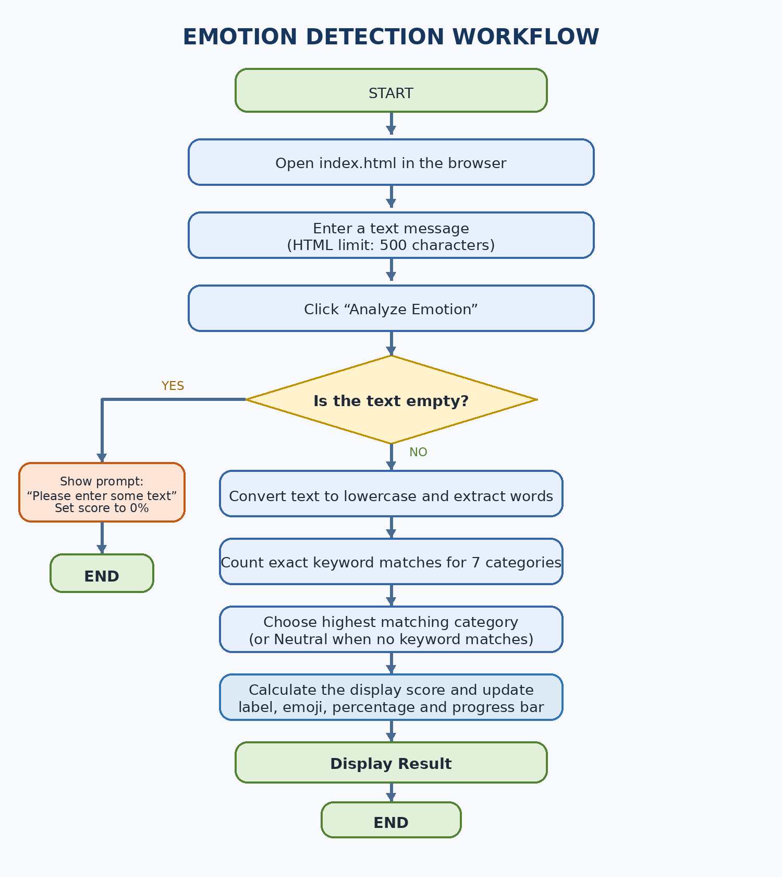
Figure 5.1: Complete workflow of the Emotion Detection application
Workflow summary: input validation → lowercase/token extraction → exact keyword matching → highest-score category selection → custom display score → result card update.

6. DESIGN AND DEVELOPMENT OF PROJECT

6.1 System Design
The supplied project is a client-side web application. It consists of a page structure, a stylesheet and a JavaScript file. Text analysis takes place locally in the browser; there is no server-side processing, database or remote API in the supplied files.
Component | Responsibility
index.html | Defines the header, analyzer card, textarea, Analyze Emotion button, result card and seven category tiles.
style.css | Controls the dark theme, background glow, cards, typography, input controls, progress bar and responsive layout.
script.js | Updates the character counter, stores keyword lists, counts matching words, chooses the result and updates the display.
Web Browser | Loads the assets and executes the JavaScript locally.

6.2 System Architecture
User Input → HTML Interface → JavaScript Processing → Keyword Matching → Score Calculation → Result Card

6.3 Input and Output
Input: plain text entered by the user, limited by maxlength="500" in the HTML textarea. Output: one emotion category, a matching emoji, a percentage-style score and a progress bar.

6.4 USER INTERFACE – MAIN PAGE
The main page includes the EmotionAI brand, an “AI Ready” status badge, introductory text, an analyzer card, a character counter, the Analyze Emotion button, a result panel and seven emotion tiles. The screenshot below shows the initial state before analysis.
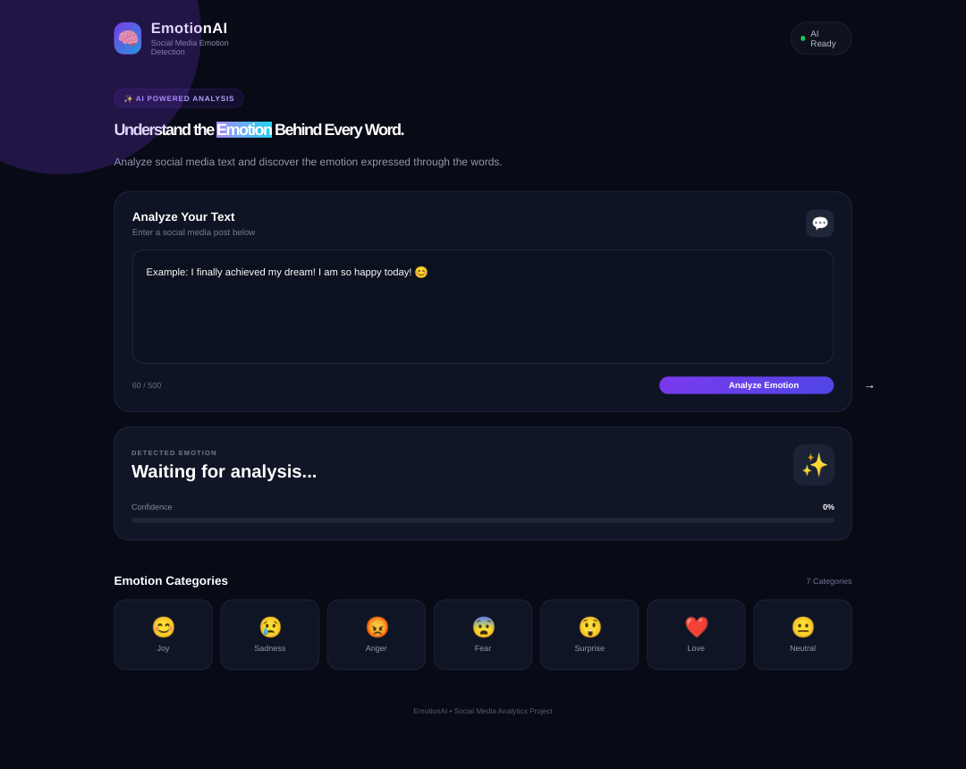
Figure 6.1: Main interface before a text analysis is performed

Interface Highlights
- Text area for a social media post.
- Live character counter and Analyze Emotion button.
- Result card with emotion label, emoji and progress indicator.
- Emotion overview: Joy, Sadness, Anger, Fear, Surprise, Love and Neutral.

6.5 MODULES AND MAIN FEATURES
Module / Feature | Description
Text Input | Accepts the text entered by the user, up to 500 characters.
Character Counter | Shows current text length in the format “current / 500”.
Emotion Dictionary | Stores the predefined words and emoji for each category.
Text Tokenization | Converts text to lowercase and extracts words using a regular expression.
Keyword Scoring | Increments category scores when a token exactly matches a listed word.
Category Selection | Chooses the category with the highest score; Neutral is the default.
Display Score | Uses a custom formula to calculate the displayed percentage.
Result Display | Updates the emotion heading, emoji, percentage and progress-bar width.
Responsive UI | Uses CSS to support different browser window sizes.

6.6 Emotion Categories
Category | Example words taken from script.js | Icon
Joy | happy, happiness, joy, excited, amazing, glad, smile | 😊
Sadness | sad, sadness, crying, lonely, hurt, miss, heartbroken | 😢
Anger | angry, anger, mad, hate, furious, rage, worst | 😡
Fear | fear, afraid, scared, worried, danger, nervous, anxious | 😨
Surprise | wow, surprised, shocked, unexpected, unbelievable, omg | 😲
Love | love, loved, lovely, romantic, kiss, caring, beautiful | ❤️
Neutral | okay, ok, fine, normal, today, weather, information, update, post | 😐

6.7 ALGORITHM AND PROCESS FLOW

Algorithm
- Start the web application.
- Read the value from the text area when Analyze Emotion is clicked.
- Trim surrounding whitespace and convert the string to lowercase.
- If the input is empty, show “Please enter some text”, set the score to 0%, and stop the current analysis.
- Extract word tokens using the regular expression /\b[\w']+\b/g.
- Initialize every emotion score to zero.
- For each token, compare it with each category keyword list and increment matching scores.
- Set the default category to Neutral; replace it only when a category has a higher positive score.
- Calculate the display score: 50 when no keywords match; otherwise round min(95, 65 + highestScore / totalWords × 35).
- Update the category label, corresponding emoji, percentage value and progress bar.
- End.

Important Note on “Confidence”
The interface labels the output as “Confidence”, but the code does not use model probabilities. It calculates a custom display percentage from the number of matching words and total tokens. The value is therefore an interface score, not a calibrated probability.

6.8 IMPORTANT CODE – HTML USER INTERFACE
File: index.html. This extract shows the actual analyzer input and button. The textarea limit is set to 500 characters. The JavaScript uses the IDs shown here to access the elements.

Code Listing 1: Analyzer input and action control
HTML — index.html
<!-- Main Analyzer -->
<section class="analyzer-card">
<div class="section-title">
<div>
<h3>Analyze Your Text</h3>
<p>Enter a social media post below</p>
</div>
<span class="input-icon">💬</span>
</div>
<textarea
id="textInput"
placeholder="Example: I finally achieved my dream! I am so happy today! 😊"
maxlength="500">
</textarea>
<div class="input-footer">
<span id="charCount">0 / 500</span>
<button id="analyzeBtn">
<span>Analyze Emotion</span>
<span class="arrow">→</span>
</button>
</div>
</section>

Result Panel

Code Listing 2: Result card and score display
HTML — index.html
<section class="result-card" id="resultCard">
<div class="result-header">
<div>
<p class="result-label">DETECTED EMOTION</p>
<h3 id="emotionResult">Waiting for analysis...</h3>
</div>
<div class="emotion-icon" id="emotionIcon">✨</div>
</div>
<div class="confidence-section">
<div class="confidence-text">
<span>Confidence</span>
<strong id="confidenceValue">0%</strong>
</div>
<div class="progress-bar">
<div class="progress-fill" id="progressFill"></div>
</div>
</div>
</section>

6.9 IMPORTANT CODE – JAVASCRIPT COUNTER AND EMOTION DICTIONARY
File: script.js. The first extract attaches an input event to the textarea. The emotion dictionary stores keyword arrays and an emoji for every category.

Code Listing 3: DOM element selection and character counter
JavaScript — script.js
const textInput = document.getElementById("textInput");
const charCount = document.getElementById("charCount");
const analyzeBtn = document.getElementById("analyzeBtn");
const emotionResult = document.getElementById("emotionResult");
const emotionIcon = document.getElementById("emotionIcon");
const confidenceValue = document.getElementById("confidenceValue");
const progressFill = document.getElementById("progressFill");
// Character Counter
textInput.addEventListener("input", function () {
const length = textInput.value.length;
charCount.textContent = `${length} / 500`;
});

Code Listing 4: Predefined keyword lists for seven categories
JavaScript — script.js
const emotions = {
Joy: { words: ["happy", "happiness", "joy", "excited", "exciting",
"love", "loving", "great", "amazing", "awesome", "wonderful",
"glad", "celebrate", "celebration", "smile", "smiling", "fun",
"enjoy", "enjoying"], icon: "😊" },
Sadness: { words: ["sad", "sadness", "cry", "crying", "lonely",
"alone", "unhappy", "hurt", "pain", "depressed", "miss",
"missing", "heartbroken", "disappointed"], icon: "😢" },
Anger: { words: ["angry", "anger", "mad", "hate", "hating",
"furious", "annoyed", "annoying", "rage", "fight", "fighting",
"stupid", "worst"], icon: "😡" },
Fear: { words: ["fear", "afraid", "scared", "scary", "terrified",
"terror", "worried", "worry", "danger", "dangerous", "nervous",
"anxious"], icon: "😨" },
Surprise: { words: ["wow", "surprise", "surprised", "shocked", "shock",
"unexpected", "unbelievable", "omg", "suddenly"], icon: "😲" },
Love: { words: ["love", "loved", "lovely", "romantic", "kiss", "care",
"caring", "dear", "darling", "beautiful"], icon: "❤️" },
Neutral: { words: ["okay", "ok", "fine", "normal", "today", "weather",
"information", "update", "post"], icon: "😐" }
};

6.10 IMPORTANT CODE – EMOTION ANALYSIS LOGIC
The following extract is taken from the Analyze Emotion click handler in script.js. It validates the input, creates match counts and chooses the emotion with the largest score.

Code Listing 5: Input validation, tokenization and keyword matching
JavaScript — script.js
analyzeBtn.addEventListener("click", function () {
const text = textInput.value.trim().toLowerCase();
if (text === "") {
emotionResult.textContent = "Please enter some text";
emotionIcon.textContent = "⚠️";
confidenceValue.textContent = "0%";
progressFill.style.width = "0%";
return;
}
const words = text.match(/\b[\w']+\b/g) || [];
let scores = {};
Object.keys(emotions).forEach(emotion => {
scores[emotion] = 0;
});
// Count matching emotion words
words.forEach(word => {
Object.keys(emotions).forEach(emotion => {
if (emotions[emotion].words.includes(word)) {
scores[emotion]++;
}
});
});
// Find highest score
let detectedEmotion = "Neutral";
let highestScore = 0;
Object.keys(scores).forEach(emotion => {
if (scores[emotion] > highestScore) {
highestScore = scores[emotion];
detectedEmotion = emotion;
}
});

Code Listing 6: Display-score formula and result update
JavaScript — script.js
// Calculate confidence (custom display score)
let confidence;
if (highestScore === 0) {
confidence = 50;
} else {
const totalWords = words.length;
confidence = Math.round(
Math.min(95, 65 + (highestScore / totalWords) * 35)
);
}
// Display Result
emotionResult.textContent = detectedEmotion;
emotionIcon.textContent = emotions[detectedEmotion].icon;
confidenceValue.textContent = `${confidence}%`;
progressFill.style.width = `${confidence}%`;
});

6.11 IMPORTANT CODE – CSS DESIGN AND RESPONSIVE INTERFACE
File: style.css. The stylesheet defines the dark background, typography, analyzer panel and textarea. The complete file also includes styles for the result card, emotion tiles, hover states and responsive screen sizes.

Code Listing 7: Main layout and input styling
CSS — style.css
* {
margin: 0;
padding: 0;
box-sizing: border-box;
}
body {
min-height: 100vh;
font-family: "Segoe UI", Arial, sans-serif;
background: #080b16;
color: #ffffff;
overflow-x: hidden;
}
.app-container {
width: min(1100px, 92%);
margin: auto;
padding: 30px 0 20px;
}
.analyzer-card {
padding: 26px;
border-radius: 24px;
background: rgba(17, 22, 38, 0.88);
border: 1px solid #252c42;
box-shadow: 0 25px 70px rgba(0, 0, 0, 0.3);
}
textarea {
width: 100%;
min-height: 170px;
resize: vertical;
border: 1px solid #292f45;
outline: none;
border-radius: 18px;
padding: 20px;
background: #0d1120;
color: #ffffff;
font-family: inherit;
font-size: 15px;
line-height: 1.6;
}
textarea:focus {
border-color: #7c3aed;
box-shadow: 0 0 0 4px rgba(124, 58, 237, 0.10);
}

Styling Notes
- The dark navy background provides contrast with white text.
- Gradient accents identify the primary Analyze Emotion button and brand elements.
- Rounded panels visually separate text input, results and emotion categories.
- Media queries in the stylesheet adjust the layout on smaller screens.

6.12 RESULT SCREENSHOT – JOY
Sample input shown in this distinct screenshot: “I am so happy and excited today! This is amazing.”
The input includes words found in the Joy keyword list. The program counts the matching words and selects Joy because it receives a higher score than the other categories.
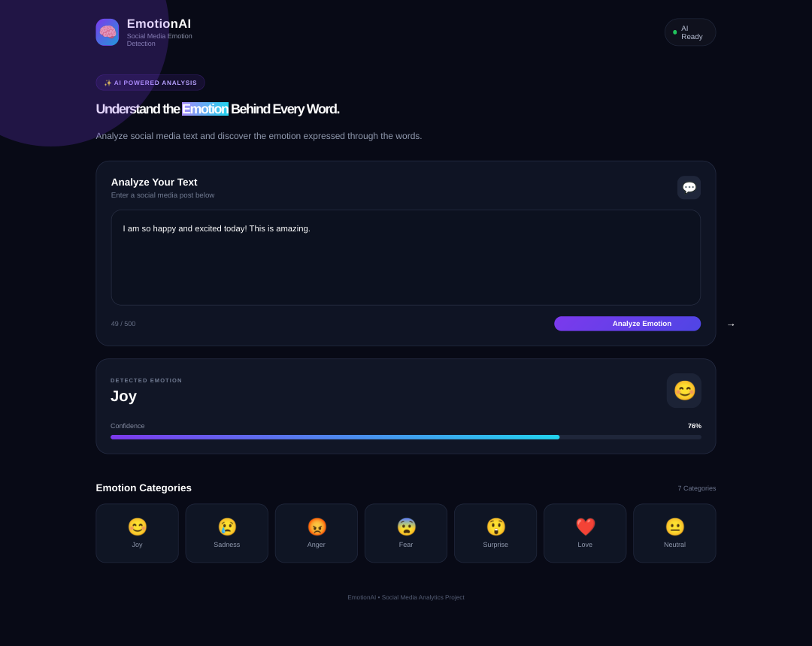
Figure 6.2: Joy result displayed by the application (76%)
Observation: the interface updates the category heading to Joy, displays the corresponding smiling emoji, and fills the progress bar to match the displayed percentage.

6.13 RESULT SCREENSHOT – SADNESS
Sample input shown in this distinct screenshot: “I feel sad and lonely. I miss my friend.”
The words “sad”, “lonely” and “miss” appear in the Sadness keyword list. The category receives the highest match count and is displayed as the output.
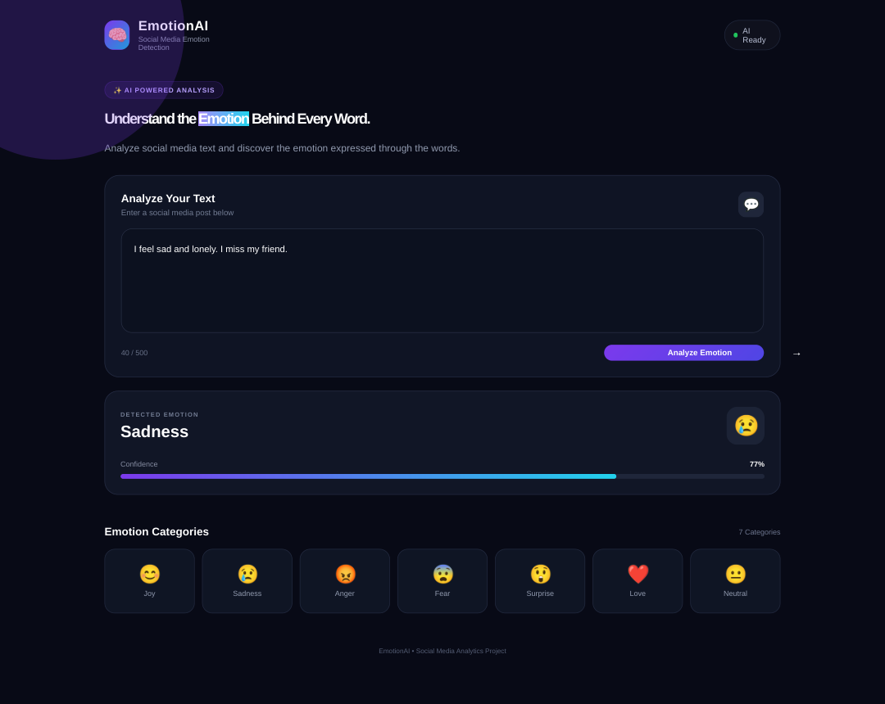
Figure 6.3: Sadness result displayed by the application (77%)
Observation: the result panel changes from the initial waiting state to Sadness, shows the crying-face emoji and updates the percentage bar.

6.14 RESULT SCREENSHOT – ANGER
Sample input shown in this distinct screenshot: “I am angry and furious about this worst situation.”
The input contains keywords “angry”, “furious” and “worst” from the Anger category. The code counts these matching tokens and displays Anger as the detected category.
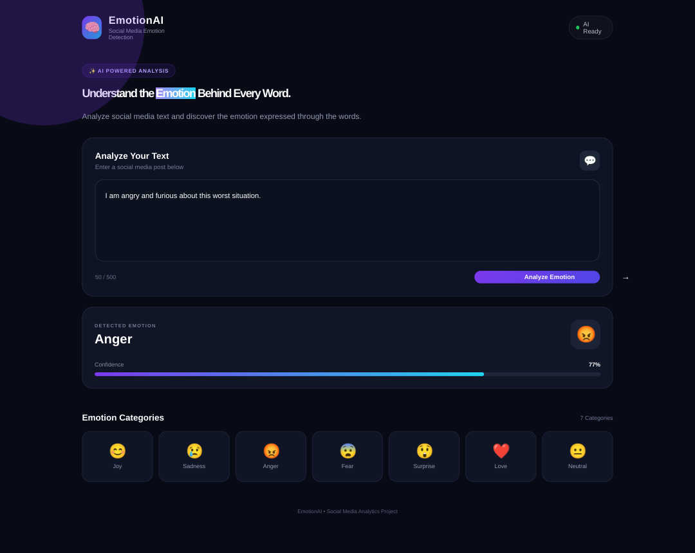
Figure 6.4: Anger result displayed by the application (77%)
Observation: the output heading shows Anger, the icon changes to the angry-face emoji and the progress bar reflects the custom score.

6.15 RESULT SCREENSHOT – NEUTRAL
Sample input shown in this distinct screenshot: “Today I am reading an information update.”
The words “today”, “information” and “update” are present in the Neutral keyword list. The code selects Neutral when its matching count is the largest; it also uses Neutral by default when no category receives a match.
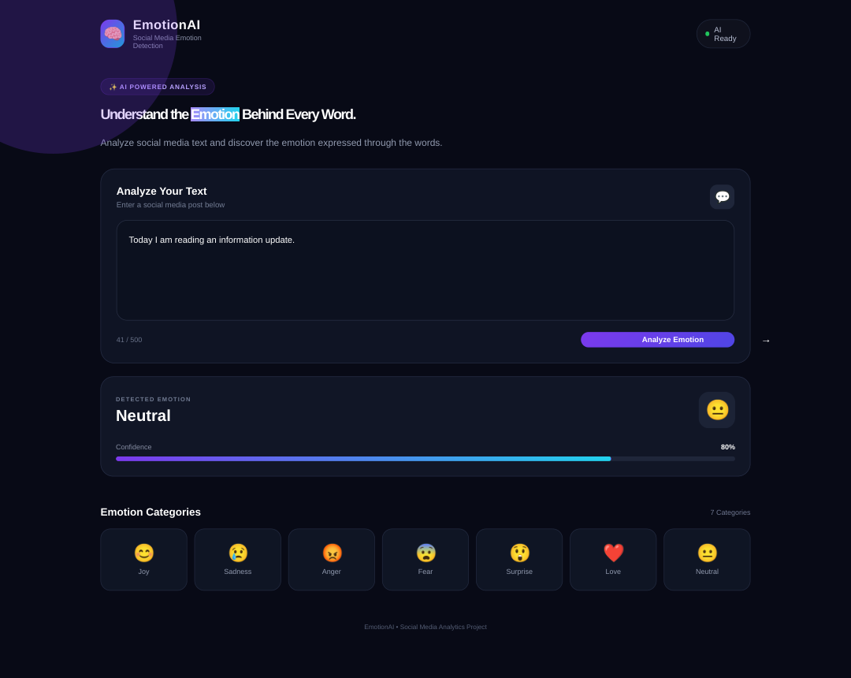
Figure 6.5: Neutral result displayed by the application (80%)
Observation: this is a separate run with a different text input and a different result state, not a duplicate of the other output screenshots.

6.16 RESULT AND TEST CASES
The following cases describe the expected behaviour derived from the supplied source files. The screenshots on the preceding pages illustrate distinct output states captured from the interface variants prepared for this report. Re-run the project on the target computer before final submission.
Test Case | Input / Action | Expected Behaviour
1 | Open index.html | Main interface loads.
2 | Type text in textarea | Character counter updates.
3 | Click Analyze with blank input | Prompt appears and display score becomes 0%.
4 | Use Joy keywords | Joy is selected when it has the highest match count.
5 | Use Sadness keywords | Sadness is selected when it has the highest match count.
6 | Use Anger keywords | Anger is selected when it has the highest match count.
7 | Use Neutral keywords / no matches | Neutral can be selected by its matches or by default.
8 | Enter more than 500 characters | The textarea maxlength limits entry to 500 characters.

Complexity and Limitations
- Keyword matching depends on exact words in fixed lists.
- Negation (for example, “not happy”), sarcasm, context and spelling variations are not handled reliably.
- The percentage is a custom formula-based display score, not a trained model confidence.
- The supplied project has no account system, database, server-side API or persistent history.

7. SCOPE OF PROJECT
The project is intended as an educational demonstration of text handling and a basic keyword-based emotion categorization method in Social Media Analytics.
- Useful for classroom demonstrations of HTML, CSS, JavaScript and string processing.
- Can categorize sample short text using the seven predefined categories.
- Can be extended with more words, languages, or batch-text input.
- Provides a starting point for evaluating more advanced text-analysis techniques.

8. PROS AND CONS OF PROJECT
Advantages | Limitations
Simple interface and clear output. | Exact keyword matching may miss context.
Runs in a modern browser without a backend. | No trained machine-learning model is included.
Immediate feedback after clicking Analyze. | Negation and sarcasm are not handled.
Seven emotion categories are represented. | Some terms may overlap in meaning.
Source code is short and easy to inspect. | Display percentage is not calibrated confidence.

9. FUTURE SCOPE
- Use a validated machine-learning or transformer model instead of, or alongside, keyword matching.
- Improve support for emojis, negation, slang, spelling variations and multiple languages.
- Evaluate the output with a labelled dataset and report accuracy, precision, recall and F1-score.
- Add batch analysis, optional history and an explanation of which words influenced a result.

10. CONCLUSION
Emotion Detection from Social Media Text demonstrates a basic method for assigning an emotion category to a short text. The project combines HTML for page structure, CSS for visual presentation and JavaScript for input handling, word matching, custom score calculation and result display.
The report includes the complete process workflow, code extracts with descriptive titles, the main interface and separate Joy, Sadness, Anger and Neutral output screenshots. The project is useful for demonstrating basic frontend development and keyword-based text processing.
Its key limitation is that exact keyword matching does not interpret full sentence context. The displayed “Confidence” value is a custom formula-based score and not a statistically validated model probability. These limitations should be clearly stated during the project demonstration.

11. REFERENCES
- MDN Web Docs – HTML, CSS and JavaScript documentation.
- JavaScript references – arrays, objects, string methods, regular expressions and DOM events.
- HTML reference – textarea maxlength attribute and form controls.
- CSS reference material – layout, responsive design, colors and typography.
- Supplied project files: index.html, style.css and script.js.
- Class notes and learning material for Social Media Analytics.

PROJECT SUBMISSION CHECKLIST
- Verify both student names, enrollment numbers, class, guide and institute details.
- Open the project in a browser and test the sample inputs before demonstration.
- Check page numbering after the report is opened in Word.
- Keep index.html, style.css and script.js together for the demo.
- Explain honestly that this version uses keyword matching and a custom display score.

