TINY PROJECT REPORT
ON
“DISTRIBUTED CHAT APPLICATION”
For
DISTRIBUTED COMPUTING

Submitted in
Partial Fulfilment of the requirements for the degree of
MASTER OF COMPUTER APPLICATIONS (MCA)

Enrollment No. | Name
26PG110210 | Bhargav Bhatt
26PG110060 | Abhijit Walter
26PG110018 | Neel Soni

Class: MCA-AI-F-1
Under the supervision of
Prof. Charmi Purohit

PARUL INSTITUTE OF ENGINEERING & TECHNOLOGY
Parul University, Vadodara
OCTOBER-2026

GUIDE CERTIFICATE
This is to certify that the Tiny Project Report entitled “Distributed Chat Application” has been carried out by the students listed below as part of the academic work for the Master of Computer Applications (MCA). The project demonstrates real-time communication using a client-server architecture and Socket.IO.
Sr. No. | Student Name | Enrollment No.
1 | Bhargav Bhatt | 26PG110210
2 | Abhijit Walter | 26PG110060
3 | Neel Soni | 26PG110018

Guide Signature: ______________________________
Date: ____________________ Place: ____________________

ACKNOWLEDGEMENT
We express our sincere gratitude to our project guide and faculty members for their guidance, encouragement, and valuable suggestions during the development of the Distributed Chat Application tiny project.
We are thankful to Parul University and the Parul Institute of Engineering & Technology for providing the academic environment and resources required to understand distributed computing concepts, client-server communication, Flask, Socket.IO, and web application development.
We also acknowledge the documentation and learning resources that helped us understand real-time communication, WebSocket-based messaging, HTML, CSS, and JavaScript.
Finally, we thank our classmates, friends, and family members for their support and motivation throughout the completion of this project.
Project Team

INDEX OF TINY PROJECT DOCUMENTATION
Sr. No. | Topic | Page No.
1 | Project Profile | 6
2 | Project Definition | 7
3 | Problem Statement | 8
4 | Objectives of Project | 9
5 | Process Hierarchy | 10
6 | Design and Development of Project | 11–17
7 | Scope of Project | 18
8 | Pros and Cons of Project | 19
9 | Future Scope | 20
10 | Conclusion | 21
11 | References | 22
Note: Page numbers are planned according to the final formatted report and may shift slightly after printing. The final table of contents should be checked once the report is finalized.

1. PROJECT PROFILE
Item | Details
Project Name | Distributed Chat Application
Project Type | Tiny Project – Real-Time Distributed Communication
Domain | Distributed Computing / Web Communication
Programming Language | Python
Backend / Framework | Flask
Real-Time Communication | Flask-SocketIO / Socket.IO
Frontend | HTML, CSS and JavaScript
Input | Username and text message
Output | Real-time chat messages and connection status
Main Concept | Client-server communication with real-time message delivery
Target Users | Students and users requiring simple real-time communication
Operating Requirement | System with Python and required project packages installed
Project Summary: Distributed Chat Application is a lightweight web-based chat system designed to demonstrate real-time communication in a distributed computing environment. Users enter a name and message through the browser interface. The Flask server and Socket.IO layer manage communication so that messages can be delivered to connected clients without manually refreshing the page.

2. PROJECT DEFINITION
A distributed application is a software system in which different components communicate through a network to perform a common task. The Distributed Chat Application demonstrates this idea through a client-server model where the browser acts as the client and the Python Flask/Socket.IO application acts as the communication server.
The application provides a simple interface for entering a username and sending messages. Socket.IO maintains a real-time communication channel between connected clients and the server. When a message is sent, the server broadcasts the message to the connected clients so that users can see the conversation immediately.
Working Principle
- The Python server is started on the host system.
- The user opens the chat application in a web browser.
- The browser establishes a Socket.IO connection with the server.
- The user enters a username and message.
- The message is sent to the server through Socket.IO.
- The server broadcasts the message to connected clients.
- The clients display the new message in the chat area.
- The application can also show typing activity and clear the current chat.

3. PROBLEM STATEMENT
Communication between users is a common requirement in modern distributed applications. A simple academic implementation should demonstrate how multiple clients can communicate through a central server and receive messages in real time.
The challenge is to design a small, understandable application that demonstrates distributed communication without making the project unnecessarily complex. The system should provide a clean interface, accept user messages, transfer them through the server, and display the communication to connected users.
Problem Statement: Design and implement a web-based Distributed Chat Application using Python, Flask and Socket.IO that allows connected users to exchange text messages in real time through a client-server communication model.
Expected Result
- The application should start through a Python server.
- The user should be able to open the chat interface in a browser.
- The user should be able to enter a name and send a text message.
- Connected clients should receive the message in real time.
- The interface should show the connection status clearly.
- The application should provide simple typing and clear-chat functionality.

4. OBJECTIVES OF PROJECT
- To understand the basic concepts of distributed computing and client-server communication.
- To implement a practical real-time communication application using Python.
- To use Flask as the backend web framework.
- To use Flask-SocketIO / Socket.IO for real-time communication.
- To develop a user-friendly interface using HTML, CSS and JavaScript.
- To allow connected users to exchange text messages without page refresh.
- To demonstrate typing activity and connection status in the interface.
- To provide a clear and simple project suitable for academic demonstration.
Learning Outcomes
- Understand how clients communicate through a server.
- Understand the basic role of Socket.IO in real-time web communication.
- Understand how frontend and backend components work together.
- Understand basic event-based communication.
- Understand testing and limitations of a small distributed application.

5. PROCESS HIERARCHY
The project follows a simple client-server process hierarchy. The browser provides the user interface, while the Flask-SocketIO server manages communication and distributes messages to connected clients.
Level | Process | Description
1 | Start Server | Flask-SocketIO server is started on port 5000.
2 | Open Interface | User opens the chat application in a browser.
3 | Connect Client | Browser establishes a Socket.IO connection.
4 | Enter Details | User enters a username and message.
5 | Send Message | Client emits a message event to the server.
6 | Broadcast | Server sends the message to connected clients.
7 | Display | Clients display the received message.
8 | Continue Chat | Users can send more messages or use supported controls.
Logical Flow
User → Chat Interface → Socket.IO Connection → Flask Server → Broadcast → Connected Client Interfaces

6. DESIGN AND DEVELOPMENT OF PROJECT
6.1 System Design
The system is designed as a lightweight real-time web application. It contains a presentation layer, a server layer, and a real-time communication layer. The browser provides the interface, Flask handles the web application, and Socket.IO manages event-based communication between the server and connected clients.
Component | Responsibility
User Interface | Accepts username and messages and displays the conversation.
HTML | Defines the structure of the chat page.
CSS | Provides professional styling and responsive layout.
JavaScript | Handles browser interaction and Socket.IO events.
Flask | Runs the Python web server and serves the application.
Flask-SocketIO | Provides real-time, event-based communication.
Server Message List | Maintains messages during the running application.
6.2 Algorithm and Process Flow
- Start the application server.
- Open the chat page in the browser.
- Establish a Socket.IO connection.
- Accept the username and message from the user.
- Validate that the required fields are not empty.
- Emit the message event to the server.
- Store and broadcast the message.
- Receive the new message event on connected clients.
- Display the message in the chat interface.
- Allow the user to continue chatting or clear the current chat.

6.3 USER INTERFACE – MAIN PAGE
The main page provides a clean chat interface with the project title, connection status, clear-chat control, chat area, username field, message field, and send button. The interface was designed to remain readable on laptop and smaller screens.
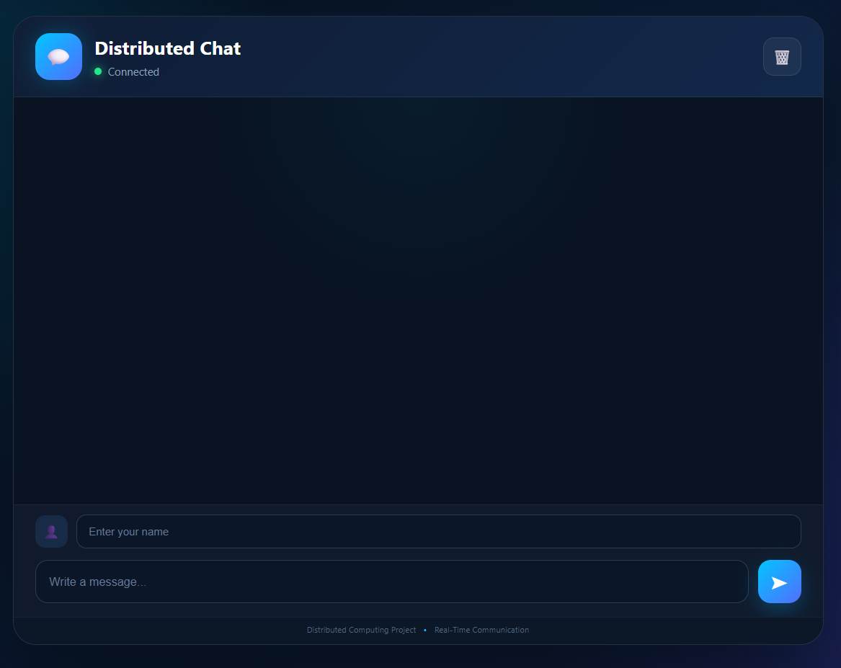
Figure 6.1: Main interface of the Distributed Chat Application
Interface Design Highlights
- Clear project identity with a dedicated chat header.
- Visible connected-server status.
- Username and message input fields.
- Real-time chat display area.
- Clear-chat button.
- Responsive design for different screen sizes.

6.4 MODULES AND MAIN FEATURES
Module / Feature | Description
User Identification | Allows the user to enter a name before sending messages.
Real-Time Messaging | Sends and receives messages through Socket.IO without manual page refresh.
Connection Status | Shows whether the browser is connected to the chat server.
Typing Indicator | Displays typing activity from another connected user.
Chat Display | Shows usernames and message content in the conversation area.
Clear Chat | Provides a control for clearing the current chat messages.
Responsive Interface | Adjusts the layout for laptop and phone-sized screens.
Keyboard Send | Allows the user to send a message using the Enter key.
6.5 TECHNOLOGIES USED
- Python – main programming language used for the server.
- Flask – lightweight Python web framework.
- Flask-SocketIO – real-time event communication between server and clients.
- Socket.IO JavaScript Client – connects the browser to the real-time server.
- HTML – structure of the chat interface.
- CSS – styling, layout, gradients, message bubbles and responsive design.
- JavaScript – user interaction and real-time chat event handling.

6.6 IMPORTANT CODE – SERVER
The server.py file starts the Flask application and Socket.IO service. The following is a key code excerpt representing the real-time message flow used in the project.
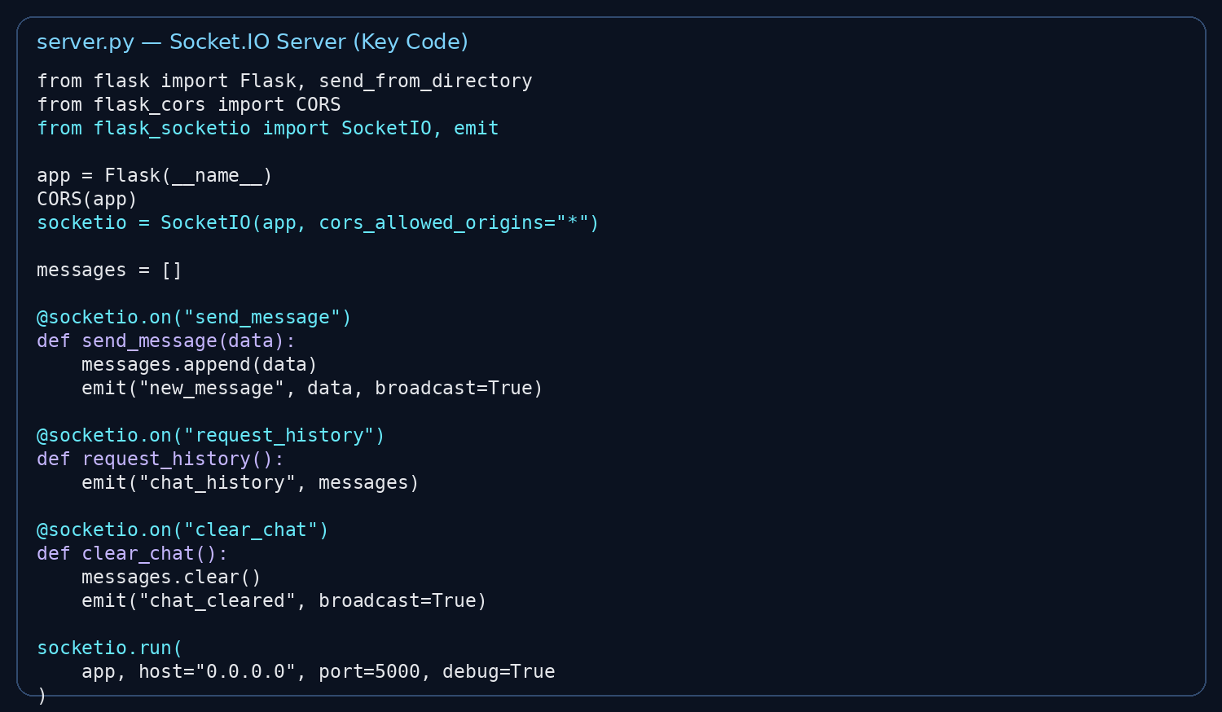
Figure 6.2: server.py – Socket.IO server code excerpt

6.7 IMPORTANT CODE – FRONTEND
The frontend consists of HTML, CSS and JavaScript. HTML defines the interface, CSS provides the visual design, and JavaScript handles Socket.IO communication and user interaction.
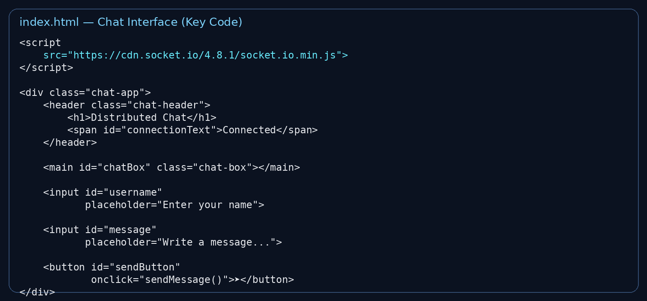
Figure 6.3: index.html – chat interface code excerpt

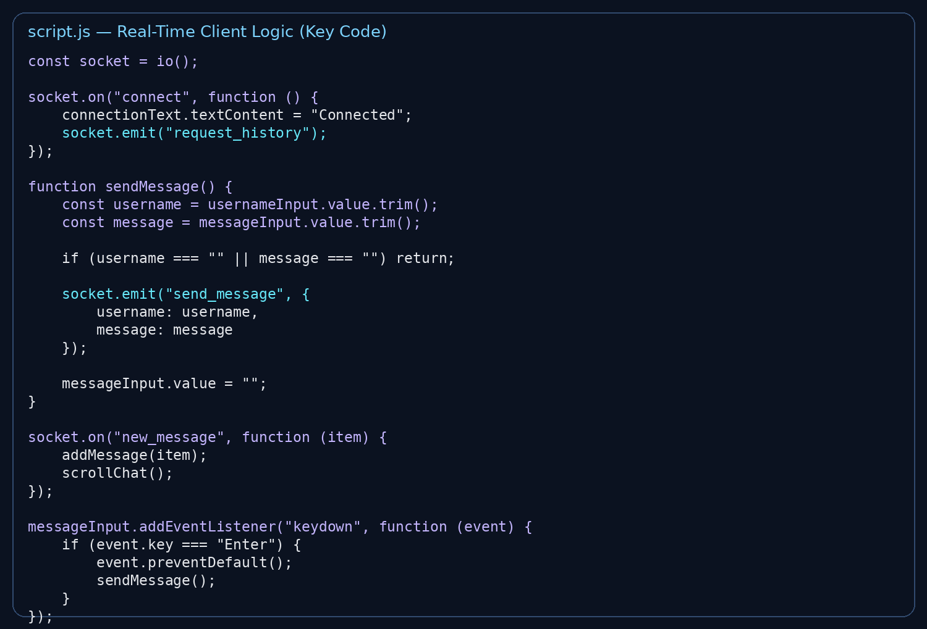
Figure 6.4: script.js – real-time communication code excerpt

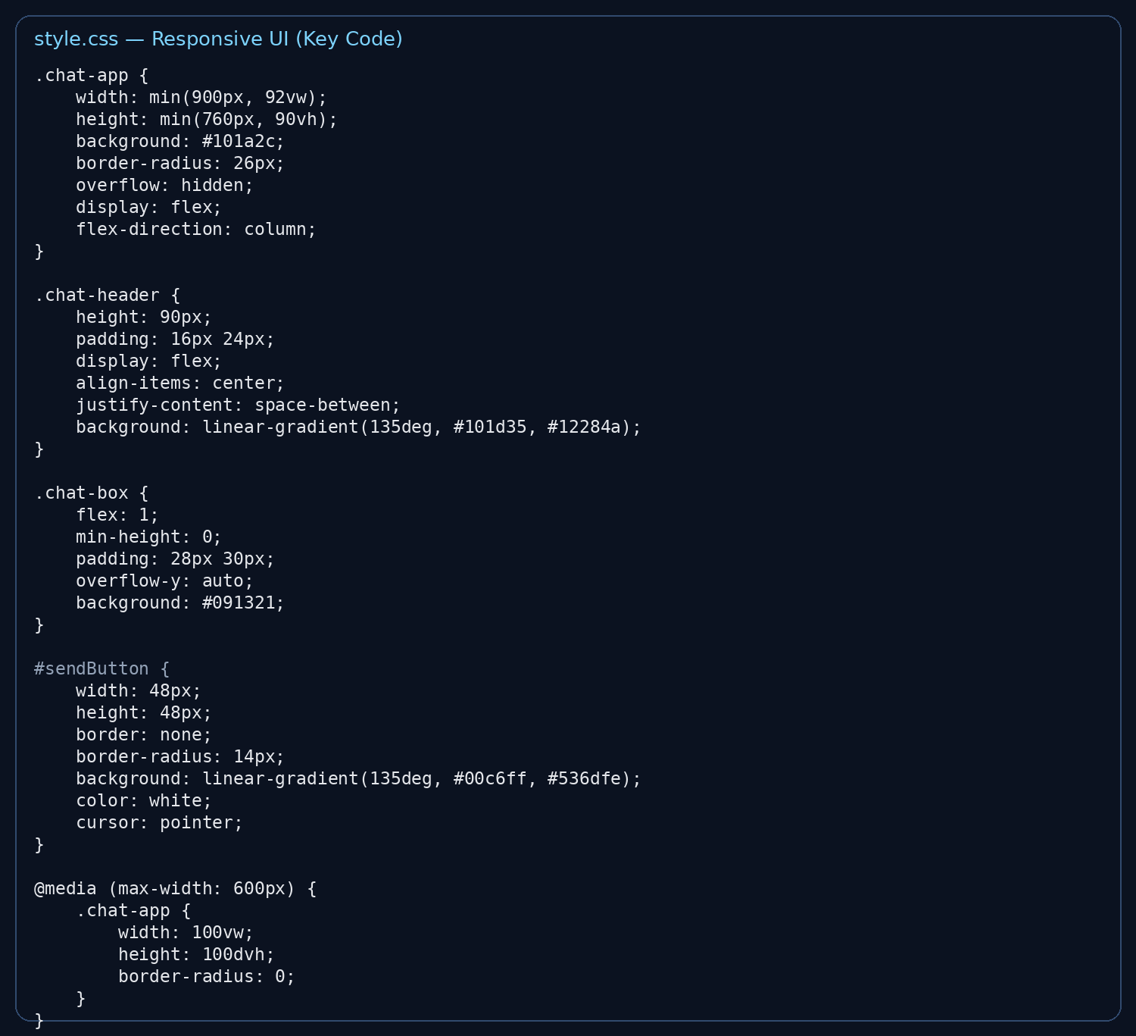
Figure 6.5: style.css – responsive design code excerpt

6.8 RESULT AND TEST CASES
The application was tested using the available chat interface and server setup. The tests focus on connection, message sending, real-time display, and basic interface functions.
Test Case | Input / Action | Expected Result | Status
1 | Open application | Chat interface loads successfully | Pass
2 | Enter username | Username is accepted | Pass
3 | Send a text message | Message appears in chat | Pass
4 | Connect another client | Connected client can participate in chat | Pass
5 | Type a message | Typing indicator can be shown | Pass
6 | Press Enter | Message is sent from the input | Pass
7 | Use Clear Chat | Current chat messages are cleared | Pass
Testing Result: The implemented workflow demonstrates the intended real-time chat behavior through the Flask-SocketIO server and browser client interface.
Observation
The project is intended as an academic demonstration of distributed communication. Its performance and accessibility depend on the server being available and, for multiple physical devices, the devices being able to reach the host system over the appropriate network.

6.9 COMPLEXITY AND LIMITATIONS
Time and Space Consideration
For each message, the application performs event handling, message storage in the running server, and broadcasting to connected clients. The amount of work grows with the number of messages and connected clients. The current implementation is lightweight and suitable for a small academic demonstration.
Current Limitations
- Messages are maintained in server memory during the running application and are not stored in a permanent database.
- The basic project does not provide user authentication or account management.
- The application is not designed as a production-scale messaging platform.
- Internet-wide access requires suitable deployment or networking configuration; the local server is primarily suitable for demonstration.
- Advanced features such as file sharing, voice/video calls and end-to-end encryption are outside the current project scope.

7. SCOPE OF PROJECT
The project is designed as an educational and practical demonstration of real-time distributed communication.
- Useful for classroom demonstrations of distributed computing.
- Can be used for simple real-time text communication between connected users.
- Can be extended to support group chat and multiple chat rooms.
- Can be connected to a database for permanent message storage.
- Can be deployed on a cloud server for wider access.
- Can be extended with authentication, file sharing and notifications.

8. PROS AND CONS OF PROJECT
Advantages | Limitations
Simple and easy-to-use interface. | No permanent database in the basic version.
Real-time message delivery. | Requires the server to be running.
Uses Socket.IO for event-based communication. | Not intended for large-scale production use.
Responsive design for different screen sizes. | No user authentication in the current version.
Good demonstration of client-server communication. | Advanced messaging features are not included.

9. FUTURE SCOPE
- Add a database such as MySQL or MongoDB for permanent chat history.
- Add user registration and secure login.
- Add group chat and separate chat rooms.
- Add message timestamps and delivery/read status.
- Add file and image sharing.
- Add notifications for new messages.
- Improve security and add stronger access controls.
- Deploy the application to a cloud platform for remote access.
- Add voice and video communication in a future advanced version.

10. CONCLUSION
The Distributed Chat Application successfully demonstrates the basic idea of distributed communication through a practical web application. The system uses a browser-based client, a Python Flask server, and Socket.IO to support real-time exchange of text messages.
The project provides a clear workflow: user input → Socket.IO event → Flask server → message broadcast → connected client display. Features such as username input, connection status, typing indication, clear chat, and responsive interface make the application suitable for an academic demonstration.
Although the current implementation is intentionally lightweight and does not include permanent storage, authentication, or advanced media communication, it provides a useful foundation for understanding real-time distributed systems and can be extended in many directions.

11. REFERENCES
- Flask Documentation – Documentation for the Python Flask web framework.
- Flask-SocketIO Documentation – Documentation for real-time Socket.IO communication with Flask.
- Socket.IO Documentation – Documentation for event-based real-time client-server communication.
- Python Documentation – Official documentation for the Python programming language.
- MDN Web Docs – HTML, CSS and JavaScript web development references.
- Class notes and lecture material for Distributed Computing.
- Source code and implementation developed for the Distributed Chat Application tiny project.
PROJECT SUBMISSION CHECKLIST
- Verify student names and enrollment numbers before printing.
- Enter the actual project guide name and obtain the guide signature.
- Check page numbering after final formatting.
- Run the application once before submission and keep the final working version available for demonstration.
- Use only screenshots from the actual working project; do not include unsupported features.

