VITYARTHI • COMPUTER SCIENCE PROJECT


SMART EXPENSE & BUDGET TRACKER
Project Report
Submitted as part of the VITyarthi Project Evaluation
SUBMITTED BY | ANUSHREE MISHRA
REGISTRATION ID | 26BCE10070
PROGRAM | B. TECH COMPUTER SCIENCE & ENGINEERING
YEAR | 1ST YEAR
FACULTY NAME | DR. CHANDAN KUMAR BEHERA
ACADEMIC YEAR | 2026–2027
TECHNOLOGY STACK
Python • Streamlit • MySQL • Pandas • Pytest
GITHUB REPOSITORY
https://github.com/Anushree-pc/Smart_Expense_Tracker.git

TABLE OF CONTENTS

S.NO. | TOPIC | PAGE NO.
1 | Introduction | 4
2 | Problem Statement | 4
3 | Objectives | 5
4 | Functional Requirements | 5-6
5 | Non-Functional Requirements | 7
6 | System Architecture | 8-9
7 | Workflow Diagram | 10
8 | Use Case Diagram | 11
9 | ER Diagram | 12
10 | Design Decisions & Rationale | 13-14
11 | Implementation Details | 15-16
12 | Screenshots | 16-20
13 | Testing Approach | 20-21
14 | Challenges Faced | 23
15 | Learnings & Key Takeaways | 24
16 | Future Enhancements | 25
17 | References | 26

1. Introduction
Managing personal money can become confusing when income, expenses, budgets, and spending records are kept manually. It can take time to check where money is going and whether a monthly budget is being followed.
I developed the Smart Expense & Budget Tracker as a Python-based web application to keep these records in one place. It lets the user record income and expenses, assign categories, set monthly budgets, check spending, analyse expenses, and generate monthly reports.
The application uses Python for the main logic, Streamlit for the interface, and MySQL for storing the data. I kept the code divided into separate modules for transactions, categories, budgets, analytics, and reports so that each part has a clear purpose.
I also added input validation, error handling, database connectivity, automated tests, and budget alerts. These features helped make the application easier to use and safer to work with.

2. Problem Statement
Managing income and expenses manually can make it difficult to keep accurate records and understand spending habits. While developing this project, I focused on the following common problems:
- Keeping track of multiple income and expense transactions.
- Understanding category-wise spending.
- Maintaining monthly budgets.
- Identifying when spending approaches a budget limit.
- Calculating total income, expenses, and remaining balance.
- Generating monthly financial reports.
The project solves these problems by keeping the financial records in one application. The user can enter transactions, set budgets, check spending, and view financial summaries without having to maintain separate records.

3. Objectives
The main objectives of this project are:
- To build a simple system for recording personal income and expenses.
- To provide an easy interface for adding and viewing transactions.
- To organize transactions into useful categories.
- To allow users to create monthly budgets for different categories.
- To show how much of each budget has been used and how much is left.
- To show a warning when spending gets close to or goes beyond a budget.
- To calculate total income, total expenses, and the remaining balance.
- To analyse spending by category and by month.
- To generate a financial report for a selected month.
- To use input validation, error handling, database management, and automated testing in the project.

4. Functional Requirements
The main functions included in the application are described below.

4.1 Transaction Management
Users can:
- Add income transactions.
- Add expense transactions.
- Choose a category for each transaction.
- Enter the amount, description, transaction type, category, and date.
- View their transaction history.
- Delete a selected transaction.
- The application checks the entered data before saving it.

4.2 Category Management
The application can:
- Store the available transaction categories in MySQL.
- Load the categories when a transaction is being added.
- Link each transaction with its selected category.

4.3 Budget Management
Users can:
- Create a monthly budget.
- Set a budget for a particular category.
- Store the budget amount, month, and year.
- Compare spending with the selected budget.
- See the amount remaining in the budget.
- View the current budget status.

4.4 Budget Alerts
The application checks budget usage and shows an alert when a spending limit is reached.
- At 80% or more of the budget, a warning is displayed.
- At 100% or more, the application shows that the budget has been exceeded.

4.5 Analytics
The application can:
- Calculate total income.
- Calculate total expenses.
- Calculate the current balance.
- Show spending for each category.
- Show monthly expense trends.
- Show the category with the highest spending.

4.6 Reports
Users can:
- Select the required month and year.
- Generate a monthly financial report.
- View the total income for that month.
- View the total expenses for that month.
- View the monthly balance.
- View the transaction records for the selected period.

5. Non-Functional Requirements
The project was also designed with a few non-functional requirements so that the application remains simple to use, reasonably safe, and easier to maintain.

5.1 Usability
The interface is kept simple so that users can move between transactions, budgets, analytics, and reports without complicated navigation.

5.2 Security
Database credentials are kept in environment variables instead of being written directly in the source code. The .env file is excluded using .gitignore, and parameterized SQL queries are used for database operations.

5.3 Reliability
Input validation and exception handling are used to deal with incorrect data and database errors. This helps prevent common problems from stopping the application unexpectedly.

5.4 Maintainability
The project is divided into separate modules for transactions, categories, budgets, analytics, and reports. This makes it easier to understand one part of the code without having to work through the whole application.

5.5 Performance
The database performs the main data retrieval and calculation queries, so the interface does not have to process all stored records itself.

5.6 Error Handling
Important values such as transaction amounts, descriptions, transaction types, budget amounts, months, and years are checked before database operations. Database errors are also handled in the code.

6. System Architecture
The application is organized into three main layers: the Streamlit interface, the Python application modules, and the MySQL database.
The user works with the application through Streamlit. The different pages call Python modules for transactions, categories, budgets, analytics, and reports. These modules use the database connection module to read from and write to MySQL.
The main parts of the architecture are shown in the diagram below.

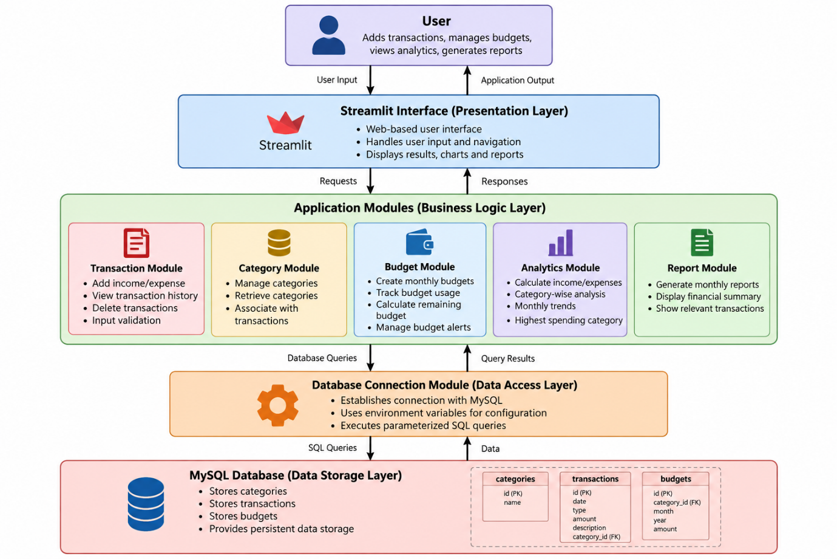

Architecture Components

1. User
The user enters transactions, creates budgets, checks analytics, and generates reports.

2. Streamlit Interface
Streamlit provides the web interface, accepts user input, and handles navigation between the different pages.

3. Application Modules
The application logic is split into separate modules for transactions, categories, budgets, analytics, and reports.

4. Database Connection Module
This module connects the Python application to MySQL using the configuration stored in environment variables.

5. MySQL Database
MySQL stores the categories, transactions, and budgets so that the data remains available when the application is used again.

7. Workflow Diagram
The workflow shows the main steps followed when a user works with the application. Data is entered through the interface, checked for errors, processed by the relevant module, and then stored in or retrieved from the MySQL database.

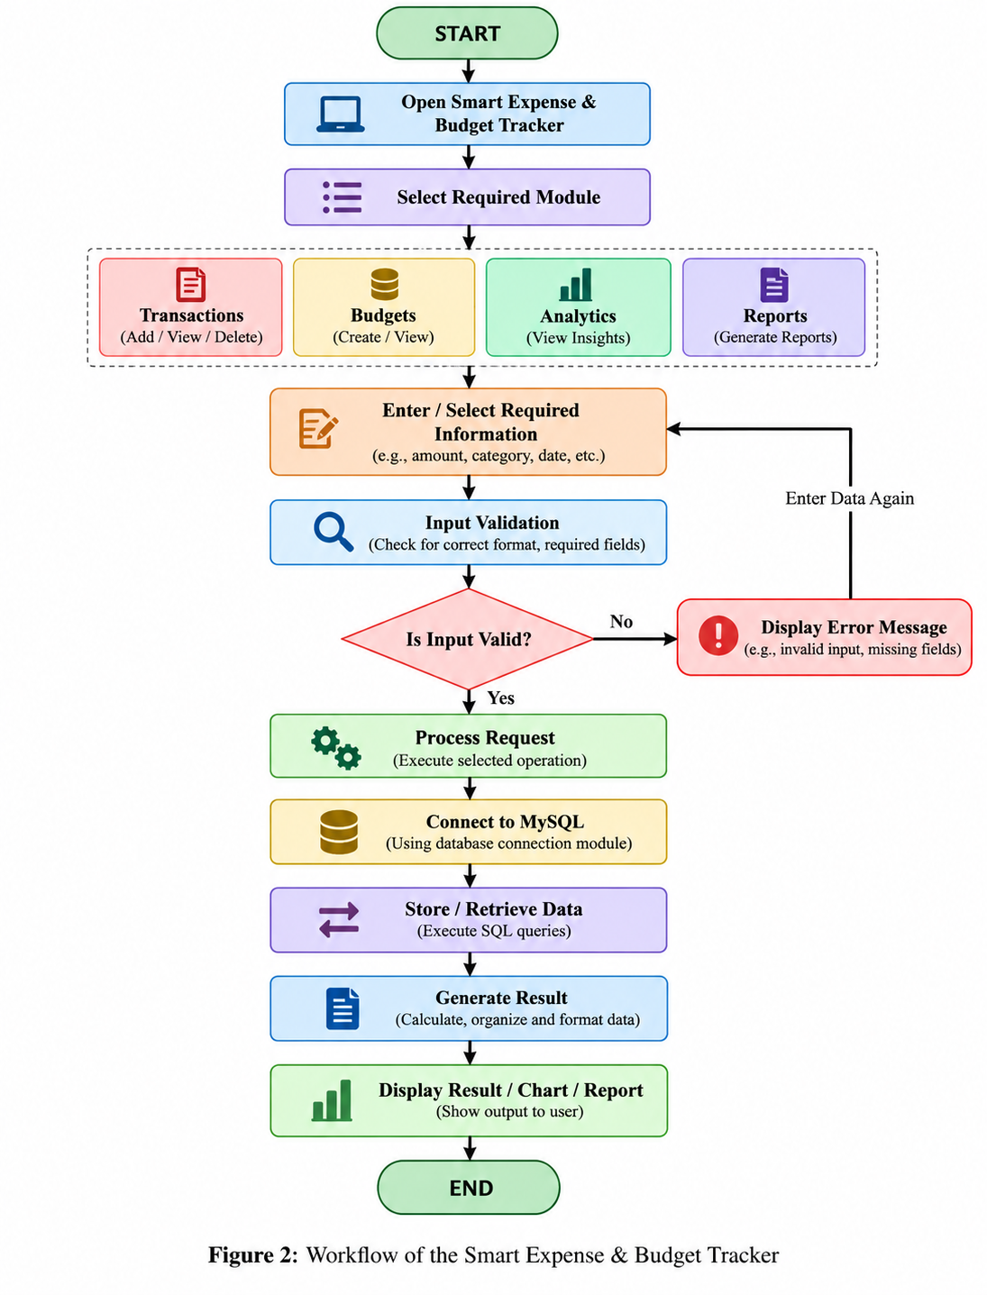

8. Use Case Diagram
The use case diagram shows the main actions available to the user. These include managing transactions and categories, creating and checking budgets, viewing analytics, generating monthly reports, and viewing budget alerts. Input validation and budget-threshold checking support these main functions.

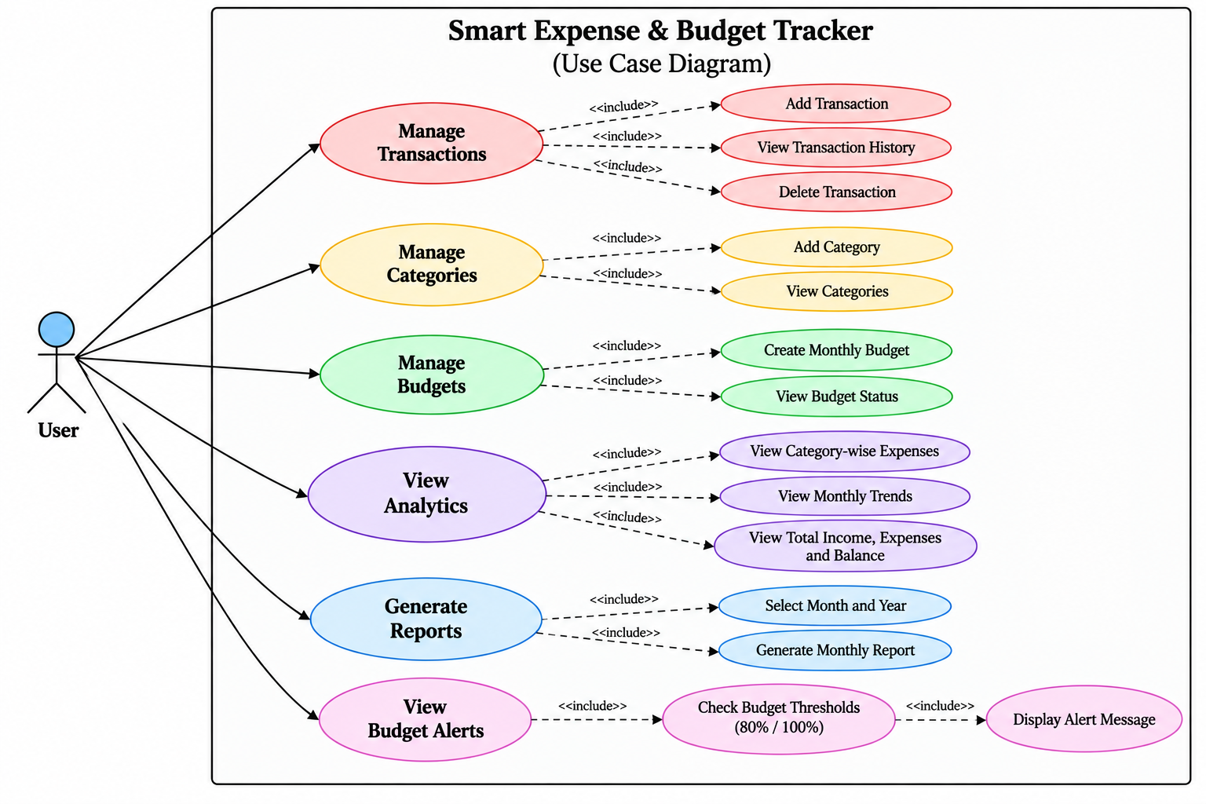
Figure 3: Use Case Diagram of the Smart Expense & Budget Tracker

9. ER Diagram
The database has three main tables: categories, transactions, and budgets. The category_id field connects transactions and budgets to their category. A single category can be linked to many transactions and budgets. Primary keys identify individual records, while foreign keys connect related records.
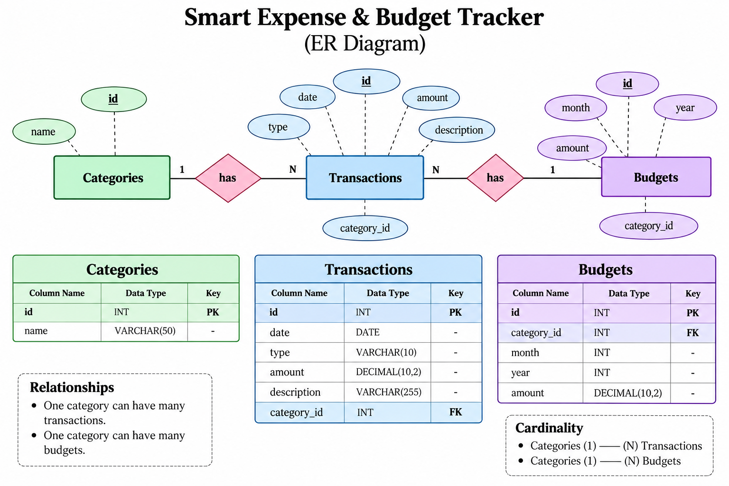

Figure 4: ER Diagram of the Smart Expense & Budget Tracker

10. Design Decisions & Rationale
The following choices were made while developing the project.

10.1 Python
I chose Python because its syntax is easy to work with and it has libraries that support database connectivity, data processing, testing, and application development.

10.2 Streamlit
I used Streamlit for the interface because it allowed me to build the web application using Python without having to create a separate frontend. It also provides forms, tables, metrics, charts, navigation, and other useful components.

10.3 MySQL
I used MySQL because the project needs to store related data such as categories, transactions, and budgets. Its relational structure also makes it possible to connect these tables using foreign keys.

10.4 Modular Architecture
I divided the project into separate modules for:
- Transaction management
- Category management
- Budget management
- Analytics
- Reports
Keeping these parts separate makes the code easier to read, test, and change.

10.5 Environment Variables
The database settings are stored in a .env file instead of being written directly in the Python files. This keeps the database password out of the source code and makes it easier to change the settings when needed.

10.6 Input Validation
The application checks important values before sending them to the database. For example, it checks transaction amounts, descriptions, transaction types, budget amounts, months, and years.

10.7 Parameterized SQL Queries
I used parameterized SQL queries when working with the database. This keeps user-provided values separate from the SQL statements and makes database operations safer.

10.8 Automated Testing
Pytest was used to test important parts of the project, including calculations, validation, budget alerts, database operations, and report generation.

11. Implementation Details
The application uses a modular Python structure. Streamlit handles the interface and MySQL stores the application data.

11.1 Application Entry Point
The app.py file is the starting point of the application. It sets up Streamlit and provides navigation to the Dashboard, Transactions, Budgets, Analytics, and Reports pages.

11.2 Transaction Module
The transaction module is responsible for:
- Adding income and expense transactions.
- Retrieving transaction history.
- Deleting transactions.
- Validating transaction information.

11.3 Category Module
The category module retrieves categories from MySQL and can also add new categories when required.

11.4 Budget Module
The budget module is responsible for:
- Creating monthly budgets.
- Retrieving budget information.
- Calculating budget status.
- Calculating remaining budget.
- Generating budget alerts.
A warning is shown when spending reaches 80% or more of the budget. When spending reaches 100% or more, the application shows an exceeded-budget alert.

11.5 Analytics Module
The analytics module calculates:
- Total income.
- Total expenses.
- Overall balance.
- Category-wise expenses.
- Monthly expense trends.
The calculated results are shown through metrics, tables, and visualizations in Streamlit.

11.6 Reports Module
The reports module creates a monthly summary for the selected month and year. It calculates income, expenses, and balance and retrieves the related transaction records.

11.7 Database Module
The database module connects the Python application to MySQL. The connection settings are loaded from environment variables.
The database currently contains three main tables:
- categories
- transactions
- budgets

11.8 Testing Module
The project includes a Pytest test module. The tests cover input validation, financial calculations, budget calculations, budget alerts, database operations, and monthly reports.

12. Screenshots
The application was tested through its main pages: Dashboard, Transactions, Budgets, Analytics, and Reports. The screenshots below show the working interface and the results produced during testing.
Some of the main results observed while testing the application were:
- Displays total income, expenses, and balance on the Dashboard.
- Allows users to add, view, and delete transactions.
- Allows users to create and monitor category-wise budgets.
- Generates alerts when budget usage reaches defined thresholds.
- Displays category-wise spending analysis.
- Displays monthly expense trends.
- Generates monthly financial reports.
- Stores financial information persistently using MySQL.
The screenshots below show the application running and demonstrate the main features.

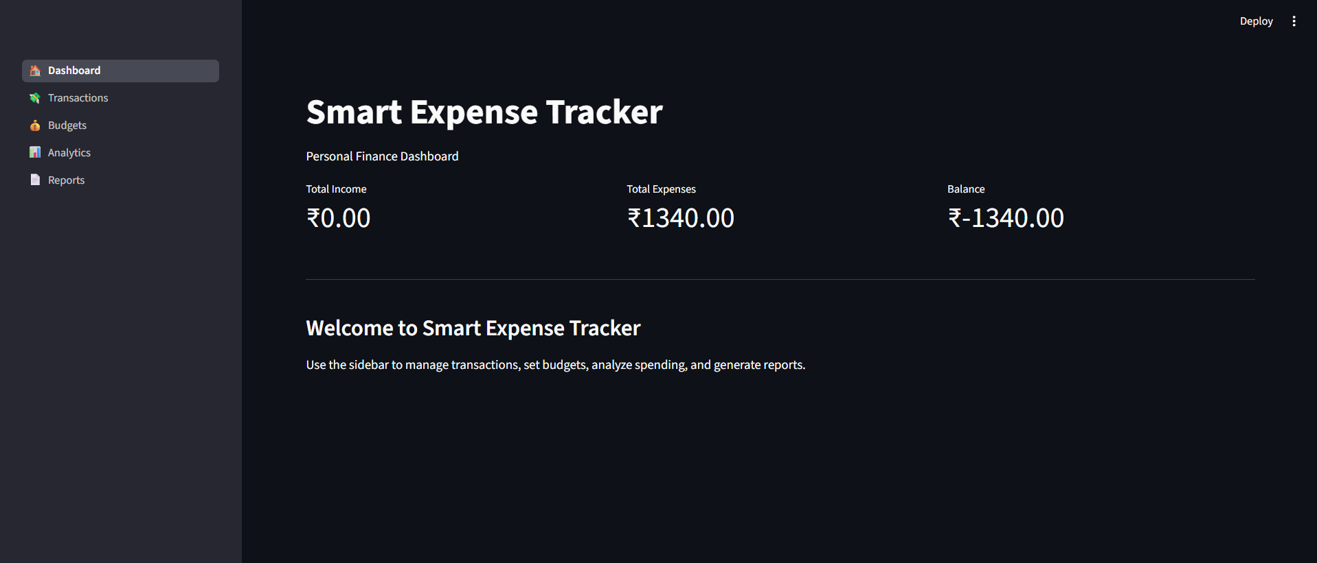
Figure 1: Dashboard displaying the overall financial summary
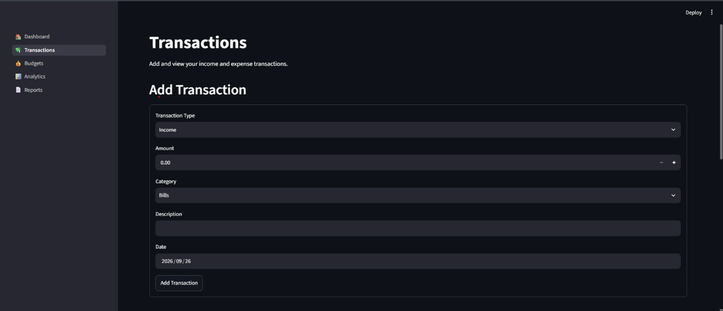
Figure 2: Transaction entry interface

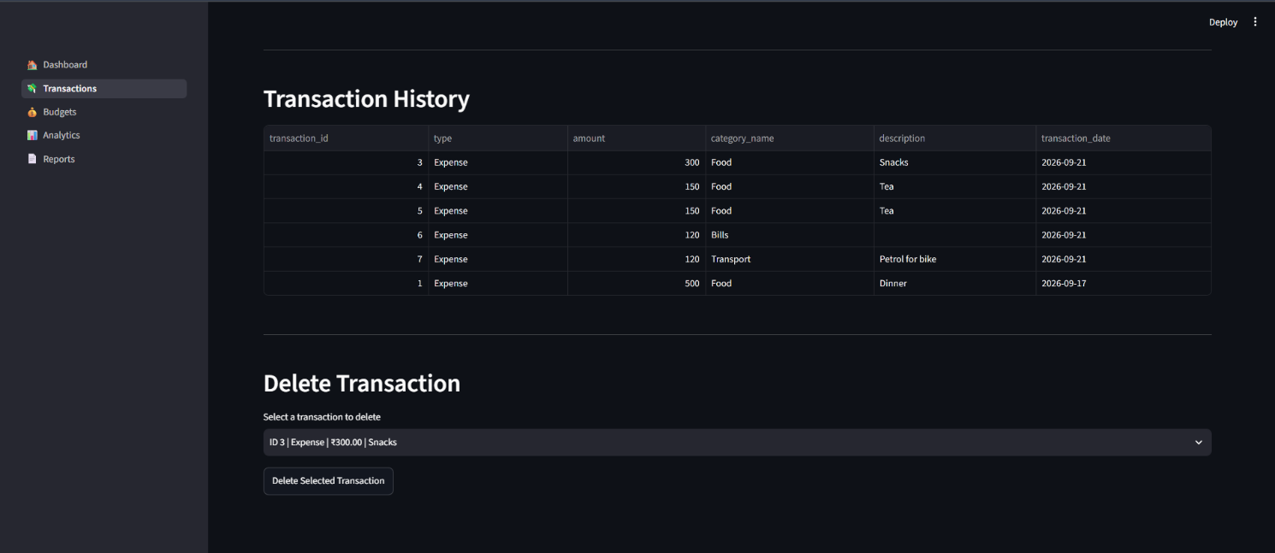
Figure 3: Transaction history and deletion interface
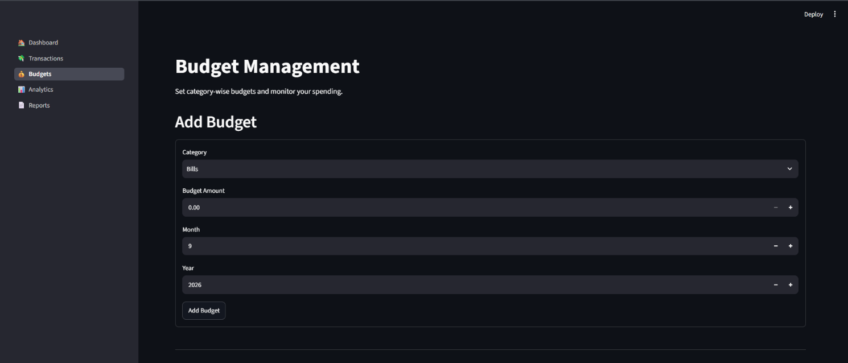
Figure 4: Budget creation interface

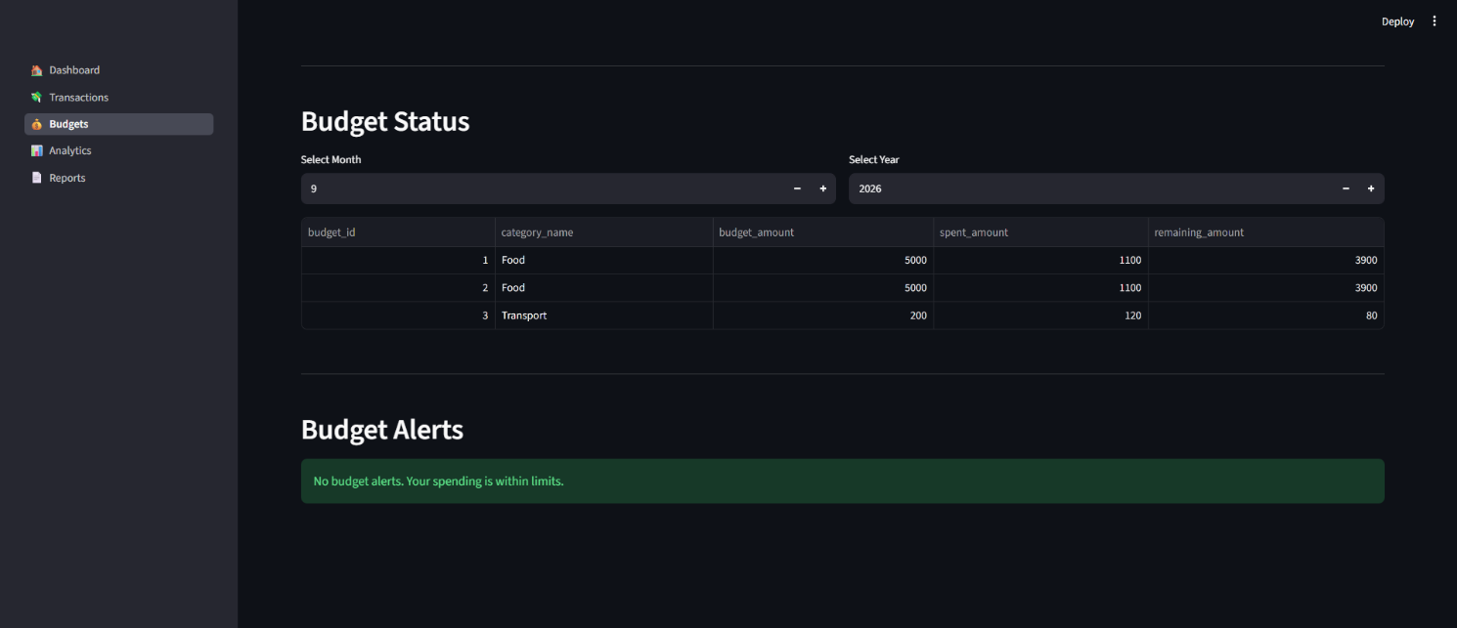
Figure 5: Budget status and budget alerts
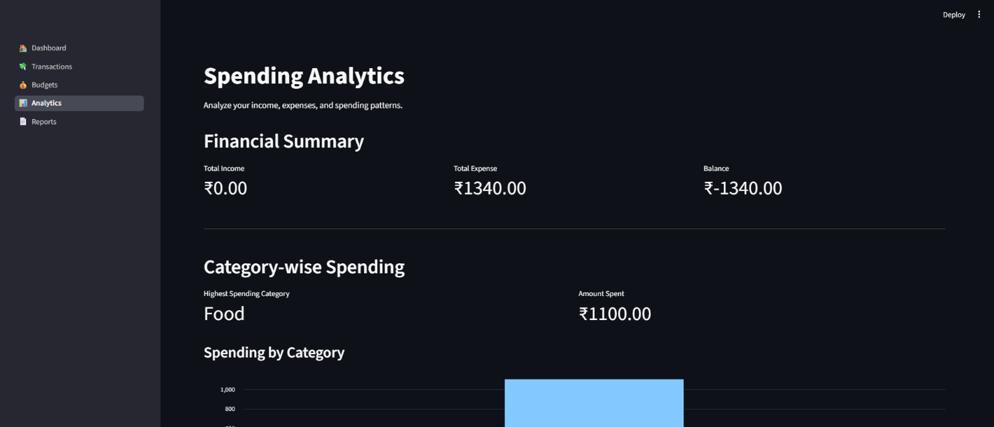
Figure 6: Spending analysis
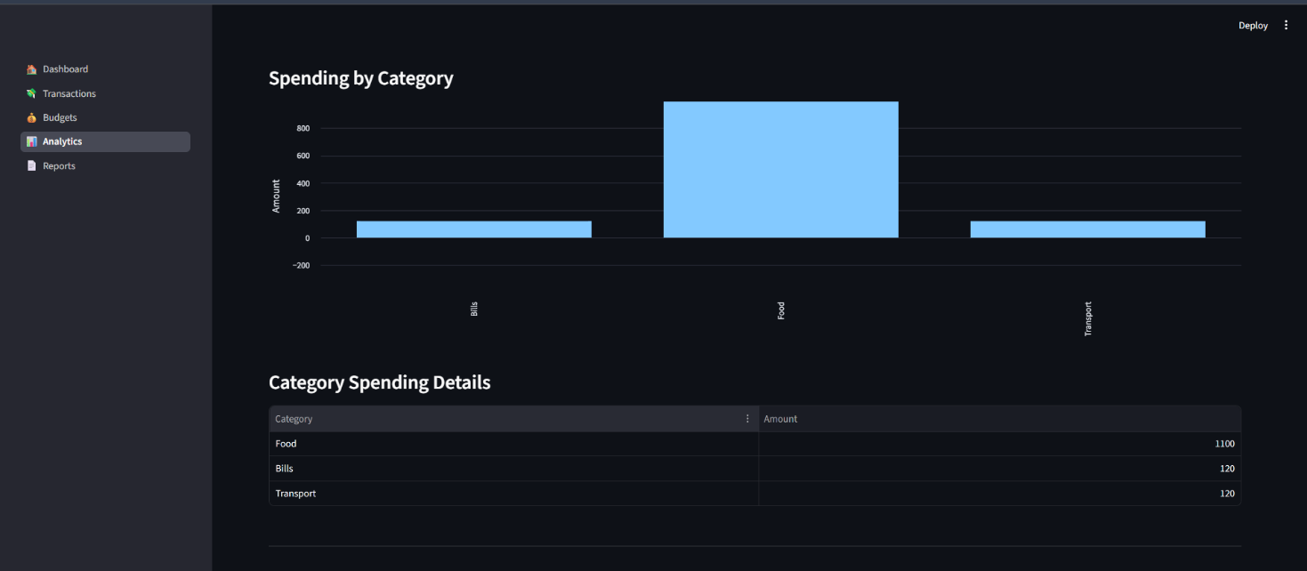
Figure 7 : Category Spending analysis
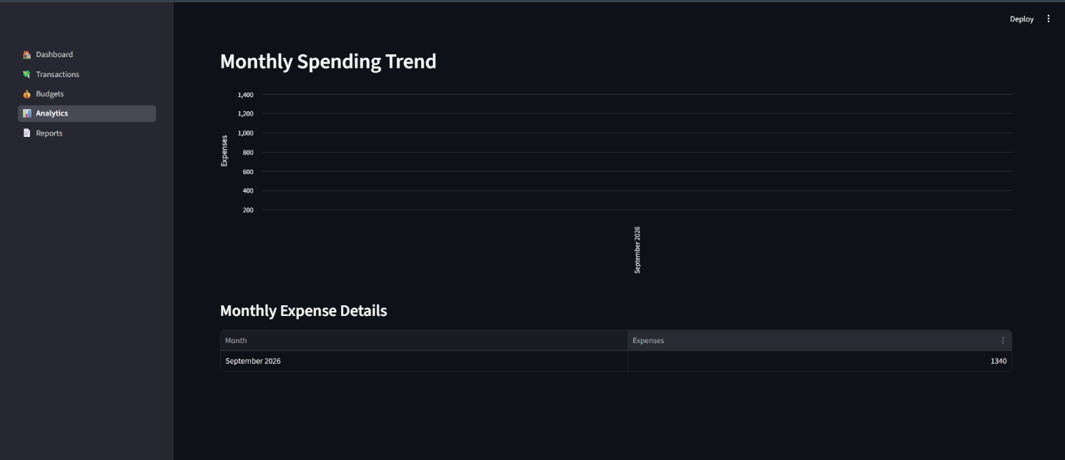
Figure 8: Monthly spending trend

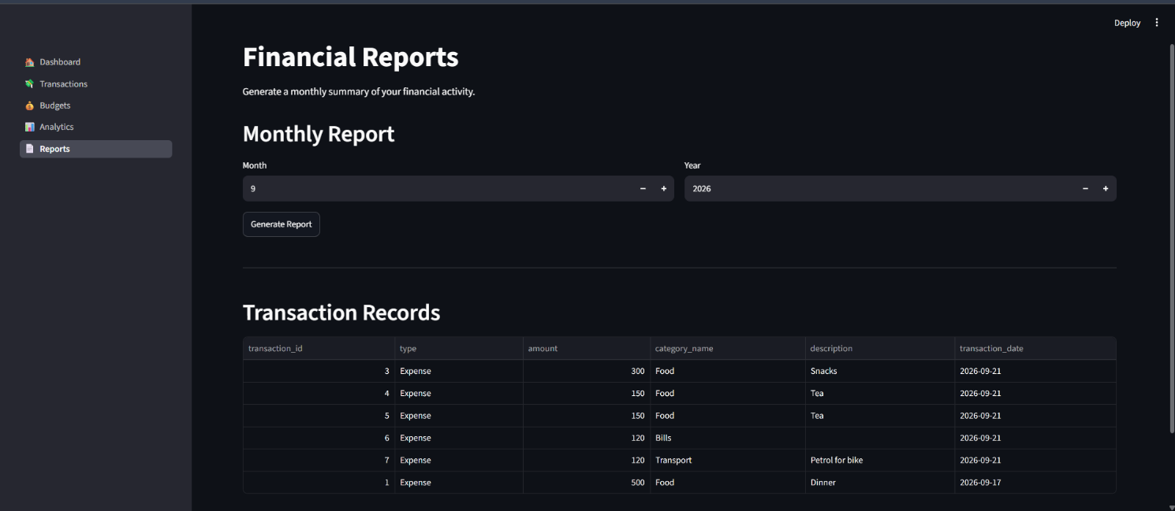
Figure 9: Monthly financial report
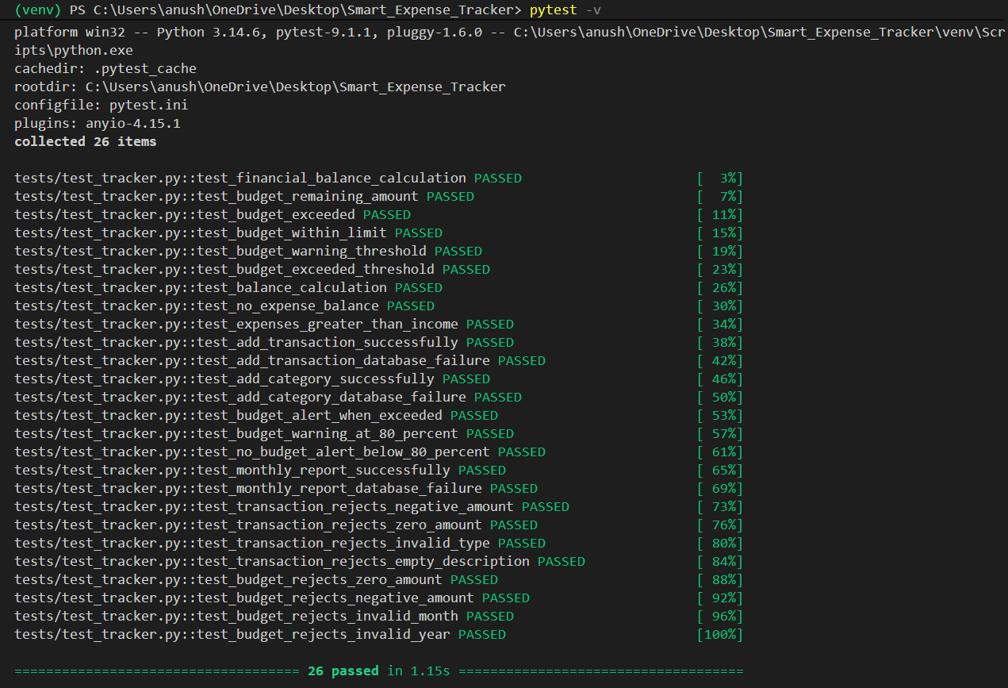
Figure 10: Pytest execution showing successful test results

13. Testing Approach
I tested the application to check whether its functions were working correctly and whether incorrect inputs were being rejected. Automated tests were written using Pytest.
Pytest is used as the automated testing framework for the project.
The tests cover the following areas:

13.1 Financial Calculations
Tests verify:
- Total income calculation.
- Total expense calculation.
- Balance calculation.

13.2 Transaction Validation
Tests verify that:
- Negative transaction amounts are rejected.
- Zero transaction amounts are rejected.
- Invalid transaction types are rejected.
- Empty transaction descriptions are rejected.

13.3 Budget Validation
Tests verify that:
- Zero budget amounts are rejected.
- Negative budget amounts are rejected.
- Invalid months are rejected.
- Invalid years are rejected.

13.4 Budget Alert Testing
Tests verify the budget alert conditions, including:
- Normal budget usage.
- Warning threshold at 80%.
- Budget exceeded condition at 100% or above.

13.5 Database Operation Testing
For database-related functions, mocked database connections were used so that the tests could check the application logic without depending completely on the live database.
The tests cover transaction, category, budget, and report operations.

13.6 Report Testing
The monthly report was tested to make sure that income, expenses, and balance were calculated correctly for the selected month and year.

13.7 Test Result
The final test run completed with:
26 tests passed
All the tested validation, calculation, database, budget-alert, and reporting functions passed successfully in the final test run.

14. Challenges Faced
While building the project, I faced several practical problems and had to debug them step by step.

14.1 Database Connectivity
Getting Python to connect correctly with MySQL required setting up the MySQL service, database, credentials, and environment variables properly.

14.2 Input Validation
I had to handle different invalid inputs such as zero or negative amounts, empty descriptions, invalid months, and invalid years.

14.3 Streamlit Application Structure
As the application grew into multiple Streamlit pages, keeping the interface files separate from the backend modules required some restructuring of the project.

14.4 Database Testing
Database functions needed to be tested without unnecessarily changing real records. I handled this by using mocked database connections in the tests.

14.5 Debugging User Interface Issues
I also found a Streamlit page logic and indentation issue that could cause a transaction to be inserted more than once. Finding and fixing this helped me understand how small UI-code mistakes can affect database operations.

14.6 Maintaining Modular Code
Keeping database operations, application logic, interface code, and tests in separate files also took some effort, but it made the final project much easier to manage.

15. Learnings & Key Takeaways
Working on this project gave me practical experience with several parts of software development.
The main things I learned were:
- How a Python application connects to and works with a MySQL database.
- How to organize a project into separate modules instead of putting everything in one file.
- How CRUD operations and database relationships work in a real application.
- How to build a simple web interface using Streamlit.
- Why input validation is important when accepting user data.
- How to handle database and application errors.
- How environment variables can be used for configuration.
- How automated testing can help find problems before submission.
- How Git and GitHub can be used to track project changes and manage source code.
- How the database design and system architecture affect the way the application is implemented.
- How debugging can gradually improve a working application.
Overall, the project helped me connect the Computer Science concepts I learned in class with a practical application involving data storage, processing, analysis, and reporting.

16. Future Enhancements
The current version covers the main requirements of an expense and budget tracker. If I continue developing it, I would like to add the following features:
- User Authentication
Add login and registration so that the application can support multiple users.
- CSV and PDF Export
Allow users to download transactions and reports in commonly used file formats.
- Recurring Transactions
Add support for expenses and income that repeat automatically.
- Advanced Analytics
Add more detailed analysis of spending patterns and financial trends.
- Mobile-Friendly Interface
Improve the layout so that the application works more comfortably on phones and tablets.
- More Visualizations
Add more charts for comparing income, expenses, categories, and budgets.
- Enhanced Financial Insights
Use previous transaction data to provide more detailed spending insights.
- Budget Management Improvements
Allow users to edit existing budgets and set up repeated monthly budgets.

17. References
- Python Documentation, Python Programming Language Documentation.
- Streamlit Documentation, Streamlit Application Development Documentation.
- MySQL Documentation, MySQL Reference Manual.
- Pytest Documentation, Pytest Documentation and Testing Framework.
- Pandas Documentation, Pandas Python Data Analysis Library Documentation.
- VITyarthi, Build Your Own Project: General Project Instructions & Submission Guidelines.
- GitHub Repository - https://github.com/Anushree-pc/Smart_Expense_Tracker.git

