
SMART EXPENSE & BUDGET TRACKER
Project Report Submitted as part of the VITyarthi


Submitted By
AnuSHREE MISHRA
Reg.Id-26BCE10070
B.Tech Computer Science & Engineering
1st Year
Academic Year: 2026–2027
GitHub Repository:

1. Introduction
Managing personal finances effectively requires users to keep track of their income, expenses, budgets, and spending patterns. When financial records are maintained manually, it can become difficult to monitor where money is being spent and whether monthly budgets are being followed.
The Smart Expense & Budget Tracker is a Python-based web application developed to provide a centralized solution for personal financial management. The application allows users to record income and expense transactions, organize them into categories, create monthly budgets, monitor budget usage, analyse spending patterns, and generate monthly financial reports.
The application uses Python for the core application logic, Streamlit for the user interface, and MySQL for persistent data storage. The project follows a modular structure in which transaction management, budget management, analytics, categories, and reports are implemented as separate modules.
The project also incorporates input validation, error handling, database connectivity, automated testing, and budget alerts to provide a structured and reliable financial management system.

2. Problem Statement
Managing personal income and expenses manually can make it difficult to maintain accurate financial records and monitor spending patterns. Users may face difficulties such as:
- Keeping track of multiple income and expense transactions.
- Understanding category-wise spending.
- Maintaining monthly budgets.
- Identifying when spending approaches a budget limit.
- Calculating total income, expenses, and remaining balance.
- Generating monthly financial reports.
Therefore, there is a need for a simple computerized system that can store financial transactions, manage budgets, analyze spending data, and provide meaningful financial summaries. The Smart Expense & Budget Tracker addresses this problem by providing a centralized web-based application for recording, managing, analyzing, and reporting personal financial information.
3. Objectives
The main objectives of the project are:
- To develop a computerized system for managing personal income and expenses.
- To provide an easy-to-use interface for adding and viewing financial transactions.
- To organize transactions using predefined categories.
- To allow users to create and manage category-wise monthly budgets.
- To monitor budget usage and calculate the remaining budget.
- To generate alerts when spending reaches significant budget thresholds.
- To calculate financial summaries such as total income, total expenses, and balance.
- To provide category-wise and monthly spending analysis.
- To generate monthly financial reports.
- To implement proper input validation, error handling, database management, and automated testing.

4. Functional Requirements
The functional requirements describe the operations that the system must perform.
4.1 Transaction Management
The system shall:
- Allow users to add income transactions.
- Allow users to add expense transactions.
- Allow users to select a category for each transaction.
- Store transaction amount, description, type, category, and date.
- Display transaction history.
- Allow users to delete selected transactions.
- Validate transaction inputs before storing them.
4.2 Category Management
The system shall:
- Store transaction categories in the database.
- Retrieve available categories when adding transactions.
- Associate transactions with their respective categories.
4.3 Budget Management
The system shall:
- Allow users to create monthly budgets.
- Associate budgets with specific categories.
- Store the budget amount, month, and year.
- Calculate the amount spent against each budget.
- Calculate the remaining budget.
- Display the current budget status.
4.4 Budget Alerts
The system shall monitor budget usage and generate alerts.
- When spending reaches 80% or more of the budget, the system displays a warning.
- When spending reaches or exceeds 100%, the system displays a budget-exceeded alert.
4.5 Analytics
The system shall:
- Calculate total income.
- Calculate total expenses.
- Calculate the current balance.
- Display category-wise expenses.
- Display monthly expense trends.
- Identify the category with the highest spending.
4.6 Reports
The system shall:
- Allow users to select a month and year.
- Generate a monthly financial report.
- Display total monthly income.
- Display total monthly expenses.
- Calculate the monthly balance.
- Display relevant transaction records.

5. Non-Functional Requirements
The project considers the following non-functional requirements. The VITyarthi guidelines require at least four non-functional requirements, with examples including performance, security, usability, reliability, maintainability, and error handling.
5.1 Usability
The application should provide a simple and understandable interface so that users can add transactions, manage budgets, view analytics, and generate reports without complicated navigation.
5.2 Security
Database credentials are stored using environment variables rather than directly in the application source code. The .env file is excluded from version control using .gitignore.
The application also uses parameterized SQL queries for database operations.
5.3 Reliability
The application includes validation and exception handling to prevent invalid inputs and handle database-related errors without causing the application to terminate unexpectedly.
5.4 Maintainability
The application follows a modular structure. Transaction management, category management, budget management, analytics, and reporting are implemented as separate Python modules. This makes individual components easier to understand, test, and modify.
5.5 Performance
Database queries are used to retrieve and calculate required financial information rather than processing the entire dataset unnecessarily in the user interface.
5.6 Error Handling
The system validates important inputs such as transaction amount, transaction type, description, budget amount, month, and year before performing database operations.
Database exceptions are also handled using error-handling mechanisms.

6. System Architecture
The Smart Expense & Budget Tracker follows a modular architecture consisting of a presentation layer, application logic layer, and database layer.
The user interacts with the application through the Streamlit interface. The interface communicates with separate Python modules responsible for transactions, categories, budgets, analytics, and reports. These modules communicate with the MySQL database through the database connection module.
The architecture can be represented as follows:

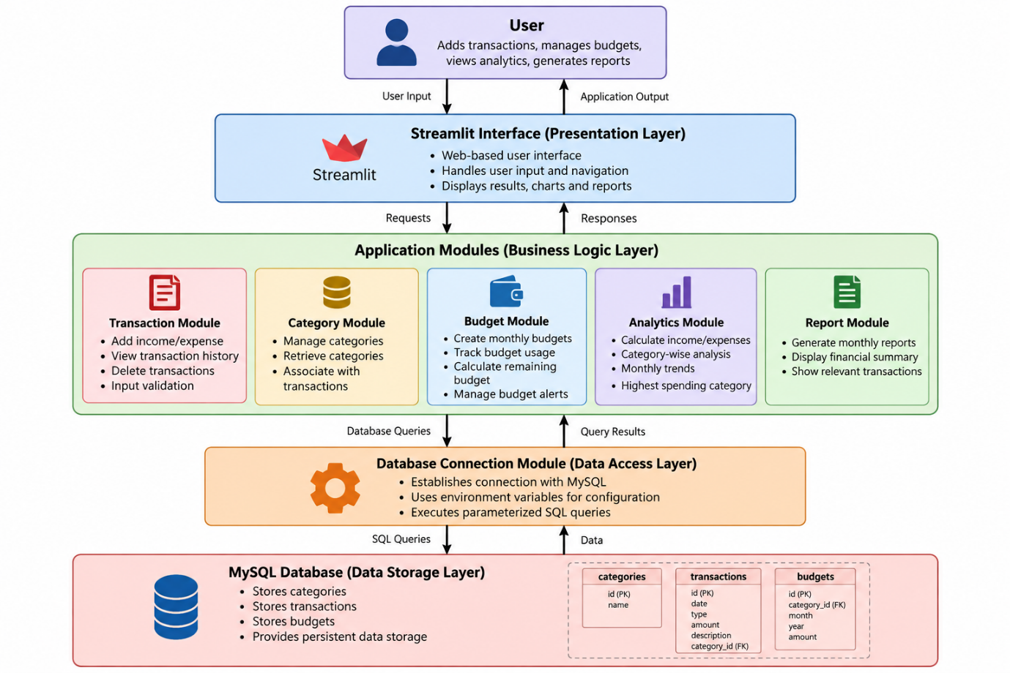

Architecture Components
1. User
The user interacts with the application to record transactions, create budgets, view analytics, and generate reports.
2. Streamlit Interface
Streamlit provides the web-based user interface and handles user input and navigation between application pages.
3. Application Modules
The application logic is divided into separate modules for transactions, categories, budgets, analytics, and reports.
4. Database Connection Module
The database connection module establishes communication between the Python application and MySQL using configuration values stored in environment variables.
5. MySQL Database
MySQL provides persistent storage for categories, transactions, and budgets.

7. Workflow Diagram
The workflow of the Smart Expense & Budget Tracker describes how a user interacts with the application, how the input is validated and processed, and how the required information is stored or retrieved from the database.
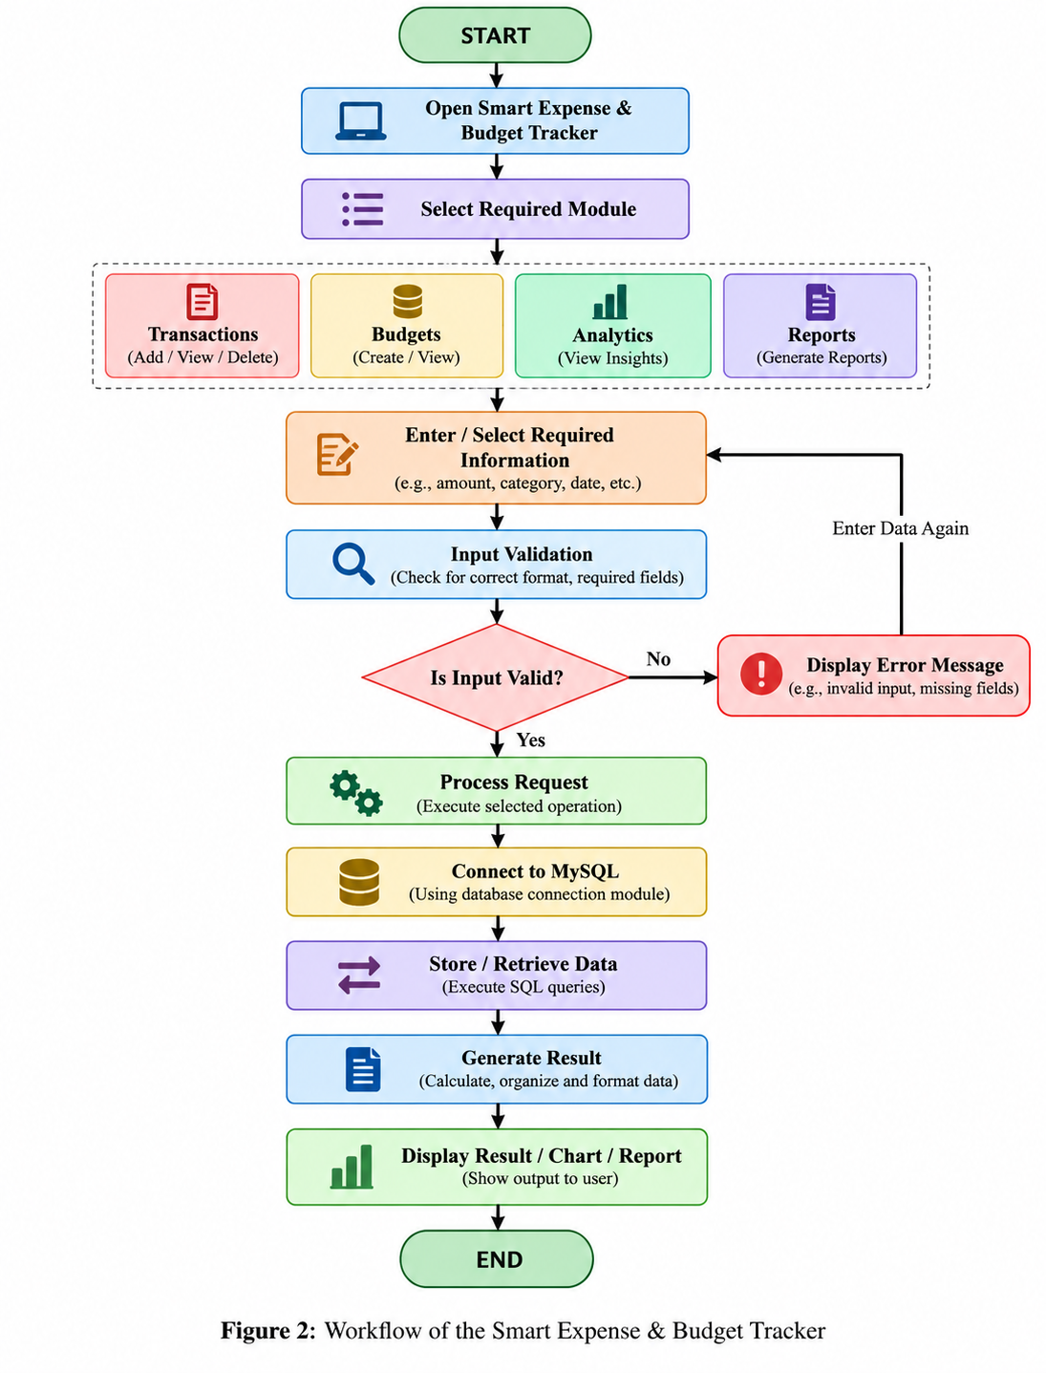

8. Use Case Diagram
The use case diagram represents the interactions between the user and the major functions of the Smart Expense & Budget Tracker. The user can manage transactions and categories, create and monitor budgets, view analytics, generate monthly reports, and view budget alerts. Input validation and budget-threshold checking are included as supporting system functions.

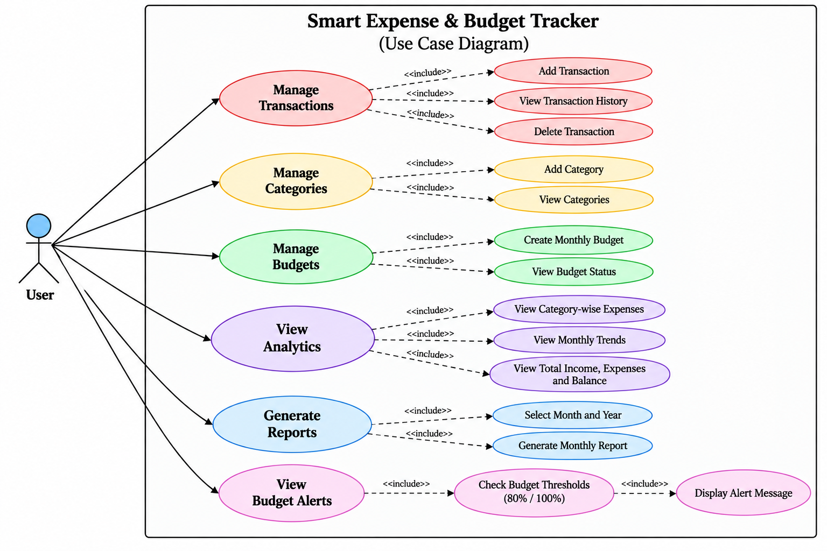
Figure 3: Use Case Diagram of the Smart Expense & Budget Tracker

9. ER Diagram
The database consists of three main tables: categories, transactions, and budgets. The category_id field connects transactions and budgets with their corresponding category. One category can be associated with multiple transactions and multiple budgets. Primary keys uniquely identify records, while foreign keys establish relationships between the tables.
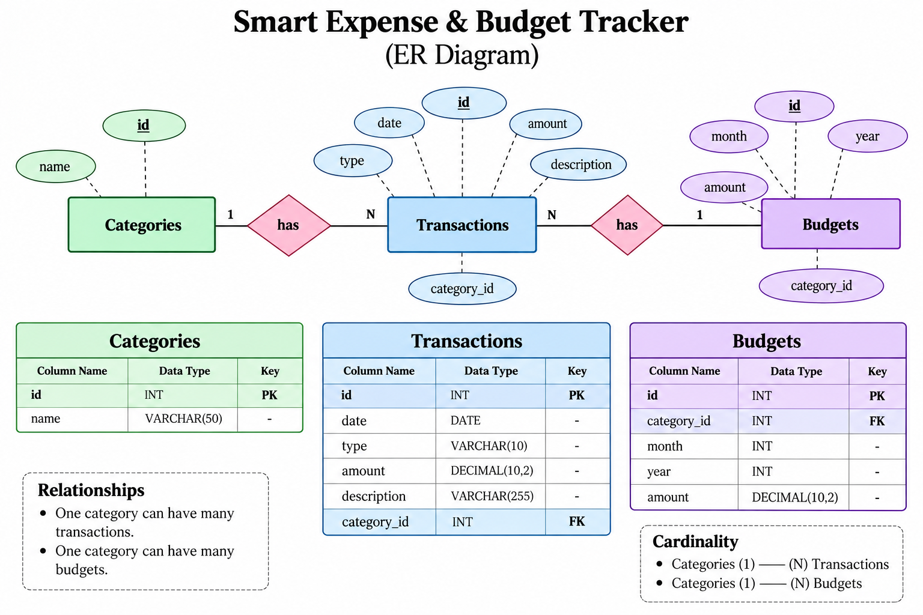

Figure 4: ER Diagram of the Smart Expense & Budget Tracker

10. Design Decisions & Rationale
The following design decisions were made during the development of the Smart Expense & Budget Tracker.
10.1 Python
Python was selected as the primary programming language because it provides simple syntax, extensive libraries, and suitable support for database connectivity, data processing, testing, and web application development.
10.2 Streamlit
Streamlit was selected for the user interface because it allows Python-based applications to be converted into interactive web applications without requiring a separate frontend framework. It also provides built-in components for forms, tables, metrics, charts, navigation, and user input.
10.3 MySQL
MySQL was selected for persistent data storage because the application manages structured and related data such as categories, transactions, and budgets. The relational structure allows foreign keys to connect transactions and budgets with their corresponding categories.
10.4 Modular Architecture
The project is divided into separate modules for:
- Transaction management
- Category management
- Budget management
- Analytics
- Reports
This separation improves code organization, maintainability, and testing.
10.5 Environment Variables
Database configuration is stored in the .env file instead of being directly written into the source code.
This prevents database credentials from being exposed in the project source and allows configuration to be changed without modifying application code.

10.6 Input Validation
Validation is performed before database operations to prevent invalid data from being stored. Examples include checking transaction amounts, descriptions, transaction types, budget amounts, months, and years.
10.7 Parameterized SQL Queries
Parameterized SQL queries are used for database operations. This separates SQL commands from user-provided values and provides safer database interaction.
10.8 Automated Testing
Pytest was used to test important application functionality such as calculations, validation, budget alerts, database operations, and report generation.

11. Implementation Details
The application is implemented using a modular Python architecture with Streamlit as the presentation layer and MySQL as the database layer.
11.1 Application Entry Point
The app.py file acts as the main entry point of the application. It configures the Streamlit application and provides navigation between the Dashboard, Transactions, Budgets, Analytics, and Reports pages.
11.2 Transaction Module
The transaction module handles:
- Adding income and expense transactions.
- Retrieving transaction history.
- Deleting transactions.
- Validating transaction information.
11.3 Category Module
The category module handles retrieving categories from the MySQL database and adding categories when required.
11.4 Budget Module
The budget module handles:
- Creating monthly budgets.
- Retrieving budget information.
- Calculating budget status.
- Calculating remaining budget.
- Generating budget alerts.
Budget alerts are generated when spending reaches 80% or more of the assigned budget, while spending at or above 100% generates an exceeded-budget alert.
11.5 Analytics Module
The analytics module calculates:
- Total income.
- Total expenses.
- Overall balance.
- Category-wise expenses.
- Monthly expense trends.
The results are displayed through metrics, tables, and visualizations in the Streamlit interface.
11.6 Reports Module
The reports module generates monthly financial summaries based on the selected month and year. It calculates income, expenses, and balance and retrieves the relevant transaction information.
11.7 Database Module
The database connection module establishes a connection between the Python application and MySQL. Database configuration is loaded from environment variables.
The database contains three main tables:
- categories
- transactions
- budgets
11.8 Testing Module
The project includes a Pytest-based testing module. Tests cover validation logic, financial calculations, budget calculations, budget alerts, database operations, and monthly report generation.
12. Screenshots
The developed application provides a functional web-based interface for managing personal financial information. The major application pages include the Dashboard, Transactions, Budgets, Analytics, and Reports sections.
The application successfully provides the following results:
- Displays total income, expenses, and balance on the Dashboard.
- Allows users to add, view, and delete transactions.
- Allows users to create and monitor category-wise budgets.
- Generates alerts when budget usage reaches defined thresholds.
- Displays category-wise spending analysis.
- Displays monthly expense trends.
- Generates monthly financial reports.
- Stores financial information persistently using MySQL.
Screenshots of the implemented application are provided below to demonstrate the working system.

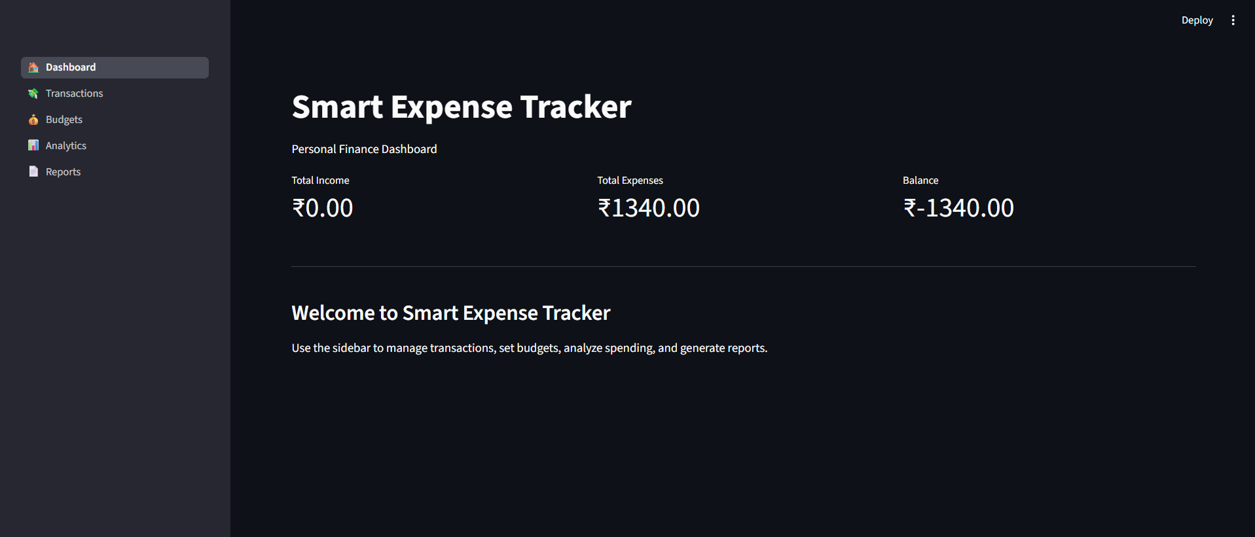
Figure 1: Dashboard displaying the overall financial summary
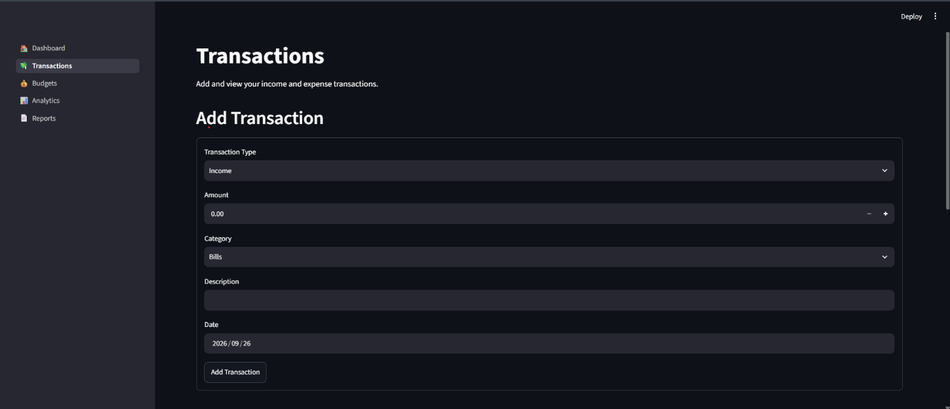
Figure 2: Transaction entry interface

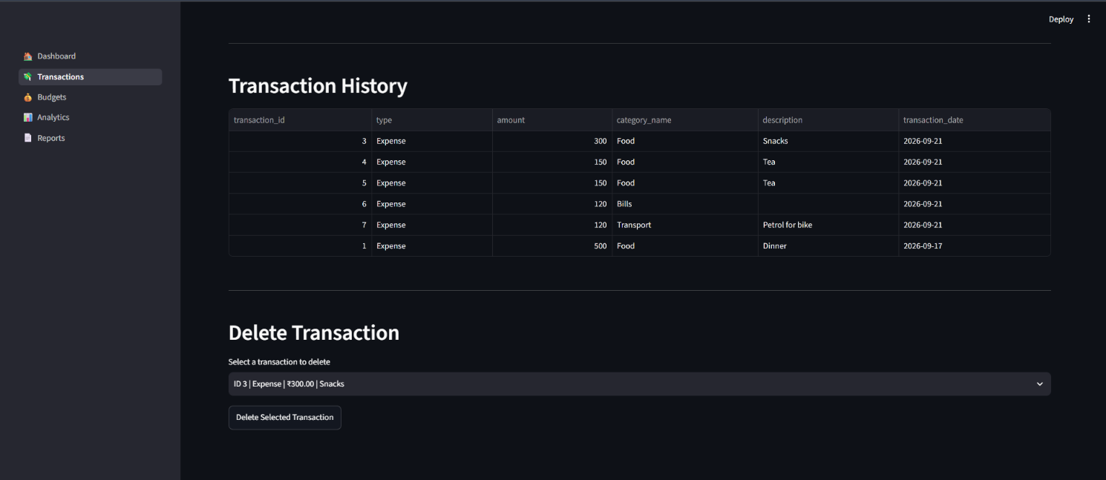
Figure 3: Transaction history and deletion interface
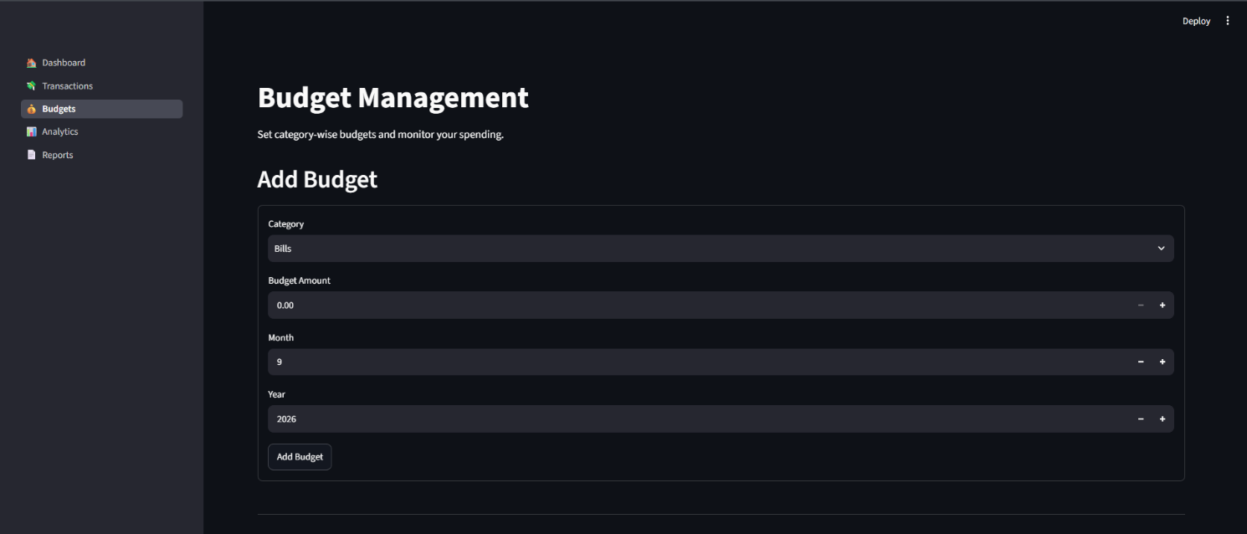
Figure 4: Budget creation interface

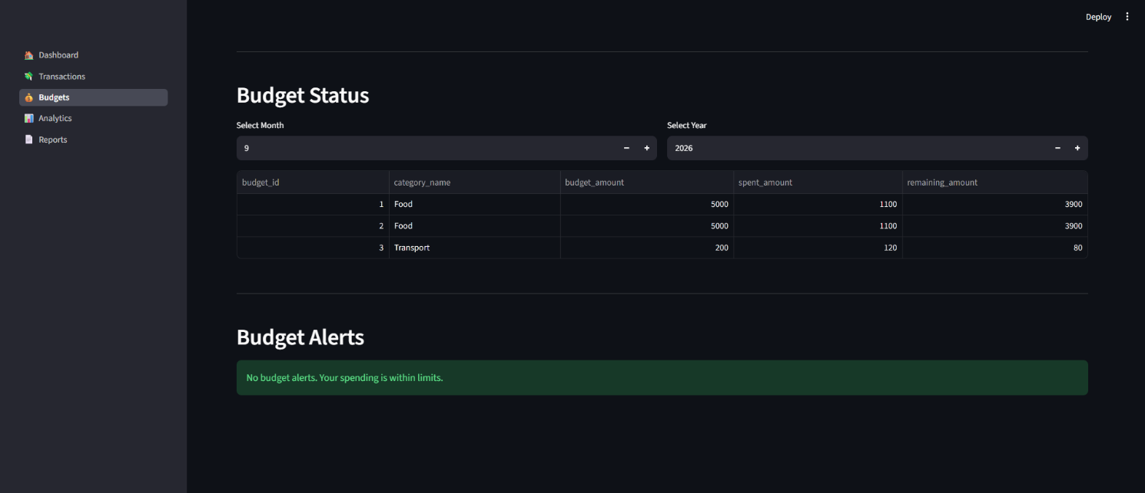
Figure 5: Budget status and budget alerts
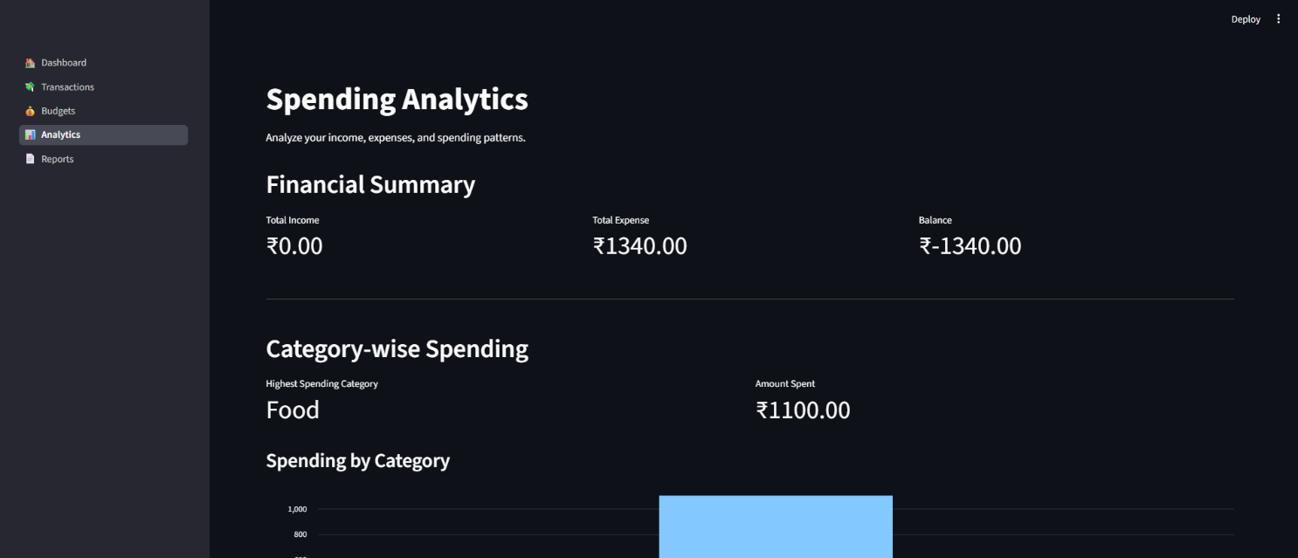
Figure 6: Spending analysis
7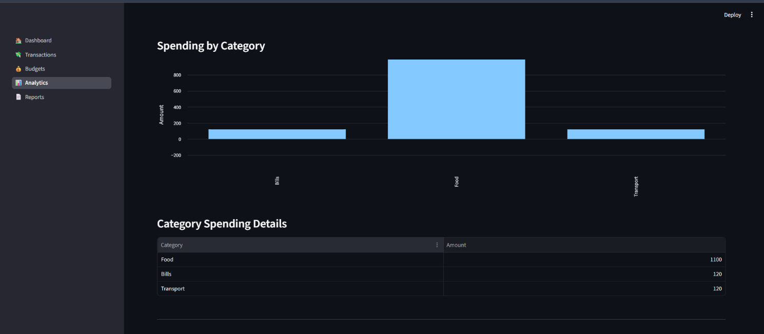
Figure 7 : Category Spending analysis

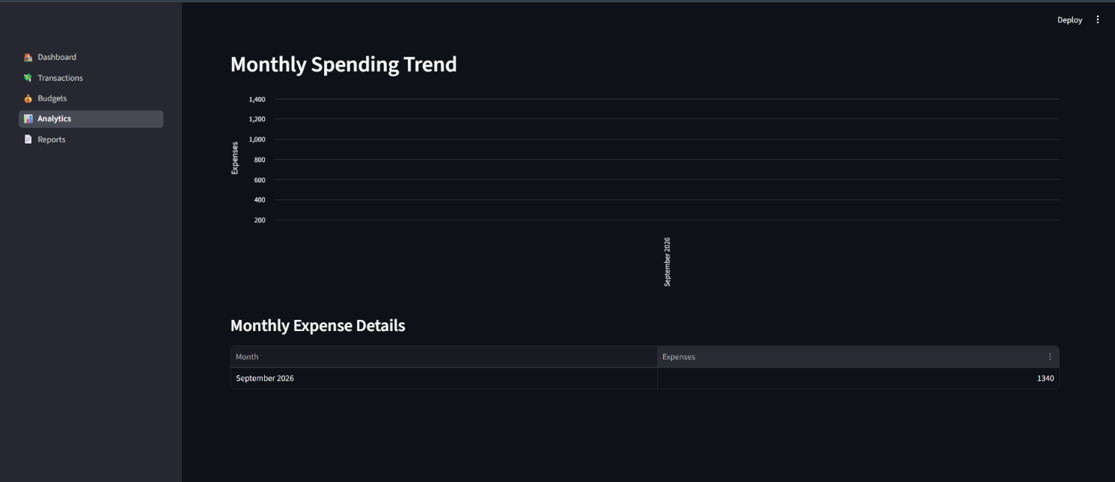
Figure 8: Monthly spending trend

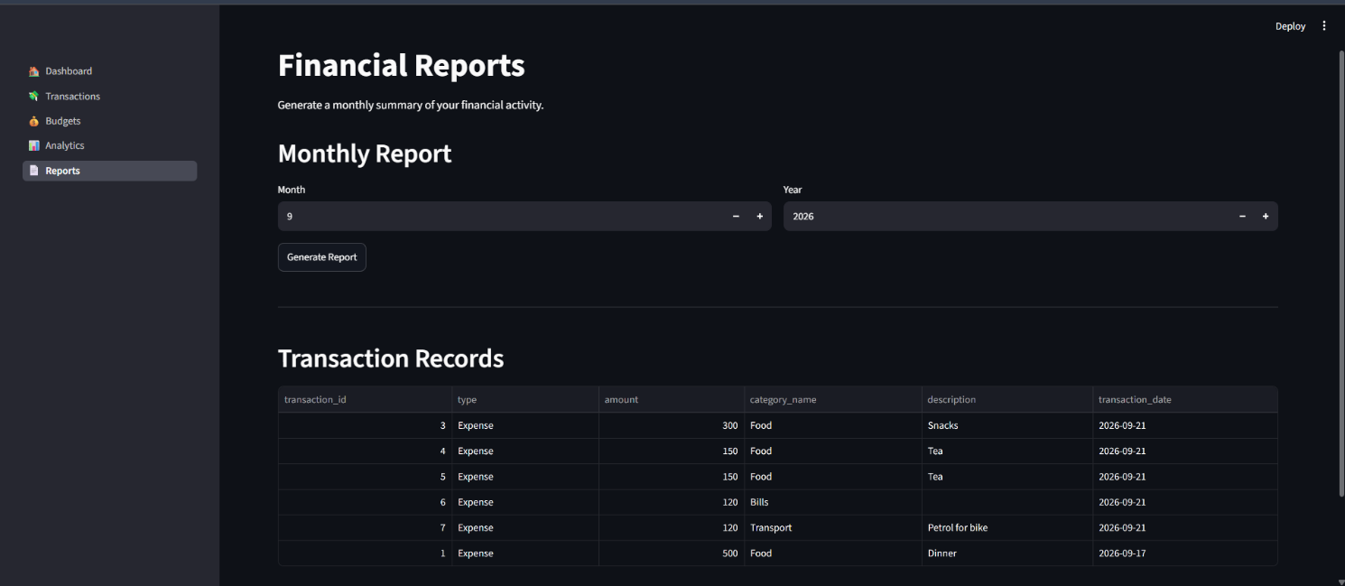
Figure 9: Monthly financial report
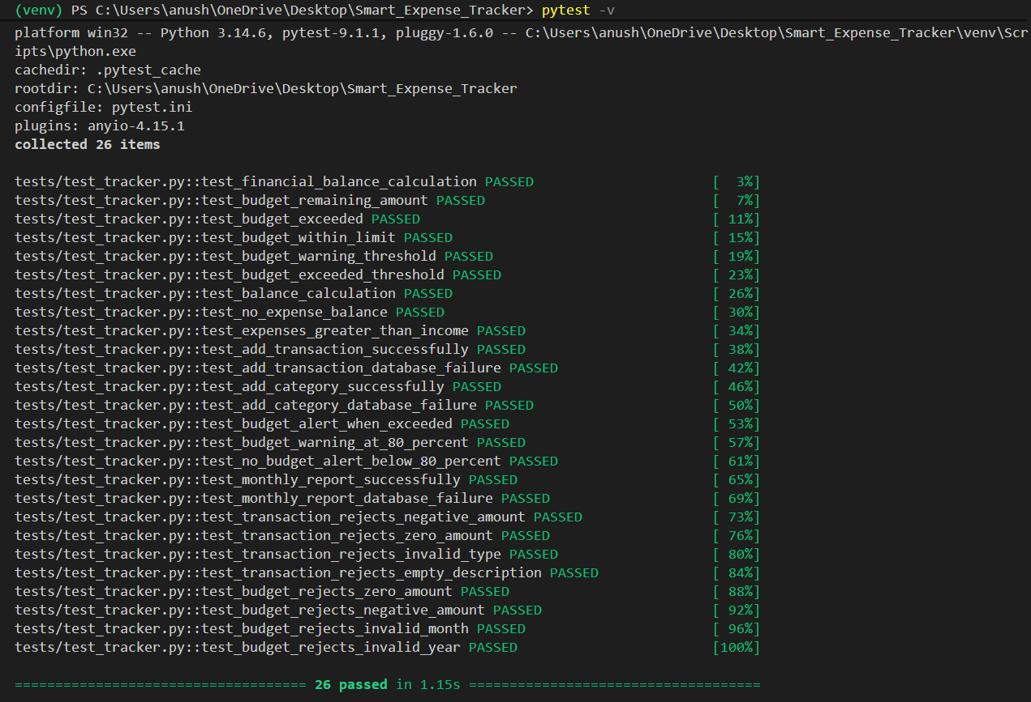
Figure 10: Pytest execution showing successful test results

13. Testing Approach
Testing was performed to verify that the application's individual functions work correctly and that invalid inputs are handled appropriately.
The project uses Pytest for automated testing.
The testing process covers the following areas:
13.1 Financial Calculations
Tests verify:
- Total income calculation.
- Total expense calculation.
- Balance calculation.
13.2 Transaction Validation
Tests verify that:
- Negative transaction amounts are rejected.
- Zero transaction amounts are rejected.
- Invalid transaction types are rejected.
- Empty transaction descriptions are rejected.
13.3 Budget Validation
Tests verify that:
- Zero budget amounts are rejected.
- Negative budget amounts are rejected.
- Invalid months are rejected.
- Invalid years are rejected.
13.4 Budget Alert Testing
Tests verify the budget alert conditions, including:
- Normal budget usage.
- Warning threshold at 80%.
- Budget exceeded condition at 100% or above.
13.5 Database Operation Testing
Database-related functions were tested using mocked database connections to verify application behavior without depending entirely on live database operations.
The tests cover transaction, category, budget, and report operations.
13.6 Report Testing
The monthly report functionality was tested to verify that income, expenses, and balance are calculated correctly for the selected month and year.
13.7 Test Result
The project test suite successfully completed with:
26 tests passed
This indicates that the tested validation, calculation, database-operation, budget-alert, and reporting functions behaved as expected during testing.

14. Challenges Faced
Several challenges were encountered during the development of the project.
14.1 Database Connectivity
Connecting the Python application to MySQL and managing database configuration required careful setup of the MySQL service, database credentials, and environment variables.
14.2 Input Validation
Different types of invalid input had to be considered, including zero or negative amounts, empty descriptions, invalid months, and invalid years.
14.3 Streamlit Application Structure
Organizing the application into multiple Streamlit pages while keeping the backend modules separate required careful project structuring.
14.4 Database Testing
Testing database-dependent functions without modifying actual database records required the use of mocked database connections.
14.5 Debugging User Interface Issues
During development, some issues related to Streamlit page logic and indentation had to be identified and corrected to ensure that transactions were not accidentally inserted multiple times.
14.6 Maintaining Modular Code
The project required separating database operations, business logic, interface components, and testing code into appropriate files to maintain a clean project structure.

15. Learnings & Key Takeaways
The development of this project provided practical experience in several areas of software development.
The major learnings include:
- Understanding how Python applications communicate with MySQL databases.
- Learning how to design and implement a modular project structure.
- Understanding CRUD operations and database relationships.
- Learning to develop web-based interfaces using Streamlit.
- Understanding the importance of input validation.
- Implementing error handling for database and application operations.
- Learning how to use environment variables for configuration.
- Understanding the importance of automated testing.
- Learning how to use Git and GitHub for project version control.
- Understanding how system architecture and database design relate to application implementation.
- Gaining experience in debugging and improving application functionality.
The project also demonstrated how concepts from Computer Science can be applied to solve a practical problem involving data management, processing, visualization, and reporting.

16. Future Enhancements
The current project provides the core functionality required for personal expense and budget management. The following enhancements could be added in future versions:
- User Authentication
Add login and registration functionality to support multiple users.
- CSV and PDF Export
Allow users to export transactions and financial reports in commonly used file formats.
- Recurring Transactions
Add support for automatically recording recurring expenses and income.
- Advanced Analytics
Provide additional spending analysis and financial trends.
- Mobile-Friendly Interface
Improve the interface for use on smartphones and tablets.
- More Visualizations
Add additional charts for comparing income, expenses, categories, and budgets.
- Enhanced Financial Insights
Provide more detailed spending insights based on historical transaction data.
- Budget Management Improvements
Add features such as editing existing budgets and managing repeated monthly budgets.

17. References
- Python Documentation, Python Programming Language Documentation.
- Streamlit Documentation, Streamlit Application Development Documentation.
- MySQL Documentation, MySQL Reference Manual.
- Pytest Documentation, Pytest Documentation and Testing Framework.
- Pandas Documentation, Pandas Python Data Analysis Library Documentation.
- VITyarthi, Build Your Own Project: General Project Instructions & Submission Guidelines.

