
SVKM’s NMIMS
Mukesh Patel School of Technology Management & Engineering /
School of Technology Management & Engineering

Year:-II | Program:- MBA Tech CE D1 | Semester:- IV

Subject:- Web Programming

Mini Project Title
Team Details
Name | Shivali Agarwal | Arth Agarwal | Anushree Balaji | Ranish Devadiga
Roll No | N002 | N003 | N006 | N024
SAP ID | 70472400139 | 70472400153 | 70472400107 | 70472400145

MBA + Bachelor of Technology (Computer Science)
First Year, Semester II
Faculty: Anuja Narvekar
AY 2025-26

INDEX
Sr. No. | Topic | Page No.
1 | Introduction | 3
2 | Requirement Analysis | 4
3 | Development Technologies | 6
4 | Implementation and Output | 7
5 | Observations and Learnings | 12
6 | Conclusion | 13

Introduction
About this Project
This project, guided by Prof. Anuja Narvekar, is a Banking Application (BrokeBank). The banking sector plays a vital role in the economic development of a country. With the advancement of technology, traditional banking systems with pen-and-paper systems have become deprecated and old. Hence, we introduce this application that ensures improved accuracy and enhanced customer experience.
This project presents the design and implementation of a Banking Management System, which is developed to perform essential banking operations such as account creation, CVV generation and hashing, automated calculations of maturity date, principal deduction, etc.
The main objective of this project is to understand and apply programming concepts in developing a real-world application. It demonstrates how banking processes can be automated to reduce manual errors, improve efficiency, and ensure reliable record management.
What does it solve?
This project solves the following key problems in old systems as well as current digital systems:
- Provides a unified platform for accounts, transactions, loans, investments, and administration
- Introduces role-based access for customers, loan officers, investors, and admins
- Ensures atomic transactions and proper logging of all financial activities
- Automates processes such as loan approval, KYC verification, and fund transfers
- Prevents invalid operations like insufficient balance transfers or unauthorized actions
- Provides dashboards and transaction histories for better tracking and decision-making

Requirement Analysis
Functional Requirements
- User Management
  - User registration and login
  - Role-based access control (Customer, Loan Officer, Investor, Admin)
  - Profile management
  - Account activation/deactivation (Admin)
- Customer Requirements
  - Create and manage bank accounts
  - Deposit and withdraw money
  - Transfer funds between accounts
  - View transaction history
  - Apply for loans
  - Create fixed deposits
  - Manage cards (apply/block/view)
- Loan Officer Requirements
  - View loan applications
  - Approve/reject loans
  - Perform KYC verification
  - Monitor customer profiles
- Investor Requirements
  - View loan investment pools
  - Invest in loans
  - Track returns and investments
- Admin Requirements
  - Manage users
  - Freeze/unfreeze accounts
  - Manage offers
  - View system reports (transactions, loans, etc.)
- System Functional Requirements
  - Maintain transaction logs
  - Perform validation before every transaction
  - Ensure atomic transactions
  - Auto-generate account/card numbers
Non-Functional Requirements
- Performance
  - System should handle multiple users simultaneously
  - Transactions should be processed with minimal delay
- Security
  - Passwords must be hashed
  - Sensitive data (CVV) must be encrypted
  - Role-based authorization must be enforced
- Reliability
  - System should prevent data inconsistency
  - Transactions must not fail midway
- Usability
  - User-friendly interface
  - Easy navigation for all roles
- Scalability
  - System should support increasing users and transactions
- Availability
  - System should be accessible whenever required
Constraints
- Limited to simulation (not connected to real banking APIs)
- Depends on internet connection (if web-based)
- Uses predefined rules instead of real financial regulations
- Limited to chosen tech stack (Node.js, Sequelize, etc.)

Development Technologies
Frontend Technologies
- HTML5: Used for structuring the web pages
- CSS3: Used for styling and responsive design
- JavaScript: Enables dynamic content and client-side interactions
Backend Technologies
- NodeJS: Used for server-side development and handling application logic
- ExpressJS: Framework used to build RESTful APIs and manage routing
Database
- PostgresSQL: Used as the relational database to store user data, transactions, loans, and other financial records
ORM
- Sequelize ORM: Used to interact with the PostgreSQL database efficiently using JavaScript
Authentication & Security
- JWT (JSON Web Tokens): Used for secure user authentication
- Password Hashing: Ensures secure storage of user credentials
- Environment Variables: Used to protect sensitive configuration data
Developmental Tools
- VSCode: Code editor used for development
- Git and Github: Version control and project management
Implementation and Output
User-Side Implementation
- User interfaces are as such:
  - Customer Dashboard
  - Loan Officer Dashboard
  - Investor Dashboard
  - Admin Dashboard
- Handles user interactions like registration, login, transactions, and account management
Services’ Implementation
- Core banking services
  - Handles:
    - Accounts
    - Transactions
    - Cards
    - Fixed Deposits
  - Responsible for:
    - Balance updates
    - Transaction processing
    - Financial validations
- Loan Service
  - Manages:
    - Loan applications
    - Approval/rejection workflows
    - Loan disbursement
  - Integrates KYC verification before approval
- Investment Service
  - Allows investors to:
    - Invest in loan pools
    - Track returns
  - Simulates real-world lending-investment flow
- Auth Service
  - Handles:
    - User authentication
    - Session management
  - Ensures secure login using password hashing
- Admin Service
  - Provides:
    - User management
    - Offer management
    - System monitoring
- API Gateway
  - Acts as a central entry point for all client requests
  - Routes requests to appropriate backend services
System Workflow
- Registration Flow
  - User registers
  - Password hashed
  - Role assigned
  - Profile created
  - OTP logic implemented for login
- Transaction Flow
  - Validate accounts
  - Check balance
  - Execute atomic transaction
  - Log entry
- Loan Flow
  - Apply
  - KYC verification
  - Officer approval
  - Loan disbursement
- Investment Flow
  - Investor funds loan pool
  - Returns tracked and updated
Database Architecture
- Entities
  - User: Stores login and role details
  - Customer: Stores banking identity
  - Account: Stores account details and balance
  - Transaction: Records all financial operations
  - Card: Stores card-related data
  - Fixed Deposit: Manages FD lifecycle
  - Loan: Stores loan details and status
  - Investor Profile: Tracks investments
  - Offer: Manages promotional offers
- Relationships
  - One user one role (customer / loan officer / investor / admin)
  - One customer multiple accounts
  - One account multiple transactions
  - One account multiple cards
  - Many customers many accounts (joint accounts)
  - One loan officer multiple loans
  - Many offers many customers
- Schema Diagram
  - 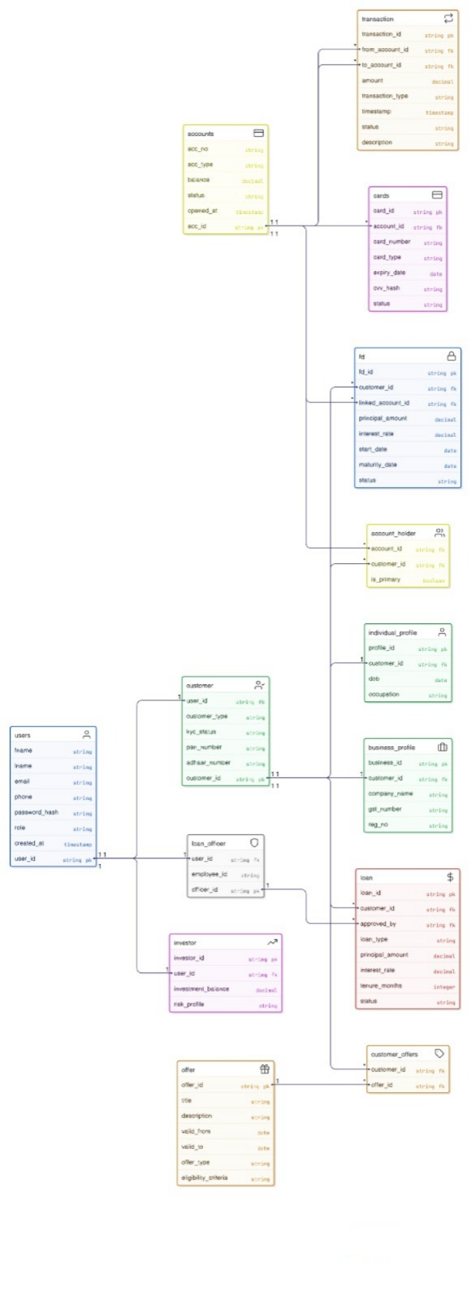
Financial Integrity Controls
- No transaction without sufficient balance
- No duplicate accounts or users
- No loan approval without verification
- Proper linkage between all entities
Architecture Diagram
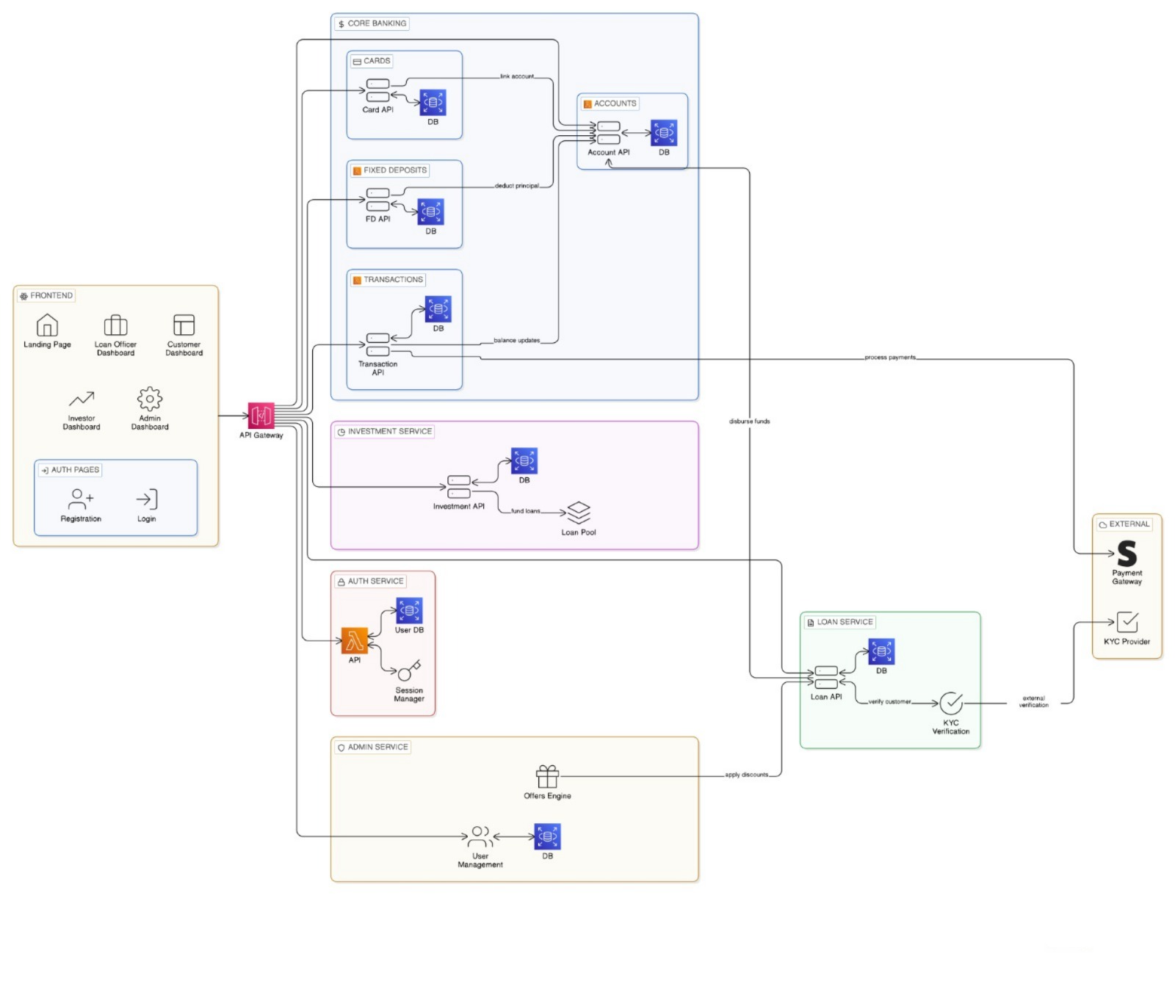
Observations and Learnings
Observations
- Banking systems are complex due to multiple interconnected modules like accounts, transactions, loans, and investments
- Maintaining data integrity is critical to avoid inconsistencies in financial records
- Role-based access control is necessary to handle different user permissions effectively
- Financial transactions must be atomic to prevent partial updates and failures
- Strong validation is required before performing any financial operation
- Modules such as accounts, loans, and investments are highly interdependent
- Security is essential for protecting sensitive user and financial data
Learnings
- Gained hands-on experience in full-stack development integrating frontend, backend, and database
- Learned to design modular and scalable system architectures
- Improved understanding of relational database design and entity relationships
- Developed skills in building and structuring RESTful APIs
- Implemented authentication and authorization for secure system access
- Understood real-world workflows like loan approval, KYC verification, and investment processes
- Enhanced debugging and problem-solving skills while handling complex system interactions

Conclusion
The Digital Banking System successfully demonstrates the design and implementation of a secure, scalable, and role-based financial application. The project effectively simulates real-world banking operations, including account management, transactions, loans, investments, and administrative control. By integrating frontend, backend, and database components, the system ensures efficient handling of financial workflows while maintaining data integrity and security. The use of structured architecture and validation mechanisms helps prevent errors and ensures reliable system performance. Overall, this project provides practical insight into modern banking systems and highlights the importance of proper system design, security, and workflow management in developing real-world applications.

