NMIMS MUKESH PATEL SCHOOL OF TECHNOLOGY
MANAGEMENT AND ENGINEERING (MPSTME)
MBA Tech Programme
A Project Report on
REAL-TIME DDoS DETECTION & MITIGATION SYSTEM
Submitted by
Anish Hegde — SAP ID: 70472400218
Anushree Balaji — SAP ID: 70472400107
Arman Deshmukh — SAP ID: 70092500034
Under the Guidance of
Prof. Dipali Maste
Academic Year 2026 – 27

ABSTRACT
Distributed Denial-of-Service (DDoS) attacks remain one of the most disruptive threats to network availability, capable of overwhelming servers and infrastructure by flooding them with high-volume traffic from multiple sources. Static, signature-based defences often struggle to keep pace with evolving attack patterns and introduce delays that limit their real-world effectiveness. This project presents a Real-Time DDoS Detection & Mitigation System that combines a lightweight threshold-based rule engine with a machine learning classifier (Random Forest) to identify malicious traffic as it arrives, while an automated mitigation module enforces firewall rules to block offending sources without manual intervention.
Network packets are captured live using Scapy, parsed into structured headers, and converted into statistical feature vectors using a sliding-window approach (packet rate, SYN/UDP/ICMP counts, and related metrics). An offline training branch, built on public attack datasets including CIC-DDoS2019, Bot-IoT and IoT-23, is used to train and periodically refresh the detection model and threshold configuration without interrupting the live pipeline. All detection and mitigation events are logged to a persistent SQLite store and visualised through a real-time dashboard.
The system is currently at the prototype stage: the system architecture and workflow have been finalised, and the dataset acquisition and preprocessing pipeline is complete, while the end-to-end integration of the live capture-to-mitigation pipeline is under active development.

TABLE OF CONTENTS
ABSTRACT 2
TABLE OF CONTENTS 3
1. INTRODUCTION 5
1.1 Background 5
1.2 Problem Statement 5
1.3 Objectives 5
1.4 Scope 6
2. LITERATURE SURVEY / EXISTING APPROACHES 7
3. SYSTEM ARCHITECTURE & DESIGN 8
3.1 Overview 8
3.2 Level-1 Data Flow Diagram 8
3.3 System Workflow 10
4. DATASET & PREPROCESSING PIPELINE 12
4.1 Dataset Sources 12
4.2 Directory Structure 12
4.3 Preprocessing Pipeline 12
4.4 Parsed Packet Fields 13
4.5 Metadata Files 13
4.6 Supported Protocols 13
4.7 Replay Sets 13
5. IMPLEMENTATION DETAILS 14
5.1 Technology Stack 14
5.2 Initialisation 14
5.3 Packet Capture & Validation 14
5.4 Feature Extraction 14
5.5 Detection Engines 14
5.6 Decision Fusion 14
5.7 Mitigation 15
5.8 Logging & Persistence 15
5.9 Dashboard 15
5.10 Continuous Operation 15
6. CURRENT IMPLEMENTATION STATUS 16
7. RESULTS & EVALUATION 17
8. DESIGN CONSIDERATIONS & CHALLENGES 18
9. FUTURE SCOPE 19
10. CONCLUSION 20
11. REFERENCES 21

1. INTRODUCTION

1.1 Background
A Distributed Denial-of-Service (DDoS) attack attempts to make a network resource unavailable to its intended users by overwhelming it with traffic generated from multiple, often geographically distributed, sources simultaneously. Common volumetric forms include SYN floods, UDP floods and ICMP floods, each exploiting protocol behaviour to exhaust bandwidth, connection tables or processing capacity at the target. The consequences of a successful attack range from service downtime and degraded user experience to direct financial and reputational damage for the affected organisation.
Because modern attacks can scale to very high packet rates within seconds, detection and response mechanisms need to operate in real time rather than relying on periodic or manual analysis. This motivates a system that continuously observes live traffic, recognises attack signatures as they emerge, and reacts automatically.

1.2 Problem Statement
Purely static, threshold-based detection is rigid: attackers can stay just under fixed limits or vary attack patterns to evade fixed rules, and thresholds tuned for one network profile may not generalise to another. Purely machine-learning-based detection, on the other hand, can be more adaptive but is only as good as the data it is trained on and may not offer an immediate first line of defence on its own. There is a need for a system that fuses the low-latency responsiveness of rule-based checks with the adaptability of a trained classifier, and that couples detection directly to an automated mitigation step rather than leaving response to manual intervention.

1.3 Objectives
- Capture and analyse live network traffic in real time at the packet level.
- Extract statistical features from traffic using a sliding-window approach.
- Detect anomalous or attack traffic using a hybrid of configurable threshold rules and a trained machine learning classifier.
- Automatically generate and enforce mitigation actions (firewall rules) against identified attack sources.
- Persist all detection and mitigation events, and visualise system status through a live dashboard.
- Build a decoupled offline pipeline to train and refresh the detection model and thresholds from public DDoS datasets.

1.4 Scope
The system focuses on network- and transport-layer volumetric attacks — SYN flood, UDP flood and ICMP flood — over IPv4 and IPv6, using packet header-level features only (no application-layer payload inspection). Application-layer (L7) attacks, encrypted traffic content analysis, and multi-node/distributed deployment are treated as extensions beyond the current prototype and are discussed under Future Scope.

2. LITERATURE SURVEY / EXISTING APPROACHES
Existing approaches to DDoS detection broadly fall into three categories. Signature and static-threshold-based systems, similar in spirit to traditional intrusion detection/prevention systems, compare traffic against fixed rules or known attack signatures. They are fast and simple to reason about, but rigid — attackers can evade fixed limits with low-and-slow or randomised traffic patterns, and thresholds require manual retuning as network conditions change.
Machine-learning-based approaches instead learn to distinguish normal from malicious traffic from labelled examples, commonly drawing on public benchmark datasets such as CIC-DDoS2019 and Bot-IoT. These approaches adapt better to previously unseen variations of an attack class, at the cost of depending on representative training data and typically requiring periodic retraining as traffic patterns drift.
Hybrid systems combine both approaches to get the benefits of each — a fast rule layer for known, obvious attack signatures, and a classifier layer for subtler or evolving patterns. This project follows the hybrid design pattern: a threshold engine and an ML engine run in parallel on the same feature vector, and their outputs are fused into a single detection decision (see Section 3).

3. SYSTEM ARCHITECTURE & DESIGN

3.1 Overview
The system is organised into three logical branches. The Online Pipeline handles live traffic end-to-end, from packet capture through to mitigation and alerting. The Persistence & Presentation branch stores every decision and event and renders them on an administrator-facing dashboard. The Offline Training Branch is deliberately decoupled from the live path: it consumes historical/offline datasets to (re)train the classifier and derive threshold values, and pushes the resulting model artefact and configuration back into the online engines asynchronously, so that retraining never blocks or slows down real-time detection.

3.2 Level-1 Data Flow Diagram
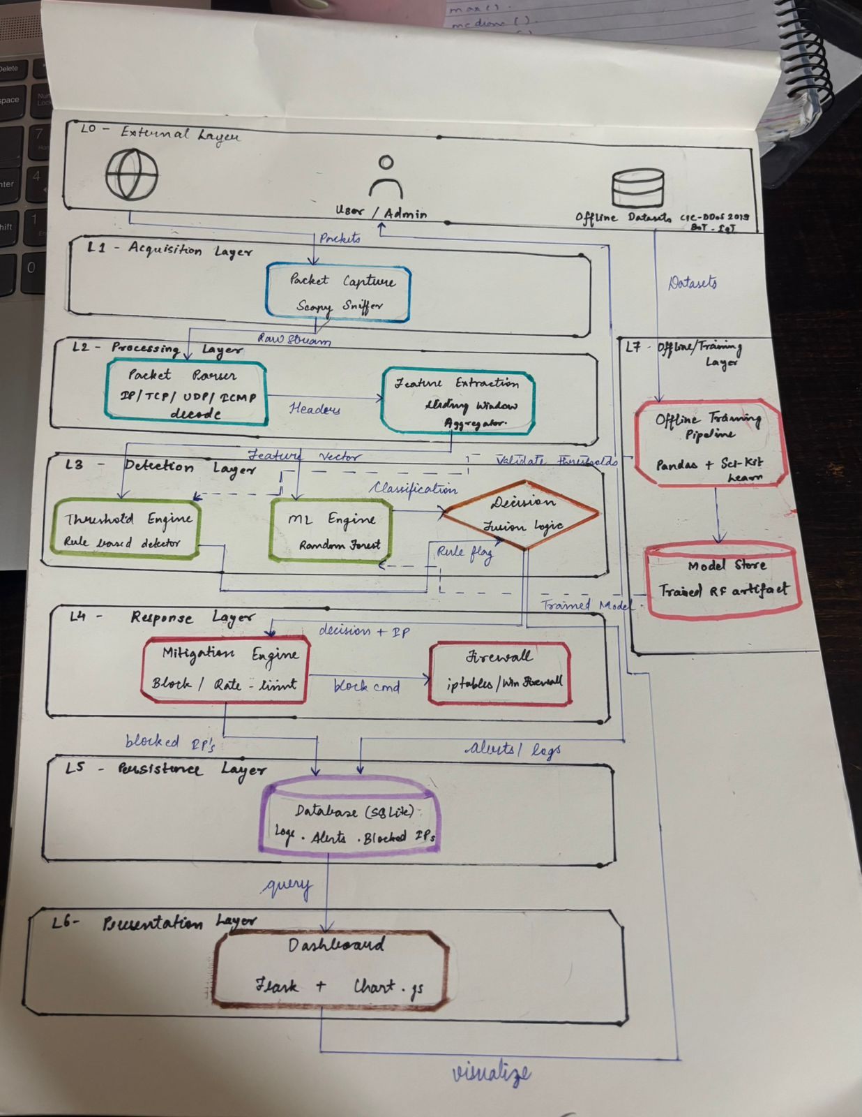
Figure 1: Level-1 Data Flow Diagram of the Real-Time DDoS Detection & Mitigation System
Table 1 describes each process shown in the DFD, and Table 2 describes each data store.
ID | Process | Description
P1 | Capture Packets | Captures raw packets from the live traffic source at the network boundary.
P2 | Parse Headers | Parses the raw packet stream into structured protocol headers (IP/TCP/UDP/ICMP fields).
P3 | Extract Features (Sliding Window) | Aggregates parsed headers over a sliding window to compute a statistical feature vector.
P4 | Threshold Rules | Compares the feature vector against configurable thresholds (loaded from D4) and raises an anomaly flag.
P5 | ML Classification | Classifies the same feature vector using a trained model (loaded from D2) and produces an ML result/label.
P6 | Fuse Decision | Combines the anomaly flag and ML result into a single decision, together with the offending source IP.
P7 | Generate Mitigation | Translates an attack decision into a concrete mitigation command (which IP to act on and how).
P8 | Enforce Firewall | Applies the firewall rule at the network boundary to block/rate-limit the offending source.
P9 | Log Event | Records the decision/alert and any mitigation data as a persistent log/alert record.
P10 | Render Dashboard | Queries stored records and renders charts/alerts for the User/Admin.
P11 | Train / Validate Model | Offline process that trains and validates the classifier on historical data, producing a model artefact and updated thresholds.

ID | Data Store | Description
D1 | Operational DB (SQLite) | Persistent store of log/alert records generated by the online pipeline.
D2 | Model Store | Holds the current trained ML model artefact, loaded by P5.
D3 | Offline Dataset Store | Holds historical/offline datasets supplied for training.
D4 | Threshold Config | Holds the current threshold configuration, loaded by P4.

3.3 System Workflow
Figure 2 traces the same architecture as a single operational loop, including initialisation and error-handling paths that the Level-1 DFD abstracts away.
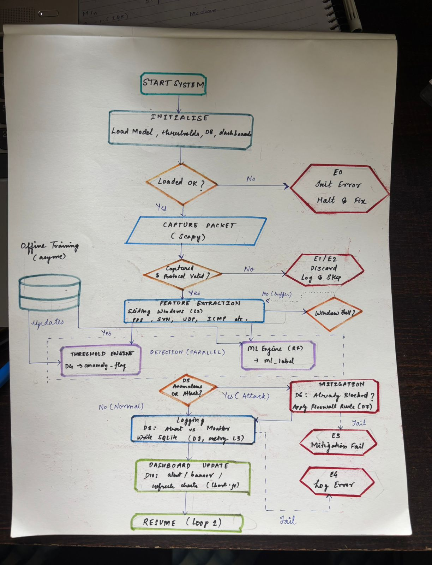
Figure 2: Simplified System Workflow
On startup, the system initialises by loading the model, thresholds, database connection and dashboard; if any of these fail to load, the system halts with an initialisation error (E0) rather than running in an undefined state. Once initialised, it enters a continuous capture loop using Scapy. Each captured packet is checked for a valid, supported protocol; invalid or unsupported packets are discarded and logged (E1/E2) rather than propagated further.
Valid packets are added to a Layer-2 sliding window that accumulates features such as packets-per-second and SYN/UDP/ICMP counts. While the window is not yet full, the system simply buffers incoming packets and returns to capture; once full, the accumulated feature vector is handed to two engines running in parallel — the Threshold Engine, which checks the vector against the values in the threshold configuration (D4) and outputs an anomaly flag, and the ML Engine, a Random Forest classifier that outputs an ML label. Both engines can be updated asynchronously from the Offline Training branch without pausing capture.
The two outputs are fused with an OR condition: traffic is treated as an attack if either the threshold engine or the ML engine flags it, favouring higher detection sensitivity. If flagged, the system checks whether the source IP is already blocked (avoiding redundant firewall rules) and, if not, applies a new rule; a failure to apply the rule is captured as a distinct error (E3). Normal traffic, and all decisions regardless of outcome, are logged — classified as an Alert or a routine Monitor entry — and written to SQLite with retry logic; persistent log failures are captured as a separate error (E4). Finally, the dashboard is updated (alert banner and refreshed charts), and the loop resumes at packet capture.
Code | Condition | Handling
E0 | Model / thresholds / DB / dashboard fail to load at startup | Halt system and require a fix before proceeding.
E1 / E2 | Packet capture or protocol validation fails | Discard the packet, log the event, and continue capturing.
E3 | Firewall rule enforcement fails | Log the mitigation failure for follow-up; does not stop the pipeline.
E4 | Write to the operational database fails after retry | Log the failure separately so persistence issues are visible on the dashboard.

4. DATASET & PREPROCESSING PIPELINE
All datasets, and every intermediate output derived from them, live under a single datasets/ directory. The layout keeps the original downloaded data strictly separate from anything the project itself generates, so that preprocessing is always reproducible and the source files are never accidentally modified.

4.1 Dataset Sources
Dataset | Role in the Project
Bot-IoT | Labelled IoT botnet attack traffic, used as an attack-traffic source for training and evaluation.
CIC-DDoS2019 | Canadian Institute for Cybersecurity dataset covering a wide range of modern DDoS attack types alongside benign traffic.
Digital Corpora (M57 Patents) | General corporate network traffic corpus, used as a source of realistic normal (benign) traffic.
Malware-Traffic-Analysis.net | Real-world malicious traffic captures, adding diversity to the attack-traffic corpus.
IoT-23 (optional) | Labelled IoT traffic captures (malicious and benign), kept optional for extended IoT-specific testing.

4.2 Directory Structure
The datasets directory is organised as follows:
- raw/ — original downloaded datasets (compressed archives and extracted PCAPs), organised per source (bot_iot, cic_ddos2019, digital_corpora/m57_patents, malware_traffic_analysis, iot23). Treated as read-only source of truth; nothing here is ever edited, renamed or deleted.
- cleaned/ — PCAP files after cleaning: standardising attack metadata, removing corrupted or incomplete captures, filtering unsupported protocols, normalising timestamps and sorting packets chronologically.
- parsed/ — the standardised, per-packet representation extracted from the cleaned captures (see field list in Section 4.4), which is what the detection engine actually consumes.
- metadata/ — indexing and bookkeeping files describing the datasets (Section 4.5).
- replay/ — curated PCAPs grouped by traffic category (normal, syn, udp, icmp) used to replay traffic against the detection engine during testing.

4.3 Preprocessing Pipeline
Every dataset is pushed through the same sequence of steps before it is usable by the detection engine:
- Raw PCAP ingestion
- Metadata standardisation
- Corrupted-capture removal
- Incomplete-capture removal
- Protocol filtering
- Timestamp normalisation
- Packet ordering (chronological sort)
- Header field extraction → parsed output

4.4 Parsed Packet Fields
The parser extracts only header-level fields — timestamp, source/destination IP, protocol, source/destination port, packet length, TCP flags, TTL and ICMP type where applicable. Application-layer payloads (HTTP, DNS, TLS, FTP, etc.) are intentionally ignored, consistent with the project's network/transport-layer scope.

4.5 Metadata Files
File | Purpose
dataset_index.csv | Inventory of every PCAP — filename, source dataset, standardised attack type, processing status (raw/cleaned/parsed), and file path.
attack_mapping.csv | Maps each dataset's own attack labels (e.g. "DDoS TCP", "SynFlood") to one standardised label (e.g. SYN_FLOOD), so labels are consistent across sources.
statistics.csv | Auto-generated statistics per capture — total packets, capture duration, average packets/sec, average packet size, and protocol distribution.

4.6 Supported Protocols
Processed | Ignored
IPv4, IPv6, TCP, UDP, ICMP | ARP, Bluetooth, STP, LLDP, USB, and all application-layer payloads (HTTP, DNS, TLS, FTP, SMTP, etc.)

4.7 Replay Sets
The replay/ folder holds four traffic categories — normal, syn, udp and icmp — used to feed known-labelled traffic back through the live pipeline so that detection accuracy and response behaviour can be measured under controlled, repeatable conditions.

5. IMPLEMENTATION DETAILS

5.1 Technology Stack
Component | Technology
Packet capture & parsing | Python with Scapy
Detection — rule engine | Configurable threshold rules (Threshold Config store)
Detection — ML engine | Random Forest classifier
Persistence | SQLite (Operational DB)
Dashboard / visualisation | Chart.js
Offline training | Batch training/validation job over stored datasets

5.2 Initialisation
On startup the system loads the current ML model, threshold configuration, database connection and dashboard. A failure at this stage (E0) halts the system rather than allowing it to run against a stale or missing configuration.

5.3 Packet Capture & Validation
Packets are captured live with Scapy. Each packet is checked for successful capture and a supported protocol (IPv4/IPv6, TCP/UDP/ICMP); anything else is discarded and logged (E1/E2) so the pipeline is not slowed down or corrupted by irrelevant traffic.

5.4 Feature Extraction
Valid packets are accumulated in a Layer-2 sliding window. Once the window is full, a feature vector is computed — packets-per-second, and counts of SYN/UDP/ICMP packets among other related metrics — and handed to the two detection engines. Until the window is full, packets are simply buffered and the loop returns to capture.

5.5 Detection Engines
The Threshold Engine compares the feature vector against the values held in the Threshold Config store and outputs a binary anomaly flag. The ML Engine — a Random Forest classifier — independently scores the same feature vector and outputs a traffic label. Both engines can receive updated thresholds/model artefacts asynchronously from the Offline Training branch without pausing the live capture loop.

5.6 Decision Fusion
The two engine outputs are combined with a logical OR: if either the threshold engine or the ML engine flags the traffic, it is treated as an attack. This favours recall (catching more true attacks) over precision, on the basis that a missed attack is costlier than an extra false alarm in this context.

5.7 Mitigation
For traffic classified as an attack, the system first checks whether the offending source IP is already blocked, to avoid issuing duplicate firewall rules. If not already blocked, it generates and applies a new firewall rule at the network boundary. A failure to apply the rule is captured separately (E3) so it can be investigated without stopping detection for other traffic.

5.8 Logging & Persistence
Every decision — attack or normal — is classified as either an Alert or a routine Monitor entry and written to the SQLite operational database, with retry logic to absorb transient write failures. A failure that persists past the retry is logged separately (E4) so persistence issues remain visible even if the primary log write did not succeed.

5.9 Dashboard
The dashboard renders an alert banner for active attacks and refreshes its charts (via Chart.js) from the operational database, giving an administrator a live view of current traffic classification and recent mitigation actions.

5.10 Continuous Operation
After logging and dashboard update, the loop resumes at packet capture, so the system runs continuously rather than as a one-shot analysis.

6. CURRENT IMPLEMENTATION STATUS
As of this report, the project is at the prototype stage:
- Completed — system architecture (Level-1 DFD) and detailed operational workflow finalised.
- Completed — dataset acquisition and the full preprocessing pipeline (raw → cleaned → parsed → metadata → replay), across Bot-IoT, CIC-DDoS2019, Digital Corpora and Malware-Traffic-Analysis.net, with IoT-23 integrated as an optional source.
- In progress — end-to-end integration of the live capture-to-mitigation pipeline (feature extraction, dual-engine detection, mitigation and logging modules).
- In progress — dashboard implementation and connection to the operational database.
- Pending — full system testing using the replay/ traffic sets and performance evaluation.
Update the items above with the exact modules completed/pending as of your submission date before finalising this report.

7. RESULTS & EVALUATION
Formal evaluation is planned using the curated replay/ traffic sets (normal, syn, udp, icmp) against the fully integrated pipeline. The following metrics are proposed for reporting once testing is complete:
- Detection accuracy, precision, recall and F1-score, broken down per attack category (SYN/UDP/ICMP flood vs normal).
- False positive rate on normal (benign) replay traffic.
- Average detection latency — time from packet capture to a fused decision.
- Mitigation response time — time from decision to firewall rule enforcement.
- System throughput — sustained packets-per-second the pipeline can process without dropping capture.
This section is a placeholder. Insert your actual figures, tables and/or charts once end-to-end testing is complete.

8. DESIGN CONSIDERATIONS & CHALLENGES
- Balancing detection speed and accuracy — addressed by running a fast threshold engine and a more accurate but heavier ML engine in parallel rather than in series.
- Avoiding redundant mitigation actions — the workflow explicitly checks whether a source IP is already blocked before applying a new firewall rule.
- Handling bursty traffic without stalling capture — the sliding window buffers packets and only triggers detection once full, decoupling capture rate from detection cadence.
- Keeping model/threshold updates from disrupting live detection — the Offline Training branch pushes updates asynchronously rather than retraining synchronously inside the live path.
- Reconciling inconsistent labels across datasets — different sources describe the same attack differently (e.g. "DDoS TCP", "TCP Flood", "SynFlood"); attack_mapping.csv standardises these into one naming convention.
- Guarding against transient persistence failures — log writes to SQLite include retry logic, with a distinct error path for failures that persist beyond the retry.

9. FUTURE SCOPE
- Extend detection to application-layer (L7) attacks such as HTTP floods and slow-rate attacks.
- Move from a single-node prototype to a distributed/multi-node deployment for higher throughput.
- Explore deep learning models (e.g. LSTM/GRU) to capture sequential traffic patterns beyond fixed-window statistics.
- Bring the optional IoT-23 dataset fully into training for stronger IoT-specific attack coverage.
- Replace static threshold configuration with automated, adaptive threshold tuning.
- Add alerting integrations (email/Slack/SIEM) alongside the dashboard.
- Package the system for cloud-native deployment with containerisation and auto-scaling mitigation.

10. CONCLUSION
This project set out to design a real-time DDoS detection and mitigation system that is both fast enough to react to volumetric attacks as they happen and adaptive enough to handle patterns a fixed rule set would miss. The resulting architecture fuses a lightweight threshold engine with a Random Forest classifier, feeds both from a common sliding-window feature extractor, and couples the detection decision directly to automated firewall-based mitigation, with all events persisted and visualised on a live dashboard.
A decoupled offline training branch, grounded in established public datasets (Bot-IoT, CIC-DDoS2019, Digital Corpora, Malware-Traffic-Analysis.net and optionally IoT-23), keeps the detection model and thresholds current without ever blocking the live pipeline. With the dataset pipeline complete and the architecture finalised, the remaining work is the end-to-end integration and evaluation of the live pipeline, after which the system can be assessed against the metrics proposed in Section 7 and extended along the directions outlined in Section 9.

11. REFERENCES
- Bot-IoT Dataset — The Cyber Range Lab, UNSW Canberra.
- CIC-DDoS2019 Dataset — Canadian Institute for Cybersecurity, University of New Brunswick.
- IoT-23 Dataset — Stratosphere Laboratory, CTU University.
- Digital Corpora — digitalcorpora.org (M57 Patents scenario).
- Malware-Traffic-Analysis.net — publicly shared malicious traffic captures.
- Scapy — Python packet manipulation library, scapy.net.
- Chart.js — open-source JavaScript charting library, chartjs.org.
Add any specific textbooks, journal papers or course material cited for the Introduction/Literature Survey sections of your submission.

