PHASE 5: Applied Data Analytics Capstone Project
E-Commerce Exploratory Data Analysis Using Python

Introduction:
The purpose of this analysis is to explore e-commerce sales performance and identify the key factors influencing revenue generation, customer retention, profitability, operational performance and customer satisfaction. The Python project integrates customer, order, order-item, product, review and geographical datasets to provide a consolidated view of business performance. The analysis uses Pandas and NumPy for data preparation and analysis, and Matplotlib and Seaborn for visualisation. The findings are designed to support data-driven decisions around product performance, customer behaviour, delivery efficiency and business growth.

Objectives:
- Analyze overall sales and revenue performance.
- Identify high-performing product categories and subcategories.
- Analyze customer segments and repeat purchasing behavior.
- Identify cancellation and return patterns.
- Analyze delivery performance and its relationship with reviews.
- Identify factors affecting customer retention.
- Identify profitable products and categories.
- Generate business insights for improving conversion and retention.

Business Questions:
1. Which product categories generate the highest revenue?
2. Which categories generate the highest profit?
3. What is the repeat customer rate?
4. Does delivery delay affect customer satisfaction?
5. Which product categories receive the best reviews?
6. How does sales revenue change over time?
7. How does order volume change month by month?
8. What is the relationship between discount percentage and net sales?

KPIs:
KPI | Value
Total Customers | 90,000
Total Orders | 99,999
Total Revenue | ₹954,473,907.12
Total Profit | ₹208,636,970.00
Average Order Value | ₹9,544.83
Cancellation Rate | 5.05%
Return Rate | 7.00%
Average Review Score | 4.09 / 5
Repeat Customer Rate | 50.44%

EDA Steps Used with respective Code:

1. Import analytical libraries and set display behavior
imports pandas, NumPy, Matplotlib and Seaborn, suppresses warnings, expands Data Frame display settings and applies a white-grid Seaborn theme. This establishes the analysis and visualization environment.
import pandas as pd
import numpy as np
import matplotlib.pyplot as plt
import seaborn as sns
import warnings
warnings.filterwarnings('ignore')
# Display settings
pd.set_option('display.max_columns', None)
pd.set_option('display.max_rows', 100)
sns.set_theme(style="whitegrid")

2. Load the six cleaned datasets
Six cleaned Excel datasets are loaded: customers, orders, order items, reviews, products and geolocation. The notebook prints each shape and confirms successful loading
import pandas as pd
customer_path = r"C:\Users\ARPIT TYAGI\OneDrive\Desktop\NIIT\7\Phase 1 (Datasets)\Cleaned datasets\customer_datasets_cleaned.xlsx"
customers = pd.read_excel(
customer_path,
sheet_name="Customers_dataset"
)
print("Customers loaded successfully!")
print(customers.shape)
display(customers.head())
orders = pd.read_excel(
r"C:\Users\ARPIT TYAGI\OneDrive\Desktop\NIIT\7\Phase 1 (Datasets)\Cleaned datasets\orders_datasets_cleaned.xlsx",
sheet_name="Orders_dataset"
)
print("Orders loaded:", orders.shape)
order_items = pd.read_excel(
r"C:\Users\ARPIT TYAGI\OneDrive\Desktop\NIIT\7\Phase 1 (Datasets)\Cleaned datasets\order_items_datasets_cleaned.xlsx",
sheet_name="Order_items_dataset"
)
print("Order Items loaded:", order_items.shape)
reviews = pd.read_excel(
r"C:\Users\ARPIT TYAGI\OneDrive\Desktop\NIIT\7\Phase 1 (Datasets)\Cleaned datasets\order_reviews_datasets_cleaned.xlsx",
sheet_name="Order_reviews_dataset"
)
print("Reviews loaded:", reviews.shape)
products = pd.read_excel(
r"C:\Users\ARPIT TYAGI\OneDrive\Desktop\NIIT\7\Phase 1 (Datasets)\Cleaned datasets\products_datasets_cleaned.xlsx",
sheet_name="Products_dataset"
)
print("Products loaded:", products.shape)
geolocation = pd.read_excel(
r"C:\Users\ARPIT TYAGI\OneDrive\Desktop\NIIT\7\Phase 1 (Datasets)\Cleaned datasets\geolocation_datasets_cleaned.xlsx",
sheet_name="Geolocation_dataset"
)
print("Geolocation loaded:", geolocation.shape)

3. Validate dataset sizes
The code checks the row/column counts again and displays sample records from every dataset. This verifies that the expected tables are present before transformations begin.
print("Customers :", customers.shape)
print("Orders :", orders.shape)
print("Order Items :", order_items.shape)
print("Reviews :", reviews.shape)
print("Products :", products.shape)
print("Geolocation :", geolocation.shape)
datasets = {
"Orders": orders,
"Order Items": order_items,
"Products": products,
"Customers": customers,
"Reviews": reviews,
"Geolocation": geolocation
}
for name, df in datasets.items():
print("\n" + "="*60)
print(name)
print("="*60)
print("Rows:", df.shape[0])
print("Columns:", df.shape[1])
display(df.head())

4. Inspect data types
The notebook displays data types for every column. This is important for distinguishing identifiers/categorical fields from numerical measures and date fields.
for name, df in datasets.items():
print("\n", name)
display(df.dtypes)

5. Check missing values
Missing-value counts are reviewed dataset by dataset. The output highlights delivery-related nulls in orders, four incomplete rows in order items, unused columns with large null counts, review-date gaps and one geolocation city gap.
for name, df in datasets.items():
print("\n" + "="*50)
print(name)
missing = df.isnull().sum()
missing = missing[missing > 0].sort_values(ascending=False)
display(missing)
Business insight: Data-quality review shows several worksheet-artifact columns with very high missingness. The cleaning function in the next step removes those columns systematically rather than treating them as meaningful business variables.

6. Check duplicate rows
Duplicate counts are checked before cleaning. The notebook finds two duplicate rows in order items and no duplicates in the other listed datasets
for name, df in datasets.items():
print(name, "duplicates:", df.duplicated().sum())
Business insight: Only the order-items table contains duplicate rows, with two duplicates reported. This check is important because duplicates can inflate revenue, quantity and profit when tables are aggregated later.

7. Remove unnecessary columns
Columns beginning with Unnamed and the Column1 field are removed across datasets through a reusable helper function. This strips worksheet artefacts and keeps the analytical tables focused.
def remove_unnecessary_columns(df):
cols_to_remove = [
col for col in df.columns
if col.startswith("Unnamed") or col == "Column1"
]
return df.drop(columns=cols_to_remove, errors='ignore')
orders = remove_unnecessary_columns(orders)
order_items = remove_unnecessary_columns(order_items)
products = remove_unnecessary_columns(products)
customers = remove_unnecessary_columns(customers)
reviews = remove_unnecessary_columns(reviews)
geolocation = remove_unnecessary_columns(geolocation)
print(orders.columns)
print(order_items.columns)
print(products.columns)
print(customers.columns)
print(reviews.columns)

8. Convert date fields to datetime
Order date columns and review_date are explicitly converted using pandas.to_datetime with errors coerced. This enables valid time-series, duration and period calculations.
date_columns = [
'order_purchase_timestamp',
'order_approved_at',
'order_delivered_shipping_date',
'order_delivered_customer_date',
'order_estimated_delivery_date'
]
for col in date_columns:
orders[col] = pd.to_datetime(orders[col], errors='coerce')
reviews['review_date'] = pd.to_datetime(
reviews['review_date'],
errors='coerce'
)
orders.info()

9. Review of descriptive statistics
The notebook generates descriptive statistics for orders, order items, products and customers. These outputs provide central tendency, spread, range and frequency context before business analysis.
print("Orders Statistics")
display(orders.describe(include='all'))
print("\nOrder Items Statistics")
display(order_items.describe())
print("\nProducts Statistics")
display(products.describe())
print("\nCustomers Statistics")
display(customers.describe(include='all'))

10. Build the master analytical dataset
Orders are left-joined to customers, then order items, then products. Review score/comment fields are joined afterward at order level. The resulting master dataset reaches 183,482 rows and 38 columns.
# Merge Orders with Customers
master = orders.merge(
customers,
on='customer_id',
how='left'
)
# Merge Order Items
master = master.merge(
order_items,
on='order_id',
how='left'
)
# Merge Products
master = master.merge(
products,
on='product_id',
how='left',
suffixes=('', '_product')
)
print("Master Dataset Shape:", master.shape)
display(master.head())
review_data = reviews[
['order_id', 'review_score', 'review_comment_message']
].drop_duplicates('order_id')
master = master.merge(
review_data,
on='order_id',
how='left'
)
print(master.shape)

11. Engineer calendar features
Purchase year, month, month name, day name and quarter are derived from order_purchase_timestamp. These features support monthly, seasonal and period-based analysis.
master['purchase_year'] = master[
'order_purchase_timestamp'
].dt.year
master['purchase_month'] = master[
'order_purchase_timestamp'
].dt.month
master['purchase_month_name'] = master[
'order_purchase_timestamp'
].dt.month_name()
master['purchase_day'] = master[
'order_purchase_timestamp'
].dt.day_name()
master['purchase_quarter'] = master[
'order_purchase_timestamp'
].dt.quarter

Business Questions and Analysis:
Each section contains the analytical question/title, a short method explanation, the stored chart output where one exists, the corresponding notebook code, and a concise business insight.

Q1. How is overall sales revenue changing over time?
Monthly net sales are aggregated by order purchase month and plotted as a line chart to reveal trend, seasonality and recurring peaks
monthly_sales = (
master.groupby(
master['order_purchase_timestamp'].dt.to_period('M')
)['Net Product Amount']
.sum()
.reset_index()
)
monthly_sales['order_purchase_timestamp'] = (
monthly_sales['order_purchase_timestamp']
.astype(str)
)
plt.figure(figsize=(14,6))
sns.lineplot(
data=monthly_sales,
x='order_purchase_timestamp',
y='Net Product Amount',
marker='o'
)
plt.title("Monthly Net Sales Trend")
plt.xlabel("Month")
plt.ylabel("Net Sales")
plt.xticks(rotation=90)
plt.tight_layout()
plt.show()

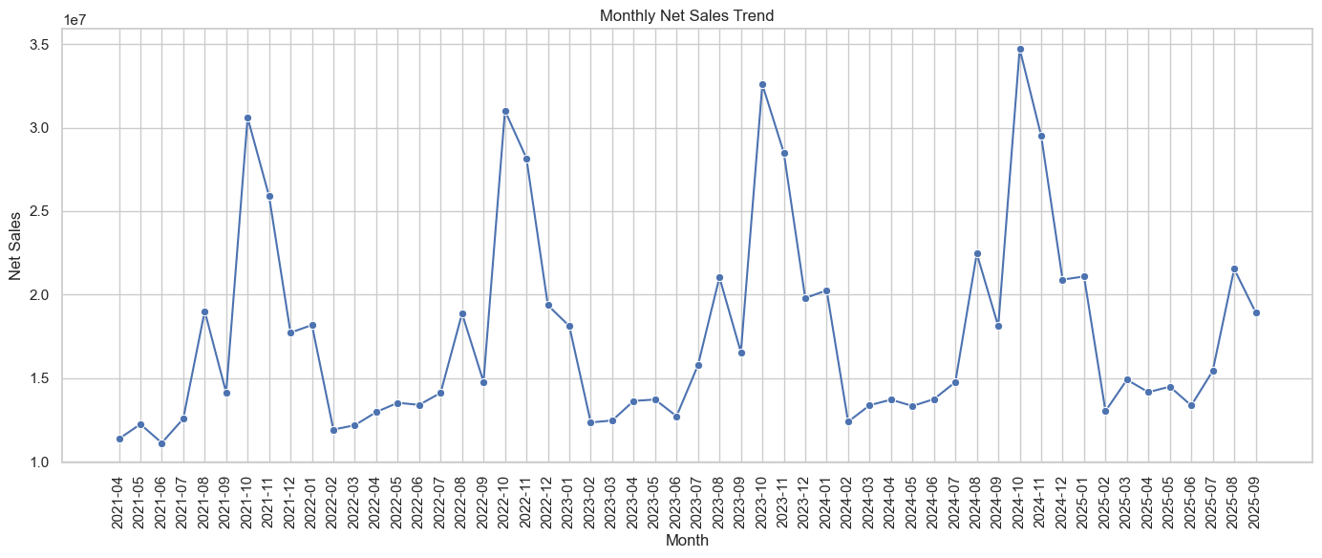
Business insight: Monthly sales are volatile and show recurring peaks and troughs, suggesting that demand is seasonal or event-driven. Planning inventory and marketing around recurring peak periods can be more useful than relying on a simple monthly average.

Q2. Which product categories generate the highest sales?
Net Product Amount is summed by Category_name, sorted descending and limited to the top 15 categories before plotting.
category_sales = (
master.groupby('Category_name')['Net Product Amount']
.sum()
.sort_values(ascending=False)
.head(15)
)
plt.figure(figsize=(12,6))
sns.barplot(
x=category_sales.values,
y=category_sales.index
)
plt.title("Top 15 Product Categories by Sales")
plt.xlabel("Net Sales")
plt.ylabel("Category")
plt.tight_layout()
plt.show()

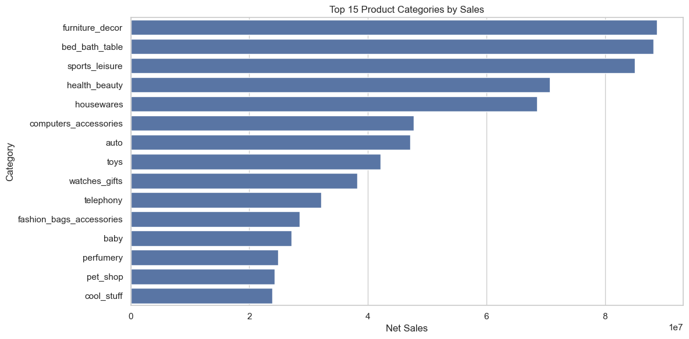
Business insight: Furniture_decor is the strongest revenue-generating category in the notebook. This category should be treated as a core revenue engine, while lower-ranked categories can be evaluated for targeted growth or assortment optimisation.

Q3. Which categories generate the highest profit?
Profit is aggregated at category level, ranked from highest to lowest and visualised for the top 15 categories.
category_profit = (
master.groupby('Category_name')['Profit']
.sum()
.sort_values(ascending=False)
.head(15)
)
plt.figure(figsize=(12,6))
sns.barplot(
x=category_profit.values,
y=category_profit.index
)
plt.title("Top 15 Categories by Profit")
plt.xlabel("Total Profit")
plt.ylabel("Category")
plt.tight_layout()
plt.show()

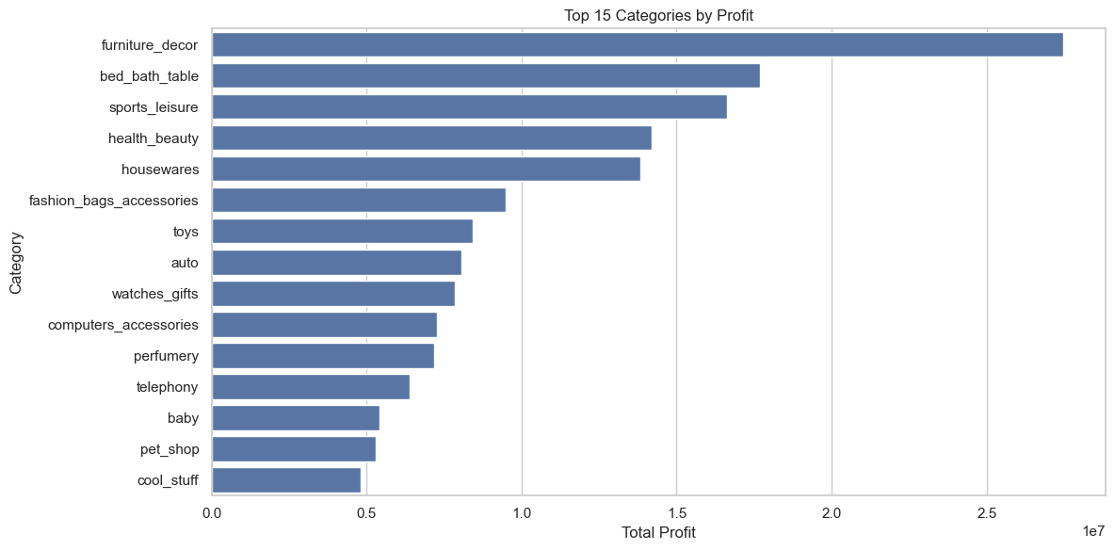
Business insight: Furniture decor is also the top profit category, so its leadership is not only volume-driven. Protecting availability, pricing discipline and customer experience in this category has high business value.

Q4. Which subcategories perform best?
Net sales are grouped by sub_category_name, sorted and restricted to the top 15 for comparison.
master.groupby('sub_category_name')['Net Product Amount']
.sum()
.sort_values(ascending=False)
.head(15)
)
plt.figure(figsize=(12,6))
sns.barplot(
x=subcategory_sales.values,
y=subcategory_sales.index
)
plt.title("Top 15 Subcategories by Sales")
plt.xlabel("Net Sales")
plt.ylabel("Subcategory")
plt.tight_layout()
plt.show()
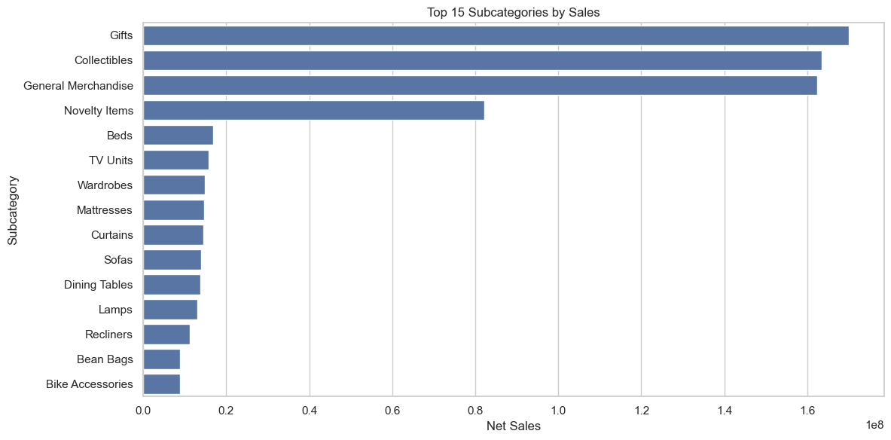
Business insight: The chart shows a small group of subcategories contributing substantially more sales than the long tail. The strongest subcategories should receive priority in assortment, stock allocation and merchandising decisions.

Q5. Which customer segments generate the most revenue?
Net Product Amount is grouped by customer_segment and displayed as a comparison of New, Returning and Loyal customers.
segment_sales = (
master.groupby('customer_segment')['Net Product Amount']
.sum()
.sort_values(ascending=False)
)
plt.figure(figsize=(8,5))
sns.barplot(
x=segment_sales.index,
y=segment_sales.values
)
plt.title("Sales by Customer Segment")
plt.xlabel("Customer Segment")
plt.ylabel("Net Sales")
plt.tight_layout()
plt.show()
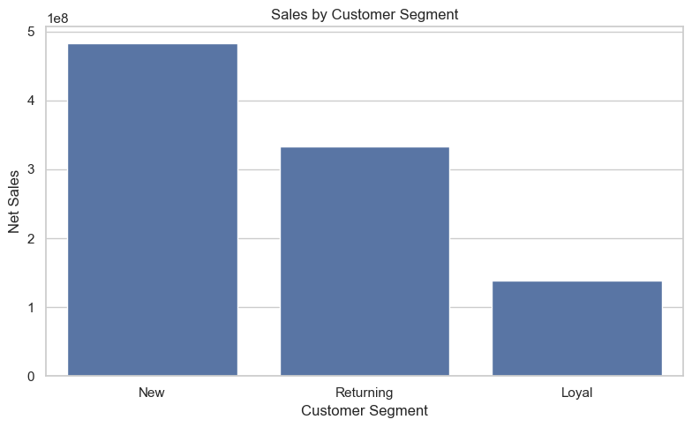
Business insight: New customers contribute the highest revenue in the notebook. This indicates strong acquisition volume, but it also makes retention important because moving more new customers into repeat behaviour can increase lifetime value.

Q6. How many customers are New, Returning and Loyal?
Customer records are counted by customer_segment and visualised to compare the size of each segment.
segment_count = customers[
'customer_segment'
].value_counts()
plt.figure(figsize=(8,5))
sns.barplot(
x=segment_count.index,
y=segment_count.values
)
plt.title("Customer Distribution by Segment")
plt.xlabel("Customer Segment")
plt.ylabel("Number of Customers")
plt.tight_layout()
plt.show()
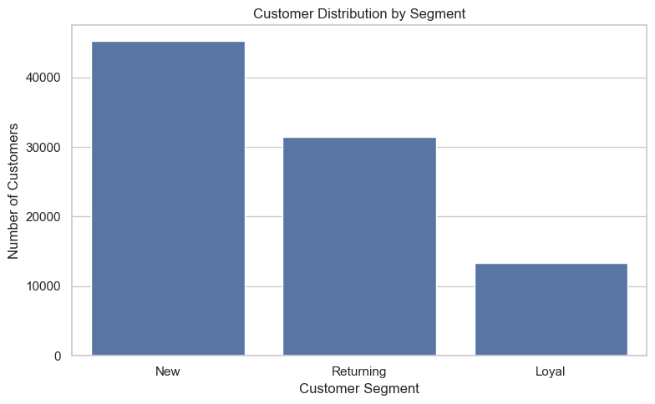
Business insight: The customer base is concentrated in New customers, followed by Returning and then Loyal customers. The scale of the New segment creates a large opportunity for targeted onboarding and conversion into repeat purchases

Q7. What is the average order value?
The notebook first calculates order-level Net Product Amount and averages those order totals. It then visualises the distribution with a histogram and KDE.
order_value = (
master.groupby('order_id')['Net Product Amount']
.sum()
)
average_order_value = order_value.mean()
print("Average Order Value:", round(average_order_value, 2))
plt.figure(figsize=(10,5))
sns.histplot(
order_value,
bins=50,
kde=True
)
plt.title("Distribution of Order Value")
plt.xlabel("Order Value")
plt.ylabel("Number of Orders")
plt.show()

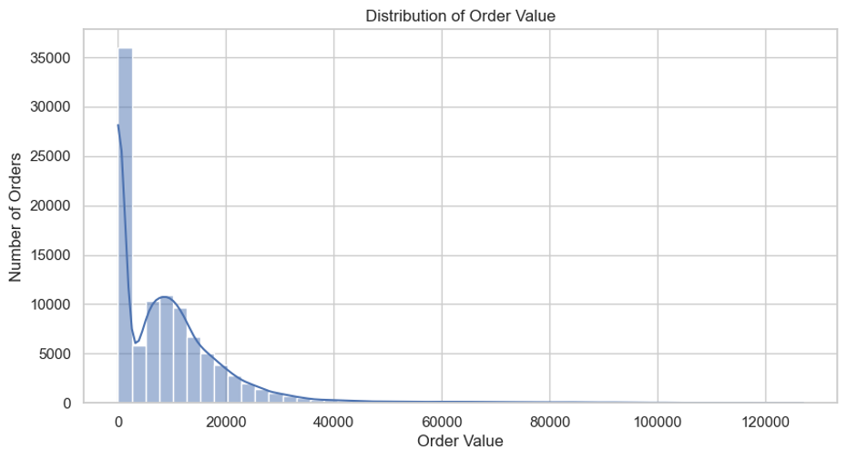
Business insight: Average Order Value is 9,544.83. The distribution is strongly right-skewed, so a small number of high-value orders pull the mean upward; median order value and AOV by segment would therefore be useful complements.

Q8. Which payment methods are most commonly used?
Orders are counted by payment_type and displayed as a bar chart.
payment_count = orders[
'payment_type'
].value_counts()
plt.figure(figsize=(9,5))
sns.barplot(
x=payment_count.index,
y=payment_count.values
)
plt.title("Orders by Payment Method")
plt.xlabel("Payment Method")
plt.ylabel("Number of Orders")
plt.xticks(rotation=30)
plt.tight_layout()
plt.show()
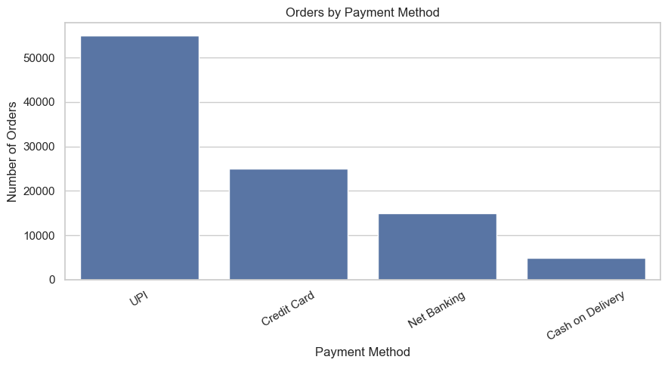
Business insight: UPI is the most common payment method, followed by other digital options. Optimizing the highest-volume payment journeys should reduce friction for the largest share of customers.

Q9. What is the cancellation rate?
Order status is counted, total orders are calculated and cancelled orders are divided by total orders to obtain cancellation rate
status_count = orders['order_status'].value_counts()
total_orders = len(orders)
cancelled_orders = (
orders['order_status'] == 'cancelled'
).sum()
cancellation_rate = (
cancelled_orders / total_orders
) * 100
print("Total Orders:", total_orders)
print("Cancelled Orders:", cancelled_orders)
print("Cancellation Rate:",
round(cancellation_rate, 2), "%")
plt.figure(figsize=(8,5))
sns.barplot(
x=status_count.index,
y=status_count.values
)
plt.title("Order Status Distribution")
plt.xlabel("Order Status")
plt.ylabel("Number of Orders")
plt.xticks(rotation=20)
plt.show()
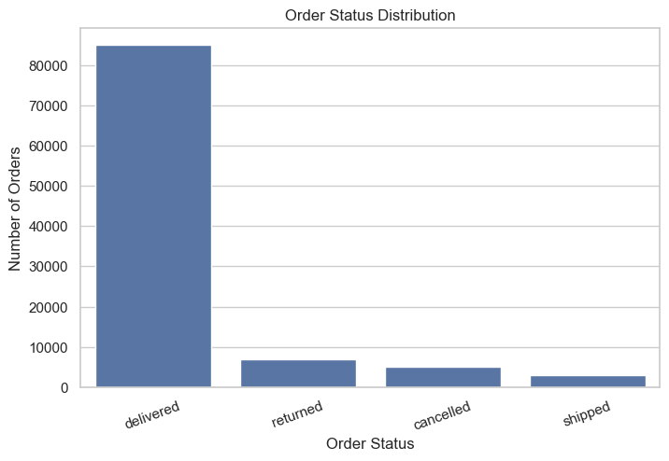

Business insight: The overall cancellation rate is 5.05% (5,048 cancelled orders out of 99,999). Cancellation is material enough to monitor as a conversion and operational KPI, especially where high-volume categories show elevated rates.

Q10. Which product categories have the highest cancellation rate?
For each category, the notebook counts distinct orders and cancelled orders, calculates the rate and plots the 15 highest category rates.
cancel_category = (
master.groupby('Category_name')
.agg(
total_orders=('order_id', 'nunique'),
cancelled_orders=(
'order_status',
lambda x: (x == 'cancelled').sum()
)
)
)
cancel_category['cancellation_rate'] = (
cancel_category['cancelled_orders'] /
cancel_category['total_orders']
) * 100
cancel_category = (
cancel_category
.sort_values('cancellation_rate', ascending=False)
.head(15)
)
display(cancel_category)
plt.figure(figsize=(12,6))
sns.barplot(
data=cancel_category.reset_index(),
x='cancellation_rate',
y='Category_name'
)
plt.title("Categories with Highest Cancellation Rate")
plt.xlabel("Cancellation Rate (%)")
plt.ylabel("Category")
plt.tight_layout()
plt.show()

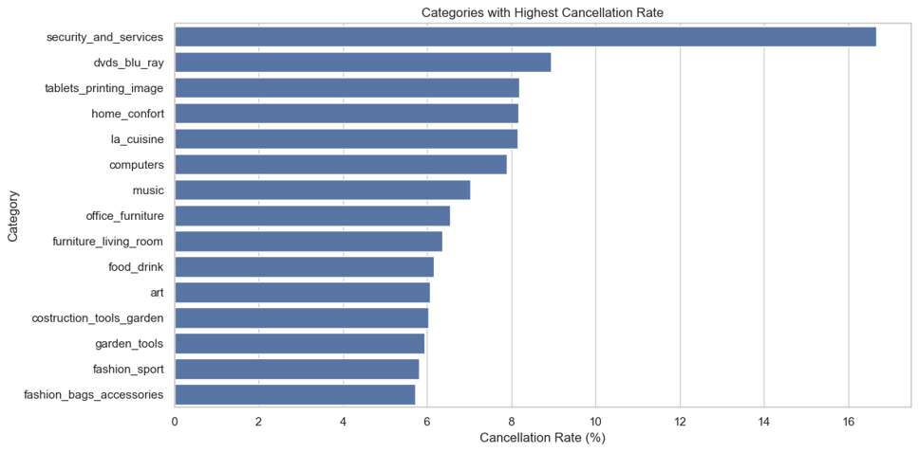
Business insight: Security_and_services has the highest observed rate at 16.67%, but it is based on only 6 orders. For actionability, high-volume categories such as fashion_bags_accessories deserve more attention even with lower percentages because the absolute number of affected orders is much larger

Q11. Which categories have the highest return rate?
Return rate is calculated by category using distinct total orders and returned orders, then the 15 highest categories are charted.
return_category = (
master.groupby('Category_name')
.agg(
total_orders=('order_id', 'nunique'),
returned_orders=(
'order_status',
lambda x: (x == 'returned').sum()
)
)
)
return_category['return_rate'] = (
return_category['returned_orders'] /
return_category['total_orders']
) * 100
return_category = (
return_category
.sort_values('return_rate', ascending=False)
.head(15)
)
display(return_category)
plt.figure(figsize=(12,6))
sns.barplot(
data=return_category.reset_index(),
x='return_rate',
y='Category_name'
)
plt.title("Categories with Highest Return Rate")
plt.xlabel("Return Rate (%)")
plt.ylabel("Category")
plt.tight_layout()
plt.show()

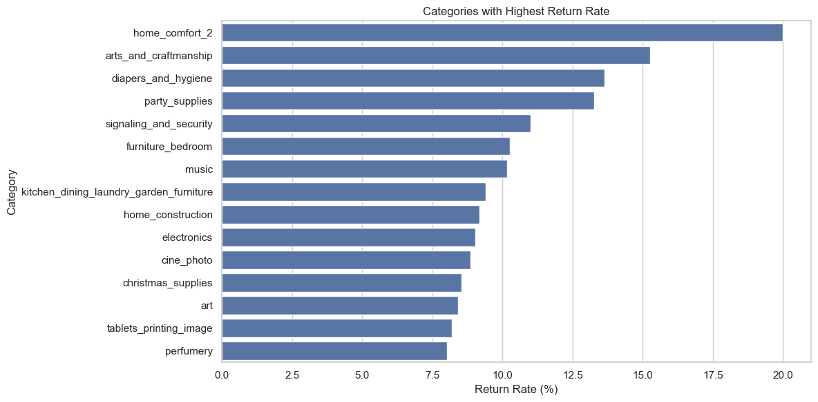
Business insight: Home_comfort_2 has the highest reported return rate at 20.00%, but this is based on just 5 orders. Higher-volume categories such as perfumery provide a more stable basis for operational action despite having a lower percentage rate.

Q12. Does delivery delay affect customer satisfaction?
Delivery Delay is plotted against review score using boxplots, and the notebook also computes the correlation between the two fields.
delivery_review = master[
['Delivery Delay', 'review_score']
].dropna()
plt.figure(figsize=(10,6))
sns.boxplot(
data=delivery_review,
x='review_score',
y='Delivery Delay'
)
plt.title("Delivery Delay vs Review Score")
plt.xlabel("Review Score")
plt.ylabel("Delivery Delay (Days)")
plt.show()
correlation = delivery_review[
['Delivery Delay', 'review_score']
].corr()
display(correlation)

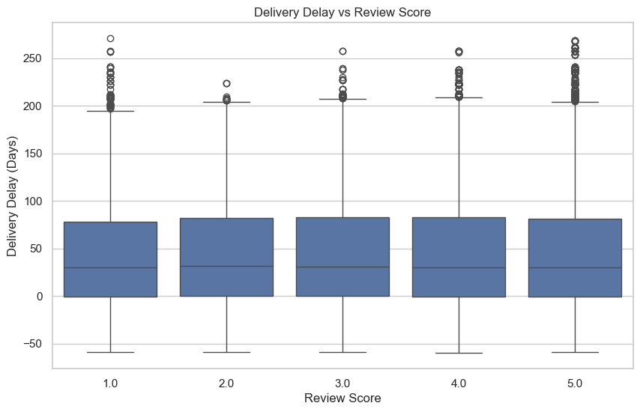
Business insight: The correlation is 0.004556, indicating almost no linear relationship in this dataset. Delivery delay therefore does not appear to be a strong standalone driver of review score in the notebook, although other service variables may still matter.

Q13. What is the relationship between review score and order status?
The notebook creates a cross-tabulation of review score by order status and visualises the resulting counts in a heatmap.
review_status = pd.crosstab(
master['order_status'],
master['review_score']
)
display(review_status)
plt.figure(figsize=(10,6))
sns.heatmap(
review_status,
annot=True,
fmt='d'
)
plt.title("Order Status vs Review Score")
plt.xlabel("Review Score")
plt.ylabel("Order Status")
plt.show()
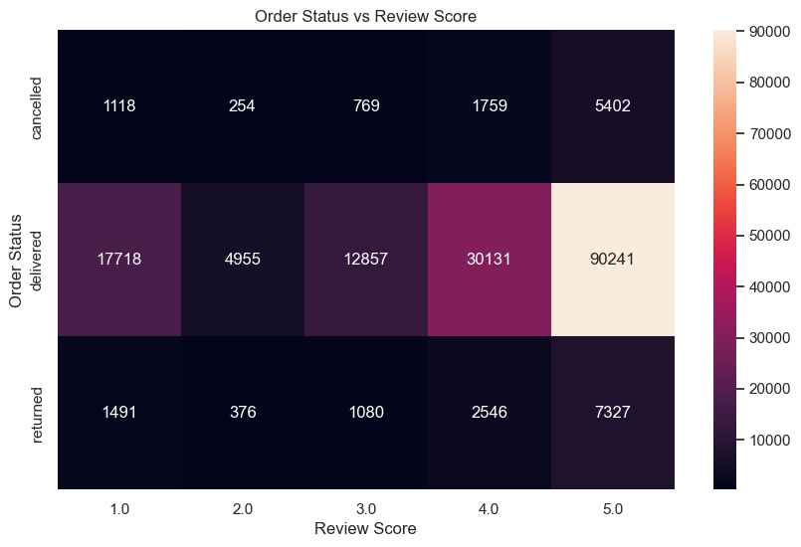

Business insight: Five-star reviews are the largest absolute group across delivered, returned and cancelled orders. Because the heatmap uses counts rather than within-status percentages, it mainly reflects status volume; normalised rates would be needed for a stronger comparative conclusion.

Q14. Which customer segments are most likely to return?
Returned orders are counted by customer segment and divided by total distinct orders for that segment.
segment_return = (
master.groupby('customer_segment')
.agg(
total_orders=('order_id', 'nunique'),
returned_orders=(
'order_status',
lambda x: (x == 'returned').sum()
)
)
)
segment_return['return_rate'] = (
segment_return['returned_orders'] /
segment_return['total_orders']
) * 100
display(segment_return)
plt.figure(figsize=(8,5))
sns.barplot(
data=segment_return.reset_index(),
x='customer_segment',
y='return_rate'
)
plt.title("Return Rate by Customer Segment")
plt.xlabel("Customer Segment")
plt.ylabel("Return Rate (%)")
plt.show()

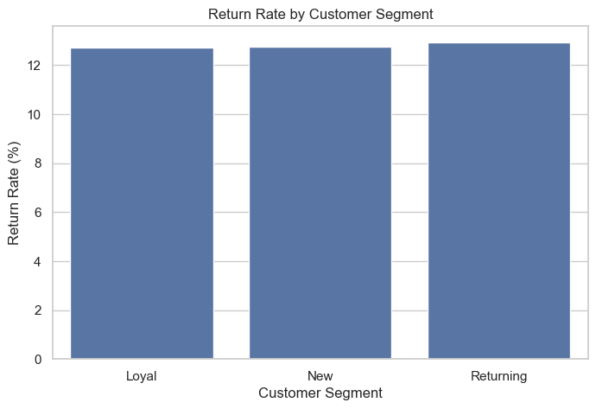
Business insight: Returning customers have the highest return rate at 12.95%, followed closely by New customers at 12.76% and Loyal customers at 12.73%. The differences are small, so customer segment alone is not a strong return-risk discriminator.

Q15. Which products contribute the most revenue?
Revenue, quantity and profit are aggregated by product, category and subcategory, then the top 20 products by revenue are plotted.
product_sales = (
master.groupby(
['product_id', 'Category_name', 'sub_category_name']
)
.agg(
revenue=('Net Product Amount', 'sum'),
quantity=('quantity', 'sum'),
profit=('Profit', 'sum')
)
.sort_values(
'revenue',
ascending=False
)
.head(20)
)
display(product_sales)
plt.figure(figsize=(12,8))
sns.barplot(
data=product_sales.reset_index(),
x='revenue',
y='product_id'
)
plt.title("Top 20 Products by Revenue")
plt.xlabel("Revenue")
plt.ylabel("Product ID")
plt.tight_layout()
plt.show()

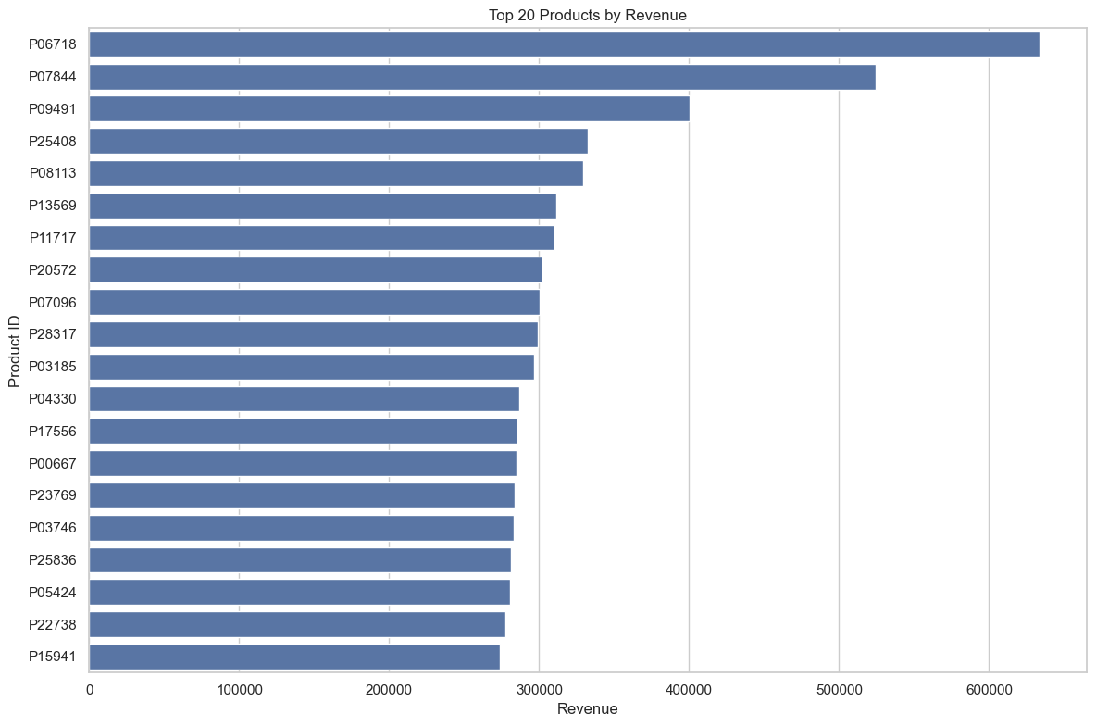

Business insight: P06718 in furniture_decor is the highest-revenue product at about 633.5K, followed by P07844 at about 524.5K. A focused assortment and inventory strategy around the top products could protect a meaningful share of revenue.

Q16. Customer Retention Analysis
The notebook builds a customer-level retention table with total orders, first purchase, last purchase and the elapsed days between first and last purchase.
customer_orders = (
orders.groupby('customer_id')
.agg(
total_orders=('order_id', 'nunique'),
first_purchase=('order_purchase_timestamp', 'min'),
last_purchase=('order_purchase_timestamp', 'max')
)
.reset_index()
)
customer_orders['days_between_purchase'] = (
customer_orders['last_purchase'] -
customer_orders['first_purchase']
).dt.days
customer_orders.head()
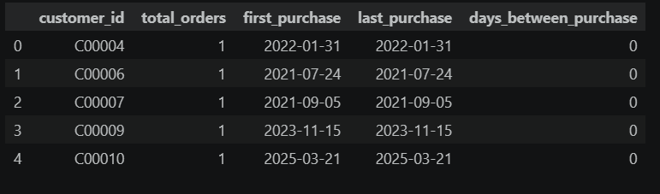
Business insight: This step creates the core features needed for retention analysis. No chart is generated in the supplied notebook for this section; the stored output is a customer-level diagnostic table.

Q17. Repeat Customer Analysis
Customers with more than one order are classified as repeat customers. The repeat-customer rate is calculated and visualised against one-time customers.
repeat_customers = customer_orders[
customer_orders['total_orders'] > 1
]
repeat_customer_rate = (
len(repeat_customers) /
len(customer_orders)
) * 100
print(
"Repeat Customer Rate:",
round(repeat_customer_rate, 2),
"%"
)
customer_type = np.where(
customer_orders['total_orders'] > 1,
'Repeat Customer',
'One-Time Customer'
)
customer_type_counts = pd.Series(
customer_type
).value_counts()
plt.figure(figsize=(8,5))
sns.barplot(
x=customer_type_counts.index,
y=customer_type_counts.values
)
plt.title("One-Time vs Repeat Customers")
plt.xlabel("Customer Type")
plt.ylabel("Number of Customers")
plt.show()

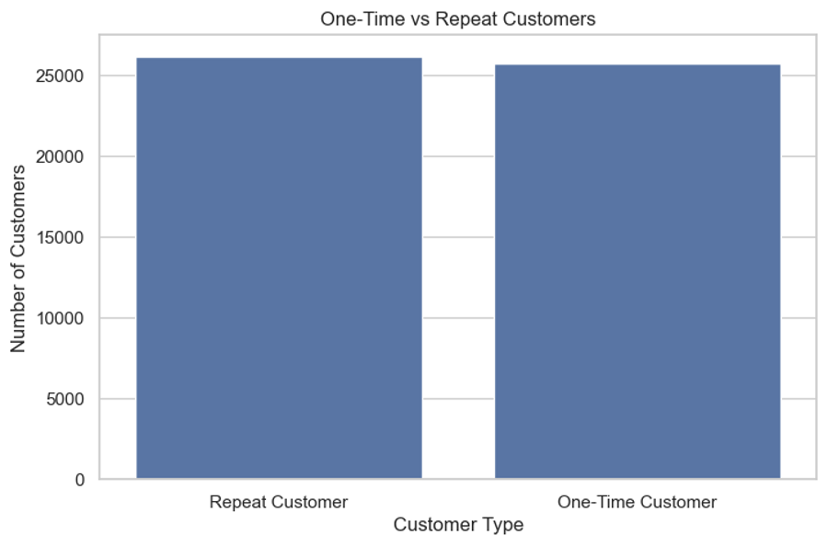
Business insight: Repeat Customer Rate is 50.44%, indicating that approximately half of customers have more than one order. This creates a strong base for retention initiatives, while the almost-even chart also shows room to convert more one-time buyers.

Q18. Customer Purchase Frequency
The notebook counts customers by their total order count and plots the frequency distribution.
purchase_frequency = (
customer_orders['total_orders']
.value_counts()
.sort_index()
)
plt.figure(figsize=(12,5))
sns.barplot(
x=purchase_frequency.index,
y=purchase_frequency.values
)
plt.title("Customer Purchase Frequency")
plt.xlabel("Number of Orders")
plt.ylabel("Number of Customers")
plt.show()

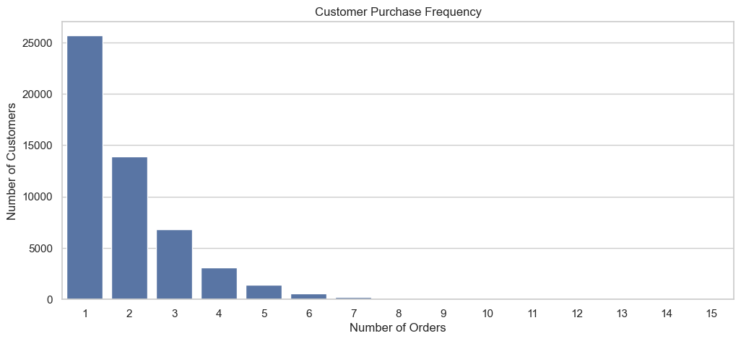
Business insight: Purchase frequency is heavily concentrated at one order and falls rapidly as order count increases. Retention efforts should therefore focus on moving customers from the first to the second purchase, where the biggest drop-off occurs

Q19. Customer Segment vs Purchase Frequency
Customer order history is merged with segment attributes and average orders per customer are calculated for each segment.
customer_analysis = customer_orders.merge(
customers[
['customer_id', 'customer_segment', 'age_group', 'gender']
],
on='customer_id',
how='left'
)
segment_frequency = (
customer_analysis.groupby('customer_segment')
['total_orders']
.mean()
.sort_values(ascending=False)
)
display(segment_frequency)
plt.figure(figsize=(8,5))
sns.barplot(
x=segment_frequency.index,
y=segment_frequency.values
)
plt.title("Average Orders per Customer Segment")
plt.xlabel("Customer Segment")
plt.ylabel("Average Number of Orders")
plt.show()

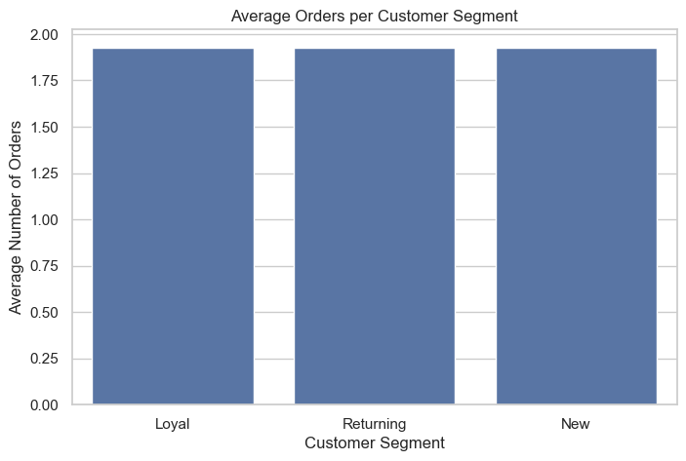
Business insight: Average orders are almost identical across segments: Loyal 1.928, Returning 1.927 and New 1.926. Segment labels therefore do not strongly separate purchase frequency in this dataset.

Q20. Age Group Analysis
Net sales are grouped by age_group and displayed as a bar chart.
age_sales = (
master.groupby('age_group')['Net Product Amount']
.sum()
.sort_values(ascending=False)
)
plt.figure(figsize=(9,5))
sns.barplot(
x=age_sales.index,
y=age_sales.values
)
plt.title("Sales by Age Group")
plt.xlabel("Age Group")
plt.ylabel("Net Sales")
plt.show()
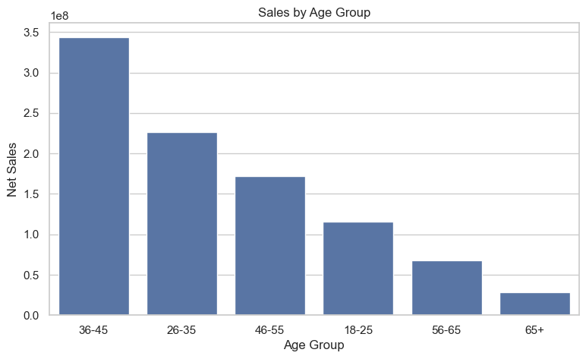
Business insight: The 36-45 age group generates the highest sales, followed by 26-35 and 46-55. This suggests that the 36-45 cohort deserves strong targeting and assortment attention, while lower-volume age groups may need tailored propositions.

Q21. Gender Analysis
Net sales are grouped by gender and visualised as a bar comparison
gender_sales = (
master.groupby('gender')['Net Product Amount']
.sum()
)
plt.figure(figsize=(7,5))
sns.barplot(
x=gender_sales.index,
y=gender_sales.values
)
plt.title("Sales by Gender")
plt.xlabel("Gender")
plt.ylabel("Net Sales")
plt.show()
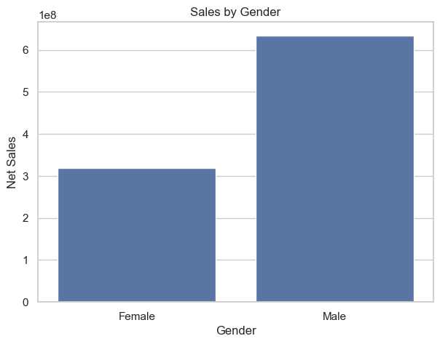
Business insight: Male customers contribute materially more sales than female customers in the notebook. This is a descriptive difference rather than a causal finding and should be interpreted alongside customer mix, age and category preferences.

Q22. Discount vs Sales Analysis
A sample of up to 10,000 records is plotted with discount percentage on the x-axis and Net Product Amount on the y-axis.
discount_analysis = master[
['discount(%)', 'Net Product Amount']
].dropna()
plt.figure(figsize=(10,6))
sns.scatterplot(
data=discount_analysis.sample(
min(10000, len(discount_analysis)),
random_state=42
),
x='discount(%)',
y='Net Product Amount',
alpha=0.5
)
plt.title("Discount Percentage vs Net Sales")
plt.xlabel("Discount (%)")
plt.ylabel("Net Product Amount")
plt.show()
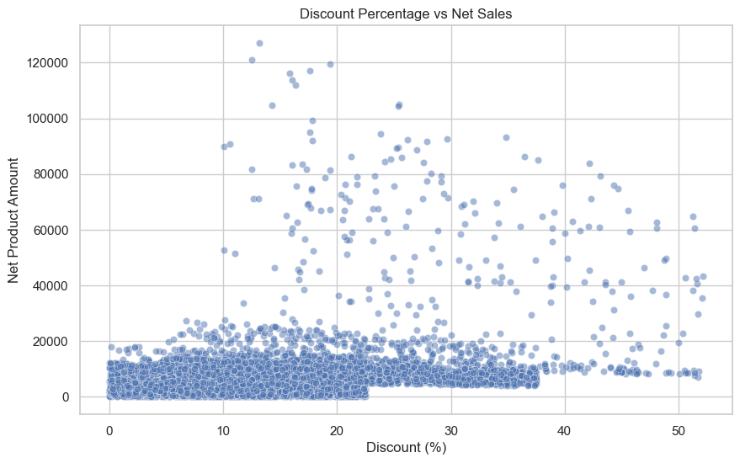

Business insight: The scatter plot does not show a strong, clean linear relationship between discount and net sales. High-value observations occur across multiple discount levels, suggesting that price discount alone is not sufficient to explain order value.

Q23. Profit Margin Analysis
Revenue and total profit are aggregated by category and converted into profit margin. The top 15 categories by margin are displayed in a table rather than a chart.
profit_category = (
master.groupby('Category_name')
.agg(
revenue=('Net Product Amount', 'sum'),
profit=('Profit', 'sum')
)
)
profit_category['profit_margin'] = (
profit_category['profit'] /
profit_category['revenue']
) * 100
profit_category = (
profit_category
.sort_values('profit_margin', ascending=False)
)
display(profit_category.head(15))
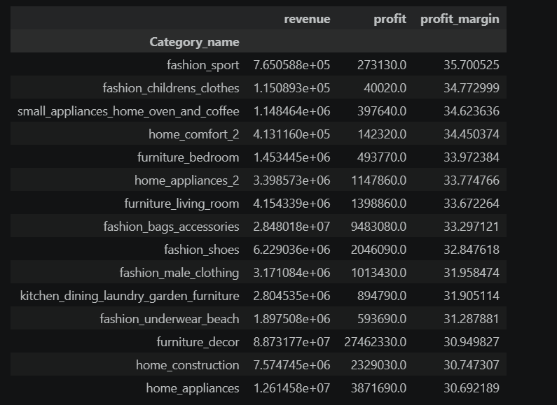
Business insight: Fashion_sport has the highest reported category profit margin at about 35.70%. The results also illustrate a useful portfolio trade-off: the highest-margin categories are not necessarily the highest-revenue categories, so decisions should balance scale and margin.

Q24. Delivery Status Analysis
Orders are counted by Delivery_Status and displayed as a bar chart.
delivery_status = (
orders['Delivery_Status']
.value_counts()
)
plt.figure(figsize=(10,6))
sns.barplot(
x=delivery_status.index,
y=delivery_status.values
)
plt.title("Delivery Performance")
plt.xlabel("Delivery Status")
plt.ylabel("Number of Orders")
plt.xticks(rotation=45)
plt.tight_layout()
plt.show()

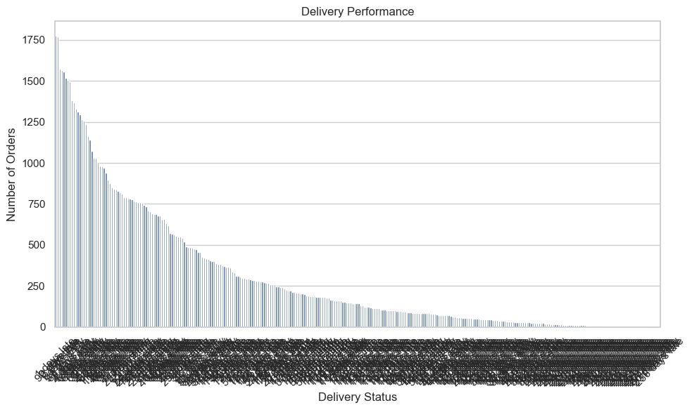
Business insight: Delivered orders dominate the status distribution, but there are many distinct early/late-day labels. For management reporting, these statuses would be easier to interpret if grouped into broader buckets such as Early, On Time and Late.

Q25. Monthly Order Trend
Orders are resampled by month and unique order IDs are counted to create a monthly trend line.
monthly_orders = (
orders.set_index('order_purchase_timestamp')
.resample('M')
['order_id']
.nunique()
)
plt.figure(figsize=(14,6))
sns.lineplot(
x=monthly_orders.index,
y=monthly_orders.values,
marker='o'
)
plt.title("Monthly Order Trend")
plt.xlabel("Month")
plt.ylabel("Number of Orders")
plt.xticks(rotation=90)
plt.show()
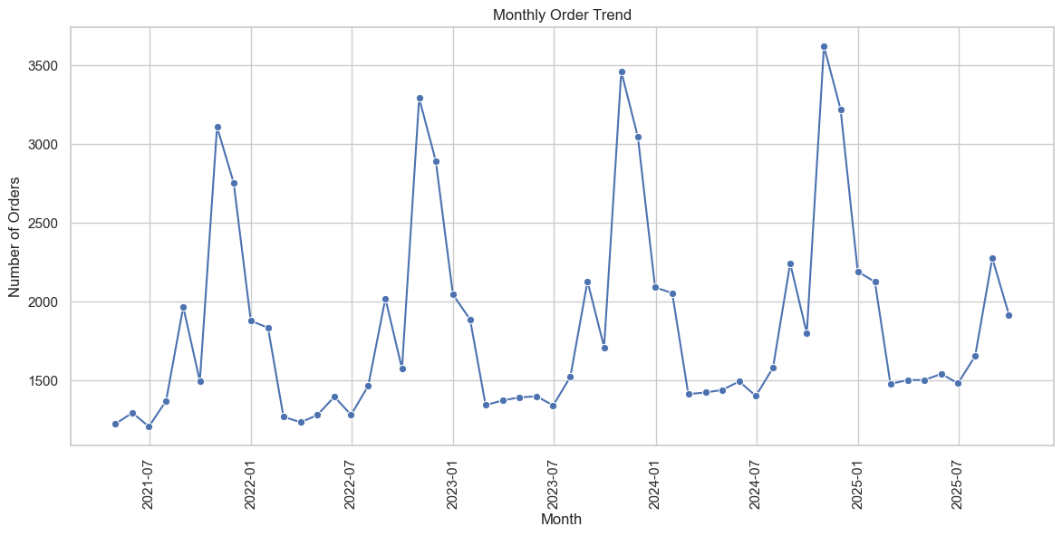
Business insight: Monthly order volume shows recurring peaks similar to the sales trend. This reinforces the need for seasonal capacity, inventory and campaign planning around repeat high-demand periods.

Q26. Review Score Distribution
Review scores are counted from 1 to 5 and visualised as a bar chart.
review_distribution = (
reviews['review_score']
.value_counts()
.sort_index()
)
plt.figure(figsize=(8,5))
sns.barplot(
x=review_distribution.index,
y=review_distribution.values
)
plt.title("Customer Review Score Distribution")
plt.xlabel("Review Score")
plt.ylabel("Number of Reviews")
plt.show()
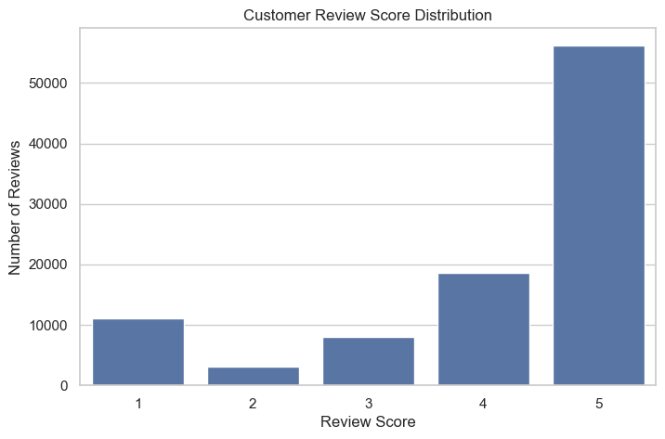
Business insight: Five-star reviews dominate, with four-star reviews next. This supports the overall positive review picture and is consistent with the reported average review score of 4.09/5.

Q27. Average Review Score by Category
Average review score is calculated by category and the 15 highest-scoring categories are displayed.
category_reviews = (
master.groupby('Category_name')
['review_score']
.mean()
.sort_values(ascending=False)
.head(15)
)
plt.figure(figsize=(12,6))
sns.barplot(
x=category_reviews.values,
y=category_reviews.index
)
plt.title("Top Categories by Average Review Score")
plt.xlabel("Average Review Score")
plt.ylabel("Category")
plt.xlim(0,5)
plt.show()
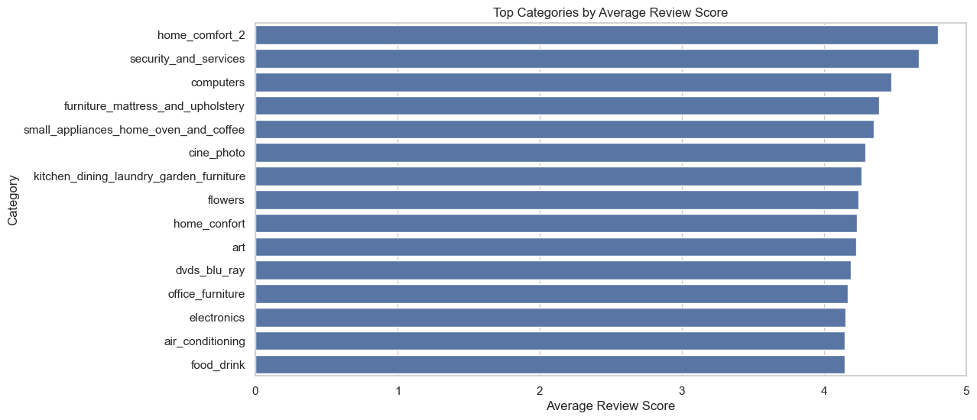
Business insight: The highest-scoring categories are tightly clustered near the upper end of the five-point scale. This indicates broad consistency in perceived product/service quality among top-rated categories, with limited separation between leaders

Q28. Correlation Analysis
A correlation matrix is built for quantity, prices, discounts, shipping, revenue components, profit, profit margin, delivery delay and review score.
numeric_columns = [
'quantity',
'unit_price',
'discount(%)',
'shipping_cost',
'Gross Amount',
'Discount Amount',
'Net Product Amount',
'Total Cost Including Shipping',
'Profit',
'Profit Margin',
'Delivery Delay',
'review_score'
]
corr_data = master[
[col for col in numeric_columns if col in master.columns]
].corr()
plt.figure(figsize=(14,10))
sns.heatmap(
corr_data,
annot=True,
fmt='.2f',
cmap='coolwarm',
center=0
)
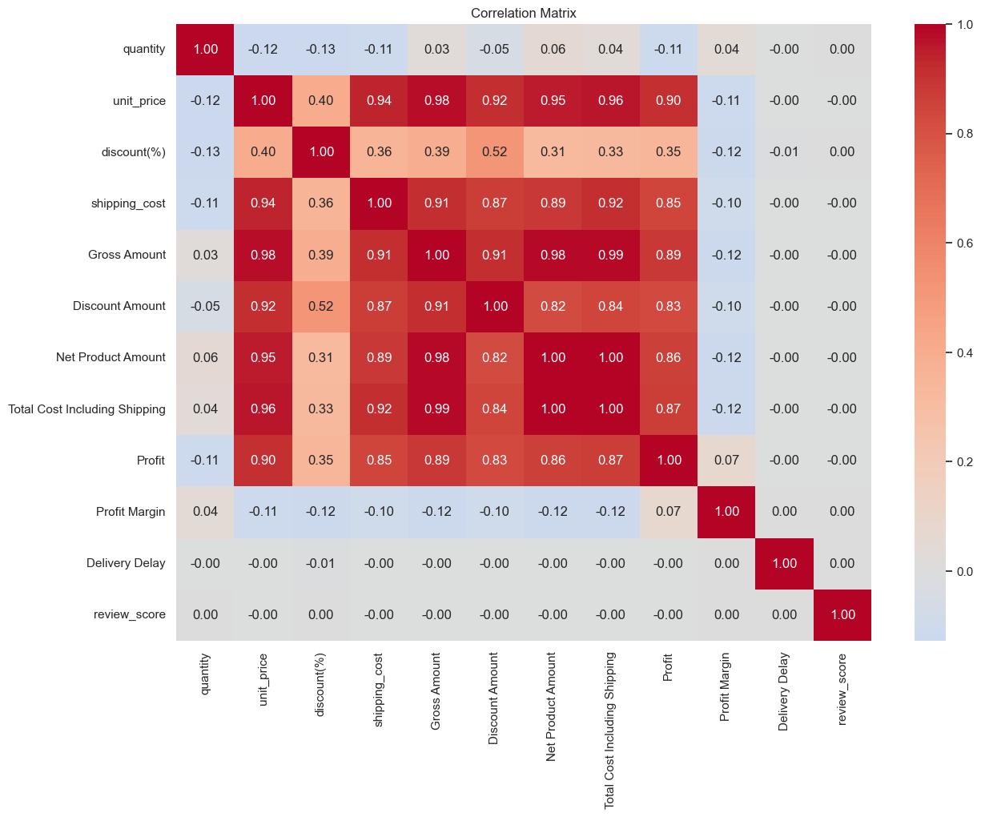
Business insight: The matrix shows strong mechanical relationships among related financial measures, while delivery delay and review score are only weakly related. This suggests that revenue and cost variables are intertwined by construction, so business interpretation should focus on non-mechanical relationships.

Q29. Key KPI Calculation
total_orders = orders['order_id'].nunique()
total_customers = customers['customer_id'].nunique()
total_revenue = master[
'Net Product Amount'
].sum()
total_profit = master[
'Profit'
].sum()
cancelled_orders = (
orders['order_status'] == 'cancelled'
).sum()
returned_orders = (
orders['order_status'] == 'returned'
).sum()
cancellation_rate = (
cancelled_orders / total_orders
) * 100
return_rate = (
returned_orders / total_orders
) * 100
average_order_value = (
master.groupby('order_id')['Net Product Amount']
.sum()
.mean()
)
average_review = reviews[
'review_score'
].mean()
print("========== E-COMMERCE KPIs ==========")
print("Total Customers :", total_customers)
print("Total Orders :", total_orders)
print("Total Revenue :", round(total_revenue, 2))
print("Total Profit :", round(total_profit, 2))
print("Average Order Value :", round(average_order_value, 2))
print("Cancellation Rate :", round(cancellation_rate, 2), "%")
print("Return Rate :", round(return_rate, 2), "%")
print("Average Review Score :", round(average_review, 2))
print("Repeat Customer Rate :", round(repeat_customer_rate, 2), "%")

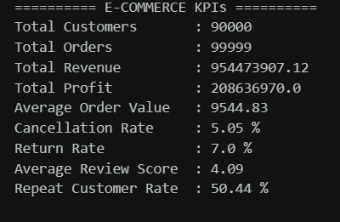
Business insight: The KPI block provides the executive snapshot: 90,000 customers, 99,999 orders, 954.47M revenue, 208.64M profit, 9,544.83 AOV, 5.05% cancellation, 7.00% return, 4.09 average review and 50.44% repeat-customer rate.

Q30. Automatic Top Business Insights
This concludes the analytical sequence with a code block that automatically extracts the leading categories, customer segment and key rates. The output below is reproduced in substance and then interpreted for management use.
top_category = (
master.groupby('Category_name')['Net Product Amount']
.sum()
.idxmax()
)
top_category_sales = (
master.groupby('Category_name')['Net Product Amount']
.sum()
.max()
)
top_profit_category = (
master.groupby('Category_name')['Profit']
.sum()
.idxmax()
)
top_customer_segment = (
master.groupby('customer_segment')
['Net Product Amount']
.sum()
.idxmax()
)
highest_cancel_category = (
cancel_category.index[0]
)
highest_return_category = (
return_category.index[0]
)
print("KEY BUSINESS INSIGHTS")
print("-" * 50)
print(
f"1. {top_category} generates the highest net sales."
)
print(
f"2. {top_profit_category} is the most profitable category."
)
print(
f"3. {top_customer_segment} customers contribute the highest revenue."
)
print(
f"4. Overall cancellation rate is {cancellation_rate:.2f}%."
)
print(
f"5. Overall return rate is {return_rate:.2f}%."
)
print(
f"6. {highest_cancel_category} has the highest cancellation rate among categories."
)
print(
f"7. {highest_return_category} has the highest return rate among categories."
)
print(
f"8. Repeat customer rate is {repeat_customer_rate:.2f}%."
)
print(
f"9. Average customer review score is {average_review:.2f}/5."
)
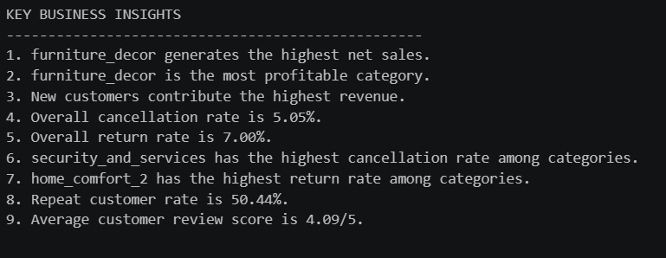

Q31. Final EDA Dashboard
The notebook finishes with a six-panel dashboard combining customer segments, order status, review scores, top categories by sales, monthly sales and one-time versus repeat customers. This is the final consolidated visual view of the preceding analysis.
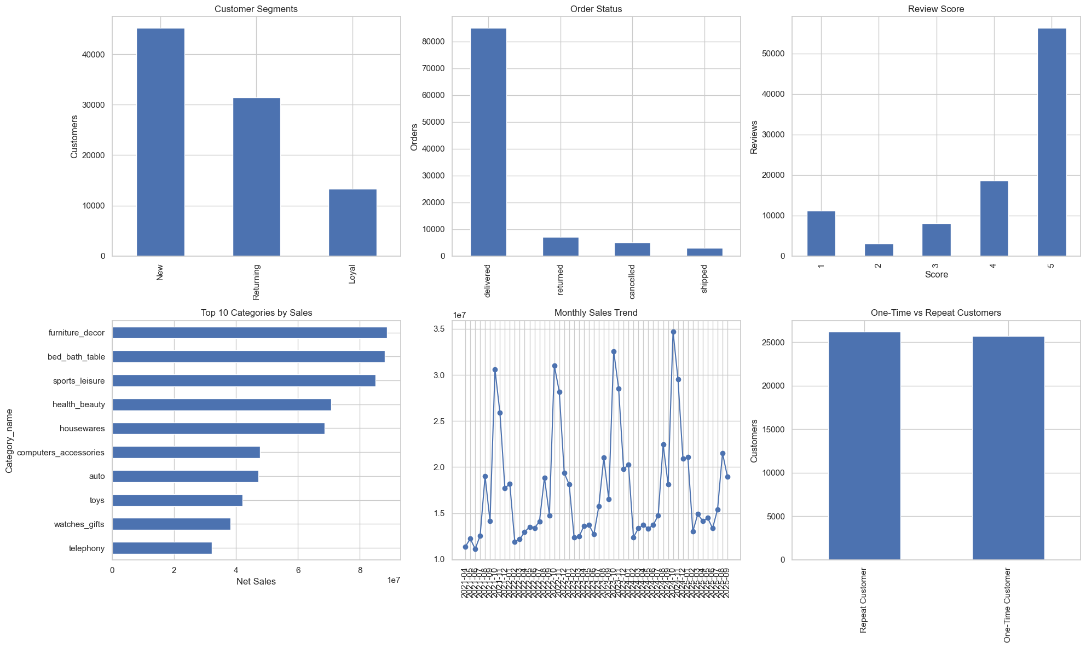
fig, axes = plt.subplots(2, 3, figsize=(20, 12))
# 1. Customer Segment
segment_count.plot(
kind='bar',
ax=axes[0,0]
)
axes[0,0].set_title("Customer Segments")
axes[0,0].set_xlabel("")
axes[0,0].set_ylabel("Customers")
# 2. Order Status
status_count.plot(
kind='bar',
ax=axes[0,1]
)
axes[0,1].set_title("Order Status")
axes[0,1].set_xlabel("")
axes[0,1].set_ylabel("Orders")
# 3. Review Score
review_distribution.plot(
kind='bar',
ax=axes[0,2]
)
axes[0,2].set_title("Review Score")
axes[0,2].set_xlabel("Score")
axes[0,2].set_ylabel("Reviews")
# 4. Top Categories
category_sales.head(10).sort_values().plot(
kind='barh',
ax=axes[1,0]
)
axes[1,0].set_title("Top 10 Categories by Sales")
axes[1,0].set_xlabel("Net Sales")
# 5. Monthly Sales
axes[1,1].plot(
monthly_sales['order_purchase_timestamp'],
monthly_sales['Net Product Amount'],
marker='o'
)
axes[1,1].set_title("Monthly Sales Trend")
axes[1,1].tick_params(axis='x', rotation=90)
# 6. Customer Type
customer_type_counts.plot(
kind='bar',
ax=axes[1,2]
)
axes[1,2].set_title("One-Time vs Repeat Customers")
axes[1,2].set_xlabel("")
axes[1,2].set_ylabel("Customers")
plt.tight_layout()
plt.show()

Business insight: The dashboard brings the main business story together: a large New-customer base, delivered orders dominating the order-status mix, strong five-star review volume, concentrated category sales, recurring monthly demand peaks and a roughly even split between repeat and one-time customers.
Conclusion
The Python-based EDA provides a consolidated view of the e-commerce business across sales, customers, products, profitability, operations and satisfaction. The analysis identifies furniture_decor as the highest net-sales and most profitable category, new customers as the largest revenue-contributing segment, a 5.05% overall cancellation rate, a 7.00% return rate, a 50.44% repeat customer rate and an average review score of 4.09/5. These findings indicate that product-category performance, customer retention, delivery efficiency and customer experience are important areas for management attention.
The analysis also demonstrates how Python can be used to transform multiple raw datasets into meaningful business insights. The final dashboard provides a concise summary that can support decisions related to product focus, retention initiatives, operational improvement, promotional planning and sustainable revenue growth.

Key Business Findings
- furniture_decor generates the highest net sales and is also the most profitable category.
- New customers contribute the highest revenue among the customer segments analysed.
- The overall cancellation rate is 5.05%.
- The overall return rate is 7.00%.
- security_and_services has the highest category cancellation rate identified by the notebook.
- home_comfort_2 has the highest category return rate identified by the notebook.
- The repeat customer rate is 50.44%.
- The average customer review score is 4.09 out of 5.
Python EDA Workflow:

1. Import Libraries
import pandas as pd
import numpy as np
import matplotlib.pyplot as plt
import seaborn as sns
import warnings
Explanation: This step prepares the data or calculates the metric needed for the subsequent EDA stage.

2. Load Datasets
customers = pd.read_excel(...)
orders = pd.read_excel(...)
order_items = pd.read_excel(...)
reviews = pd.read_excel(...)
products = pd.read_excel(...)
geolocation = pd.read_excel(...)
Explanation: This step prepares the data or calculates the metric needed for the subsequent EDA stage.

3. Inspect the Data
df.shape
df.dtypes
df.isnull().sum()
df.duplicated().sum()
Explanation: This step prepares the data or calculates the metric needed for the subsequent EDA stage.

4. Prepare Dates
orders[col] = pd.to_datetime(orders[col], errors='coerce')
Explanation: This step prepares the data or calculates the metric needed for the subsequent EDA stage.

5. Create Master Dataset
master = orders.merge(customers, on='customer_id', how='left')
master = master.merge(order_items, on='order_id', how='left')
master = master.merge(products, on='product_id', how='left')
Explanation: This step prepares the data or calculates the metric needed for the subsequent EDA stage.

6. Add Time Features
master['purchase_year'] = master['order_purchase_timestamp'].dt.year
master['purchase_month'] = master['order_purchase_timestamp'].dt.month
Explanation: This step prepares the data or calculates the metric needed for the subsequent EDA stage.

7. Analyse and Visualise
Use groupby(), agg(), value_counts(), resample(), correlation matrices and Seaborn/Matplotlib charts to answer the business questions.
Explanation: This step prepares the data or calculates the metric needed for the subsequent EDA stage.

8. Calculate KPIs
Calculate total customers, total orders, revenue, profit, AOV, cancellation rate, return rate, average review score and repeat customer rate.
Explanation: This step prepares the data or calculates the metric needed for the subsequent EDA stage.

9. Final Dashboard
Combine the main analytical views into a single Python dashboard for management-level interpretation.
Explanation: This step prepares the data or calculates the metric needed for the subsequent EDA stage.

