# Task 4 – Aggregate Functions and Grouping-Elevate Lab SQL Developer Internship

## Aggregate Functions:

In this task, I applied aggregate functions such as Sum, Average, Count, Min. Max on numeric columns in the travellers table to summarize data such as total, average, minimum, and maximum values. I created a new 'payment' table and connected it to the travellers table using traveller_id.

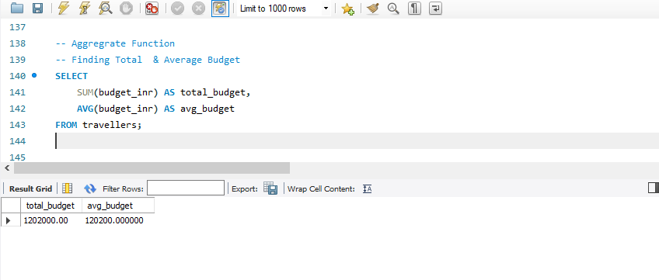

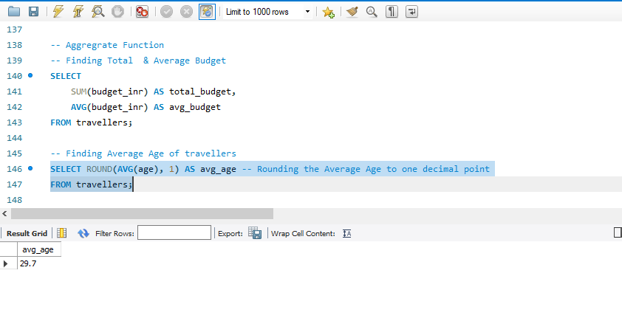

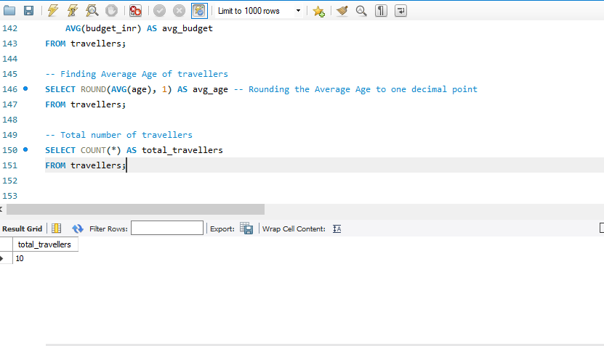

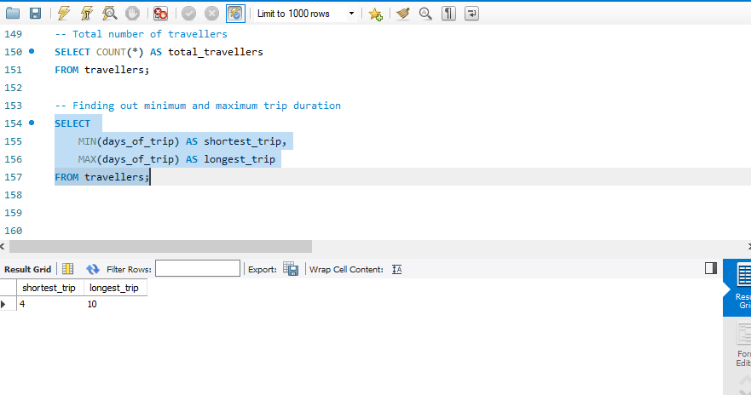

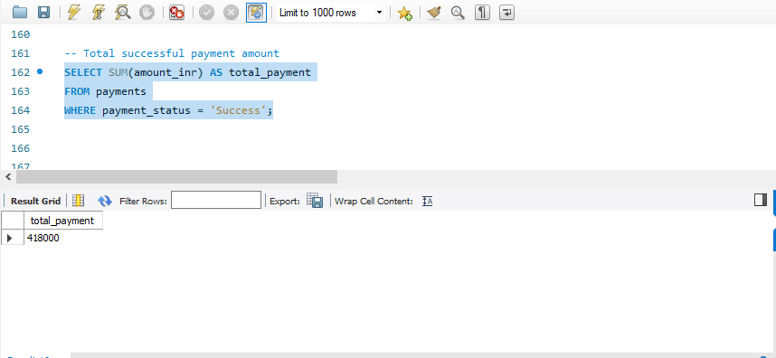

## GROUP BY

I used the GROUP BY clause to categorize and summarize traveler data and payments data

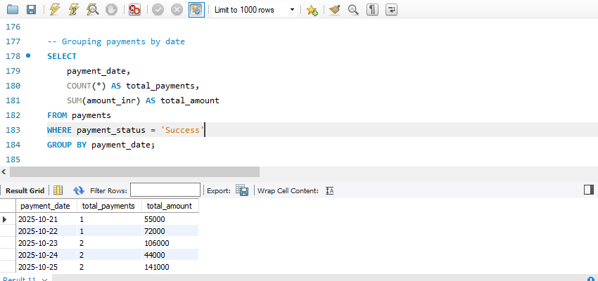

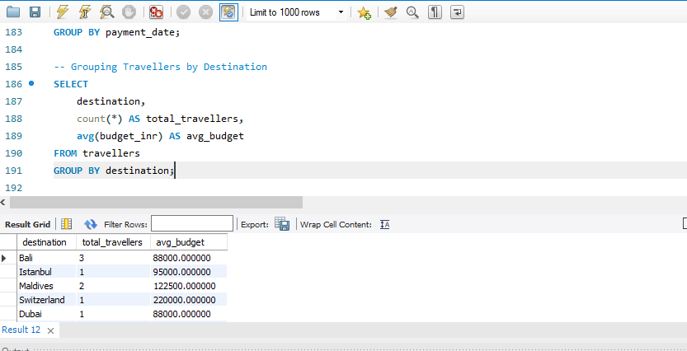

## HAVING

I created a new 'payment' table and connected it to the travellers table using traveller_id. Then, I used the HAVING clause to filter grouped results based on aggregate values.

