**Task 5: SQL Developer Internship - Elevate Labs**

**Joins**

In this task, I worked on understanding and implementing various types of SQL joins using two related tables: Interns and Mentors.

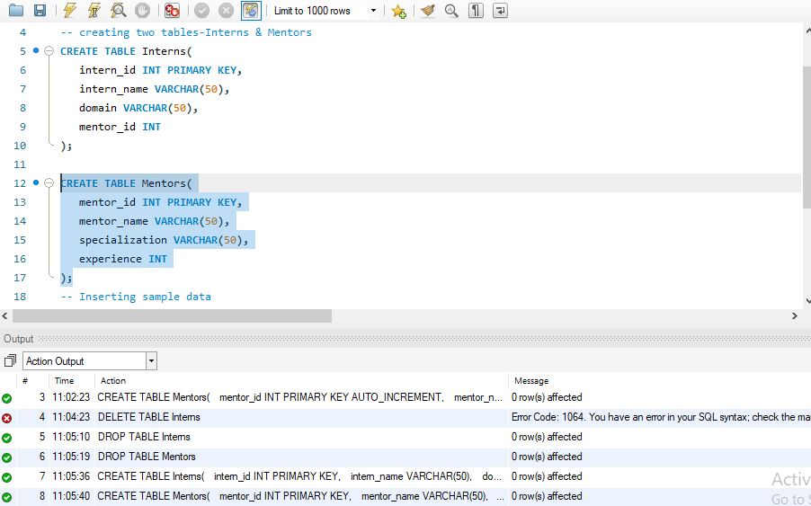

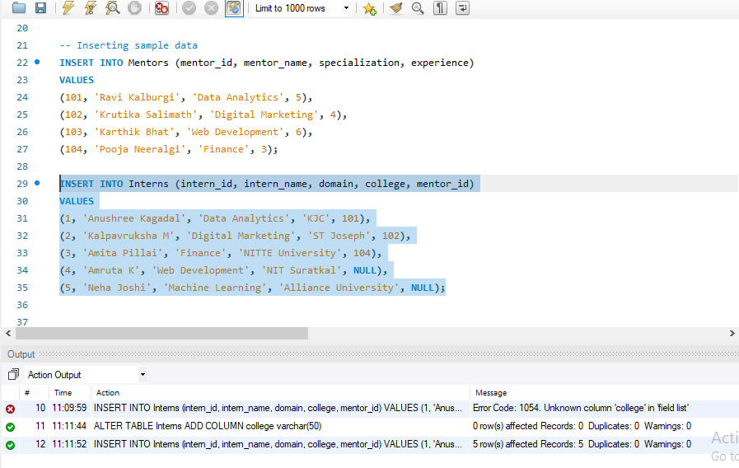

**Inner Join:**

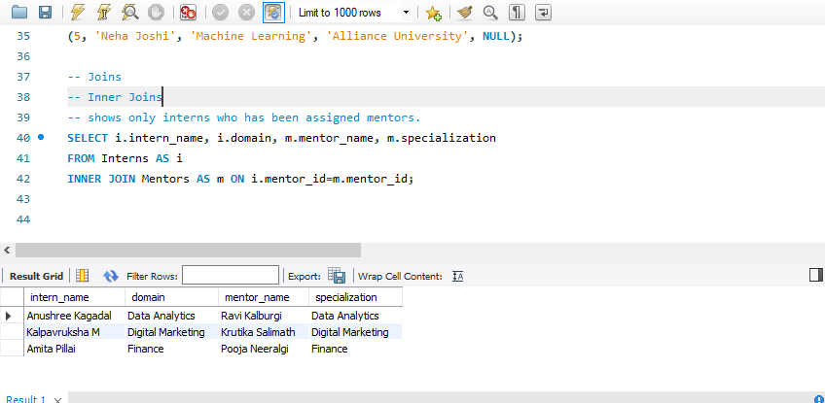

**Left Join:**

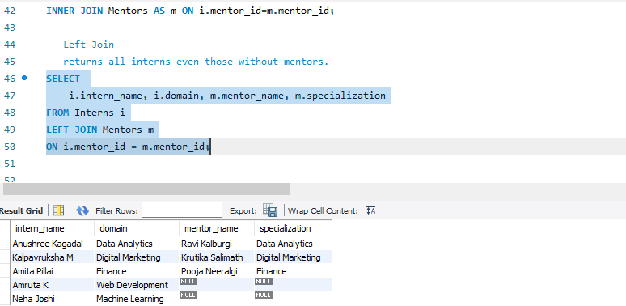

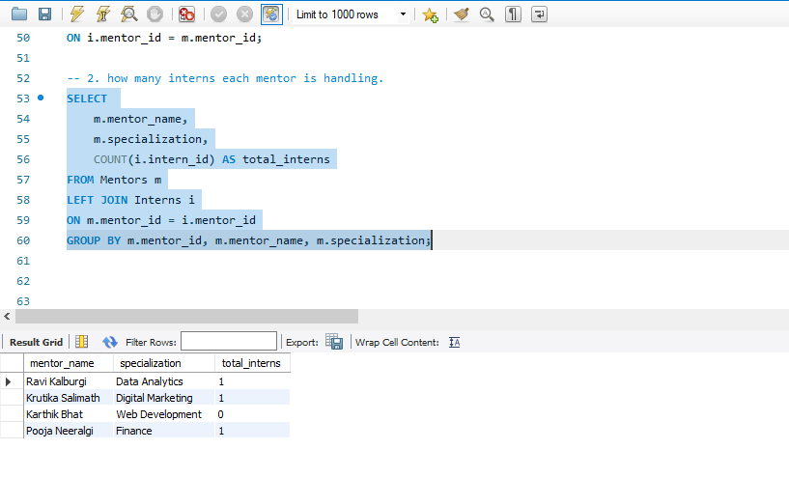

**Right Join:**

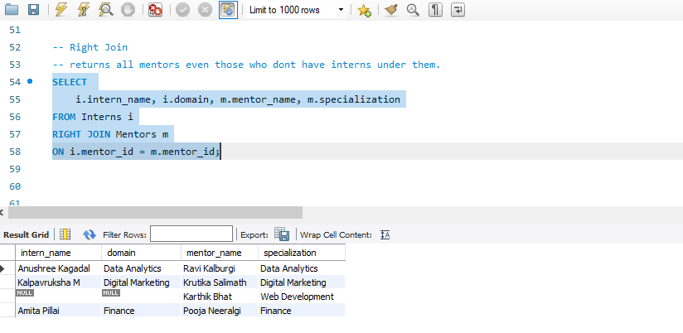

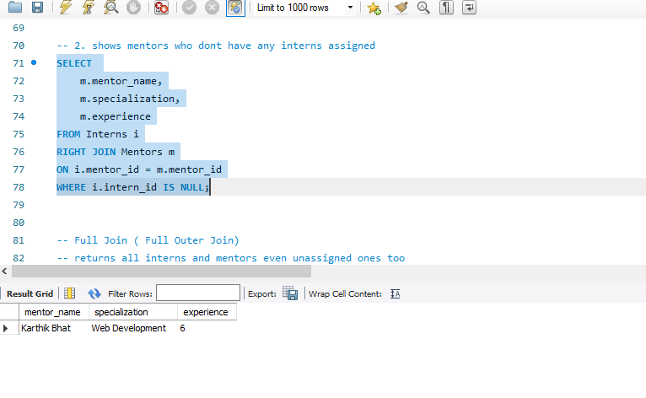

**Full Outer Join:**

MySQL does not directly support FULL OUTER JOIN, so I used a UNION of LEFT JOIN and RIGHT JOIN to achieve it.

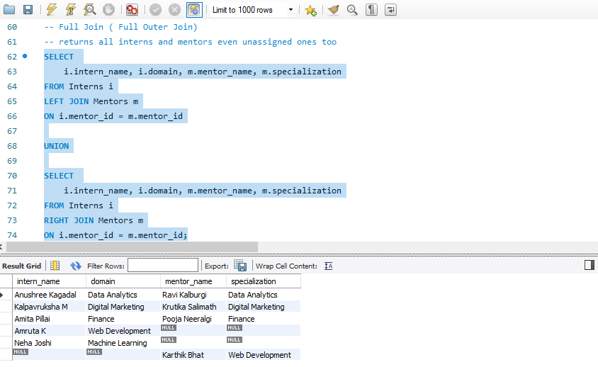

**Natural Join:**

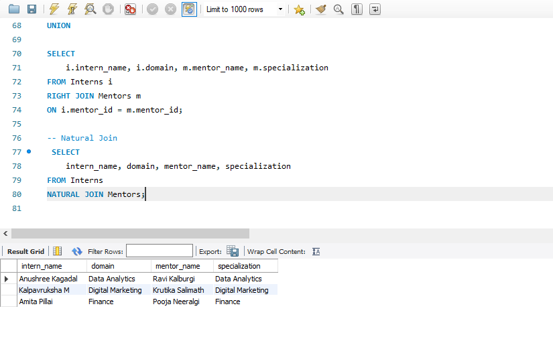

**Cross Join:**

