# Task 6: SQL Developer Internship - Elevate Labs

## Subqueries:

I used Internship Database having Interns & Mentors table from Task 5 to execute and practice subquery concepts.

### Scalar Subqueries

I explored how scalar subqueries return one value that can be utilized within the SELECT, WHERE, or HAVING clause.

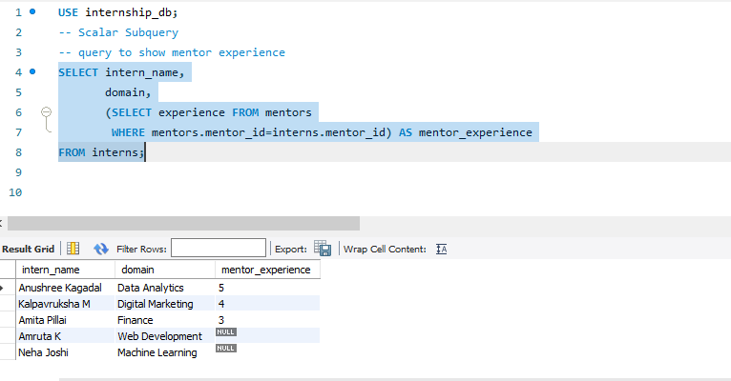

### Subqueries using IN

### Aims to show how subqueries can be applied within the IN clause to make selections based on values provided by another query.

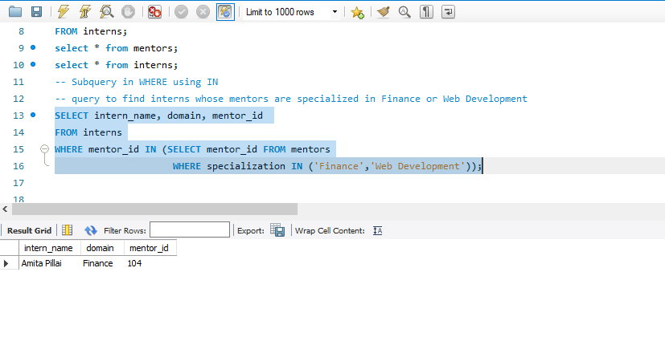

### EXISTS / Correlated Subqueries:

### Illustrates the use of EXISTS and correlated subqueries. Such subqueries are executed once for each row in the outer query and assist in verifying if related data exists in a different table.

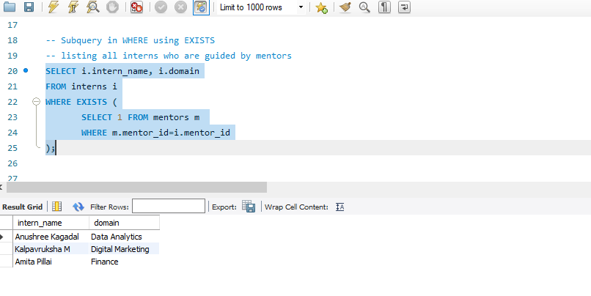

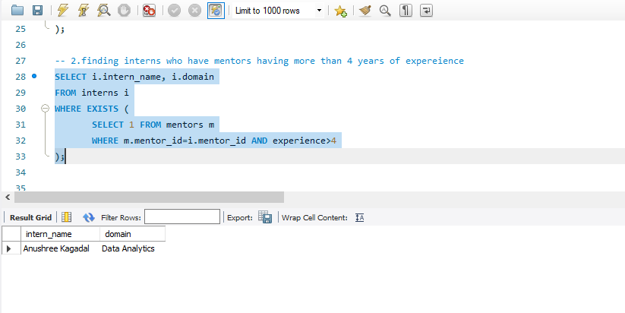

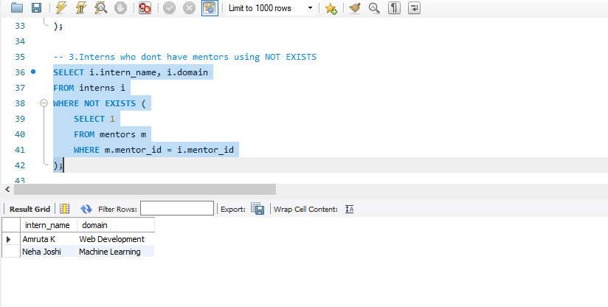

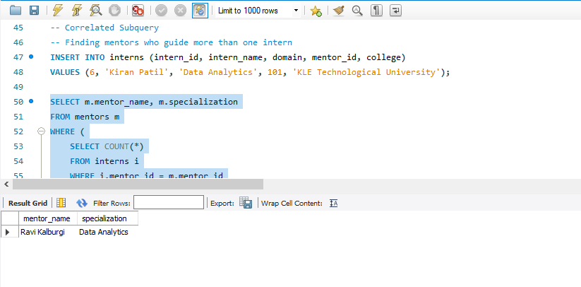

### Subquery in FROM Clause:

Subquery within the FROM clause, also referred to as an inline view. This method permits one to create a temporary result set that can be queried again

