# Task 8: SQL Developer Internship - Elevate Labs

## Stored Procedures and Functions:

I used travel_agency Database having Travellers table to execute and practice stored procedure and functions concepts.

### Simple Stored Procedure:

This stored procedure is used to add loyalty points to travelers, if traveler doesn’t exist in loyalty points table it also has condition to add that new traveler and add points to them.

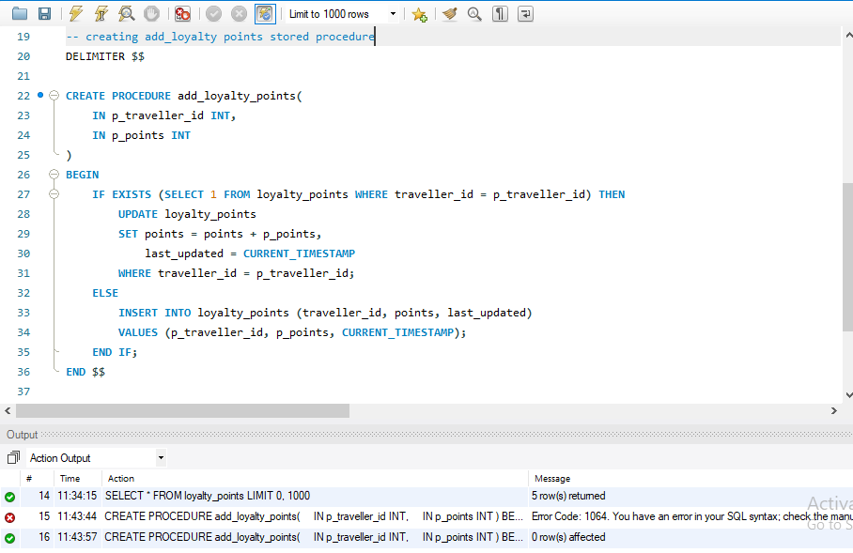

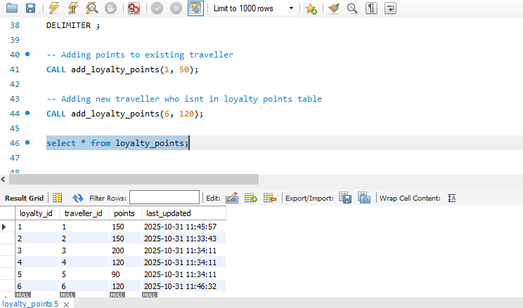

### Functions:

Creating function called get_reward_value and converting the points to rewards in indian rupees considering 1 points = 10 rupee.

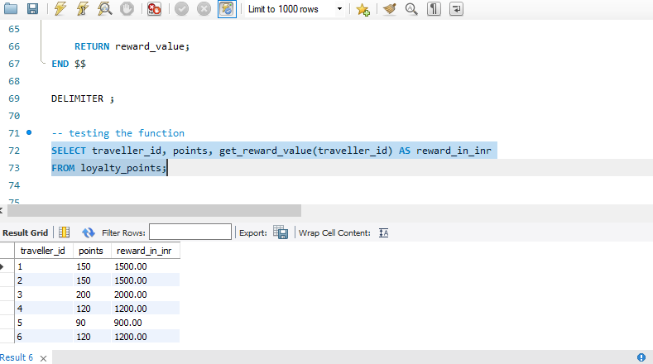

### Stored Proceudre with If-Else condition:

Created a stored procedure called check_loyalty_status to check membership based on points categorized into Gold, Silver and regular member.

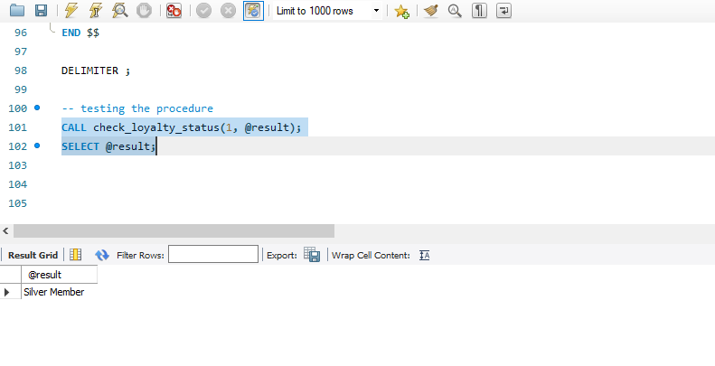

### Stored Proceudre with Loop:

Created a stored procedure named countdown_trip having loop to display the count down of days till the trip day.

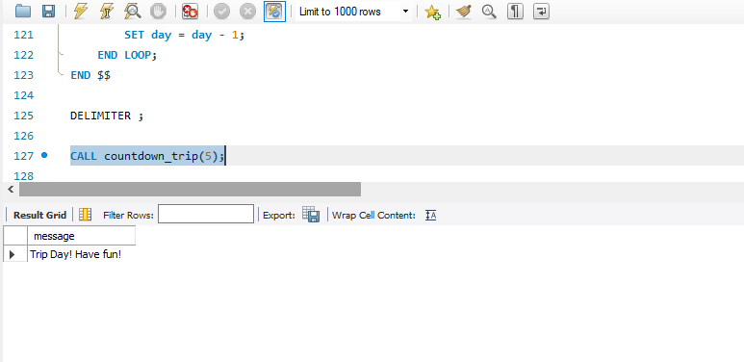

### Function with If condition:

Created a function named traveler_budget_category to categorize the travelers into budget based category based such as Luxury Traveller, Comfort Traveller and Budget Traveller.

