**E- Recycle**

**Landfilling**

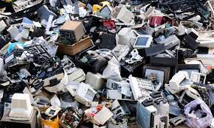Landfilling is the most widespread method for electronic waste disposal. It involves excavating trenches or pits and burying e-waste within them. Layers of earth are used to cover and seal the pits. However, this method has environmental concerns due to the potential leaching of hazardous substances into the soil and groundwater.

**Incineration**

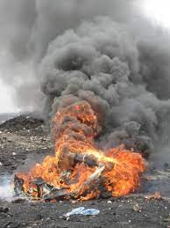Incineration is a controlled combustion process in which e-waste is burned in a specially designed incinerator unit at high temperatures, ranging from 900 to 10,000 degrees Celsius. This process helps convert hazardous substances within the e-waste into less hazardous compounds. While incineration can reduce the volume of waste, it can also release pollutants into the air if not properly performed.

**Recycling**

Many items of e-waste can be dismantled and their parts repurposed into new products. E-waste recycling techniques can recover precious metals from circuit boards and be melted down to make new devices or used for other products such as jewelry.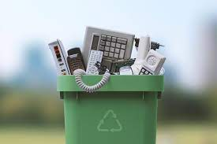 Recycling involves dismantling electronic waste to recover valuable materials and safely manage hazardous components.

**Support Brands with EPR Policies**

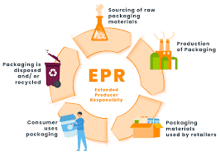Choose to buy electronics from brands that have implemented [**Extended Producer Responsibility (EPR)**](https://enterclimate.com/blog/is-extended-producer-responsibility-mandatory-in-india/) policies. These brands are committed to taking responsibility for properly disposing and recycling their products.

**Acid Bath**

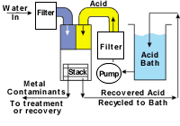Soaking electronic circuits in powerful sulphuric, hydrochloric, or nitric acid solutions separates metals from the electronic pathways. The metals can then be recycled and used in the manufacture of new products. However, the highly hazardous acid waste needs to be very carefully disposed of to prevent it from finding its way into local water sources – essentially trading one waste disposal problem for another.