./



Version Number:

Team Members :

Team No:

Module: Model Based System Engineering

|  |  |  |  |  |  |
| --- | --- | --- | --- | --- | --- |
| **Ver.Rel. No.** | **Release Date** | **Prepared. By** | **Reviewed By** | **Approved By** | **Remarks/Revision Details** |
|  |  |  |  |  |  |
|  |  |  |  |  |  |
|  |  |  |  |  |  |
|  |  |  |  |  |  |
|  |  |  |  |  |  |

**Document History**

# Simple Embedded System

## **Fitness Tracker (Smart Watch)**

* A Fitness tracker is a watch that offers extra functionality and connectivity on top of the features offered by standard watches
* They do this by including a embedded system that carries out the normal functionality we expect.
* This can be worn on the wrist. Common pieces of functionality found in these types of watch are: Heart rate monitor, Step Count Monitor, Temperature and Humidity Sensor

## **Block Diagram:**

[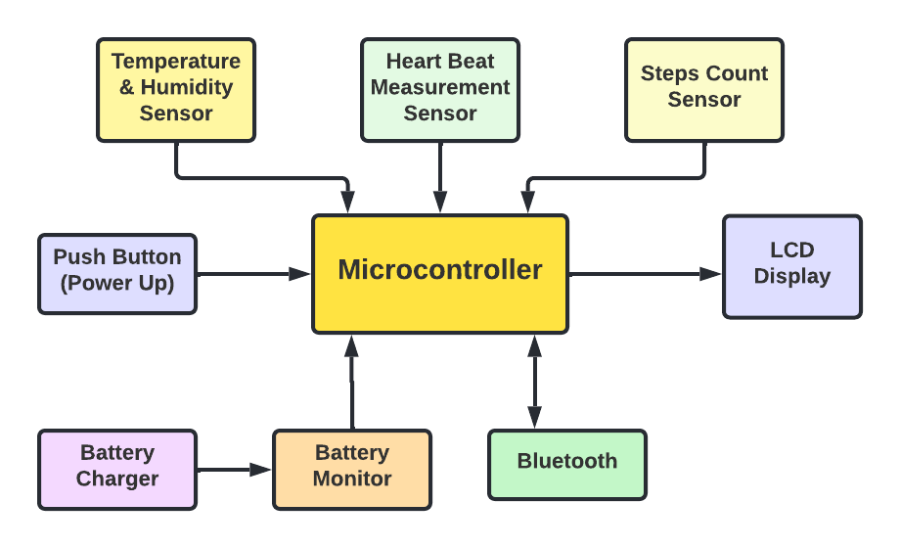](https://user-images.githubusercontent.com/98867361/154792665-3b9adea4-e928-490b-bed0-f8e5bf13630b.png)

### Microcontroller

* Microcontroller is used to do a specific task

### LCD Display

* To display all the parameters like temperature, humidity, step count and Heart Beat Counts on the screen

### Battery Charger

* Fitness tracker is built with battery. to charge the battery battery charger is connected

## **Requirements**

## **High Level Requirements:**

|  |  |
| --- | --- |
| **ID** | **Description** |
| HR01 | Should be able to turn on after pushing Power button |
| HR02 | Should be able to display Temperature and Humidity on screen |
| HR03 | Should be able to display Heart beat rate on the screen |
| HR04 | Should be able to display Steps count on the screen |
| HR05 | Should be able to connect to the Bluetooth |

## **Low level Requirements:**

|  |  |
| --- | --- |
| **ID** | **Description** |
| LR01 | Should be able to monitor and charge the battery |
| LR02 | Temperature and Humidity should be sensed by sensor |
| LR03 | Heart Beat rate should be count by sensor |
| LR04 | Sensor should sense the number of steps user take |
| LR05 | Bluetooth should be connected to the available nearby device |

# Mid-Complex Embedded System

## **Automatic Teller Machine**

## **Block Diagram:**

[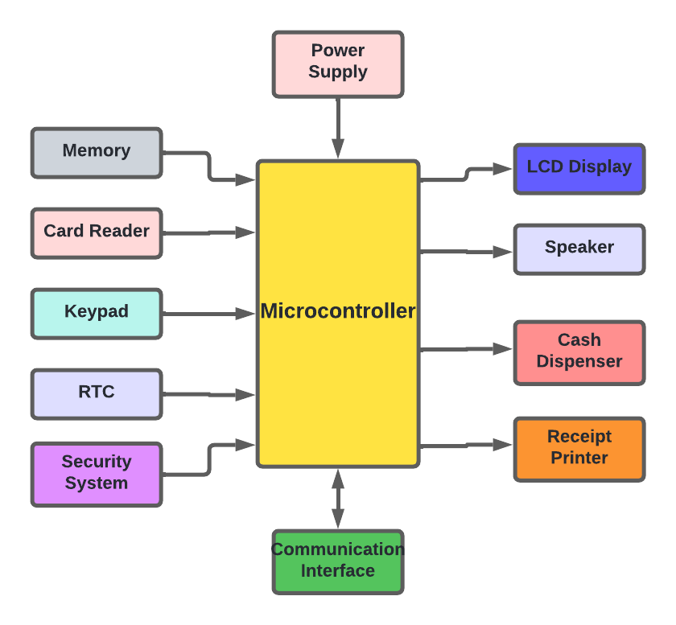](https://user-images.githubusercontent.com/98867361/154805841-384be628-4d9e-421e-89e3-7bc9a3374598.png)