Basic Chatbot Using Python

Objective
The objective of this project is to create a simple rule-based chatbot using Python. The chatbot interacts with users and responds to predefined questions such as greetings, date, time, name, and thanks.

Software Used
- Python
- Visual Studio Code (VS Code)

Code
from datetime import datetime
print("Chatbot: Hello! My name is AlphaBot.")
while True:
user = input("You: ").lower()
if user == "hello":
print("Chatbot: Hi! Nice to meet you.")
elif user == "what is your name":
print("Chatbot: My name is AlphaBot.")
elif user == "how are you":
print("Chatbot: I am fine, thank you!")
elif user == "time":
current_time = datetime.now().strftime("%H:%M:%S")
print("Chatbot: Current time is", current_time)
elif user == "date":
current_date = datetime.now().strftime("%d-%m-%Y")
print("Chatbot: Today's date is", current_date)
elif user == "thanks":
print("Chatbot: You're welcome!")
elif user == "bye":
print("Chatbot: Goodbye!")
break
else:
print("Chatbot: Sorry, I don't understand.")

Output
Chatbot: Hello! My name is AlphaBot.
You: hello
Chatbot: Hi! Nice to meet you.
You: how are you
Chatbot: I am fine, thank you!
You: date
Chatbot: Today's date is 21-06-2026
You: time
Chatbot: Current time is 10:30:15
You: thanks
Chatbot: You're welcome!
You: bye
Chatbot: Goodbye!

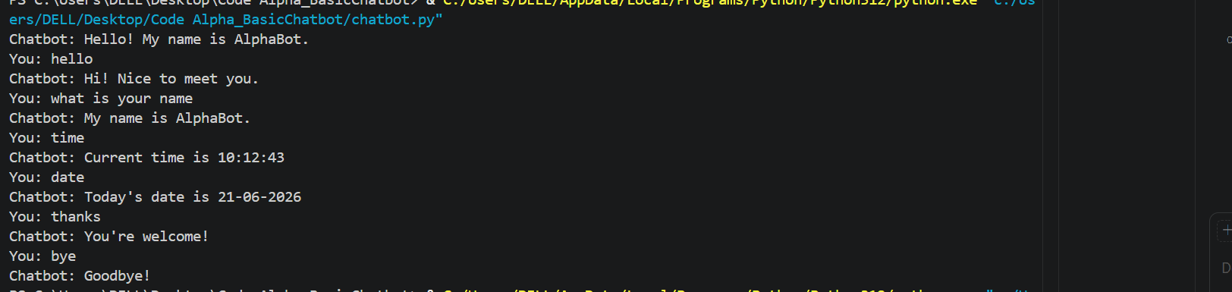

Explanation

1. datetime Module
Used to display the current date and time.

2. while True Loop
Keeps the chatbot running continuously until the user enters "bye".

3. input()
Takes input from the user.

4. if-elif-else Statements
Checks the user's message and provides the appropriate response.

5. break Statement
Stops the chatbot when the user types "bye".

Conclusion
This project demonstrates the basic concepts of Python programming such as loops, conditional statements, user input, and the datetime module. It is a simple chatbot that can interact with users through predefined responses.

