create table travel

(

email varchar2(30)primary key,

address varchar2(40),

paddress varchar2(50),

destination varchar2(40)

);

insert into travel values('geeta','geeta@gmail.com','hassan','udupi');

insert into travel values('sheetal','sheetal@gmail.com','kodagu','bangalore');

insert into travel values('dev','dev@gmail.com','bangalore','dharwad');

select * from travel;

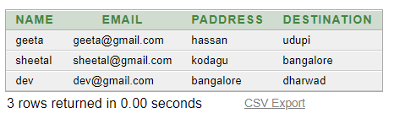

desc travel;

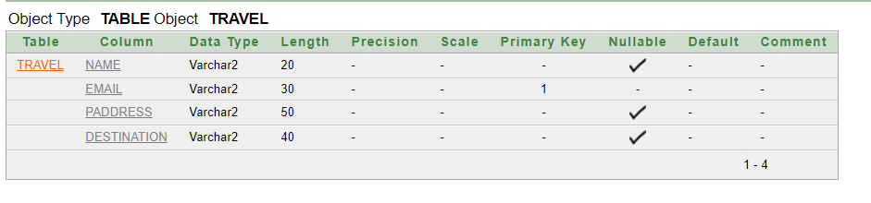

**Travel Help Form**

**Email ID**

**Present Address**

**Destination Address**

C:\Users\UDAYNA~1\AppData\Local\Temp\ksohtml8656\wps1.png

create table donate

(

name varchar2(30),

email varchar2(30)primary key,

amount number

);

insert into donate values('Seema','seemak@gmail.com', 5000);

insert into donate values('Nehal','nehal@gmail.com', 7000);

insert into donate values('Ronit','ronit@gmail.com', 3000);

select * from donate;

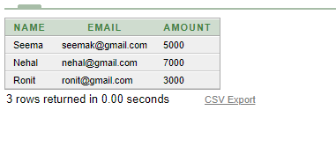

desc donate;

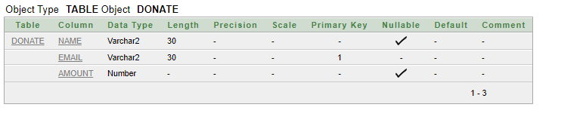

**Donate Form**

**Name**

**Email ID**

**Amount**

**C:\Users\UDAYNA~1\AppData\Local\Temp\ksohtml8656\wps1.png**