**Theme 1 - Sustainable products for human wellness**

**Ensuring healthy lives and promoting well-being for all at all ages is essential to sustainable development.**

## WHAT TO DESIGN?

Development of products that addresses a real clinical need. That should be affordable, energy-efficient, easy to handle, flexible, and do more with less. Product design should be innovative and will be a great boon to patients/medical practitioners and users. Design affordable, portable, and easy-to-use customized medical equipment. You can also redesign the existing medical equipment into a sustainable product.

## HOW TO DESIGN?

Understand healthcare support needed by common citizens in an easy-to-use, convenient form. Innovation for low-cost, affordable products with simplified designs is expected. Teams opting for this theme would be preferred to have a collaboration of one member from Engineering and one from the Medical sciences field.

## WHO WILL GET THE BENEFITS?

Doctor, Physician, Patients, and common citizens.

# Theme 2 – Green Energy generation, transmission and storage

**Energy is central to nearly every major challenge and opportunity.**

## WHAT TO DESIGN?

It aims to "Ensure access to affordable, reliable, sustainable and modern energy for all. You can also design Expand and upgrade energy services for developing countries.

## HOW TO DESIGN?

Understand the need for clean energy for all. Design a clean energy generation or utilization product to reduce the use of natural resources. The Design should be affordable and easy to use. Upgrading the existing solution and new ideas/concepts/innovations are encouraged.

## WHO WILL GET THE BENEFITS?

Common Citizens, Industries, and Our Nature.

# Theme 3 – Sustainable Habitat / City Infrastructure

**There needs to be a future in which cities provide opportunities for all, with access to basic services, energy, housing, transportation, and more.**

## WHAT TO DESIGN?

You can Design Safe and affordable housing systems or you can design Affordable and sustainable public transport systems. Design the product that helps to grow the cities minimizing the use of natural resources.

## HOW TO DESIGN?

Design an affordable design solution or product to reduce the cost of house manufacturing. You can also design a sustainable public transport system such as a bus, train, and many more.

## WHO WILL GET THE BENEFITS?

Urban cities as well as the lower-income earning population

# Theme 4 – Sustainable Mobility

**There needs to be a future in which mobility will be a focus area and innovative and creative solutions will be required to cater to the need of future generations.**

## WHAT TO DESIGN?

Potential solutions include developing efficient and accessible individual transportation, innovative solution for electric and hybrid vehicles, and developing intelligent public transportation systems. The goal is to create transportation systems that are environmentally friendly, socially equitable, and economically viable while promoting the efficient and sustainable use of transportation resources.

## HOW TO DESIGN?

To design sustainable mobility solutions, follow these key steps: assess transportation needs and problems, define clear goals, engage stakeholders, develop a design plan, test and evaluate solutions, and implement and scale the solutions. Some specific solutions include public transportation, active transportation, electric/hybrid vehicles, car-sharing/ride-sharing services, and intelligent transportation systems.

## WHO WILL GET THE BENEFITS?

Public health, Low-income communities, Local governments, Reduced traffic congestion, and Improved quality of life.

# Sample Problem Statements

To help students better understand the themes and make progress in the competition, we have compiled a collection of sample problem statements for the AAKRUTI Global 2024 contest.

We encourage you to refer to these problem statements for Inspiration and to come up you’re your innovative ideas to tackle the challenges presented by the United Nations Sustainable Development Goals.

📝👉 As mentioned, these problem statements are provided to give you a reference, hence do not just take these problem statement as your product design project for participation. If any team is using these problem statement directly without any changes, they will get less weightage by jury member during evaluation. Hence please use these problem statements as inspiration and come up with your own creative solution. 👈📝

Best of luck for your participation in AAKRUTI Global 2024 . 💪

Let's work together to create a sustainable future for all." 🤝

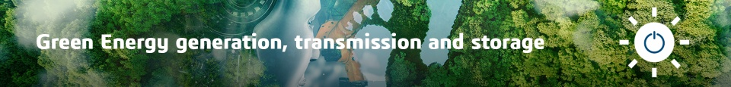

* Create a wind-powered generator for urban environments that is both efficient & aesthetically pleasing
* Solar-Powered Water Desalination Unit for Remote Locations
* Stubble Burning is one of the major problems, India is facing from few decades. This problem comes due to a increased rate of agricultural diversity India has and low awareness towards the pollution. This problem can be Dealt with in two ways, 1) By making a storage to degrade the mass which is produced and the generated fertilizer can be given back to the fields. 2) A faster way to deal with this problem is to make an Incinerator to trap the burned C02 and other harmful gasses and transform it into sub products of like ink, road building material like coal tar. Technology for converting the gases into ink is already in use the setup should be made portable and cheap enough for farmers and other users to use.
* GreenJet: Micro Gas Turbine/Jet Engine Integration for HEVs with Improved Efficiency and Lower Emissions
* Self charging e-vehicals (scooters/cars/Bus) with roof top solar panels
* Instead of using simple fibres for windows and paints for roof and walls, can we generate electricity from them using solar technology.
* Spiral Heat Exchanger Design for Space Applications
* Re-designing office space to reduce carbon emission

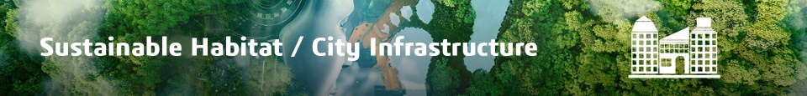

* Odorless compost treatment plant for apartments
* Help people with vision disabilities (blind and visually impaired) get a better experience on the metro stations to commute from one station to other.
* Design of eco-friendly packaging materials for perishable fruits and Vegetables
* Domestic Water Usage : Minimize/Recycle/Reuse
* Design a sustainable and affordable home garden kit that promotes urban agriculture and food self-sufficiency
* Re-designing office space to reduce carbon emission
* Designing a innovative and portable waste food recycling into compost system for homes
* Create a sustainable alternative option for the small plastic sachets (eg. ketchup, hair oil) which are creating an envionmental challenge and increasing plastic pollution
* Create an easy-to-use plastic waste disposal system
* A robo machine which identifies the pot holes ( Scan) on the road and fill it with sustainable material ( Using 3Dprinting technique)
* Need of sustainable Air Purification Systems for city .As we know with time, the air pollution will increase. Best example of this kind of city is Delhi. As we know by burring plastic, tyre or other such substances can produce toxic gases. Which case many hazardous effects on health. We need a innovative idea to reduce air pollution.

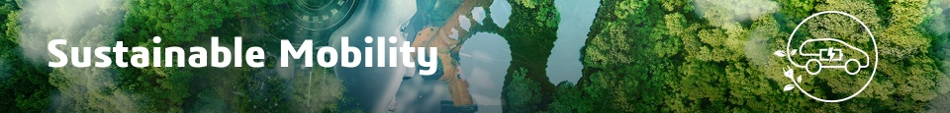

* Moped, Bicycles, Hoverboards and Segway are the available vehicles for travelling short distance which run over electricity and hence require recharging and that can be done with the help of Solar
* Design of exhaust for reduced vehicle emissions. This problem arises as the world is moving towards electric vehicles but the ones that run on gasolines will still be present in the market and these vehicles will leave a dark mark on the planet. The harmful emissions need to be reduced. They can be filtered out and their designs be modified
* Motorized bullock cart
* Design a compact and lightweight electric bicycle that is easy to store and transport
* Design a sustainable and affordable cargo bike
* Intelligent exhaust monitoring
* electric bike/Cycle for delivery ( Swiggy, zomato) for all season ( Rainy, summer, winter)
* Solar power driven drone/plane for delivery purpose

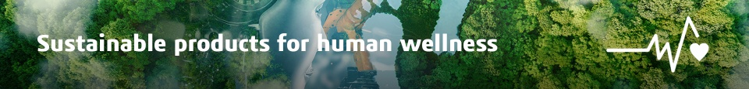

* Eco- Friendly Water cooler used in Summer season that can save energy and give sustainability
* Design a low-cost, portable medical device for remote areas with limited access to healthcare facilities
* Design of Reusable Tissue Cleaner to reduce Wet Wipes Pollution.
* In Sugarcane farming we need to remove old leaps after a certain period. it is very time consuming process but if farmer does that it helps to increase his income. so we need any machine which can do this and save manual time.
* Create a sustainable and affordable solution for producing reusable menstrual products
* Reshaping the human anatomy to assist healing of affected joints
* Sustainable refrigeration system for harvest management to be deployed in villages
* Creating, Designing sustainable packaging for everyday consumer products(especially fast food) & redesigning the traditional packaging to reduce its environmental impact.
* Flexible packaging solution (Solution for daily items like Milk pacakge, 1rs pouch ), reusable packaging
* Posture correcting chair