GCC Compilation Process

Device used – M1 MacBook Air

Submitted by – Anushthan Saxena (S20210010027)

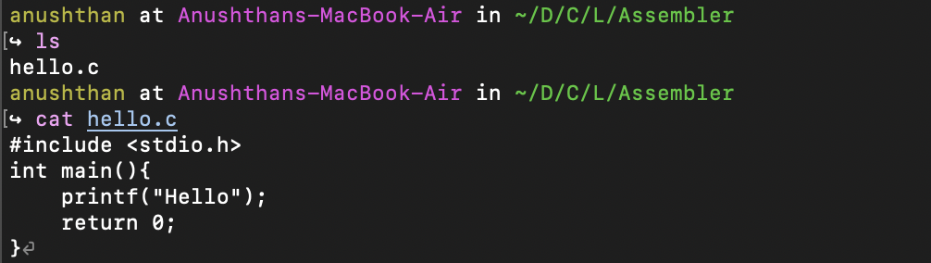

Starting with this simple hello program

* ***Preprocessing:*** We create a “.i” file using “ **cpp hello.c > hello.i** “. However, this program gives multiple errors regarding system architecture difference in M1 macs.

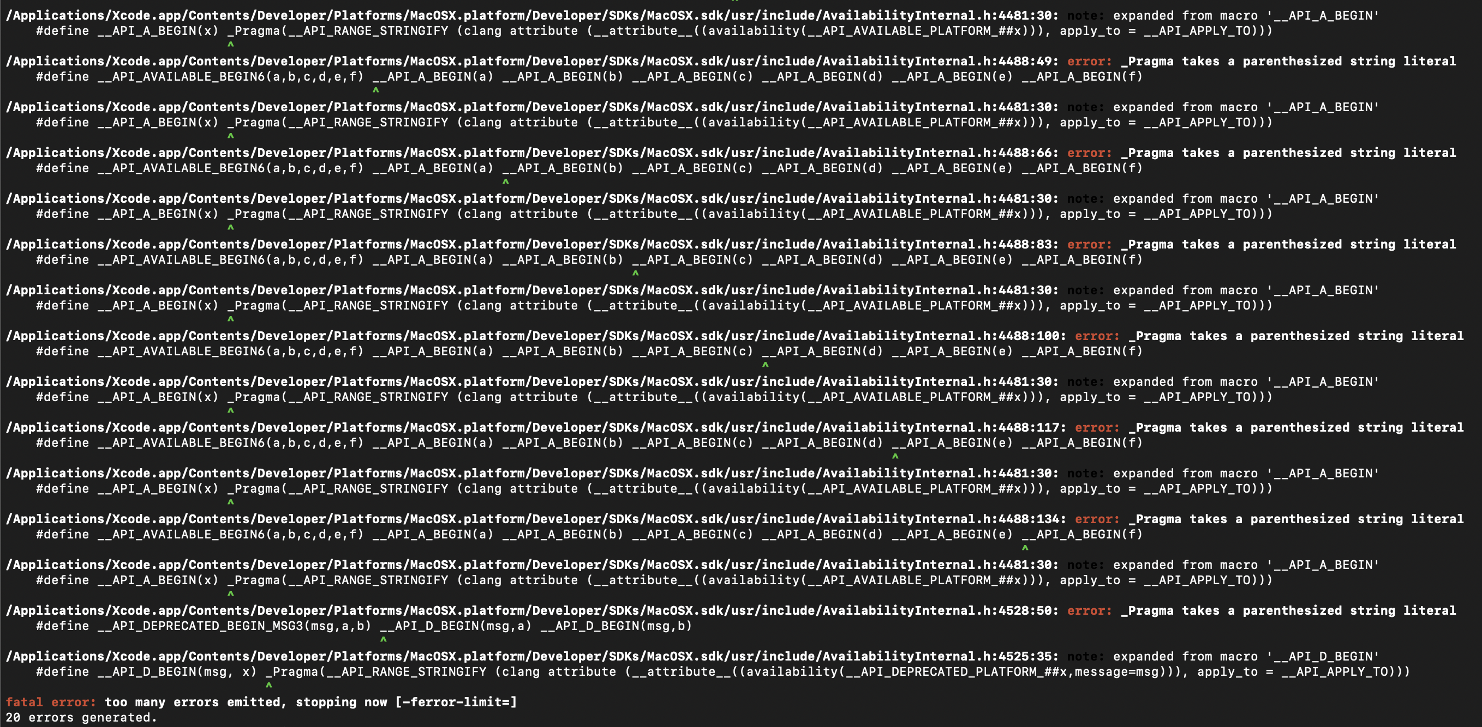

So we use the alternative **“gcc -E -o hello.i hello.c”**

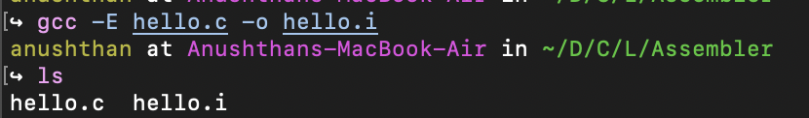

* ***Compilation:*** next we convert this “.i” file to a “.s” file using **“gcc -S hello.i”**

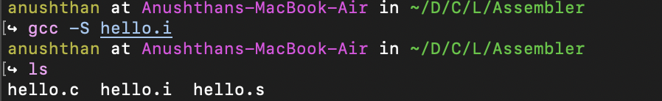

* ***Assembly:*** The assembler will convert this “.s” code to an object file “.o”, using the command “**as -o hello.o hello.s”**

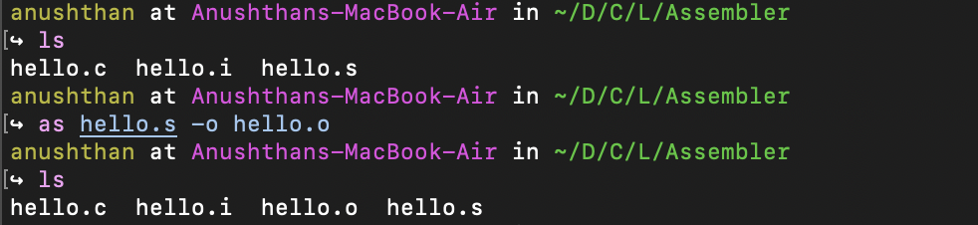

* ***Linker:*** Normaly, the linker links the object code with the library code to produce an executable file with the command “**ld -o hello.out hello.o <library_path> -lc”**

This library path can be found out using “**which printf”.**

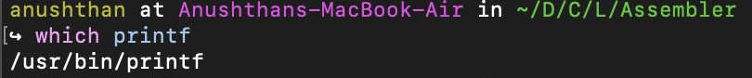

**Here we run into a problem regarding M1 Architecture. Linker doesn’t work by itself for the aarch64 ARM architecture which M1 has.**



**It is shown with an example below:**

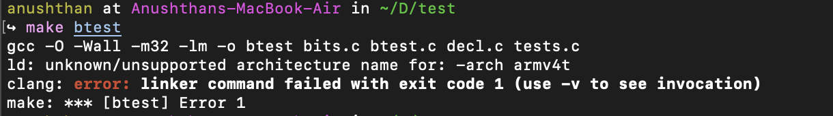



**Therefore, we directly use the Apple gcc command to get the final executable file.**

