Source code:
<!DOCTYPE html>
<html lang="en">
<head>
<meta charset="UTF-8">
<meta name="viewport" content="width=device-width, initial-scale=1.0">
<meta name="description" content="Campusly - The next-generation college event and club management platform. Discover campus events, join student communities, and build unforgettable memories.">
<title>Campusly — College Event & Club Management Platform</title>

<!-- Google Fonts: Outfit for modern headings & Plus Jakarta Sans for clean body text -->
<link rel="preconnect" href="https://fonts.googleapis.com">
<link rel="preconnect" href="https://fonts.gstatic.com" crossorigin>
<link href="https://fonts.googleapis.com/css2?family=Outfit:wght@400;500;600;700;800;900&family=Plus+Jakarta+Sans:wght@300;400;500;600;700;800&display=swap" rel="stylesheet">

<style>
/* ==========================================================================
1. CSS VARIABLES & DESIGN TOKENS
========================================================================== */
:root {
/* Background Colors */
--bg-void: #060713;
--bg-deep: #0a0c20;
--bg-card: rgba(16, 20, 44, 0.65);
--bg-card-hover: rgba(26, 33, 71, 0.78);
--bg-glass-subtle: rgba(255, 255, 255, 0.035);

/* Accents & Gradients */
--electric-blue: #3b82f6;
--vibrant-violet: #8b5cf6;
--neon-cyan: #06b6d4;
--hot-pink: #ec4899;
--emerald: #10b981;
--amber: #f59e0b;

/* Multi-stop Gradients */
--grad-primary: linear-gradient(135deg, #3b82f6 0%, #8b5cf6 50%, #06b6d4 100%);
--grad-fire: linear-gradient(135deg, #ec4899 0%, #8b5cf6 100%);
--grad-cyan-blue: linear-gradient(135deg, #06b6d4 0%, #3b82f6 100%);
--grad-text: linear-gradient(135deg, #60a5fa 0%, #c084fc 50%, #38bdf8 100%);
--grad-card-border: linear-gradient(135deg, rgba(255, 255, 255, 0.16) 0%, rgba(139, 92, 246, 0.25) 50%, rgba(6, 182, 212, 0.08) 100%);

/* Borders & Shadows */
--border-glass: rgba(255, 255, 255, 0.09);
--border-glass-glow: rgba(139, 92, 246, 0.4);
--shadow-subtle: 0 10px 30px -10px rgba(0, 0, 0, 0.5);
--shadow-glow-blue: 0 0 35px -5px rgba(59, 130, 246, 0.35);
--shadow-glow-purple: 0 0 45px -8px rgba(139, 92, 246, 0.38);
--shadow-glow-cyan: 0 0 35px -5px rgba(6, 182, 212, 0.35);

/* Typography */
--text-heading: #ffffff;
--text-body: #94a3b8;
--text-light: #e2e8f0;
--text-muted: #64748b;

/* Radii & Transitions */
--radius-sm: 8px;
--radius-md: 14px;
--radius-lg: 20px;
--radius-xl: 28px;
--radius-full: 9999px;
--ease-out-expo: cubic-bezier(0.16, 1, 0.3, 1);
--ease-in-out-smooth: cubic-bezier(0.4, 0, 0.2, 1);
}

/* ==========================================================================
2. GLOBAL RESETS & BASE STYLING
========================================================================== */
*, *::before, *::after {
margin: 0;
padding: 0;
box-sizing: border-box;
}

html {
scroll-behavior: smooth;
font-size: 16px;
color-scheme: dark;
}

body {
font-family: 'Plus Jakarta Sans', -apple-system, BlinkMacSystemFont, 'Segoe UI', Roboto, sans-serif;
background-color: var(--bg-void);
color: var(--text-light);
line-height: 1.6;
overflow-x: hidden;
position: relative;
min-height: 100vh;
-webkit-font-smoothing: antialiased;
-moz-osx-font-smoothing: grayscale;
}

h1, h2, h3, h4, h5, h6 {
font-family: 'Outfit', sans-serif;
color: var(--text-heading);
font-weight: 700;
line-height: 1.2;
letter-spacing: -0.02em;
}

a {
text-decoration: none;
color: inherit;
transition: all 0.3s var(--ease-out-expo);
}

img {
max-width: 100%;
height: auto;
display: block;
}

.container {
width: 100%;
max-width: 1280px;
margin-left: auto;
margin-right: auto;
padding-left: 24px;
padding-right: 24px;
}

/* Gradient Text Utility */
.gradient-text {
background: var(--grad-text);
-webkit-background-clip: text;
-webkit-text-fill-color: transparent;
display: inline-block;
}

.gradient-text-alt {
background: var(--grad-primary);
-webkit-background-clip: text;
-webkit-text-fill-color: transparent;
display: inline-block;
}

/* ==========================================================================
3. AMBIENT BACKGROUND & FLOATING GLOW BLOBS
========================================================================== */
.ambient-canvas {
position: fixed;
inset: 0;
pointer-events: none;
z-index: 0;
overflow: hidden;
}

.cyber-grid {
position: absolute;
inset: 0;
background-image:
linear-gradient(rgba(255, 255, 255, 0.025) 1px, transparent 1px),
linear-gradient(90deg, rgba(255, 255, 255, 0.025) 1px, transparent 1px);
background-size: 60px 60px;
background-position: center top;
mask-image: radial-gradient(ellipse at 50% 20%, rgba(0,0,0,0.7) 0%, transparent 75%);
-webkit-mask-image: radial-gradient(ellipse at 50% 20%, rgba(0,0,0,0.7) 0%, transparent 75%);
}

.ambient-blob {
position: absolute;
border-radius: 50%;
filter: blur(100px);
opacity: 0.32;
will-change: transform;
animation: moveAmbientBlob 18s infinite alternate ease-in-out;
}

.blob-1 {
width: 600px;
height: 600px;
background: radial-gradient(circle, #4f46e5 0%, #7c3aed 60%, transparent 80%);
top: -120px;
left: -120px;
animation-duration: 20s;
}

.blob-2 {
width: 550px;
height: 550px;
background: radial-gradient(circle, #06b6d4 0%, #3b82f6 60%, transparent 80%);
top: 25%;
right: -140px;
animation-duration: 24s;
animation-delay: -5s;
}

.blob-3 {
width: 500px;
height: 500px;
background: radial-gradient(circle, #8b5cf6 0%, #ec4899 60%, transparent 80%);
bottom: 10%;
left: 20%;
animation-duration: 22s;
animation-delay: -10s;
}

@keyframes moveAmbientBlob {
0% {
transform: translate(0, 0) scale(1);
}
33% {
transform: translate(70px, -60px) scale(1.12);
}
66% {
transform: translate(-50px, 80px) scale(0.92);
}
100% {
transform: translate(30px, -40px) scale(1.05);
}
}

/* Pulsing Background Floating Particles */
.glowing-dot {
position: absolute;
width: 4px;
height: 4px;
background: #fff;
border-radius: 50%;
box-shadow: 0 0 10px 2px rgba(96, 165, 250, 0.9);
animation: dotGlow 4s infinite ease-in-out alternate;
}

.dot-1 { top: 18%; left: 14%; animation-delay: 0.5s; }
.dot-2 { top: 32%; left: 88%; animation-delay: 1.8s; }
.dot-3 { top: 72%; left: 8%; animation-delay: 2.7s; }
.dot-4 { top: 84%; left: 78%; animation-delay: 1.1s; }

@keyframes dotGlow {
0% { opacity: 0.2; transform: scale(0.8); }
100% { opacity: 0.9; transform: scale(1.5); }
}

/* ==========================================================================
4. STICKY FLOATING GLASS NAVBAR
========================================================================== */
.site-header {
position: sticky;
top: 16px;
z-index: 1000;
padding: 0 20px;
margin-bottom: 20px;
}

.nav-wrapper {
max-width: 1240px;
margin: 0 auto;
background: rgba(10, 13, 32, 0.72);
backdrop-filter: blur(20px);
-webkit-backdrop-filter: blur(20px);
border: 1px solid var(--border-glass);
border-radius: var(--radius-full);
padding: 10px 22px;
display: flex;
align-items: center;
justify-content: space-between;
box-shadow: 0 16px 36px -12px rgba(0, 0, 0, 0.65), 0 0 20px -5px rgba(139, 92, 246, 0.15);
transition: all 0.3s ease;
}

.nav-wrapper:hover {
border-color: rgba(139, 92, 246, 0.3);
box-shadow: 0 18px 40px -10px rgba(0, 0, 0, 0.75), 0 0 28px -4px rgba(139, 92, 246, 0.25);
}

/* Logo Brand */
.brand-logo {
display: flex;
align-items: center;
gap: 12px;
text-decoration: none;
}

.logo-symbol {
width: 42px;
height: 42px;
border-radius: 50%;
background: linear-gradient(135deg, #3b82f6, #8b5cf6, #06b6d4);
display: flex;
align-items: center;
justify-content: center;
box-shadow: 0 0 16px rgba(59, 130, 246, 0.5);
position: relative;
flex-shrink: 0;
overflow: hidden;
}

.logo-symbol::before {
content: '';
position: absolute;
inset: 2px;
background: #0a0c20;
border-radius: 50%;
z-index: 1;
}

.logo-symbol svg {
position: relative;
z-index: 2;
width: 20px;
height: 20px;
fill: url(#logoGrad);
}

.brand-meta {
display: flex;
flex-direction: column;
}

.brand-title {
font-size: 1.25rem;
font-weight: 800;
letter-spacing: 0.08em;
color: #fff;
line-height: 1.1;
}

.brand-subtitle {
font-size: 0.65rem;
color: var(--neon-cyan);
letter-spacing: 0.05em;
text-transform: uppercase;
font-weight: 600;
}

/* Navigation Links Desktop */
.nav-links {
display: flex;
align-items: center;
gap: 32px;
list-style: none;
}

.nav-link {
font-size: 0.92rem;
font-weight: 500;
color: var(--text-body);
position: relative;
padding: 6px 0;
}

.nav-link::after {
content: '';
position: absolute;
bottom: 0;
left: 0;
width: 0;
height: 2px;
background: var(--grad-primary);
border-radius: 2px;
transition: width 0.3s var(--ease-out-expo);
}

.nav-link:hover {
color: #ffffff;
}

.nav-link:hover::after {
width: 100%;
}

/* Navbar Actions */
.nav-actions {
display: flex;
align-items: center;
gap: 16px;
}

/* Pure CSS Mobile Hamburger Toggle via Checkbox Hack */
#mobile-nav-toggle {
display: none;
}

.hamburger-btn {
display: none;
cursor: pointer;
width: 36px;
height: 36px;
flex-direction: column;
justify-content: center;
align-items: center;
gap: 5px;
border-radius: var(--radius-sm);
background: var(--bg-glass-subtle);
border: 1px solid var(--border-glass);
transition: all 0.3s ease;
}

.hamburger-btn span {
display: block;
width: 20px;
height: 2px;
background: #fff;
border-radius: 2px;
transition: all 0.3s ease;
}

/* Button Styles */
.btn-primary {
display: inline-flex;
align-items: center;
justify-content: center;
gap: 9px;
background: var(--grad-primary);
color: #ffffff;
font-weight: 600;
font-size: 0.95rem;
padding: 12px 26px;
border-radius: var(--radius-full);
border: none;
cursor: pointer;
position: relative;
overflow: hidden;
box-shadow: 0 8px 24px -6px rgba(59, 130, 246, 0.5);
transition: transform 0.3s var(--ease-out-expo), box-shadow 0.3s var(--ease-out-expo);
}

.btn-primary::before {
content: '';
position: absolute;
top: 0;
left: -100%;
width: 100%;
height: 100%;
background: linear-gradient(90deg, transparent, rgba(255, 255, 255, 0.25), transparent);
transition: left 0.6s ease;
}

.btn-primary:hover {
transform: translateY(-2px);
box-shadow: 0 14px 30px -4px rgba(99, 102, 241, 0.65), 0 0 15px rgba(6, 182, 212, 0.4);
}

.btn-primary:hover::before {
left: 100%;
}

.btn-secondary {
display: inline-flex;
align-items: center;
justify-content: center;
gap: 9px;
background: rgba(255, 255, 255, 0.05);
color: var(--text-light);
font-weight: 600;
font-size: 0.95rem;
padding: 12px 26px;
border-radius: var(--radius-full);
border: 1px solid var(--border-glass);
cursor: pointer;
backdrop-filter: blur(10px);
transition: all 0.3s var(--ease-out-expo);
}

.btn-secondary:hover {
background: rgba(255, 255, 255, 0.1);
color: #ffffff;
border-color: rgba(255, 255, 255, 0.25);
transform: translateY(-2px);
box-shadow: 0 8px 20px -6px rgba(0, 0, 0, 0.4);
}

/* ==========================================================================
5. HERO SECTION
========================================================================== */
.hero-section {
position: relative;
z-index: 1;
padding: 50px 0 90px;
min-height: calc(100vh - 120px);
display: flex;
align-items: center;
}

.hero-grid {
display: grid;
grid-template-columns: 1.15fr 0.95fr;
gap: 50px;
align-items: center;
}

/* Hero Left Content */
.hero-content {
display: flex;
flex-direction: column;
gap: 24px;
}

.hero-badge {
display: inline-flex;
align-items: center;
gap: 10px;
padding: 7px 18px;
background: rgba(139, 92, 246, 0.12);
border: 1px solid rgba(139, 92, 246, 0.3);
border-radius: var(--radius-full);
width: fit-content;
box-shadow: 0 0 20px rgba(139, 92, 246, 0.15);
}

.live-dot {
width: 8px;
height: 8px;
background: #10b981;
border-radius: 50%;
box-shadow: 0 0 8px #10b981;
animation: pulseDot 2s infinite ease-in-out;
}

@keyframes pulseDot {
0% { transform: scale(0.9); opacity: 0.7; }
50% { transform: scale(1.3); opacity: 1; }
100% { transform: scale(0.9); opacity: 0.7; }
}

.hero-badge-text {
font-size: 0.75rem;
font-weight: 700;
letter-spacing: 0.1em;
color: #c084fc;
text-transform: uppercase;
}

.hero-title {
font-size: clamp(2.8rem, 5.2vw, 4.4rem);
font-weight: 800;
line-height: 1.08;
letter-spacing: -0.03em;
}

.hero-description {
font-size: clamp(1.05rem, 1.25vw, 1.2rem);
color: var(--text-body);
max-width: 540px;
line-height: 1.65;
}

.hero-cta-group {
display: flex;
align-items: center;
gap: 16px;
flex-wrap: wrap;
padding-top: 8px;
}

.hero-trust-link {
display: inline-flex;
align-items: center;
gap: 6px;
font-size: 0.88rem;
color: var(--neon-cyan);
font-weight: 500;
transition: gap 0.2s ease, color 0.2s ease;
}

.hero-trust-link:hover {
color: #67e8f9;
gap: 10px;
}

/* Hero Right Visual Mockup */
.hero-visual-container {
position: relative;
display: flex;
justify-content: center;
align-items: center;
perspective: 1200px;
}

.hero-main-card {
width: 100%;
max-width: 480px;
background: rgba(14, 18, 42, 0.75);
backdrop-filter: blur(24px);
-webkit-backdrop-filter: blur(24px);
border-radius: var(--radius-xl);
border: 1px solid rgba(255, 255, 255, 0.12);
box-shadow:
0 25px 60px -15px rgba(0, 0, 0, 0.8),
0 0 35px -5px rgba(99, 102, 241, 0.25);
overflow: hidden;
position: relative;
transform: rotateY(-3deg) rotateX(4deg);
transition: transform 0.6s var(--ease-out-expo), box-shadow 0.6s ease;
animation: mainCardFloat 7s infinite ease-in-out;
}

.hero-main-card:hover {
transform: rotateY(0deg) rotateX(0deg) scale(1.02);
box-shadow:
0 30px 70px -12px rgba(0, 0, 0, 0.9),
0 0 45px 0px rgba(139, 92, 246, 0.35);
}

@keyframes mainCardFloat {
0%, 100% {
transform: translateY(0px) rotateY(-3deg) rotateX(3deg);
}
50% {
transform: translateY(-14px) rotateY(-1deg) rotateX(5deg);
}
}

.card-topbar {
padding: 14px 18px;
background: rgba(255, 255, 255, 0.03);
border-bottom: 1px solid var(--border-glass);
display: flex;
align-items: center;
justify-content: space-between;
}

.window-controls {
display: flex;
gap: 6px;
}

.window-controls span {
width: 10px;
height: 10px;
border-radius: 50%;
display: inline-block;
}

.ctrl-red { background: #ef4444; }
.ctrl-yellow { background: #f59e0b; }
.ctrl-green { background: #10b981; }

.card-search-pill {
background: rgba(0, 0, 0, 0.35);
border: 1px solid rgba(255, 255, 255, 0.06);
border-radius: var(--radius-full);
padding: 4px 14px;
font-size: 0.72rem;
color: var(--text-muted);
display: flex;
align-items: center;
gap: 6px;
}

.card-media {
position: relative;
height: 220px;
overflow: hidden;
}

.card-media img {
width: 100%;
height: 100%;
object-fit: cover;
transition: transform 0.6s ease;
}

.hero-main-card:hover .card-media img {
transform: scale(1.05);
}

.card-media-overlay {
position: absolute;
inset: 0;
background: linear-gradient(0deg, rgba(14, 18, 42, 0.95) 0%, rgba(14, 18, 42, 0.3) 60%, transparent 100%);
}

.card-live-tag {
position: absolute;
top: 14px;
left: 14px;
background: rgba(236, 72, 153, 0.85);
color: #fff;
font-size: 0.7rem;
font-weight: 700;
padding: 4px 10px;
border-radius: var(--radius-full);
backdrop-filter: blur(8px);
text-transform: uppercase;
letter-spacing: 0.05em;
}

.card-body-content {
padding: 20px;
}

.card-body-content h3 {
font-size: 1.25rem;
margin-bottom: 6px;
}

.card-body-content p {
font-size: 0.85rem;
color: var(--text-body);
margin-bottom: 14px;
}

.card-metric-row {
display: flex;
align-items: center;
justify-content: space-between;
padding-top: 12px;
border-top: 1px solid var(--border-glass);
}

.avatar-group {
display: flex;
align-items: center;
}

.avatar-group img {
width: 28px;
height: 28px;
border-radius: 50%;
border: 2px solid #0e122a;
margin-left: -8px;
object-fit: cover;
}

.avatar-group img:first-child {
margin-left: 0;
}

.avatar-count {
width: 28px;
height: 28px;
border-radius: 50%;
background: var(--grad-primary);
border: 2px solid #0e122a;
margin-left: -8px;
display: flex;
align-items: center;
justify-content: center;
font-size: 0.68rem;
font-weight: 700;
color: #fff;
}

/* Floating Satellite Cards */
.floating-card {
position: absolute;
background: rgba(18, 23, 52, 0.82);
backdrop-filter: blur(20px);
-webkit-backdrop-filter: blur(20px);
border: 1px solid rgba(255, 255, 255, 0.14);
border-radius: var(--radius-md);
padding: 14px 18px;
box-shadow: 0 20px 45px -10px rgba(0, 0, 0, 0.7);
z-index: 3;
transition: all 0.3s ease;
}

.floating-card:hover {
border-color: rgba(139, 92, 246, 0.4);
box-shadow: 0 24px 50px -8px rgba(139, 92, 246, 0.35);
}

/* Card 1: Upcoming Event */
.card-satellite-1 {
top: -24px;
right: -32px;
animation: floatSat1 6s infinite ease-in-out;
}

@keyframes floatSat1 {
0%, 100% { transform: translateY(0px); }
50% { transform: translateY(-12px); }
}

.sat-tag {
font-size: 0.65rem;
font-weight: 700;
text-transform: uppercase;
letter-spacing: 0.08em;
color: var(--neon-cyan);
margin-bottom: 2px;
}

.sat-title {
font-size: 0.95rem;
font-weight: 700;
color: #fff;
}

.sat-sub {
font-size: 0.75rem;
color: var(--text-body);
display: flex;
align-items: center;
gap: 6px;
margin-top: 4px;
}

.sat-sub svg {
width: 12px;
height: 12px;
fill: var(--vibrant-violet);
}

/* Card 2: Club Spotlight */
.card-satellite-2 {
bottom: 30px;
left: -48px;
animation: floatSat2 7.5s infinite ease-in-out;
animation-delay: -2s;
}

@keyframes floatSat2 {
0%, 100% { transform: translateY(0px); }
50% { transform: translateY(14px); }
}

.sat-club-flex {
display: flex;
align-items: center;
gap: 12px;
}

.sat-club-icon {
width: 38px;
height: 38px;
border-radius: 10px;
background: linear-gradient(135deg, #06b6d4, #3b82f6);
display: flex;
align-items: center;
justify-content: center;
color: #fff;
box-shadow: 0 4px 12px rgba(6, 182, 212, 0.4);
}

.sat-club-icon svg {
width: 20px;
height: 20px;
fill: #ffffff;
}

/* Card 3: Event Registration */
.card-satellite-3 {
bottom: -32px;
right: 20px;
animation: floatSat3 6.8s infinite ease-in-out;
animation-delay: -4s;
min-width: 200px;
}

@keyframes floatSat3 {
0%, 100% { transform: translateY(0px); }
50% { transform: translateY(-10px); }
}

.progress-header {
display: flex;
justify-content: space-between;
align-items: center;
font-size: 0.75rem;
margin-bottom: 6px;
}

.progress-title {
color: var(--text-light);
font-weight: 600;
}

.progress-val {
color: #10b981;
font-weight: 700;
}

.progress-bar-track {
width: 100%;
height: 7px;
background: rgba(255, 255, 255, 0.08);
border-radius: 10px;
overflow: hidden;
position: relative;
}

.progress-bar-fill {
height: 100%;
width: 87%;
background: linear-gradient(90deg, #10b981, #06b6d4);
border-radius: 10px;
box-shadow: 0 0 10px rgba(16, 185, 129, 0.6);
}

/* ==========================================================================
6. STATISTICS STRIP
========================================================================== */
.stats-section {
position: relative;
z-index: 2;
padding: 30px 0 60px;
}

.stats-glass-strip {
background: rgba(14, 18, 42, 0.6);
backdrop-filter: blur(20px);
-webkit-backdrop-filter: blur(20px);
border: 1px solid var(--border-glass);
border-radius: var(--radius-xl);
padding: 40px 30px;
display: grid;
grid-template-columns: repeat(4, 1fr);
gap: 24px;
box-shadow: 0 20px 45px -15px rgba(0, 0, 0, 0.5);
position: relative;
overflow: hidden;
}

.stats-glass-strip::before {
content: '';
position: absolute;
top: 0;
left: 20%;
right: 20%;
height: 1px;
background: linear-gradient(90deg, transparent, rgba(139, 92, 246, 0.6), transparent);
}

.stat-item {
display: flex;
flex-direction: column;
align-items: center;
text-align: center;
position: relative;
}

.stat-item:not(:last-child)::after {
content: '';
position: absolute;
right: 0;
top: 15%;
height: 70%;
width: 1px;
background: rgba(255, 255, 255, 0.08);
}

.stat-number {
font-size: clamp(2.4rem, 3.8vw, 3.6rem);
font-weight: 800;
font-family: 'Outfit', sans-serif;
line-height: 1;
margin-bottom: 8px;
letter-spacing: -0.02em;
}

.stat-label {
font-size: 0.95rem;
color: var(--text-body);
font-weight: 500;
}

/* ==========================================================================
7. FEATURES SECTION
========================================================================== */
.features-section {
position: relative;
z-index: 2;
padding: 90px 0;
}

.section-header {
text-align: center;
max-width: 680px;
margin: 0 auto 60px;
}

.section-tag {
display: inline-block;
font-size: 0.75rem;
font-weight: 700;
text-transform: uppercase;
letter-spacing: 0.12em;
color: var(--neon-cyan);
margin-bottom: 12px;
padding: 5px 14px;
background: rgba(6, 182, 212, 0.1);
border: 1px solid rgba(6, 182, 212, 0.25);
border-radius: var(--radius-full);
}

.section-title {
font-size: clamp(2.2rem, 3.5vw, 3rem);
margin-bottom: 16px;
}

.section-subtitle {
font-size: 1.05rem;
color: var(--text-body);
line-height: 1.6;
}

.features-grid {
display: grid;
grid-template-columns: repeat(3, 1fr);
gap: 28px;
}

.feature-card {
background: var(--bg-card);
backdrop-filter: blur(16px);
-webkit-backdrop-filter: blur(16px);
border: 1px solid var(--border-glass);
border-radius: var(--radius-lg);
padding: 34px 28px;
display: flex;
flex-direction: column;
position: relative;
overflow: hidden;
transition: transform 0.4s var(--ease-out-expo), border-color 0.4s ease, box-shadow 0.4s ease;
}

.feature-card::before {
content: '';
position: absolute;
top: 0;
left: 0;
right: 0;
height: 2px;
background: var(--grad-primary);
opacity: 0;
transition: opacity 0.4s ease;
}

.feature-card:hover {
transform: translateY(-8px);
border-color: rgba(139, 92, 246, 0.35);
box-shadow: 0 20px 40px -10px rgba(0, 0, 0, 0.7), 0 0 25px -5px rgba(139, 92, 246, 0.2);
background: var(--bg-card-hover);
}

.feature-card:hover::before {
opacity: 1;
}

.feature-icon-wrapper {
width: 54px;
height: 54px;
border-radius: 16px;
display: flex;
align-items: center;
justify-content: center;
margin-bottom: 22px;
position: relative;
background: rgba(255, 255, 255, 0.05);
border: 1px solid rgba(255, 255, 255, 0.1);
transition: all 0.3s ease;
}

.feature-card:hover .feature-icon-wrapper {
transform: scale(1.1);
box-shadow: 0 0 20px rgba(99, 102, 241, 0.4);
}

.feature-icon-wrapper svg {
width: 26px;
height: 26px;
}

.icon-blue { background: rgba(59, 130, 246, 0.15); border-color: rgba(59, 130, 246, 0.3); }
.icon-purple { background: rgba(139, 92, 246, 0.15); border-color: rgba(139, 92, 246, 0.3); }
.icon-cyan { background: rgba(6, 182, 212, 0.15); border-color: rgba(6, 182, 212, 0.3); }
.icon-pink { background: rgba(236, 72, 153, 0.15); border-color: rgba(236, 72, 153, 0.3); }
.icon-amber { background: rgba(245, 158, 11, 0.15); border-color: rgba(245, 158, 11, 0.3); }
.icon-emerald { background: rgba(16, 185, 129, 0.15); border-color: rgba(16, 185, 129, 0.3); }

.feature-card h3 {
font-size: 1.25rem;
margin-bottom: 12px;
color: #fff;
}

.feature-card p {
font-size: 0.92rem;
color: var(--text-body);
line-height: 1.6;
margin-bottom: 22px;
flex-grow: 1;
}

.feature-link {
display: inline-flex;
align-items: center;
gap: 6px;
font-size: 0.85rem;
font-weight: 600;
color: var(--electric-blue);
transition: all 0.2s ease;
}

.feature-link svg {
width: 14px;
height: 14px;
transition: transform 0.2s ease;
}

.feature-card:hover .feature-link {
color: var(--neon-cyan);
}

.feature-card:hover .feature-link svg {
transform: translateX(4px);
}

/* ==========================================================================
8. UPCOMING EVENTS SECTION
========================================================================== */
.events-section {
position: relative;
z-index: 2;
padding: 90px 0;
}

.events-grid {
display: grid;
grid-template-columns: repeat(3, 1fr);
gap: 30px;
}

.event-card {
background: var(--bg-card);
backdrop-filter: blur(18px);
-webkit-backdrop-filter: blur(18px);
border: 1px solid var(--border-glass);
border-radius: var(--radius-xl);
overflow: hidden;
display: flex;
flex-direction: column;
transition: transform 0.4s var(--ease-out-expo), box-shadow 0.4s ease, border-color 0.4s ease;
position: relative;
}

.event-card:hover {
transform: translateY(-10px);
border-color: rgba(139, 92, 246, 0.4);
box-shadow: 0 25px 50px -12px rgba(0, 0, 0, 0.8), 0 0 30px -5px rgba(99, 102, 241, 0.3);
}

.event-thumbnail-wrap {
position: relative;
height: 230px;
overflow: hidden;
}

.event-thumbnail {
width: 100%;
height: 100%;
object-fit: cover;
transition: transform 0.7s var(--ease-out-expo);
}

.event-card:hover .event-thumbnail {
transform: scale(1.08);
}

.event-overlay {
position: absolute;
inset: 0;
background: linear-gradient(180deg, rgba(6, 7, 19, 0.1) 0%, rgba(6, 7, 19, 0.85) 100%);
}

.event-badge {
position: absolute;
top: 16px;
left: 16px;
padding: 5px 12px;
border-radius: var(--radius-full);
font-size: 0.72rem;
font-weight: 700;
text-transform: uppercase;
letter-spacing: 0.05em;
backdrop-filter: blur(10px);
z-index: 2;
}

.badge-tech {
background: rgba(59, 130, 246, 0.85);
color: #fff;
box-shadow: 0 0 14px rgba(59, 130, 246, 0.5);
}

.badge-cultural {
background: rgba(236, 72, 153, 0.85);
color: #fff;
box-shadow: 0 0 14px rgba(236, 72, 153, 0.5);
}

.badge-summit {
background: rgba(139, 92, 246, 0.85);
color: #fff;
box-shadow: 0 0 14px rgba(139, 92, 246, 0.5);
}

.event-date-pill {
position: absolute;
top: 16px;
right: 16px;
background: rgba(10, 13, 32, 0.85);
border: 1px solid rgba(255, 255, 255, 0.15);
backdrop-filter: blur(10px);
padding: 6px 12px;
border-radius: var(--radius-sm);
text-align: center;
z-index: 2;
}

.event-date-pill .day {
font-size: 1rem;
font-weight: 800;
color: #fff;
line-height: 1;
}

.event-date-pill .month {
font-size: 0.65rem;
text-transform: uppercase;
color: var(--neon-cyan);
font-weight: 700;
letter-spacing: 0.05em;
}

.event-content {
padding: 24px;
display: flex;
flex-direction: column;
flex-grow: 1;
}

.event-meta-info {
display: flex;
align-items: center;
gap: 12px;
font-size: 0.78rem;
color: var(--text-muted);
margin-bottom: 8px;
}

.event-content h3 {
font-size: 1.35rem;
margin-bottom: 10px;
color: #fff;
transition: color 0.3s ease;
}

.event-card:hover h3 {
color: #93c5fd;
}

.event-content p {
font-size: 0.9rem;
color: var(--text-body);
line-height: 1.55;
margin-bottom: 22px;
flex-grow: 1;
}

.event-footer {
display: flex;
align-items: center;
justify-content: space-between;
padding-top: 16px;
border-top: 1px solid var(--border-glass);
}

.event-action-link {
display: inline-flex;
align-items: center;
gap: 6px;
font-size: 0.88rem;
font-weight: 700;
color: var(--neon-cyan);
transition: all 0.2s ease;
}

.event-card:hover .event-action-link {
gap: 10px;
color: #67e8f9;
}

/* ==========================================================================
9. CLUBS SECTION
========================================================================== */
.clubs-section {
position: relative;
z-index: 2;
padding: 90px 0;
}

.clubs-grid {
display: grid;
grid-template-columns: repeat(4, 1fr);
gap: 24px;
}

.club-card {
background: var(--bg-card);
backdrop-filter: blur(16px);
-webkit-backdrop-filter: blur(16px);
border: 1px solid var(--border-glass);
border-radius: var(--radius-lg);
overflow: hidden;
display: flex;
flex-direction: column;
transition: all 0.4s var(--ease-out-expo);
position: relative;
}

.club-card:hover {
transform: translateY(-8px);
border-color: rgba(6, 182, 212, 0.4);
box-shadow: 0 20px 45px -10px rgba(0, 0, 0, 0.7), 0 0 25px -4px rgba(6, 182, 212, 0.25);
}

.club-image-wrap {
position: relative;
height: 170px;
overflow: hidden;
}

.club-image {
width: 100%;
height: 100%;
object-fit: cover;
transition: transform 0.6s ease;
}

.club-card:hover .club-image {
transform: scale(1.08);
}

.club-overlay {
position: absolute;
inset: 0;
background: linear-gradient(0deg, rgba(16, 20, 44, 0.95) 0%, rgba(16, 20, 44, 0.2) 70%, transparent 100%);
}

.club-badge {
position: absolute;
top: 12px;
right: 12px;
background: rgba(10, 13, 32, 0.75);
border: 1px solid rgba(255, 255, 255, 0.12);
backdrop-filter: blur(8px);
padding: 4px 10px;
border-radius: var(--radius-full);
font-size: 0.72rem;
color: var(--neon-cyan);
font-weight: 600;
}

.club-body {
padding: 20px;
display: flex;
flex-direction: column;
flex-grow: 1;
}

.club-body h3 {
font-size: 1.15rem;
margin-bottom: 8px;
color: #fff;
}

.club-body p {
font-size: 0.85rem;
color: var(--text-body);
line-height: 1.5;
margin-bottom: 18px;
flex-grow: 1;
}

.club-footer {
display: flex;
align-items: center;
justify-content: space-between;
padding-top: 14px;
border-top: 1px solid var(--border-glass);
}

.member-count {
font-size: 0.78rem;
color: var(--text-muted);
display: flex;
align-items: center;
gap: 5px;
}

.member-count svg {
width: 14px;
height: 14px;
fill: var(--vibrant-violet);
}

.club-link {
font-size: 0.82rem;
font-weight: 700;
color: var(--electric-blue);
display: flex;
align-items: center;
gap: 4px;
transition: all 0.2s ease;
}

.club-card:hover .club-link {
color: var(--neon-cyan);
gap: 7px;
}

/* ==========================================================================
10. COMMUNITY SECTION (SPLIT LAYOUT)
========================================================================== */
.community-section {
position: relative;
z-index: 2;
padding: 100px 0;
}

.community-grid {
display: grid;
grid-template-columns: 1fr 1fr;
gap: 60px;
align-items: center;
}

/* Community Left: Dynamic Photo Collage with Floating Badges */
.community-visual {
position: relative;
}

.community-image-frame {
position: relative;
border-radius: var(--radius-xl);
overflow: hidden;
border: 1px solid rgba(255, 255, 255, 0.15);
box-shadow: 0 25px 60px -15px rgba(0, 0, 0, 0.8), 0 0 35px -5px rgba(139, 92, 246, 0.3);
}

.community-image-frame img {
width: 100%;
height: 480px;
object-fit: cover;
transition: transform 0.6s ease;
}

.community-image-frame:hover img {
transform: scale(1.03);
}

.community-image-overlay {
position: absolute;
inset: 0;
background: linear-gradient(135deg, rgba(59, 130, 246, 0.2) 0%, rgba(139, 92, 246, 0.3) 100%), linear-gradient(0deg, rgba(6, 7, 19, 0.6) 0%, transparent 60%);
}

/* Floating Accent Badges on Community Frame */
.comm-float-pill-1 {
position: absolute;
top: 24px;
left: 24px;
background: rgba(10, 13, 32, 0.85);
backdrop-filter: blur(12px);
border: 1px solid rgba(255, 255, 255, 0.15);
border-radius: var(--radius-full);
padding: 8px 18px;
display: flex;
align-items: center;
gap: 8px;
box-shadow: 0 10px 25px rgba(0,0,0,0.5);
animation: floatSlowComm 6s infinite ease-in-out;
}

.comm-float-pill-2 {
position: absolute;
bottom: 30px;
right: -20px;
background: rgba(10, 13, 32, 0.9);
backdrop-filter: blur(16px);
border: 1px solid rgba(139, 92, 246, 0.35);
border-radius: var(--radius-lg);
padding: 16px 20px;
box-shadow: 0 20px 40px rgba(0,0,0,0.7), 0 0 20px rgba(139, 92, 246, 0.25);
animation: floatSlowComm 7s infinite ease-in-out;
animation-delay: -3s;
}

@keyframes floatSlowComm {
0%, 100% { transform: translateY(0); }
50% { transform: translateY(-10px); }
}

.comm-pill-title {
font-size: 0.88rem;
font-weight: 700;
color: #fff;
}

.comm-pill-sub {
font-size: 0.72rem;
color: var(--neon-cyan);
}

/* Community Right Content */
.community-content {
display: flex;
flex-direction: column;
gap: 24px;
}

.community-checklist {
list-style: none;
display: flex;
flex-direction: column;
gap: 14px;
margin: 10px 0 16px;
}

.community-checklist li {
display: flex;
align-items: flex-start;
gap: 12px;
font-size: 0.95rem;
color: var(--text-light);
}

.checklist-icon {
width: 22px;
height: 22px;
border-radius: 50%;
background: rgba(16, 185, 129, 0.15);
border: 1px solid rgba(16, 185, 129, 0.4);
display: flex;
align-items: center;
justify-content: center;
flex-shrink: 0;
margin-top: 2px;
}

.checklist-icon svg {
width: 12px;
height: 12px;
fill: #10b981;
}

/* ==========================================================================
11. HOW IT WORKS (TIMELINE SECTION)
========================================================================== */
.timeline-section {
position: relative;
z-index: 2;
padding: 90px 0;
}

.timeline-wrapper {
position: relative;
margin-top: 50px;
}

/* Connecting horizontal gradient line */
.timeline-line {
position: absolute;
top: 40px;
left: 5%;
right: 5%;
height: 2px;
background: linear-gradient(90deg, #3b82f6 0%, #8b5cf6 50%, #06b6d4 100%);
z-index: 1;
opacity: 0.45;
}

.timeline-grid {
display: grid;
grid-template-columns: repeat(4, 1fr);
gap: 28px;
position: relative;
z-index: 2;
}

.timeline-step {
display: flex;
flex-direction: column;
align-items: center;
text-align: center;
}

.step-node {
width: 80px;
height: 80px;
border-radius: 50%;
background: #0a0d20;
border: 2px solid rgba(139, 92, 246, 0.4);
display: flex;
align-items: center;
justify-content: center;
font-size: 1.5rem;
font-weight: 800;
font-family: 'Outfit', sans-serif;
color: #fff;
margin-bottom: 24px;
position: relative;
box-shadow: 0 0 25px rgba(139, 92, 246, 0.35);
transition: all 0.3s ease;
}

.step-node::before {
content: '';
position: absolute;
inset: -6px;
border-radius: 50%;
background: var(--grad-primary);
opacity: 0.25;
z-index: -1;
animation: pulseGlow 3s infinite ease-in-out alternate;
}

@keyframes pulseGlow {
0% { transform: scale(0.95); opacity: 0.2; }
100% { transform: scale(1.15); opacity: 0.5; }
}

.timeline-step:hover .step-node {
transform: scale(1.12);
border-color: var(--neon-cyan);
box-shadow: 0 0 35px rgba(6, 182, 212, 0.6);
}

.step-content {
background: var(--bg-card);
backdrop-filter: blur(14px);
border: 1px solid var(--border-glass);
border-radius: var(--radius-md);
padding: 24px 20px;
width: 100%;
transition: all 0.3s ease;
}

.timeline-step:hover .step-content {
border-color: rgba(255, 255, 255, 0.2);
transform: translateY(-5px);
background: var(--bg-card-hover);
}

.step-content h3 {
font-size: 1.2rem;
margin-bottom: 8px;
color: #fff;
}

.step-content p {
font-size: 0.88rem;
color: var(--text-body);
line-height: 1.5;
}

/* ==========================================================================
12. TESTIMONIALS SECTION
========================================================================== */
.testimonials-section {
position: relative;
z-index: 2;
padding: 90px 0;
}

.testimonials-grid {
display: grid;
grid-template-columns: repeat(3, 1fr);
gap: 28px;
}

.testimonial-card {
background: var(--bg-card);
backdrop-filter: blur(16px);
-webkit-backdrop-filter: blur(16px);
border: 1px solid var(--border-glass);
border-radius: var(--radius-lg);
padding: 32px 28px;
display: flex;
flex-direction: column;
justify-content: space-between;
position: relative;
transition: all 0.4s var(--ease-out-expo);
}

.testimonial-card:hover {
transform: translateY(-8px);
border-color: rgba(139, 92, 246, 0.4);
box-shadow: 0 20px 45px -10px rgba(0, 0, 0, 0.7), 0 0 25px -4px rgba(139, 92, 246, 0.25);
}

.quote-icon {
width: 32px;
height: 32px;
fill: rgba(139, 92, 246, 0.4);
margin-bottom: 16px;
}

.testimonial-text {
font-size: 0.98rem;
line-height: 1.65;
color: var(--text-light);
font-style: italic;
margin-bottom: 24px;
}

.stars-row {
display: flex;
gap: 4px;
margin-bottom: 18px;
}

.stars-row svg {
width: 16px;
height: 16px;
fill: #f59e0b;
}

.author-info {
display: flex;
align-items: center;
gap: 14px;
padding-top: 16px;
border-top: 1px solid var(--border-glass);
}

.author-avatar {
width: 46px;
height: 46px;
border-radius: 50%;
object-fit: cover;
border: 2px solid var(--vibrant-violet);
}

.author-meta h4 {
font-size: 0.95rem;
color: #fff;
margin-bottom: 2px;
}

.author-meta p {
font-size: 0.78rem;
color: var(--neon-cyan);
font-weight: 500;
}

/* ==========================================================================
13. FINAL IMPACT CTA SECTION
========================================================================== */
.cta-section {
position: relative;
z-index: 2;
padding: 90px 0 120px;
}

.cta-box {
position: relative;
background: linear-gradient(135deg, rgba(26, 21, 62, 0.85) 0%, rgba(14, 18, 42, 0.92) 50%, rgba(8, 29, 60, 0.85) 100%);
backdrop-filter: blur(24px);
-webkit-backdrop-filter: blur(24px);
border: 1px solid rgba(139, 92, 246, 0.4);
border-radius: var(--radius-xl);
padding: 70px 40px;
text-align: center;
overflow: hidden;
box-shadow: 0 30px 80px -20px rgba(0, 0, 0, 0.85), 0 0 60px -10px rgba(139, 92, 246, 0.4);
}

.cta-box::before {
content: '';
position: absolute;
top: -50%;
left: 20%;
width: 60%;
height: 200%;
background: radial-gradient(circle, rgba(99, 102, 241, 0.25) 0%, transparent 70%);
pointer-events: none;
}

.cta-content {
position: relative;
z-index: 2;
max-width: 680px;
margin: 0 auto;
}

.cta-title {
font-size: clamp(2.4rem, 4.2vw, 3.8rem);
font-weight: 800;
line-height: 1.15;
margin-bottom: 16px;
}

.cta-subtitle {
font-size: clamp(1.1rem, 1.4vw, 1.3rem);
color: var(--neon-cyan);
font-weight: 600;
letter-spacing: 0.05em;
margin-bottom: 36px;
}

.cta-btn-large {
display: inline-flex;
align-items: center;
gap: 12px;
background: var(--grad-primary);
color: #ffffff;
font-weight: 700;
font-size: 1.15rem;
padding: 16px 42px;
border-radius: var(--radius-full);
border: none;
cursor: pointer;
box-shadow: 0 10px 35px -5px rgba(59, 130, 246, 0.6), 0 0 25px rgba(139, 92, 246, 0.4);
transition: all 0.3s var(--ease-out-expo);
position: relative;
overflow: hidden;
}

.cta-btn-large:hover {
transform: translateY(-3px) scale(1.02);
box-shadow: 0 16px 45px -5px rgba(59, 130, 246, 0.8), 0 0 35px rgba(6, 182, 212, 0.6);
}

/* ==========================================================================
14. PROFESSIONAL SAAS FOOTER
========================================================================== */
.site-footer {
position: relative;
z-index: 2;
background: #04050d;
border-top: 1px solid var(--border-glass);
padding: 70px 0 35px;
}

.footer-grid {
display: grid;
grid-template-columns: 1.5fr 1fr 1fr 1fr;
gap: 40px;
margin-bottom: 50px;
}

.footer-brand {
display: flex;
flex-direction: column;
gap: 16px;
}

.footer-desc {
font-size: 0.9rem;
color: var(--text-body);
max-width: 320px;
line-height: 1.6;
}

.footer-heading {
font-size: 1rem;
font-weight: 700;
color: #fff;
margin-bottom: 20px;
text-transform: uppercase;
letter-spacing: 0.08em;
}

.footer-links {
list-style: none;
display: flex;
flex-direction: column;
gap: 12px;
}

.footer-links a {
font-size: 0.9rem;
color: var(--text-body);
transition: color 0.2s ease, transform 0.2s ease;
display: inline-block;
}

.footer-links a:hover {
color: #fff;
transform: translateX(4px);
}

.social-links-list {
display: flex;
gap: 14px;
}

.social-link-btn {
width: 40px;
height: 40px;
border-radius: 50%;
background: rgba(255, 255, 255, 0.05);
border: 1px solid var(--border-glass);
display: flex;
align-items: center;
justify-content: center;
transition: all 0.3s ease;
}

.social-link-btn svg {
width: 18px;
height: 18px;
fill: var(--text-body);
transition: fill 0.3s ease;
}

.social-link-btn:hover {
background: rgba(139, 92, 246, 0.2);
border-color: var(--vibrant-violet);
transform: translateY(-3px);
box-shadow: 0 0 15px rgba(139, 92, 246, 0.5);
}

.social-link-btn:hover svg {
fill: #fff;
}

.footer-bottom {
padding-top: 30px;
border-top: 1px solid rgba(255, 255, 255, 0.06);
display: flex;
align-items: center;
justify-content: space-between;
font-size: 0.85rem;
color: var(--text-muted);
flex-wrap: wrap;
gap: 16px;
}

.footer-bottom-links {
display: flex;
gap: 24px;
}

.footer-bottom-links a:hover {
color: var(--neon-cyan);
}

/* ==========================================================================
15. RESPONSIVE MEDIA QUERIES (Pure CSS)
========================================================================== */

/* Tablets & Below (<= 1024px) */
@media (max-width: 1024px) {
.hero-grid {
grid-template-columns: 1fr;
gap: 60px;
text-align: center;
}

.hero-content {
align-items: center;
}

.hero-description {
max-width: 600px;
}

.hero-cta-group {
justify-content: center;
}

.hero-visual-container {
margin-top: 30px;
}

.features-grid {
grid-template-columns: repeat(2, 1fr);
}

.events-grid {
grid-template-columns: repeat(2, 1fr);
}

.clubs-grid {
grid-template-columns: repeat(2, 1fr);
}

.stats-glass-strip {
grid-template-columns: repeat(2, 1fr);
gap: 30px;
}

.stat-item:nth-child(2)::after {
display: none;
}

.community-grid {
grid-template-columns: 1fr;
gap: 50px;
}

.timeline-line {
display: none;
}

.timeline-grid {
grid-template-columns: repeat(2, 1fr);
}

.testimonials-grid {
grid-template-columns: 1fr;
max-width: 580px;
margin: 0 auto;
}

.footer-grid {
grid-template-columns: repeat(2, 1fr);
}
}

/* Mobile Screens (<= 768px) */
@media (max-width: 768px) {
.site-header {
top: 10px;
padding: 0 12px;
}

.nav-wrapper {
padding: 8px 16px;
border-radius: var(--radius-lg);
}

.hamburger-btn {
display: flex;
}

/* Mobile menu toggled via pure CSS checkbox */
.nav-links {
position: absolute;
top: calc(100% + 12px);
left: 12px;
right: 12px;
background: rgba(10, 13, 32, 0.95);
backdrop-filter: blur(24px);
-webkit-backdrop-filter: blur(24px);
border: 1px solid var(--border-glass);
border-radius: var(--radius-lg);
padding: 24px;
flex-direction: column;
gap: 18px;
box-shadow: 0 25px 50px rgba(0, 0, 0, 0.85);
display: none;
}

#mobile-nav-toggle:checked ~ .nav-wrapper .nav-links {
display: flex;
}

#mobile-nav-toggle:checked ~ .nav-wrapper .hamburger-btn span:nth-child(1) {
transform: translateY(7px) rotate(45deg);
}

#mobile-nav-toggle:checked ~ .nav-wrapper .hamburger-btn span:nth-child(2) {
opacity: 0;
}

#mobile-nav-toggle:checked ~ .nav-wrapper .hamburger-btn span:nth-child(3) {
transform: translateY(-7px) rotate(-45deg);
}

.nav-actions .btn-primary {
display: none;
}

.features-grid {
grid-template-columns: 1fr;
}

.events-grid {
grid-template-columns: 1fr;
}

.clubs-grid {
grid-template-columns: 1fr;
}

.timeline-grid {
grid-template-columns: 1fr;
}

.card-satellite-1 {
right: -10px;
top: -30px;
}

.card-satellite-2 {
left: -10px;
}

.card-satellite-3 {
right: -10px;
}

.comm-float-pill-2 {
right: 10px;
}
}

/* Small Phones (<= 480px) */
@media (max-width: 480px) {
.hero-section {
padding: 30px 0 60px;
}

.stats-glass-strip {
grid-template-columns: 1fr;
}

.stat-item::after {
display: none !important;
}

.card-satellite-1,
.card-satellite-2,
.card-satellite-3 {
position: relative;
top: auto;
left: auto;
right: auto;
bottom: auto;
margin-top: 12px;
width: 100%;
animation: none;
}

.hero-visual-container {
display: flex;
flex-direction: column;
gap: 14px;
}

.hero-main-card {
transform: none !important;
animation: none;
}

.cta-box {
padding: 45px 20px;
}

.footer-grid {
grid-template-columns: 1fr;
}

.footer-bottom {
flex-direction: column;
text-align: center;
gap: 12px;
}

.footer-bottom-links {
justify-content: center;
}
}

/* Accessibility: Prefers Reduced Motion */
@media (prefers-reduced-motion: reduce) {
*, *::before, *::after {
animation-duration: 0.01ms !important;
animation-iteration-count: 1 !important;
transition-duration: 0.01ms !important;
scroll-behavior: auto !important;
}
}
</style>
</head>
<body>

<!-- SVG DEFS FOR GRADIENTS -->
<svg width="0" height="0" style="position: absolute;">
<defs>
<linearGradient id="logoGrad" x1="0%" y1="0%" x2="100%" y2="100%">
<stop offset="0%" stop-color="#38bdf8"/>
<stop offset="50%" stop-color="#818cf8"/>
<stop offset="100%" stop-color="#c084fc"/>
</linearGradient>
<linearGradient id="iconGradPrimary" x1="0%" y1="0%" x2="100%" y2="100%">
<stop offset="0%" stop-color="#60a5fa"/>
<stop offset="100%" stop-color="#a855f7"/>
</linearGradient>
</defs>
</svg>

<!-- AMBIENT BACKGROUND SYSTEM (Pure CSS) -->
<div class="ambient-canvas" aria-hidden="true">
<div class="cyber-grid"></div>
<div class="ambient-blob blob-1"></div>
<div class="ambient-blob blob-2"></div>
<div class="ambient-blob blob-3"></div>
<div class="glowing-dot dot-1"></div>
<div class="glowing-dot dot-2"></div>
<div class="glowing-dot dot-3"></div>
<div class="glowing-dot dot-4"></div>
</div>

<!-- PURE CSS MOBILE TOGGLE CONTROLLER (Zero JavaScript) -->
<input type="checkbox" id="mobile-nav-toggle" aria-label="Toggle navigation menu">

<!-- FLOATING STICKY NAVIGATION BAR -->
<header class="site-header">
<div class="nav-wrapper">
<!-- Brand Logo -->
<a href="#" class="brand-logo" title="Campusly Homepage">
<div class="logo-symbol">
<svg viewBox="0 0 24 24">
<path d="M12 2L2 7l10 5 10-5-10-5zM2 17l10 5 10-5M2 12l10 5 10-5" stroke="url(#logoGrad)" stroke-width="2" stroke-linecap="round" stroke-linejoin="round" fill="none"/>
</svg>
</div>
<div class="brand-meta">
<span class="brand-title">CAMPUSLY</span>
<span class="brand-subtitle">College Event &amp; Club Platform</span>
</div>
</a>

<!-- Navigation Links -->
<ul class="nav-links">
<li><a href="#" class="nav-link">Home</a></li>
<li><a href="#events" class="nav-link">Events</a></li>
<li><a href="#clubs" class="nav-link">Clubs</a></li>
<li><a href="#community" class="nav-link">Community</a></li>
<li><a href="#about" class="nav-link">About</a></li>
</ul>

<!-- Nav Actions & Mobile Button -->
<div class="nav-actions">
<a href="#events" class="btn-primary">
<span>Get Started</span>
<svg width="16" height="16" viewBox="0 0 24 24" fill="none" stroke="currentColor" stroke-width="2" stroke-linecap="round" stroke-linejoin="round">
<line x1="5" y1="12" x2="19" y2="12"></line>
<polyline points="12 5 19 12 12 19"></polyline>
</svg>
</a>

<!-- Pure CSS Hamburger Trigger -->
<label for="mobile-nav-toggle" class="hamburger-btn" aria-label="Toggle navigation">
<span></span>
<span></span>
<span></span>
</label>
</div>
</div>
</header>

<!-- MAIN CONTENT -->
<main>

<!-- ==========================================================================
HERO SECTION
========================================================================== -->
<section class="hero-section" id="hero">
<div class="container">
<div class="hero-grid">

<!-- Hero Content Left -->
<div class="hero-content">
<div class="hero-badge">
<span class="live-dot"></span>
<span class="hero-badge-text">SMART CAMPUS • CONNECT • COLLABORATE • CREATE</span>
</div>

<h1 class="hero-title">
Your Campus.<br>
<span class="gradient-text">Your Community.</span><br>
Your Events.
</h1>

<p class="hero-description">
One intelligent platform to discover college events, join clubs, connect with students, and build unforgettable campus experiences.
</p>

<div class="hero-cta-group">
<a href="#events" class="btn-primary">
<span>Explore Events</span>
<svg width="18" height="18" viewBox="0 0 24 24" fill="none" stroke="currentColor" stroke-width="2" stroke-linecap="round" stroke-linejoin="round">
<line x1="5" y1="12" x2="19" y2="12"></line>
<polyline points="12 5 19 12 12 19"></polyline>
</svg>
</a>
<a href="#clubs" class="btn-secondary">
<span>Discover Clubs</span>
</a>
</div>

<a href="#community" class="hero-trust-link">
Built for modern campus communities &rarr;
</a>
</div>

<!-- Hero Visual Right (Glassmorphic Mockup & Floating Cards) -->
<div class="hero-visual-container">

<!-- Floating Satellite Card 1: Upcoming Event -->
<div class="floating-card card-satellite-1">
<div class="sat-tag">Upcoming Event</div>
<div class="sat-title">TechFest 2026</div>
<div class="sat-sub">
<svg viewBox="0 0 24 24"><circle cx="12" cy="12" r="10"/><polyline points="12 6 12 12 16 14"/></svg>
<span>24 OCT • 10:00 AM</span>
</div>
</div>

<!-- Central Glass Dashboard Visual -->
<div class="hero-main-card">
<div class="card-topbar">
<div class="window-controls">
<span class="ctrl-red"></span>
<span class="ctrl-yellow"></span>
<span class="ctrl-green"></span>
</div>
<div class="card-search-pill">
<svg width="12" height="12" viewBox="0 0 24 24" fill="none" stroke="currentColor" stroke-width="2"><circle cx="11" cy="11" r="8"/><line x1="21" y1="21" x2="16.65" y2="16.65"/></svg>
<span>campusly.internal/hub</span>
</div>
</div>
<div class="card-media">
<img src="https://images.unsplash.com/photo-1531482615713-2afd69097998?auto=format&fit=crop&w=1200&q=80" alt="Students collaborating at an active campus innovation hub">
<div class="card-media-overlay"></div>
<span class="card-live-tag">&#9679; LIVE CAMPUS FEED</span>
</div>
<div class="card-body-content">
<h3>National Hackathon &amp; Innovation Expo</h3>
<p>Over 40 colleges competing for the $10,000 Grand Prize. Keynote by AI leaders.</p>
<div class="card-metric-row">
<div class="avatar-group">
<img src="https://images.unsplash.com/photo-1494790108377-be9c29b29330?auto=format&fit=crop&w=100&q=80" alt="Student participant">
<img src="https://images.unsplash.com/photo-1507003211169-0a1dd7228f2d?auto=format&fit=crop&w=100&q=80" alt="Student participant">
<img src="https://images.unsplash.com/photo-1500648767791-00dcc994a43e?auto=format&fit=crop&w=100&q=80" alt="Student participant">
<div class="avatar-count">+480</div>
</div>
<span style="font-size: 0.78rem; font-weight: 700; color: var(--neon-cyan);">Auditorium Hall A</span>
</div>
</div>
</div>

<!-- Floating Satellite Card 2: Club Spotlight -->
<div class="floating-card card-satellite-2">
<div class="sat-club-flex">
<div class="sat-club-icon">
<svg viewBox="0 0 24 24"><path d="M12 2a2 2 0 0 1 2 2c0 .74-.4 1.39-1 1.73V7h1a7 7 0 0 1 7 7h1a1 1 0 0 1 1 1v3a1 1 0 0 1-1 1h-1v1a2 2 0 0 1-2 2H5a2 2 0 0 1-2-2v-1H2a1 1 0 0 1-1-1v-3a1 1 0 0 1 1-1h1a7 7 0 0 1 7-7h1V5.73c-.6-.34-1-.99-1-1.73a2 2 0 0 1 2-2z"/></svg>
</div>
<div>
<div class="sat-tag">Club Spotlight</div>
<div class="sat-title">AI &amp; Robotics Club</div>
<div style="font-size: 0.75rem; color: #10b981; font-weight: 600;">+128 Members This Week</div>
</div>
</div>
</div>

<!-- Floating Satellite Card 3: Event Registration -->
<div class="floating-card card-satellite-3">
<div class="progress-header">
<span class="progress-title">Event Registration</span>
<span class="progress-val">87% Filled</span>
</div>
<div class="progress-bar-track">
<div class="progress-bar-fill"></div>
</div>
</div>

</div>

</div>
</div>
</section>

<!-- ==========================================================================
STATISTICS STRIP
========================================================================== -->
<section class="stats-section" aria-label="Key Platform Statistics">
<div class="container">
<div class="stats-glass-strip">
<div class="stat-item">
<div class="stat-number gradient-text">50+</div>
<div class="stat-label">Active Clubs</div>
</div>
<div class="stat-item">
<div class="stat-number gradient-text">120+</div>
<div class="stat-label">Annual Events</div>
</div>
<div class="stat-item">
<div class="stat-number gradient-text">8K+</div>
<div class="stat-label">Student Members</div>
</div>
<div class="stat-item">
<div class="stat-number gradient-text">95%</div>
<div class="stat-label">Student Engagement</div>
</div>
</div>
</div>
</section>

<!-- ==========================================================================
FEATURE SECTION
========================================================================== -->
<section class="features-section" id="features">
<div class="container">
<div class="section-header">
<span class="section-tag">Campus Ecosystem</span>
<h2 class="section-title">Everything Campus Life, In One Place</h2>
<p class="section-subtitle">
From discovering events to joining communities, make every campus moment count.
</p>
</div>

<div class="features-grid">

<!-- Feature Card 1 -->
<div class="feature-card">
<div class="feature-icon-wrapper icon-blue">
<svg viewBox="0 0 24 24" fill="none" stroke="#3b82f6" stroke-width="2" stroke-linecap="round" stroke-linejoin="round">
<rect x="3" y="4" width="18" height="18" rx="2" ry="2"></rect>
<line x1="16" y1="2" x2="16" y2="6"></line>
<line x1="8" y1="2" x2="8" y2="6"></line>
<line x1="3" y1="10" x2="21" y2="10"></line>
</svg>
</div>
<h3>Event Discovery</h3>
<p>Find technical, cultural, sports and academic events happening across campus.</p>
<a href="#events" class="feature-link">
Explore Discoveries
<svg viewBox="0 0 24 24" fill="none" stroke="currentColor" stroke-width="2"><polyline points="9 18 15 12 9 6"></polyline></svg>
</a>
</div>

<!-- Feature Card 2 -->
<div class="feature-card">
<div class="feature-icon-wrapper icon-purple">
<svg viewBox="0 0 24 24" fill="none" stroke="#8b5cf6" stroke-width="2" stroke-linecap="round" stroke-linejoin="round">
<path d="M17 21v-2a4 4 0 0 0-4-4H5a4 4 0 0 0-4 4v2"></path>
<circle cx="9" cy="7" r="4"></circle>
<path d="M23 21v-2a4 4 0 0 0-3-3.87"></path>
<path d="M16 3.13a4 4 0 0 1 0 7.75"></path>
</svg>
</div>
<h3>Club Management</h3>
<p>Discover student clubs, communities and organizations that match your interests.</p>
<a href="#clubs" class="feature-link">
Browse Clubs
<svg viewBox="0 0 24 24" fill="none" stroke="currentColor" stroke-width="2"><polyline points="9 18 15 12 9 6"></polyline></svg>
</a>
</div>

<!-- Feature Card 3 -->
<div class="feature-card">
<div class="feature-icon-wrapper icon-cyan">
<svg viewBox="0 0 24 24" fill="none" stroke="#06b6d4" stroke-width="2" stroke-linecap="round" stroke-linejoin="round">
<path d="M14 2H6a2 2 0 0 0-2 2v16a2 2 0 0 0 2 2h12a2 2 0 0 0 2-2V8z"></path>
<polyline points="14 2 14 8 20 8"></polyline>
<line x1="16" y1="13" x2="8" y2="13"></line>
<line x1="16" y1="17" x2="8" y2="17"></line>
<polyline points="10 9 9 9 8 9"></polyline>
</svg>
</div>
<h3>Smart Registration</h3>
<p>Register for events quickly and keep track of everything in one place.</p>
<a href="#events" class="feature-link">
Instant Access
<svg viewBox="0 0 24 24" fill="none" stroke="currentColor" stroke-width="2"><polyline points="9 18 15 12 9 6"></polyline></svg>
</a>
</div>

<!-- Feature Card 4 -->
<div class="feature-card">
<div class="feature-icon-wrapper icon-pink">
<svg viewBox="0 0 24 24" fill="none" stroke="#ec4899" stroke-width="2" stroke-linecap="round" stroke-linejoin="round">
<circle cx="12" cy="12" r="10"></circle>
<line x1="2" y1="12" x2="22" y2="12"></line>
<path d="M12 2a15.3 15.3 0 0 1 4 10 15.3 15.3 0 0 1-4 10 15.3 15.3 0 0 1-4-10 15.3 15.3 0 0 1 4-10z"></path>
</svg>
</div>
<h3>Student Community</h3>
<p>Connect with students who share your interests, goals and passions.</p>
<a href="#community" class="feature-link">
Meet Members
<svg viewBox="0 0 24 24" fill="none" stroke="currentColor" stroke-width="2"><polyline points="9 18 15 12 9 6"></polyline></svg>
</a>
</div>

<!-- Feature Card 5 -->
<div class="feature-card">
<div class="feature-icon-wrapper icon-amber">
<svg viewBox="0 0 24 24" fill="none" stroke="#f59e0b" stroke-width="2" stroke-linecap="round" stroke-linejoin="round">
<path d="M18 8A6 6 0 0 0 6 8c0 7-3 9-3 9h18s-3-2-3-9"></path>
<path d="M13.73 21a2 2 0 0 1-3.46 0"></path>
</svg>
</div>
<h3>Event Notifications</h3>
<p>Stay updated about upcoming events, registrations and important announcements.</p>
<a href="#events" class="feature-link">
Never Miss Out
<svg viewBox="0 0 24 24" fill="none" stroke="currentColor" stroke-width="2"><polyline points="9 18 15 12 9 6"></polyline></svg>
</a>
</div>

<!-- Feature Card 6 -->
<div class="feature-card">
<div class="feature-icon-wrapper icon-emerald">
<svg viewBox="0 0 24 24" fill="none" stroke="#10b981" stroke-width="2" stroke-linecap="round" stroke-linejoin="round">
<line x1="18" y1="20" x2="18" y2="10"></line>
<line x1="12" y1="20" x2="12" y2="4"></line>
<line x1="6" y1="20" x2="6" y2="14"></line>
</svg>
</div>
<h3>Campus Analytics</h3>
<p>Understand participation and engagement through meaningful campus insights.</p>
<a href="#about" class="feature-link">
View Insights
<svg viewBox="0 0 24 24" fill="none" stroke="currentColor" stroke-width="2"><polyline points="9 18 15 12 9 6"></polyline></svg>
</a>
</div>

</div>
</div>
</section>

<!-- ==========================================================================
EVENTS PREVIEW SECTION
========================================================================== -->
<section class="events-section" id="events">
<div class="container">
<div class="section-header">
<span class="section-tag">Campus Calendar</span>
<h2 class="section-title">Upcoming Events</h2>
<p class="section-subtitle">
Discover thrilling hackathons, cultural fests, and summits taking place right on your campus.
</p>
</div>

<div class="events-grid">

<!-- Event 1: TECHFEST 2026 -->
<article class="event-card">
<div class="event-thumbnail-wrap">
<img class="event-thumbnail" src="https://images.unsplash.com/photo-1504384308090-c894fdcc538d?auto=format&fit=crop&w=800&q=80" alt="TechFest 2026 Innovation Stage">
<div class="event-overlay"></div>
<span class="event-badge badge-tech">Technology</span>
<div class="event-date-pill">
<div class="day">24</div>
<div class="month">OCT</div>
</div>
</div>
<div class="event-content">
<div class="event-meta-info">
<span>&#128205; Tech Complex • Main Stage</span>
<span>&#128101; 1,200 Attendees</span>
</div>
<h3>TECHFEST 2026</h3>
<p>Annual innovation and technology festival featuring robotics showdowns, 36-hour hackathons, and hardware showcases.</p>
<div class="event-footer">
<span style="font-size: 0.8rem; color: #10b981; font-weight: 600;">Free Student Entry</span>
<a href="#hero" class="event-action-link">
<span>View Event</span>
<span>&rarr;</span>
</a>
</div>
</div>
</article>

<!-- Event 2: CULTURAL CARNIVAL -->
<article class="event-card">
<div class="event-thumbnail-wrap">
<img class="event-thumbnail" src="https://images.unsplash.com/photo-1514525253161-7a46d19cd819?auto=format&fit=crop&w=800&q=80" alt="Cultural Carnival vibrant light show">
<div class="event-overlay"></div>
<span class="event-badge badge-cultural">Cultural</span>
<div class="event-date-pill">
<div class="day">02</div>
<div class="month">NOV</div>
</div>
</div>
<div class="event-content">
<div class="event-meta-info">
<span>&#128205; Open Air Amphitheatre</span>
<span>&#128101; 2,500 Attendees</span>
</div>
<h3>CULTURAL CARNIVAL</h3>
<p>Celebrate music, art, dance and diversity with campus rock bands, expressive drama showcases, and multicultural food bazaars.</p>
<div class="event-footer">
<span style="font-size: 0.8rem; color: #ec4899; font-weight: 600;">Pass Required</span>
<a href="#hero" class="event-action-link">
<span>View Event</span>
<span>&rarr;</span>
</a>
</div>
</div>
</article>

<!-- Event 3: AI & ROBOTICS SUMMIT -->
<article class="event-card">
<div class="event-thumbnail-wrap">
<img class="event-thumbnail" src="https://images.unsplash.com/photo-1485827404703-89b55fcc595e?auto=format&fit=crop&w=800&q=80" alt="AI & Robotics Summit showcase">
<div class="event-overlay"></div>
<span class="event-badge badge-summit">Technical</span>
<div class="event-date-pill">
<div class="day">15</div>
<div class="month">NOV</div>
</div>
</div>
<div class="event-content">
<div class="event-meta-info">
<span>&#128205; Innovation Center • Hall 3</span>
<span>&#128101; 850 Attendees</span>
</div>
<h3>AI &amp; ROBOTICS SUMMIT</h3>
<p>Explore the future of artificial intelligence and robotics with live autonomous demonstrations, generative AI labs, and research talks.</p>
<div class="event-footer">
<span style="font-size: 0.8rem; color: #06b6d4; font-weight: 600;">Certificate Included</span>
<a href="#hero" class="event-action-link">
<span>View Event</span>
<span>&rarr;</span>
</a>
</div>
</div>
</article>

</div>
</div>
</section>

<!-- ==========================================================================
CLUBS SECTION
========================================================================== -->
<section class="clubs-section" id="clubs">
<div class="container">
<div class="section-header">
<span class="section-tag">Student Organizations</span>
<h2 class="section-title">Find Your People</h2>
<p class="section-subtitle">
Join communities that turn shared interests into meaningful experiences.
</p>
</div>

<div class="clubs-grid">

<!-- Club 1: AI & Robotics Club -->
<div class="club-card">
<div class="club-image-wrap">
<img class="club-image" src="https://images.unsplash.com/photo-1581092160607-ee22621dd758?auto=format&fit=crop&w=800&q=80" alt="AI and Robotics Club members building hardware">
<div class="club-overlay"></div>
<span class="club-badge">Hardware &amp; AI</span>
</div>
<div class="club-body">
<h3>AI &amp; Robotics Club</h3>
<p>Design autonomous robots, train neural nets, and compete in national robotics leagues.</p>
<div class="club-footer">
<span class="member-count">
<svg viewBox="0 0 24 24"><path d="M17 21v-2a4 4 0 0 0-4-4H5a4 4 0 0 0-4 4v2"/><circle cx="9" cy="7" r="4"/></svg>
320+ Members
</span>
<a href="#community" class="club-link">
<span>Explore</span>
<span>&rarr;</span>
</a>
</div>
</div>
</div>

<!-- Club 2: Coding Club -->
<div class="club-card">
<div class="club-image-wrap">
<img class="club-image" src="https://images.unsplash.com/photo-1517694712202-14dd9538aa97?auto=format&fit=crop&w=800&q=80" alt="Coding Club students collaborating on software">
<div class="club-overlay"></div>
<span class="club-badge">Software &amp; Web</span>
</div>
<div class="club-body">
<h3>Coding Club</h3>
<p>From competitive programming to open-source software, ship real code and master modern stacks.</p>
<div class="club-footer">
<span class="member-count">
<svg viewBox="0 0 24 24"><path d="M17 21v-2a4 4 0 0 0-4-4H5a4 4 0 0 0-4 4v2"/><circle cx="9" cy="7" r="4"/></svg>
580+ Members
</span>
<a href="#community" class="club-link">
<span>Explore</span>
<span>&rarr;</span>
</a>
</div>
</div>
</div>

<!-- Club 3: Photography Club -->
<div class="club-card">
<div class="club-image-wrap">
<img class="club-image" src="https://images.unsplash.com/photo-1516035069371-29a1b244cc32?auto=format&fit=crop&w=800&q=80" alt="Photography Club camera in focus">
<div class="club-overlay"></div>
<span class="club-badge">Creative Arts</span>
</div>
<div class="club-body">
<h3>Photography Club</h3>
<p>Master digital storytelling, studio lighting, photowalks, and capture iconic campus memories.</p>
<div class="club-footer">
<span class="member-count">
<svg viewBox="0 0 24 24"><path d="M17 21v-2a4 4 0 0 0-4-4H5a4 4 0 0 0-4 4v2"/><circle cx="9" cy="7" r="4"/></svg>
240+ Members
</span>
<a href="#community" class="club-link">
<span>Explore</span>
<span>&rarr;</span>
</a>
</div>
</div>
</div>

<!-- Club 4: Cultural Club -->
<div class="club-card">
<div class="club-image-wrap">
<img class="club-image" src="https://images.unsplash.com/photo-1460723237483-7a6dc9d0b212?auto=format&fit=crop&w=800&q=80" alt="Cultural Club stage performance and music">
<div class="club-overlay"></div>
<span class="club-badge">Music &amp; Drama</span>
</div>
<div class="club-body">
<h3>Cultural Club</h3>
<p>Express yourself through music bands, street theatre, theatrical arts, and annual cultural extravaganzas.</p>
<div class="club-footer">
<span class="member-count">
<svg viewBox="0 0 24 24"><path d="M17 21v-2a4 4 0 0 0-4-4H5a4 4 0 0 0-4 4v2"/><circle cx="9" cy="7" r="4"/></svg>
410+ Members
</span>
<a href="#community" class="club-link">
<span>Explore</span>
<span>&rarr;</span>
</a>
</div>
</div>
</div>

</div>
</div>
</section>

<!-- ==========================================================================
COMMUNITY SECTION (SPLIT LAYOUT)
========================================================================== -->
<section class="community-section" id="community">
<div class="container">
<div class="community-grid">

<!-- Community Visual Left -->
<div class="community-visual">
<div class="community-image-frame">
<img src="https://images.unsplash.com/photo-1523240795612-9a054b0db644?auto=format&fit=crop&w=1000&q=80" alt="Diverse university students collaborating outdoors on campus">
<div class="community-image-overlay"></div>
</div>

<!-- Floating Badges -->
<div class="comm-float-pill-1">
<span class="live-dot"></span>
<div>
<div class="comm-pill-title">Active Collaborations</div>
<div class="comm-pill-sub">34 rooms buzzing live</div>
</div>
</div>

<div class="comm-float-pill-2">
<div style="display: flex; align-items: center; gap: 10px;">
<div style="width: 38px; height: 38px; border-radius: 50%; background: var(--grad-primary); display: flex; align-items: center; justify-content: center; font-weight: 800; color: #fff;">
&starf;
</div>
<div>
<div class="comm-pill-title">Top Campus Impact</div>
<div class="comm-pill-sub">Over 1,200 peer projects born</div>
</div>
</div>
</div>
</div>

<!-- Community Right Content -->
<div class="community-content">
<span class="section-tag">Peer Networking</span>
<h2 class="section-title">Campus Life Is Better Together.</h2>
<p class="section-subtitle">
Discover communities, meet new people, share your ideas, and participate in experiences that go beyond the classroom.
</p>

<ul class="community-checklist">
<li>
<div class="checklist-icon">
<svg viewBox="0 0 24 24"><polyline points="20 6 9 17 4 12"></polyline></svg>
</div>
<span><strong>Cross-Disciplinary Teams:</strong> Team up with engineers, designers, and business students for campus initiatives.</span>
</li>
<li>
<div class="checklist-icon">
<svg viewBox="0 0 24 24"><polyline points="20 6 9 17 4 12"></polyline></svg>
</div>
<span><strong>Mentorship &amp; Senior Guidance:</strong> Connect with club alumni and seniors who have navigated internships and hackathons.</span>
</li>
<li>
<div class="checklist-icon">
<svg viewBox="0 0 24 24"><polyline points="20 6 9 17 4 12"></polyline></svg>
</div>
<span><strong>Shared Passion Channels:</strong> Join interest-based discussions from competitive gaming to robotics research.</span>
</li>
</ul>

<div>
<a href="#events" class="btn-primary">
<span>Join the Community &rarr;</span>
</a>
</div>
</div>

</div>
</div>
</section>

<!-- ==========================================================================
HOW IT WORKS SECTION (TIMELINE)
========================================================================== -->
<section class="timeline-section" id="how-it-works">
<div class="container">
<div class="section-header">
<span class="section-tag">Simple Journey</span>
<h2 class="section-title">How It Works</h2>
<p class="section-subtitle">
Get plugged into your campus pulse in four intuitive, friction-free steps.
</p>
</div>

<div class="timeline-wrapper">
<div class="timeline-line"></div>
<div class="timeline-grid">

<!-- Step 01 -->
<div class="timeline-step">
<div class="step-node">01</div>
<div class="step-content">
<h3>Discover</h3>
<p>Explore upcoming events and student clubs with smart campus filters.</p>
</div>
</div>

<!-- Step 02 -->
<div class="timeline-step">
<div class="step-node">02</div>
<div class="step-content">
<h3>Connect</h3>
<p>Find communities and students with shared interests, goals and passions.</p>
</div>
</div>

<!-- Step 03 -->
<div class="timeline-step">
<div class="step-node">03</div>
<div class="step-content">
<h3>Participate</h3>
<p>Register for events with 1-click passes and become an active member.</p>
</div>
</div>

<!-- Step 04 -->
<div class="timeline-step">
<div class="step-node">04</div>
<div class="step-content">
<h3>Experience</h3>
<p>Build lasting connections, unlock real skills, and make unforgettable memories.</p>
</div>
</div>

</div>
</div>
</div>
</section>

<!-- ==========================================================================
TESTIMONIAL SECTION
========================================================================== -->
<section class="testimonials-section" id="about">
<div class="container">
<div class="section-header">
<span class="section-tag">Student Voices</span>
<h2 class="section-title">Loved by Students &amp; Organizers</h2>
<p class="section-subtitle">
See how Campusly transformed the university experience for thousands of students.
</p>
</div>

<div class="testimonials-grid">

<!-- Testimonial 1 -->
<div class="testimonial-card">
<div>
<svg class="quote-icon" viewBox="0 0 24 24"><path d="M14.017 21v-7.391c0-5.704 3.731-9.57 8.983-10.609l.995 2.151c-2.432.917-3.995 3.638-3.995 5.849h4v10h-9.983zm-14.017 0v-7.391c0-5.704 3.748-9.57 9-10.609l.996 2.151c-2.433.917-3.996 3.638-3.996 5.849h3.983v10h-9.983z"/></svg>
<div class="stars-row">
<svg viewBox="0 0 24 24"><polygon points="12 2 15.09 8.26 22 9.27 17 14.14 18.18 21.02 12 17.77 5.82 21.02 7 14.14 2 9.27 8.91 8.26 12 2"/></svg>
<svg viewBox="0 0 24 24"><polygon points="12 2 15.09 8.26 22 9.27 17 14.14 18.18 21.02 12 17.77 5.82 21.02 7 14.14 2 9.27 8.91 8.26 12 2"/></svg>
<svg viewBox="0 0 24 24"><polygon points="12 2 15.09 8.26 22 9.27 17 14.14 18.18 21.02 12 17.77 5.82 21.02 7 14.14 2 9.27 8.91 8.26 12 2"/></svg>
<svg viewBox="0 0 24 24"><polygon points="12 2 15.09 8.26 22 9.27 17 14.14 18.18 21.02 12 17.77 5.82 21.02 7 14.14 2 9.27 8.91 8.26 12 2"/></svg>
<svg viewBox="0 0 24 24"><polygon points="12 2 15.09 8.26 22 9.27 17 14.14 18.18 21.02 12 17.77 5.82 21.02 7 14.14 2 9.27 8.91 8.26 12 2"/></svg>
</div>
<p class="testimonial-text">
&ldquo;Campus events used to be scattered across different WhatsApp groups and bulletin boards. Now I can discover everything from one platform effortlessly.&rdquo;
</p>
</div>
<div class="author-info">
<img class="author-avatar" src="https://images.unsplash.com/photo-1534528741775-53994a69daeb?auto=format&fit=crop&w=200&q=80" alt="Student Community Member avatar">
<div class="author-meta">
<h4>Priya Sharma</h4>
<p>&mdash; Student Community Member</p>
</div>
</div>
</div>

<!-- Testimonial 2 -->
<div class="testimonial-card">
<div>
<svg class="quote-icon" viewBox="0 0 24 24"><path d="M14.017 21v-7.391c0-5.704 3.731-9.57 8.983-10.609l.995 2.151c-2.432.917-3.995 3.638-3.995 5.849h4v10h-9.983zm-14.017 0v-7.391c0-5.704 3.748-9.57 9-10.609l.996 2.151c-2.433.917-3.996 3.638-3.996 5.849h3.983v10h-9.983z"/></svg>
<div class="stars-row">
<svg viewBox="0 0 24 24"><polygon points="12 2 15.09 8.26 22 9.27 17 14.14 18.18 21.02 12 17.77 5.82 21.02 7 14.14 2 9.27 8.91 8.26 12 2"/></svg>
<svg viewBox="0 0 24 24"><polygon points="12 2 15.09 8.26 22 9.27 17 14.14 18.18 21.02 12 17.77 5.82 21.02 7 14.14 2 9.27 8.91 8.26 12 2"/></svg>
<svg viewBox="0 0 24 24"><polygon points="12 2 15.09 8.26 22 9.27 17 14.14 18.18 21.02 12 17.77 5.82 21.02 7 14.14 2 9.27 8.91 8.26 12 2"/></svg>
<svg viewBox="0 0 24 24"><polygon points="12 2 15.09 8.26 22 9.27 17 14.14 18.18 21.02 12 17.77 5.82 21.02 7 14.14 2 9.27 8.91 8.26 12 2"/></svg>
<svg viewBox="0 0 24 24"><polygon points="12 2 15.09 8.26 22 9.27 17 14.14 18.18 21.02 12 17.77 5.82 21.02 7 14.14 2 9.27 8.91 8.26 12 2"/></svg>
</div>
<p class="testimonial-text">
&ldquo;I discovered the perfect robotics club for my interests and met teammates I would never have connected with otherwise. We just won our first national hackathon!&rdquo;
</p>
</div>
<div class="author-info">
<img class="author-avatar" src="https://images.unsplash.com/photo-1539571696357-5a69c17a67c6?auto=format&fit=crop&w=200&q=80" alt="Engineering Student avatar">
<div class="author-meta">
<h4>Alex Chen</h4>
<p>&mdash; Engineering Student</p>
</div>
</div>
</div>

<!-- Testimonial 3 -->
<div class="testimonial-card">
<div>
<svg class="quote-icon" viewBox="0 0 24 24"><path d="M14.017 21v-7.391c0-5.704 3.731-9.57 8.983-10.609l.995 2.151c-2.432.917-3.995 3.638-3.995 5.849h4v10h-9.983zm-14.017 0v-7.391c0-5.704 3.748-9.57 9-10.609l.996 2.151c-2.433.917-3.996 3.638-3.996 5.849h3.983v10h-9.983z"/></svg>
<div class="stars-row">
<svg viewBox="0 0 24 24"><polygon points="12 2 15.09 8.26 22 9.27 17 14.14 18.18 21.02 12 17.77 5.82 21.02 7 14.14 2 9.27 8.91 8.26 12 2"/></svg>
<svg viewBox="0 0 24 24"><polygon points="12 2 15.09 8.26 22 9.27 17 14.14 18.18 21.02 12 17.77 5.82 21.02 7 14.14 2 9.27 8.91 8.26 12 2"/></svg>
<svg viewBox="0 0 24 24"><polygon points="12 2 15.09 8.26 22 9.27 17 14.14 18.18 21.02 12 17.77 5.82 21.02 7 14.14 2 9.27 8.91 8.26 12 2"/></svg>
<svg viewBox="0 0 24 24"><polygon points="12 2 15.09 8.26 22 9.27 17 14.14 18.18 21.02 12 17.77 5.82 21.02 7 14.14 2 9.27 8.91 8.26 12 2"/></svg>
<svg viewBox="0 0 24 24"><polygon points="12 2 15.09 8.26 22 9.27 17 14.14 18.18 21.02 12 17.77 5.82 21.02 7 14.14 2 9.27 8.91 8.26 12 2"/></svg>
</div>
<p class="testimonial-text">
&ldquo;Managing event registrations has become so much easier. We eliminated long paper lines, registration chaos, and reached 3x more students across campus departments.&rdquo;
</p>
</div>
<div class="author-info">
<img class="author-avatar" src="https://images.unsplash.com/photo-1517841905240-472988babdf9?auto=format&fit=crop&w=200&q=80" alt="Student Coordinator avatar">
<div class="author-meta">
<h4>Sarah Jenkins</h4>
<p>&mdash; Student Coordinator</p>
</div>
</div>
</div>

</div>
</div>
</section>

<!-- ==========================================================================
FINAL CTA SECTION
========================================================================== -->
<section class="cta-section">
<div class="container">
<div class="cta-box">
<div class="cta-content">
<h2 class="cta-title">
Make Every Campus Moment Count.
</h2>
<p class="cta-subtitle">
Discover. Connect. Participate. Belong.
</p>
<a href="#events" class="cta-btn-large">
<span>Explore Campus Life</span>
<span>&rarr;</span>
</a>
</div>
</div>
</div>
</section>

</main>

<!-- ==========================================================================
FOOTER
========================================================================== -->
<footer class="site-footer">
<div class="container">
<div class="footer-grid">

<!-- Col 1: Brand Info -->
<div class="footer-brand">
<a href="#" class="brand-logo">
<div class="logo-symbol">
<svg viewBox="0 0 24 24">
<path d="M12 2L2 7l10 5 10-5-10-5zM2 17l10 5 10-5M2 12l10 5 10-5" stroke="url(#logoGrad)" stroke-width="2" stroke-linecap="round" stroke-linejoin="round" fill="none"/>
</svg>
</div>
<div class="brand-meta">
<span class="brand-title">CAMPUSLY</span>
<span class="brand-subtitle">College Event &amp; Club Platform</span>
</div>
</a>
<p class="footer-desc">
Connecting students, clubs and campus experiences through one modern platform.
</p>
</div>

<!-- Col 2: Platform Links -->
<div>
<h4 class="footer-heading">Platform</h4>
<ul class="footer-links">
<li><a href="#events">Events</a></li>
<li><a href="#clubs">Clubs</a></li>
<li><a href="#community">Community</a></li>
<li><a href="#hero">Registrations</a></li>
</ul>
</div>

<!-- Col 3: Resources Links -->
<div>
<h4 class="footer-heading">Resources</h4>
<ul class="footer-links">
<li><a href="#about">About</a></li>
<li><a href="#how-it-works">Help Center</a></li>
<li><a href="#features">FAQs</a></li>
<li><a href="#about">Contact</a></li>
</ul>
</div>

<!-- Col 4: Social Links -->
<div>
<h4 class="footer-heading">Social</h4>
<div class="social-links-list">
<!-- Instagram -->
<a href="https://instagram.com" target="_blank" rel="noopener noreferrer" class="social-link-btn" aria-label="Instagram">
<svg viewBox="0 0 24 24"><rect x="2" y="2" width="20" height="20" rx="5" ry="5" fill="none" stroke="currentColor" stroke-width="2"/><path d="M16 11.37A4 4 0 1 1 12.63 8 4 4 0 0 1 16 11.37z" fill="none" stroke="currentColor" stroke-width="2"/><line x1="17.5" y1="6.5" x2="17.51" y2="6.5" stroke="currentColor" stroke-width="2"/></svg>
</a>
<!-- LinkedIn -->
<a href="https://linkedin.com" target="_blank" rel="noopener noreferrer" class="social-link-btn" aria-label="LinkedIn">
<svg viewBox="0 0 24 24"><path d="M16 8a6 6 0 0 1 6 6v7h-4v-7a2 2 0 0 0-2-2 2 2 0 0 0-2 2v7h-4v-7a6 6 0 0 1 6-6z" fill="none" stroke="currentColor" stroke-width="2"/><rect x="2" y="9" width="4" height="12" fill="none" stroke="currentColor" stroke-width="2"/><circle cx="4" cy="4" r="2" fill="none" stroke="currentColor" stroke-width="2"/></svg>
</a>
<!-- YouTube -->
<a href="https://youtube.com" target="_blank" rel="noopener noreferrer" class="social-link-btn" aria-label="YouTube">
<svg viewBox="0 0 24 24"><path d="M22.54 6.42a2.78 2.78 0 0 0-1.94-2C18.88 4 12 4 12 4s-6.88 0-8.6.46a2.78 2.78 0 0 0-1.94 2A29 29 0 0 0 1 11.75a29 29 0 0 0 .46 5.33A2.78 2.78 0 0 0 3.4 19c1.72.46 8.6.46 8.6.46s6.88 0 8.6-.46a2.78 2.78 0 0 0 1.94-2 29 29 0 0 0 .46-5.25 29 29 0 0 0-.46-5.33z" fill="none" stroke="currentColor" stroke-width="2"/><polygon points="9.75 15.02 15.5 11.75 9.75 8.48 9.75 15.02" fill="currentColor"/></svg>
</a>
</div>
</div>

</div>

<!-- Footer Bottom -->
<div class="footer-bottom">
<p>&copy; 2026 Campusly. College Event &amp; Club Management Platform.</p>
<div class="footer-bottom-links">
<a href="#">Privacy Policy</a>
<a href="#">Terms of Service</a>
<a href="#">Campus Guidelines</a>
</div>
</div>
</div>
</footer>

</body>
</html>
Screenshots:
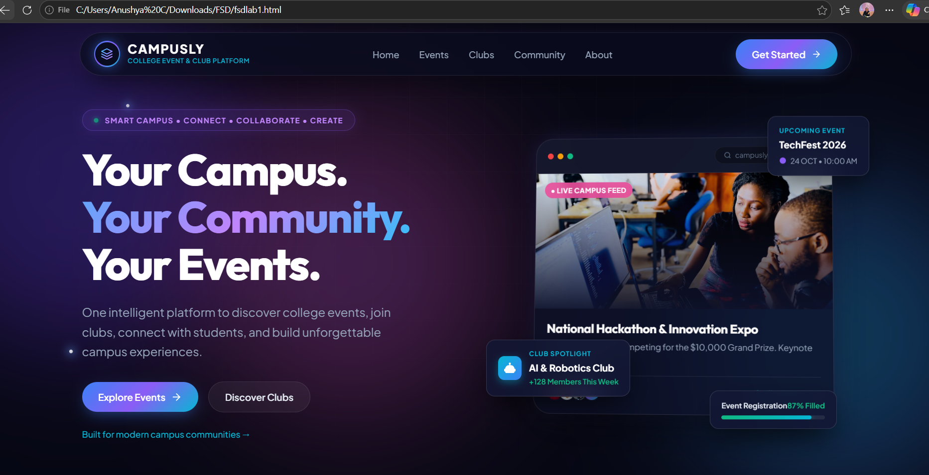
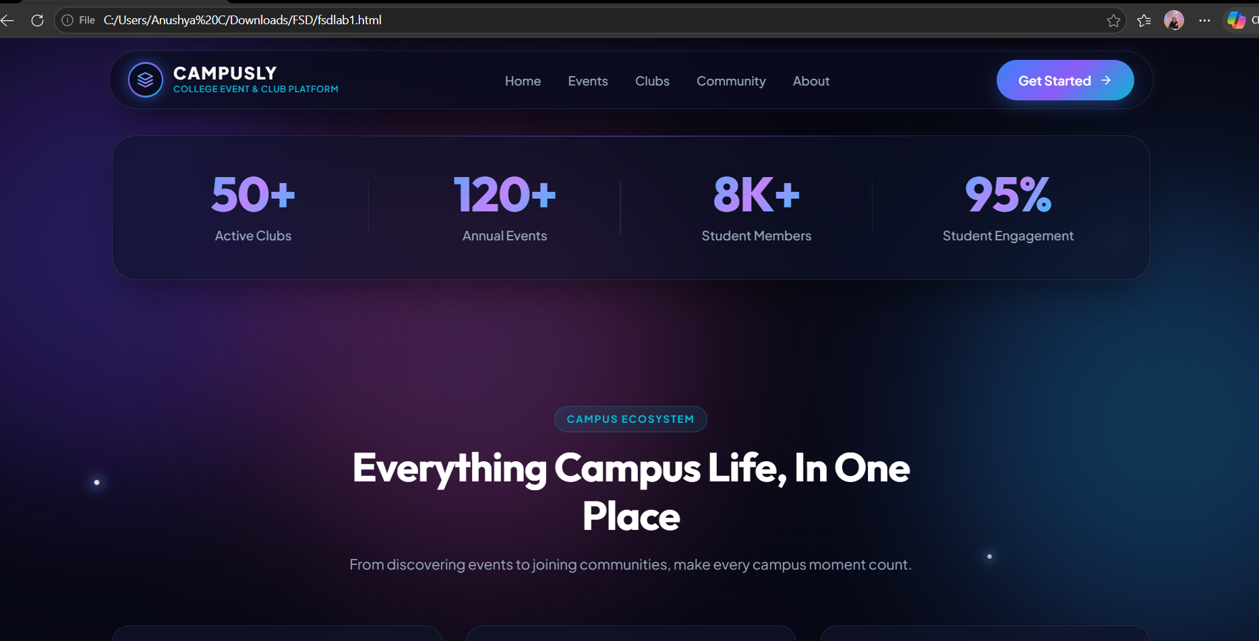

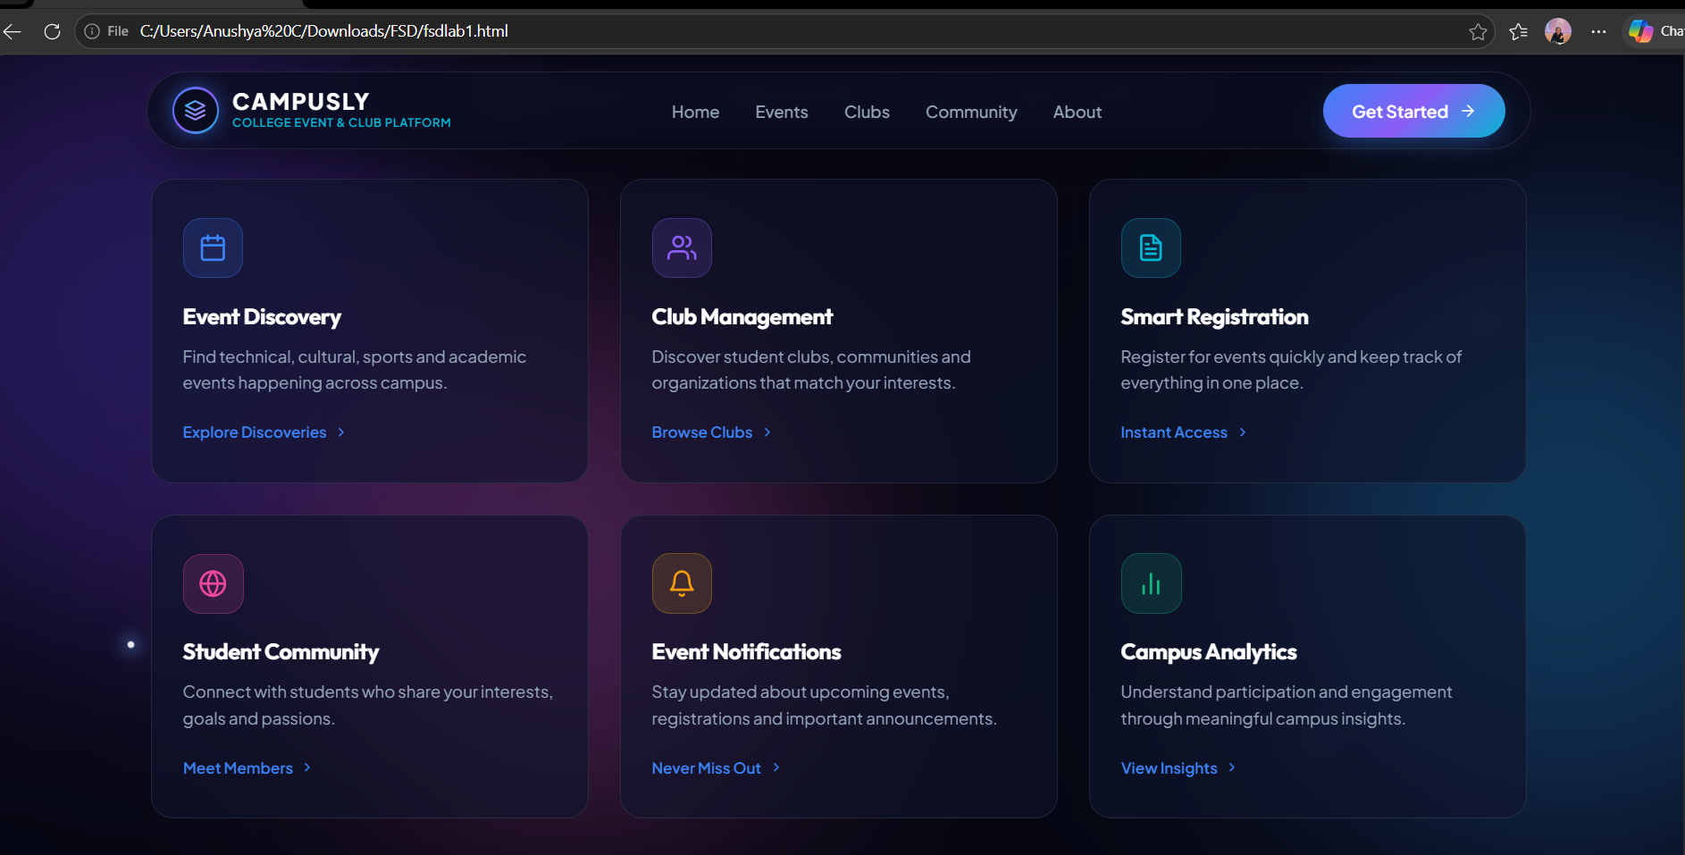

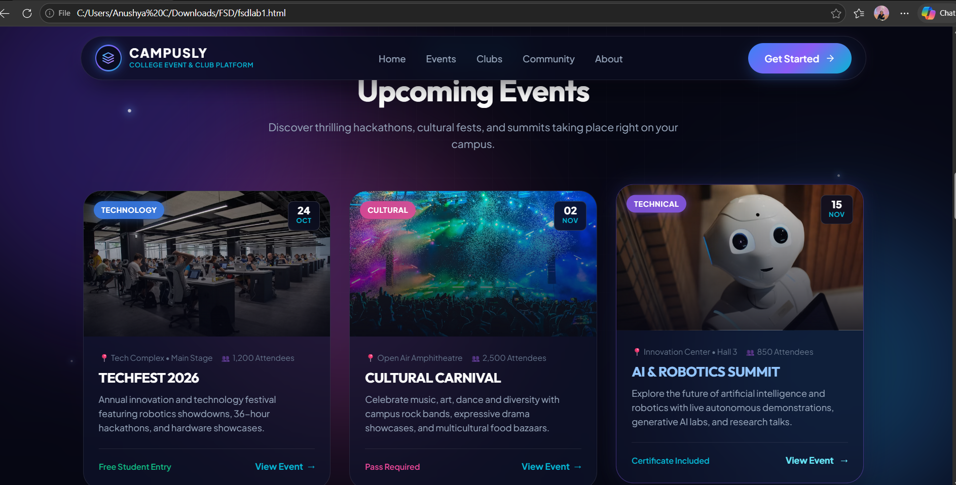

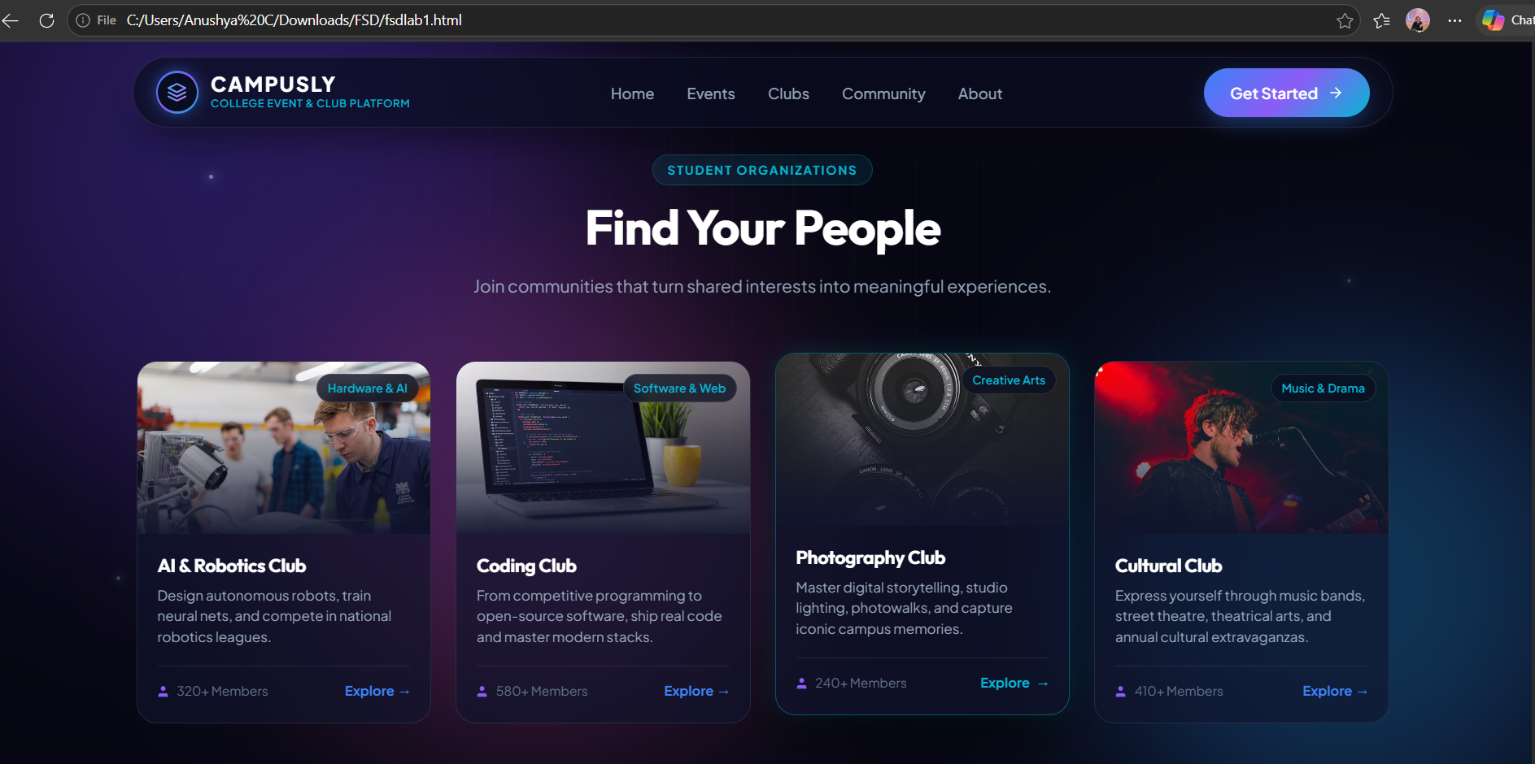

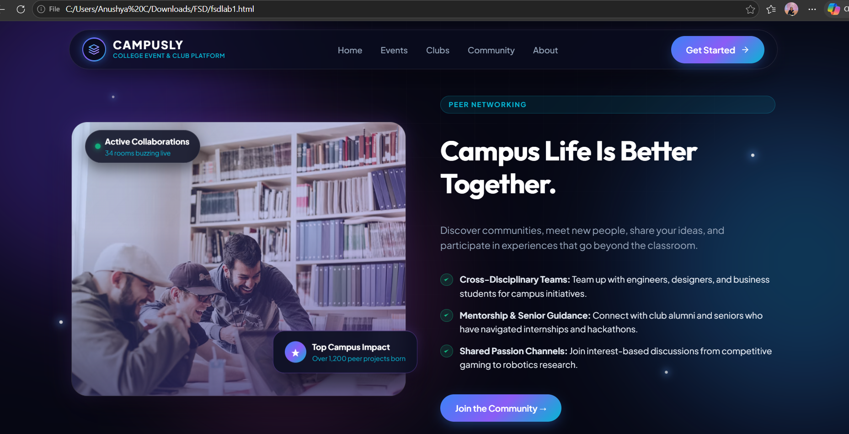

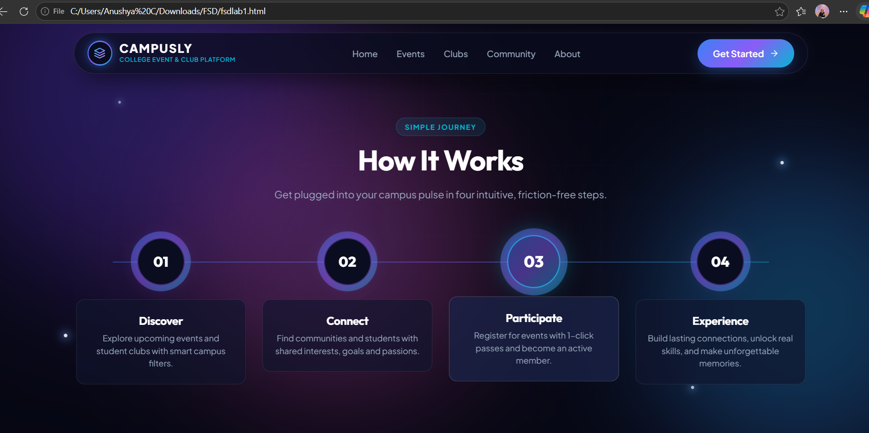

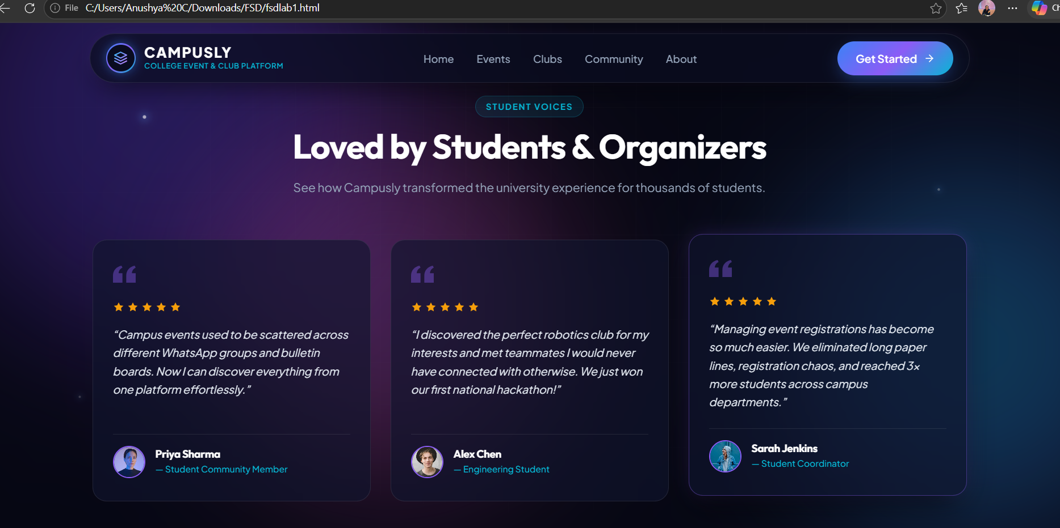

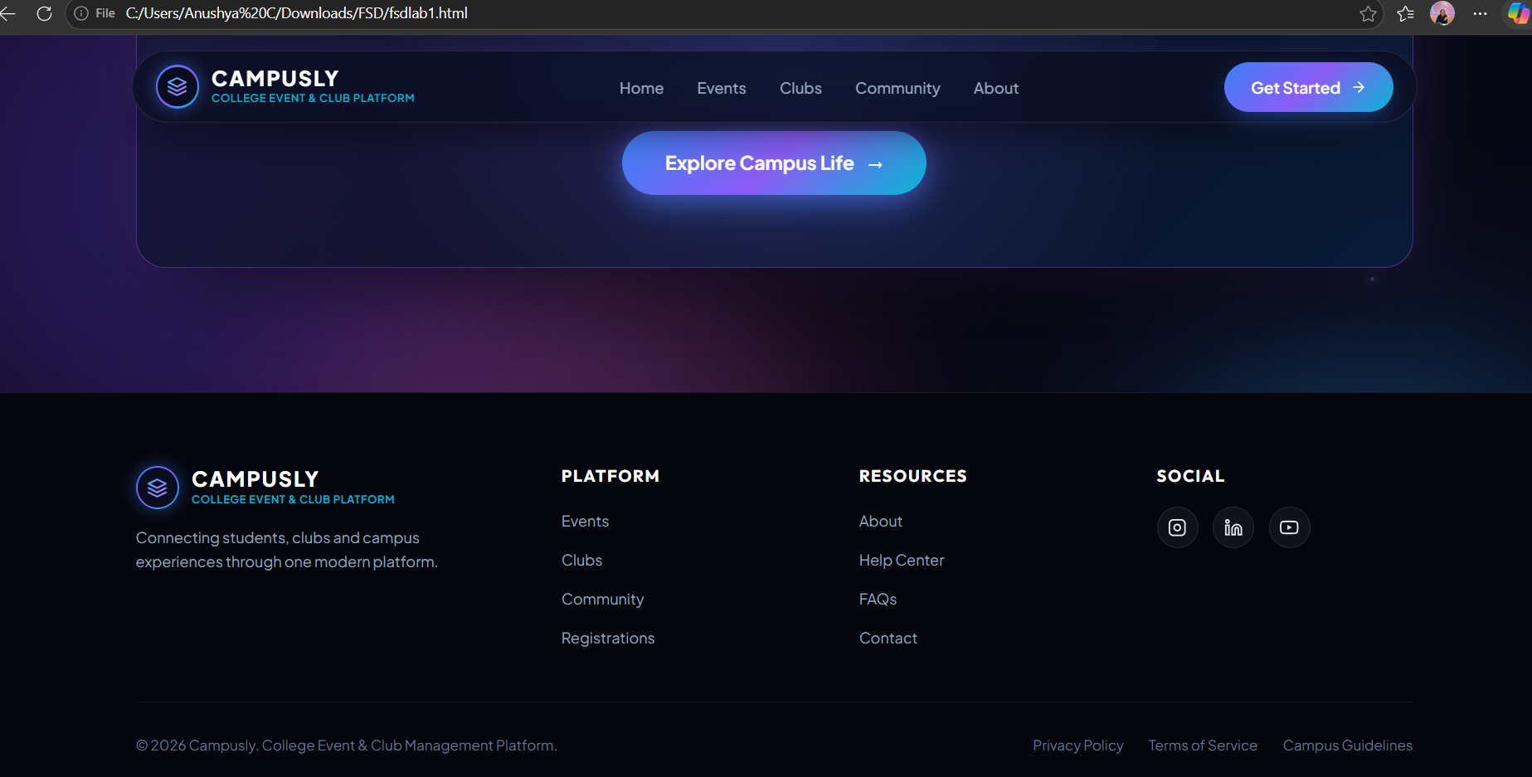

Github repository link:
https://github.com/Anushyaaaa/Full-Stack-Development
Ai tools used:
I used chatgpt to generate the html code.
Prompt used: i need a very beautiful interactive landing page html code for my domain College Event & Club Management Platform this is my domain. it should not be basic it should have pictures and visual effects. dont use javascript i only want the landing page

