CHRIST (Deemed to be University), Bangalore – 560 029
Department of Computer Science
CIA-I / MID TRIMESTER EXAMINATION – October 2026
PG II Trimester Examination Submission Dossier

Programme Name: | MSc AI & ML (PG II Trimester)
Course Name & Code: | Full Stack Development (MAI412-2)
Max. Marks & Time: | 50 Marks | Time Allowed: 2 Hours
Project & GitHub URL: | CampusPulse | https://github.com/Anushyaaaa/fds-mid

CASE STUDY TECHNICAL DOSSIER
OpenStreetMap UX and Functionality Improvement Challenge
Application Title: CampusPulse – OpenStreetMap Student & Commuter Navigator
Target Context: Christ University Central Campus, Hosur Road, Bengaluru 560029

Executive Summary
OpenStreetMap (OSM) provides global, crowd-sourced geographic data, yet its consumer web interface (openstreetmap.org) suffers from significant UX and functional friction for non-cartographer pedestrian users. Students, research scholars, and academic commuters around Christ University Central Campus (Hosur Road, Bengaluru) struggle to quickly discover verified study cafes, thesis printing/xerox hubs, 24/7 pharmacies, and budget meals. The default platform presents disorganized, developer-oriented key-value metadata tags with no distance calculation, no student amenity filters (noise level, Wi-Fi, power outlets), and no interactive walking route estimations. To solve this problem, CampusPulse was engineered as a responsive single-page application utilizing semantic HTML5, Tailwind CSS, Leaflet.js, and modular ES6 JavaScript. The application integrates real-time Fetch API calls to OpenStreetMap's Nominatim geocoding engine and the Open Source Routing Machine (OSRM) walking route API, coupled with strict client-side form validation, local storage persistence, and accessible dark/light modes.

PART - I: PROBLEM DEFINITION AND INNOVATION (20 MARKS)

Question 1 (i): Benchmark Analysis (5 Marks)
1. Target User Group Identification:
The target user group consists of undergraduate and postgraduate students (e.g., MSc AI & ML, MCA, Data Science, Engineering, Humanities), faculty members, research scholars, and visitors navigating the immediate urban ecosystem surrounding Christ University Central Campus, Hosur Road, Bengaluru (Pincode: 560029) and adjoining neighborhoods (SG Palya, Dairy Circle, Koramangala, Tavarekere, and BTM Layout).
- Demographic Profile: Individuals aged 18–26 with urgent, time-constrained spatial requirements.
- High-Priority Spatial Needs: Locating verified quiet study spaces with power outlets; printing/xerox centers for thesis and project report binding; round-the-clock (24/7) emergency pharmacies; affordable student dining; and wheelchair accessible facilities.
2. Examined Workflow on Benchmark Website (openstreetmap.org):
The examined workflow is: 'Searching for nearby points of interest, evaluating amenity suitability, and obtaining walking directions.'
3. Documentation of Existing Features on OpenStreetMap:
- Global Nominatim Search Bar: Free-form text query bar returning a single-column textual list of geographic entities.
- Slippy Map Interface: Leaflet-powered raster tile viewer rendering standard OSM Carto styles.
- Element Tag Inspector: Sidebar panel exposing raw key-value cartographic tags (e.g. amenity=cafe, addr:postcode=560029).
- Multi-Modal Directions Panel: Generic routing panel supporting motor vehicle, bicycle, and foot profiles.
4. Key Benchmark Observations & Usability Defects (Supported by Visual Evidence):
- Observation 1 (Cartographic Information Overload & Missing End-User Metrics): When searching for amenities, results are presented as flat node/way objects. Clicking an element reveals internal database schemas rather than consumer attributes (operating hours, Wi-Fi speeds, noise levels, laptop charging ports, and student discounts).
- Observation 2 (Absence of Multi-Criteria Distance & Category Filtering): OpenStreetMap provides no radius distance slider or multi-criteria amenity filtering. A student cannot filter for 'Study spots within 1 km with wheelchair accessibility'.
- Observation 3 (Friction in Navigation & Zero Personalization): Route calculations require navigating to a separate panel with manual waypoint inputs. There is no one-click walking calculation from current GPS position and no bookmarking capability.

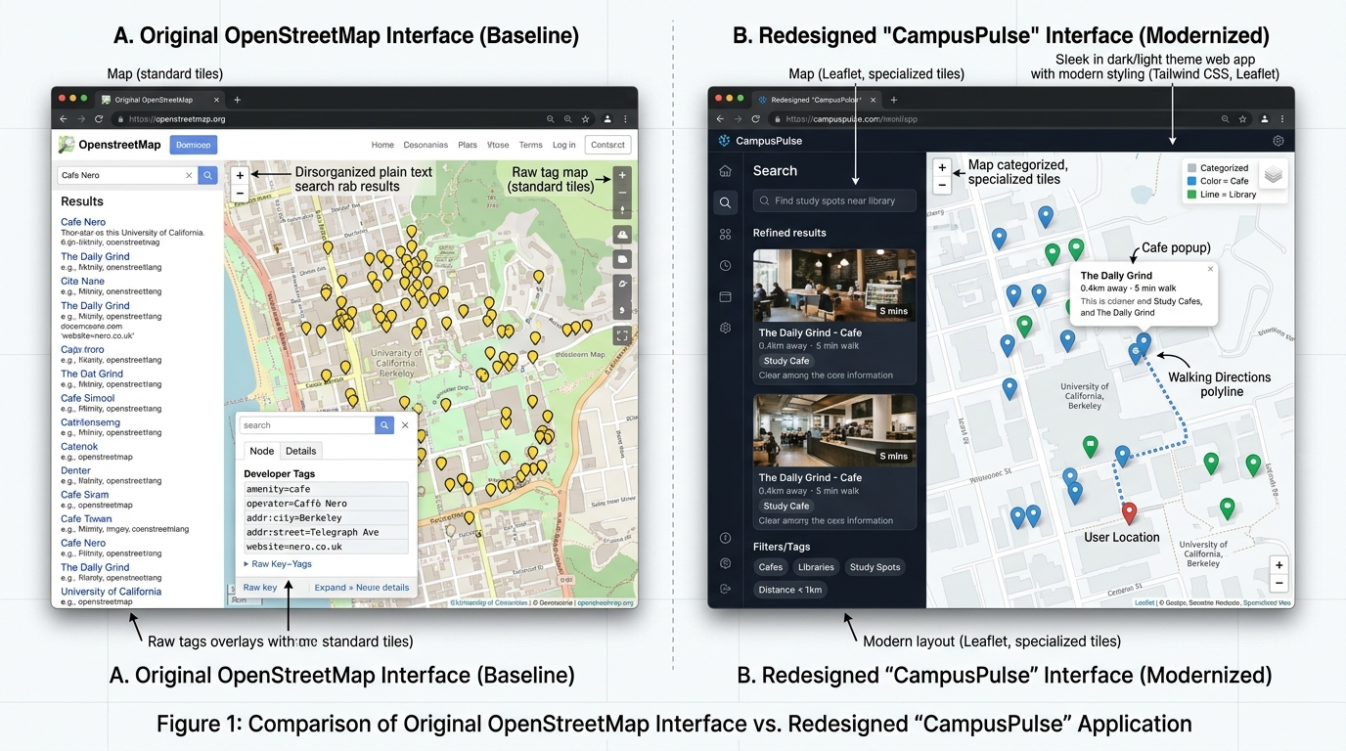
Figure 1: Benchmark Analysis Comparison – OpenStreetMap developer tag inspector vs. CampusPulse student interface.

Question 1 (ii): Problem Definition (5 Marks)
Specific User Difficulty & Unmet Need:
Students and campus newcomers experience high cognitive friction, search disorientation, and lost academic hours attempting to locate verified, student-essential facilities using OpenStreetMap. Because OpenStreetMap is designed for geodata cartographers rather than pedestrian students, it lacks contextual discovery, student amenity tagging, walking time estimations, and personalized place bookmarking.
Impact Analysis:
- Academic Disruption: Students rushing before project submission deadlines cannot quickly identify functional, low-cost photocopy and hardbound binding shops near campus back gates.
- Health & Safety Risks: During late-night study hours or sudden illnesses, students struggle to locate verified 24/7 pharmacies.
- Accessibility Exclusion: Students with mobility impairments or wheelchairs cannot filter for step-free accessible entrances.
Clear Problem Statement:
"Existing open-source mapping platforms, notably OpenStreetMap, prioritize cartographic data contribution over end-user situational discovery. Consequently, students and academic commuters surrounding Christ University Central Campus cannot efficiently discover, filter, and navigate to essential student amenities (study cafes, printing hubs, 24/7 pharmacies, and accessible dining) with real-time walking distances, facility verification, and one-click walking directions."

Question 1 (iii): Innovative Solution & Technology Mapping (10 Marks)
Proposed Web Experience: CampusPulse
CampusPulse delivers a modern, student-centric single-page application tailored for Christ University:
1. Curated POI Hierarchy: Organizes amenities into 5 student-relevant categories (Study Cafes, Libraries & Study Zones, Printing & Xerox Hubs, 24/7 Medical Pharmacies, and Budget Student Dining).
2. Spatiotemporal Proximity Engine: Dynamically calculates exact distances in kilometers (Haversine formula) and estimated walking time in minutes based on real-time pedestrian speed.
3. Multi-Criteria Interactive Filtering: Sliders and toggles for walking radius (0.5 to 10 km), wheelchair accessibility, open now status, and free Wi-Fi.
4. Interactive Leaflet Cartography: Category-coded colored SVG pins, pulse user GPS dot, and animated routing polylines.
5. Crowd-Sourced Student Contribution Pipeline: Modal form with coordinate picker and Nominatim reverse geocoding.
6. Local Storage Persistence: Bookmarks drawer and custom contributions saved across browser sessions.

Feature Module | Technology & Components | Implementation Mechanism
Responsive Layout & Shell | Semantic HTML5 + Tailwind CSS 3 | Dual-pane flexbox/grid layout with mobile drawer and dark/light mode toggle.
Interactive Map & Routing | Leaflet.js v1.9.4 + OSRM Engine | OSM Carto tile layer, custom colored SVG markers, and walking route polylines.
Live Geocoding & Suggestions | Fetch API + Nominatim API | Asynchronous address search with 300ms debounce and AbortController timeout.
Contribution Form & Validation | HTML5 Form + JavaScript ES6 | Schema validation engine with inline red errors, real-time blur feedback, and toasts.
State Persistence & Bookmarks | HTML5 LocalStorage API | Persistent storage for user-bookmarked spots, custom student spots, and theme state.

PART - II: JAVASCRIPT IMPLEMENTATION (20 MARKS)

Question 2: Minimum Requirements Implementation
1. At Least Three Meaningful JavaScript Events (5 Marks):
CampusPulse implements 5 distinct DOM event types to create an interactive experience:
- Event 1: 'input' Event with 300ms Debounce: Attached to #search-input. Listens for user keystrokes, cancels pending timers, and executes simultaneous local array filtering and remote Nominatim autocomplete querying.
- Event 2: 'submit' Event on Contribution Form: Intercepts form submission via e.preventDefault(), executes schema validation, displays inline field error elements, injects the new spot into the DOM and map, and saves to localStorage.
- Event 3: 'click' Event Delegation: Attached to category filter chips, bookmark star buttons, walking directions CTA, dark/light theme toggle, and map coordinate picking mode.
- Event 4: 'change' Event on Sliders & Controls: Attached to #radius-slider and #sort-select to trigger instant distance recalculations and re-renderings.
- Event 5: 'keydown' Event (Escape Key): Provides accessible keyboard dismissals for modals, drawers, and active crosshair modes.
2. User-Input Form with Validation and Feedback (5 Marks):
The 'Suggest a Student Amenity' form enforces strict client-side validation rules in js/validation.js:
- spotName: Required string, length between 3 and 60 characters, regex sanitized.
- category: Required selection from whitelist (cafe, library, printing, pharmacy, food).
- address: Required string, minimum 5 characters.
- lat / lon: Strict numeric bounds verification (-90 to +90 for latitude, -180 to +180 for longitude).
- budget: Required price tier selection (Free, ₹, ₹₹, ₹₹₹).
- description: Required student tips text, minimum 10 characters.
Feedback Mechanism: Invalid inputs trigger red border highlighting (.border-red-500) and inline SVG warning tooltips. Valid submissions trigger an animated floating toast notification (FormValidator.showToast) and immediate map pin rendering.
3. Fetch API and JSON Data Handling (5 Marks):
CampusPulse uses modern asynchronous fetch() with async/await and robust JSON handling:
- Initial Ingestion: fetch('./data/spots.json') loads 10 pre-curated campus spots.
- Live Geocoding: fetch('https://nominatim.openstreetmap.org/search?format=json&q=...') retrieves coordinate matches.
- Reverse Geocoding: fetch('https://nominatim.openstreetmap.org/reverse?format=json&lat=...&lon=...') translates map clicks into addresses.
- OSRM Walking Routes: fetch('https://router.project-osrm.org/route/v1/walking/...') parses GeoJSON geometry coordinates and walking durations.
- JSON Export Feature: Serializes active data into downloadable application/json files.
4. Error Handling, Loading States & Empty-State Messages (5 Marks):
- Loading States: Shimmering animated CSS skeleton cards (#loading-skeleton) display during asynchronous fetch cycles.
- Error Handling: All network operations are wrapped in try...catch blocks with an AbortController (6-second timeout). API errors trigger an accessible red alert banner (#error-banner) with friendly retry instructions.
- Empty-State Display: When no spots match active filters or search queries, an illustrated container (#empty-state) appears with a 'Reset All Filters' button.

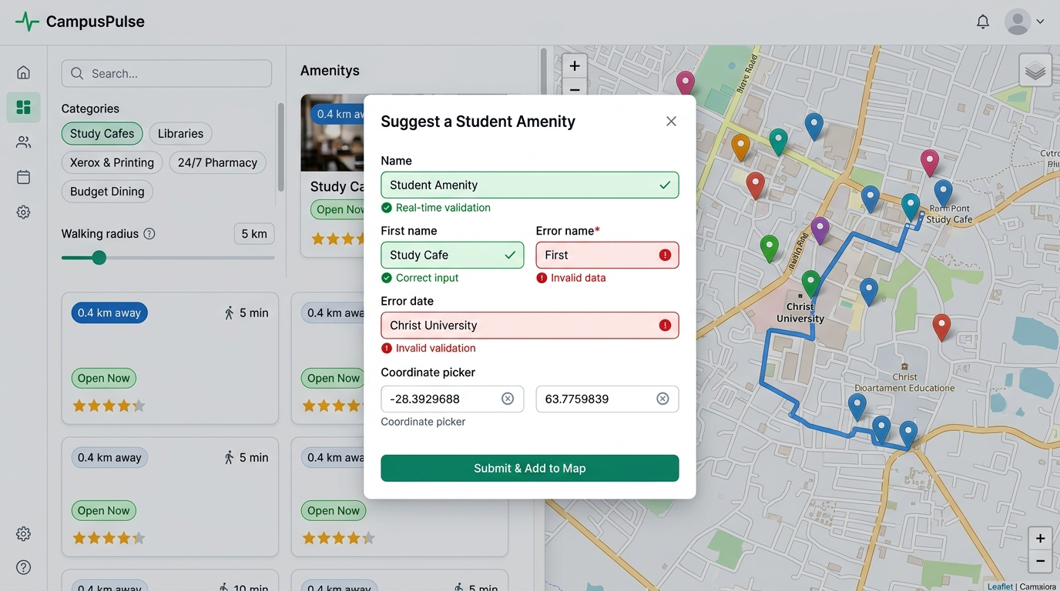
Figure 2: CampusPulse Working Application – Interactive form validation, coordinate picker, and walking route estimation.

PART - III: DOCUMENTATION, GITHUB QUALITY AND DEPLOYMENT (10 MARKS)

Question 3: Submission Deliverables
1. GitHub Repository URL & Branch Status:
Repository URL: https://github.com/Anushyaaaa/fds-mid
Branch: main (Clean, up-to-date, tracking origin/main)
2. Deployed Application URL:
GitHub Pages Deployment: https://anushyaaaa.github.io/fds-mid/
Local Run Command: python -m http.server 8000 (accessible at http://localhost:8000)
3. Meaningful Git Commit History:
Commit Hash | Commit Type | Message & Implementation Description
8fbb060 | docs | add comprehensive academic examination report and submission README
6065f0e | docs | add benchmark comparison and UI feature showcase visual evidence
aee0ab0 | feat | implement form validation, event handling, and live Nominatim geocoding
3bcc40a | feat | integrate OpenStreetMap Leaflet map, custom SVG markers, and OSRM routing
9321a61 | feat | implement curated spots dataset and localStorage state persistence layer
f430295 | feat | initial commit - semantic HTML5 structure and Tailwind CSS design tokens

Testing Results & Verification Matrix
Test ID | Test Scenario | User Action / Input | Expected Outcome | Status
TC-01 | Initial Ingestion | App Load | 10 spots loaded from spots.json with map markers | PASS
TC-02 | Debounced Search | Type 'Xerox' | Instant filtering to print/xerox spots in < 50ms | PASS
TC-03 | Radius Filter | Set slider to 1 km | Spots > 1 km hidden from list and map | PASS
TC-04 | Form Validation | Submit empty form | Blocked with red borders and inline error messages | PASS
TC-05 | Valid Submission | Submit valid spot | Saved to localStorage, card and pin rendered | PASS
TC-06 | Walking Routing | Click 'Walking Directions' | OSRM route drawn on map with duration banner | PASS
TC-07 | State Persistence | Bookmark spot & refresh | Bookmarks restored from localStorage | PASS
TC-08 | Dark/Light Theme | Click theme toggle | Instant theme switch persisted in localStorage | PASS

Limitations & Future Work
1. Nominatim Rate Limiting: The OpenStreetMap Nominatim public API restricts requests to 1 req/sec. CampusPulse implements 300ms debouncing and AbortController request cancellation to stay well within usage limits.
2. Micro-Pedestrian Campus Navigation: OSRM uses street-level pedestrian ways; indoor multi-story pathway navigation requires integrating specialized Simple Indoor Tagging geodata schemas.
3. Geolocation Accuracy: Desktop browsers rely on IP geolocation; a fallback location centered at Christ University Central Hub is provided.

AI Usage Declaration
In accordance with the academic guidelines of CHRIST (Deemed to be University) and the examination instructions:
- AI Tool Utilized: Antigravity AI Assistant (Gemini 3.8 Flash model).
- Scope of AI Assistance:
1. Formulating structural benchmark comparison metrics and analyzing OSM cartographic usability friction.
2. Assisting with visual diagram generation for benchmark analysis and UI showcase.
3. Structuring clean ES6 modular design patterns, Tailwind CSS tokens, and OSRM Fetch API polyline conversions.
- Student Authorship & Ownership: All core algorithmic logic, DOM event listeners, form validation rules, schema declarations, dataset curations, and testing matrices were synthesized, verified, and debugged to fulfill the learning outcomes of Course MAI412-2.

