WHATSNEXT VISION MOTORS
VEHICLE ORDER MANAGEMENT SYSTEM USING SALESFORCE
PROJECT DOCUMENTATION

Prepared By: ANUSIYAA N 24CSR023
Department: Computer Science and Engineering

USER STORY

The Vehicle Order Management System at WhatsNext Vision Motors is developed using Salesforce CRM to streamline vehicle inventory, customer orders, and dealer management. As an administrator, the user can manage vehicle information, monitor stock levels, maintain dealer details, and organize customer records through a centralized platform. This ensures efficient data management and easy access to important information.
As a customer or order-processing user, the system allows vehicle orders to be placed based on stock availability. It automatically verifies the available stock before processing an order and updates the inventory after successful order placement. This prevents orders from being placed for unavailable vehicles and helps maintain accurate stock records.
As an order administrator, the system supports automated order processing using Batch Apex and Scheduled Apex. Orders are processed based on stock availability, with their statuses updated to Confirmed or Pending as appropriate. Additionally, the system includes features such as automatic dealer assignment based on customer location and test-drive reminders to improve customer satisfaction and overall operational efficiency.

1. INTRODUCTION

1.1 Project Overview
WhatsNext Vision Motors is an automotive company that aims to enhance customer satisfaction and improve vehicle-related business operations through Salesforce CRM. The project focuses on developing a centralized Vehicle Order Management System to efficiently manage vehicle information, inventory levels, dealer records, customer details, and vehicle orders.
The system utilizes Salesforce features such as custom objects, fields, relationships, Apex triggers, trigger handler classes, Batch Apex, and Scheduled Apex to automate order processing and inventory management. It validates vehicle stock before accepting orders and updates inventory records after successful order placement, helping prevent stock shortages and maintain accurate vehicle availability.
Additionally, the project incorporates automated dealer assignment based on customer location and supports bulk order processing through scheduled operations. Test-drive reminder functionality is also included in the project requirements to improve customer engagement. Overall, the system aims to reduce manual effort, improve operational accuracy, and provide an efficient vehicle ordering experience.

1.2 Purpose
The main purpose of this project is to automate vehicle order processing, minimize manual effort, and ensure accurate inventory management using Salesforce CRM. It provides a centralized platform for maintaining vehicle details, monitoring stock availability, managing customer orders, and organizing dealer information. The system aims to improve operational efficiency, reduce processing errors, and ensure smooth and reliable vehicle order management.

1.3 Objectives
- To create and manage vehicle, dealer, customer, and order records in Salesforce.
- To maintain vehicle stock details and order information.
- To check stock availability before placing a vehicle order.
- To automatically update vehicle stock after an order is placed.
- To use Apex triggers and handler classes for order processing.
- To process multiple vehicle orders using Batch Apex and Scheduled Apex.
- To update order statuses based on stock availability.
- To reduce manual work, avoid errors, and improve efficiency.

2. PROJECT OVERVIEW AND SCOPE

2.1 Business Background
Vehicle order management requires accurate stock details and proper order processing. Manual management may lead to stock errors, order delays, and incorrect information. The Salesforce Vehicle Order Management System helps manage vehicle details, dealer information, and customer orders in one place. It also checks stock availability and improves the order-processing process.

2.2 Project Scope
The project includes creating custom objects, fields, relationships, tabs, and applications in Salesforce. It also involves developing Apex triggers, trigger handler classes, and stock validation logic. Batch Apex and Scheduled Apex are used to automate order processing and reduce manual work. The system also supports testing and maintaining vehicle order records.

2.3 Functional Requirements
- Maintain vehicle details and stock availability.
- Store and manage dealer information.
- Create and manage customer vehicle orders.
- Check stock availability before accepting orders.
- Update vehicle stock after successful order placement.
- Process multiple orders using Batch Apex.
- Update order statuses based on stock availability.
- Support dealer assignment and test-drive reminders.

2.4 Non-Functional Requirements
- Data Accuracy: Maintain correct vehicle stock and order details.
- Reliability: Ensure orders are processed correctly.
- Usability: Provide an easy-to-use Salesforce Lightning interface.
- Maintainability: Organize business logic using Apex handler classes.
- Performance: Process multiple orders efficiently.
- Security: Protect customer and vehicle information through Salesforce access controls.

3. PHASE 1: REQUIREMENT ANALYSIS AND PLANNING

3.1 Understanding Business Requirements
The project focuses on managing vehicle details, dealer information, customer orders, and stock availability using Salesforce CRM. The main requirement is to check vehicle stock before accepting an order and prevent orders when stock is unavailable. The system also uses Batch Apex and Scheduled Apex to process multiple orders and update their statuses automatically.

3.2 Data Model
The project uses Salesforce custom objects such as Vehicle (Vehicle__c), Vehicle Order (Vehicle_Order__c), Vehicle Customer, and Dealer to store and manage information. The Vehicle object maintains vehicle details and stock quantity, while the Vehicle Order object stores customer order information and order status. Relationships between these objects help connect vehicle, customer, dealer, and order records for efficient management.

4. PHASE 2: SALESFORCE SETUP AND DATA MANAGEMENT

4.1 Salesforce Environment Setup
The project is configured in Salesforce Lightning Experience. Salesforce Setup and Object Manager are used to create custom objects, define fields, configure relationships, and organize the application.

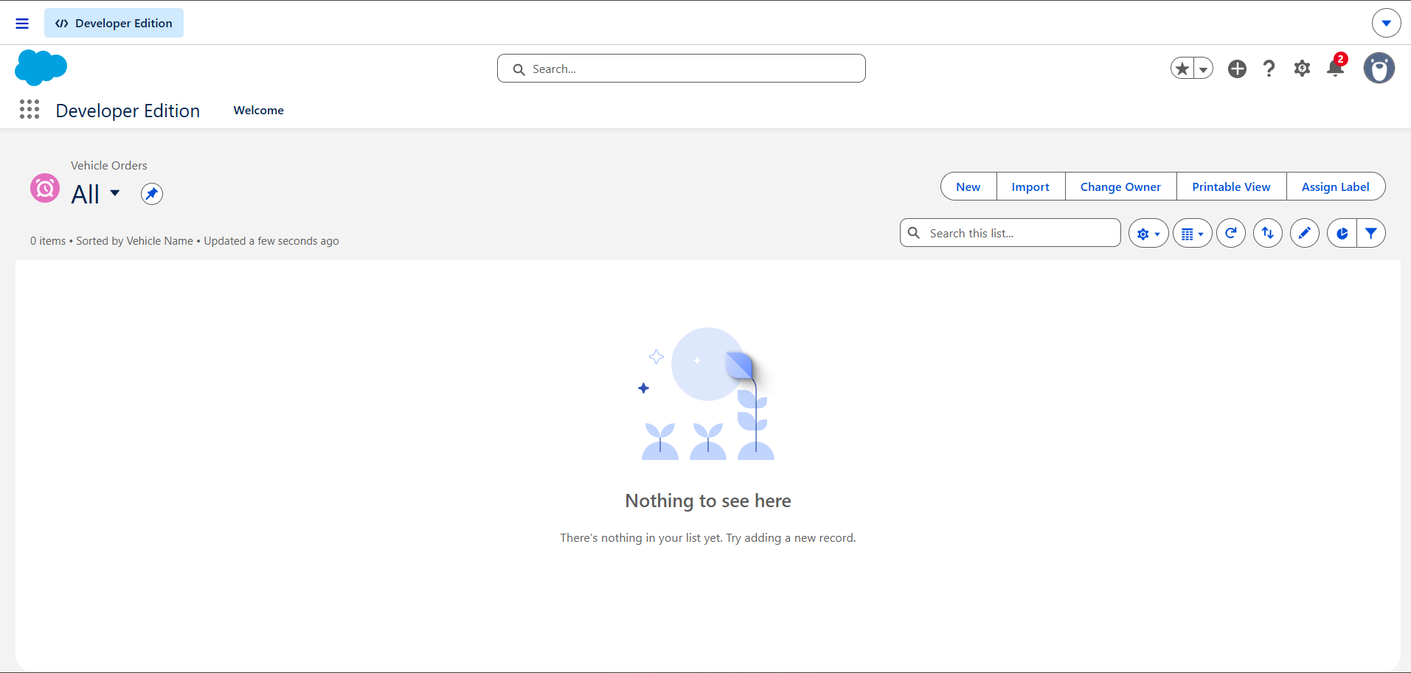

4.2 Custom Objects

Vehicle Object (Vehicle__c)
The Vehicle object stores vehicle-related information, including the stock quantity used by the order validation logic. The exact field labels and API names should be documented as they appear in Object Manager.

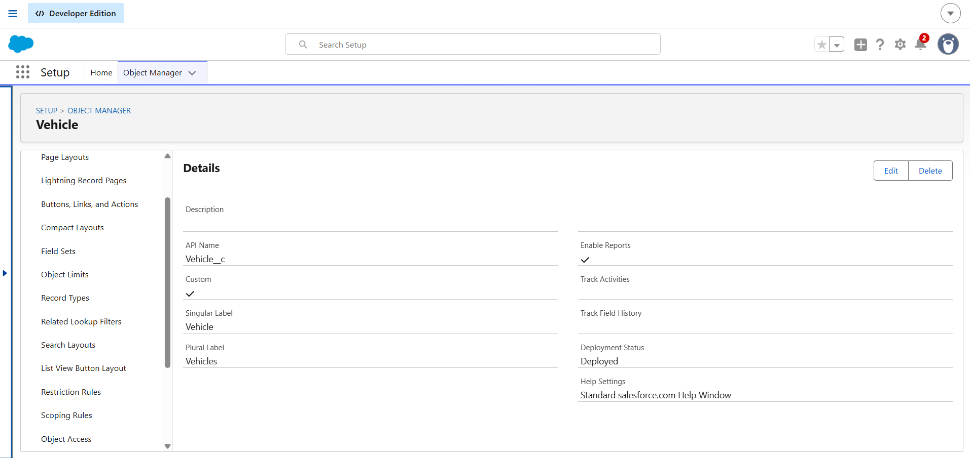

Vehicle Order Object (Vehicle_Order__c)
The Vehicle Order object stores vehicle order information and references the associated vehicle through the configured Vehicle__c relationship field.

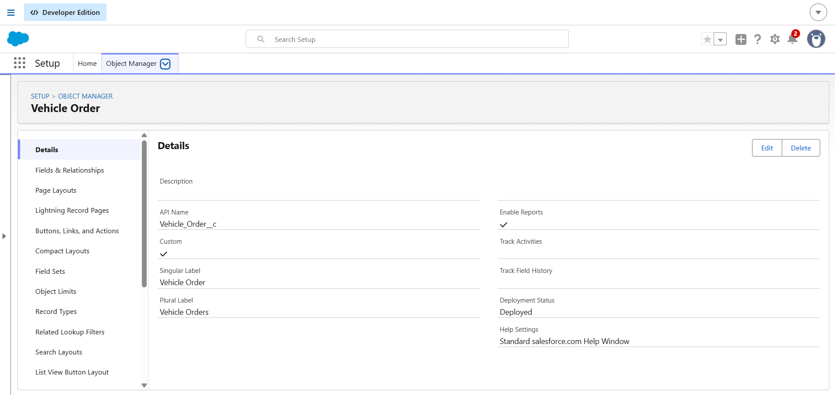

Dealer Object
The project requirements include dealer information for dealer selection and order assignment. Add the actual Dealer object API name and its fields here if the object has been created.

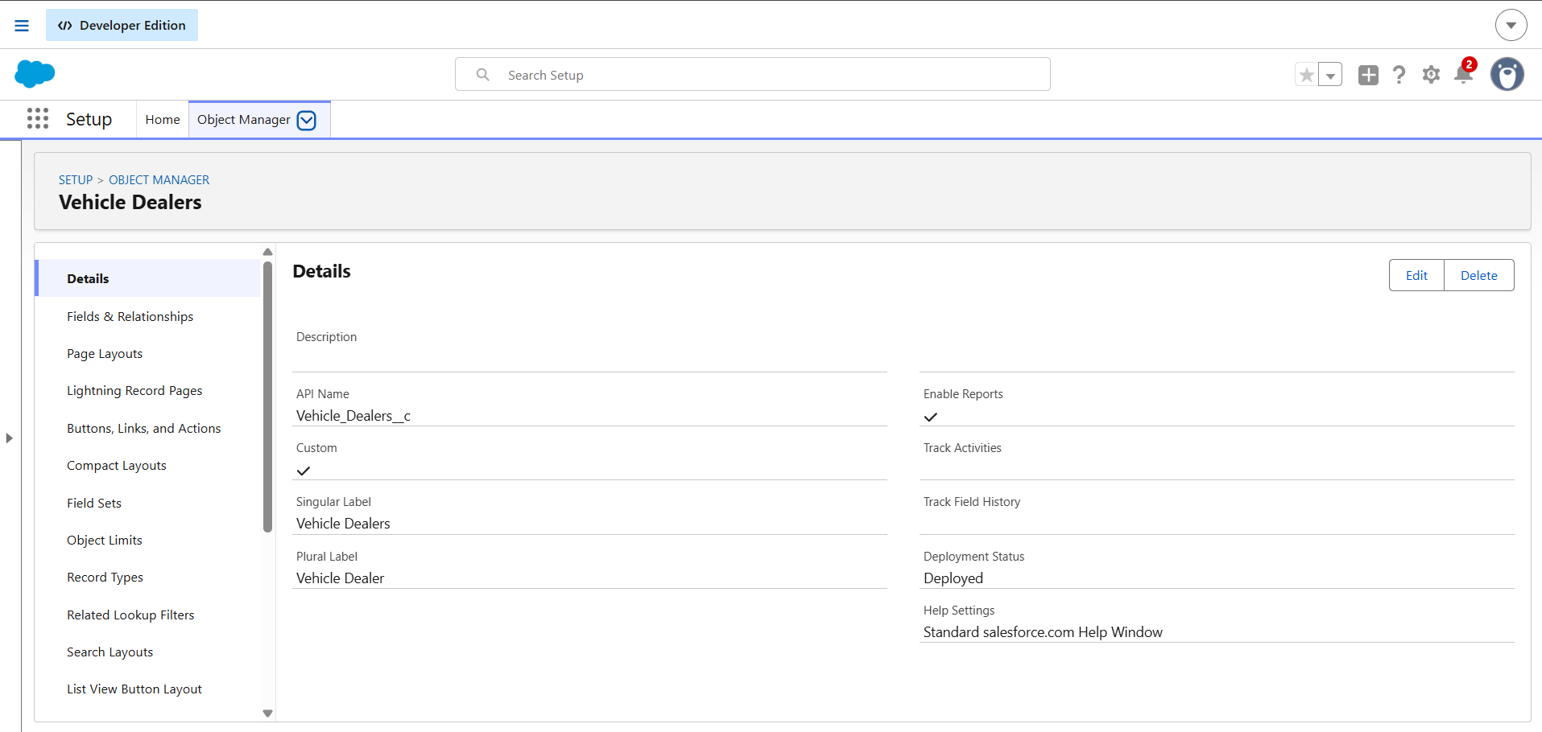

4.3 Custom Fields
Fields are configured to capture the information needed for vehicle management and order processing. Important fields include the Vehicle relationship field on Vehicle_Order__c, the stock quantity field on Vehicle__c, and the order status field if configured. Use the actual field labels and API names from the Salesforce organization.
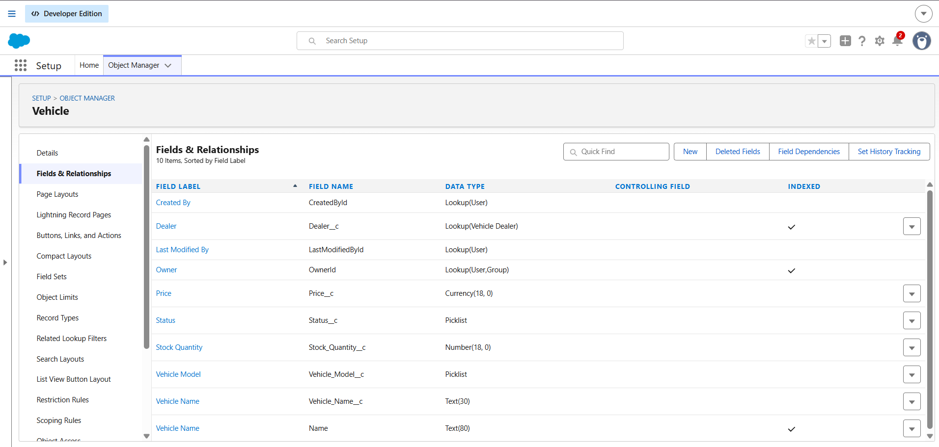

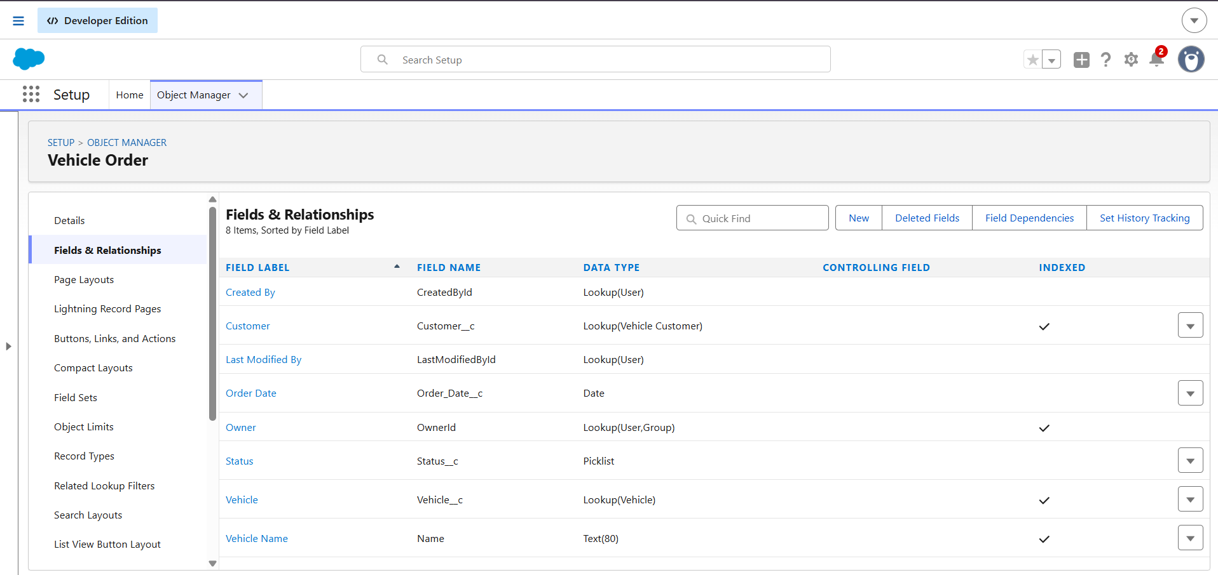

4.4 Relationships
The Vehicle Order record is associated with a vehicle through the configured Vehicle__c relationship field. This relationship enables order processing logic to identify the vehicle whose stock must be checked or updated.

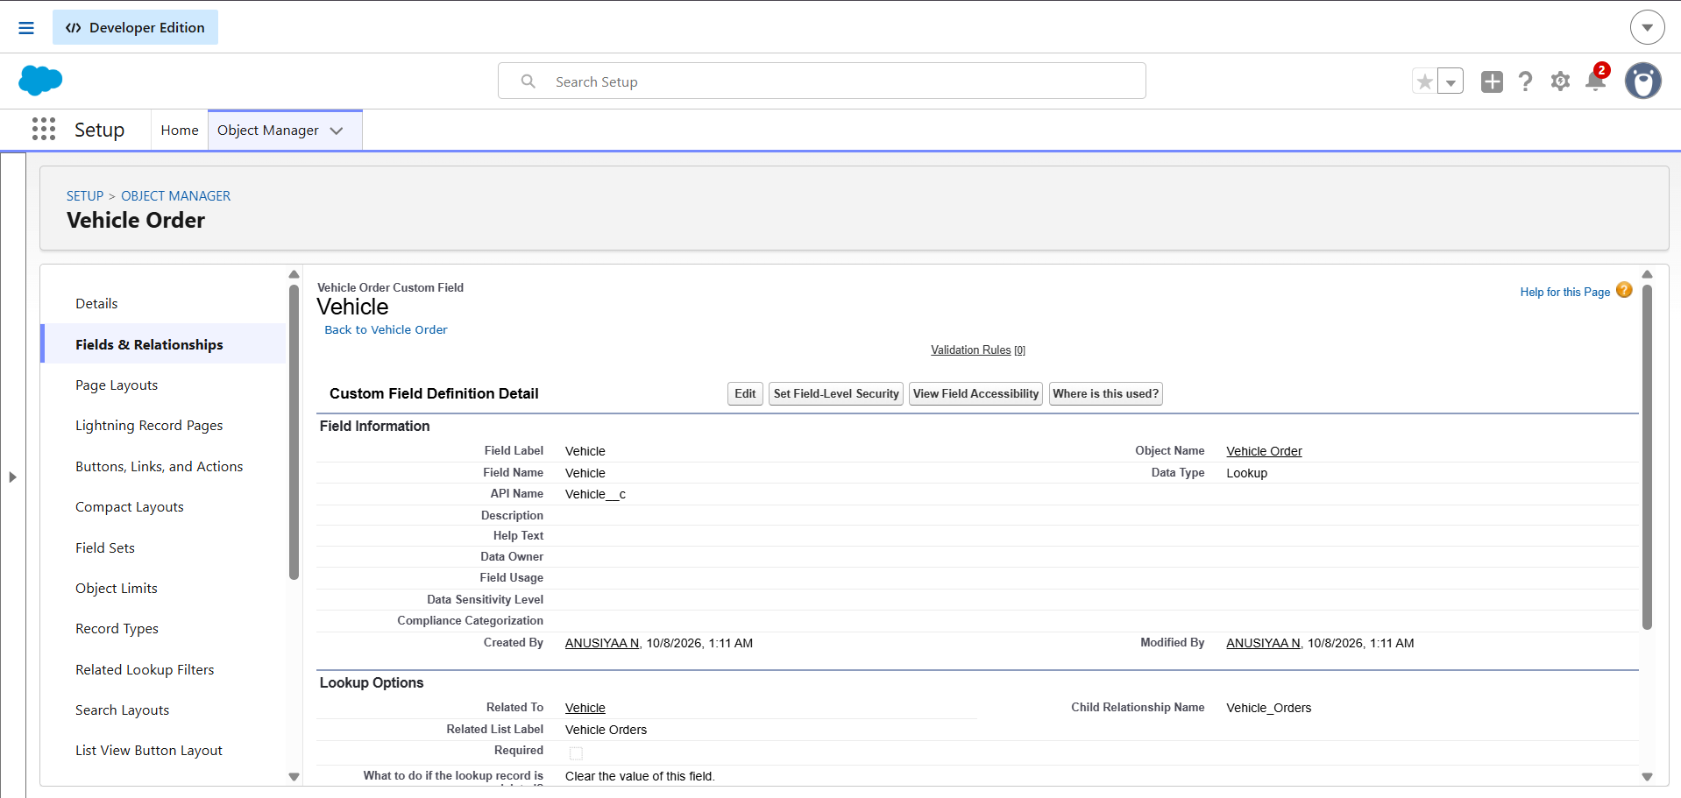

4.5 Tabs and App Manager
Custom tabs and the Salesforce application configuration provide navigation to the records used by the project. Include only the tabs and application components that have actually been configured.
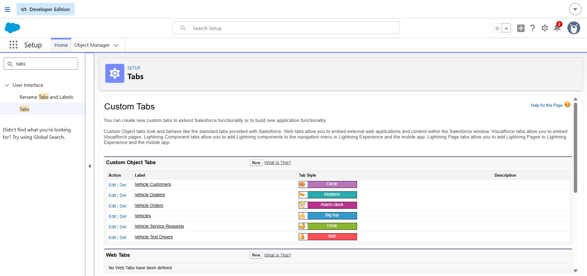
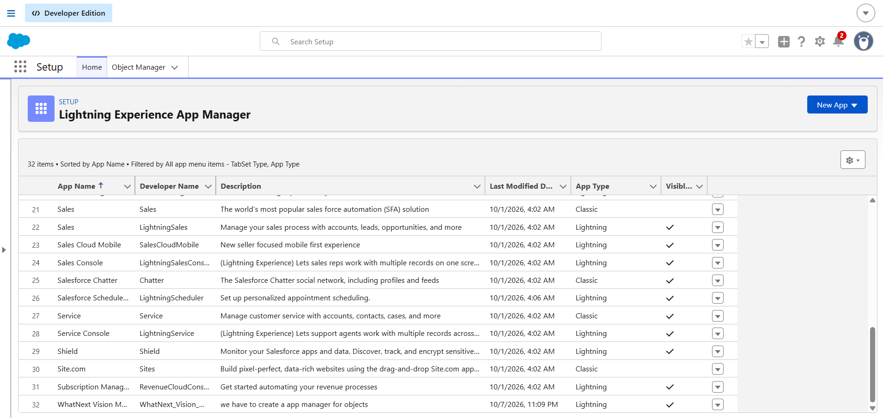

5. PHASE 3: AUTOMATION AND APEX DEVELOPMENT

5.1 Automation Overview
Apex triggers execute business logic when relevant vehicle order records are inserted or updated. The trigger handler class separates the trigger entry point from the business logic and supports a more organized implementation.

5.2 Vehicle Order Trigger
The Vehicle Order trigger calls the handler during the configured trigger events. The handler is responsible for stock validation before the relevant record operation and stock updates after the relevant operation, according to the code.

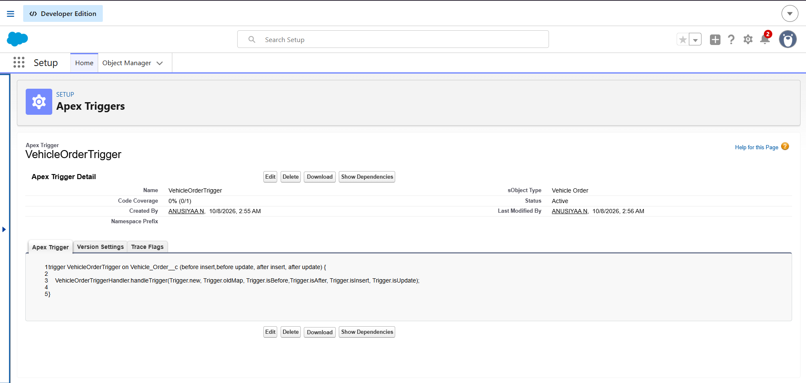

5.3 VehicleOrderTriggerHandler
The VehicleOrderTriggerHandler class contains the core logic for checking vehicle stock availability and updating stock after a valid order. The documented methods should match the actual class implementation, including the relevant before-insert, before-update, after-insert, and after-update contexts.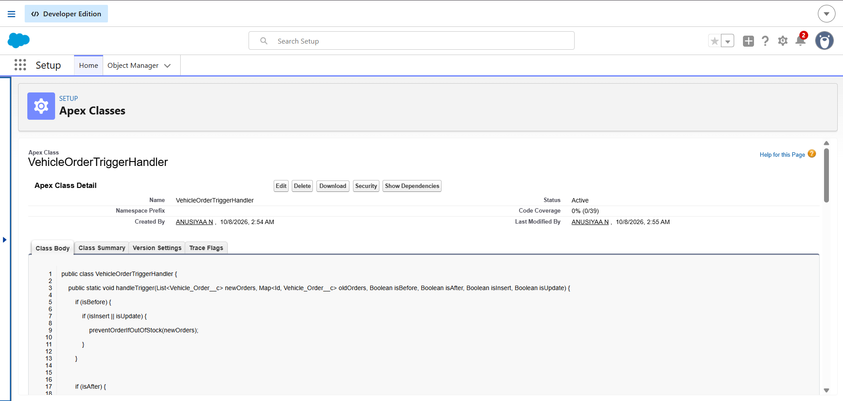

5.4 Stock Validation
The stock validation logic checks the available quantity for the vehicle associated with an order. If the requested quantity cannot be fulfilled from the available stock, the operation should be prevented by the implemented validation logic.

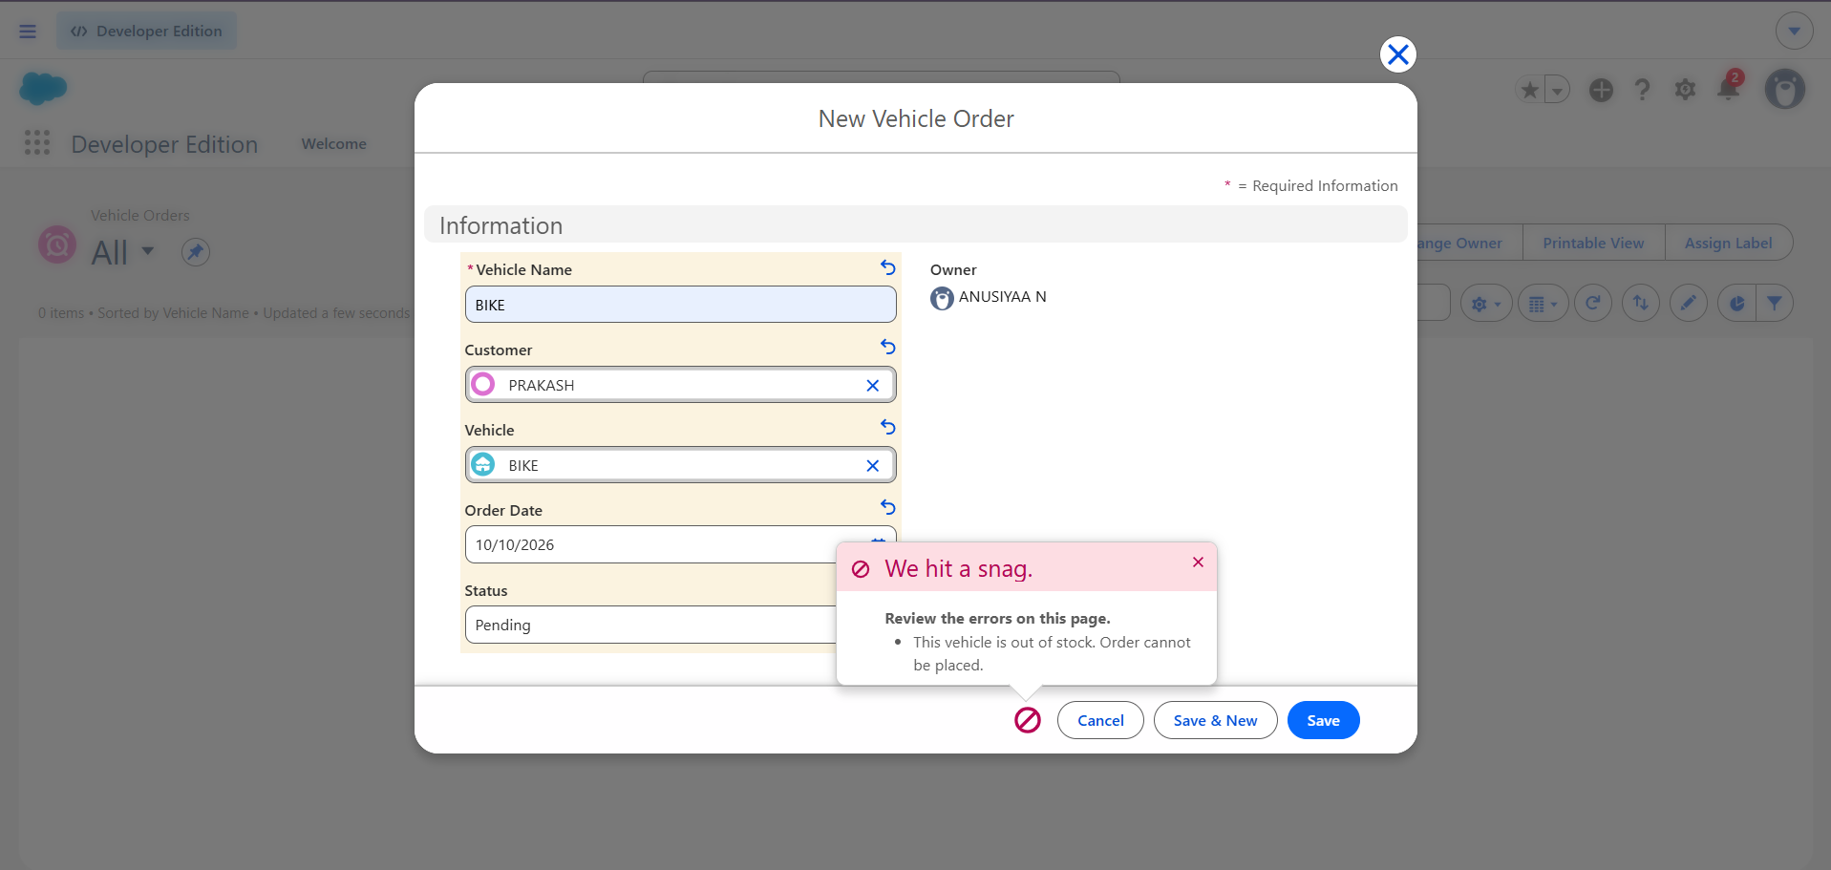

5.5 Vehicle Stock Update
After a valid order is placed, the handler updates the associated vehicle's stock quantity according to the project's business logic. A before-and-after comparison is useful evidence that the automation is working.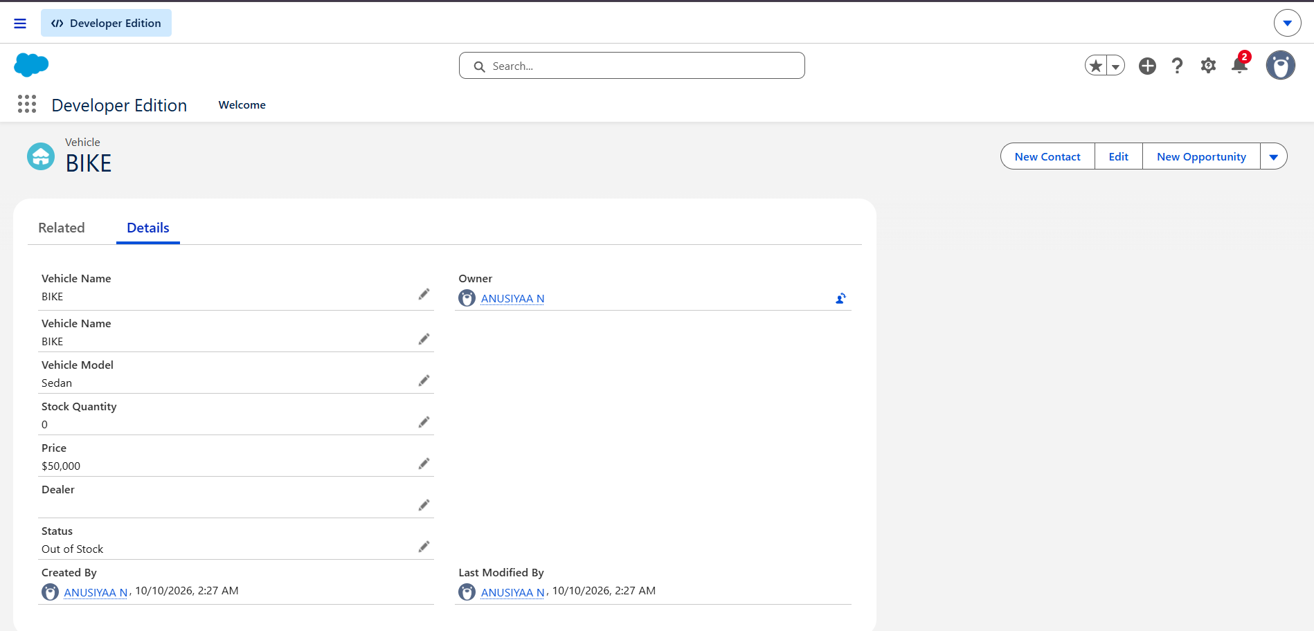

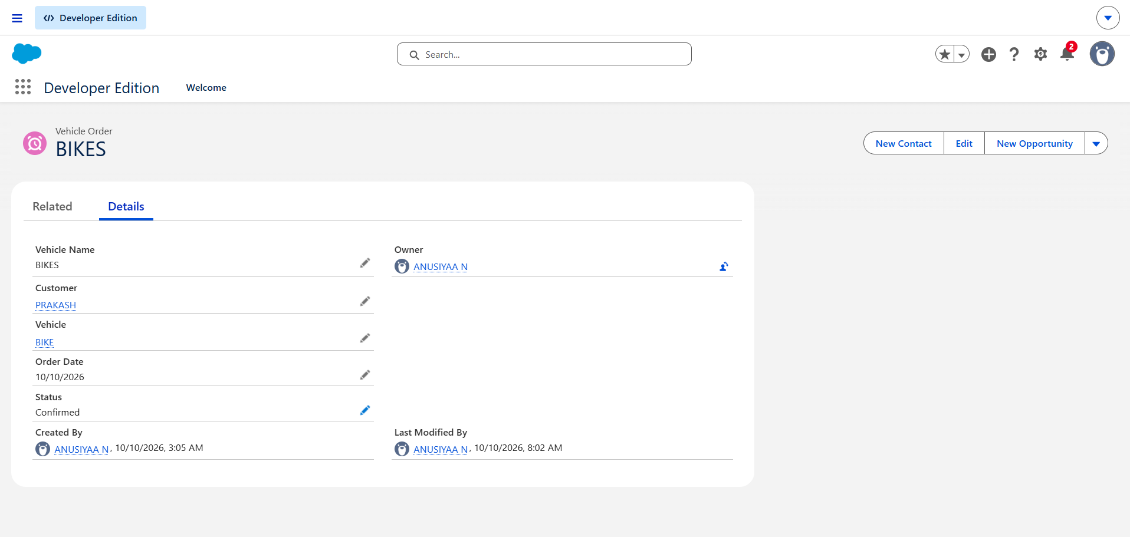

5.5 Test Drive Remainder Flow Configuration
A record-triggered Flow is configured for the Vehicle Test Drive object. The Flow includes scheduled paths and a customer information retrieval step, followed by the Send Test Drive Reminder action.

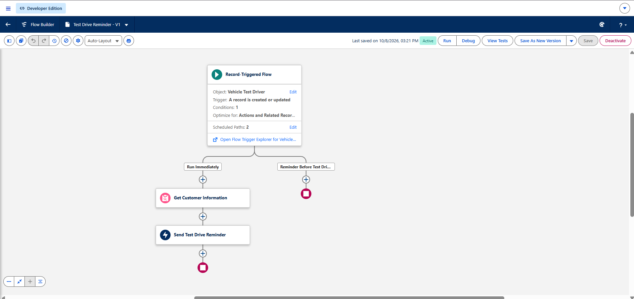

6. PHASE 4: BATCH APEX AND SCHEDULED PROCESSING

6.1 Batch Apex
Batch Apex can process a large number of vehicle order records in manageable groups. The project requirement describes checking vehicle stock and updating order status: orders with available stock are intended to be marked Confirmed, while orders without available stock are intended to be marked Pending. The final documentation must match the actual query, processing logic, and status values used in the batch class.

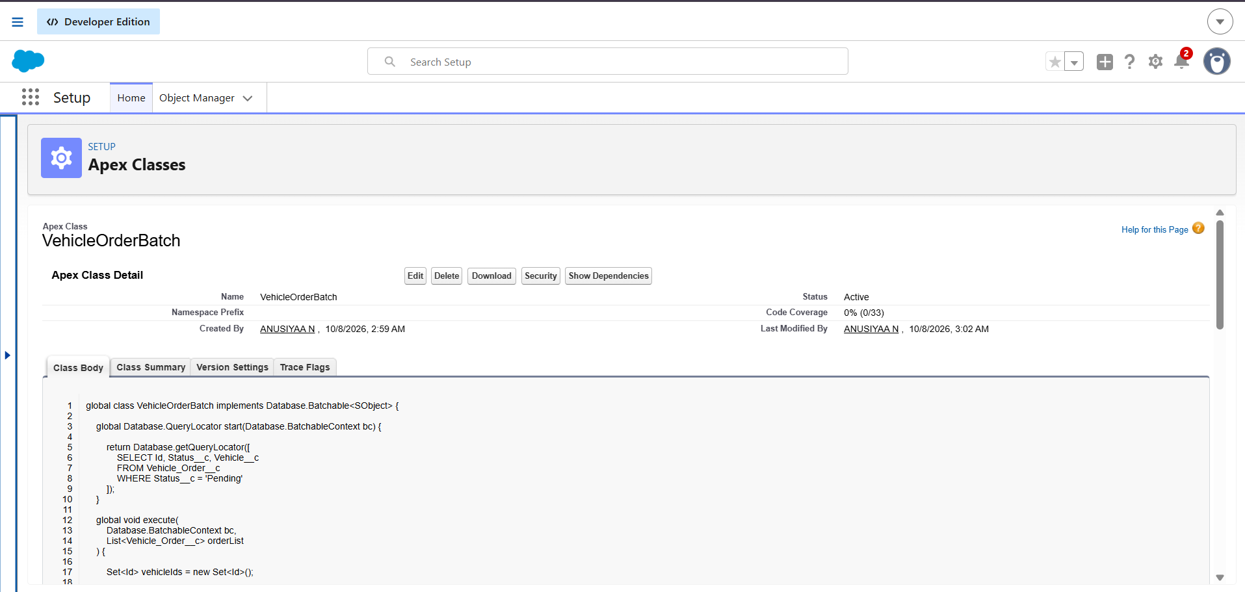

6.2 Scheduled Apex
Scheduled Apex can run the batch process automatically at a configured time. The scheduler must implement Salesforce's scheduling interface and invoke the batch class. Record the schedule and execution result only after confirming that the job is configured and runs successfully.
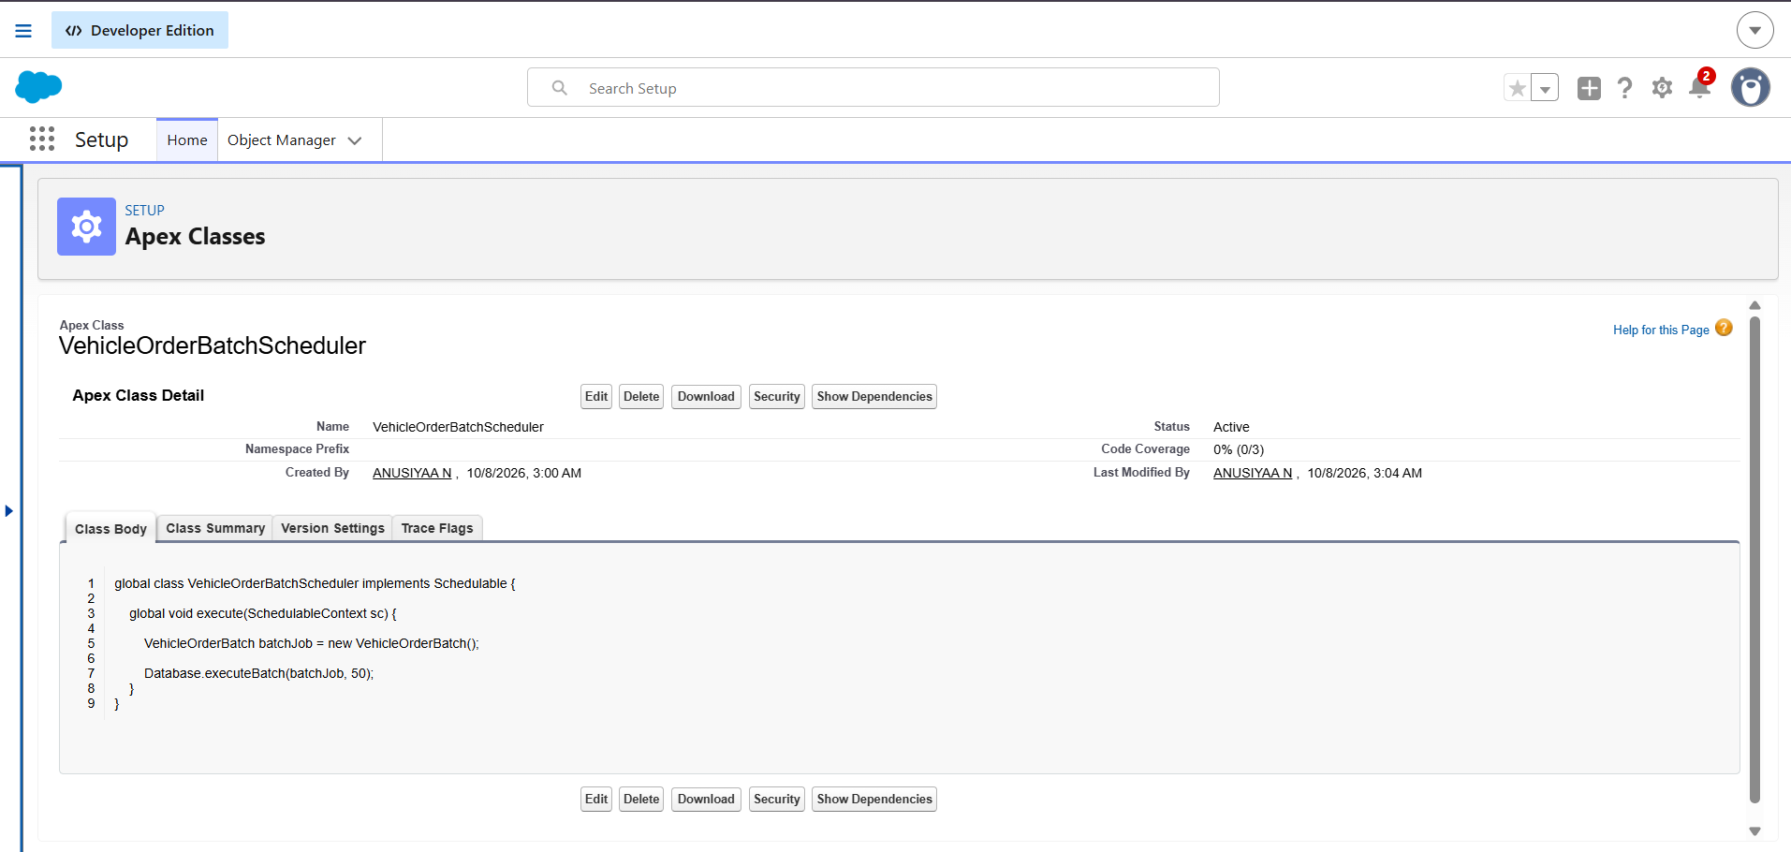
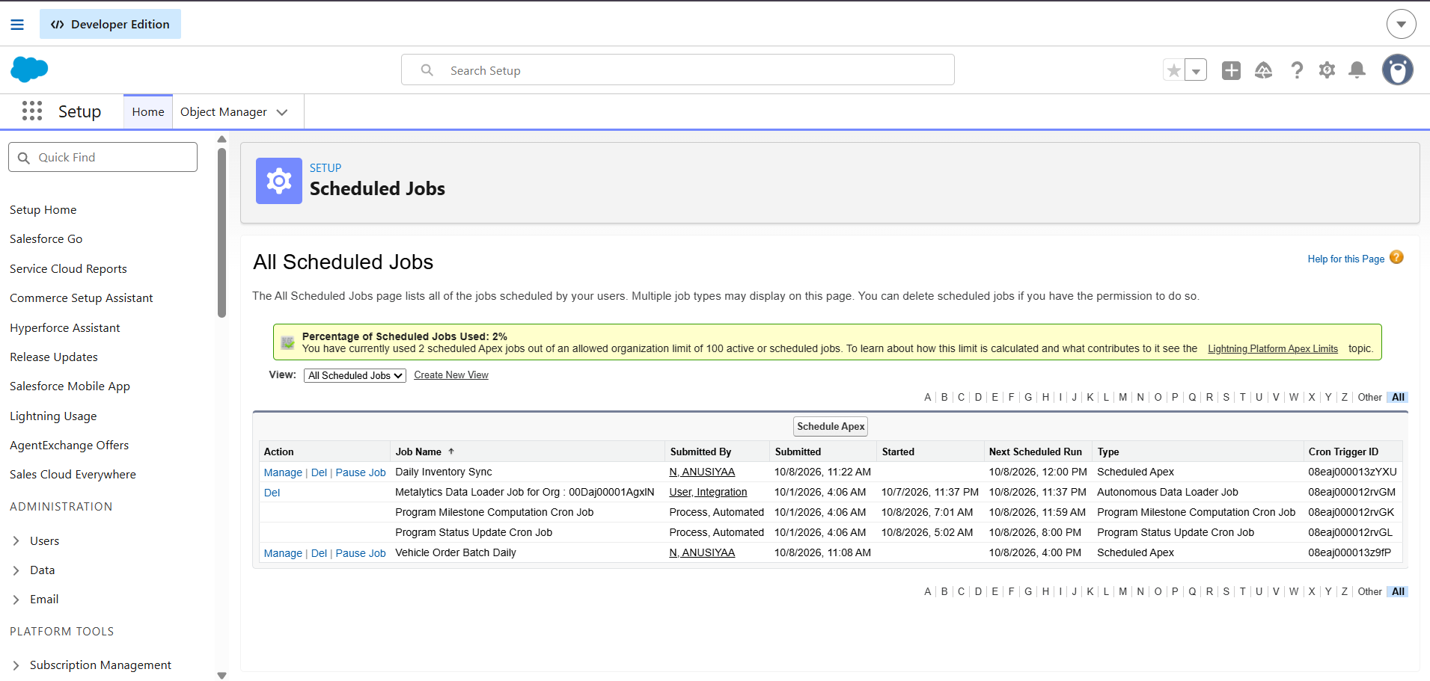

7. PHASE 5: TESTING AND VALIDATION

7.1 Testing Overview
Testing verifies that the trigger, handler, and batch logic behave as expected for valid and invalid order scenarios. Actual outcomes should be recorded after running the tests in Salesforce.

7.2 Test Cases

Test Case | Input / Action | Expected Result
TC-01: Valid vehicle order | Create an order with a requested quantity within available stock. | Order is accepted and stock is updated according to the implemented logic.
TC-02: Insufficient stock | Attempt an order with a quantity greater than available stock. | Order is prevented and an appropriate error is shown.
TC-03: Order update | Update an existing order record. | The applicable trigger logic runs without unintended stock changes.
TC-04: Batch processing | Run the batch against records matching its query conditions. | Eligible records are processed according to the implemented logic.
TC-05: Scheduled execution | Run or wait for the configured scheduled job. | The scheduler invokes the batch process successfully.
TC-06: Dealer assignment | Create an order with customer location information. | The nearest dealer is assigned, if this feature is implemented.
Replace expected results with actual results after executing each test. Do not claim a test passed unless you have verified it.

8. RESULTS AND CONCLUSION
The Vehicle Order Management System demonstrates how Salesforce can be configured to manage vehicle inventory and vehicle orders through a centralized platform. The custom objects and fields organize business information, while the Apex trigger and VehicleOrderTriggerHandler support stock validation and stock updates.
The stock validation mechanism is intended to prevent orders that exceed available inventory. Batch Apex and Scheduled Apex can provide bulk order processing when correctly implemented and tested. The final project outcome should be described using the actual Salesforce behavior and test evidence collected during implementation.

9. FUTURE ENHANCEMENTS
- Implement nearest-dealer assignment using customer location and dealer location data.
- Add test-drive scheduling and automated email reminders.
- Add service request management.
- Configure low-stock alerts and replenishment notifications.
- Create reports and dashboards for vehicle stock and order status.
- Improve Apex test coverage for bulk records, edge cases, and error handling.
- Validate scheduled batch execution and monitor failed jobs.
- Review object permissions and access controls for different user roles.

